VISHAL G Mod 6 Assignments

1. Capture and analyse ARP packets usings wireshark, Inspect the request and reply frames
and discuss the role of the senders IP and MAC address in these packets:

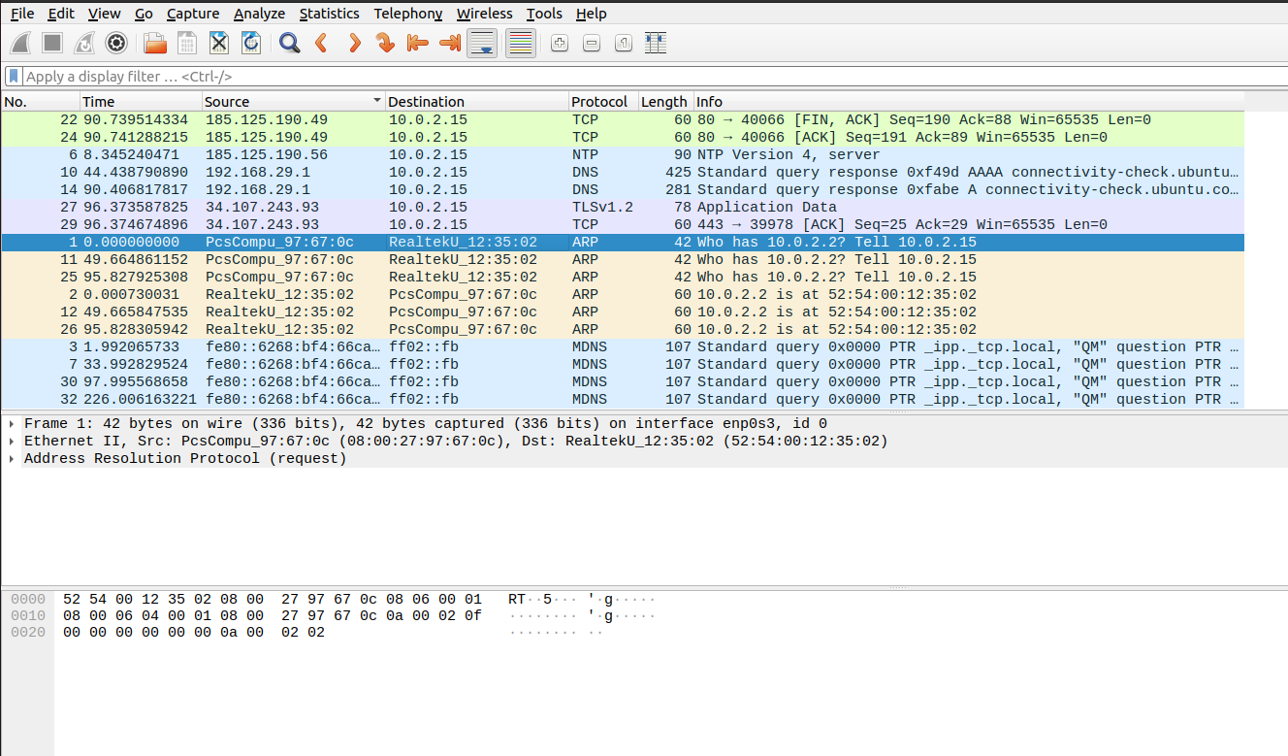

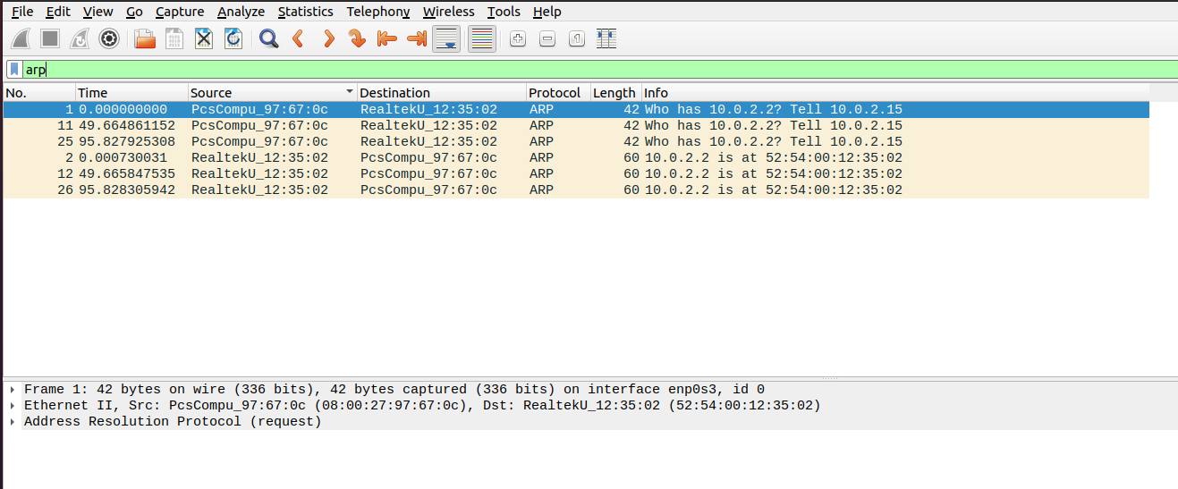

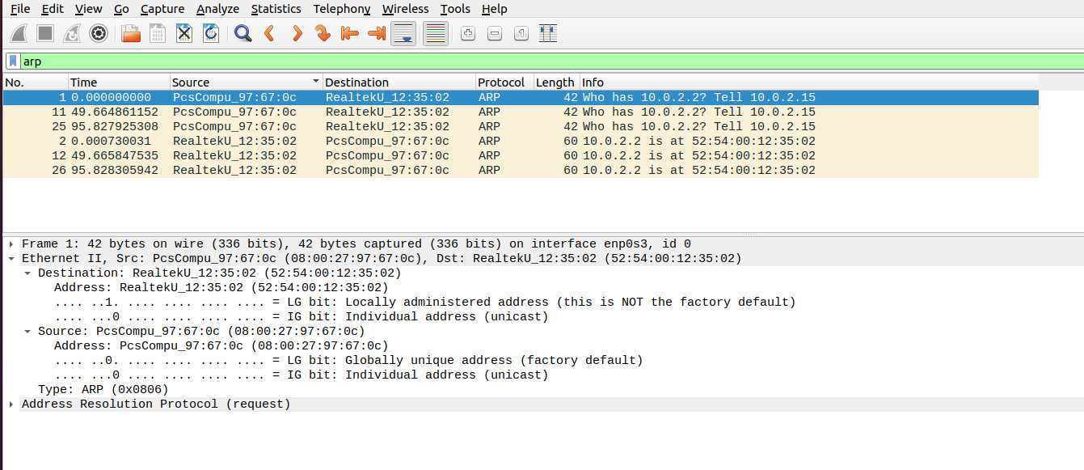

Source MAC Address is the MAC address of the host machine’s enp0s3 network interface:
vishal@Ubuntu20:~$ ip a
1: lo: <LOOPBACK,UP,LOWER_UP> mtu 65536 qdisc noqueue state UNKNOWN group default qlen 1000
link/loopback 00:00:00:00:00:00 brd 00:00:00:00:00:00
inet 127.0.0.1/8 scope host lo
valid_lft forever preferred_lft forever
inet6 ::1/128 scope host
valid_lft forever preferred_lft forever
2: enp0s3: <BROADCAST,MULTICAST,UP,LOWER_UP> mtu 1500 qdisc fq_codel state UP group default qlen 1000
link/ether 08:00:27:97:67:0c brd ff:ff:ff:ff:ff:ff
inet 10.0.2.15/24 brd 10.0.2.255 scope global dynamic noprefixroute enp0s3
valid_lft 85606sec preferred_lft 85606sec
inet6 fe80::6268:bf4:66ca:67d6/64 scope link noprefixroute
valid_lft forever preferred_lft forever
System’s IP address is 10.0.2.15 which gets the destination IP as 10.0.2.2. ARP helps the system to link the Dynamic IP address to the Device Physical address. Address resolution protocol, searches for the Device Physical Address.
From System to ARP Protocol: Who has 10.0.2.2?
Length of the Above message: 42 bit
ARP Acknowledgement:

Destination: RealtekU_12:35:02 (52:54:00:12:35:02)
Address: RealtekU_12:35:02 (52:54:00:12:35:02)
.... ..1. .... .... .... .... = LG bit: Locally administered address (this is NOT the factory default)
.... ...0 .... .... .... .... = IG bit: Individual address (unicast)
Now the system knows the actual device from its MAC address irrespective of its dynamic IP addresses.

In ARP (Address Resolution Protocol), the sender's IP and MAC address play different roles in ARP request and response frames.
In an ARP request, the sender’s IP address is the IP address of the device making the request. It helps the target device identify who is asking for its MAC address. The sender’s MAC address is the physical address (unique hardware address) of the requesting device. It’s important because the target device will use this address to reply back. The purpose of the ARP request is essentially the sender saying, "Hey, I have this IP address (Target IP). If you're the owner of this IP, please respond with your MAC address. You can reply to my MAC address which I have included in this request."

3. Manually Configure static Ips on the client devices and verify the connectivity using ping

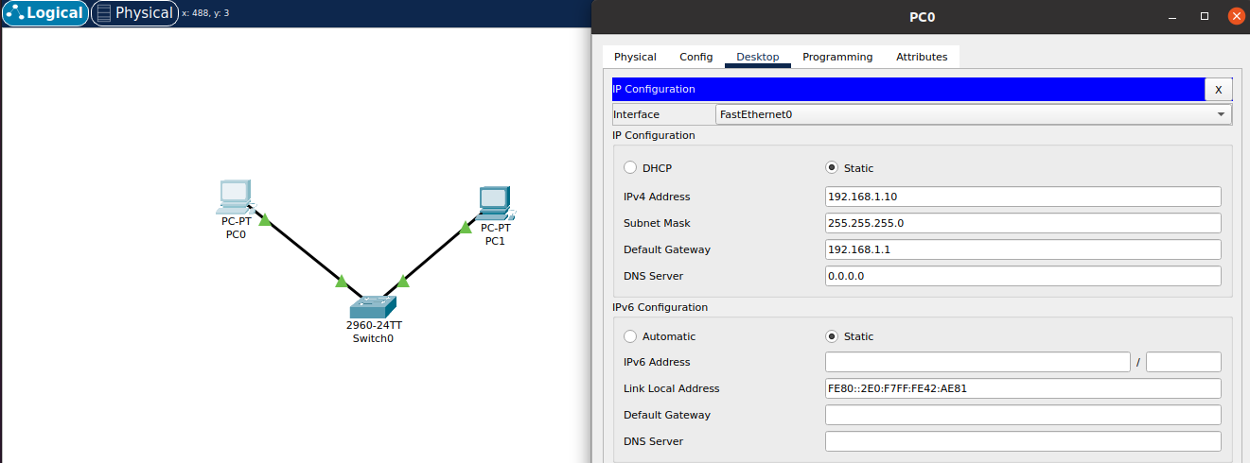

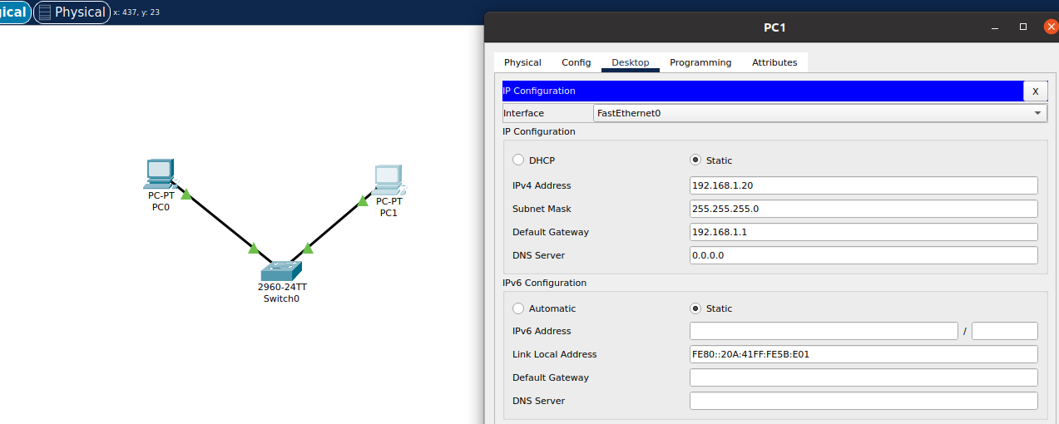

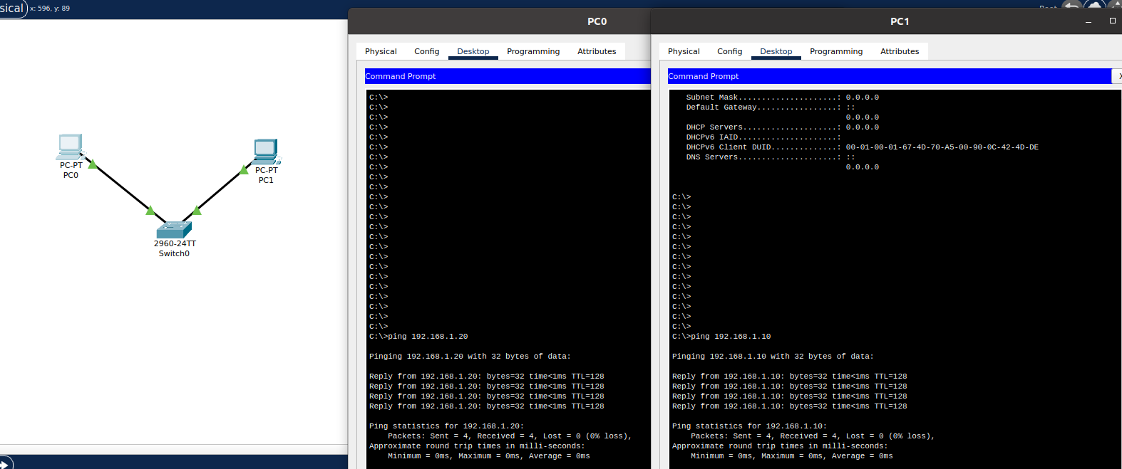

3. Given a network address of 10.0.0.0/24, divide it into 4 equal subnet. Calculate the new subnet mask. Determine the valid host range of each subnet. Assign IP in packet tracer and verify connectivity.

Subnet Mask calculcation:

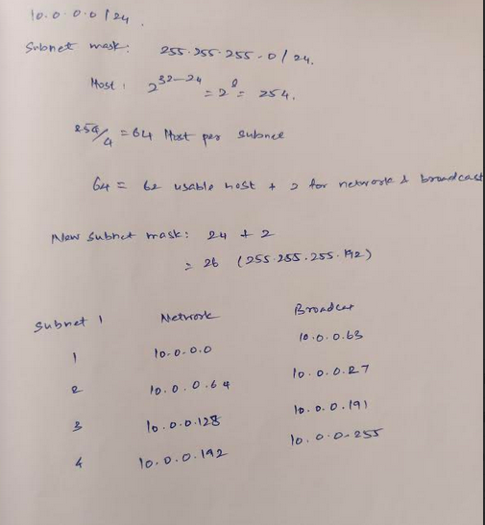
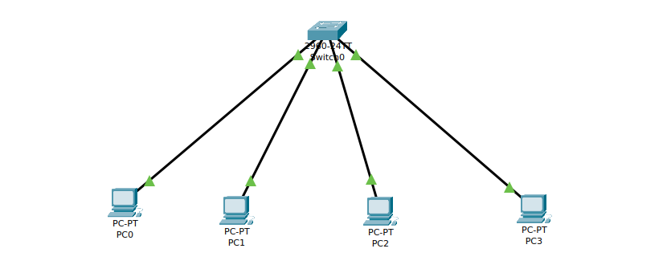

PC pinging:

Cisco Packet Tracer PC Command Line 1.0
C:\>ping 10.0.0.65

Pinging 10.0.0.65 with 32 bytes of data:

Request timed out.
Request timed out.
Request timed out.
Request timed out.

Ping statistics for 10.0.0.65:
Packets: Sent = 4, Received = 0, Lost = 4 (100% loss),

C:\>ping 10.0.0.129

Pinging 10.0.0.129 with 32 bytes of data:

Request timed out.
Request timed out.
Request timed out.
Request timed out.

Ping statistics for 10.0.0.129:
Packets: Sent = 4, Received = 0, Lost = 4 (100% loss),

C:\>ping 10.0.0.193

Pinging 10.0.0.193 with 32 bytes of data:

Request timed out.
Request timed out.
Request timed out.
Request timed out.

Ping statistics for 10.0.0.193:
Packets: Sent = 4, Received = 0, Lost = 4 (100% loss),
Due to absence of inter subnet routing, Pcs in different subnet cant communicate with each other.

4. You are given 3 IP addresses. Determine its class, if its private or public, Explain how NAT would handle a private IP when accessing the internet.
192.168.10.5, 172.20.15.1, 8.8.8.8

- 192.168.10.5
  - Class: Class C (Range: 192.0.0.0 to 223.255.255.255)
  - Private/Public: Private (Range: 192.168.0.0 to 192.168.255.255)
- 172.20.15.1
  - Class: Class B (Range: 128.0.0.0 to 191.255.255.255)
  - Private/Public: Private (Range: 172.16.0.0 to 172.31.255.255)
- 8.8.8.8
  - Class: Class A (Range: 0.0.0.0 to 127.255.255.255)
  - Private/Public: Public (Google Public DNS Server)
How NAT Handles Private IPs:
Network Address Translation (NAT) is used to allow private IP addresses to communicate with the public internet. When a device with a private IP address wants to access the internet:
- Translation: The private IP address is replaced with a public IP address by the NAT device (usually a router).
- Port Mapping: NAT keeps track of active connections by mapping ports to private IP addresses, allowing multiple devices to share a single public IP.
- Response Handling: When a response comes back from the internet, NAT uses the mapping table to direct the response to the correct private IP address.

5. In Cisco Packet tracer, Configure Nat on a router to allow internal devices to access the internet. Test Connectivity by pinging an external IP. Capture the traffic in Wireshark and analyse the sourfe Ip before and after NAT translation.
Connections:

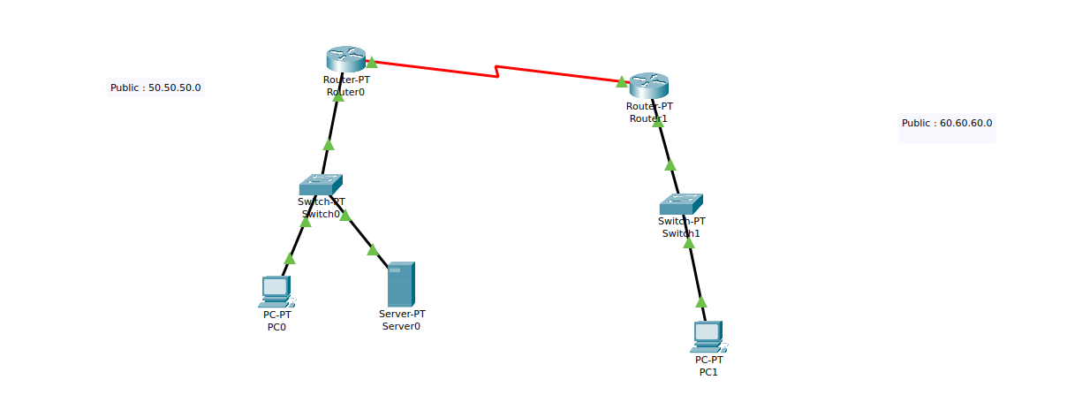

ROUTER ) CLI:

Router(config)#interface FastEthernet0/0
Router(config-if)#ip address 11.11.11.1 255.0.0.0
Router(config-if)#ip address 11.11.11.1 255.0.0.0
Router(config-if)#
Router(config-if)#
Router(config-if)#exit
Router(config)#interface FastEthernet0/0
Router(config-if)#no shutdown
Router(config-if)#
%LINK-5-CHANGED: Interface FastEthernet0/0, changed state to up

%LINEPROTO-5-UPDOWN: Line protocol on Interface FastEthernet0/0, changed state to up

Router(config-if)#
Router(config-if)#exit
Router(config)#interface Serial2/0
Router(config-if)#ip address 192.168.10.1 255.255.255.0
Router(config-if)#ip address 192.168.10.1 255.255.255.0
Router(config-if)#no shutdown
Router(config-if)#ip address 192.162.10.1 255.255.255.0
Router(config-if)#
%LINK-5-CHANGED: Interface Serial2/0, changed state to up

%LINEPROTO-5-UPDOWN: Line protocol on Interface Serial2/0, changed state to up

Router(config-if)#exit
Router(config)#ip nat inside source static 11.11.11.2 50.50.50.2
Router(config)#ip nat inside source static 11.11.11.3 50.50.50.3
Router(config)#interface
% Incomplete command.
Router(config)#interface fastEthernet 0/0
Router(config-if)#ip nat inside
Router(config-if)#exit
Router(config)#interface fastEthernet 1/0
Router(config-if)#ip nat inside
Router(config-if)#exit
Router(config)#interface serial 2/0
Router(config-if)#ip nat outside
Router(config-if)#exit
Router(config)#ip route 60.0.0.0 255.0.0.0 192.162.10.2
ROUTER 1 CLI:

Router>enable
Router#
Router#configure terminal
Enter configuration commands, one per line. End with CNTL/Z.
Router(config)#interface FastEthernet0/0
Router(config-if)#ip address 21.21.21.1 255.0.0.0
Router(config-if)#ip address 21.21.21.1 255.0.0.0
Router(config-if)#no shutdown
Router(config-if)#
%LINK-5-CHANGED: Interface FastEthernet0/0, changed state to up

%LINEPROTO-5-UPDOWN: Line protocol on Interface FastEthernet0/0, changed state to up

Router(config-if)#
Router(config-if)#exit
Router(config)#interface Serial2/0
Router(config-if)#ip address 192.162.10.2 255.255.255.0
Router(config-if)#ip address 192.162.10.2 255.255.255.0
Router(config-if)#no shutdown
Router(config-if)#
%LINK-5-CHANGED: Interface Serial2/0, changed state to up

%LINEPROTO-5-UPDOWN: Line protocol on Interface Serial2/0, changed state to up

Router(config-if)#exit
Router(config)#ip nat inside source static 21.21.21.2 60.60.60.2
Router(config)#interface fastEthernet 0/0
Router(config-if)#ip nat inside
Router(config-if)#exit
Router(config)#interface serial 2/0
Router(config-if)#ip nat outside
Router(config-if)#exit
Router(config)#ip route 50.0.0.0 255.0.0.0 192.162.10.1
Router(config)#exit
Router#
%SYS-5-CONFIG_I: Configured from console by console

Router#show ip route
Codes: C - connected, S - static, I - IGRP, R - RIP, M - mobile, B - BGP
D - EIGRP, EX - EIGRP external, O - OSPF, IA - OSPF inter area
N1 - OSPF NSSA external type 1, N2 - OSPF NSSA external type 2
E1 - OSPF external type 1, E2 - OSPF external type 2, E - EGP
i - IS-IS, L1 - IS-IS level-1, L2 - IS-IS level-2, ia - IS-IS inter area
* - candidate default, U - per-user static route, o - ODR
P - periodic downloaded static route

Gateway of last resort is not set

C 21.0.0.0/8 is directly connected, FastEthernet0/0
S 50.0.0.0/8 [1/0] via 192.162.10.1
C 192.162.10.0/24 is directly connected, Serial2/0

PC 0:
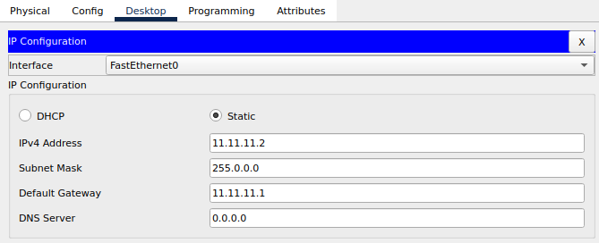

PC 1:

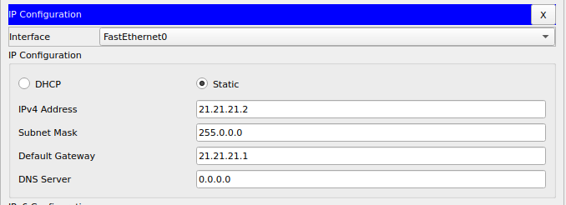

Linked the group of Pcs on the right to a Group IP address irresepective of the original IP address of its own, Thus Network Address translation allows those PC to be accessed by the newly assignment Public IP address and thereby safegaurding the information on the private Ip addresses.
RESULT:
Cisco Packet Tracer PC Command Line 1.0
C:\>ping 60.60.60.2

Pinging 60.60.60.2 with 32 bytes of data:

Request timed out.
Reply from 60.60.60.2: bytes=32 time=33ms TTL=126
Reply from 60.60.60.2: bytes=32 time=9ms TTL=126
Reply from 60.60.60.2: bytes=32 time=10ms TTL=126

Ping statistics for 60.60.60.2:
Packets: Sent = 4, Received = 3, Lost = 1 (25% loss),
Approximate round trip times in milli-seconds:
Minimum = 9ms, Maximum = 33ms, Average = 17ms

C:\>ping 21.21.21.2

Pinging 21.21.21.2 with 32 bytes of data:

Reply from 11.11.11.1: Destination host unreachable.
Reply from 11.11.11.1: Destination host unreachable.
Reply from 11.11.11.1: Destination host unreachable.
Reply from 11.11.11.1: Destination host unreachable.

Ping statistics for 21.21.21.2:
Packets: Sent = 4, Received = 0, Lost = 4 (100% loss),
This shows Destination host is unreachable upon using its Private IP address but rather by the Public IP address given to the group of Pcs connected to the network.

