VISHAL G

1. Capture and analyse ARP packets usings wireshark, Inspect the request and reply frames
and discuss the role of the senders IP and MAC address in these packets:

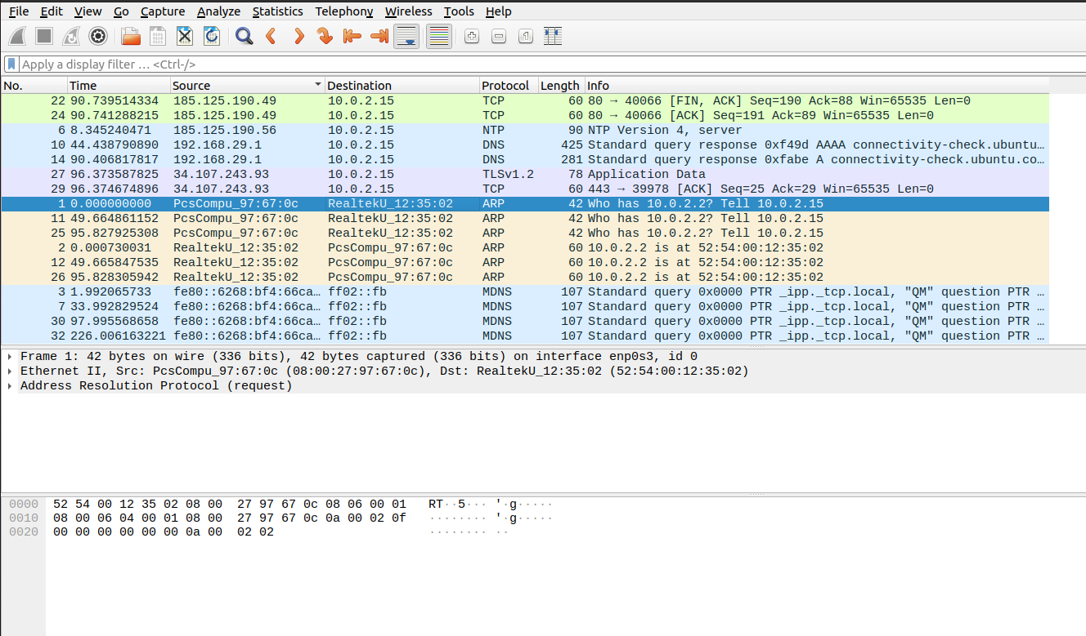

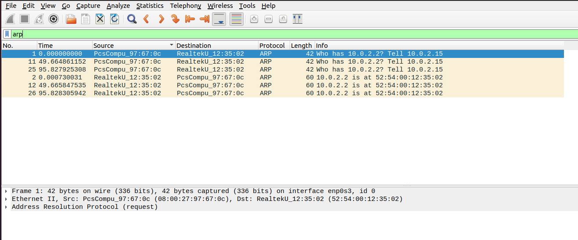

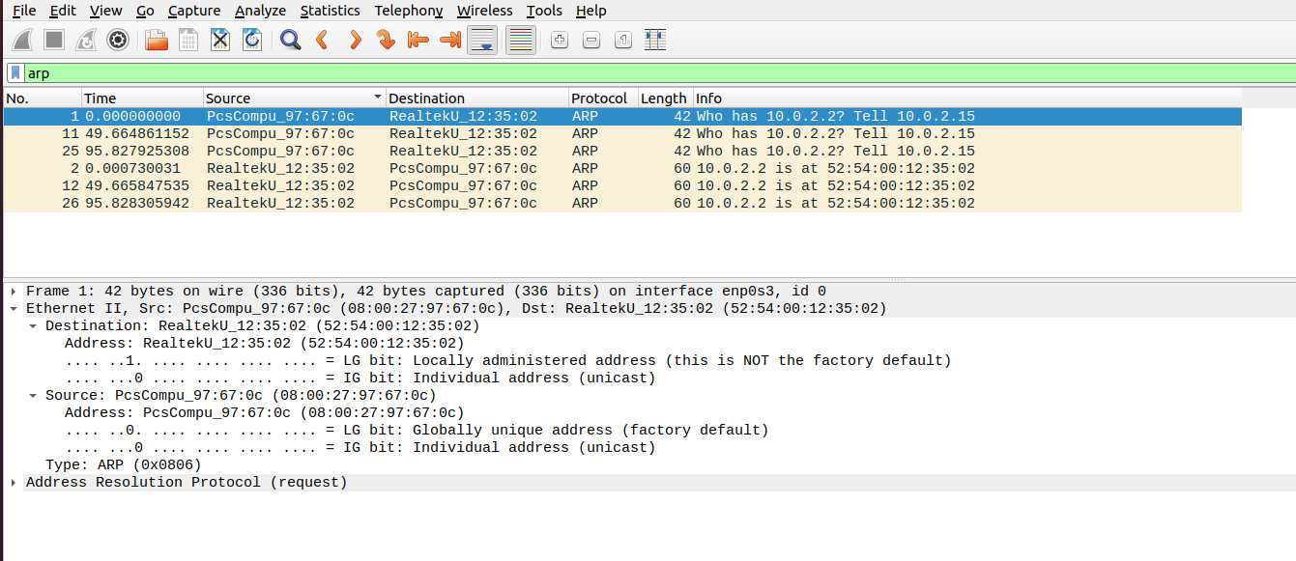

Source MAC Address is the MAC address of the host machine’s enp0s3 network interface:
vishal@Ubuntu20:~$ ip a
1: lo: <LOOPBACK,UP,LOWER_UP> mtu 65536 qdisc noqueue state UNKNOWN group default qlen 1000
link/loopback 00:00:00:00:00:00 brd 00:00:00:00:00:00
inet 127.0.0.1/8 scope host lo
valid_lft forever preferred_lft forever
inet6 ::1/128 scope host
valid_lft forever preferred_lft forever
2: enp0s3: <BROADCAST,MULTICAST,UP,LOWER_UP> mtu 1500 qdisc fq_codel state UP group default qlen 1000
link/ether 08:00:27:97:67:0c brd ff:ff:ff:ff:ff:ff
inet 10.0.2.15/24 brd 10.0.2.255 scope global dynamic noprefixroute enp0s3
valid_lft 85606sec preferred_lft 85606sec
inet6 fe80::6268:bf4:66ca:67d6/64 scope link noprefixroute
valid_lft forever preferred_lft forever
System’s IP address is 10.0.2.15 which gets the destination IP as 10.0.2.2. ARP helps the system to link the Dynamic IP address to the Device Physical address. Address resolution protocol, searches for the Device Physical Address.
From System to ARP Protocol: Who has 10.0.2.2?
Length of the Above message: 42 bit
ARP Acknowledgement:

Destination: RealtekU_12:35:02 (52:54:00:12:35:02)
Address: RealtekU_12:35:02 (52:54:00:12:35:02)
.... ..1. .... .... .... .... = LG bit: Locally administered address (this is NOT the factory default)
.... ...0 .... .... .... .... = IG bit: Individual address (unicast)
Now the system knows the actual device from its MAC address irrespective of its dynamic IP addresses.

In ARP (Address Resolution Protocol), the sender's IP and MAC address play different roles in ARP request and response frames.
In an ARP request, the sender’s IP address is the IP address of the device making the request. It helps the target device identify who is asking for its MAC address. The sender’s MAC address is the physical address (unique hardware address) of the requesting device. It’s important because the target device will use this address to reply back. The purpose of the ARP request is essentially the sender saying, "Hey, I have this IP address (Target IP). If you're the owner of this IP, please respond with your MAC address. You can reply to my MAC address which I have included in this request."

2. Using packet tracer, simulate ARP spoofing attack, Analyse the behaviour of devices on the network when they recieve a malicious ARP responce

Connectionns:
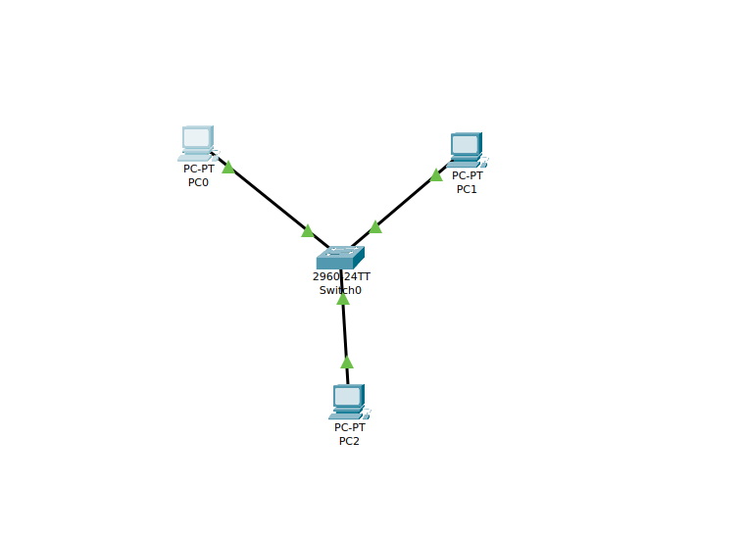
PC2 here is the attacker that changes the MAC address of the PC1 and there by performing ARP spoofing

PC0 Output:

Before Spoofing:
C:\>ipconfig /all

FastEthernet0 Connection:(default port)

Connection-specific DNS Suffix..:
Physical Address................: 00E0.F742.AE81
Link-local IPv6 Address.........: FE80::2E0:F7FF:FE42:AE81
IPv6 Address....................: ::
IPv4 Address....................: 192.168.1.10
Subnet Mask.....................: 255.255.255.0
Default Gateway.................: ::
192.168.1.1
DHCP Servers....................: 0.0.0.0
DHCPv6 IAID.....................:
DHCPv6 Client DUID..............: 00-01-00-01-93-71-DD-95-00-E0-F7-42-AE-81
DNS Servers.....................: ::
0.0.0.0

Bluetooth Connection:

Connection-specific DNS Suffix..:
Physical Address................: 0005.5E08.1BBE
Link-local IPv6 Address.........: ::
IPv6 Address....................: ::
IPv4 Address....................: 0.0.0.0
Subnet Mask.....................: 0.0.0.0
Default Gateway.................: ::
0.0.0.0
DHCP Servers....................: 0.0.0.0
DHCPv6 IAID.....................:
DHCPv6 Client DUID..............: 00-01-00-01-93-71-DD-95-00-E0-F7-42-AE-81
DNS Servers.....................: ::
0.0.0.0

C:\>
C:\>arp -a
No ARP Entries Found
C:\>ping 192.168.1.20

Pinging 192.168.1.20 with 32 bytes of data:

Reply from 192.168.1.20: bytes=32 time<1ms TTL=128
Reply from 192.168.1.20: bytes=32 time<1ms TTL=128
Reply from 192.168.1.20: bytes=32 time<1ms TTL=128
Reply from 192.168.1.20: bytes=32 time<1ms TTL=128

Ping statistics for 192.168.1.20:
Packets: Sent = 4, Received = 4, Lost = 0 (0% loss),
Approximate round trip times in milli-seconds:
Minimum = 0ms, Maximum = 0ms, Average = 0ms

C:\>arp -a
Internet Address Physical Address Type
192.168.1.20 000a.415b.0e01 dynamic

PC2 Details:

C:\>ipconfig /all

FastEthernet0 Connection:(default port)

Connection-specific DNS Suffix..:
Physical Address................: 0090.0C42.4DDE
Link-local IPv6 Address.........: FE80::290:CFF:FE42:4DDE
IPv6 Address....................: ::
IPv4 Address....................: 192.168.1.30
Subnet Mask.....................: 255.255.255.0
Default Gateway.................: ::
192.168.1.1
DHCP Servers....................: 0.0.0.0
DHCPv6 IAID.....................:
DHCPv6 Client DUID..............: 00-01-00-01-DC-47-E8-9C-00-90-0C-42-4D-DE
DNS Servers.....................: ::
0.0.0.0

Bluetooth Connection:

Connection-specific DNS Suffix..:
Physical Address................: 00D0.BCC4.9A21
Link-local IPv6 Address.........: ::

After Spoofing:
PC1 Details:

FastEthernet0 Connection:(default port)

Connection-specific DNS Suffix..:
Physical Address................: 0090.0C42.4DDE
Link-local IPv6 Address.........: FE80::20A:41FF:FE5B:E01
IPv6 Address....................: ::
IPv4 Address....................: 192.168.1.20
Subnet Mask.....................: 255.255.255.0
Default Gateway.................: ::
192.168.1.1
DHCP Servers....................: 0.0.0.0
DHCPv6 IAID.....................:
DHCPv6 Client DUID..............: 00-01-00-01-67-4D-70-A5-00-90-0C-42-4D-DE
DNS Servers.....................: ::
0.0.0.0

Bluetooth Connection:

Connection-specific DNS Suffix..:
Physical Address................: 0004.9AD6.88BC
Link-local IPv6 Address.........: ::
--More--

Pinging PC1 from PC0 after spoofing:
C:\>ping 192.168.1.20

Pinging 192.168.1.20 with 32 bytes of data:

Reply from 192.168.1.20: bytes=32 time<1ms TTL=128
Reply from 192.168.1.20: bytes=32 time<1ms TTL=128
Reply from 192.168.1.20: bytes=32 time<1ms TTL=128
Reply from 192.168.1.20: bytes=32 time<1ms TTL=128

Ping statistics for 192.168.1.20:
Packets: Sent = 4, Received = 4, Lost = 0 (0% loss),
Approximate round trip times in milli-seconds:
Minimum = 0ms, Maximum = 0ms, Average = 0ms

C:\>ap -a
Invalid Command.

C:\>arp -a
Internet Address Physical Address Type
192.168.1.20 0090.0c42.4dde dynamic

3. Manually Configure static Ips on the client devices and verify the connectivity using ping

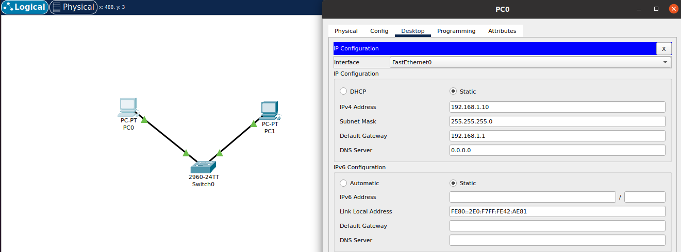

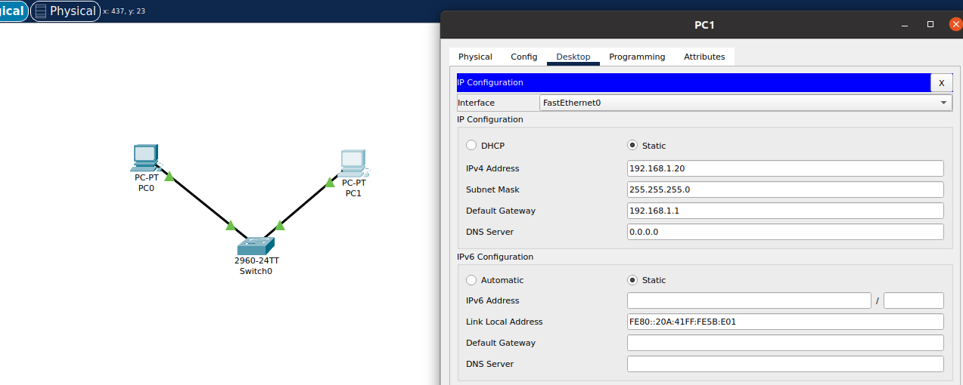

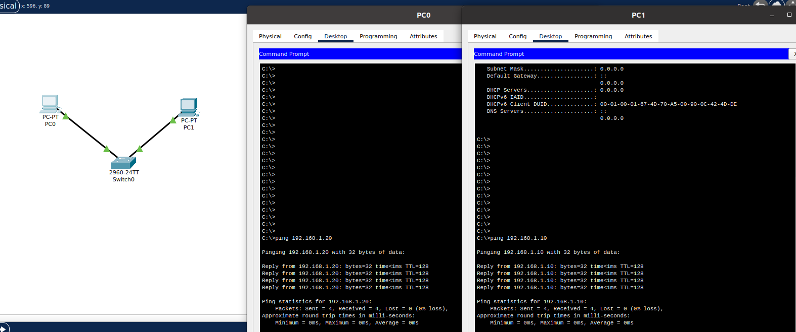

4. Use wireshark to capture DHCP Discover, Offer, Request and acknowledhee message and explain the process.
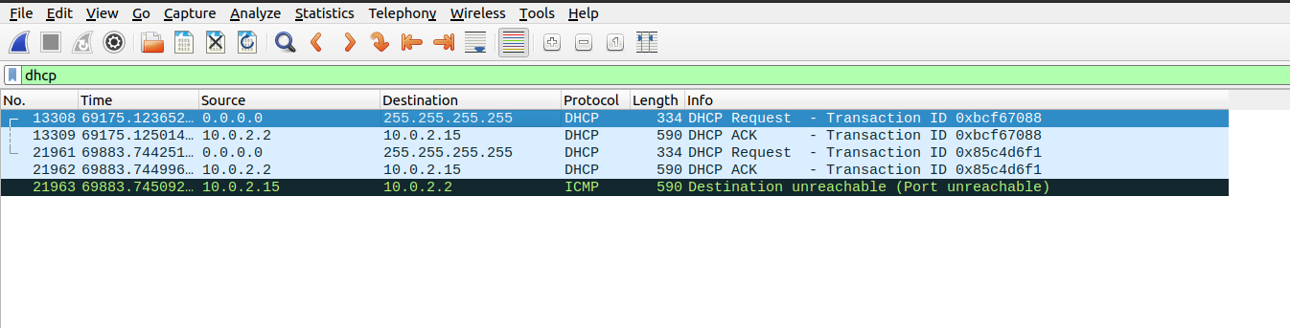
The DHCP process involves four essential messages exchanged between a client and a DHCP server: Discover, Offer, Request, and Acknowledgement (DORA). This process ensures the dynamic allocation of IP addresses and other network configuration details.
- Discover (Client to Network - Broadcast):
When a device connects to a network and requires an IP address, it initiates the process by broadcasting a DHCP Discover message. This message is sent to all devices on the network to identify available DHCP servers. Since the client does not have an IP address yet, it uses a broadcast address (255.255.255.255) to reach the DHCP server.
- Offer (Server to Client - Unicast/Broadcast):
Upon receiving the Discover message, any DHCP server present on the network responds with a DHCP Offer message. This message includes an available IP address, subnet mask, default gateway, DNS server addresses, and the lease duration. The server temporarily reserves the offered IP address to avoid assigning it to other clients.
- Request (Client to Server - Broadcast):
After receiving one or more offers, the client responds with a DHCP Request message to indicate acceptance of a specific offer. This message is broadcasted to inform all DHCP servers in the network of the chosen offer. The client explicitly identifies the server whose offer it is accepting by including the server’s identifier in the request.
- Acknowledgement (Server to Client - Unicast):
The DHCP server sends a DHCP Acknowledgement (ACK) message to confirm the allocation of the requested IP address. The server finalizes the lease, making the IP address officially available for use by the client. Additionally, the DHCP server may provide other configuration parameters, such as DNS server addresses and router information.

5. Given an IP range of 192.168.1.0/24, divide the network into 4 subnets and manually create the new subnet mask and the range of valid IP adderssses in Cisco Packet tracer.
Given Ip: 192.168.1.0/24
Subnet Mask : 255.255.255.0

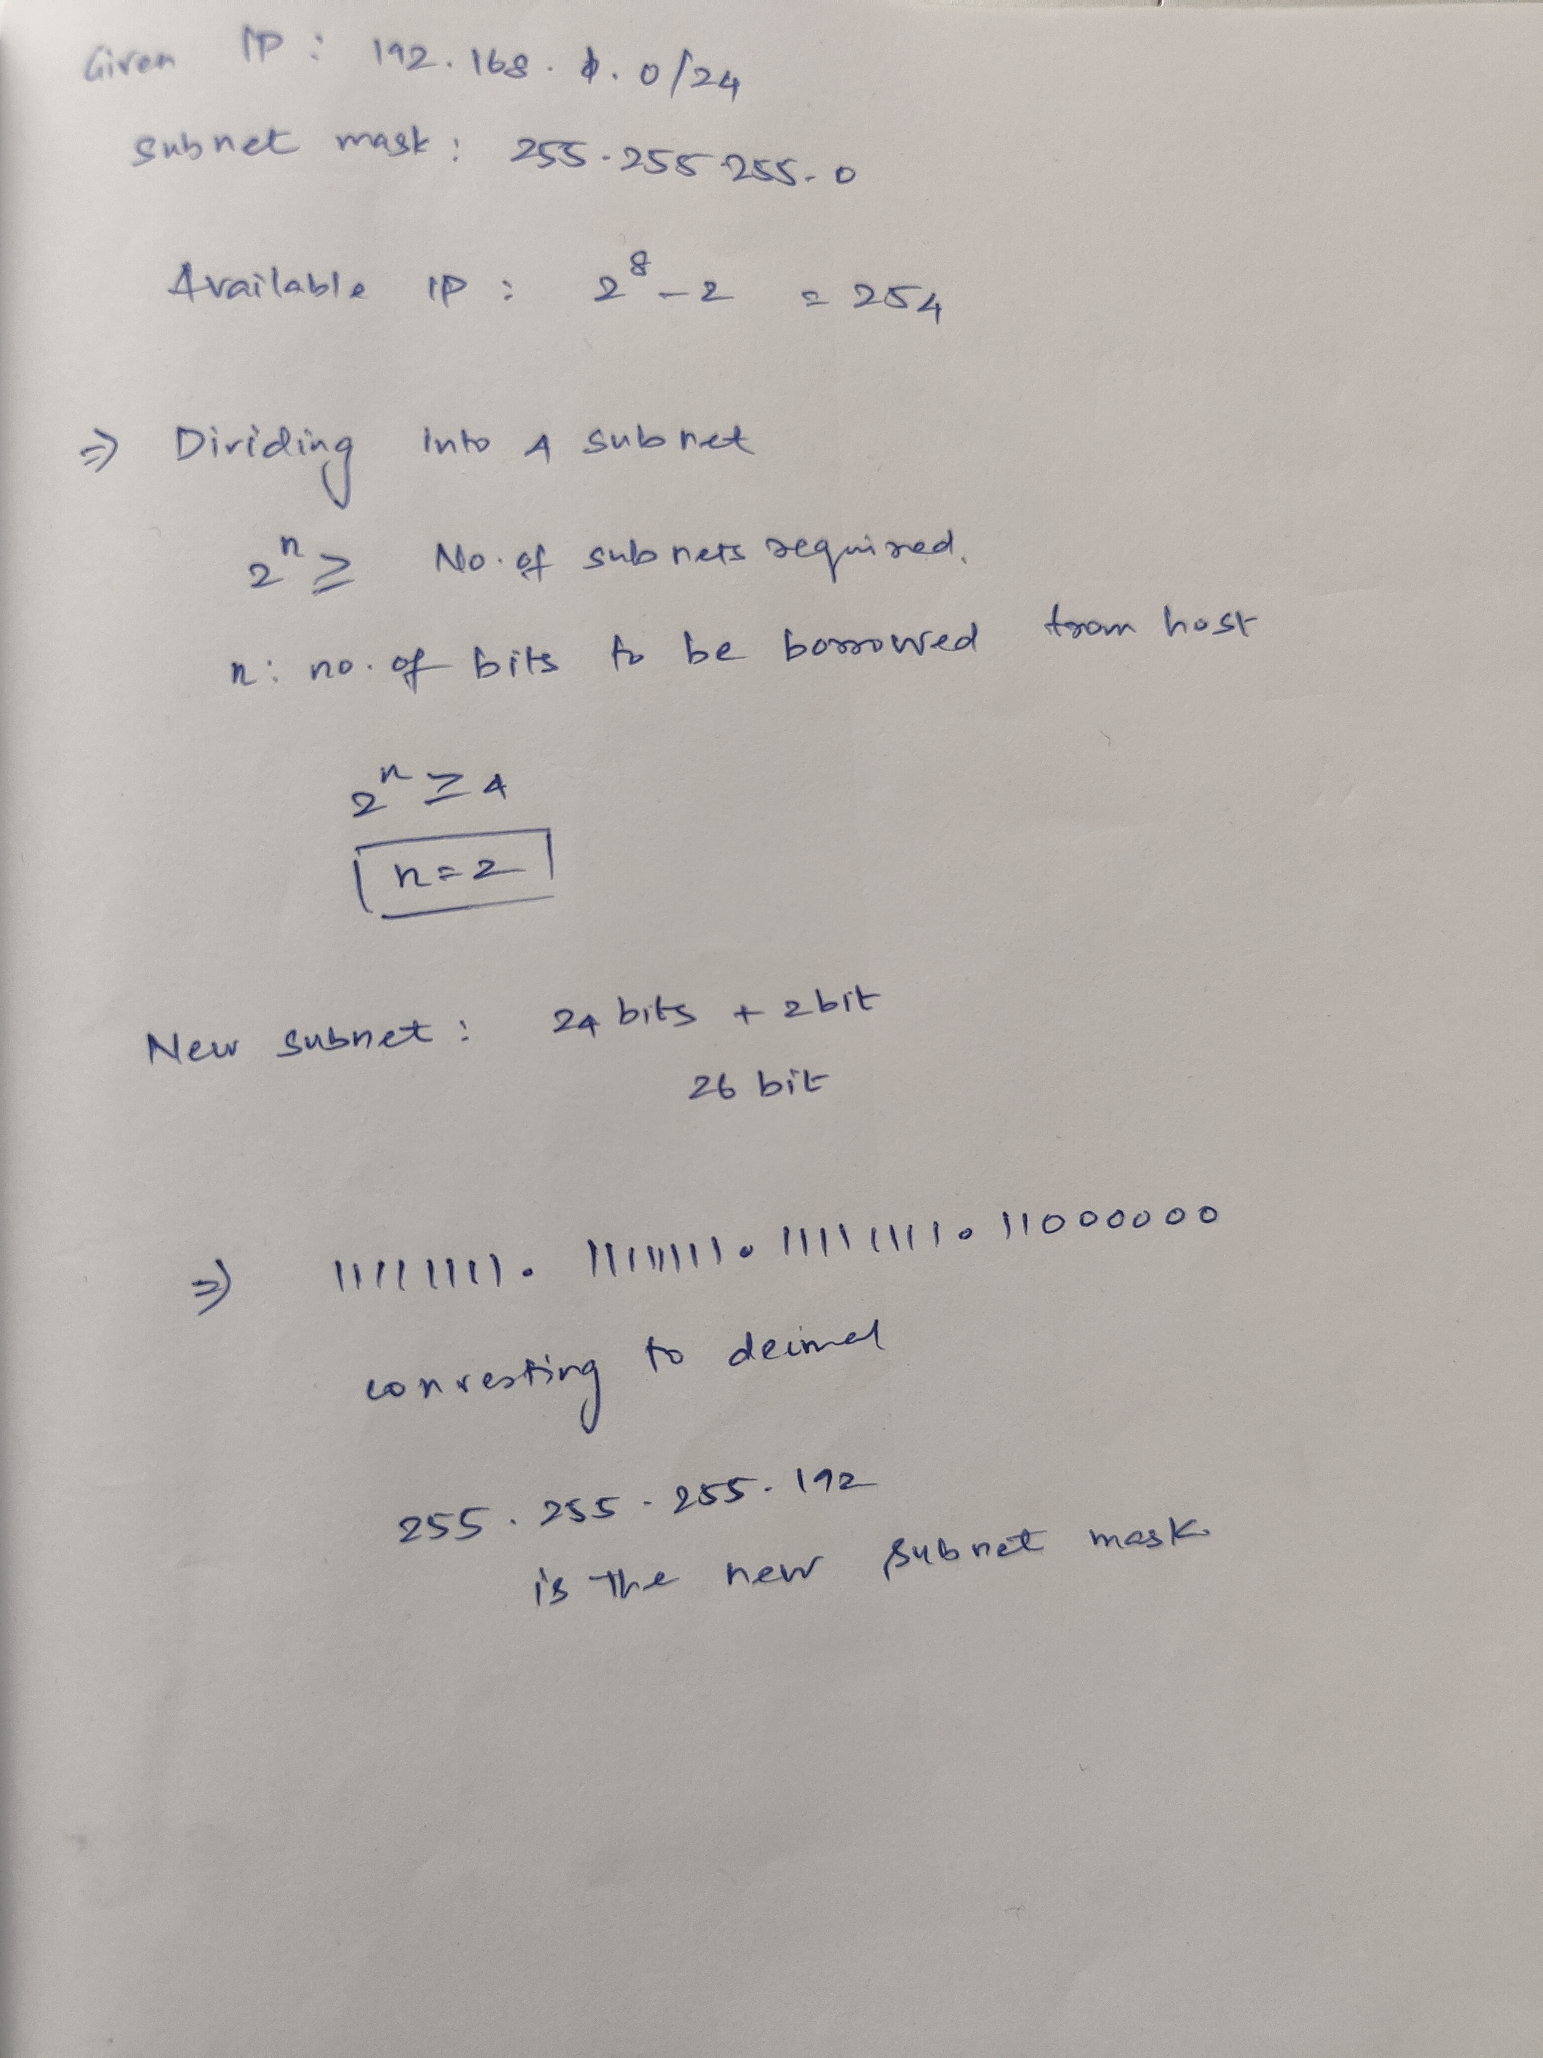

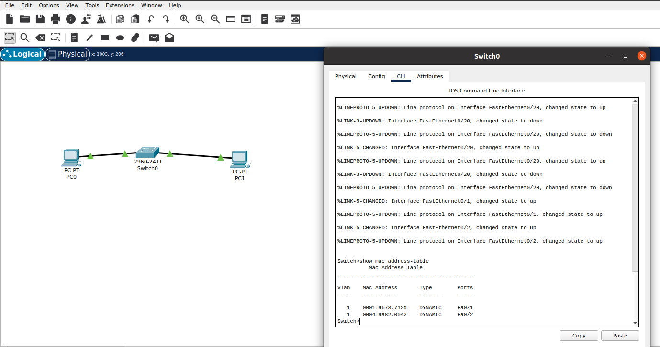
No of available IP : 254
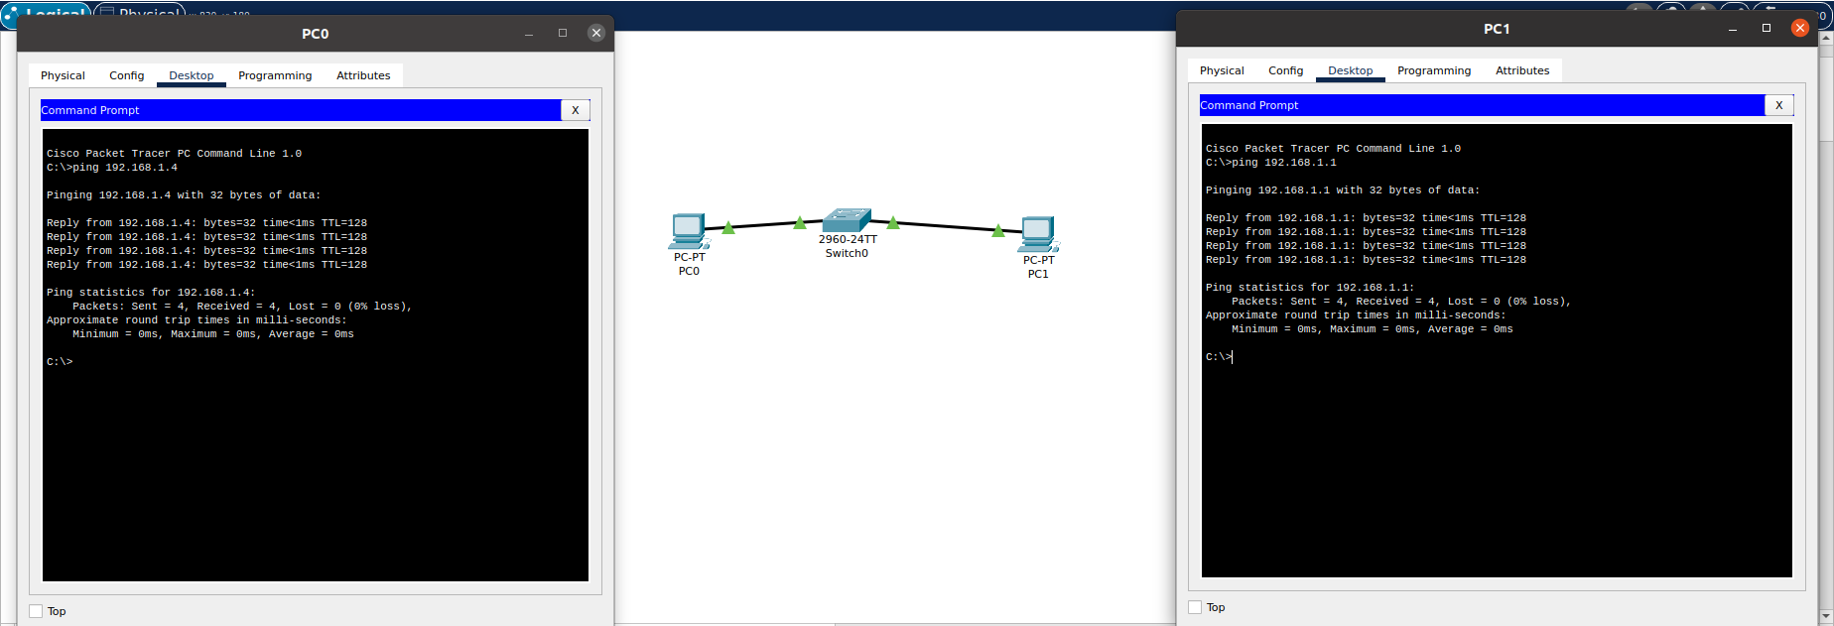

6. You are given three IP addresses, Identify the class of each IP addresses, what is the default subnet mask for each class along wiht the IP address range for each classes.

IP Address | Class | Default Subnet Mask | IP Range
10.1.1.1 | A | 255.0.0.0 | 0.0.0.0 - 127.255.255.255
172.16.5.10 | B | 255.255.0.0 | 128.0.0.0 - 191.255.255.255
192.168.1.5 | C | 255.255.255.0 | 192.0.0.0 - 223.255.255.255

7. Create a Small network in Cisco packet tracer and with multiple devices, use private IP address on the Pcs and configure the router to perform NAT to allow the pCs to access Internet

Test: Test the NAT configuration by pinging an external IP from the Pcs and capture the traffic using wireshark

What is the source IP address before and after the NAT?

Cisco Connections:

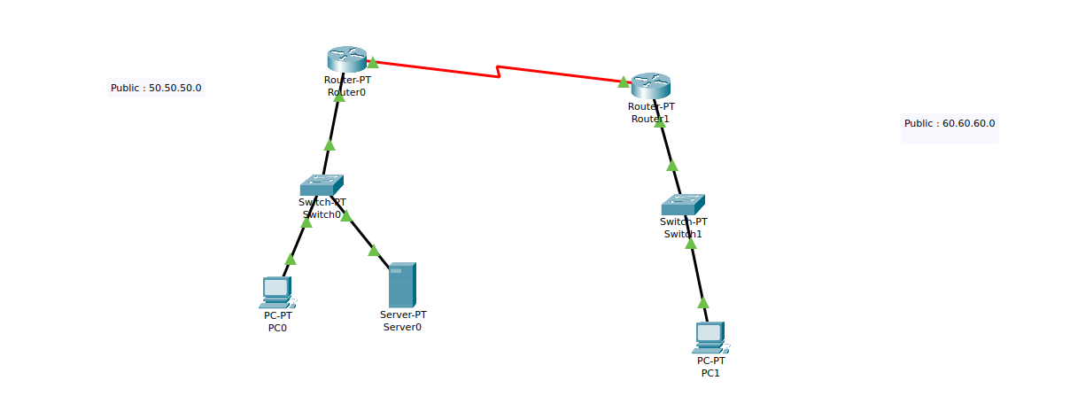

ROUTER ) CLI:

Router(config)#interface FastEthernet0/0
Router(config-if)#ip address 11.11.11.1 255.0.0.0
Router(config-if)#ip address 11.11.11.1 255.0.0.0
Router(config-if)#
Router(config-if)#
Router(config-if)#exit
Router(config)#interface FastEthernet0/0
Router(config-if)#no shutdown
Router(config-if)#
%LINK-5-CHANGED: Interface FastEthernet0/0, changed state to up

%LINEPROTO-5-UPDOWN: Line protocol on Interface FastEthernet0/0, changed state to up

Router(config-if)#
Router(config-if)#exit
Router(config)#interface Serial2/0
Router(config-if)#ip address 192.168.10.1 255.255.255.0
Router(config-if)#ip address 192.168.10.1 255.255.255.0
Router(config-if)#no shutdown
Router(config-if)#ip address 192.162.10.1 255.255.255.0
Router(config-if)#
%LINK-5-CHANGED: Interface Serial2/0, changed state to up

%LINEPROTO-5-UPDOWN: Line protocol on Interface Serial2/0, changed state to up

Router(config-if)#exit
Router(config)#ip nat inside source static 11.11.11.2 50.50.50.2
Router(config)#ip nat inside source static 11.11.11.3 50.50.50.3
Router(config)#interface
% Incomplete command.
Router(config)#interface fastEthernet 0/0
Router(config-if)#ip nat inside
Router(config-if)#exit
Router(config)#interface fastEthernet 1/0
Router(config-if)#ip nat inside
Router(config-if)#exit
Router(config)#interface serial 2/0
Router(config-if)#ip nat outside
Router(config-if)#exit
Router(config)#ip route 60.0.0.0 255.0.0.0 192.162.10.2
ROUTER 1 CLI:

Router>enable
Router#
Router#configure terminal
Enter configuration commands, one per line. End with CNTL/Z.
Router(config)#interface FastEthernet0/0
Router(config-if)#ip address 21.21.21.1 255.0.0.0
Router(config-if)#ip address 21.21.21.1 255.0.0.0
Router(config-if)#no shutdown
Router(config-if)#
%LINK-5-CHANGED: Interface FastEthernet0/0, changed state to up

%LINEPROTO-5-UPDOWN: Line protocol on Interface FastEthernet0/0, changed state to up

Router(config-if)#
Router(config-if)#exit
Router(config)#interface Serial2/0
Router(config-if)#ip address 192.162.10.2 255.255.255.0
Router(config-if)#ip address 192.162.10.2 255.255.255.0
Router(config-if)#no shutdown
Router(config-if)#
%LINK-5-CHANGED: Interface Serial2/0, changed state to up

%LINEPROTO-5-UPDOWN: Line protocol on Interface Serial2/0, changed state to up

Router(config-if)#exit
Router(config)#ip nat inside source static 21.21.21.2 60.60.60.2
Router(config)#interface fastEthernet 0/0
Router(config-if)#ip nat inside
Router(config-if)#exit
Router(config)#interface serial 2/0
Router(config-if)#ip nat outside
Router(config-if)#exit
Router(config)#ip route 50.0.0.0 255.0.0.0 192.162.10.1
Router(config)#exit
Router#
%SYS-5-CONFIG_I: Configured from console by console

Router#show ip route
Codes: C - connected, S - static, I - IGRP, R - RIP, M - mobile, B - BGP
D - EIGRP, EX - EIGRP external, O - OSPF, IA - OSPF inter area
N1 - OSPF NSSA external type 1, N2 - OSPF NSSA external type 2
E1 - OSPF external type 1, E2 - OSPF external type 2, E - EGP
i - IS-IS, L1 - IS-IS level-1, L2 - IS-IS level-2, ia - IS-IS inter area
* - candidate default, U - per-user static route, o - ODR
P - periodic downloaded static route

Gateway of last resort is not set

C 21.0.0.0/8 is directly connected, FastEthernet0/0
S 50.0.0.0/8 [1/0] via 192.162.10.1
C 192.162.10.0/24 is directly connected, Serial2/0

PC 0:
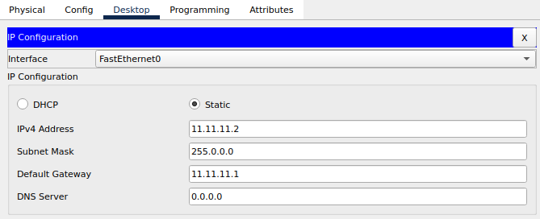

PC 1:

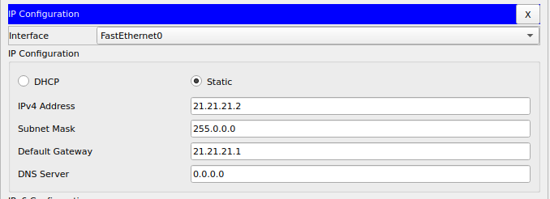

Linked the group of Pcs on the right to a Group IP address irresepective of the original IP address of its own, Thus Network Address translation allows those PC to be accessed by the newly assignment Public IP address and thereby safegaurding the information on the private Ip addresses.
RESULT:
Cisco Packet Tracer PC Command Line 1.0
C:\>ping 60.60.60.2

Pinging 60.60.60.2 with 32 bytes of data:

Request timed out.
Reply from 60.60.60.2: bytes=32 time=33ms TTL=126
Reply from 60.60.60.2: bytes=32 time=9ms TTL=126
Reply from 60.60.60.2: bytes=32 time=10ms TTL=126

Ping statistics for 60.60.60.2:
Packets: Sent = 4, Received = 3, Lost = 1 (25% loss),
Approximate round trip times in milli-seconds:
Minimum = 9ms, Maximum = 33ms, Average = 17ms

C:\>ping 21.21.21.2

Pinging 21.21.21.2 with 32 bytes of data:

Reply from 11.11.11.1: Destination host unreachable.
Reply from 11.11.11.1: Destination host unreachable.
Reply from 11.11.11.1: Destination host unreachable.
Reply from 11.11.11.1: Destination host unreachable.

Ping statistics for 21.21.21.2:
Packets: Sent = 4, Received = 0, Lost = 4 (100% loss),
This shows Destination host is unreachable upon using its Private IP address but rather by the Public IP address given to the group of Pcs connected to the network.

