VISHAL G MOD 7, 8 Assignments
1. Try Test-Connection and nslookup commands for websites

TEST-CONNECTION:

PS C:\Users\Vishal> Test-Connection www.google.com

Source Destination IPV4Address IPV6Address Bytes Time(ms)
------ ----------- ----------- ----------- ----- --------
LAPTOP-2GP... www.google.com 142.250.183.100 2404:6800:4002:816::2004 32 42
LAPTOP-2GP... www.google.com 142.250.183.100 2404:6800:4002:816::2004 32 45
LAPTOP-2GP... www.google.com 142.250.183.100 2404:6800:4002:816::2004 32 44
LAPTOP-2GP... www.google.com 142.250.183.100 2404:6800:4002:816::2004 32 44

PS C:\Users\Vishal> Test-Connection www.facebook.com

Source Destination IPV4Address IPV6Address Bytes Time(ms)
------ ----------- ----------- ----------- ----- --------
LAPTOP-2GP... www.facebook... 57.144.122.1 2a03:2880:f34e:1:face:b00c:0:25de 32 6
LAPTOP-2GP... www.facebook... 57.144.122.1 2a03:2880:f34e:1:face:b00c:0:25de 32 10
LAPTOP-2GP... www.facebook... 57.144.122.1 2a03:2880:f34e:1:face:b00c:0:25de 32 9
LAPTOP-2GP... www.facebook... 57.144.122.1 2a03:2880:f34e:1:face:b00c:0:25de 32 11

PS C:\Users\Vishal> Test-Connection www.amazon.com

Source Destination IPV4Address IPV6Address Bytes Time(ms)
------ ----------- ----------- ----------- ----- --------
LAPTOP-2GP... www.amazon.com 108.159.17.235 2600:9000:2354:8400:7:49a5:5fd4:b121 32 8
LAPTOP-2GP... www.amazon.com 108.159.17.235 2600:9000:2354:8400:7:49a5:5fd4:b121 32 9
LAPTOP-2GP... www.amazon.com 108.159.17.235 2600:9000:2354:8400:7:49a5:5fd4:b121 32 10
LAPTOP-2GP... www.amazon.com 108.159.17.235 2600:9000:2354:8400:7:49a5:5fd4:b121 32 8

PS C:\Users\Vishal> Test-Connection www.github.com

Source Destination IPV4Address IPV6Address Bytes Time(ms)
------ ----------- ----------- ----------- ----- --------
LAPTOP-2GP... www.github.com 20.207.73.82 32 24
LAPTOP-2GP... www.github.com 20.207.73.82 32 25
LAPTOP-2GP... www.github.com 20.207.73.82 32 25
LAPTOP-2GP... www.github.com 20.207.73.82 32 22

PS C:\Users\Vishal> Test-Connection www.cisco.com

Source Destination IPV4Address IPV6Address Bytes Time(ms)
------ ----------- ----------- ----------- ----- --------
LAPTOP-2GP... www.cisco.com 23.213.214.90 2405:200:1630:19b::b33 32 5
LAPTOP-2GP... www.cisco.com 23.220.238.70 2405:200:1630:1b0::b33 32 5
LAPTOP-2GP... www.cisco.com 23.220.238.70 2405:200:1630:1b0::b33 32 7
LAPTOP-2GP... www.cisco.com 23.213.214.90 2600:140f:400:186::b33 32 6

NSLOOKUP command:

PS C:\Users\Vishal> nslookup www.google.com
Server: reliance.reliance
Address: 2405:201:e028:f01a::c0a8:1d01

Non-authoritative answer:
Name: www.google.com
Addresses: 2404:6800:4002:81b::2004
142.250.207.228

PS C:\Users\Vishal> nslookup www.facebook.com
Server: reliance.reliance
Address: 2405:201:e028:f01a::c0a8:1d01

Non-authoritative answer:
Name: star-mini.c10r.facebook.com
Addresses: 2a03:2880:f349:1:face:b00c:0:25de
57.144.156.1
Aliases: www.facebook.com

PS C:\Users\Vishal> nslookup www.amazon.com
Server: reliance.reliance
Address: 2405:201:e028:f01a::c0a8:1d01

Non-authoritative answer:
Name: e15316.dsca.akamaiedge.net
Addresses: 2405:200:1630:18e::3bd4
2405:200:1630:19a::3bd4
108.159.17.235
Aliases: www.amazon.com
tp.47cf2c8c9-frontier.amazon.com
www.amazon.com.edgekey.net

PS C:\Users\Vishal> nslookup www.github.com
Server: reliance.reliance
Address: 2405:201:e028:f01a::c0a8:1d01

Non-authoritative answer:
Name: github.com
Address: 20.207.73.82
Aliases: www.github.com

PS C:\Users\Vishal> nslookup www.cisco.com
Server: reliance.reliance
Address: 2405:201:e028:f01a::c0a8:1d01

Non-authoritative answer:
Name: e2867.dsca.akamaiedge.net
Addresses: 2405:200:1630:1b0::b33
2405:200:1630:19b::b33
23.213.214.90
Aliases: www.cisco.com
www.cisco.com.akadns.net
wwwds.cisco.com.edgekey.net
wwwds.cisco.com.edgekey.net.globalredir.akadns.net

2. Use Wireshark to capture and analuse DNS, TCP, UDP traffic and packet header, packet flow, options and flag.

DNS:
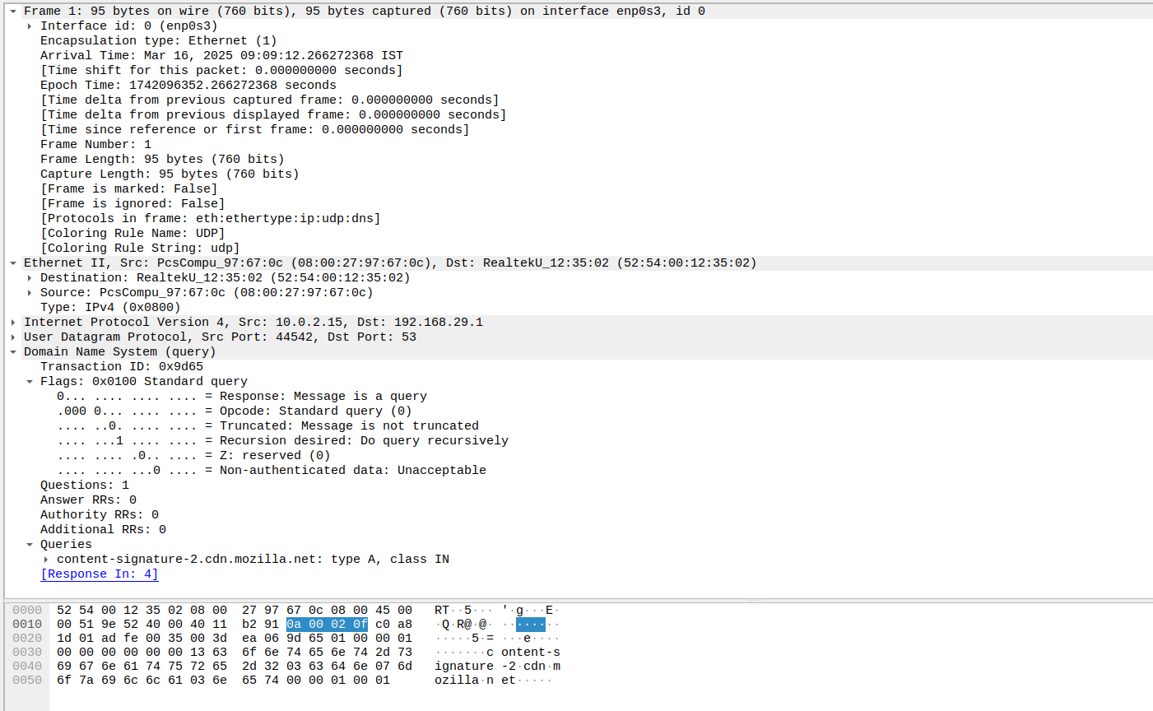

TCP:

The 3 way handshake including SYN, SYN-ACK, an ACK is depicted here.

SYN:
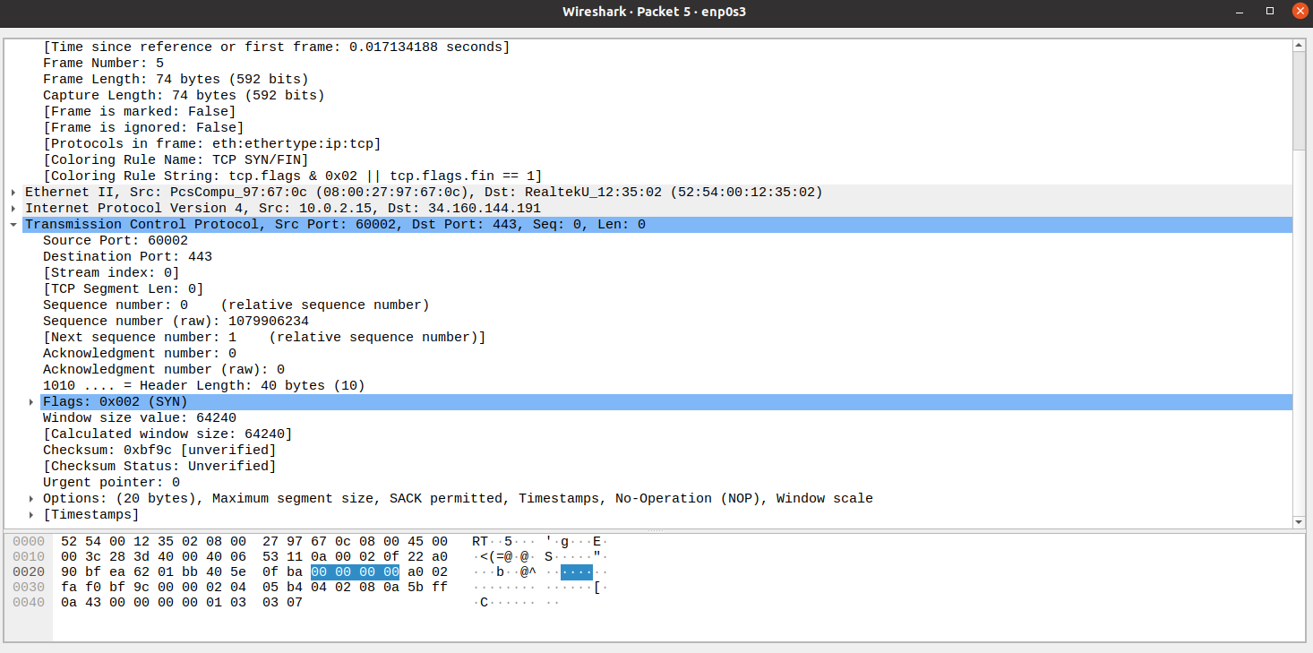

SYN-ACK:
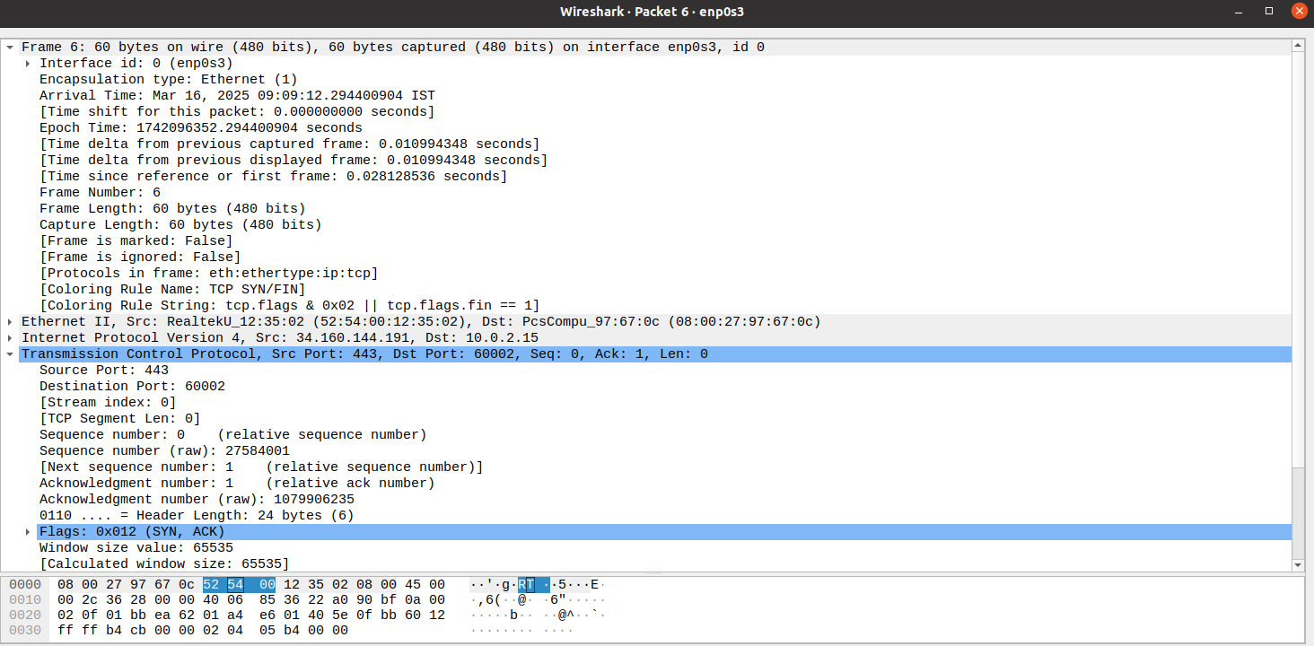
ACK:

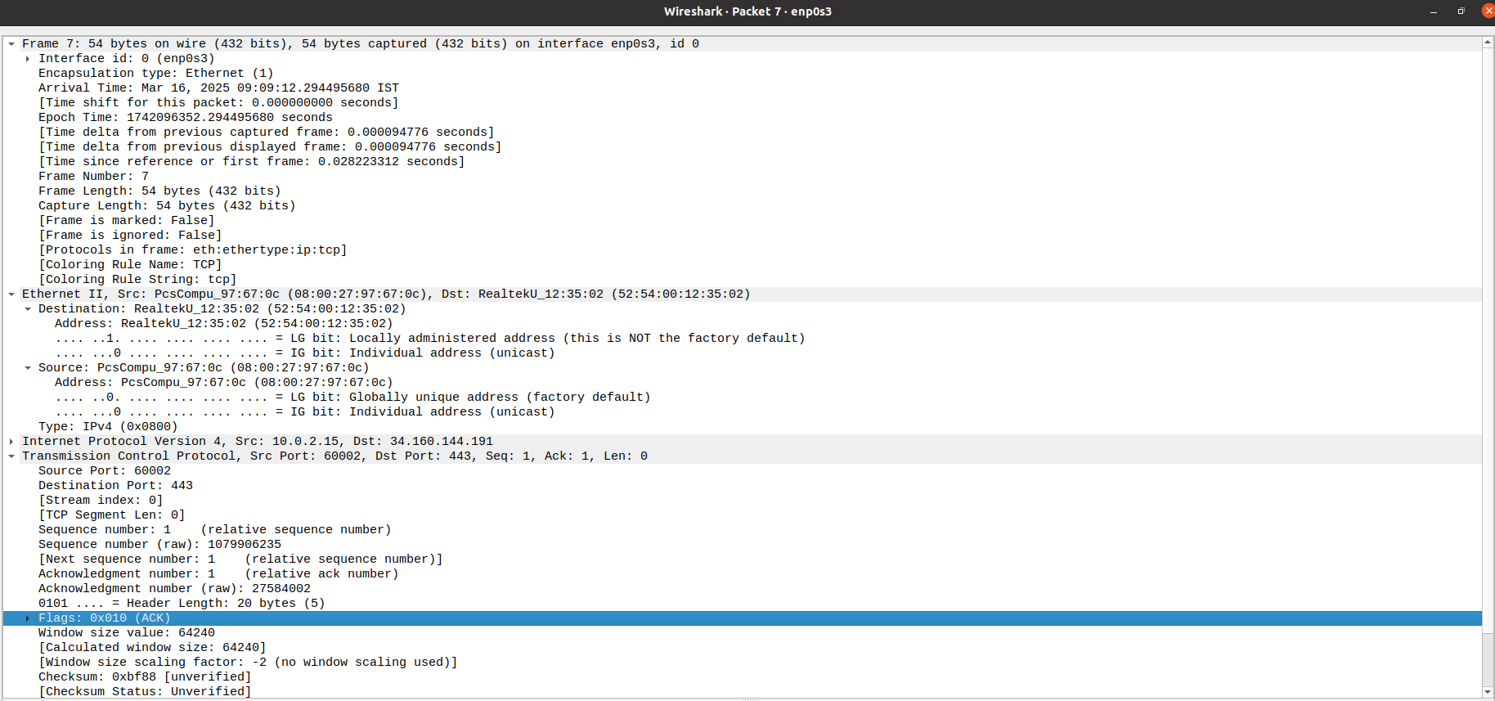

TLS after handshake:

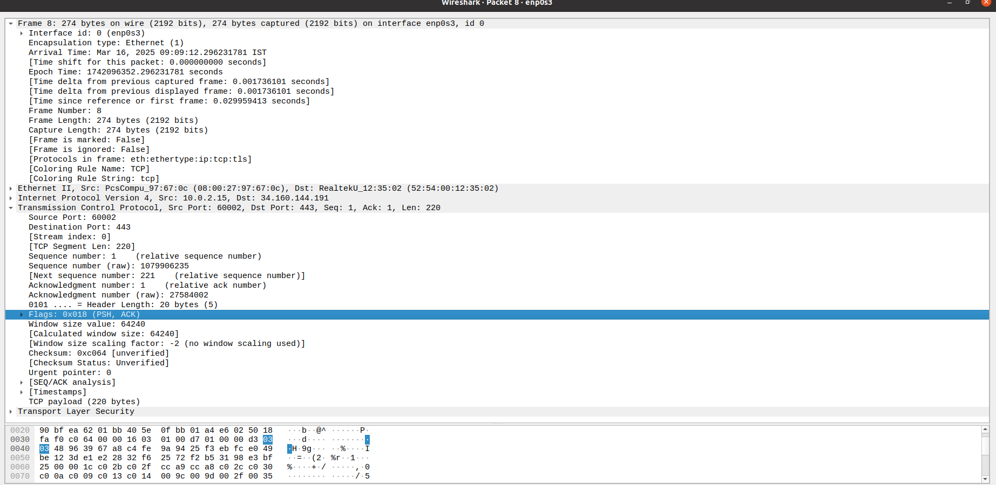

UDP:

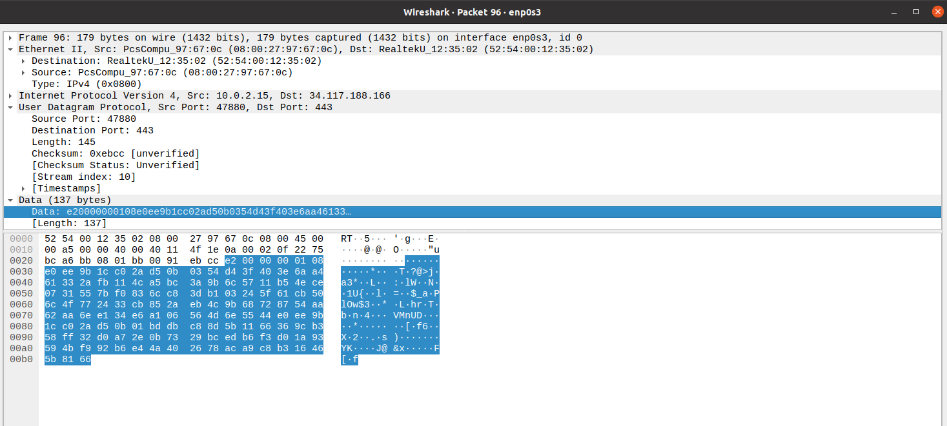

3. Explore traceroute/tracert for different website and analyse the parameters in the output and explore different optionss for traceroute command

vishal@Ubuntu20:~$ traceroute www.google.com
traceroute to www.google.com (142.250.192.164), 64 hops max
1 10.0.2.2 0.307ms 0.446ms 0.588ms
2 10.0.2.2 7.671ms 2.533ms 1.588ms
vishal@Ubuntu20:~$ traceroute -w www.google.com
traceroute: ridiculous waiting time `www.google.com'
vishal@Ubuntu20:~$ traceroute -w 2 www.google.com
traceroute to www.google.com (142.250.192.164), 64 hops max
1 10.0.2.2 0.716ms 0.375ms 1.168ms
2 10.0.2.2 2.046ms 1.735ms 1.854ms
vishal@Ubuntu20:~$ traceroute -w 1 www.google.com
traceroute to www.google.com (142.250.192.164), 64 hops max
1 10.0.2.2 1.905ms 0.668ms 0.707ms
2 10.0.2.2 2.481ms 1.893ms 1.951ms
vishal@Ubuntu20:~$ traceroute -m 115 www.google.com
traceroute to www.google.com (142.250.192.164), 115 hops max
1 10.0.2.2 5.196ms 0.538ms 0.938ms
2 10.0.2.2 2.662ms 3.062ms 2.975ms
vishal@Ubuntu20:~$ traceroute -m 15 www.google.com
traceroute to www.google.com (142.250.192.164), 15 hops max
1 10.0.2.2 0.744ms 7.652ms 0.564ms
2 10.0.2.2 7.489ms 3.194ms 19.193ms
vishal@Ubuntu20:~$ traceroute www.google.com
traceroute to www.google.com (142.250.195.196), 64 hops max
1 10.0.2.2 0.495ms 1.192ms 3.810ms
2 10.0.2.2 2.261ms 2.481ms 1.980ms
vishal@Ubuntu20:~$ traceroute -p 8020 www.google.com
traceroute to www.google.com (142.250.77.228), 64 hops max
1 10.0.2.2 22.921ms 0.611ms 2.135ms
2 10.0.2.2 3.336ms 2.210ms 2.340ms

4. Using Cisco Packet tracer
5. Set up Trunk ports between switches and try ping between different vlan

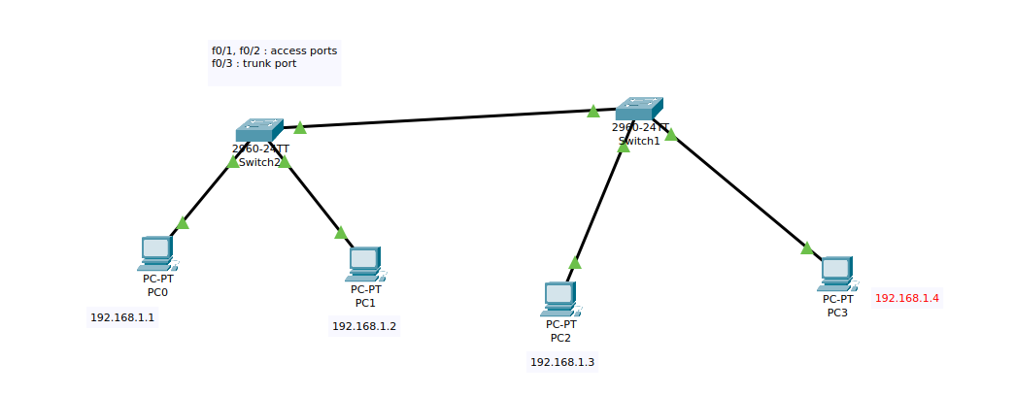

Setting Up VLAN and Trunk port:

Switches:
Switch>enable
Switch#conf t
Enter configuration commands, one per line. End with CNTL/Z.
Switch(config)#show vlan
^
% Invalid input detected at '^' marker.
Switch(config)#do show vlan

VLAN Name Status Ports
---- -------------------------------- --------- -------------------------------
1 default active Fa0/1, Fa0/2, Fa0/3, Fa0/4
Fa0/5, Fa0/6, Fa0/7, Fa0/8
Fa0/9, Fa0/10, Fa0/11, Fa0/12
Fa0/13, Fa0/14, Fa0/15, Fa0/16
Fa0/17, Fa0/18, Fa0/19, Fa0/20
Fa0/21, Fa0/22, Fa0/23, Fa0/24
Gig0/1, Gig0/2
1002 fddi-default active
1003 token-ring-default active
1004 fddinet-default active
1005 trnet-default active

VLAN Type SAID MTU Parent RingNo BridgeNo Stp BrdgMode Trans1 Trans2
---- ----- ---------- ----- ------ ------ -------- ---- -------- ------ ------
1 enet 100001 1500 - - - - - 0 0
1002 fddi 101002 1500 - - - - - 0 0
1003 tr 101003 1500 - - - - - 0 0
1004 fdnet 101004 1500 - - - ieee - 0 0
1005 trnet 101005 1500 - - - ibm - 0 0

Switch(config)#vlan 10
Switch(config-vlan)#exit
Switch(config)#vlan 20

Switch(config-vlan)#exit
Switch(config)#do show vlan

VLAN Name Status Ports
---- -------------------------------- --------- -------------------------------
1 default active Fa0/1, Fa0/2, Fa0/3, Fa0/4
Fa0/5, Fa0/6, Fa0/7, Fa0/8
Fa0/9, Fa0/10, Fa0/11, Fa0/12
Fa0/13, Fa0/14, Fa0/15, Fa0/16
Fa0/17, Fa0/18, Fa0/19, Fa0/20
Fa0/21, Fa0/22, Fa0/23, Fa0/24
Gig0/1, Gig0/2
10 VLAN0010 active
20 VLAN0020 active
1002 fddi-default active
1003 token-ring-default active
1004 fddinet-default active
1005 trnet-default active

VLAN Type SAID MTU Parent RingNo BridgeNo Stp BrdgMode Trans1 Trans2
---- ----- ---------- ----- ------ ------ -------- ---- -------- ------ ------
1 enet 100001 1500 - - - - - 0 0
10 enet 100010 1500 - - - - - 0 0
20 enet 100020 1500 - - - - - 0 0
1002 fddi 101002 1500 - - - - - 0 0
1003 tr 101003 1500 - - - - - 0 0
1004 fdnet 101004 1500 - - - ieee - 0 0
1005 trnet 101005 1500 - - - ibm - 0 0

VLAN Type SAID MTU Parent RingNo BridgeNo Stp BrdgMode Trans1 Trans2
---- ----- ---------- ----- ------ ------ -------- ---- -------- ------ ------

Remote SPAN VLANs
------------------------------------------------------------------------------

Primary Secondary Type Ports
------- --------- ----------------- ------------------------------------------
Switch(config)#
Switch(config)#interface f0/1
Switch(config-if)#switchport mode access
Switch(config-if)#sw
Switch(config-if)#switchport access vlan 10
Switch(config-if)#exit
Switch(config)#interface f0/2
Switch(config-if)#sw
Switch(config-if)#switchport mode access
Switch(config-if)#switchport access vlan 20
Switch(config-if)#exit
Switch(config)#do show vlan

VLAN Name Status Ports
---- -------------------------------- --------- -------------------------------
1 default active Fa0/3, Fa0/4, Fa0/5, Fa0/6
Fa0/7, Fa0/8, Fa0/9, Fa0/10
Fa0/11, Fa0/12, Fa0/13, Fa0/14
Fa0/15, Fa0/16, Fa0/17, Fa0/18
Fa0/19, Fa0/20, Fa0/21, Fa0/22
Fa0/23, Fa0/24, Gig0/1, Gig0/2
10 VLAN0010 active Fa0/1
20 VLAN0020 active Fa0/2
1002 fddi-default active
1003 token-ring-default active
1004 fddinet-default active
1005 trnet-default active

VLAN Type SAID MTU Parent RingNo BridgeNo Stp BrdgMode Trans1 Trans2
---- ----- ---------- ----- ------ ------ -------- ---- -------- ------ ------
1 enet 100001 1500 - - - - - 0 0
10 enet 100010 1500 - - - - - 0 0
20 enet 100020 1500 - - - - - 0 0
1002 fddi 101002 1500 - - - - - 0 0
1003 tr 101003 1500 - - - - - 0 0
1004 fdnet 101004 1500 - - - ieee - 0 0
1005 trnet 101005 1500 - - - ibm - 0 0

VLAN Type SAID MTU Parent RingNo BridgeNo Stp BrdgMode Trans1 Trans2
---- ----- ---------- ----- ------ ------ -------- ---- -------- ------ ------

Remote SPAN VLANs
------------------------------------------------------------------------------

Primary Secondary Type Ports
------- --------- ----------------- ------------------------------------------
Switch(config)#
Switch(config)#exit
Switch#
%SYS-5-CONFIG_I: Configured from console by console

Switch#%SPANTREE-2-RECV_PVID_ERR: Received 802.1Q BPDU on non trunk FastEthernet0/3 VLAN1.

%SPANTREE-2-BLOCK_PVID_LOCAL: Blocking FastEthernet0/3 on VLAN0001. Inconsistent port type.

%LINEPROTO-5-UPDOWN: Line protocol on Interface FastEthernet0/3, changed state to down

%LINEPROTO-5-UPDOWN: Line protocol on Interface FastEthernet0/3, changed state to up

Setting up vlan:
Commands:

$ do show vlan : to show all the vlan connections
$ interface f0/3 : fastEthernet 0/3 is used to be trunk
$ switchport mode trunk
$ switchport trunk allowed vlan 1, 10, 20
$ exit
$ show running-config

Final Running Cnfig:
Switch#show running-config
Building configuration...

Current configuration : 1244 bytes
!
version 15.0
no service timestamps log datetime msec
no service timestamps debug datetime msec
no service password-encryption
!
hostname Switch
!
!
!
!
!
!
spanning-tree mode pvst
spanning-tree extend system-id
!
interface FastEthernet0/1
switchport access vlan 10
switchport mode access
!
interface FastEthernet0/2
switchport access vlan 20
switchport mode access
!
interface FastEthernet0/3
switchport trunk allowed vlan 1,10,20
switchport mode trunk
!
interface FastEthernet0/4
!
interface FastEthernet0/5
!
interface FastEthernet0/6
!
interface FastEthernet0/7
!
interface FastEthernet0/8
!
interface FastEthernet0/9
!
interface FastEthernet0/10
!
interface FastEthernet0/11
!
interface FastEthernet0/12
!
interface FastEthernet0/13
!
interface FastEthernet0/14
!
interface FastEthernet0/15
!
interface FastEthernet0/16
!
interface FastEthernet0/17
!
interface FastEthernet0/18
!
interface FastEthernet0/19
!
interface FastEthernet0/20
!
interface FastEthernet0/21
!
interface FastEthernet0/22
!
interface FastEthernet0/23
!
interface FastEthernet0/24
!
interface GigabitEthernet0/1
!
interface GigabitEthernet0/2
!
interface Vlan1
no ip address
shutdown
!
!
!
!
line con 0
!
line vty 0 4
login
line vty 5 15
login
!
!
!
!
end

After Configuring Trunk port :

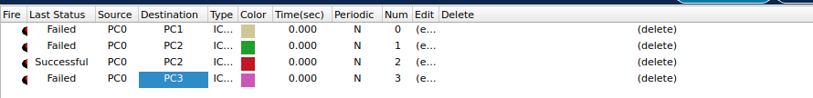

6. Change the native VLAN on a trunk port. Test for VLAN mismatches and troubleshoot

Changing the native VLAN:

BEFORE:

Switch#show interfaces trunk
Port Mode Encapsulation Status Native vlan
Fa0/3 auto n-802.1q trunking 1

Port Vlans allowed on trunk
Fa0/3 1-1005

Port Vlans allowed and active in management domain
Fa0/3 1,10,20

Port Vlans in spanning tree forwarding state and not pruned
Fa0/3 1,10,20

ON PROGRRESS:

Switch(config)#interface f0/3
Switch(config-if)#switchport trunk native vlan 99
Switch(config-if)#exit

RESULT:

Switch#show interfaces trunk
Port Mode Encapsulation Status Native vlan
Fa0/3 auto n-802.1q trunking 99

Port Vlans allowed on trunk
Fa0/3 1-1005

Port Vlans allowed and active in management domain
Fa0/3 1,10,20

Port Vlans in spanning tree forwarding state and not pruned
Fa0/3 1,10,20

Switch#
%CDP-4-NATIVE_VLAN_MISMATCH: Native VLAN mismatch discovered on FastEthernet0/3 (99), with Switch FastEthernet0/3 (1).

This issue arises because the native vlan on the other switch attached doesnt coincide with the one that we have changed, better way to trouble shoot this issue is to change the other switch native vlan into the new one that we have changed. Any other connection except the defined VLAN goes cia the native vlan, thus the native vlan should be same allowing the data to move in a defined location in both the connected vlan via trunk port

SORTING ISSUE:

On the other Switch connected via the Trunk port:

Switch#
%CDP-4-NATIVE_VLAN_MISMATCH: Native VLAN mismatch discovered on FastEthernet0/3 (1), with Switch FastEthernet0/3 (99).

%CDP-4-NATIVE_VLAN_MISMATCH: Native VLAN mismatch discovered on FastEthernet0/3 (1), with Switch FastEthernet0/3 (99).

%CDP-4-NATIVE_VLAN_MISMATCH: Native VLAN mismatch discovered on FastEthernet0/3 (1), with Switch FastEthernet0/3 (99).

Switch#show interfaces trunk
Port Mode Encapsulation Status Native vlan
Fa0/3 on 802.1q trunking 1

Port Vlans allowed on trunk
Fa0/3 1,10,20

Port Vlans allowed and active in management domain
Fa0/3 1,10,20

Port Vlans in spanning tree forwarding state and not pruned
Fa0/3 1,10,20

Switch#
%CDP-4-NATIVE_VLAN_MISMATCH: Native VLAN mismatch discovered on FastEthernet0/3 (1), with Switch FastEthernet0/3 (99).

Switch#conf t
Enter configuration commands, one per line. End with CNTL/Z.
Switch(config)#interface f0/3
Change the native VLAN port again:

Switch(config-if)#switchport trunk native vlan 99
Switch(config-if)#exit
Switch(config)#exit

Switch#show interfaces trunk
Port Mode Encapsulation Status Native vlan
Fa0/3 on 802.1q trunking 99

Port Vlans allowed on trunk
Fa0/3 1,10,20

Port Vlans allowed and active in management domain
Fa0/3 1,10,20

Port Vlans in spanning tree forwarding state and not pruned
Fa0/3 1,10,20

7. Configure a management VLAN and assign an IP address for remote access. Test SSH or Telnet to the switch

Switch#conf t
Enter configuration commands, one per line. End with CNTL/Z.
Switch(config)#interface vlan 20
Switch(config-if)#
%LINK-5-CHANGED: Interface Vlan20, changed state to up

%LINEPROTO-5-UPDOWN: Line protocol on Interface Vlan20, changed state to up

Switch(config-if)#ip address 192.168.2.5 255.255.255.0
Switch(config-if)#exit

Switch(config)#do show vlan

VLAN Name Status Ports
---- -------------------------------- --------- -------------------------------
1 default active Fa0/4, Fa0/5, Fa0/6, Fa0/7
Fa0/8, Fa0/9, Fa0/10, Fa0/11
Fa0/12, Fa0/13, Fa0/14, Fa0/15
Fa0/16, Fa0/17, Fa0/18, Fa0/19
Fa0/20, Fa0/21, Fa0/22, Fa0/23
Fa0/24, Gig0/1, Gig0/2
10 VLAN0010 active Fa0/1
20 VLAN0020 active Fa0/2
1002 fddi-default active
1003 token-ring-default active
1004 fddinet-default active
1005 trnet-default active

VLAN Type SAID MTU Parent RingNo BridgeNo Stp BrdgMode Trans1 Trans2
---- ----- ---------- ----- ------ ------ -------- ---- -------- ------ ------
1 enet 100001 1500 - - - - - 0 0
10 enet 100010 1500 - - - - - 0 0
20 enet 100020 1500 - - - - - 0 0
1002 fddi 101002 1500 - - - - - 0 0
1003 tr 101003 1500 - - - - - 0 0
1004 fdnet 101004 1500 - - - ieee - 0 0
1005 trnet 101005 1500 - - - ibm - 0 0

VLAN Type SAID MTU Parent RingNo BridgeNo Stp BrdgMode Trans1 Trans2
---- ----- ---------- ----- ------ ------ -------- ---- -------- ------ ------

Remote SPAN VLANs
------------------------------------------------------------------------------

Primary Secondary Type Ports

After assigning IP to VLAN :

Vlan20 is up, line protocol is up
Hardware is CPU Interface, address is 0001.63d3.8801 (bia 0001.63d3.8801)
Internet address is 192.168.2.5/24

8. You have a Cisco switch and a Voip phone that need to be placed in a voice VLAn 20 and a PC of VLAN 10, Configure the switch port to support both voice and data traffic.

CONNECTIONS:

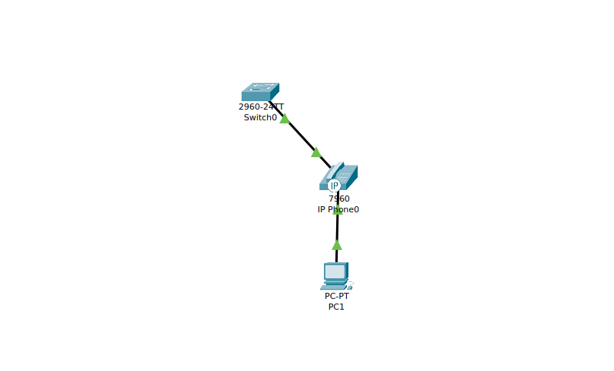

Switch>enable
Switch#conf t
Enter configuration commands, one per line. End with CNTL/Z.
Switch(config)#vlan 10
Switch(config-vlan)#exit
Switch(config)#vlan 20
Switch(config-vlan)#exit
Switch(config)#int f0/1
%LINK-3-UPDOWN: Interface FastEthernet0/2, changed state to down

%LINEPROTO-5-UPDOWN: Line protocol on Interface FastEthernet0/2, changed state to down

%LINK-5-CHANGED: Interface FastEthernet0/1, changed state to up

%LINEPROTO-5-UPDOWN: Line protocol on Interface FastEthernet0/1, changed state to up

Switch(config)#int f0/1
Switch(config-if)#switchport mode access
Switch(config-if)#switchport access vlan 10
Switch(config-if)#swit
Switch(config-if)#switchport voice vlan 20

Switch(config)#do sh interfaces f0/1 switchport
Name: Fa0/1
Switchport: Enabled
Administrative Mode: static access
Operational Mode: static access
Administrative Trunking Encapsulation: dot1q
Operational Trunking Encapsulation: native
Negotiation of Trunking: Off
Access Mode VLAN: 10 (VLAN0010)
Trunking Native Mode VLAN: 1 (default)
Voice VLAN: 20

9. Allow VLAN 10 to communicate with VLAN 20

Switch(config)#interface vlan 10
Switch(config-if)#
%LINK-5-CHANGED: Interface Vlan10, changed state to up

%LINEPROTO-5-UPDOWN: Line protocol on Interface Vlan10, changed state to up

Switch(config-if)#ip address 192.168.10.1 255.255.255.0
Switch(config-if)#no shutdown
Switch(config-if)#interface vlan 20
Switch(config-if)#
%LINK-5-CHANGED: Interface Vlan20, changed state to up

Switch(config-if)#ip address 192.168.20.1 255.255.255.0
Switch(config-if)#no shutdown
Switch(config-if)#exit

10. Try Inter VLAN routing with Router.

CONNECTIONS:

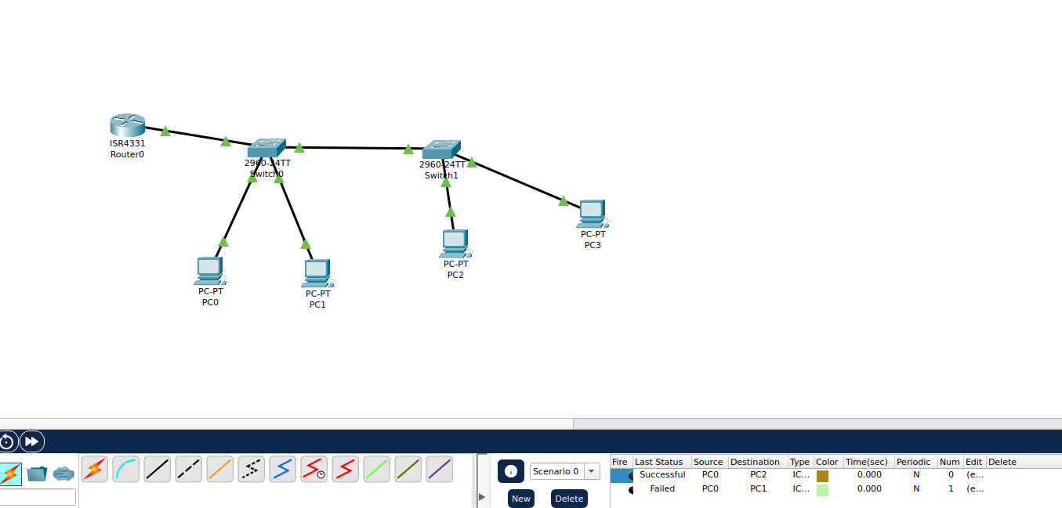
Switch 1:

Switch>en
Switch#conf t
Enter configuration commands, one per line. End with CNTL/Z.
Switch(config)#vlan 10
Switch(config-vlan)#exit
Switch(config)#vlan 20
Switch(config-vlan)#exit
Switch(config)#int f0/1
Switch(config-if)#switchport mode access
Switch(config-if)#switchport access vlan 10
Switch(config-if)#exit
Switch(config)#int f0/2
Switch(config-if)#switchport mode access
Switch(config-if)#switchport access vlan 20
Switch(config-if)#exit

Switch 0:

Switch>en
Switch#conf t
Enter configuration commands, one per line. End with CNTL/Z.
Switch(config)#int f0/1
Switch(config-if)#exit
Switch(config)#vlan 10
Switch(config-vlan)#exit
Switch(config)#vlan 20
Switch(config-vlan)#exit
Switch(config)#int f0/1
Switch(config-if)#switchport mode access
Switch(config-if)#sw
Switch(config-if)#switchport access vlan 10
Switch(config-if)#int f0/2
Switch(config-if)#switchport mode access
Switch(config-if)#switchport access vlan 20
Switch(config-if)#exit

Switch(config)#int g0/1
Switch(config-if)#switchport mode trunk

Switch(config-if)#
%LINEPROTO-5-UPDOWN: Line protocol on Interface GigabitEthernet0/1, changed state to down

%LINEPROTO-5-UPDOWN: Line protocol on Interface GigabitEthernet0/1, changed state to up
Switch(config-if)#switchport trunk allowed vlan 1,10,20

ROUTER:

Router(config)#int g0/0/0
Router(config-if)#no shut

Router(config-if)#
%LINK-5-CHANGED: Interface GigabitEthernet0/0/0, changed state to up

%LINEPROTO-5-UPDOWN: Line protocol on Interface GigabitEthernet0/0/0, changed state to up

Router(config-if)#int g0/0/0.10
Router(config-subif)#
%LINK-5-CHANGED: Interface GigabitEthernet0/0/0.10, changed state to up

%LINEPROTO-5-UPDOWN: Line protocol on Interface GigabitEthernet0/0/0.10, changed state to up

Router(config-subif)#ip address 10.0.0.1 255.255.255.128

% Configuring IP routing on a LAN subinterface is only allowed if that
subinterface is already configured as part of an IEEE 802.10, IEEE 802.1Q,
or ISL vLAN.

Router(config-subif)#encapsulation dot1q 13
Router(config-subif)#ip address 10.0.0.1 255.255.255.128
Router(config-subif)#int g0/0/0.20
Router(config-subif)#
%LINK-5-CHANGED: Interface GigabitEthernet0/0/0.20, changed state to up

%LINEPROTO-5-UPDOWN: Line protocol on Interface GigabitEthernet0/0/0.20, changed state to up

Router(config-subif)#encapsulation dot1q 10
Router(config-subif)#ip address 10.0.0.1 255.255.255.128
% 10.0.0.0 overlaps with GigabitEthernet0/0/0.10
Router(config-subif)#encapsulation dot1q 20
Router(config-subif)#ip address 10.0.0.129 255.255.255.128

11. Implement ACL to restrict traffic based on source and destination ports. Test rules by simulating legitimate and unauthorised traffic.

12. Configure standard Access Control list on a router to permit traffic from a specific range.

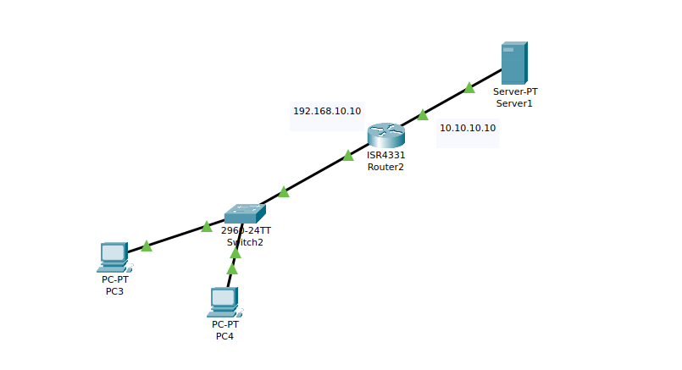
Router Config:

Router(config)#int g0/0/0
Router(config-if)#ip address 192.168.10.10 255.255.255.0
Router(config-if)#no shutdown

Router(config-if)#
%LINK-5-CHANGED: Interface GigabitEthernet0/0/0, changed state to up

%LINEPROTO-5-UPDOWN: Line protocol on Interface GigabitEthernet0/0/0, changed state to up

Router(config-if)#int g0/0/1
Router(config-if)#ip address 10.10.10.10 255.0.0.0
Router(config-if)#no shutdown

Router(config-if)#
%LINK-5-CHANGED: Interface GigabitEthernet0/0/1, changed state to up

%LINEPROTO-5-UPDOWN: Line protocol on Interface GigabitEthernet0/0/1, changed state to up
^Z
Router#
%SYS-5-CONFIG_I: Configured from console by console

Router#conf t
Enter configuration commands, one per line. End with CNTL/Z.
Router(config)#ip access-list standard 11
Router(config-std-nacl)#?
<1-2147483647> Sequence Number
default Set a command to its defaults
deny Specify packets to reject
exit Exit from access-list configuration mode
no Negate a command or set its defaults
permit Specify packets to forward
remark Access list entry comment
Router(config-std-nacl)#
Router(config-std-nacl)#deny host 192.168.10.2
Router(config-std-nacl)#permit any

Router(config)#int g0/0/0
Router(config-if)#ip access-group 11 ?
in inbound packets
out outbound packets
Router(config-if)#ip access-group 11
% Incomplete command.
Router(config-if)#ip access-group 11 in
Router(config-if)#exit
Router(config)#^Z
Router#
%SYS-5-CONFIG_I: Configured from console by console

RESULT:

13. Extended ACL to block specific application such as HTTP and FTP traffic.

Removing the permit of accessing web browser to reach a server in one of the PC and removing the accesss to check the ping of the web browser in the another/
Router config:

Router>en
Router#conf t
Enter configuration commands, one per line. End with CNTL/Z.
Router(config)#ip access-list extended 100
Router(config-ext-nacl)#deny ?
ahp Authentication Header Protocol
eigrp Cisco's EIGRP routing protocol
esp Encapsulation Security Payload
gre Cisco's GRE tunneling
icmp Internet Control Message Protocol
ip Any Internet Protocol
ospf OSPF routing protocol
tcp Transmission Control Protocol
udp User Datagram Protocol
Router(config-ext-nacl)#deny icmp host 192.168.10.1 host 10.10.10.11
Router(config-ext-nacl)#deny tcp host 192.168.10.2 host 10.10.10.11 eq http ?
% Unrecognized command
Router(config-ext-nacl)#deny tcp host 192.168.10.2 host 10.10.10.11 eq www
Router(config-ext-nacl)#permit ip any any
Router(config-ext-nacl)#permit icmp any any
Router(config-ext-nacl)#permit tcp any any
Router(config-ext-nacl)#end

Router#conf t
Enter configuration commands, one per line. End with CNTL/Z.
Router(config)#int g0/0/0
Router(config-if)#ip access-group 100 in
Router(config-if)#int g0/0/1
Router(config-if)#ip access-group 100 out

PC 1: Cant Ping the web browser

RESULT:

C:\>ping 10.10.10.11

Pinging 10.10.10.11 with 32 bytes of data:

Reply from 192.168.10.10: Destination host unreachable.
Reply from 192.168.10.10: Destination host unreachable.
Reply from 192.168.10.10: Destination host unreachable.
Reply from 192.168.10.10: Destination host unreachable.

Ping statistics for 10.10.10.11:
Packets: Sent = 4, Received = 0, Lost = 4 (100% loss),

Accessing via web brower is possible from PC 1:
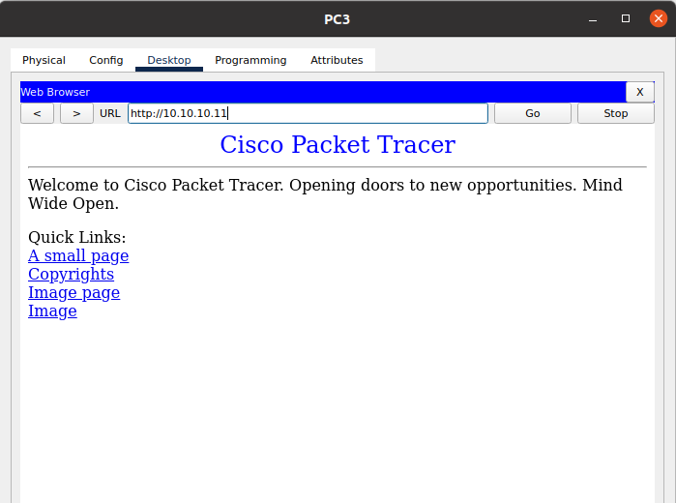

PC 2: Cant use to www reach to the web browser
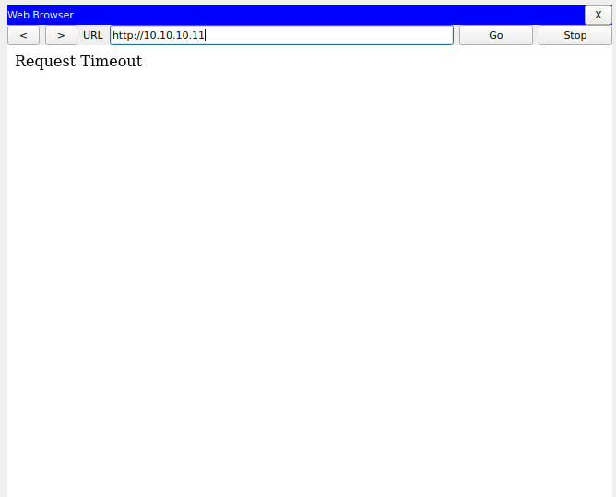

RESULT ACCESS LIST:

Router#sh access-list
Standard IP access list 11
10 deny host 192.168.10.2
20 permit any (37 match(es))
Extended IP access list 100
10 deny icmp host 192.168.10.1 host 10.10.10.11 (4 match(es))
20 deny tcp host 192.168.10.2 host 10.10.10.11 eq www (12 match(es))
30 permit ip any any (10 match(es))
40 permit icmp any any
50 permit tcp any any

14. Try Static NAT, Dynamic NAT and PAT to translate Ips

Static NAT:

sudo iptables -t nat -A PREROUTING -d 203.0.113.10 -j DNAT --to-destination 192.168.1.10
sudo iptables -t nat -A POSTROUTING -s 192.168.1.10 -j SNAT --to-source 203.0.113.10

RESULT:

vishal@Ubuntu20:~$ sudo iptables -t nat -L -v -n
Chain PREROUTING (policy ACCEPT 0 packets, 0 bytes)
pkts bytes target prot opt in out source destination
0 0 DNAT all -- * * 0.0.0.0/0 203.0.113.10 to:192.168.1.10

Chain INPUT (policy ACCEPT 0 packets, 0 bytes)
pkts bytes target prot opt in out source destination

Chain OUTPUT (policy ACCEPT 0 packets, 0 bytes)
pkts bytes target prot opt in out source destination

Chain POSTROUTING (policy ACCEPT 0 packets, 0 bytes)
pkts bytes target prot opt in out source destination
0 0 SNAT all -- * * 192.168.1.10 0.0.0.0/0 to:203.0.113.10

Dynamic NAT:

vishal@Ubuntu20:~$ sudo iptables -t nat -A POSTROUTING -s 192.168.1.0/24 -j SNAT --to 203.0.113.10-203.0.113.20
vishal@Ubuntu20:~$
vishal@Ubuntu20:~$ sudo iptables -t nat -L -v -n
Chain PREROUTING (policy ACCEPT 0 packets, 0 bytes)
pkts bytes target prot opt in out source destination
0 0 DNAT all -- * * 0.0.0.0/0 203.0.113.10 to:192.168.1.10

Chain INPUT (policy ACCEPT 0 packets, 0 bytes)
pkts bytes target prot opt in out source destination

Chain OUTPUT (policy ACCEPT 2 packets, 158 bytes)
pkts bytes target prot opt in out source destination

Chain POSTROUTING (policy ACCEPT 2 packets, 158 bytes)
pkts bytes target prot opt in out source destination
0 0 SNAT all -- * * 192.168.1.10 0.0.0.0/0 to:203.0.113.10
0 0 SNAT all -- * * 192.168.1.0/24 0.0.0.0/0 to:203.0.113.10-203.0.113.20

PAT:

vishal@Ubuntu20:~$ sudo iptables -t nat -A POSTROUTING -s 192.168.1.0/24 -j MASQUERADE
vishal@Ubuntu20:~$ sudo iptables -t nat -L -v -n
Chain PREROUTING (policy ACCEPT 0 packets, 0 bytes)
pkts bytes target prot opt in out source destination
0 0 DNAT all -- * * 0.0.0.0/0 203.0.113.10 to:192.168.1.10

Chain INPUT (policy ACCEPT 0 packets, 0 bytes)
pkts bytes target prot opt in out source destination

Chain OUTPUT (policy ACCEPT 0 packets, 0 bytes)
pkts bytes target prot opt in out source destination

Chain POSTROUTING (policy ACCEPT 0 packets, 0 bytes)
pkts bytes target prot opt in out source destination
0 0 SNAT all -- * * 192.168.1.10 0.0.0.0/0 to:203.0.113.10
0 0 SNAT all -- * * 192.168.1.0/24 0.0.0.0/0 to:203.0.113.10-203.0.113.20
0 0 MASQUERADE all -- * * 192.168.1.0/24 0.0.0.0/0

15. Download iperf in laptop and make sure they are in same network. Try different iperf commands with tcp, udp, birectionsl ,reverse , multicast, parallel options and analyse the bandwidth and rate of transmission, delay, jitter etc.
SERVER SIDE:

vishal@Ubuntu20:~$ iperf3 -s
-----------------------------------------------------------
Server listening on 5201
-----------------------------------------------------------

CLIENT SIDE:

vishal@vishal-VirtualBox:~$ iperf3 -c 10.0.2.15
Connecting to host 10.0.2.15, port 5201
[ 5] local 10.0.2.15 port 34036 connected to 10.0.2.15 port 5201
[ ID] Interval Transfer Bitrate Retr Cwnd
[ 5] 0.00-1.00 sec 2.75 GBytes 23.6 Gbits/sec 1 3.00 MBytes
[ 5] 1.00-2.00 sec 1.78 GBytes 15.3 Gbits/sec 1 3.75 MBytes
[ 5] 2.00-3.00 sec 1.31 GBytes 11.3 Gbits/sec 0 4.18 MBytes
[ 5] 3.00-4.00 sec 925 MBytes 7.75 Gbits/sec 0 4.18 MBytes
[ 5] 4.00-5.00 sec 842 MBytes 7.06 Gbits/sec 3 3.12 MBytes
[ 5] 5.00-6.00 sec 998 MBytes 8.35 Gbits/sec 21 2.62 MBytes
[ 5] 6.00-7.00 sec 1.05 GBytes 9.01 Gbits/sec 0 3.50 MBytes
[ 5] 7.00-8.00 sec 667 MBytes 5.58 Gbits/sec 2 4.00 MBytes
[ 5] 8.00-9.00 sec 896 MBytes 7.52 Gbits/sec 0 4.12 MBytes
[ 5] 9.00-10.00 sec 627 MBytes 5.25 Gbits/sec 2 4.12 MBytes
- - - - - - - - - - - - - - - - - - - - - - - - -
[ ID] Interval Transfer Bitrate Retr
[ 5] 0.00-10.00 sec 11.8 GBytes 10.1 Gbits/sec 30 sender
[ 5] 0.00-10.00 sec 11.8 GBytes 10.1 Gbits/sec receiver

iperf Done.
vishal@vishal-VirtualBox:~$ iperf3 -c 10.0.2.15 -u -b 100M
Connecting to host 10.0.2.15, port 5201
[ 5] local 10.0.2.15 port 58158 connected to 10.0.2.15 port 5201
[ ID] Interval Transfer Bitrate Total Datagrams
[ 5] 0.00-1.37 sec 9.38 MBytes 57.6 Mbits/sec 300
[ 5] 1.37-2.76 sec 12.1 MBytes 72.8 Mbits/sec 388
[ 5] 2.76-3.02 sec 14.1 MBytes 457 Mbits/sec 452
[ 5] 3.02-4.33 sec 9.69 MBytes 62.1 Mbits/sec 310
[ 5] 4.33-5.06 sec 13.3 MBytes 153 Mbits/sec 426
[ 5] 5.06-6.86 sec 11.9 MBytes 55.3 Mbits/sec 381
[ 5] 6.86-7.01 sec 12.8 MBytes 727 Mbits/sec 410
[ 5] 7.01-8.39 sec 10.4 MBytes 63.1 Mbits/sec 331
[ 5] 8.39-9.00 sec 13.6 MBytes 188 Mbits/sec 436
[ 5] 9.00-10.00 sec 11.9 MBytes 99.4 Mbits/sec 381
- - - - - - - - - - - - - - - - - - - - - - - - -
[ ID] Interval Transfer Bitrate Jitter Lost/Total Datagrams
[ 5] 0.00-10.00 sec 119 MBytes 100 Mbits/sec 0.000 ms 0/3815 (0%) sender
[ 5] 0.00-10.01 sec 68.9 MBytes 57.7 Mbits/sec 0.482 ms 1611/3815 (42%) receiver

iperf Done.
vishal@vishal-VirtualBox:~$ iperf3 -c 10.0.2.15 --bidir
Connecting to host 10.0.2.15, port 5201
[ 5] local 10.0.2.15 port 52274 connected to 10.0.2.15 port 5201
[ 7] local 10.0.2.15 port 52290 connected to 10.0.2.15 port 5201
[ ID][Role] Interval Transfer Bitrate Retr Cwnd
[ 5][TX-C] 0.00-1.00 sec 1.12 GBytes 9.61 Gbits/sec 1 4.25 MBytes
[ 7][RX-C] 0.00-1.01 sec 1.57 GBytes 13.4 Gbits/sec
[ 5][TX-C] 1.00-2.02 sec 712 MBytes 5.89 Gbits/sec 1 4.25 MBytes
[ 7][RX-C] 1.01-2.02 sec 1.68 GBytes 14.3 Gbits/sec
[ 5][TX-C] 2.02-3.00 sec 1.25 GBytes 10.9 Gbits/sec 0 4.25 MBytes
[ 7][RX-C] 2.02-3.00 sec 1.88 GBytes 16.4 Gbits/sec
[ 5][TX-C] 3.00-4.00 sec 1.52 GBytes 13.1 Gbits/sec 1 4.25 MBytes
[ 7][RX-C] 3.00-4.01 sec 1.65 GBytes 14.1 Gbits/sec
[ 5][TX-C] 4.00-5.00 sec 1.31 GBytes 11.2 Gbits/sec 0 4.25 MBytes
[ 7][RX-C] 4.01-5.00 sec 1.47 GBytes 12.7 Gbits/sec
[ 5][TX-C] 5.00-6.00 sec 1.20 GBytes 10.3 Gbits/sec 1 4.25 MBytes
[ 7][RX-C] 5.00-6.00 sec 1.13 GBytes 9.75 Gbits/sec
[ 5][TX-C] 6.00-7.00 sec 546 MBytes 4.58 Gbits/sec 4 4.25 MBytes
[ 7][RX-C] 6.00-7.01 sec 648 MBytes 5.39 Gbits/sec
[ 5][TX-C] 7.00-8.00 sec 390 MBytes 3.28 Gbits/sec 0 4.25 MBytes
[ 7][RX-C] 7.01-8.00 sec 703 MBytes 5.94 Gbits/sec
[ 5][TX-C] 8.00-9.00 sec 488 MBytes 4.09 Gbits/sec 6 4.25 MBytes
[ 7][RX-C] 8.00-9.00 sec 727 MBytes 6.11 Gbits/sec
[ 5][TX-C] 9.00-10.05 sec 273 MBytes 2.19 Gbits/sec 1 4.25 MBytes
[ 7][RX-C] 9.00-10.05 sec 310 MBytes 2.49 Gbits/sec
- - - - - - - - - - - - - - - - - - - - - - - - -
[ ID][Role] Interval Transfer Bitrate Retr
[ 5][TX-C] 0.00-10.05 sec 8.76 GBytes 7.49 Gbits/sec 15 sender
[ 5][TX-C] 0.00-10.05 sec 8.76 GBytes 7.49 Gbits/sec receiver
[ 7][RX-C] 0.00-10.05 sec 11.7 GBytes 10.0 Gbits/sec 83 sender
[ 7][RX-C] 0.00-10.05 sec 11.7 GBytes 10.0 Gbits/sec receiver

iperf Done.
vishal@vishal-VirtualBox:~$ iperf3 -c 10.0.2.15 -R
Connecting to host 10.0.2.15, port 5201
Reverse mode, remote host 10.0.2.15 is sending
[ 5] local 10.0.2.15 port 39248 connected to 10.0.2.15 port 5201
[ ID] Interval Transfer Bitrate
[ 5] 0.00-1.01 sec 464 MBytes 3.87 Gbits/sec
[ 5] 1.01-2.01 sec 263 MBytes 2.20 Gbits/sec
[ 5] 2.01-3.00 sec 463 MBytes 3.91 Gbits/sec
[ 5] 3.00-4.00 sec 329 MBytes 2.76 Gbits/sec
[ 5] 4.00-5.01 sec 400 MBytes 3.34 Gbits/sec
[ 5] 5.01-6.00 sec 441 MBytes 3.73 Gbits/sec
[ 5] 6.00-7.01 sec 334 MBytes 2.78 Gbits/sec
[ 5] 7.01-8.01 sec 337 MBytes 2.82 Gbits/sec
[ 5] 8.01-9.00 sec 156 MBytes 1.32 Gbits/sec
[ 5] 9.00-10.00 sec 183 MBytes 1.53 Gbits/sec
- - - - - - - - - - - - - - - - - - - - - - - - -
[ ID] Interval Transfer Bitrate Retr
[ 5] 0.00-10.04 sec 3.32 GBytes 2.84 Gbits/sec 105 sender
[ 5] 0.00-10.00 sec 3.31 GBytes 2.85 Gbits/sec receiver

iperf Done.
vishal@vishal-VirtualBox:~$ iperf3 -c 10.0.2.15 -P 5
Connecting to host 10.0.2.15, port 5201
[ 5] local 10.0.2.15 port 57130 connected to 10.0.2.15 port 5201
[ 7] local 10.0.2.15 port 57134 connected to 10.0.2.15 port 5201
[ 9] local 10.0.2.15 port 57138 connected to 10.0.2.15 port 5201
[ 11] local 10.0.2.15 port 57150 connected to 10.0.2.15 port 5201
[ 13] local 10.0.2.15 port 57166 connected to 10.0.2.15 port 5201
[ ID] Interval Transfer Bitrate Retr Cwnd
[ 5] 0.00-1.01 sec 355 MBytes 2.96 Gbits/sec 2 4.18 MBytes
[ 7] 0.00-1.03 sec 189 MBytes 1.55 Gbits/sec 2 2.19 MBytes
[ 9] 0.00-1.05 sec 316 MBytes 2.53 Gbits/sec 1 3.50 MBytes
[ 11] 0.00-1.05 sec 226 MBytes 1.80 Gbits/sec 3 2.06 MBytes
[ 13] 0.00-1.05 sec 282 MBytes 2.25 Gbits/sec 2 2.87 MBytes
[SUM] 0.00-1.01 sec 1.34 GBytes 11.4 Gbits/sec 10
- - - - - - - - - - - - - - - - - - - - - - - - -
[ 5] 1.01-2.03 sec 105 MBytes 862 Mbits/sec 3 4.18 MBytes
[ 7] 1.03-2.03 sec 84.4 MBytes 704 Mbits/sec 0 2.69 MBytes
[ 9] 1.05-2.20 sec 87.8 MBytes 638 Mbits/sec 0 3.62 MBytes
[ 11] 1.05-2.20 sec 58.9 MBytes 430 Mbits/sec 0 2.19 MBytes
[ 13] 1.05-2.21 sec 56.1 MBytes 406 Mbits/sec 0 3.12 MBytes
[SUM] 1.01-2.03 sec 392 MBytes 3.21 Gbits/sec 3
- - - - - - - - - - - - - - - - - - - - - - - - -
[ 5] 2.03-3.00 sec 93.2 MBytes 808 Mbits/sec 1 4.12 MBytes
[ 7] 2.03-3.00 sec 99.2 MBytes 859 Mbits/sec 0 2.94 MBytes
[ 9] 2.20-3.02 sec 45.2 MBytes 462 Mbits/sec 0 4.00 MBytes
[ 11] 2.20-3.11 sec 91.1 MBytes 844 Mbits/sec 1 2.44 MBytes
[ 13] 2.21-3.14 sec 65.1 MBytes 588 Mbits/sec 0 3.37 MBytes
[SUM] 2.03-3.00 sec 394 MBytes 3.41 Gbits/sec 2
- - - - - - - - - - - - - - - - - - - - - - - - -
[ 5] 3.00-4.01 sec 114 MBytes 954 Mbits/sec 0 4.12 MBytes
[ 7] 3.00-4.02 sec 344 MBytes 2.83 Gbits/sec 10 3.18 MBytes
[ 9] 3.02-4.02 sec 146 MBytes 1.22 Gbits/sec 5 4.12 MBytes
[ 11] 3.11-4.04 sec 312 MBytes 2.79 Gbits/sec 0 3.68 MBytes
[ 13] 3.14-4.05 sec 148 MBytes 1.37 Gbits/sec 0 3.68 MBytes
[SUM] 3.00-4.01 sec 1.04 GBytes 8.88 Gbits/sec 15
- - - - - - - - - - - - - - - - - - - - - - - - -
[ 5] 4.01-5.00 sec 207 MBytes 1.74 Gbits/sec 0 4.12 MBytes
[ 7] 4.02-5.00 sec 328 MBytes 2.81 Gbits/sec 2 3.87 MBytes
[ 9] 4.02-5.01 sec 187 MBytes 1.58 Gbits/sec 2 2.94 MBytes
[ 11] 4.04-5.02 sec 280 MBytes 2.41 Gbits/sec 0 4.18 MBytes
[ 13] 4.05-5.03 sec 192 MBytes 1.63 Gbits/sec 0 4.00 MBytes
[SUM] 4.01-5.00 sec 1.17 GBytes 10.1 Gbits/sec 4
- - - - - - - - - - - - - - - - - - - - - - - - -
[ 5] 5.00-6.00 sec 292 MBytes 2.45 Gbits/sec 1 4.12 MBytes
[ 7] 5.00-6.16 sec 301 MBytes 2.18 Gbits/sec 1 4.18 MBytes
[ 9] 5.01-6.17 sec 254 MBytes 1.85 Gbits/sec 0 3.68 MBytes
[ 11] 5.02-6.29 sec 331 MBytes 2.19 Gbits/sec 3 4.18 MBytes
[ 13] 5.03-6.29 sec 530 MBytes 3.54 Gbits/sec 3 4.12 MBytes
[SUM] 5.00-6.00 sec 1.67 GBytes 14.3 Gbits/sec 8
- - - - - - - - - - - - - - - - - - - - - - - - -
[ 5] 6.00-7.07 sec 202 MBytes 1.59 Gbits/sec 1 4.12 MBytes
[ 7] 6.16-7.44 sec 386 MBytes 2.52 Gbits/sec 0 4.18 MBytes
[ 9] 6.17-7.45 sec 340 MBytes 2.23 Gbits/sec 0 3.93 MBytes
[ 11] 6.29-7.45 sec 230 MBytes 1.67 Gbits/sec 1 4.18 MBytes
[ 13] 6.29-7.45 sec 279 MBytes 2.01 Gbits/sec 0 4.12 MBytes
[SUM] 6.00-7.07 sec 1.40 GBytes 11.3 Gbits/sec 2
- - - - - - - - - - - - - - - - - - - - - - - - -
[ 5] 7.07-8.01 sec 157 MBytes 1.40 Gbits/sec 1 4.12 MBytes
[ 7] 7.44-8.02 sec 160 MBytes 2.34 Gbits/sec 0 4.18 MBytes
[ 9] 7.45-8.02 sec 108 MBytes 1.58 Gbits/sec 0 4.06 MBytes
[ 11] 7.45-8.06 sec 197 MBytes 2.71 Gbits/sec 1 4.18 MBytes
[ 13] 7.45-8.06 sec 74.2 MBytes 1.02 Gbits/sec 0 4.12 MBytes
[SUM] 7.07-8.01 sec 696 MBytes 6.19 Gbits/sec 2
- - - - - - - - - - - - - - - - - - - - - - - - -
[ 5] 8.01-9.02 sec 192 MBytes 1.60 Gbits/sec 1 4.12 MBytes
[ 7] 8.02-9.04 sec 150 MBytes 1.23 Gbits/sec 0 4.18 MBytes
[ 9] 8.02-9.04 sec 158 MBytes 1.30 Gbits/sec 1 4.18 MBytes
[ 11] 8.06-9.04 sec 160 MBytes 1.37 Gbits/sec 1 4.18 MBytes
[ 13] 8.06-9.04 sec 205 MBytes 1.76 Gbits/sec 2 4.12 MBytes
[SUM] 8.01-9.02 sec 866 MBytes 7.20 Gbits/sec 5
- - - - - - - - - - - - - - - - - - - - - - - - -
[ 5] 9.02-10.09 sec 44.2 MBytes 347 Mbits/sec 0 4.12 MBytes
[ 7] 9.04-10.09 sec 53.4 MBytes 425 Mbits/sec 0 4.18 MBytes
[ 9] 9.04-10.09 sec 99.1 MBytes 790 Mbits/sec 0 4.18 MBytes
[ 11] 9.04-10.09 sec 94.0 MBytes 749 Mbits/sec 1 4.18 MBytes
[ 13] 9.04-10.09 sec 87.5 MBytes 697 Mbits/sec 0 4.12 MBytes
[SUM] 9.02-10.09 sec 378 MBytes 2.96 Gbits/sec 1
- - - - - - - - - - - - - - - - - - - - - - - - -
[ ID] Interval Transfer Bitrate Retr
[ 5] 0.00-10.09 sec 1.75 GBytes 1.49 Gbits/sec 10 sender
[ 5] 0.00-10.12 sec 1.75 GBytes 1.48 Gbits/sec receiver
[ 7] 0.00-10.09 sec 2.05 GBytes 1.75 Gbits/sec 15 sender
[ 7] 0.00-10.12 sec 2.05 GBytes 1.74 Gbits/sec receiver
[ 9] 0.00-10.09 sec 1.76 GBytes 1.50 Gbits/sec 9 sender
[ 9] 0.00-10.12 sec 1.76 GBytes 1.49 Gbits/sec receiver
[ 11] 0.00-10.09 sec 1.95 GBytes 1.66 Gbits/sec 11 sender
[ 11] 0.00-10.12 sec 1.95 GBytes 1.66 Gbits/sec receiver
[ 13] 0.00-10.09 sec 1.91 GBytes 1.62 Gbits/sec 7 sender
[ 13] 0.00-10.12 sec 1.91 GBytes 1.62 Gbits/sec receiver
[SUM] 0.00-10.09 sec 9.42 GBytes 8.02 Gbits/sec 52 sender
[SUM] 0.00-10.12 sec 9.42 GBytes 7.99 Gbits/sec receiver

iperf Done.

