**Module – 5**

**Advance topics in a function**

**1) Write a function add to add two numbers and call the function in another file.**

**add.sh**

**add() {**

**local result=$(( $1 + $2 ))**

**}**

**Operation.sh**

**source add.sh**

**result=$(add 10 20)**

**echo "Ans:$result"**

**o/p**

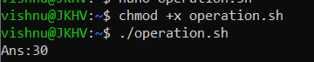

**Recursive function**

1. **Write a program where the recursive function calculates the sum of N numbers**

**calculate_sum() {**

**local n=$1**

**if [ $n -eq 0 ]; then**

**echo 0**

**else**

**local prev=$(calculate_sum $((n - 1)))**

**local current=$((prev + n))**

**echo $current**

**fi**

**}**

**read -p "Enter the value of N: " N**

**result=$(calculate_sum $N)**

**echo "The sum of first $N numbers is: $result"**

**o/p**

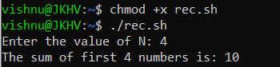

**Basics of Redirection (error handling)**

**1) Write a program in any language like C, C++, Java.**

**2) And redirect the output or error to a new file.**

**#include <stdio.h>**

**int main() {**

**printf("Hi Vishnu.\n");**

**fprintf(stderr, "This is an error.\n");**

**return 0;**

**}**

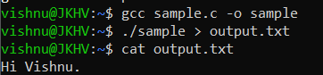

**More on Redirection**

**1) Create X_file.txt file with some content.**

**2) Redirect the content of both out_file.txt and X_file.txt to a new file**

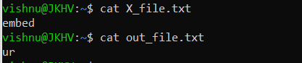

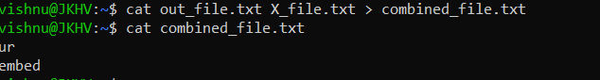

**Here document and Here string**

**1) Convert a string to uppercase using:**

**a) Here document**

**string="hello world"**

**echo "$string" | tr '[:lower:]' '[:upper:]'**

**b) Here string**

**string="hello world"**

**tr '[:lower:]' '[:upper:]' <<< "$string"**

**Hint: tr a-z A-Z**

