1. Capture and analyse ARP packets using Wireshark. Inspect the ARP request and reply frames

when your device attempts to find the router's MAC address. Discuss the importance of ARP

in packet forwarding.

Troggering ARP packets by pinging to my router from my machine :

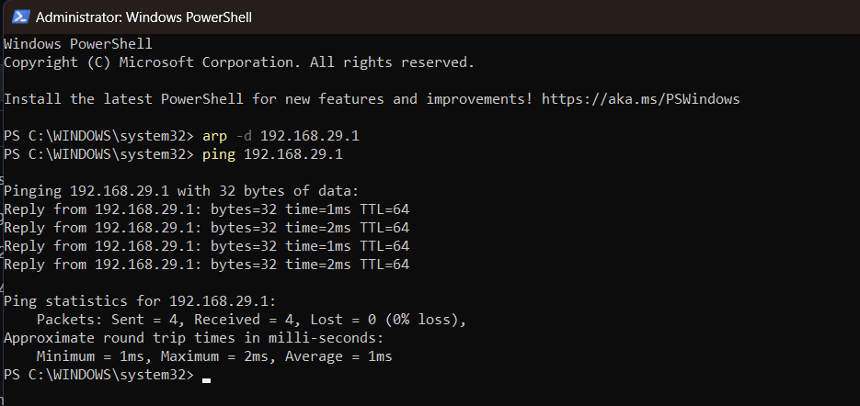

Wire shark outputs :

Arp broadcast :

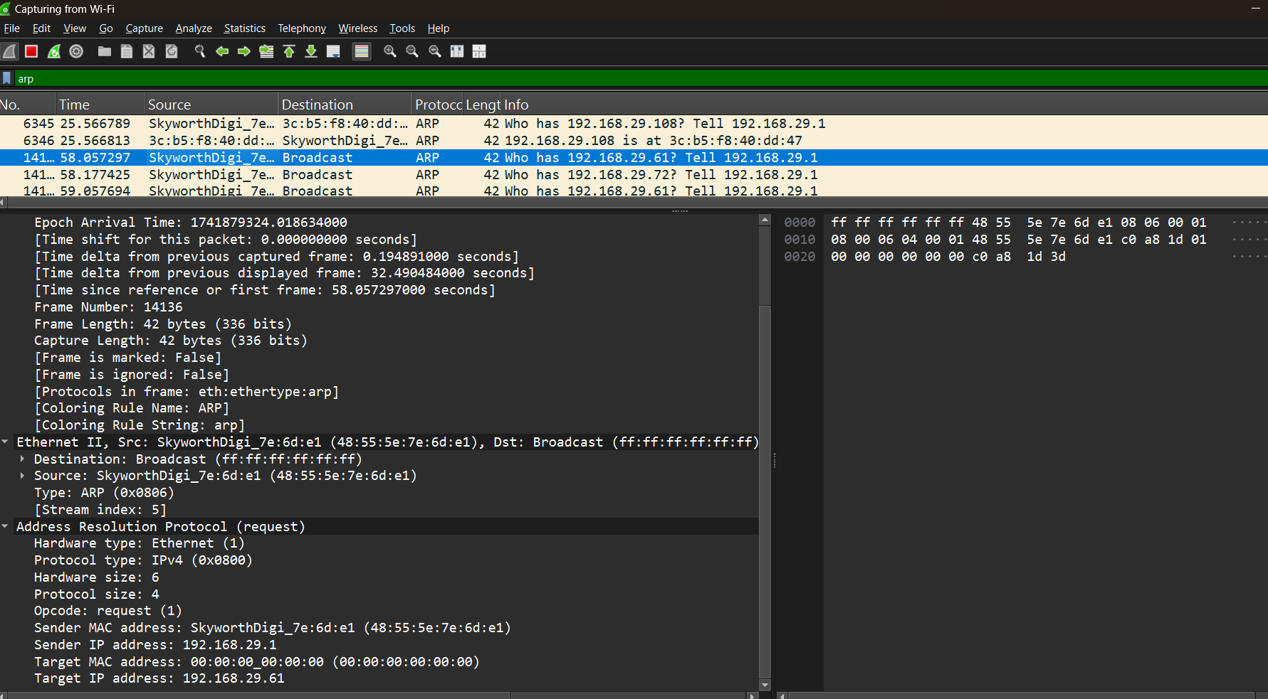

In the above initially sending the broadcast packets from my system and then next step the router will send the reply packets .

Reply packets from the router :

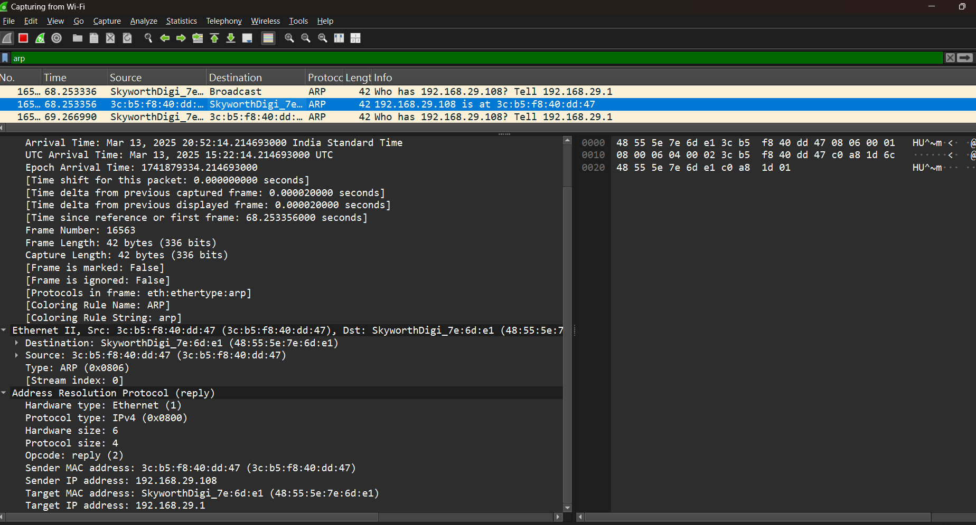

In reply the routers mac address will be sent to the machine .

1. ARP resolves IP addresses to MAC addresses, enabling devices to communicate on a local network.
2. It ensures packets are correctly forwarded to the router (default gateway) for destinations outside the local network.
3. ARP reduces network overhead by caching IP-to-MAC mappings, improving efficiency.
4. It supports both broadcast (ARP requests) and unicast (ARP replies) communication for seamless packet delivery.