**1. In which OSL layer the Wi-Fi standard/protocol fits.**

Wi-Fi spans **both the Data Link Layer (Layer 2) and the Physical Layer (Layer 1)**, but it is mainly categorized under Layer 2 since it includes MAC addressing and frame-based communication.

At Physical layer, Wi-Fi handles the actual **radio wave transmission** between devices.It does modulation,encoding,frequency allocation and channel assignment.

At data link layer ,Wi-Fi functions primarily in the **MAC (Media Access Control) sublayer** of Layer 2, managing access to the wireless network and data transmission.

**2. Can you share the Wi-Fi devices that you are using day to day life, share that device's wireless capability/properties after connecting to network. Match your device to corresponding Wi-Fi Generations based on properties**

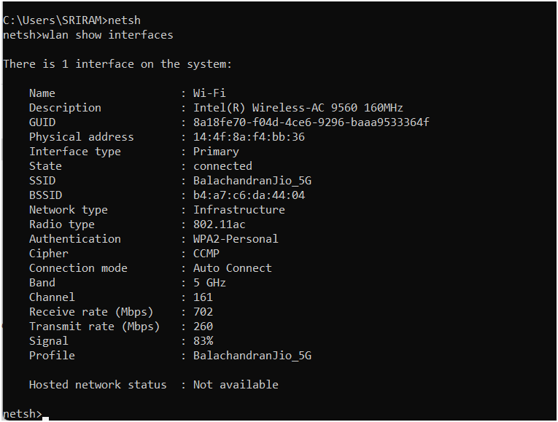

**3. what is BSS and ESS?**

**Basic Service Set(BSS):**

A BSS is the basic building block of a Wi-Fi network. It consists of One Access Point (AP) Multiple wireless clients (stations or STAs) connected to the AP

Types of BSS:

1. Infrastructure BSS → Devices communicate via an AP. (Common in homes, offices, etc.)
2. Independent BSS (IBSS) → Devices communicate directly in ad-hoc mode (no AP).

**Extended Service Set (ESS):**

An ESS is a collection of multiple BSSs connected together. It consists of: Multiple APs, each creating its own BSS. A shared SSID (Service Set Identifier) to allow seamless roaming. A wired backbone (distribution system, DS) connecting the APs.

**4. what are the basic functionalities of Wi-Fi Accesspoint**

A Wi-Fi Access Point (AP) is a device that allows wireless devices (stations or STAs) to connect to a wired network using Wi-Fi. It acts as a bridge between wireless clients (like smartphones, laptops) and the main network (router, switch, or internet).The key functionalitis are:

* Wireless Connectivity
* Network Bridge
* Roaming and Handoff
* Data Transmission and Reception
* Wireless Security and Authentication

**5. Difference between Bridge mode and Repeater mode**

**Bridge mode:**

It connects two separate networks to act as a single network.

It operates Layer 2

It can be wired or wireless

**Reapter Mode:**

It Extends an existing Wi-Fi signal by retransmitting it to reach further areas.

It operates Layer 1

It can be Wireless

**6. what are the differences between 802.11a and 802.11b.**

1. 802.11a

🔹 Frequency: 5 GHz  
🔹 Speed: Up to 54 Mbps  
🔹 Range: ~35 meters indoors, ~120 meters outdoors  
🔹 Interference Resistance: High (fewer devices use 5 GHz, so less congestion)

2. 802.11b

🔹 Frequency: 2.4 GHz  
🔹 Speed: Up to 11 Mbps  
🔹 Range: ~38 meters indoors, ~140 meters outdoors  
🔹 Interference Resistance: Low (more devices use 2.4 GHz, leading to congestion)

**7. Configure your modem/hotspot to operate only in 2.4Ghz and connect your laptop/Wi-Fi device , and capture the capability/properties in your Wi-Fi device. Repeat the same in 5Ghz and tabulate all the differences you observed during this**

Login to your Router/Hotspot settings

Open a browser and enter 192.168.1.1 or 192.168.0.1 (check your router’s IP).

Login with the admin username/password (usually found on the device).

Disable 5GHz and Enable Only 2.4GHz

Go to Wireless Settings > Wi-Fi Band Selection.

Disable 5GHz and keep 2.4GHz enabled.

Save settings and restart the router/hotspot.

Connect Your Laptop to the 2.4GHz Wi-Fi

Check Wi-Fi Properties in Your Device

**8. What is the difference between IEEE and WFA**

The Institute of Electrical and Electronics Engineers (IEEE) and the Wi-Fi Alliance (WFA) are two key organizations involved in the development and adoption of Wi-Fi technology. While IEEE defines the technical standards, WFA ensures their implementation and interoperability.

IEEE (Institute of Electrical and Electronics Engineers)

IEEE is responsible for developing and maintaining the 802.11 standards, which define the technical specifications for Wi-Fi, including speed, frequency bands, and security protocols.

WFA (Wi-Fi Alliance)

The Wi-Fi Alliance is a non-profit organization that certifies Wi-Fi devices for interoperability and compliance with IEEE standards. It ensures that different manufacturers' products work seamlessly together.

**9. List down the type of Wi-Fi internet connectivity backhaul, share your home/college's wireless Internet connectivity backhaul name and its properties**

Wi-Fi backhaul refers to the connection between the Wi-Fi Access Points (APs) and the main network

Types of Wi-Fi Backhaul:

Fiber Optic – Best for High-speed broadband

Ethernet – Best for Offices, data centers, and homes needing stable connectivity

Coaxial Cable – Best for Home broadband in urban areas

**10. List down the Wi-Fi topologies and use cases of each one.**

Basic Service Set (BSS):

Use Cases:

* Home Wi-Fi networks where a router provides internet access.
* Office networks with multiple employees connected wirelessly.
* Public hotspots such as cafes, airports, and malls.

Extended Service Set (ESS):

Use Cases:

* Corporate offices, universities, and hospitals requiring wide coverage.
* Airports and shopping malls with multiple APs ensuring seamless connectivity.
* Smart city projects providing continuous Wi-Fi across different locations.

Ad-Hoc Mode:

Use Cases:

* Quick file transfers between laptops and mobile devices.
* Temporary wireless networks for gaming LAN parties.
* Emergency communication networks in disaster-hit areas.

Wifi:

Use Cases:

* Wireless printing (e.g., phone to printer connection).
* File transfer between devices (e.g., Android’s Wi-Fi Direct, Apple’s AirDrop).
* Smart TV casting and screen mirroring.