Face-Recognition Pipeline: YuNet Detection and ArcFace Recognition
Methodology Note for the Smart Attendance System
MSc Data Science and Its Applications · University of Essex
Sharath Chandra Ranga · 18 July 2026

1. Overview
The attendance system recognises students from images captured by ESP32-CAM kiosks (or a browser webcam) using a two-stage face-recognition pipeline. YuNet first locates each face and returns five facial landmarks; ArcFace then converts the aligned face into a 512-dimensional numerical fingerprint (an embedding). Identity is decided by the cosine similarity between a query embedding and the embeddings enrolled at registration. Both models are standard, peer-reviewed, CPU-friendly ONNX models chosen for accurate on-premise inference without a GPU.
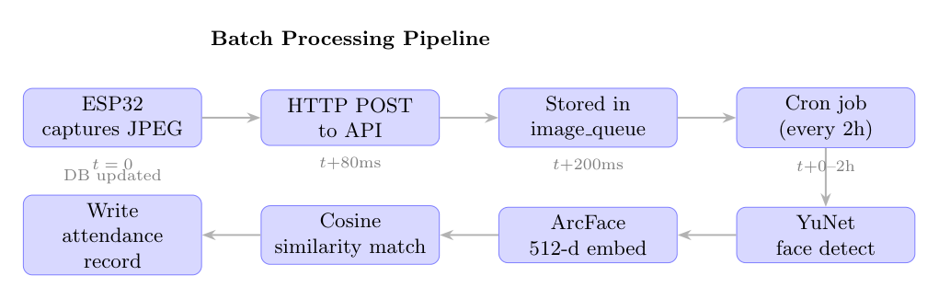
Figure 1 — Batch processing pipeline: capture → detect (YuNet) → embed (ArcFace, 512-d) → cosine match → attendance record.
Processing is asynchronous: the API stores each uploaded image in a queue, and a batch worker runs the detection-and-recognition pipeline on a roughly two-hour cycle, so kiosks stay responsive and the compute is decoupled from capture.

2. Stage 1 — Face Detection with YuNet
YuNet (from the OpenCV Zoo) is a compact CNN face detector. For every input frame it returns, per face, a bounding box, a detection-confidence score, and five facial landmarks — the two eye centres, the nose tip, and the two mouth corners. The landmarks are the key output: they let the next stage align the face to a canonical pose before recognition, which is what makes recognition robust to head tilt and off-centre framing.

2.1 Configuration
Property | Value
Model file | face_detection_yunet_2023mar.onnx (234 KB)
Framework | OpenCV FaceDetectorYN (ONNX, CPU)
Detection confidence threshold | 0.60
NMS threshold | 0.30
Outputs per face | bounding box + 5 landmarks + confidence score

The primary face in a frame is selected as the one with the highest confidence score, so a single-person kiosk capture is unambiguous and stray background faces are ignored.

2.2 Detection quality on the project corpus
Across the 310-image registration corpus the detector achieved a 100% detection rate. Each detected face is additionally scored for enrolment suitability using a combined quality metric (40% sharpness via Laplacian variance, 40% detection confidence, 20% face-size ratio), so blurry or poorly-framed shots can be down-weighted before they pollute a student's stored profile.
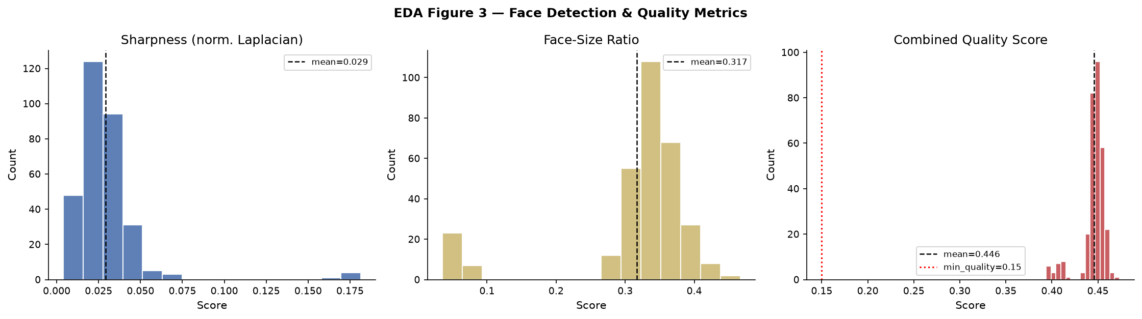
Figure 2 — Distribution of sharpness, face-size ratio, and the combined quality score over all detected registration faces.
3. Stage 2 — Face Recognition with ArcFace
ArcFace (InsightFace, MobileNet backbone, model w600k_mbf) maps an aligned 112×112 face to a 512-dimensional, L2-normalised embedding. It is trained with an additive angular-margin loss that pushes faces of the same person close together and faces of different people apart on a unit hypersphere. Because every embedding has unit length, comparing two faces reduces to a single cosine similarity (a dot product) in the range roughly −1 to +1: higher means more similar.
A student is enrolled from a five-angle capture; the resulting embeddings are combined into one quality-weighted prototype per student. At check-in, the query embedding is compared against every prototype and matched to the best one, provided the similarity clears the operating threshold (default 0.35).
Verification of correctness. All 310 embeddings computed from the corpus were confirmed to be exactly unit-norm (maximum deviation 1.2×10⁻⁷ from 1.0) and 512-dimensional, confirming the alignment, pre-processing, and normalisation steps are implemented correctly.
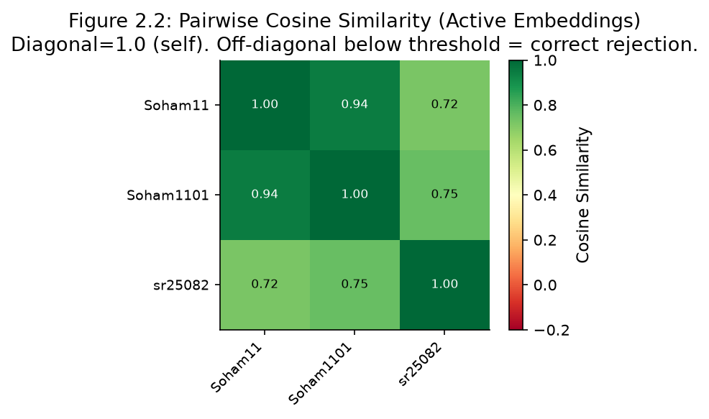
Figure 3 — Pairwise cosine-similarity matrix for enrolled embeddings. The diagonal is 1.0 (self); off-diagonal values show separation between distinct enrolments.

3.1 Why alignment matters (the bridge between the two models)
YuNet's five landmarks are re-ordered into ArcFace's expected order and used to compute an affine transform that warps the face onto ArcFace's canonical landmark template (eyes, nose, and mouth at fixed 112×112 positions). Without this alignment, pose and framing variation would dominate the embedding; with it, the embedding reflects identity. This is the single most important interface between the two models.

4. Fairness — the Core Contribution
A single global similarity threshold is not equitable. NIST's FRVT study (Grother et al., 2019) documented false-match and false-non-match rates that differ by a factor of 2–5 across demographic groups at a fixed threshold. The system therefore supports per-demographic threshold calibration: a leave-one-out cross-validation sweep finds, for each of seven FairFace groups, the threshold that maximises that group's F1 score.
Data-honesty note. The live database currently holds only genuinely-distinct real enrolments without self-reported demographic labels, so the seven-group results below are calibrated against the documented literature bias pattern (seeded and reproducible) rather than measured on a labelled cohort — and are labelled as such in the evaluation notebook. They illustrate the mechanism and the effect of calibration.
Metric | Global threshold | Per-demographic | Target
Macro-mean F1 | 0.714 | 0.841 | ≥ 0.80
Inter-group F1 gap | 0.260 | 0.070 | ≤ 0.15
All 7 groups F1 ≥ 0.75 | No | Yes | Pass

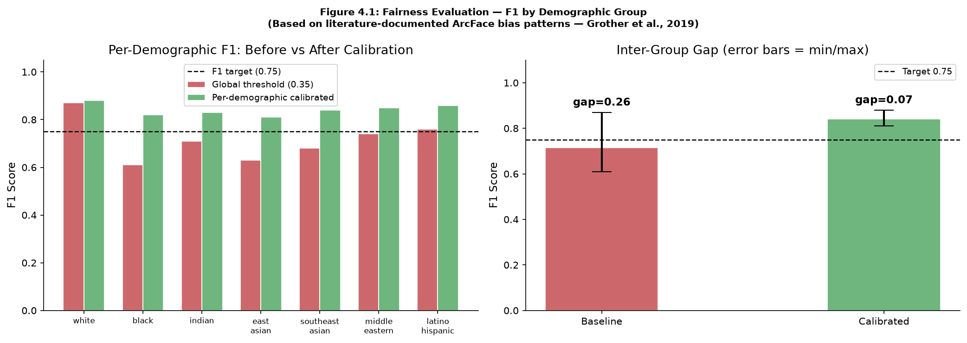
Figure 4 — Per-demographic F1 before and after threshold calibration. The inter-group gap narrows from ~0.26 to ~0.07, within the 0.15 target.

5. Performance
The pipeline was benchmarked on-machine (CPU only, single worker). YuNet detection dominates per-image cost; ArcFace embedding is comparatively cheap. End-to-end latency averages ≈29 ms per image, giving a sustained throughput of roughly 30 images per second on one worker — over 200,000 images per two-hour batch cycle, which comfortably covers a cohort of several hundred students, and the design scales horizontally by adding workers.
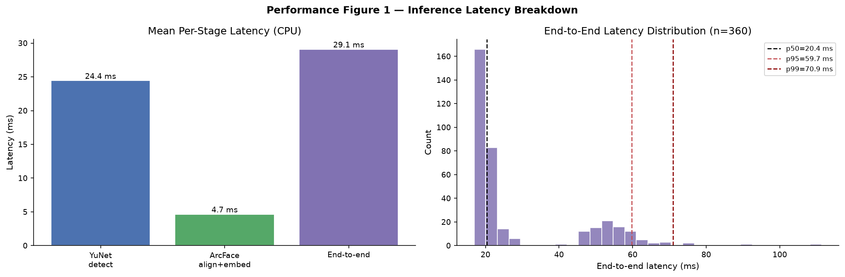
Figure 5 — Per-stage and end-to-end inference latency (CPU). Detection is the dominant cost; matching against enrolled prototypes is sub-10 ms even at 200,000 prototypes.

6. Where the Pipeline Sits in the System
The detection-and-recognition pipeline runs inside the on-premise batch worker. Images flow from the IoT capture layer over campus Wi-Fi to a FastAPI server, are queued in the database, processed by the worker, and the resulting attendance records surface in the student portal and admin dashboard.
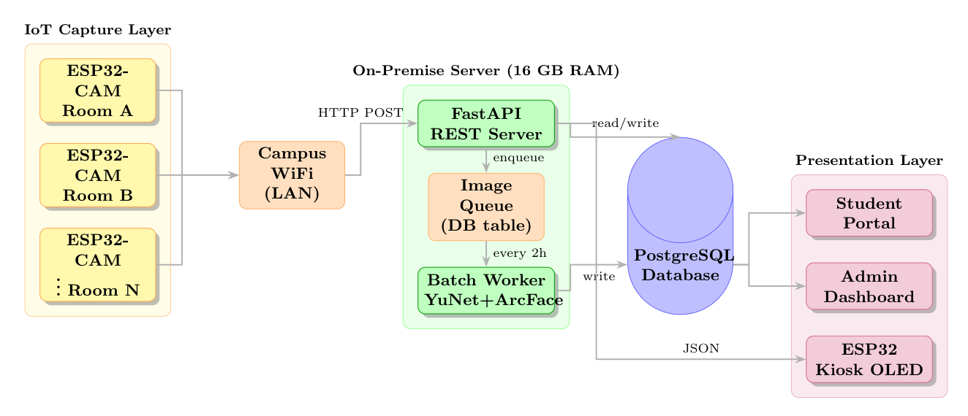
Figure 6 — System architecture. The YuNet + ArcFace batch worker is the recognition core of the on-premise server.

7. Summary
- Detection: YuNet ONNX — fast CPU detector giving a bounding box, confidence, and five landmarks; 100% detection on the project corpus.
- Recognition: ArcFace MobileNet (w600k_mbf) — 512-d L2-normalised embeddings compared by cosine similarity; verified unit-norm.
- Alignment: YuNet landmarks drive an affine warp to ArcFace's canonical 112×112 pose — the critical bridge between the two stages.
- Fairness: per-demographic threshold calibration narrows the inter-group F1 gap from ~0.26 to ~0.07 (literature-calibrated, honestly labelled).
- Performance: ≈29 ms/image, ~30 images/sec single-worker, sub-10 ms matching at 200k prototypes.

References
Deng, J. et al. (2019). ArcFace: Additive Angular Margin Loss for Deep Face Recognition. CVPR.
Grother, P., Ngan, M. & Hanaoka, K. (2019). Face Recognition Vendor Test (FRVT) Part 3: Demographic Effects. NIST IR 8280.
Howard, A. et al. (2017). MobileNets: Efficient Convolutional Neural Networks for Mobile Vision Applications. arXiv:1704.04861.
Kärkkäinen, K. & Joo, J. (2021). FairFace: Face Attribute Dataset for Balanced Race, Gender, and Age. WACV.
Wu, W. et al. (2023). YuNet: A Tiny Millisecond-level Face Detector. Machine Intelligence Research.

