|  |  |
| --- | --- |
| **MaxArrays** | |
| Find the duplicates number | 1 |
| Sort array of 0 1 and 2’s | 1 |
| Maximum sum sub-array | 2 |
| Merge intervals | 2 |
| Pascal’s triangle | 3 |
| Next permutation | 3 |
| Count the number of beautiful sub-arrays | 4 |
| Rearrange array to maximize prefix score | 4 |
| K-th missing positive integer | 5 |
| Two sum | 5 |
| Best Time to Buy and Sell Stock | 6 |
| Merge sorted array | 6 |
| Remove element from an array | 7 |
| Design browser history | 7 |
| Maximize Greatness of an array | 8 |
| Check knight tour configuration | 8 |

**Find the duplicate number**

Brute force: tc: O(NlogN), sc: O(1)

Better approach: tc: O(N), sc: O(N)

Optimal approach: tc: O(N), sc: O(1)

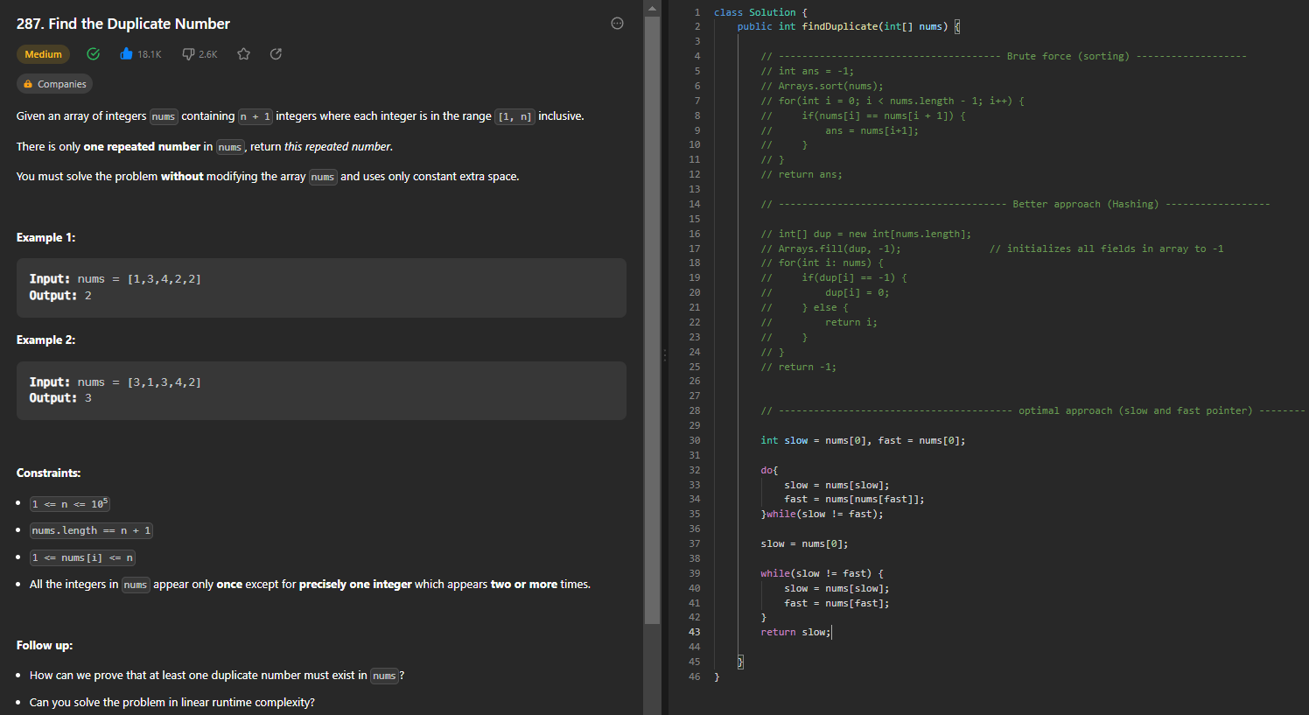

**Sort 0 1 and 2’s**

Brute force: tc: O(NlogN), sc: O(1)

Better approach: tc: O(N + N), sc: O(1)

Optimal approach: tc: O(N), sc: O(1)

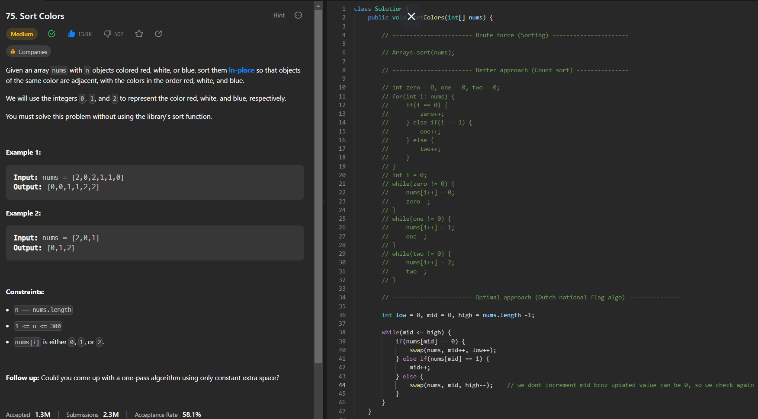

**Maximum sum subarray**

Brute force: tc: O(N^3), sc: O(1)

Better approach: tc: O(N^2), sc: O(1)

Optimal approach: tc: O(N), sc: O(1)

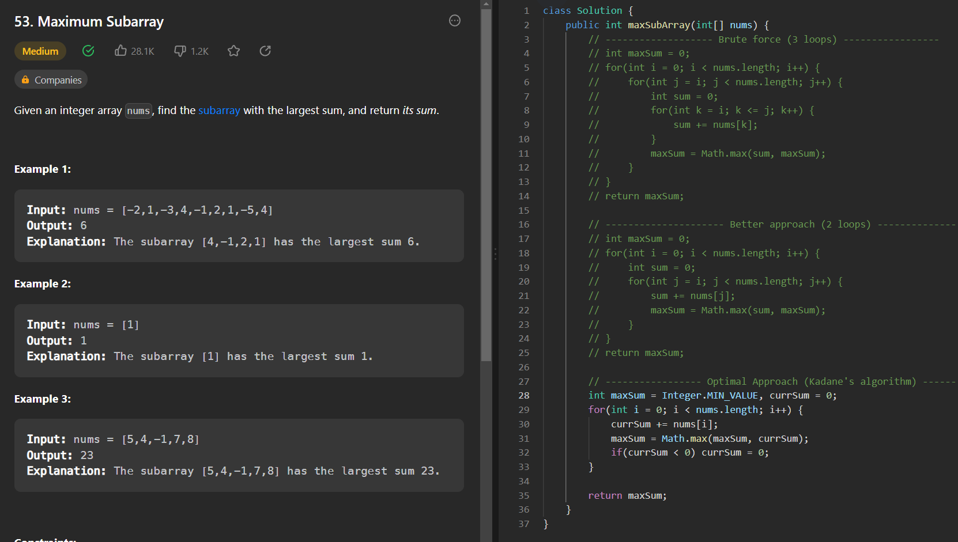

**Merge Intervals**

Approach 1: tc: O(NlogN), sc: O(1) if we ignore ans array space, if not it is O(N)

Approach 2: tc: O(NlogN), sc: O(1) if we ignore ans array space, if not it is O(N)

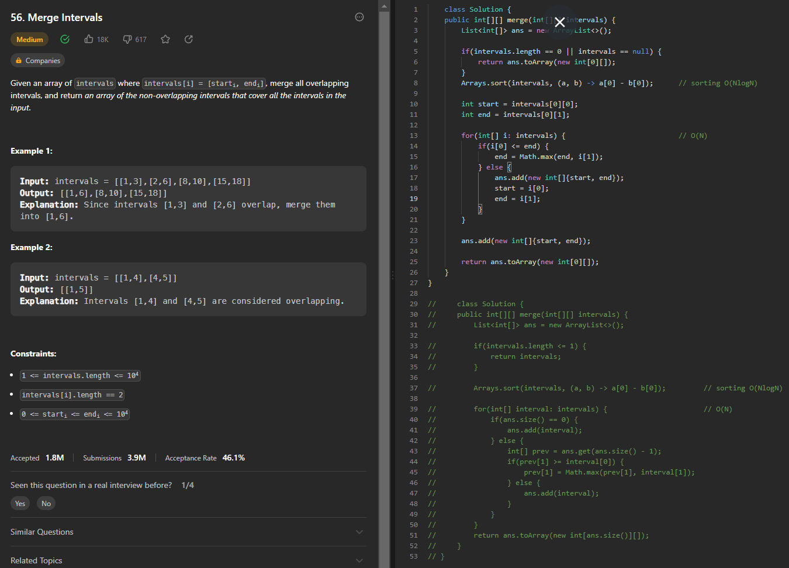

**Pascal’s triangle**

Tc: O(n * n)

Sc: O(n * n)

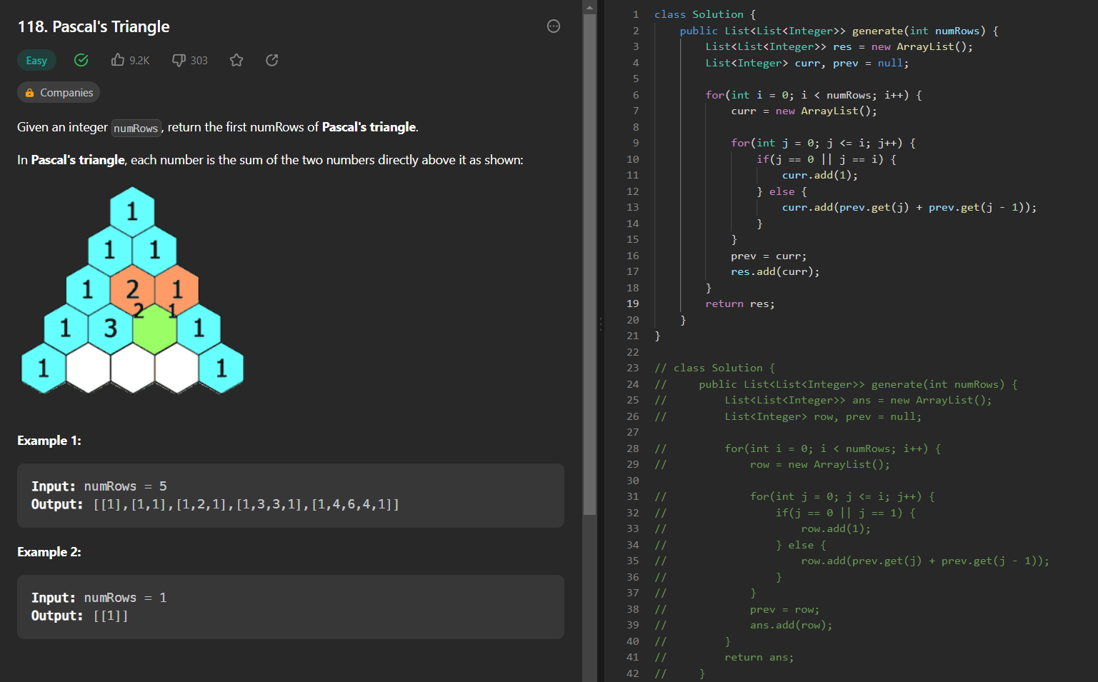

**Next permutation**

Tc: O(n + n + n) => O(3n) => O(n)

Sc: O(1)

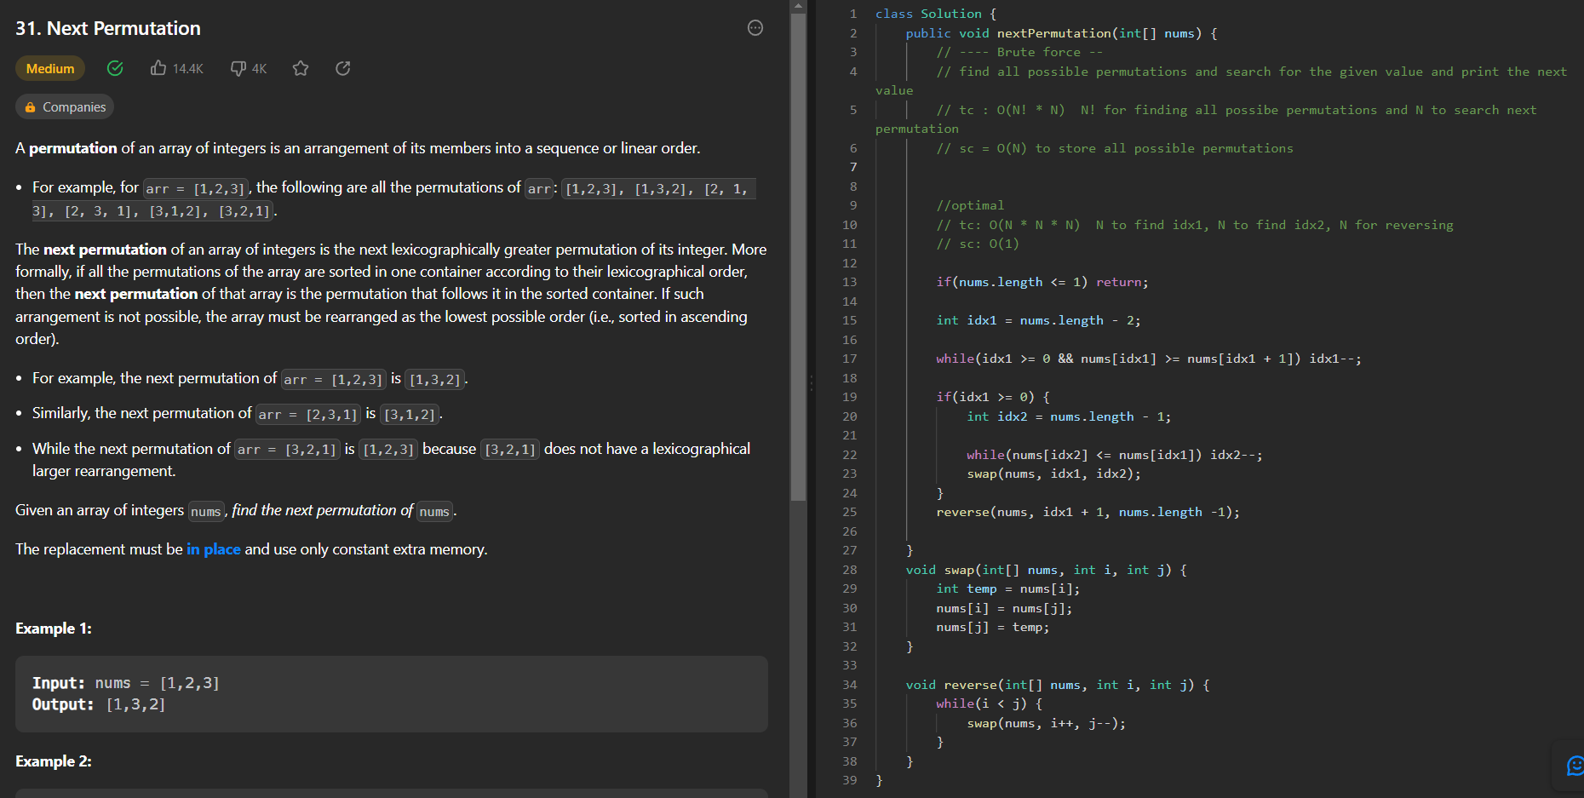

**Count the number of beautiful subarrays**

Tc: O(n)

Sc: O(n)

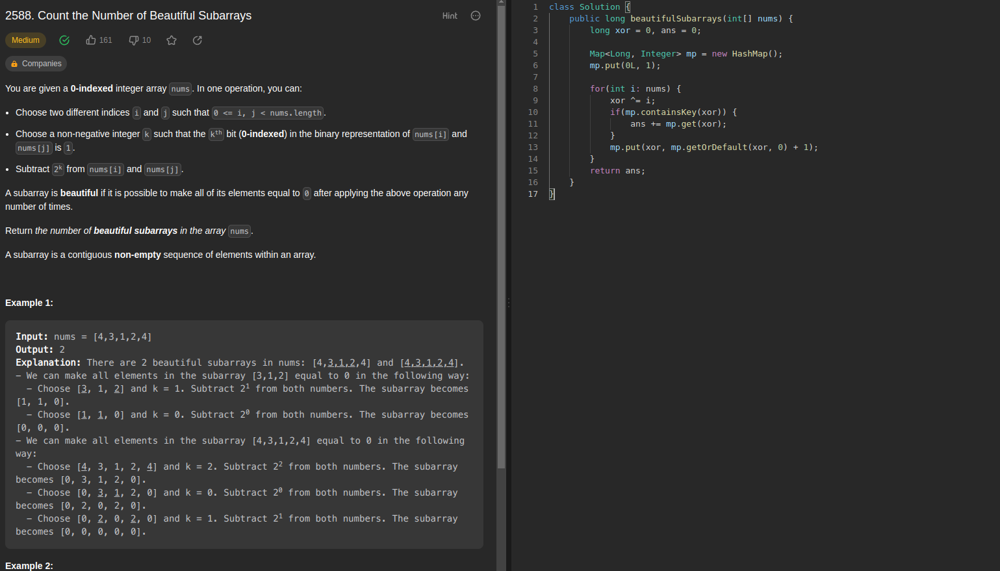

**Rearrange array to maximize prefix score**

Tc: O(NlogN) // sorting

Sc: O(1)

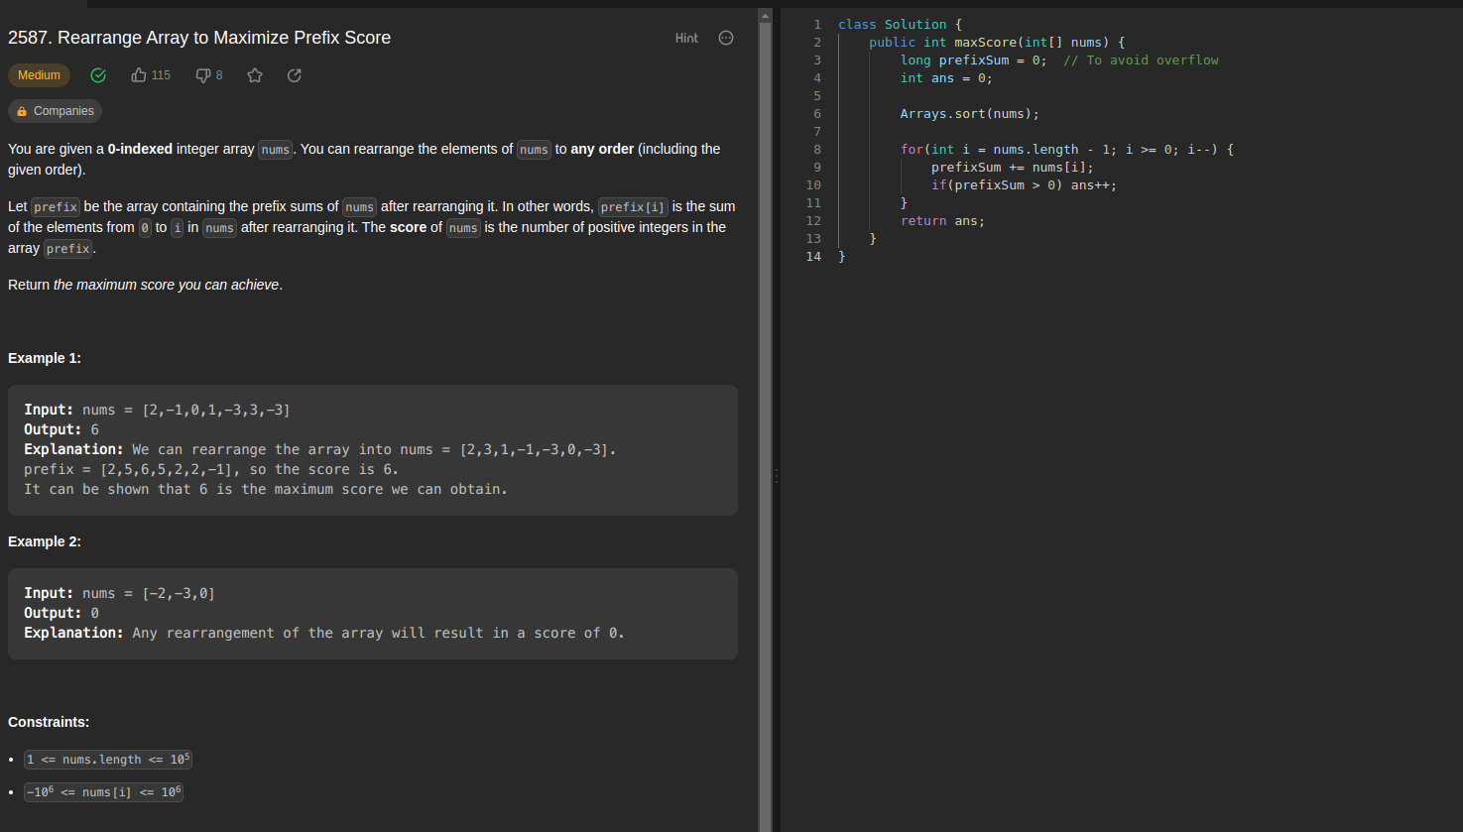

**Kth missing positive integer:**

Tc: O(logN)

Sc: O(1)

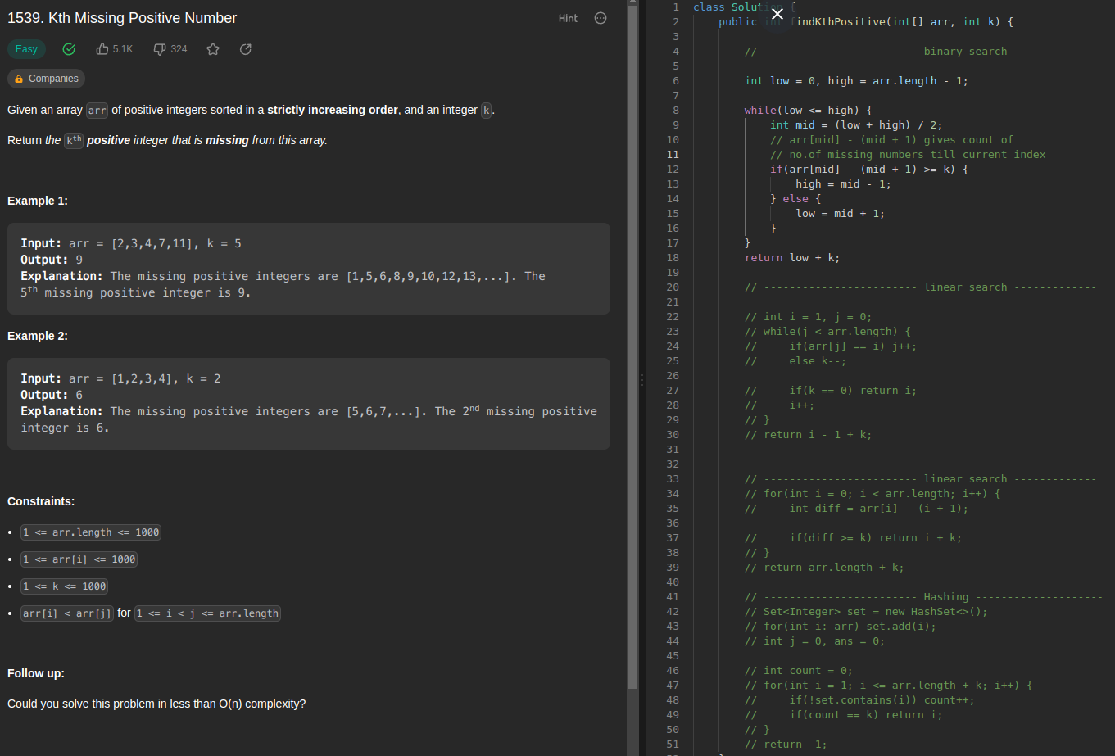

**Two sum**

If given array is sorted use two pointer approach else use hashmap

TC: O(N)

SC: O(N) // given array is not sorted

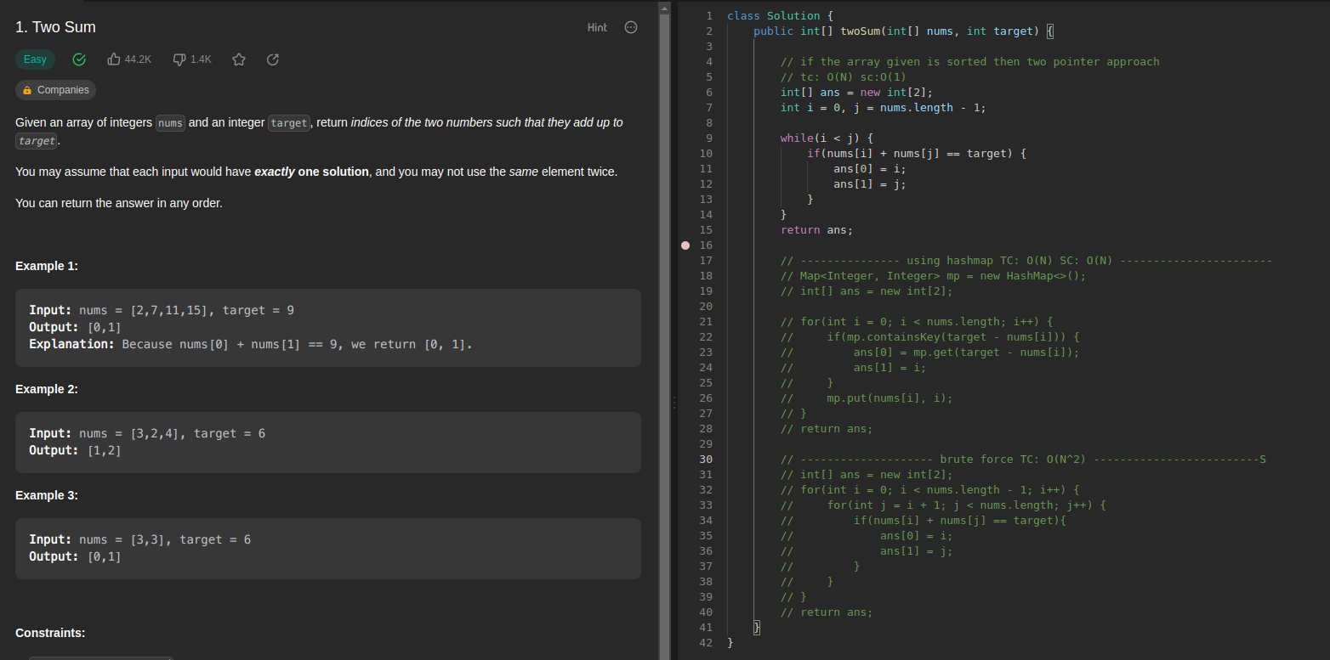

**Best Time to Buy and Sell Stock:**

TC: O(N)

SC: O(1)

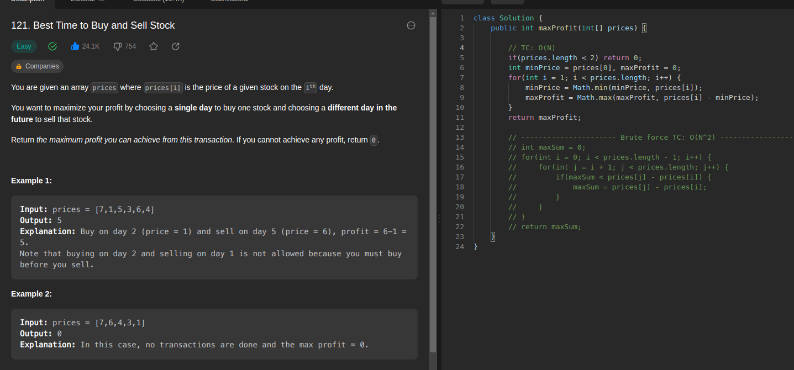

**Merge sorted array:**

TC: O(M + N)

SC: O(1)

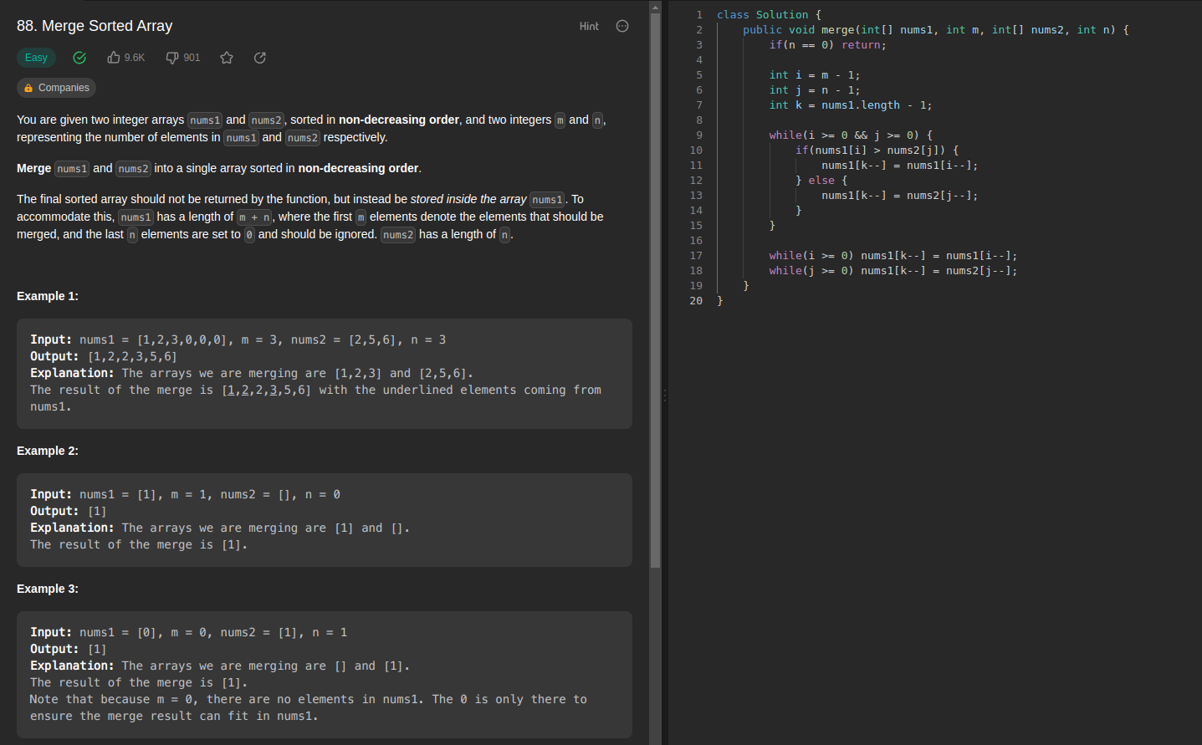

**Remove element from an array:**

TC: O(N)

SC: O(1)

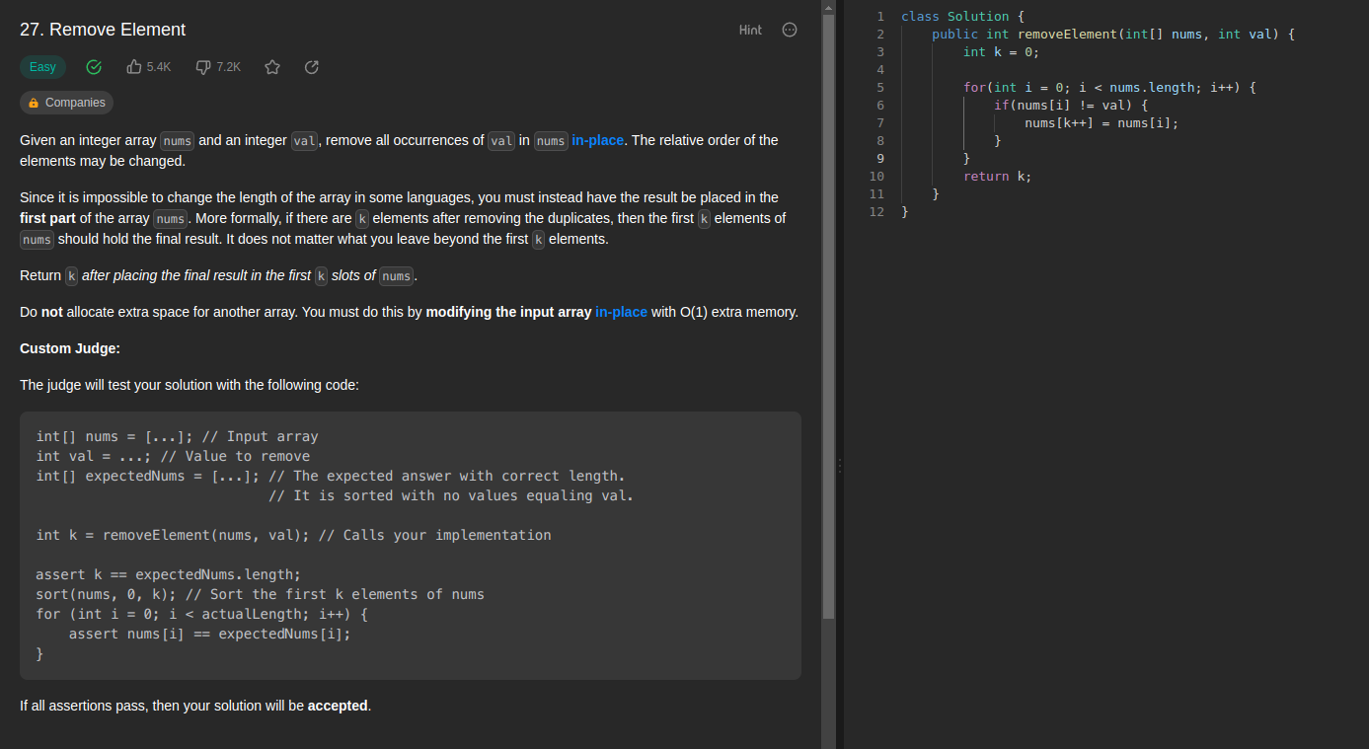

**Design browser History:**

TC: O(N)

SC: O(N)

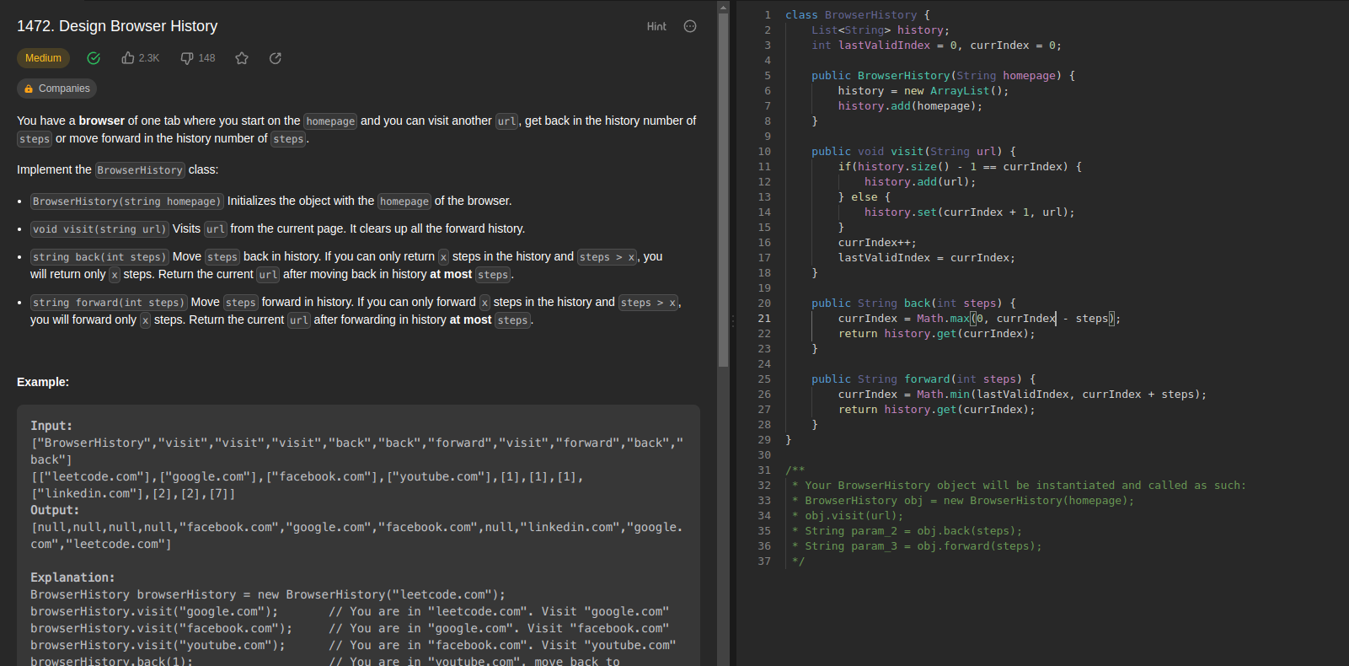

**Maximize greatness of an array:**

TC: O(NlogN)

SC: O(1)

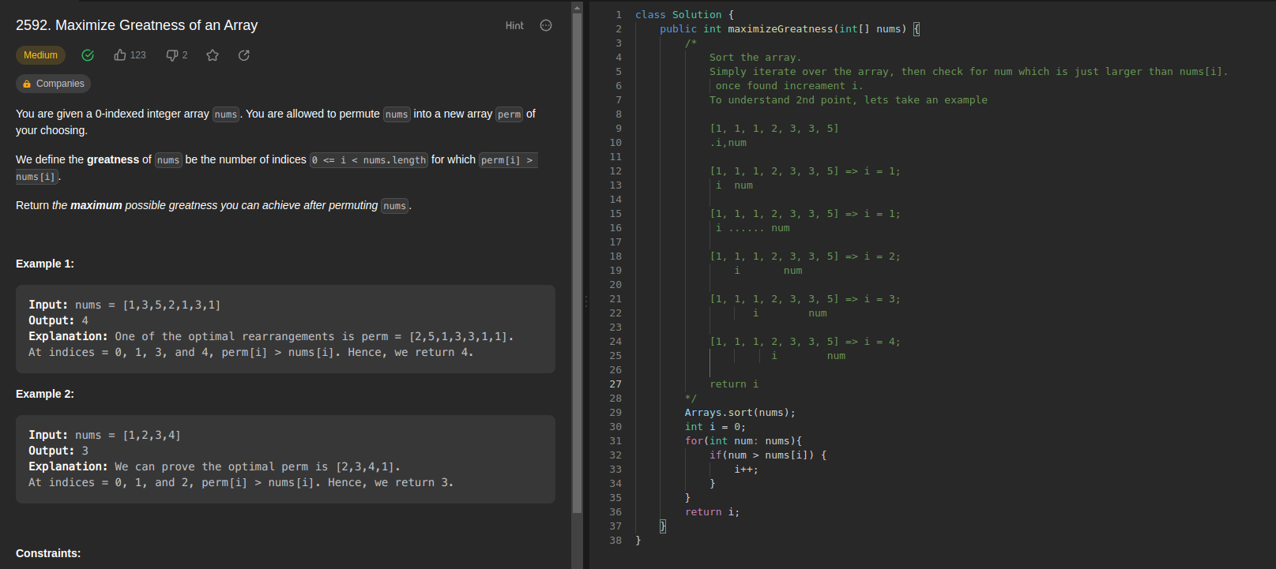

**Check knight tour configuration:**

TC: O(N^2) // for traversing n * n matrix

SC: O(1)

