|  |  |
| --- | --- |
| **GRAPHS** | |
| Minimum Score of a path between two cities | 1 |
| Number of operations to make network connected | 1 |
|  |  |
|  |  |
|  |  |
|  |  |
|  |  |

**[Minimum score of a path between two cities:](https://leetcode.com/problems/minimum-score-of-a-path-between-two-cities/)**

TC: O(N + E)

SC: O(N + E)

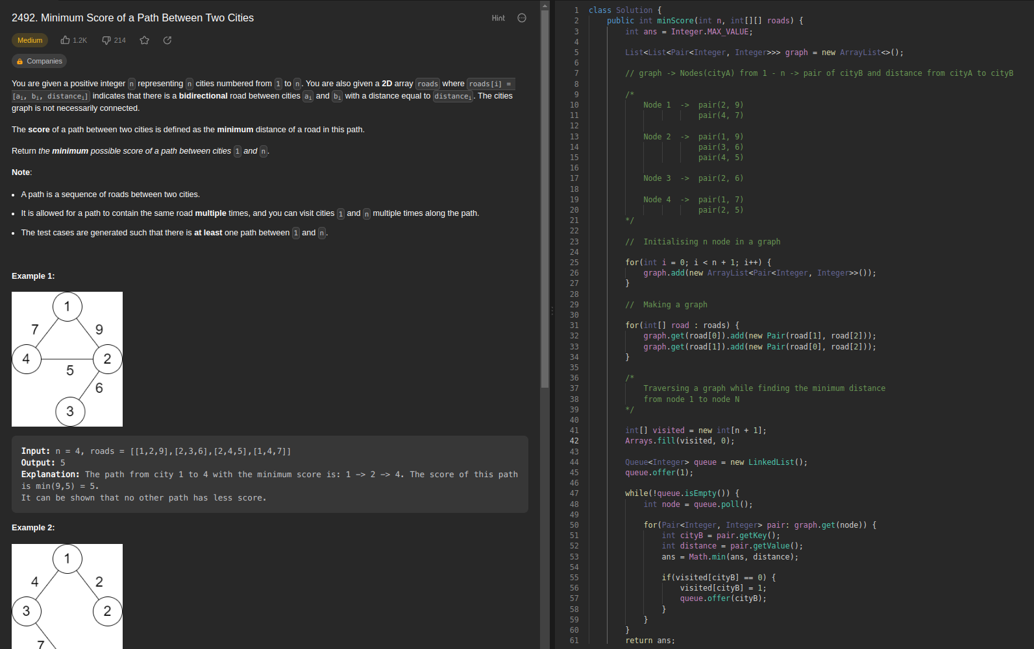

**[Number of Operations to Make Network Connected:](https://leetcode.com/problems/number-of-operations-to-make-network-connected/description/)**

TC: O(connections) // Traversing over the entire connections array

SC: O(N) // Node in the graph

