|  |  |
| --- | --- |
| **Tries** | |
| Implement Trie (Prefix Tree) - Recursive methods | 1 |
| Implement Tire (Prefix Tree) - Iterative methods | 1 |
|  |  |
|  |  |
|  |  |
|  |  |
|  |  |

**Implement Trie (Prefix Tree) - Recursive methods**

TC: O(N)

SC; O(S)

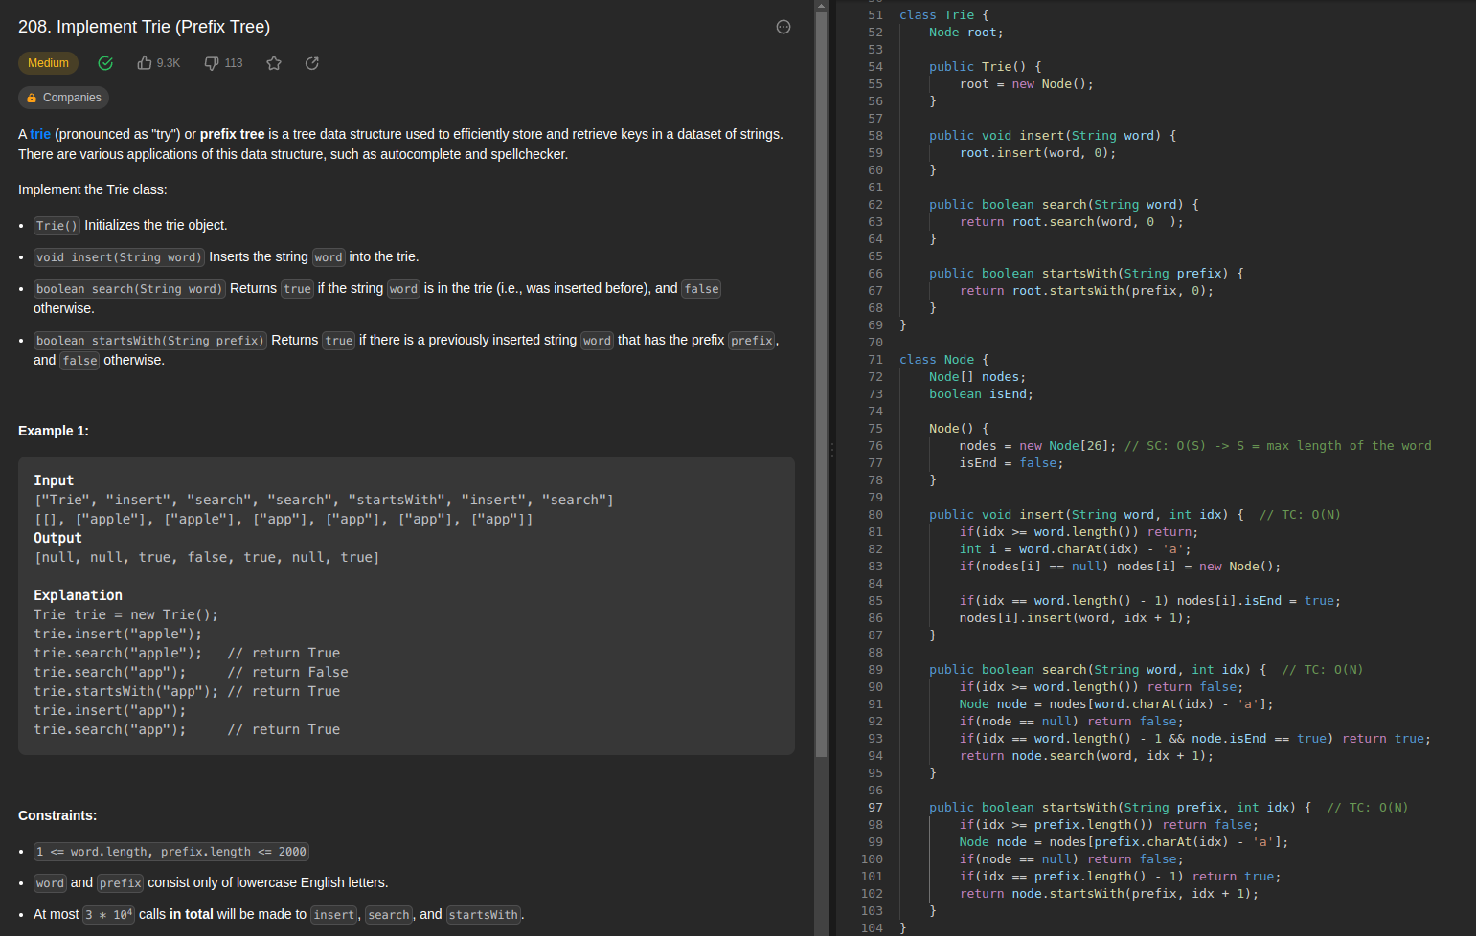

**Implement Trie (Prefix Tree) - Iterative methods**

TC: O(N)

SC: O(S)

