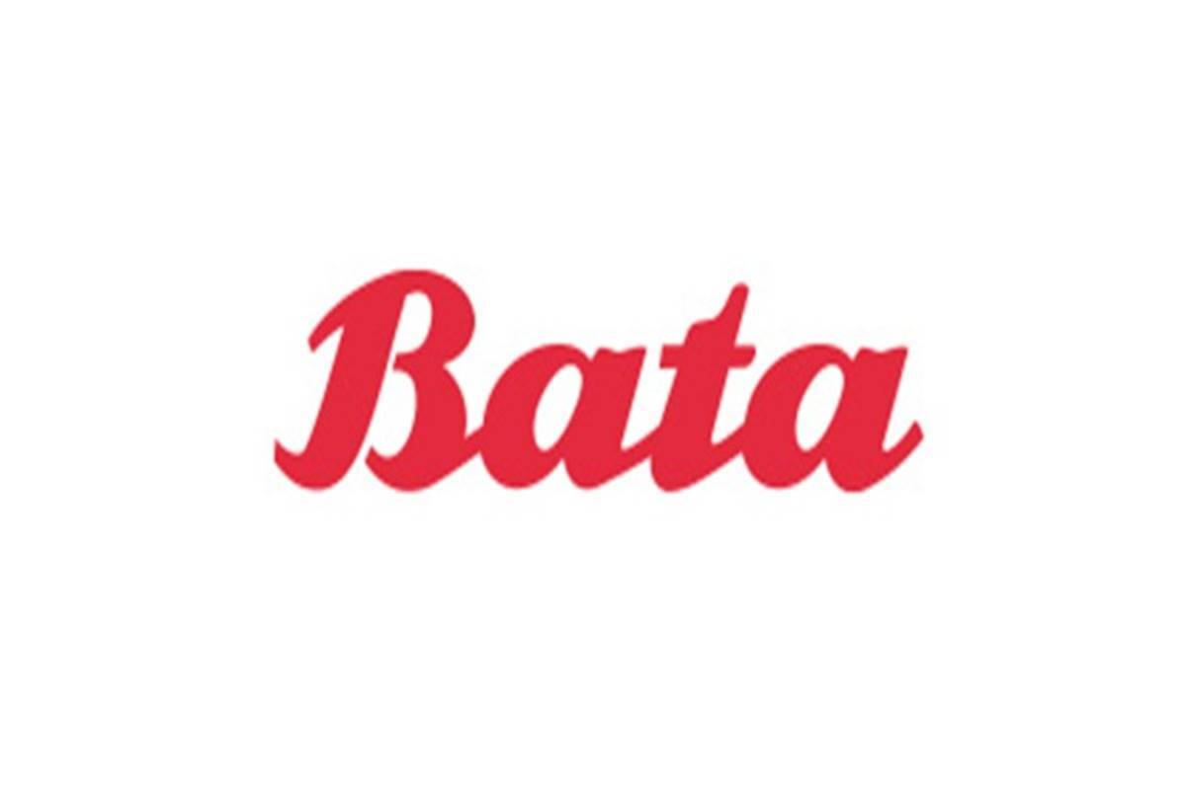

Conducted at

**Bata India Ltd**

Submitted in partial fulfilment of the course requirement of

**Post Graduate Diploma**

**In**

**Management**

**Guided by:**

Prof R K Vijaya Sarathy

Dayanand Sagar Business School

**Submitted by:**

Name: Sharath.P

Reg no: DSBSPGDMA1922.

October

2019-2021



**Dayananda Sagar Business School,**

Shavige Malleshwara Hills, Kumaraswamy Layout,

Bengaluru-560078.

**GUIDE CERTIFICATION**

This is to certify that the report titled **“DISSERTATION ”** has been prepared under my guidance and supervision. The report is submitted in partial fulfilment of the requirements for the award of Post Graduate Diploma in Management (Approved by **AICTE**) by Student name: **SHARATH.P** with Registration number: **DSBSPGDMA1922** and this report/study has not formed basis for the award of my degree or diploma in any university/Institution.

Date: 24th November, 2020. (Prof R K Vijaya Sarathy)

Place: Bengaluru. DSBS, Bengaluru.

**STUDENT DECLARATION**

I hereby declare that the report/study titled **“DISSERTATION ”** prepared under the guidance of **Prof R K Vijaya Sarathy** (Faculty Guide) submitted in partial fulfillment of the requirements for the award of Post Graduate Diploma in Management (Approved by **AICTE**) in Dayananda Sagar Business School is my original work and has not been submitted for the award of any other degree/diploma in any university/institution.

Date: 24th November, 2020. Sharath.P

Place:Bengaluru. DSBSPGDMA1922

Acknowledgement

Apart from the efforts of me, the success of any project depends largely on the encouragement and guidelines of many others. I take this opportunity to express my gratitude to the people who have been instrumental in the successful completion of this project.

The guidance and support received from all the members who contributed and who contribute to this project, was vital for the success of the project. I am grateful for their constant support and help.

# INDEX

|  |  |  |
| --- | --- | --- |
| **Pg.no** | **Topic** | **Sr.no.** |
| 1. | **INTRODUCTION** | 06 |
| 1.1 | ABOUT THE STUDY | 06-07 |
| 1.2 | OBJECTIVES OF THE STUDY | 08 |
| 1.3 | SIGNIFICANCE OF THE STUDY | 09 |
| 1.4 | SCOPE OF THE STUDY | 10 |
| 1.5 | LIMITATIONS OF THE STUDY | 11 |
| 2. | **COMPANY PROFILE** | 12 |
| 2.1 | HISTORY | 12-16 |
| 2.2 | ABOUT THE COMPANY | 17 |
| 2.3 | GROWTH STRATEGY | 18 |
| 2.4 | BRAND IDENTITY | 19 |
| 2.5 | SLOGAN | 20 |
| 2.6 | AWARDS | 21-23 |
| 2.7 | VISION AND MISSION | 24 |
| 2.8 | BOARD OF DIRECTORS | 25 |
| 2.9 | PRODUCTS AND SERVICES OFFERED | 26 |
| 3. | **CONCEPT OF METHODOLOGY** | 27 |
| 3.1 | RESEARCH METHODOLOGY | 27 |
| 3.2 | PRIMARY DATA | 28 |
| 3.3 | TOOLS AND TECHNIQUES OF COLLECTING SECONDARY DATA | 29 |
| 3.4 | INTRODUCTION AND DEFINITION OF THE TOPIC | 30 |
| 3.5 | SAMPLE SIZE AND SAMPLE TECHNIQUES | 31 |
| 4. | **DATA ANALYSIS** | 32-49 |
| 5. | **CONCLUSION AND SUGGESTIONS** | 50-52 |
|  | **ANNEXURE AND BIBLIOGRAPHY** | 53-55 |

**INTRODUCTION**

### About the Study:-

Gone are the days when consumers were least bothered about their footwear and wore whatever was offered to them how they need a strong and sustainable brand which can offer sound tangible benefits, a footwear which is durable, comfortable as well as stylish which can enhance their looks.

India is a country, which has always appreciated a naval ideal and a naval product. When woodland and Mescos ventured into the Indian market they would have not anticipated that their product would be so readily accepted by the Indian consumers, in spite of being targeted at a premium price, people accepted it because it was not only a new thing but also offered value for their money. Seeing the success of this footwear MNC’s like as Nike, Reebok, and Adidas did not wait for the second call and with their regular promotional activities the message was clearly penetrated in the mind of the consumers about the benefits of the brand. In spite of being highly priced, these companies are doing well in the Indian market, for that is Nike; Nike is constantly creating new niches and protecting niches by the designing shoes for different sports activities. After creating marketing for a particular niche they expand the niche by designing different versions.

In this first moving world with accelerating awareness through the electronic and communications devices consumer consciousness has gained the tremendous momentum. They simply do not make the purchase of a product if they are not aware of its entity. Footwear companies are always into vigorous research to hold the consumers into their hands by satisfying their needs and wants. Emerging competitions from the competitors help the

consumers to enjoy the benefits of the tussle. Every company wants to occupy the heart of every consumer and please them in a way they like. The quotation “consumer is not a king but a queen” rightly fits in the era.

Bata limited is the largest footwear company in the Asia and always analyses the market potentiality and consumers perception and to offer them the product of their need, wants and demands and satisfy them to the fullest.

The study is conducted to analyses the market potentiality and consumer perception of the Bata foot wear in Pune among its competitive and the brand standing of Bata in Pune city.

# OBJECTIVES OF THE STUDY

1. To determine the percentage of people using branded footwear in Pune.
2. To determine the most preferred shoe type in Pune.
3. To determine the awareness of Bata brand among various shoe brands.
4. To find out the percentage of people using Bata shoes.
5. To determine the preference of Bata brand among various other shoe brands.

# SIGNIFICANCE

* 1. It will help us to study the products offered by the company in detail.
  2. It will help us get an inner view of the company.
  3. It will help us to understand the company’s position in the Market.
  4. It will help us to better understand the functioning of the company.

# SCOPE OF THE STUDY

The research study entitled comparative analysis of market potentiality, market share and consumer’s perception for Bata foot wear with special reference to Bata family shoes in Pune under taken by the researcher covers the following research activity.

Study on market potentiality depends on different type of market share .the study also gives the extent of satisfaction and dissatisfaction among the users so that the company can take the desired step to minimize the dissatisfaction level. Study of the various factors which plays a major role in purchasing decision with provide the opportunity for the company to get the information about the most common factors which influences the purchase decision. The study helps to determine the average annual expenditure of the customers and the price that is affordable for them to purchase footwear. In order to frame its price range

accordingly. The aim of the study is to estimate the market potentiality and consumer perception in Pune and compare it with its competitive brands and also forecast the various opportunities available in the market for Bata footwear for coming years. Therefore it is expected that the research findings would give valuable results which would benefit for the company –Bata India limited, to make vital decision and to frame their marketing programmers more effectively and efficiently to be a premier and a market leader in the footwear industry.

# LIMITATIONS OF THE STUDY

* + 1. The study is limited only to formal leather shoes; and sports shoes.
    2. Since the time duration of the project was 2 to 3 weeks hence it was not possible to go for a very wide sample, so the sample size was limited to 100.
    3. In the comparative study, the researcher has considered only a few leading footwear brands in the market like liberty, woodland, Nike, Mescos, Reebok suggested by the company.
    4. Since it is a convenient study, some sort of discrepancies might be there in the data available.

### ORGANISATIONAL HISTORY:-

Our history and language are full of reference to shoes and chappals and the time honored craft of show and chappal making. Shoemakers were the first craftsmen to establish guilds in the middle ages and through the builds societies of craftsmen within a common trade come a standard of quality, which earned the shoemaker a well-established position in the community. The quality and care the shoemaker has taken with his craft has earned him a place in the history and Bata shoe organisation is proved to follow in this tradition of time quality craftsmanship. Today Bata shoe organisation is truly “Shoemaker and chappal maker to the world” and we invite you to join us and learn a little about the long history of shoes and how they are designed and constructed.

Primitive man made his own shoes from the skins of the wild animal he hunted and, where the climate was cold, he tied or around his lower leg. Primitive men were for the most part, nomadic and he bound his feet for protection against the bites of insect, often thorny forest flow and the heat of the earth on the dry plains. How the primitive men bound his feet dependent on where lived and this form the very beginning we see that shoes were used for protection but that to some extent the environment, the weather and the land dictated style.

Thus, sandal was the earliest from of show made by a “specialist” shoemaker. The early Egyptians made sandals, which consisted of a sole head to the foot by single piece of leather, which is circled the big toe. This from of sandal is called a thongs are still popular today in certain parts of the world.

The Egyptian had an interesting custom, which indeed seems to be or origin of expression under foot. The Egyptian painted or carved images of their enemies on the bottom of their sandals. They believed, they could hurt their foe by treading on their image, hence the expression; to be under foot”

Early shoe design was often taken from nature and in addition to sandals the Egyptians also wore a shoe within up turned toe model on the elephants tusk. The Mesopotamian used the same design, but with a longer curved toe. Some believed that the Chinese might have originated the curved toe design, as the boat with a peaked toe is quite common among the Mongols today.

The early Greeks where barefoot except in foul weather and it was not until the Hellenistic period around 232 BC that going barefoot out of dears become a sign of slavery. At that time the wearing of shoes signified that the wearer was free and beginning barefoot come to signify that the person was a slaved. Early Greek shoes were made from one piece of leather, which was drawn over the foot by a threaded throng and tied around the ankle.

The Romans carried their shoe style throughout the ancient world as the conquered. They brought “Roman Style” shoes to French and to Britain. The Moons who conquered the Spain in the 8th century (711 AD), introduced a beautifully – soft-dyed leather known as Cordovan. Their shoes fit snugly and covered the foot and the ankle. They came to be called “Babylonian” shoes.

Thus we see the different materials different regions of the known world. As people traveled, traded, conquered, shoes style was carried from one region to another. The shoemaker became a specialist, a respected, influential and need member of the society. Shoes and chappals where made

for specific uses, designed for specific climates and where often decorated to harmonies with clothing style. Leather, wood and plant elements (rice stalk in China and palm leaves in Egypt) where the primary materials utilized in shoe making. In Europe, however leather remained an important part of the shoemaker craft.

##### SHOE AND CHAPPAL’S STYLING A REFLECATION OF SOCIALOGICAL CHANGES:

In Europe, during the middle age distinct periods of style emerged together with heavy ornamentation. Shoes of style where, of course, restricted to the wealthy, but shoemakers, together with other craftsmen, began to emerge as a kind of middle class between the ruling novelty and the serfs. In the 10th century there began a long period marked by increasingly pointed shoes. There were wasted, and often featured embroidered stitching. In the 11th century the soft, painted oriental slipper become popular. It is believed that the crusaders probably introduced the oriental slipper. The peasants of this period wore a wooden shoe called Sabot.

During several uprising against their landlords the peasants trampled their crops under foot as an act of defense. Thus the derivation of the word “Sabotage”.

In the early 14th century during the early renaissance period the pointed toe reached twelve inches beyond the foot and was stuffed with whalebone. Men of this period held the toes of their shoes with the chains, which were attached to greater at the knees. Following pointed toes the style became that exaggerated width with the sides of shoes slashed and stuffed to give the foot and extra wide appearance, usually at the toe. Next came the Chopine from Italy, a slipper with dramatically elevated toe. Eventually, the hell and sole were cut separately and the sole was reduced in height. The high heel, worn

by both men and women, was introduced in the 16th century. During the 17th and 18th century many styles came and went and a wide materials were used.

THE FRENCH COURT OF LOUIS THE XIV dictated the shoe styles of the period, which seemed to reflect what many people saw as the “excess” of the court. In fact at one time, men’s shoes climb stairs backwards falling over their shoes. As a parallel development to “dress shoes” this period also gap reached to the development of special military boots. The Hessian were will know and the term “Wellington” came to mean rubber boots in English speaking countries.

In the late 18th century shoe style underwent radical changes as they reflected popular politics. The French Revolution was followed by

period of simplicity in shoe styles as people revealed against the lavishness of the court. Sandals, heels – kless slippers and low-cut shoes were adopted and the only acceptable decoration was a simple buckle.

This history of shoes very much apart of all history. In the beginning, necessity dictated style and then though conquest, travel and trade, styles where exchanged among the people of the world materials varied and decoration in footwear became popular to and luxurious.. Simplicity then returned and shoes reflected the egalitarian ideas of the day. Style, decoration and variety were to eventually return, of course.

Craftsmen shoemakers in single pairs produced one shoe; each cut, stitched and tracked by hand in a time consuming, laborious method. The result; an expensive, custom-made pair of shoes design in accordance with specifications and whims of a wealthy client, more often than not a privileged member of a select segment of society.

The industrial revolution of the 19th century was to bring about vast changes in the shoemakers’ craft, transforming the art though mass production techniques into a rapid, highly automated, mechanical process. For the first time in history, good quality people, thus achieving the long- short-after dream.

In turn, the automation of the shoe industry gave reach to the modern fashion – oriented footwear industry. As peoples basic demanded and sought after more specialized footwear; footwear for sports, for leisure, for work, footwear that satisfied needs of both fashion and function. Today the footwear industry, the assimilation of scientific methods and the findings of modern radical research particularly in the realm of sports medicine in developing footwear in accordance with the

physiology of the human foot and the dynamics of the body in motion. Placed on reality. Ever looking to the future with optimism. This is the golden profile of Bata India.

**ABOUT THE COMPANY**

**Asia’s** largest footwear company strives to maintain its lead with an image of superiority, professionalisms and round the clock efficiency. A visit to any factory or office in the country bears testimony to that. Bracing to meet the 21st century, Bata is gearing itself with the latest in technology and a forward- looking approach to human resource development. Staggering 16,000 people work at various functional centers in Bata India. While another 2,00000 are indirectly employed.

**The world of Bata India:** There are four factories, at Batanagar near Calcutta now it is Kolkata, at Faridabad in Haryana, Bataganj near Patna in Bihar and at Peenya in Bangalore. Taking stock of them all means accounting for thousand of trained men and women, millions of pairs of footwear on the production line.

**The people –our assets:** The Company firmly believes that giving its people the right encouragement, yields incomparable rewards. Even with technology and progress man doesn’t take second place at Bata India. Emphasis is given to man management and every opportunity is given so that people can grow with the organization. Each year a large number of regional, national and international courses are held to train Bata employees. it is a Bata policy to provide equal opportunity, to promote on merit and to stimulate it’s people into thinking globally .always abreast with current trends and technology, Bata India brings latest in line technology in factory, and the workers to many all to mated industries where work force shrink in direct proportion to their rate of technological thinking .Bata India keeps it’s employment levels steady.

# GROWTH STRATEGY

The organization is the world’s largest manufacturer and marketer of footwear. It has 83 companies spread all over the globe both in developed and developing countries. The organization is the leader in the use of modern technology and the latest management and marketing techniques. Its 73 manufacturing units produce a vastly comprehensive line of footwear from women’s high fashion shoes to artic boots; men’s dress shoes to popular sports shoes for the children. It operates 6300 company owned stores all over the world. This includes Bata family Athletes world Bubble gummers, Rizzi, Heyraud and Marie Claire stores. In addition Bata has around 50 thousands retailers the combined production and sales total 270,000,000 pairs of shoes per year. The Bata shoe organization has 67 thousands employees on its roles today. Bata limited; the world headquarters of Bata shoe organization located in Toronto is manned by experts in manufacturing, marketing, finance, product development and personnel. A work force that is available for training and guidance in all operations in the field.

Today Bata India has become a legend behind it’s a sage of determination and pursuit of excellence. A spirit of enterprise that has made Bata India a complex, multidimensional giant ever at the service of millions of people in India. How did it all begin?

Today the largest footwear manufacturer is India. The biggest footwear market has wide wingspan-it covers the entire length and breath of the country. The company prides itself in having your manufacturing units, two tanneries, and a number of ancillary units. Pursuing an active policy of encouraging exports since 1935, Bata India exports the largest number of canvas shoes from the country.

# BRAND IDENTITY

The brand identity and position of Bata has been carefully crafted and painstakingly embedded as a value proposition in the minds of consumers for generations. It certainly promises a lot of value by virtue of consistent

quality and positive word-of-mouth.



# SLOGAN

### NO ONE IN THE WORLD KNOW SHOES LIKE WE DO.

1. **ONE BATA,ONE WORLD.**

**AWARDS**

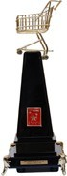**Bata India awarded the prestigious Images award 2009** Bata India, the leading footwear retailer in the country was awarded the Images award for the Most Admired Retailer of the Year – Fashion & Lifestyle. This was announced at the India Retail Forum in Mumbai, where the top retail companies in India converged.

**Expanding & nurturing the largest footwear retail network**

A retail network of over 1200 stores gives us a reach unmatched by any other company. The Bata Shoe Store is amongst the most recognisable and favoured landmark in any major market in India.

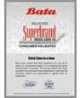**Bata India continues with its Superbrand status** The Bata brand was chosen after a very in-depth and detailed evaluation procedure. Marketing and Business

professionals who compromise the Superbrands Council evaluate and select on parameters like trust, emotional loyalty and re-call of the brand which creates strong customer loyalty.



**Awards - 2008**

**Bata India awarded Amity Corporate Excellence Award**

Bata India Ltd. has been awarded the Amity Corporate Excellence Award for Best Retail Chain. This is

the third time in a row that Bata India has been honoured with this prestigious award for Corporate

Excellence. The Corporate Excellence Awards are held annually by Amity International Business.

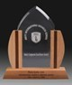

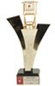

**Awards - 2007**

**Amity Corporate Excellence**

Bata India has been awarded the AMITY CORPORATE EXCELLENCE AWARD on **21st February 2008**. This award has been given for Bata's excellent performance and retail growth during the past year.

**IMAGES Retail Award**

This award was received in the footwear category on on **6th September 2007**. This award was a part of Reid & Taylor Awards for Retail Excellence presented during India Retail Summit 2006.

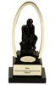**Super Brands Award**

It is awarded to the 1st top ten Super brands of India. Super brand signifies the recognition that the consumer is giving to the Brand Image, Brand Value and Brand Delivery. The award ceremony was held in Mumbai on **12th April 2007**

**FMCG Consumer Reaction Award**

Bata won FMCG Consumer Reaction Award in Fashion & Specialties (Shoes) on **March 2007**. The Award was presented by: Bharati Vidyapeeth's Institute of Management Studies & Research (BVIMSR).



**Awards - 2006**

**Lycra Images Fashion Awards**

Bata is honoured for 3 consecutive years as Most Admired Brand of the year in Footwear Category on **25th January 2007**.

**Retailer of the Year Award**

This award was received on **24th Nov 2006** in the footwear category. This award was a part of Reid & Taylor Awards for Retail Excellence presented during India Retail Summit 2006.

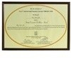**Amity Corporate Excellence Award**

This award was given to Bata by Amity International Business School on **22nd – 24th Feb 2006** for having achieved an enviable position of one of the best and most admired company of the world with their unparalleled performance.

**Awards - 2005**

**Super Brands Awards**

It is awarded to the 1st top ten Super brands of India on **23rd Sept 2005**. Super brand signifies the recognition that the consumer is giving to the Brand Image, Brand Value and Brand Delivery

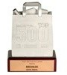**Retail Asia Pacific Top 500 Awards**

Bata won the Top Retailer 2006-India Bronze award on **7th Sept 2005**. This award is given by Retail Asia Pacific TOP 500

# VISION AND MISSION

### VISION:-

Vision is that igniting spark that can inspire and energise people to do better.the focus of vision is to reach out hungrily for the future and drag it into the present.

Bata India today wishes to reposition itself as a market driven,fashion concious lifestyle.Focus on a variety of customer groups.

### MISSION:-

A mission statement articulates the philosphy of the company with

respect to the business in specific and society in general.once the mission statement of company is finalised and adapted,it provides a readymade guideline to employees of the organisation about its principles,policies and practices.

Bata will provide its products and services to all the age groups in the community.will also provide the finest quality through customer involvement.

# BOARD OF DIRECTORS

### Bata India Ltd.:-

|  |  |  |
| --- | --- | --- |
| **S.No** | **Name** | **Designation** |
| 1 | Ashwani Windlass | Chairman / Chair Person |
| 2 | Mr.J Carbajal | Director |
| 3 | Mr.N Sankar | Director |
| 4 | Mr.Uday Khanna | Director |
| 5 | Mr.S Sinha | Director |
| 6 | Mr.Jack G N Clemons | Director |
| 7 | Mr.George Nigel John Clemons | Director |

# PRODUCTS AND SERVICE OFFERED

##### Wide product assortment

Bata Collections target a wide range of customers and offer an excellent price-quality ratio.

Bata’s exclusive models along with national and international brands are carefully selected and updated in response to market demand.

##### Personalised service

Qualified and enthusiastic sales associates who take customers’ satisfaction to heart.

In many countries customer service goes beyond the stores with home deliveries, orders made possible via catalogues, the web or even call centres.

##### Clear product merchandising

Easy-to-shop store layout with clear product display by category and by style.

##### Guaranteed customer satisfaction

In any Bata store in the world we repair, exchange or refund any products with defects.

We exchange or refund on unworn merchandise if you change your mind

**CONCEPT OF METHODOLOGY**

**MEANING OF RESEARCH :-**

Research is discovery of facts, developments of facts and verification of facts. Research is an Endeavour to discover intellectual and practical solutions to the problems through the applications of scientific methods to the knowledgeable universe; research is the process which involves defining and redefining problems, hypotheses and conclusion after careful testing. Research is the last report when individuals, organizations and societies create some problems for which there are no answers, or when there is inconsistency among answers. It is systematic way of knowing more about the world. Research can be done in arbitrary or in a systematic manner.

##### DEFINITIONS:-

“Research is a careful investigation or inquiry specially through search for new facts in any branch of knowledge” –BY OXFORD DICTIONARY.

“A systematized efforts to gain new knowledge”. –BY REDMAN &MORY

### MEANING OF RESEARCH METHODOLOGY:-

Research methodology is a way to systematically solve the research problem. It may be understood as a science of how research is done systematically. In simple word; all those methods that are used by the researcher during the course of studying the research problem are termed research methodology.

### PRIMARY DATA

Sources plan for primary data, Research technique: Survey

Contact method: Personal visit to the concerned organization and individual in addition to telephonic interviews.

Research instrument: Questionnaire.

The primary data are those which are collected a fresh and for the first time and thus happen to be original in character. The primary data was collected through experiments or survey conducted in Pune.

**TOOLS AND TECHNIQUES OF COLLECTING SECONDARY DATA**

The research instruments in this study were the questionnaire method.

The questionnaire was used to avail the vital information needed. The questionnaire was open as well as closed ended with multiple choice and ranking questions. The term questionnaire refers to a self-administered process, where by the respondents read the questions and records his answers with out the assistance of an interviewer.

Questionnaire constructing consists of 5 steps.

1. Specifying the information needed.
2. Determining the type of questionnaire to be asked.
3. Deciding the number and sequence of questionnaire.
4. Preparing the preliminary draft of questionnaire.
5. Revising and resetting the questionnaire.

Collection of data through questionnaire was considered suitable to extract information and draw the results since footwear is a product which is used by every one, there fore no other method apart from questionnaire is suitable, it was designed after carefully consideration of the various attributes and was pre tested to modify the questions and avoid the errors.

#### INTRODUCTION AND DEFINITION OF THE TOPIC

**MARKET POTENTIAL:-**

The intensity of possible contacts with markets. If a plant could be located in a number of locations, it is useful to be able to estimate the probable volume of sales which could be at each possible site. This is the market potential.

The maximum number of consumers available will usually be determined by market research, but it may sometimes be calculated from demographic data or government statistics. Ultimately there will, of course, be limitations on the number of consumers. For guidance one can look to the numbers using similar products. Alternatively, one can look to what has happened in other countriesThe maximum potential individual usage, or at least the maximum attainable average usage (there will always be a spread of usage across a range of customers), will usually be determined from market research figures. It is important, however, to consider what lies behind such usage.

**CONSUMER PERCEPTION:-**

Perception means adding meaning to the sensation by the help of past experience. And it is a cognitive process. services are having the distinct charactristics of intangibility, hetrogeneity, and most important the consumption and production happening at same time.

The perception of customer for the price of services is different from that of products. a person getting the sercice asseses the other persons abilities, competencies etc. in a very short period so the relate the efficiency of the person with the price to be paid to avail that service.

#### SAMPLE SIZE AND SAMPLE TECHNIQUES

100 consumers from different area of Pune were surveyed .

100 was the sample size and approximately 10-20 respondents from each area were interviewed.

Collection of data through questionnaire was considered suitable to extract information and draw the results since footwear is a product which is used by every one, there fore no other method/Technique apart from questionnaire is suitable, it was designed after carefully consideration of the various attributes and was pre tested to modify the questions and avoid the errors.

### DATA ANALYSIS

##### CLASSIFICATIONS & TABULATION OF DATA:-

The preparation, tabulation and analysis of raw data consist of following steps: -

1. Preparing of raw data including editing and coding.
2. Tabulating the data.
3. Determining whether significant difference exists between categories with the help of simple statistical tools like Average, percentage, and co-relation.
4. Making Recommendations.

**Tabulating the data**: After the raw data have been fully prepared the tabulation work can begin.

Researcher should first prepare a plan specifying which items of data are to be tabulated and whether each item is to be tabulated separately or in combination with other items.

##### STATISTICAL ANALYSIS & INTERPRATION OF DATA:-

In order to extract meaningful information collected data analysis is carried out. The data is first classified as- coded, edited; and tabulated for the purpose of analyzing the same. Simple statistical tools – percentage, Average, and measures of dispersion-, have conducted the analysis alternatively; the collected data has been analyzed by using diagrams, graphs and charts.

Data analysis is the process of placing data in ordered form, combing them with existing information’s and extracting meaning from them.

Interpretation is the process of drawing; conclusions from the gathered data in a study.

**ANALYSIS AND TABULATION PART**

### Table 1.

Percentage of people using branded Footwear.

|  |  |  |
| --- | --- | --- |
| Foot Wear | No. of respondents | (%) Percentage |
| Branded | 65 | 65% |
| Unbranded | 25 | 25% |
| Both | 10 | 10% |
| Total | 100 | 100% |

Source: From Survey Data

**Analysis:** Out of 100 Respondents, 65% people are wearing branded footwear, 25% people are wearing unbranded

footwear and 10% people are wearing both the type of Branded and Unbranded Footwear.

### GRAPH NO.1

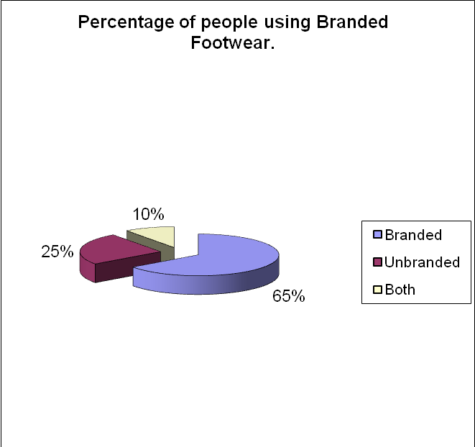

**Table No.2:**

Preference of Shoe type among the customers.

|  |  |  |
| --- | --- | --- |
| Shoe Type | No. of Respondents | (%) Percentage |
| Formal Leather shoes | 55 | 55% |
| Sports Shoes | 35 | 35% |
| Both | 10 | 10% |
| Total | 100 | 100% |

Source: From Survey Data

Analysis: Out of 100 Respondents, 55% people are wearing Formal heat wear shoes, 35% people are wearing sport shoes and 10% people are wearing both the type of Formal heat wear shoes and Sports shoes.

### GRAPH NO.2

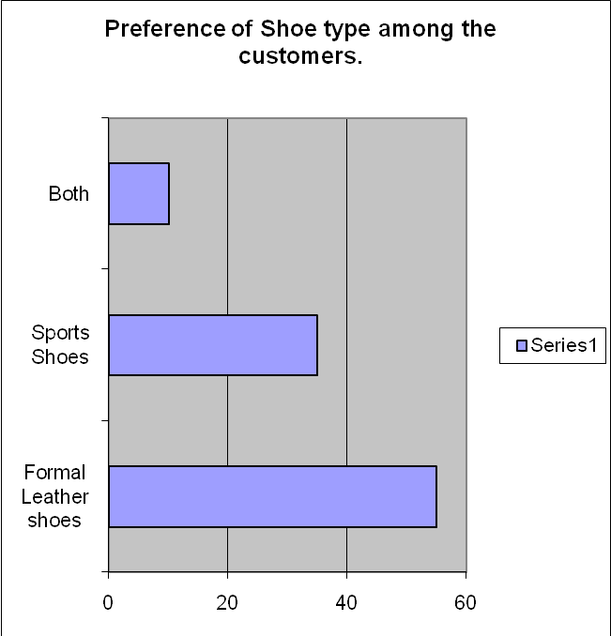

**Table No. 3**

##### Brand Awareness of Formal Footwear shoes:

|  |  |  |
| --- | --- | --- |
| Brand Names | No. of Respondents | (%) Percentage |
| Bata | 45 | 45% |
| Liberty | 25 | 25% |
| Mescos | 5 | 5% |
| Woodland | 10 | 10% |
| Others | 15 | 15% |
| Total | 100 | 100% |

Source: From Survey Data

Analysis: The above table shows that 15% of the respondents are wearing Bata leather shoes, 25% respondents are wearing Liberty formal leather shoes, 5% respondents are wearing Mescos ash shoes, 10% respondents are wearing Woodland 15% are using or wearing other companies’ formal leather shoes.

**GRAPH NO.3**

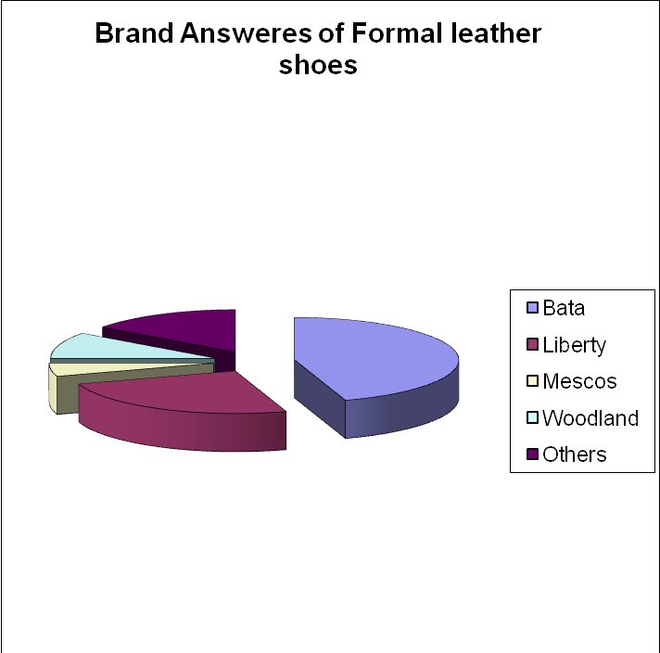

**Table 4.**

**Brand awareness of Sport shoes**

|  |  |  |
| --- | --- | --- |
| Brand Names | No. of respondents | (%) Percentage |
| Bata | 15 | 15% |
| Action | 10 | 10% |
| Woodland | 25 | 25% |
| Mescos | 5 | 5% |
| Reebok | 12 | 12% |
| Nike | 12 | 12% |
| Adidas | 16 | 16% |
| Other | 5 | 5% |
| Total | 100 | 100% |

**Source**: From Survey Data

**Analysis**: The above table shows that 15% of the respondents are wearing Bata Sport shoes, 10% respondents wearing Action sport shoes, 25% of respondents wearing Woodland sport shoes, 5% respondents are wearing Mescos sport shoes, 12% of respondents are wearing Reebok, 12% of respondents are wearing Nike Shoes, 16% of thee respondents are wearing Adidas sport shoes, 5% of respondents are wearing other

### GRAPH NO.4

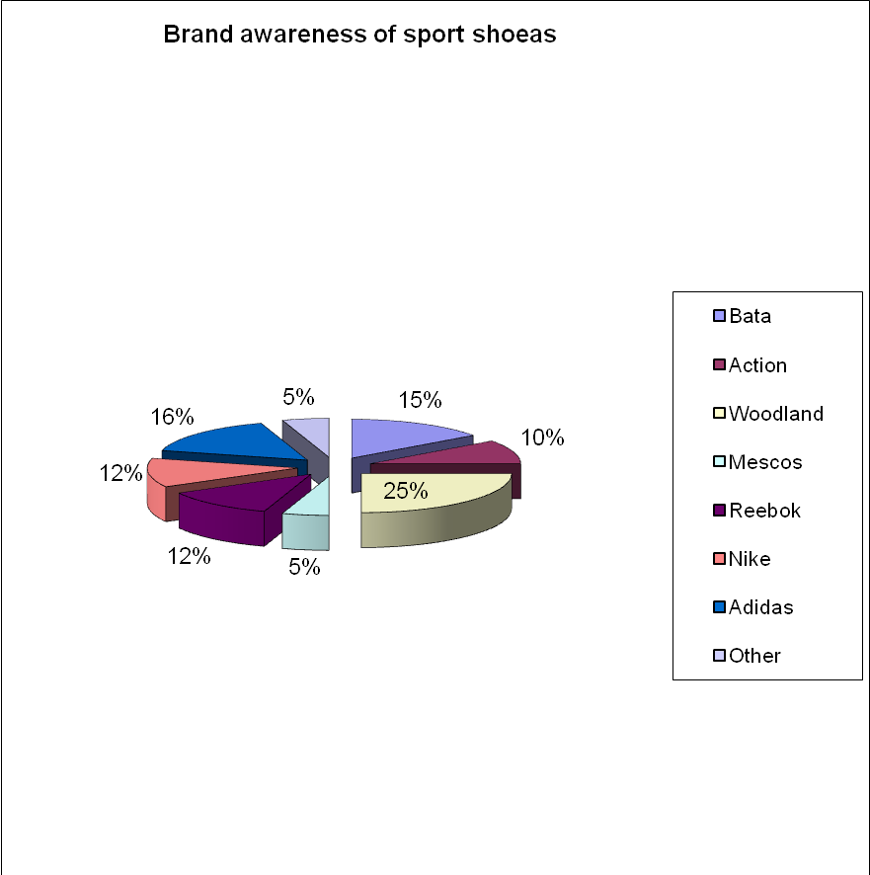

**Table 5**

##### Percentage of people are using Bata Kids shoes

|  |  |  |
| --- | --- | --- |
| Brand Names | No of Respondents | Percentage |
| Bata | 65 | 65% |
| Liberty | 15 | 15% |
| Mescos | 3 | 3% |
| Reebok | 10 | 10% |
| Others | 7 | 7% |
| Total | 100 | 100 |

**Source: Primary or Survey Data.**

**Analysis**: The above table shows that 65% of the respondents are using Bata. 15% of the respondents are using Liberty kid’s shoes, 10% of the respondents are using Reebok Kids shoes, 7% of the respondents are using other company’s kid’s shoes for their children.

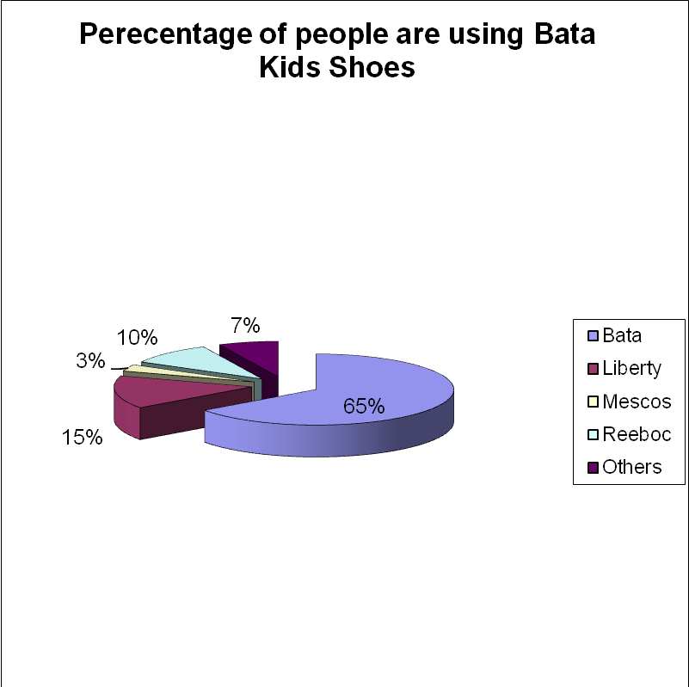

**Table No.6**

**Table showing the factors influencing to buy competitors Brand**

|  |  |  |
| --- | --- | --- |
| Factors | No. of respondents | (%) Percentage |
| Price | 45 | 45% |
| Quality | 20 | 20% |
| Style | 10 | 10% |
| Durability | 5 | 5% |
| Comfort | 20 | 20% |
| Total | 100 | 100% |

**Source: Primary or Survey Data**

.

**Analysis:** From the above table we can understand that respondents of 45% of them depends on price, 20% of respondents buy because quality is good, 10% of respondents buy because of style, 5% of the respondents buy because of durability, 20% of the respondents buy because of comfort ability.

### GRAPH NO.6

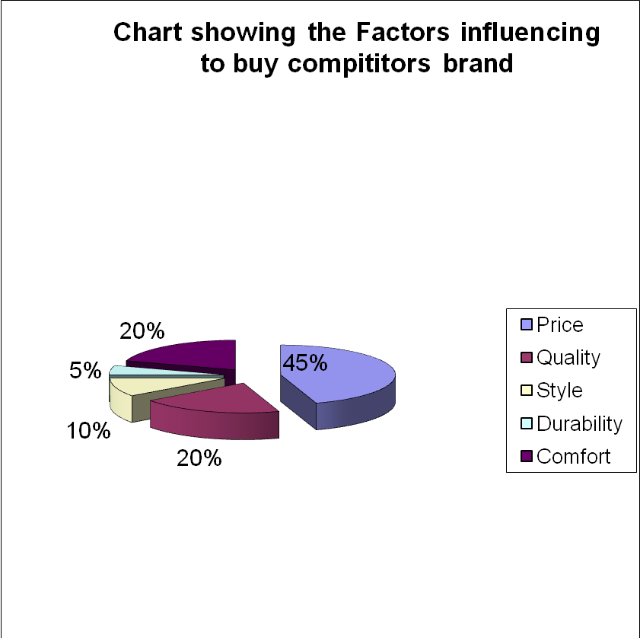

**Table NO.7**

##### Table showing who influence them to buy Footwear.

|  |  |  |
| --- | --- | --- |
| Factors | No. of Respondents | Percentage (%) |
| Friends | 25 | 25% |
| Relatives | 18 | 18% |
| Advertisement | 48 | 48% |
| Point of purchase  display | 0 | 0% |
| Past Experiences | 6 | 6% |
| Others | 3 | 3% |
| Total | 100 | 100% |

**Source: Primary or Survey Data**

**Analysis**: From the above table we can understand that 48% of the the respondents are buying because of advertisements influences to them, 25% of respondents are buy because of friends are influences them, 18% of the respondents are buy because of the relatives are influences them to purchase, 6% of the respondents are purchase because of the past experience and other 3% of the respondents are purchasing in their own mood.

### 

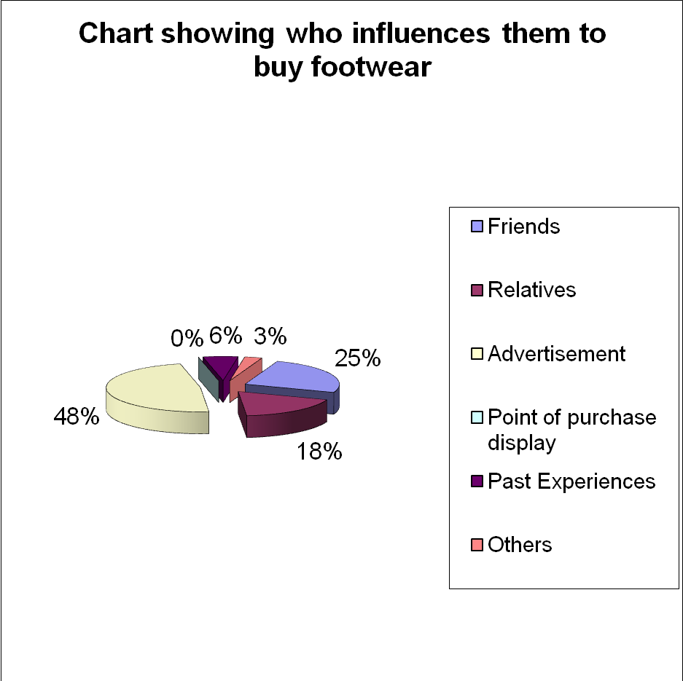

**Table 8.**

##### Table showing the income level of the customer.

|  |  |  |
| --- | --- | --- |
| Income Level | No. of Respondents | Percentage (%) |
| Below 5,000 | 5 | 5% |
| 6,000- 10,000 | 7 | 7% |
| 10,000-15,000 | 18 | 18% |
| 15,000- 20,000 | 15 | 15% |
| Above 20,000 | 55 | 55% |
| Total | 100 | 100% |

**Source: Primary or Survey Data**

**Analysis**: From the above table we can understand that the 55% of the respondents income level above 20,000 ,15% of the respondents income level between (15,000-20,000), 18% of the respondents income level between (10,000- 15,000), 7% of the respondents income level between (5,000-

10,000), 5% of the respondents income level below 5,000.

### GRAPH NO.8

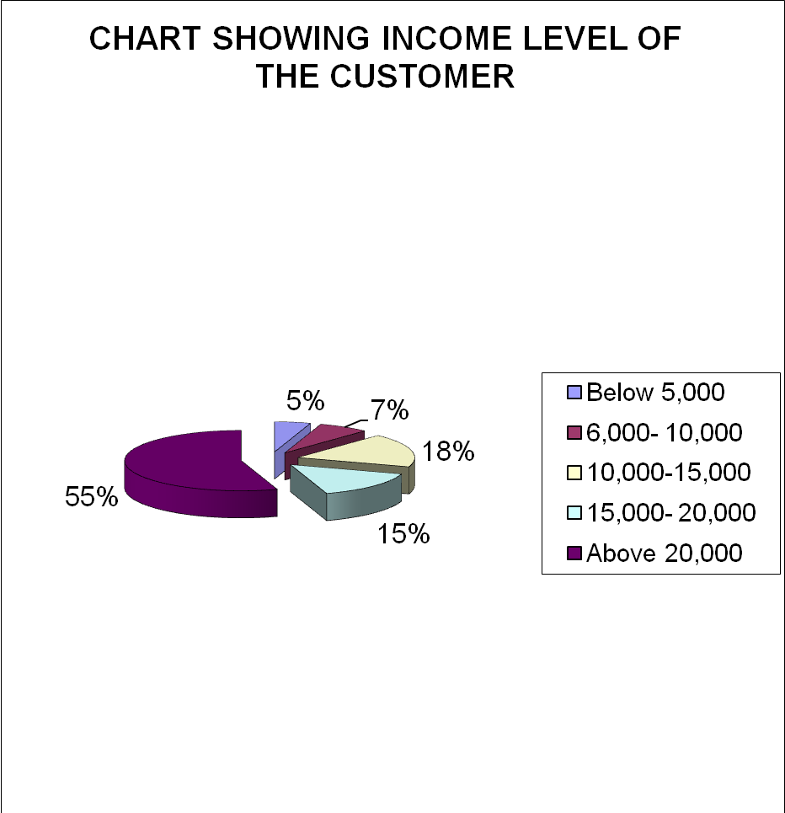

**SUGGESTIONS AND CONCLUSIONS**

**SUGGESTIONS:-**

1. **TO MAKE IT ATTRACTIVE**: Bata formal leather shoes, sports shoes, kids shoes can be made more attractive by displaying the available range and the uniqueness of the range, it should be so displayed that the consumer is tempted to buy it.
2. **TO IMPROVE DISTRIBUTION POLICY**: the distribution can be finding out which product is being demanded more and the rate of consumption of the product and hereby supplying the product in time to meet the demand.
3. **R&D ACTIVITIES**: R&D activities include-activities like making shoes comfortable, attractive and adding features, which the consumers and the customers of the present generation are used to like that is snuggery, ventilations, etc.
4. **SCHEMES**: the company can introduce schemes to improve sales. Schemes may include free gifts, discounts in winter seasons for the aged customers and discount in school seasons for school shoes and the same for casual shoes during the vacation period, and in the months of May and June as the festival seasons.
5. The company should concentrate towards the mode of its advertisement. While launching a new model it should give the preference to the advertising media, which is the best source of information. As a promotional activity company can also sponsor some kinds of sports events etc.
6. The company can also go for making an agreement with some government or private sectors or institutions for supplying its product on contract basis.
7. In order to promote brand name for the Bata has to now concentrate more on advertising in regional newspapers, magazines and TV network that reaches the ultimate customer.
8. Bata should take rate of its close competitors and their marketing strategies in comparison with their own and do the needful from time to time in order to have a market share.
9. Bata should conduct regular marketing surveys to understand the current taste and expectations of the customers.
10. More trendy and flashy design should be launched which would sweep the customers of all ages.
11. More provision should be made by Bata for its middle class customers by launching more products to cater to their needs and demands.

### CONCLUSIONS*:-*

On the basis of findings made through analysis, we can conclude the following factors-

The Percentage of people using branded footwear is very high in Pune city.65% of the people prefer both types of shoes that is formal leather shoe & sports shoes. The awareness of Bata brand in formal leather shoes category is better than other brands as like as Liberty, woodland, e.t.c.Bata is on 1ST Position, liberty and Reebok in 2nd & 3rd place.

In formal leather shoes category Bata is having highest market share. In sports shoes category Reebok, would be the preferred brand followed by Nike, or woodland or any other shoes. In this comparative study’s survey more than 80% Respondents are businessman. Some respondents are child, they are wearing different types of kid’s shoes, housewives are also using Batas leather sandals etc.

### ANNEXURE AND BIBLIOGRAPHY

**BIBLIOGRAPHY:-**

### Books Referred

**Philip Kotler, “Marketing management”, Hall of India, Mumbai, 2000.**

**S.S Sherlekar, “Principle of Marketing”, Sapna Publishers, Hyderabad, 1998.**

**C. R. Kothari, “Research Methodology”, Himalaya publisher, Delhi, 1999.**

- -

**Journals & Magazines** Business Today Business India Business World

**News Papers & Magazines** The Economic Times The Asian Age

The Hindu

### Website:

1. [**www.batapeenya.com**](http://www.batapeenya.com/)
2. [**www.bata.in**](http://www.bata.in/)