ASSIGNMENT 6.2

Sharath Chandra Tummanapally

2021-10-05

### Markdown Basics

## Favorite Foods

1. Mutton Biryani.
2. Pizza.
3. Chicken Wings.

## Images

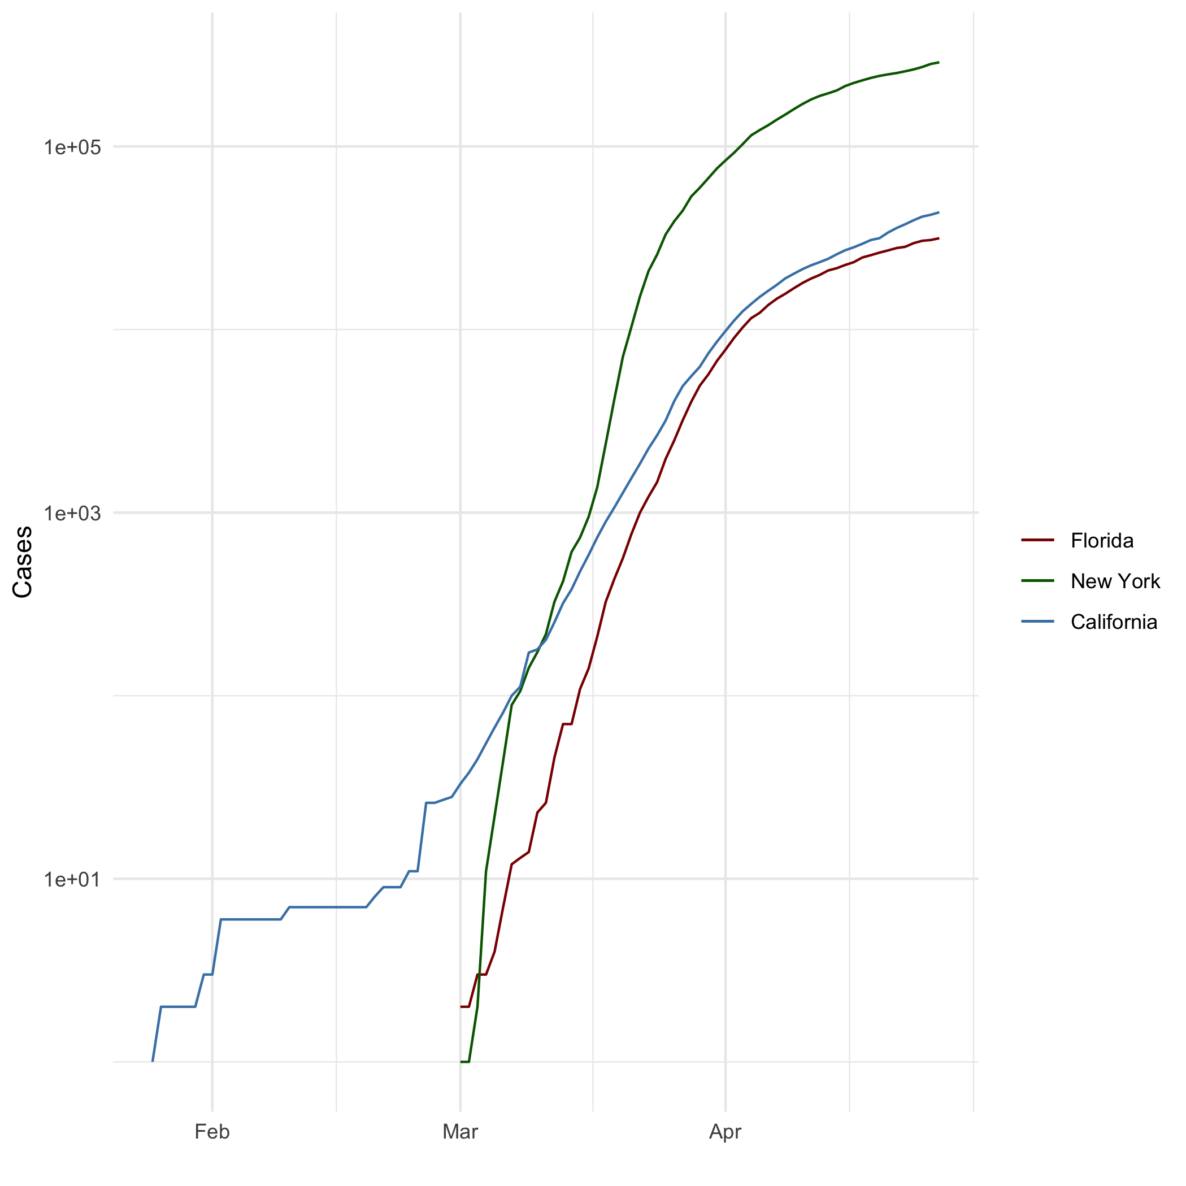

All Cases (Log Plot)

## Add a Quote

If you can’t do great things, do small things in great way.

## Add an Equation

$E=mc^{2}$

## Add a Footnote

[1]

## Add Citations

* R for Everyone
* Discovering Statistics Using R

# Inline Code

## NY Times COVID-19 Data

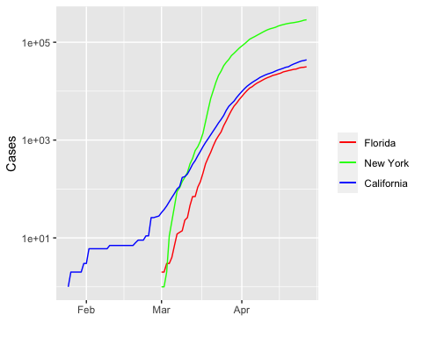

## R4DS Height vs Earnings

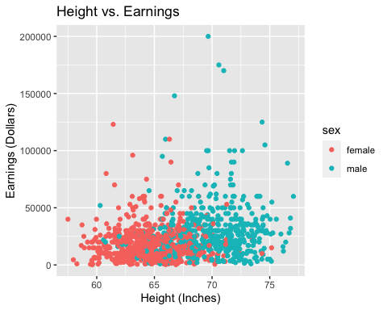

# Tables

## Knitr Table with Kable

One Ring to Rule Them All

|  |  |  |  |  |
| --- | --- | --- | --- | --- |
| name | race | in_fellowship | ring_bearer | age |
| Aragon | Men | TRUE | FALSE | 88 |
| Bilbo | Hobbit | FALSE | TRUE | 129 |
| Frodo | Hobbit | TRUE | TRUE | 51 |
| Galadriel | Elf | FALSE | FALSE | 7000 |
| Sam | Hobbit | TRUE | TRUE | 36 |
| Gandalf | Maia | TRUE | TRUE | 2019 |
| Legolas | Elf | TRUE | FALSE | 2931 |
| Sauron | Maia | FALSE | TRUE | 7052 |
| Gollum | Hobbit | FALSE | TRUE | 589 |

## Pandoc Table

##   
##   
## +-----------+--------+---------------+-------------+------+  
## | name | race | in_fellowship | ring_bearer | age |  
## +===========+========+===============+=============+======+  
## | Aragon | Men | TRUE | FALSE | 88 |  
## +-----------+--------+---------------+-------------+------+  
## | Bilbo | Hobbit | FALSE | TRUE | 129 |  
## +-----------+--------+---------------+-------------+------+  
## | Frodo | Hobbit | TRUE | TRUE | 51 |  
## +-----------+--------+---------------+-------------+------+  
## | Galadriel | Elf | FALSE | FALSE | 7000 |  
## +-----------+--------+---------------+-------------+------+  
## | Sam | Hobbit | TRUE | TRUE | 36 |  
## +-----------+--------+---------------+-------------+------+  
## | Gandalf | Maia | TRUE | TRUE | 2019 |  
## +-----------+--------+---------------+-------------+------+  
## | Legolas | Elf | TRUE | FALSE | 2931 |  
## +-----------+--------+---------------+-------------+------+  
## | Sauron | Maia | FALSE | TRUE | 7052 |  
## +-----------+--------+---------------+-------------+------+  
## | Gollum | Hobbit | FALSE | TRUE | 589 |  
## +-----------+--------+---------------+-------------+------+

1. This is a sample footnote