B U I L D G U I D E
Solaris
Studio
How a webcam augmented-reality guitar game is built in Unity, explained from zero.
Unity 6000.0.39f1 · URP 17 · Sentis 2.6 · MediaPipe · C#
October 2026

Contents
Start here 4
1 What we built 5
The whole thing on one page 6
2 Set up your own project 7
2.1 What to install 7
2.2 Create the project 7
2.3 Project settings that matter 7
2.4 Bring in the models 8
2.5 Make the scene 8
3 Project anatomy 10
3.1 What Unity shows you 10
3.2 The code folders 11
3.3 Assembly definitions 12
3.4 The registry: one list of every asset 12
4 How the game starts 14
4.1 What App builds 14
4.2 Watching it happen 14
4.3 The two Canvases 15
5 Screens 17
5.1 The screen lifecycle 17
5.2 AppScreen: the whole base class 18
5.3 The ScreenRouter 18
5.4 A complete tiny screen 18
6 Building the interface in code 20
6.1 UIKit: make things 20
6.2 Fonts and TextMeshPro 20
6.3 Theme: the one place for colours and fonts 21
6.4 Anim: movement that feels soft 21
6.5 The widgets 21
7 Making it beautiful: shaders and key art 22
7.1 Shaders in 60 seconds 22
7.2 Turning a mock-up into a living screen 23
7.3 RefSpace: put things where the design had them 24
7.4 Screens 1 and 2 in detail 24
7.5 Film grain 25
8 The AR brain: camera, vision, gestures 26
8.1 The camera: CameraFeed 26
8.2 Vision: from pixels to 21 points 26
8.3 Gestures: from points to meaning 29
9 Music and sound 32
9.1 Chords 32
9.2 Songs are text files 32
9.3 The audio engine 33
9.4 Scoring 34
10 The Stage: where AR happens 36
10.1 Layers, back to front 36
10.2 What is anchored to what 37
10.3 Mirroring and cover-fit 37
11 Recipes: "I want to add ..." 38
12 Build, test, automate 41
12.1 Build the game 41
12.2 The tests 41
12.3 Run any screen without a camera 41
12.4 Keys while playing 42
13 When something goes wrong 43
14 Why this is AR and not just computer vision 44

Start here
Solaris Studio is an augmented-reality guitar game for a Windows laptop. You hold up fingers to choose chords, your other hand shapes the sound, and the song plays around a live picture of you from the webcam. This guide explains how it is built in Unity, in plain words, so that you can understand it, change it, or build something like it yourself.
Almost nothing in the project is hand-placed in the Unity editor. The scene holds one empty object. Everything else (screens, buttons, text, hand tracking, the guitar sound) is created by code when the game starts. That makes the project small, easy to read, and easy to extend: to add something you add a file, not a pile of clicks.

How to read this guide
- New to Unity? Read chapters 1 to 5 in order. They show where the buttons are and how the pieces connect.
- Want to copy the idea? Chapters 6 to 10 explain each part: interface, art, hand tracking, sound, and the AR stage.
- Want to change something? Jump to chapter 11. Every recipe names the exact file and shows the code.

Eight words you will meet
Word | Meaning in one line
Scene | A saved level. Ours has just one: Main.unity.
GameObject | A thing in the scene. On its own it is an empty box with a position.
Component | A script or feature you attach to a GameObject, for example our App script.
Canvas | The surface that all 2D interface (text, images, buttons) is drawn on.
Asset | Any file in the Assets folder: picture, font, shader, sound, AI model.
Shader | A small program that runs on the graphics card and decides the colour of every pixel.
Package | An add-on library you install from Unity (for example the AI runtime Sentis).
Tensor | A block of numbers fed to, or returned from, an AI model.

Credits: test photographs are from Wikimedia Commons (CC BY-SA, see TestData/CREDITS.md); fonts are Figtree, Playfair Display, EB Garamond and Italiana (SIL OFL); the hand, face and person models are Google MediaPipe (Apache-2.0) converted for Unity.

1 What we built
You play a song by showing chord shapes with your left hand. Your right hand controls how it sounds. The camera image of you stays in the middle of the screen, and the interface floats around you. The game has seven screens.
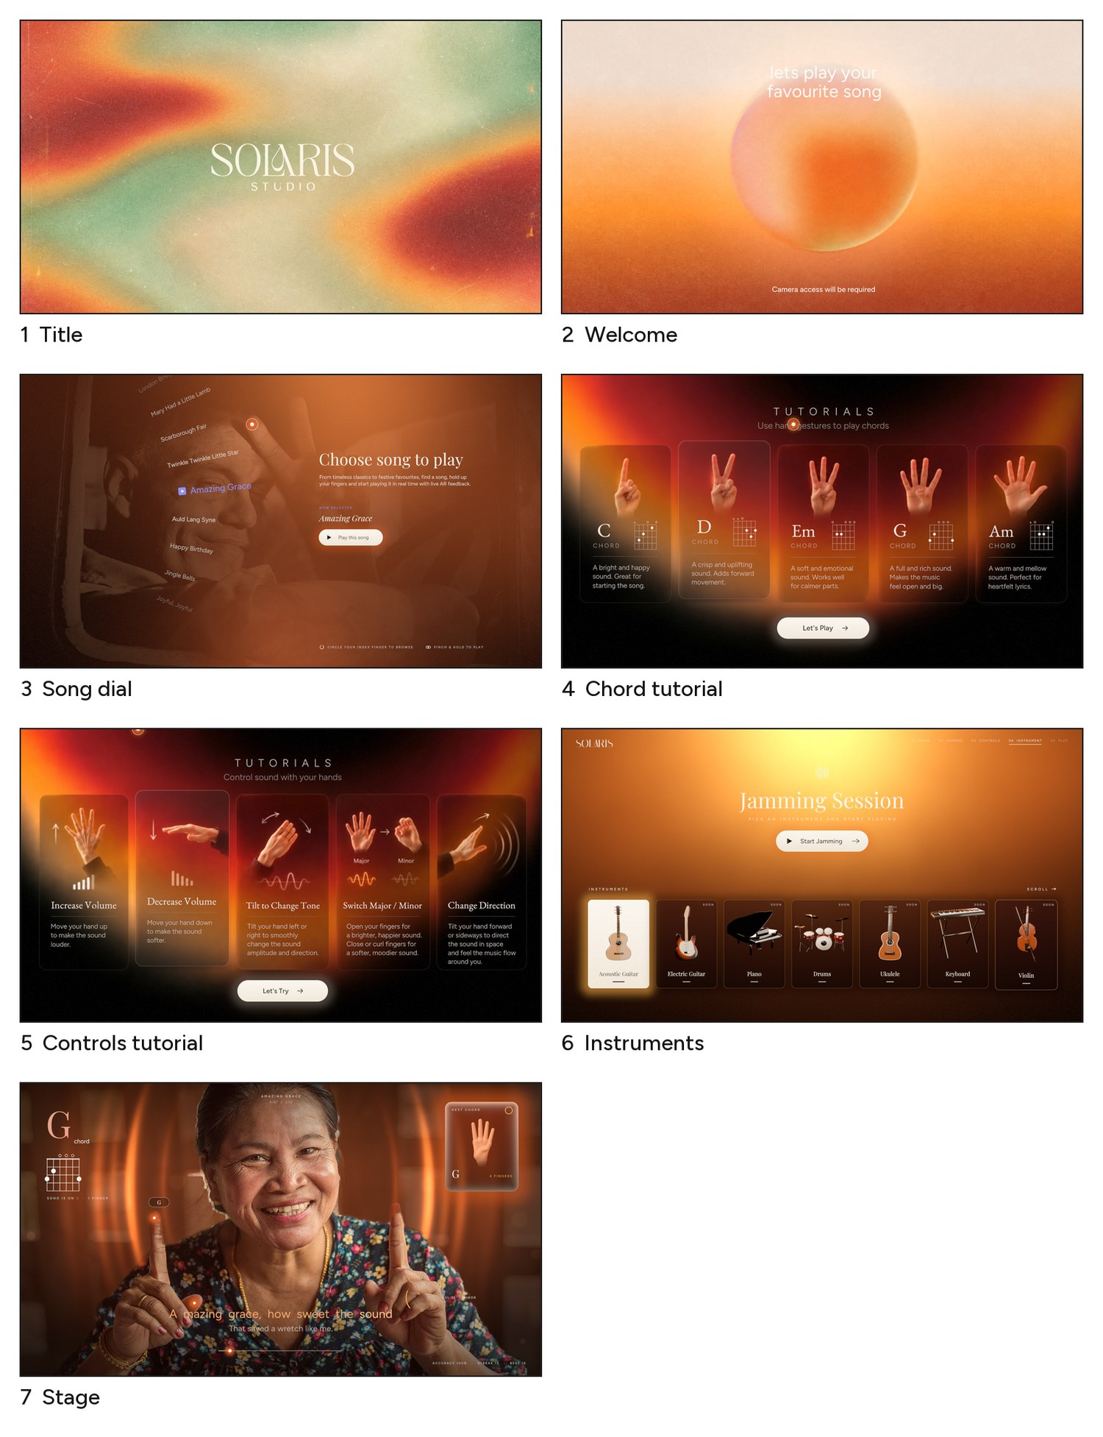
Figure 1. The seven screens, as rendered by the finished game.
Screen | What it does | How you control it
1 Title | The key art. Only its red glows breathe. | Any key or click
2 Welcome | A sun-like orb bounces slowly. Starts the camera. | Any key or click
3 Song dial | Song titles on a wheel over a faint camera view. | Draw circles with your index finger; pinch and hold to play
4 Chord tutorial | Five cards: 1 to 5 fingers make C, D, Em, G, Am. | Show fingers; the matching card lifts and strums
5 Controls tutorial | Five cards for volume, tone, major/minor, direction. | Move the second hand; the matching card lifts
6 Instruments | Pick an instrument (acoustic guitar works today). | Arrows, click or pinch
7 Stage | You, cut out from your room, with sound waves behind you. | Play chords; Esc pauses; results at the end

The whole thing on one page
Four stages, always in the same order. The webcam gives pictures; AI models find your hands; a small piece of maths turns hand shapes into musical choices; the audio engine and the screens react.
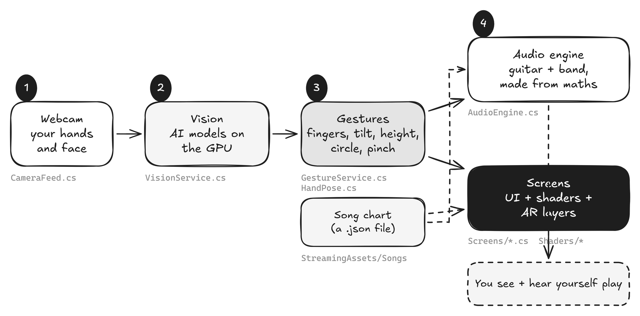
Figure 2. Data flows left to right, every frame. The song chart tells both the sound and the screens what is coming.
The five ideas that make the project simple
1. One scene, one object. The scene holds an empty object with a script called App. App builds everything else.
2. A screen is a class. Each of the seven screens is a small C# class with Build, Enter and Tick.
3. Vision, then gestures, then music. Each stage only talks to the next one, so you can change one without touching the others.
4. Art is layers plus shaders. Pictures are cut into layers, then put back together on the graphics card, which lets parts of them move.
5. Sound is maths. There are no audio files. Guitar strings and the band are calculated live.

2 Set up your own project
You can follow this chapter to recreate the project from nothing, or only use it to understand what the finished project already contains. The finished project does steps 3 to 7 for you with one menu click: Solaris > Setup Project.

2.1 What to install
Tool | Version used | Why
Unity Hub + Unity Editor | 6000.0.39f1 (Unity 6) | The engine. Install the Windows build support.
A code editor | Visual Studio or VS Code | To read and edit the C# files.
A webcam and a GPU | FHD camera; RTX 4060 laptop | The AI models run on the graphics card through compute shaders.
Python 3 (optional) | numpy, scipy, pillow | Only for the art tools in Tools/ that cut mock-ups into layers.
Blender (optional) | 5.1 | Only to re-render the instrument pictures.
ffmpeg (optional) | any recent | Only to turn captured frames into preview videos.

2.2 Create the project
- Open Unity Hub, press New project, choose the Universal 3D template (this is the URP render pipeline), name it, and press Create project.
- Open Window > Package Management > Package Manager. Press the + button at the top left and choose Install package by name. Install these, one at a time: com.unity.ai.inference (Sentis, the AI runtime) and com.unity.inputsystem (keyboard and mouse). TextMeshPro is already inside com.unity.ugui.
- Unity may ask to restart because of the Input System. Say Yes.
Package | Version | Job in the project
com.unity.ai.inference | 2.6.1 | Runs the MediaPipe models on the GPU (namespace Unity.InferenceEngine)
com.unity.render-pipelines.universal | 17.0.3 | URP, the render pipeline that every shader here targets
com.unity.inputsystem | 1.13.0 | Keyboard and mouse (the hands are our own input)
com.unity.ugui | 2.0.0 | The Canvas UI system and TextMeshPro
com.unity.mathematics, burst, collections | 1.3.2, 1.8.19, 2.5.1 | Maths helpers used by the AI package
com.unity.test-framework | 1.4.6 | The Test Runner window

2.3 Project settings that matter
Open Edit > Project Settings. These are the settings the game depends on; ProjectSetup.cs sets all of them from code.
Where | Setting | Value | Why
Player > Other Settings | Color Space | Linear | Correct light blending for the glows and the grain
Player > Other Settings | Graphics API | Direct3D11 only (untick Auto) | The AI compute shaders are tested there
Player > Other Settings | Scripting Backend | Mono | Fast to build; no extra tools needed
Player > Other Settings | Active Input Handling | Both | New Input System plus legacy for safety
Player > Resolution | Run In Background | On | Keeps tracking alive if the window loses focus
Player > Resolution | Fullscreen Mode | Fullscreen Window | Alt+Tab friendly
Graphics | Default Render Pipeline | SolarisURP asset | HDR off, MSAA off, shadows off: we draw our own look

2.4 Bring in the models
The AI models are ordinary files. Drag them into Assets/Solaris/Models and Unity imports .onnx files as ModelAssets that Sentis can run.
File | Source | Job
hand_detector.onnx | huggingface.co/unity/inference-engine-blaze-hand | Finds palms in a whole frame (192 x 192 input)
hand_landmarks_detector.onnx | same | Gives 21 points for one hand (224 x 224 input)
blaze_face_short_range.onnx | huggingface.co/unity/inference-engine-blaze-face | Finds the face centre (128 x 128)
selfie_segmenter_landscape.onnx | onnx-community/mediapipe_selfie_segmentation_landscape | Cuts you out of the background (256 x 144)
hand_anchors.csv, face_anchors.csv | generated once from the model definitions | Reference boxes the detector outputs are measured against

Tip
Run Solaris > Inspect Models to print every model’s inputs and outputs. If you swap in a different model, this tells you the new names and shapes.

2.5 Make the scene
- File > New Scene, choose an empty scene.
- GameObject > Create Empty, rename it Solaris, then Add Component and pick App.
- File > Save As Assets/Solaris/Scenes/Main.unity, then File > Build Profiles, press Add Open Scenes.
That is the whole scene. If you ran Solaris > Setup Project, it did this for you:
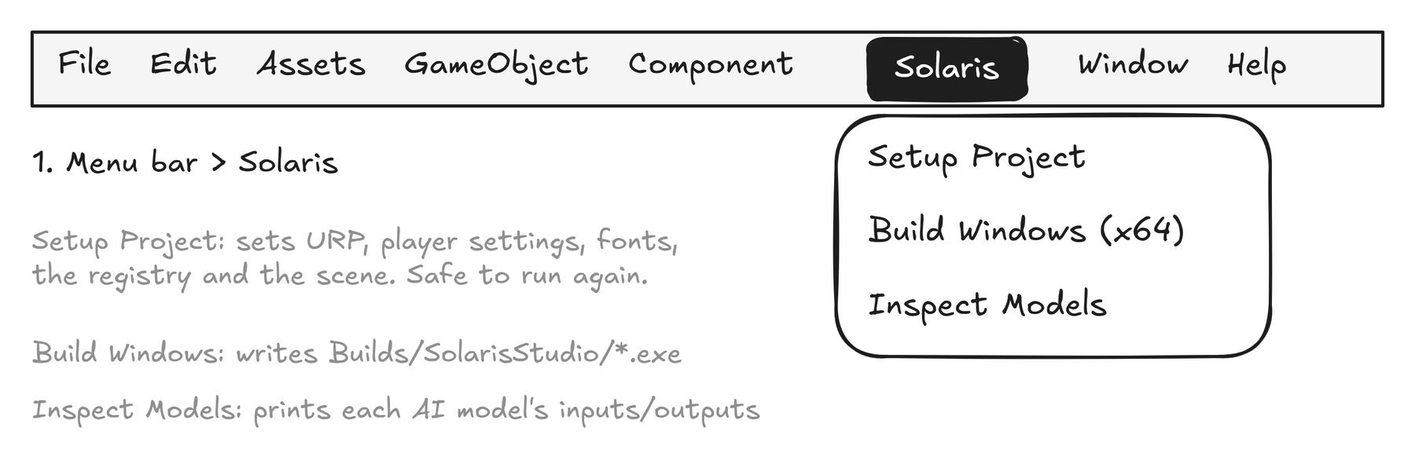
Figure 3. The menu that the Editor scripts add. Setup Project is safe to run any number of times.

3 Project anatomy
Everything we wrote lives in one folder, Assets/Solaris. Read this map once; the rest of the guide keeps referring to it.
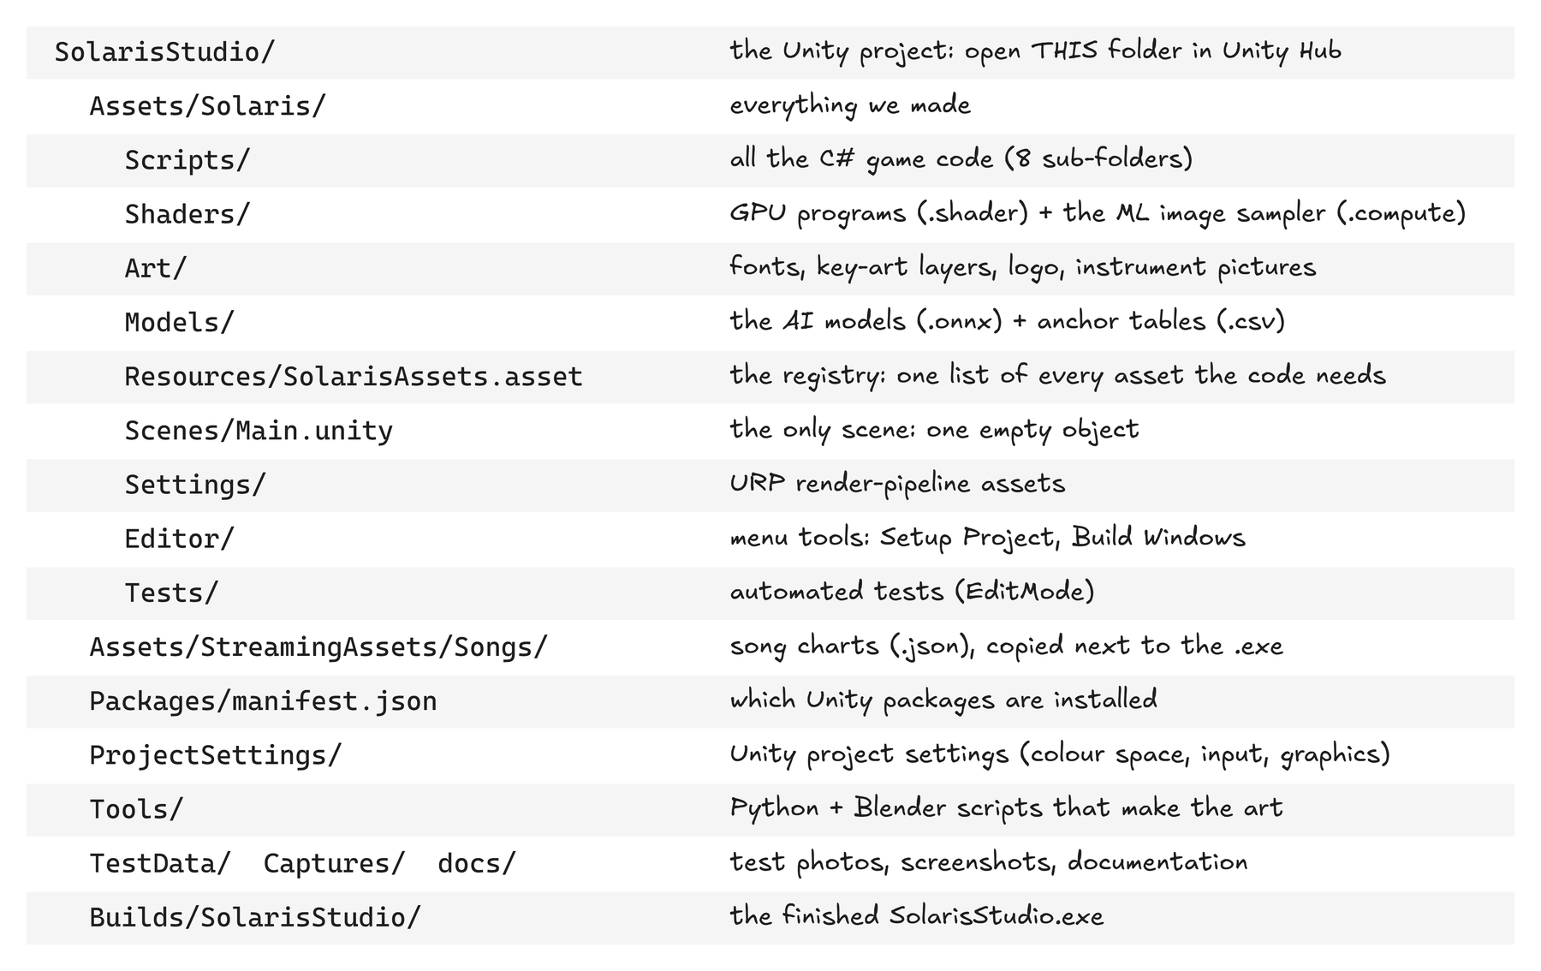
Figure 4. The project folders and what each is for.

3.1 What Unity shows you
This is the Unity window with the project open. Notice how little is in the Hierarchy: one object. All the content is in the Project window at the bottom.
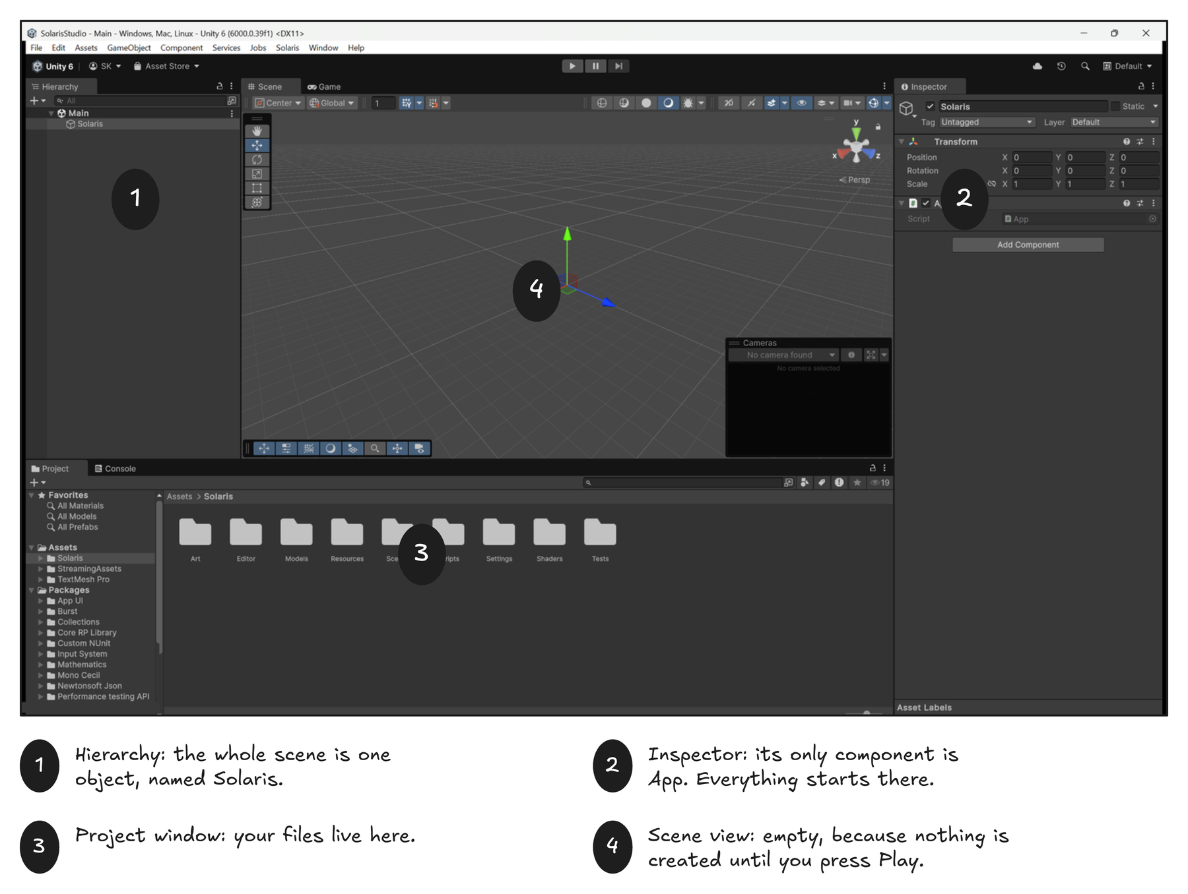
Figure 5. The Unity editor with the project open. 1 Hierarchy. 2 Inspector. 3 Project window. 4 Scene view.
Window | What to look at
1 Hierarchy | The list of GameObjects in the open scene. Ours: Solaris.
2 Inspector | The components on the selected object. Solaris has a Transform and our App script.
3 Project | Your files. Click a folder in the tree to see its contents.
4 Scene / Game | Scene is the editor camera; Game is what the player sees. Our scene view is empty because nothing exists until Play.

3.2 The code folders
Folder (Scripts/...) | Main files | Job
Core | App, ScreenRouter, AppScreen, SolarisAssets, Anim, Theme, AppArgs | Start-up, screen switching, the asset registry, tweens, colours, command-line switches
Vision | CameraFeed, VisionService, HandTrack, VisionMath | Webcam to AI models to 21 hand points
Gestures | GestureService, HandPose | Hand points to finger counts, volume, tone, circles, pinch
Music | Chords, Song | Chord shapes, the song file format, the song library
Audio | AudioEngine, Dsp, Band | Everything you hear, calculated on the audio thread
UI | UIKit, RefSpace, TutorialBoard, ShapeGraphic, LineGraphic, Widgets, GlassCard | Building interface from code
Screens | TitleScreen ... StageScreen (7 files) | One class per screen
Rendering | GrainOverlay, ProceduralLayer | Film grain and animated backgrounds
Diagnostics | DebugHud, VisionSelfTest | The F1 overlay and the photo self-test

3.3 Assembly definitions
Three small files ending in .asmdef split the code into groups that Unity compiles separately: Solaris.Runtime (the game), Solaris.Editor (menu tools, editor only) and Solaris.Tests (tests, editor only). Splitting keeps compile times short and stops editor-only code from sneaking into the built game. To make one: Assets > Create > Scripting > Assembly Definition.

3.4 The registry: one list of every asset
In a normal Unity scene you drag fonts and shaders into slots. We create the interface from code, so there are no slots. Instead, one asset called SolarisAssets lists every font, texture, shader and model. Code asks it for things: SolarisAssets.Get.sans.
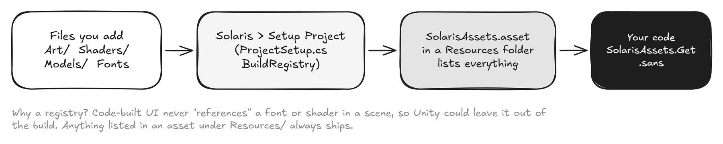
Figure 6. You add a file, run Setup Project, and the registry learns about it.
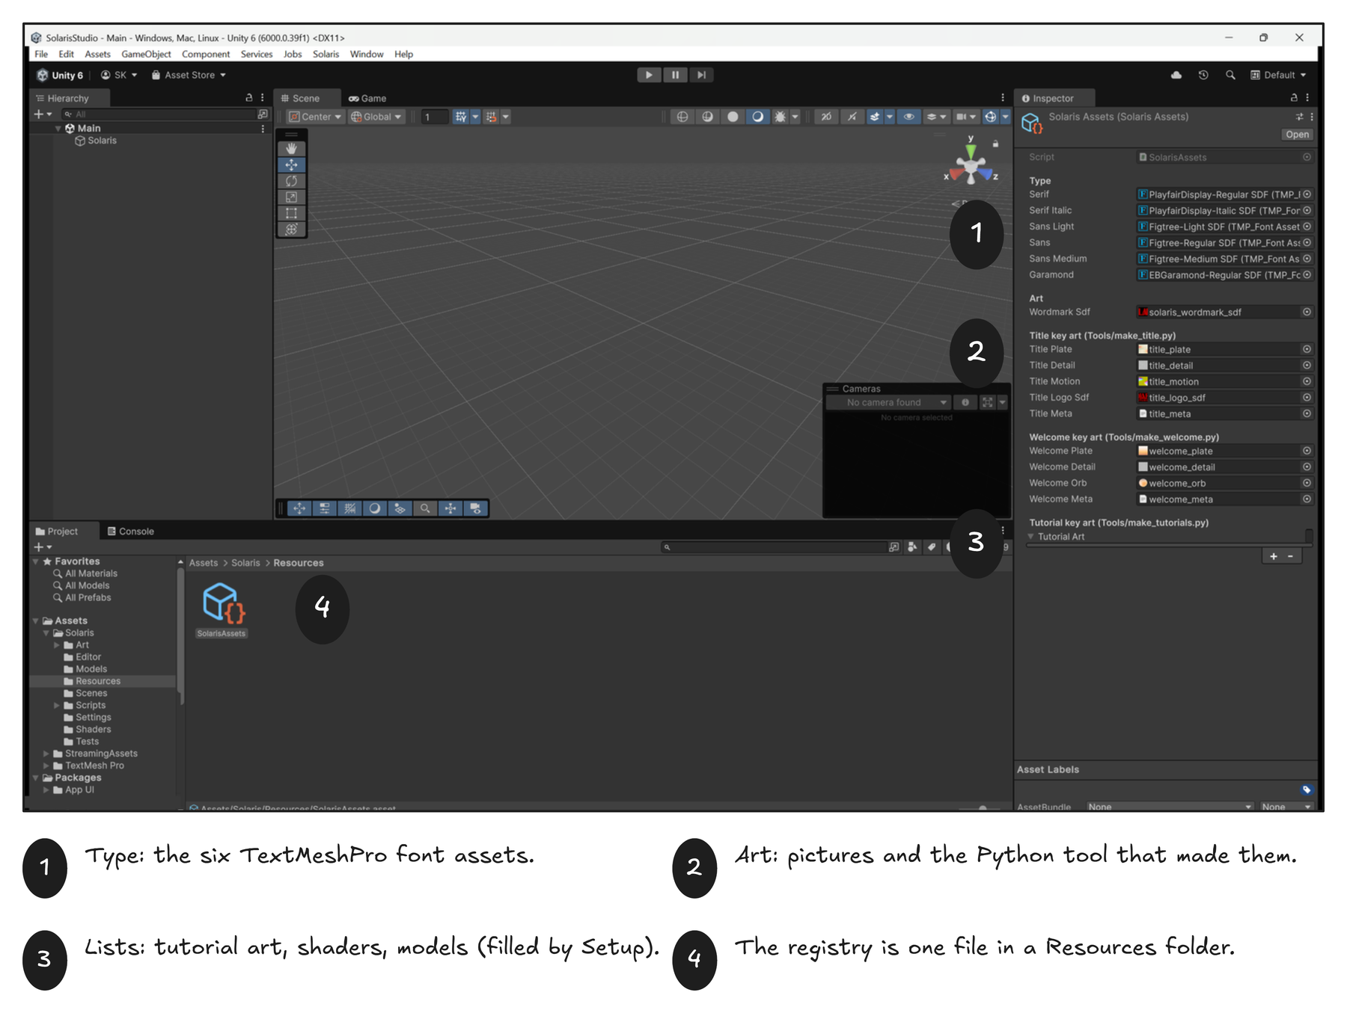
Figure 7. The registry asset selected in the Project window. Its fields are the slots your code reads.
Pictures that are used as data (grain, colour plates, masks) need special import settings so Unity does not change their numbers. Select the file and look at the Inspector:
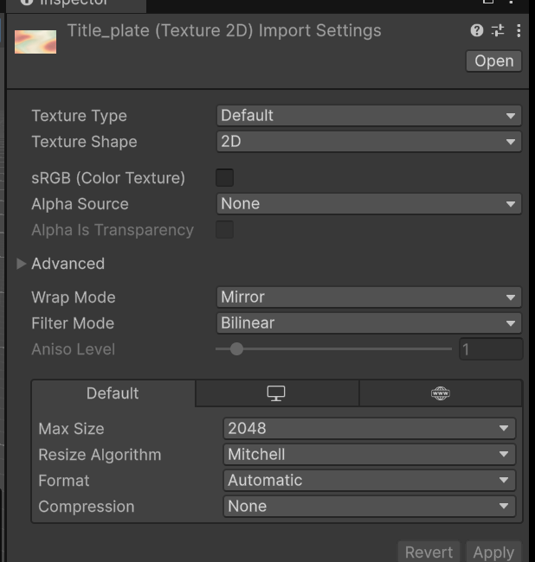
Figure 8. title_plate.png: sRGB off, Wrap Mode Mirror, Compression None. ProjectSetup.ConfigureData sets this for you.

4 How the game starts
When you press Play, Unity creates the one GameObject from the scene and wakes its App script. App.Awake does the rest.
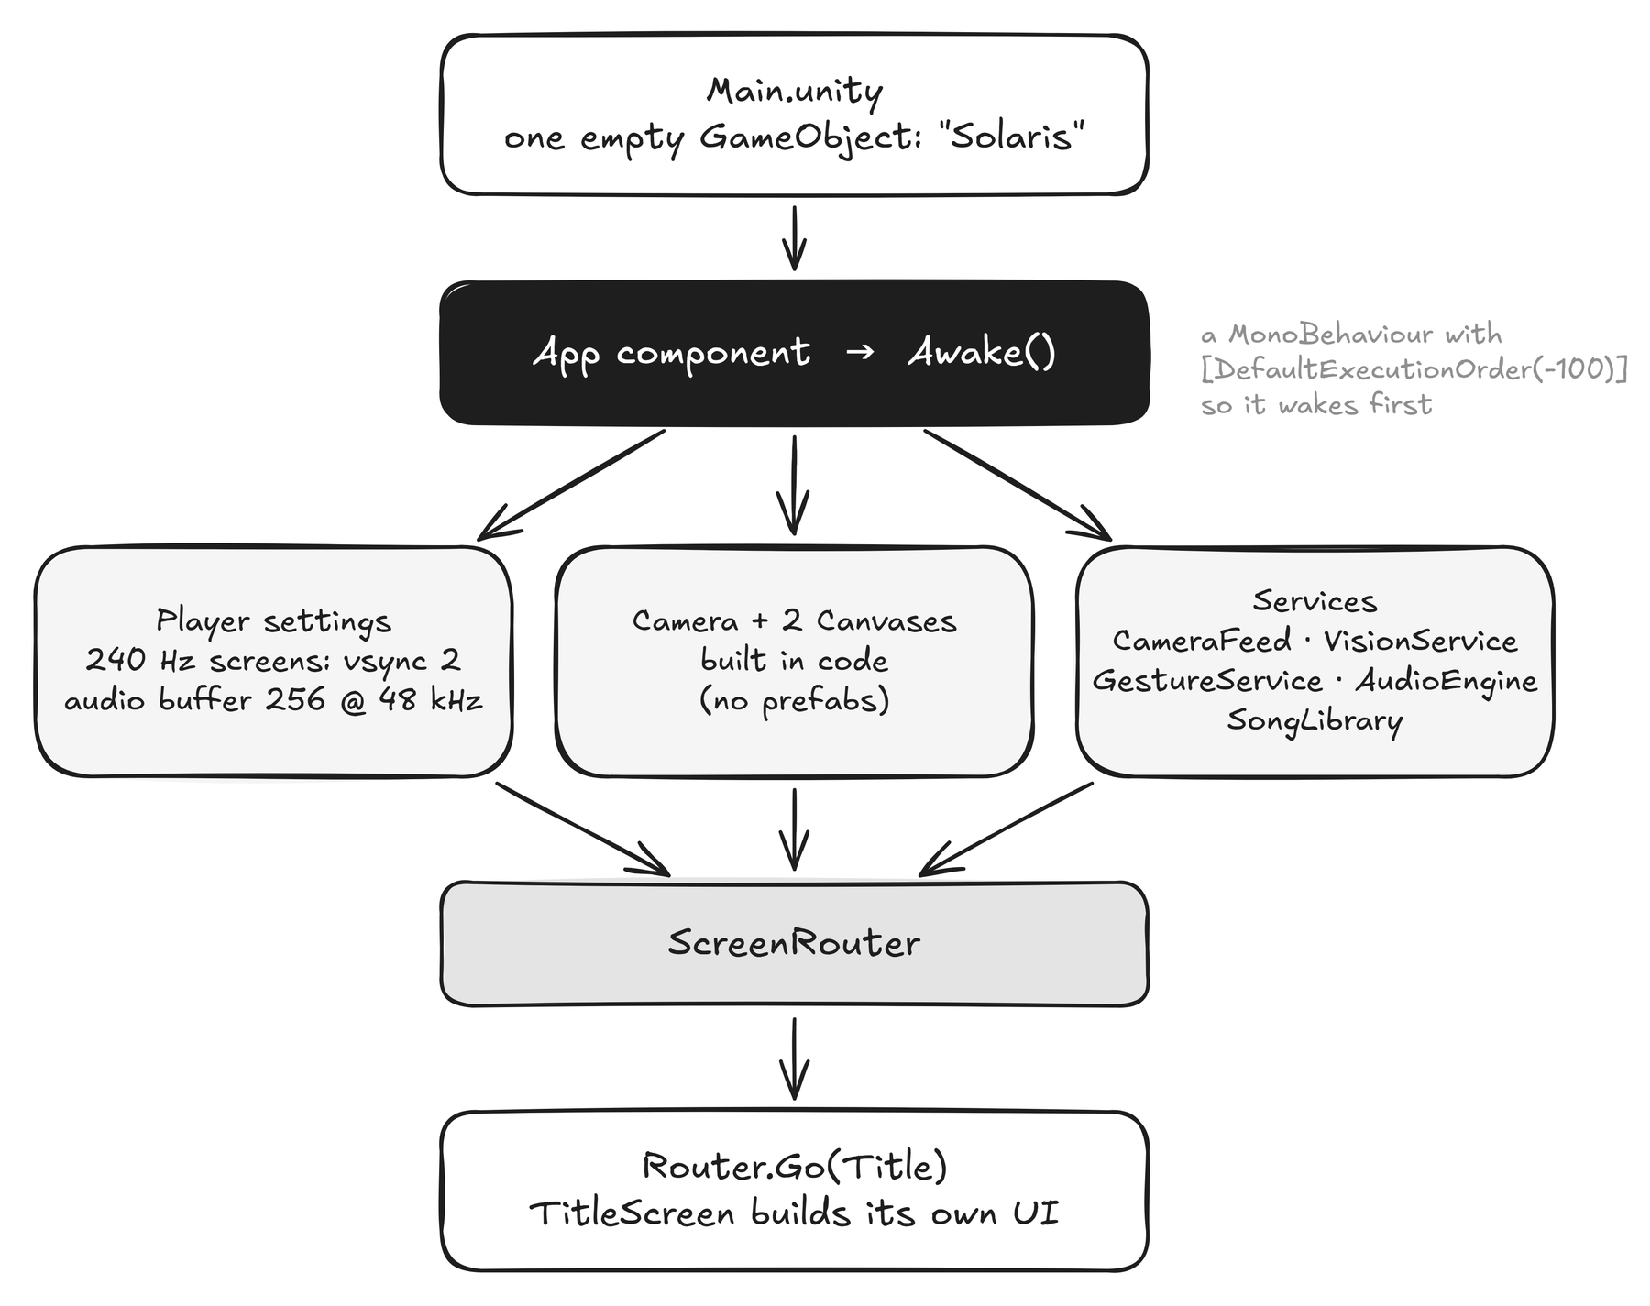
Figure 9. The start-up sequence, top to bottom.

4.1 What App builds
Step in Awake() | What it does
ConfigurePlayer() | Sets vsync (every 2nd refresh on 240 Hz screens), no screen sleep, audio at 48 kHz with a 256-sample buffer (about 5 ms).
BuildRenderingAndUI() | Makes a Camera and two Canvases in code (next section) and an EventSystem for mouse clicks.
SongLibrary.Load() | Reads every .json file in StreamingAssets/Songs.
Services | Adds CameraFeed, VisionService, GestureService and AudioEngine as components on a child object called Services.
ScreenRouter | Created last. Start() then calls Router.Go(Title).

The App class also owns the long-lived state in one place, so every screen reaches everything through it: App.Gestures, App.Audio, App.Songs, App.Session (the song you picked).

4.2 Watching it happen
Press Play and watch the Hierarchy. The scene object grows a tree that did not exist before: a Camera, a Canvas that holds the current screen, an Overlay canvas, the Services, and under the Canvas the screen itself, with every card, text and button as a child.
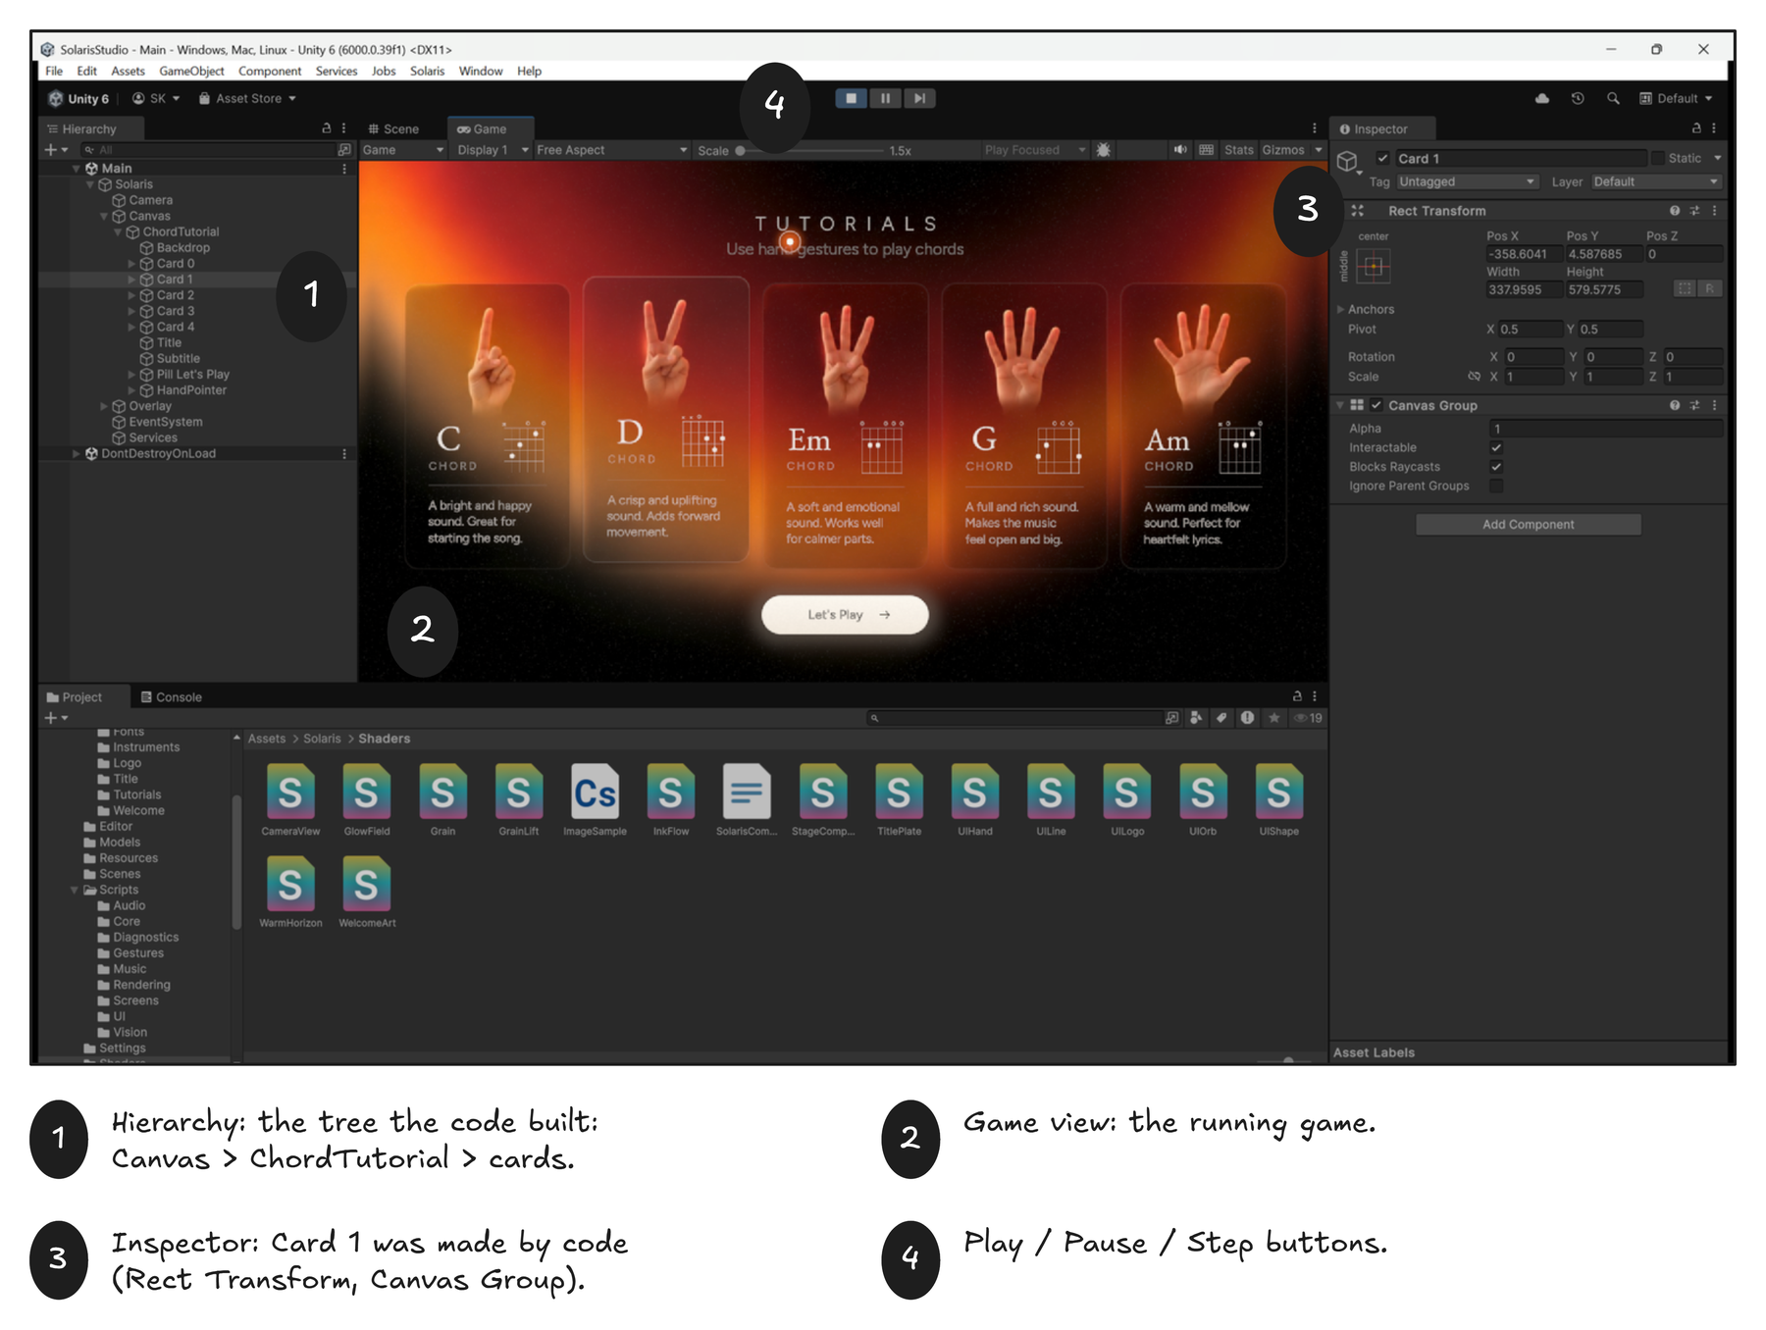
Figure 10. Play mode. 1 The Hierarchy now shows what the code built. 2 The Game view. 3 The Inspector shows a card created by code. 4 The Console line at the bottom.
Why build the interface in code?
A fully coded interface can be copied, versioned and diffed like any other file. Layout rules (like "centre this at 62% of the screen height") live in one place, and repeating things (five cards that differ only in text) is a loop, not five copy-pasted prefabs. The price: you cannot drag things around. This project accepts that trade for exact control.

4.3 The two Canvases
A Canvas is the surface that interface elements are drawn on. App makes two.
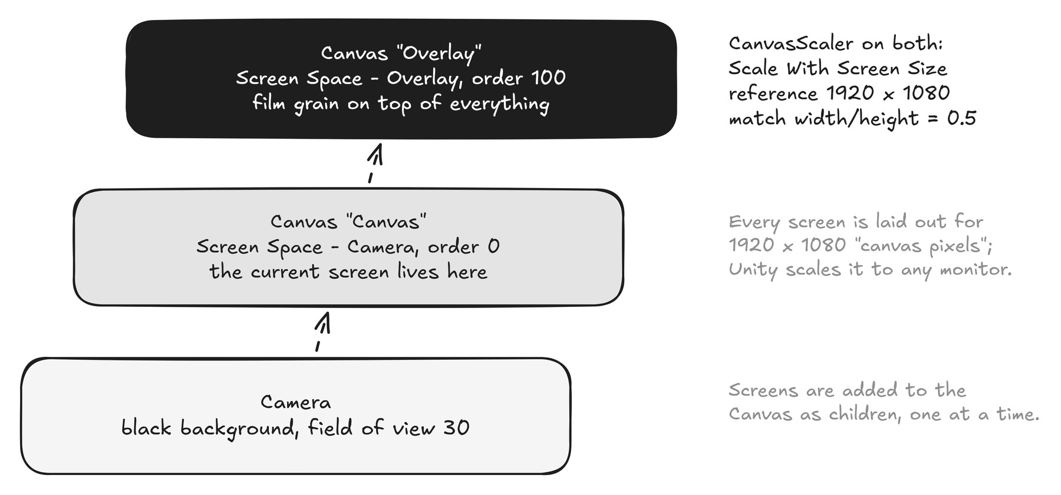
Figure 11. Two canvases over one camera.
CanvasScaler is the component that makes the same layout fit every monitor. We set it to Scale With Screen Size, reference resolution 1920 x 1080, match 0.5. So when you write "put this 300 units from the left", it means 300 pixels on a 1920-wide design, and Unity scales it up or down.

5 Screens
A screen is a class that inherits from AppScreen. The router creates it, you build its interface, and it destroys itself when you leave.
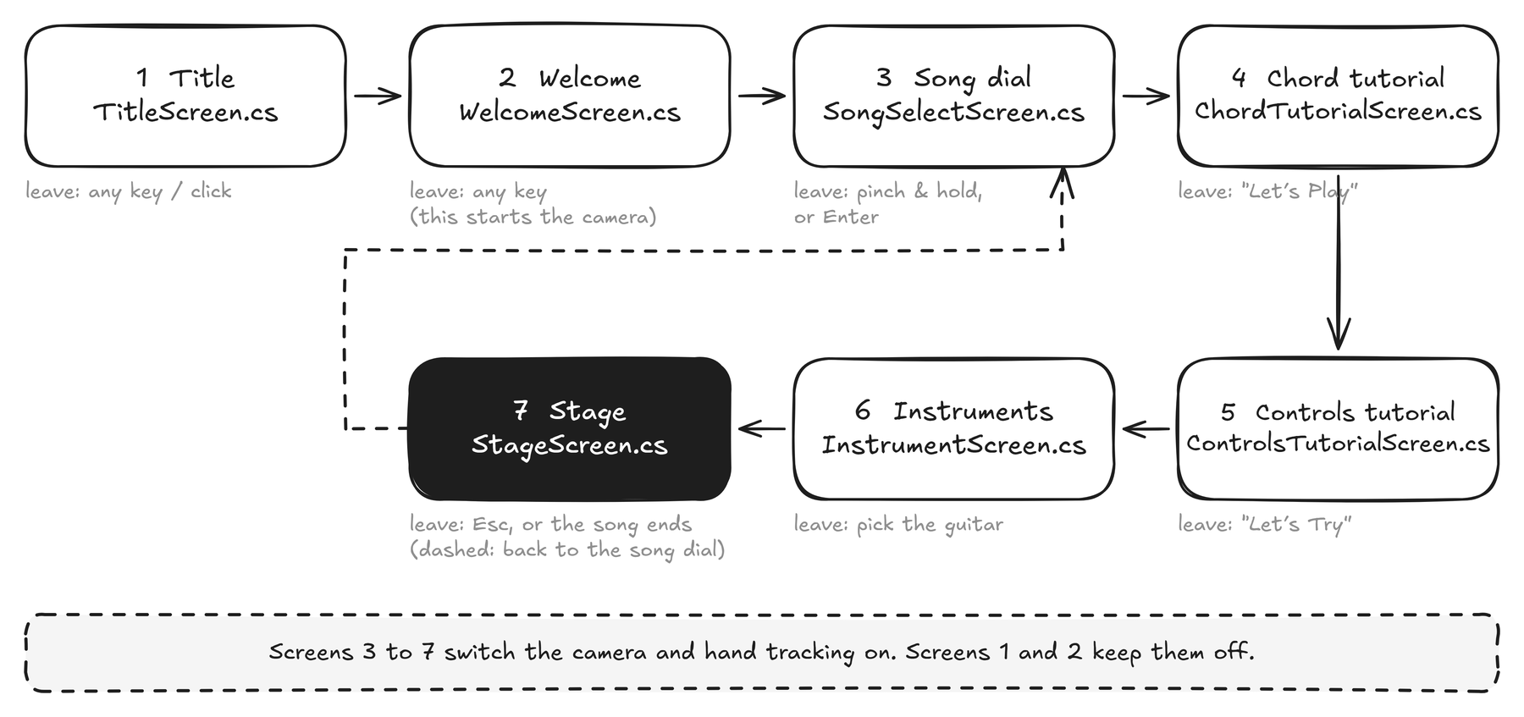
Figure 12. The seven screens and how you move between them.

5.1 The screen lifecycle
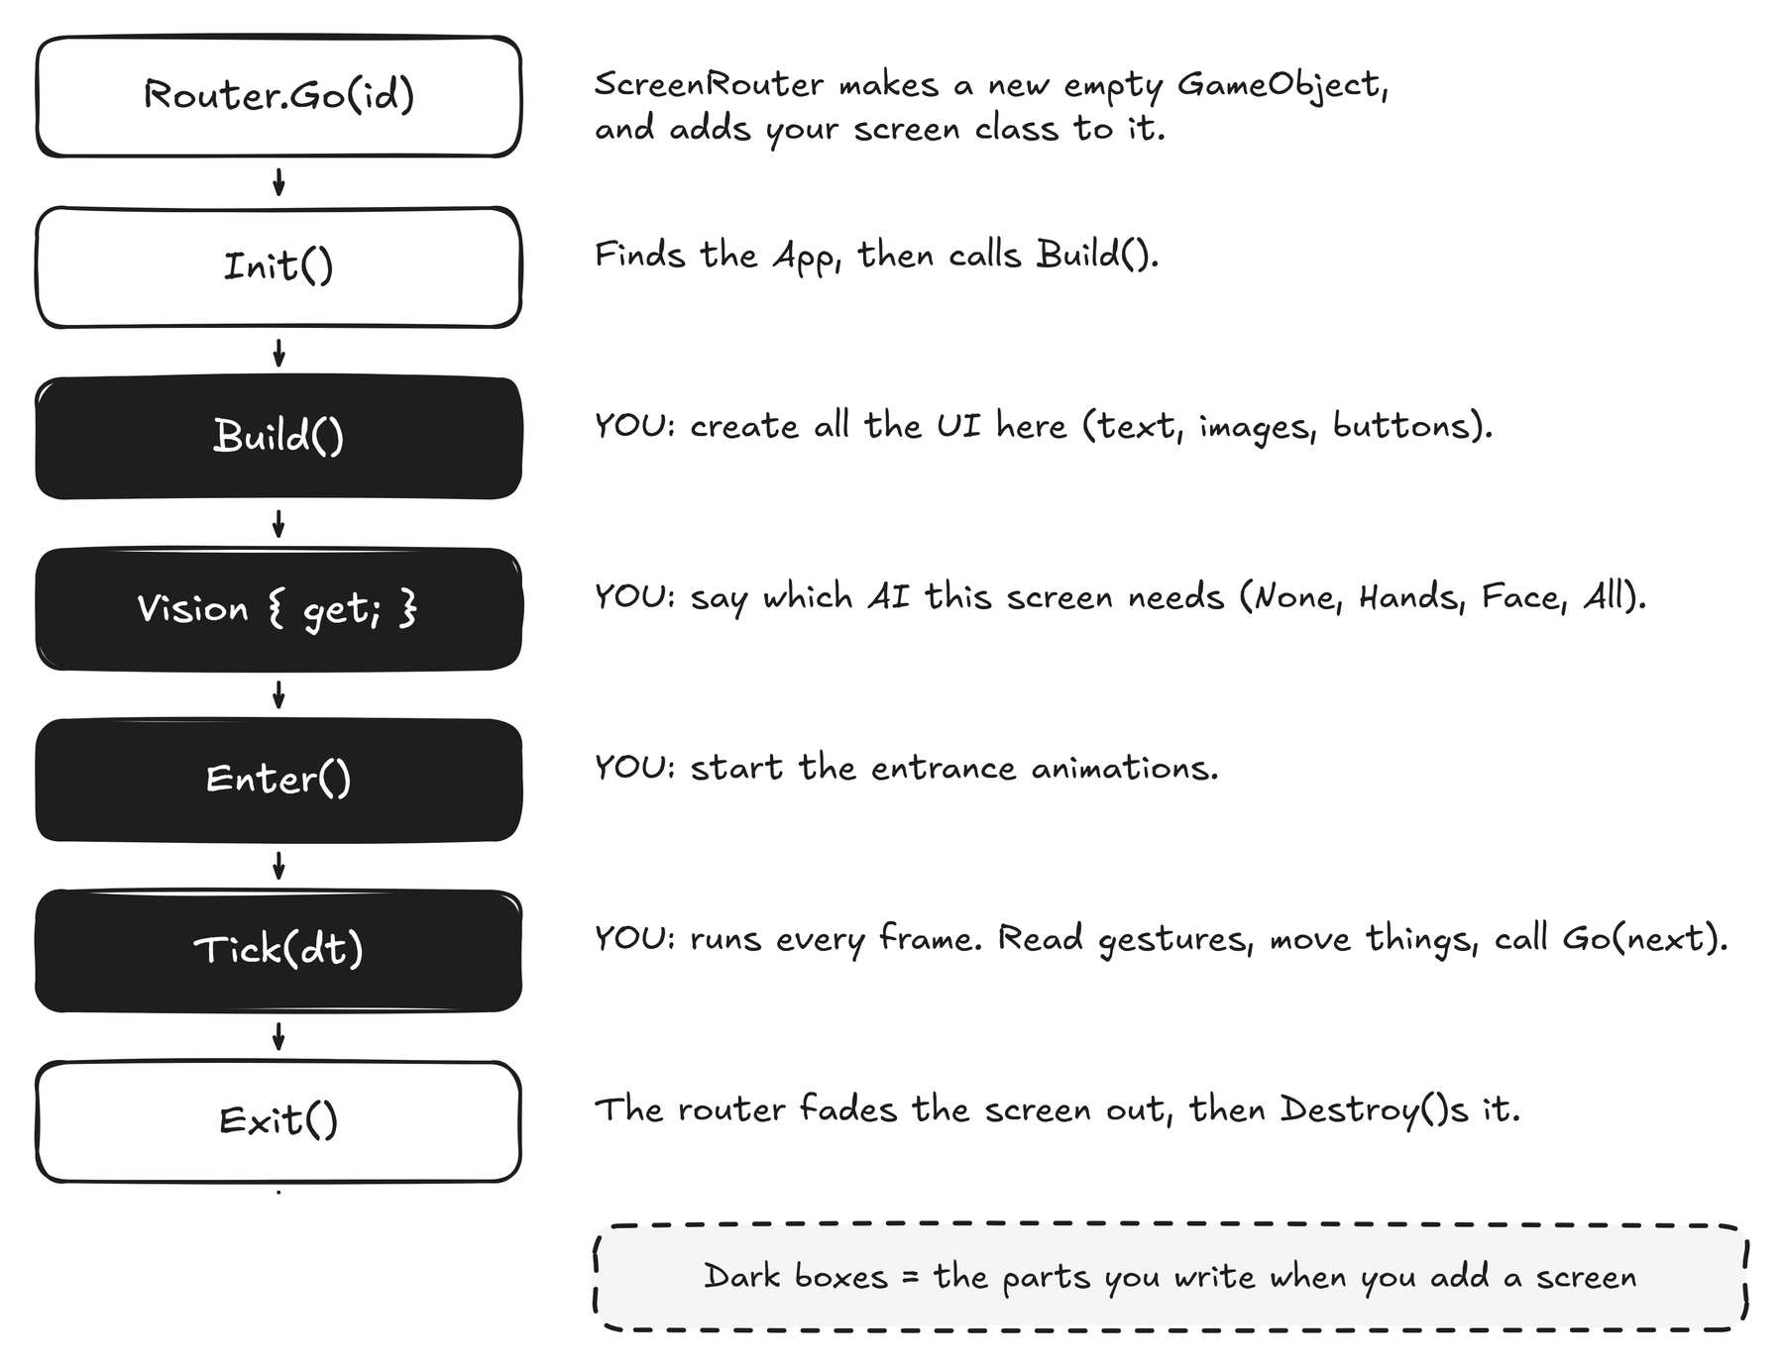
Figure 13. What happens, in order, every time a screen opens and closes. Dark boxes are the parts you write.

5.2 AppScreen: the whole base class
This is nearly the entire base class, so you can see how little there is to learn.
AppScreen.cs (shortened)
public abstract class AppScreen : MonoBehaviour
{
protected App App { get; private set; } // reach every service
public RectTransform Root { get; private set; } // put your UI under this
public abstract ScreenId Id { get; }

public virtual float Grain => 0.07f; // film-grain strength
public virtual float GrainLift => 0f; // extra light grain on dark screens
public virtual VisionNeeds Vision => VisionNeeds.None; // which AI to run

protected abstract void Build(); // you create the UI here
public virtual void Enter() { } // you start animations here
protected virtual void Tick(float dt) { } // you read gestures here

protected void Go(ScreenId next) => App.Router.Go(next); // leave
}

Vision is how a screen asks for AI. The router reads it and switches the models on or off, so the title screen never wastes the graphics card on hand tracking.
Vision value | Switches on | Used by
None | nothing; the camera stays off | Title, Welcome
Hands | camera + hand tracking | Song dial, tutorials, Instruments
All | hands + face + person cut-out | Stage

5.3 The ScreenRouter
The router keeps a dictionary from ScreenId to class. Go(id) creates a new GameObject with a CanvasGroup, adds the class, calls Init, Build and Enter, then cross-fades: the old screen fades out and is destroyed, the new one fades in about a third of a second later.
ScreenRouter.cs
static readonly Dictionary<ScreenId, Type> k_Types = new Dictionary<ScreenId, Type>
{
{ ScreenId.Title, typeof(Screens.TitleScreen) },
{ ScreenId.Welcome, typeof(Screens.WelcomeScreen) },
{ ScreenId.SongSelect, typeof(Screens.SongSelectScreen) },
{ ScreenId.ChordTutorial, typeof(Screens.ChordTutorialScreen) },
...
};

5.4 A complete tiny screen
A new screen that shows a word and moves on when you hold up three fingers:
HelloScreen.cs (example)
public sealed class HelloScreen : AppScreen
{
public override ScreenId Id => ScreenId.Hello; // add Hello to the enum first
public override VisionNeeds Vision => VisionNeeds.Hands; // we want hand tracking

protected override void Build()
{
var word = UIKit.Text(Root, "Hello", Theme.Serif, 80, Theme.Cream);
word.rectTransform.Center(Vector2.zero, new Vector2(900, 120));
}

public override void Enter() => Anim.Reveal(Root, 0.2f, 20f, 1.2f); // fade + rise

protected override void Tick(float dt)
{
if (App.Gestures.Fingers == 3) Go(ScreenId.SongSelect); // three fingers
if (Pressed(Key.Escape)) Go(ScreenId.Title);
}
}

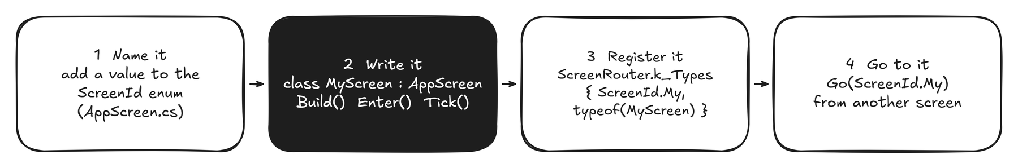
Figure 14. The four steps to add a screen.

6 Building the interface in code
Four small tools cover nearly everything: UIKit (make things), Theme (colours and fonts), Anim (movement) and a handful of widgets. Read the files; each is short.

6.1 UIKit: make things
Call | What you get
UIKit.Node(name, parent) | An empty rectangle (a GameObject with a RectTransform).
UIKit.Text(parent, text, font, size, colour, align) | A TextMeshPro text.
UIKit.Raw(parent, texture, material) | A picture, optionally drawn by a custom shader.
UIKit.Shape(parent, colour, radius) | A rounded rectangle with border, gradient and soft shadow.
UIKit.Icon(parent, kind, colour, size) | A drawn icon (arrow, play, pinch ...).
rt.Stretch() rt.Place(anchor, position, size) rt.Center(position, size) | Position helpers for a RectTransform.

Example from the song-dial screen: a heading and a button.
SongSelectScreen.cs
var heading = UIKit.Text(col, "Choose song to play", Theme.Serif, 60, Theme.Cream,
TextAlignmentOptions.TopLeft, -0.5f);
heading.rectTransform.Place(new Vector2(0, 1), // anchor: top-left of its parent
new Vector2(0, 0), // position from that anchor
new Vector2(660, 80), // size
new Vector2(0, 1)); // pivot

m_Play = PillButton.Create(col, "Play this song", new Vector2(236, 60), VectorIcon.Kind.Play, null);
m_Play.Clicked += Choose; // C# event

Anchors in 20 seconds
Every RectTransform has an anchor (a point from 0,0 bottom-left to 1,1 top-right of its parent) and a position measured from that anchor. Place(new Vector2(0,1), ...) means "measure from the top-left corner". Stretch() means "fill the parent".

6.2 Fonts and TextMeshPro
Text uses TextMeshPro, which draws letters from a font atlas (a picture of the glyphs) using a signed-distance-field shader, so text stays sharp at any size. To make a font usable:
- Drop the .ttf file into Assets/Solaris/Art/Fonts.
- Window > TextMeshPro > Font Asset Creator. Pick the file, choose SDFAA, atlas 1024 x 1024, Generate Font Atlas, then Save. (ProjectSetup.Font() does exactly this from code.)
- Add one line to BuildRegistry and a property to Theme (recipe 6 in chapter 11).

6.3 Theme: the one place for colours and fonts
Theme.cs holds the palette (Cream, Paper, Rust, Ember ...) and the font shortcuts (Theme.Serif, Theme.Sans, Theme.Garamond). Change a value there and every screen follows.

6.4 Anim: movement that feels soft
Two ideas. A tween moves a value from 0 to 1 over a time with an easing curve. A spring chases a target and settles without overshoot, which is ideal for things that follow a hand.
Anim.cs in use
// fade a card in after 0.45 s, over 1.3 s, easing out
Anim.Run(1.3f, k => group.alpha = k, Ease.OutQuint, 0.45f);

// the song wheel glides toward its target every frame
float position = m_Scroll.Step(m_Target, dt, 6f, 1f);

// shortcut: fade and lift an element into place
Anim.Reveal(rectTransform, delay: 0.4f, lift: 18f, duration: 1.4f);

Frame time is clamped to 1/30 s inside Anim and AppScreen, so a slow first frame pauses animations instead of skipping them.

6.5 The widgets
Widget | File | What it is
ShapeGraphic | UI/ShapeGraphic.cs | Rounded rectangle drawn by one shader (distance field): fill gradient, hairline border, glow
LineGraphic, VectorIcon | UI/LineGraphic.cs | Anti-aliased strokes and a tiny icon set
PillButton | UI/Widgets.cs | The cream call-to-action. Works by click, Enter, or a hand pinch-hold
HandPointer | UI/Widgets.cs | The glowing dot that follows your index finger and presses buttons
ChordDiagram | UI/Widgets.cs | Draws a guitar chord box from the fret numbers in Chords.cs
GlassCard | UI/GlassCard.cs | A frosted card used on the Instruments screen
TutorialBoard + RefSpace | UI/ | Builds screens 4 and 5 from the mock-up images (see chapter 7)

7 Making it beautiful: shaders and key art
The look comes from two things: custom shaders, and a trick for turning flat design images into living screens.

7.1 Shaders in 60 seconds
A shader is a small program that the graphics card runs once for every pixel. It receives the pixel’s position and returns a colour. All our shaders are in Assets/Solaris/Shaders and are registered by name, like Solaris/BG/GlowField.
Shader | Used by | Idea
BG/TitlePlate | Title, tutorials | Draws a colour plate plus separate grain; can nudge only the red glows
BG/WelcomeArt | Welcome | Sky plate + a bouncing orb layer, blended in linear light, + grain
BG/GlowField | Song dial, Instruments | Dark gradient with up to four drifting ember glows
BG/InkFlow, WarmHorizon | early versions | Procedural flowing colours (kept for reference)
UI/Shape | every rounded shape | Signed-distance rounded rectangle with border and shadow
UI/Line, UI/Logo, UI/Orb, UI/Hand | icons, wordmark, hand figure | Strokes, a sharp logo, a lit sphere, a ray-marched 3D hand
CameraView | Song dial | Mirrored, cover-fitted camera with a warm duotone and a fingertip spotlight
StageComposite | Stage | The AR composite: backdrop, bokeh, waves, you (person mask)
Grain, GrainLift | every screen | Static film grain; one darkens, one adds light for dark screens
ImageSample.compute | Vision | Cuts a rotated crop of the camera image into an AI input

Make a new animated background
- Create Assets/Solaris/Shaders/MyGlow.shader (copy GlowField.shader and rename the first line to Shader "Solaris/BG/MyGlow").
- Run Solaris > Setup Project so the registry picks the shader up.
- In a screen’s Build() use it as a background:
in your screen
var bg = ProceduralLayer.Create(Root, "Solaris/BG/MyGlow", 0.5f); // 0.5 = render at half resolution
bg.Material.SetColor("_Top", Theme.Hex("2B1007"));
bg.Material.SetVector("_G0", new Vector4(0.62f, 1.02f, 0.62f, 0.95f)); // glow x, y, radius, strength

ProceduralLayer renders the shader into a half-size texture and upscales it. Backgrounds are soft by design, so this saves work and looks the same.

7.2 Turning a mock-up into a living screen
Screens 1, 2, 4 and 5 were designed as pictures. Instead of redrawing them, a Python tool cuts each picture into layers, and the game puts them back together.
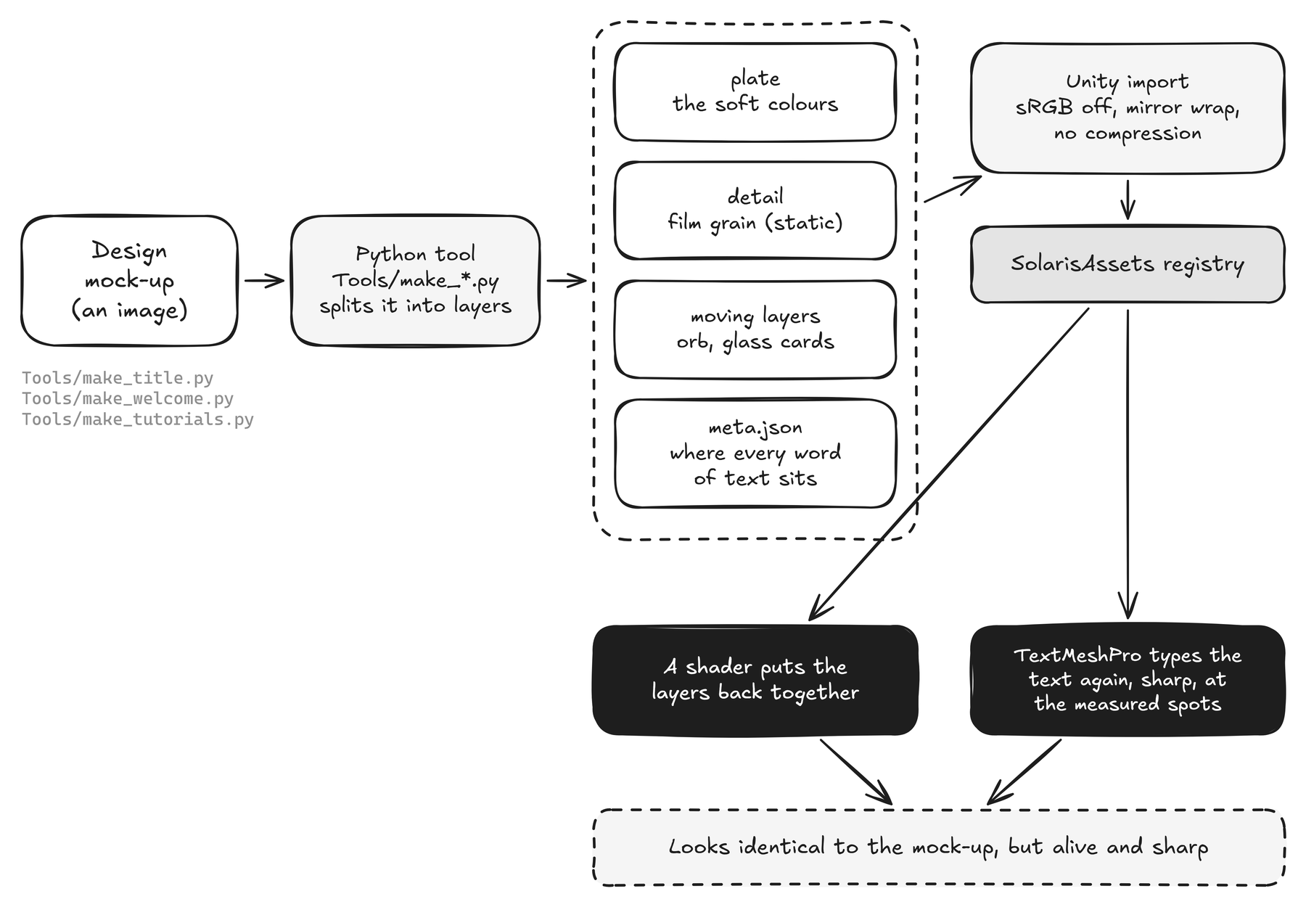
Figure 15. From a design image to a live screen.
Tool (Tools/...) | Cuts | Outputs
make_title.py | Screen 1 | colour plate, grain, a map of the red glows, the lettering as a distance field
make_welcome.py | Screen 2 | sky, grain, the orb as its own transparent layer, where text sits
make_tutorials.py | Screens 4 and 5 | background, five glass cards each (with photo hands baked in), text positions
make_logo.py | Wordmark | the SOLARIS lettering as a distance-field texture
blender/make_instruments.py | Instruments | rendered product pictures of each instrument

Why this works
Static layers stay static. Grain never moves, so the screen never looks like TV noise. Only the layer you want alive (the red glows, the orb) is displaced.
Text is typed again, not copied. The tool measures where every line sat. The game sets real TextMeshPro text at those exact spots, so it is sharp on any screen.
Linear-light blending. Unity blends colours in linear light, which is brighter than the design tool. Theme.DesignAlpha corrects see-through whites so they look as designed.

7.3 RefSpace: put things where the design had them
RefSpace converts a pixel position in the original design image into a position on the canvas. The shaders and RefSpace both use the same rule: fit the image width, extend the rest by mirroring. So the design looks the same on 16:9 and 16:10 screens.
RefSpace.cs in use
var rs = new RefSpace(1248, 691, App.CanvasSize); // the mock-up is 1248 x 691
rs.Place(card, 43, 162, 263, 541); // a box, in mock-up pixels
rs.FitLine(title, 508, 745, 92); // text whose ink spans x 508..745, baseline y 92

FitLine measures the real glyph ink with RefSpace.Ink (not TextMeshPro’s padded box) and solves the font size. A test in TextFitTests.cs guards this.

7.4 Screens 1 and 2 in detail
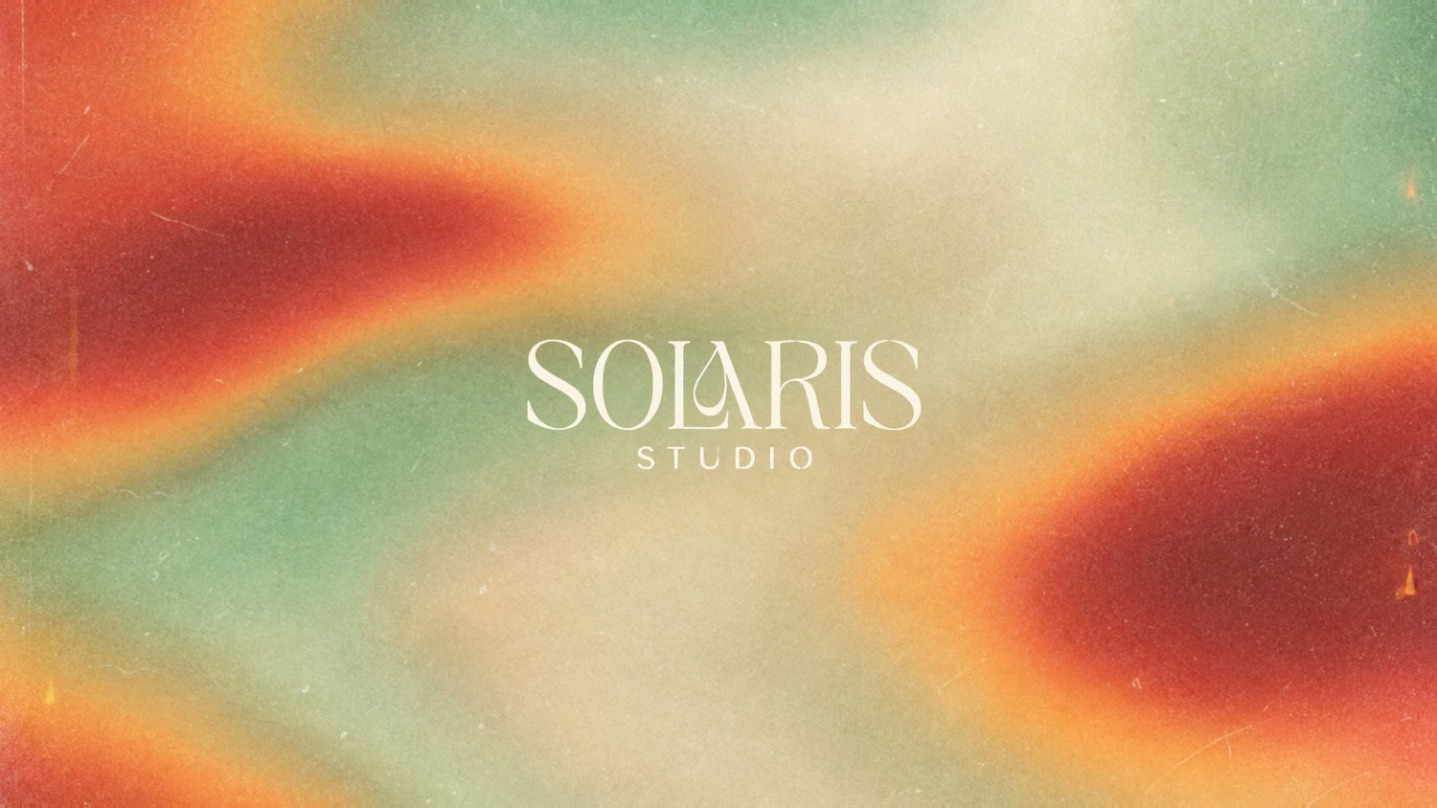
Figure 16. Screen 1. The art is the designer’s own image; only the red glows breathe.
Title. The plate texture is sampled through a tiny, slowly changing displacement, but only where a mask says "this is a red glow". Grain, dust and the lettering are separate and never move.
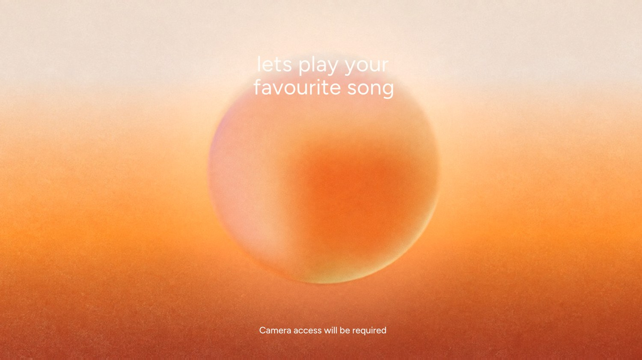
Figure 17. Screen 2. The orb is its own layer, so it can bounce.
Welcome. The orb bounces with real physics: gravity pulls it down, a soft spring floor catches it, and each rebound resets the launch speed so the bounce never fades. It squashes at the floor and stretches in the air. As it rises the sky warms slightly and a halo grows. The code is in WelcomeScreen.Simulate:
WelcomeScreen.cs (idea)
m_Gravity = 8f * Apex / (FlightTime * FlightTime); // reach Apex in FlightTime
m_Launch = m_Gravity * FlightTime / 2f; // speed that gets us there
m_Spring = Mathf.Pow(Mathf.PI / ContactTime, 2f); // soft floor: half a sine wave of contact
// each frame, 8 sub-steps: add gravity; below the floor add the spring; on leaving the floor reset velocity to m_Launch

7.5 Film grain
Grain is one fixed 1024 x 1024 texture where one texel equals one screen pixel. It never changes between frames, so it adds texture without flicker. Two shaders apply it: Grain multiplies (good on light screens), GrainLift adds tiny specks of light (needed on near-black screens, where multiplying changes nothing). Each screen chooses its strength with Grain and GrainLift.

8 The AR brain: camera, vision, gestures
This chapter is the heart of the project. It turns a plain webcam picture into "the left hand shows three fingers".

8.1 The camera: CameraFeed
- Opens a WebCamTexture at 1920 x 1080, 30 frames per second.
- Picks the right camera. Laptops often expose a second, infrared (Windows Hello) camera. The code scores each device by name and avoids "IR", "infrared" and virtual cameras.
- Copies every new camera frame into one upright RenderTexture that all the AI code reads. The frame is not mirrored; mirroring is applied later, so geometry stays honest.
- For tests it can read a still photo instead (-solaris-camera-image), so the real webcam is never used in automated runs.

8.2 Vision: from pixels to 21 points
VisionService runs on the graphics card using Sentis. For every new camera frame it runs the steps below, and never makes the game wait: results are read back asynchronously.
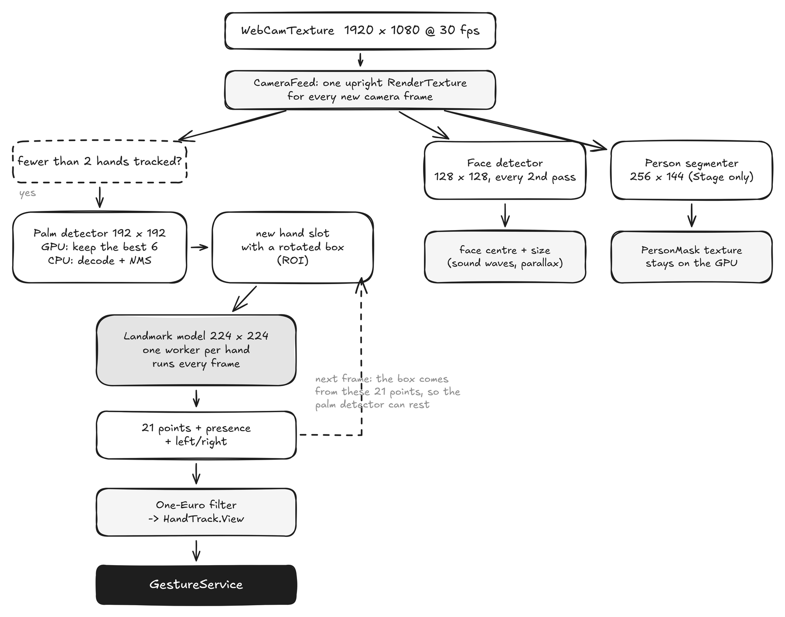
Figure 18. One pass of the vision loop. Three models, three lanes.

Detecting versus tracking
Finding a hand from scratch is expensive; following one is cheap. So the code has two states per hand slot:
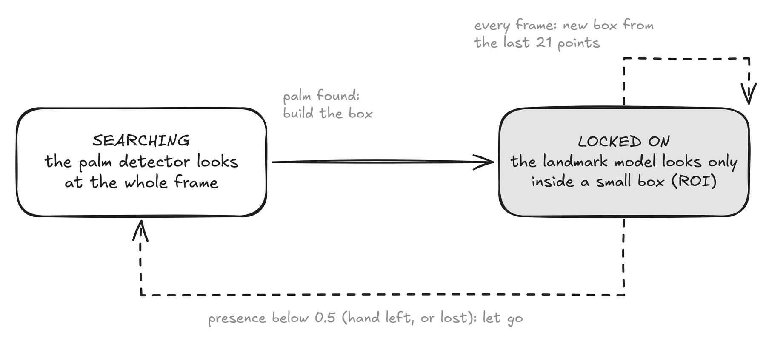
Figure 19. Search with the palm detector only while a hand is missing.

The 21 points
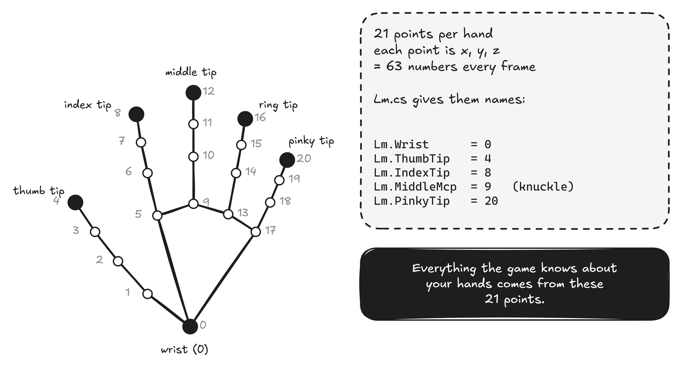
Figure 20. Every hand is reduced to these 21 numbered points. Lm.cs gives them names.
Here is the real thing, running on a test photograph. The green skeleton is what the landmark model returns; the box is the face detector.
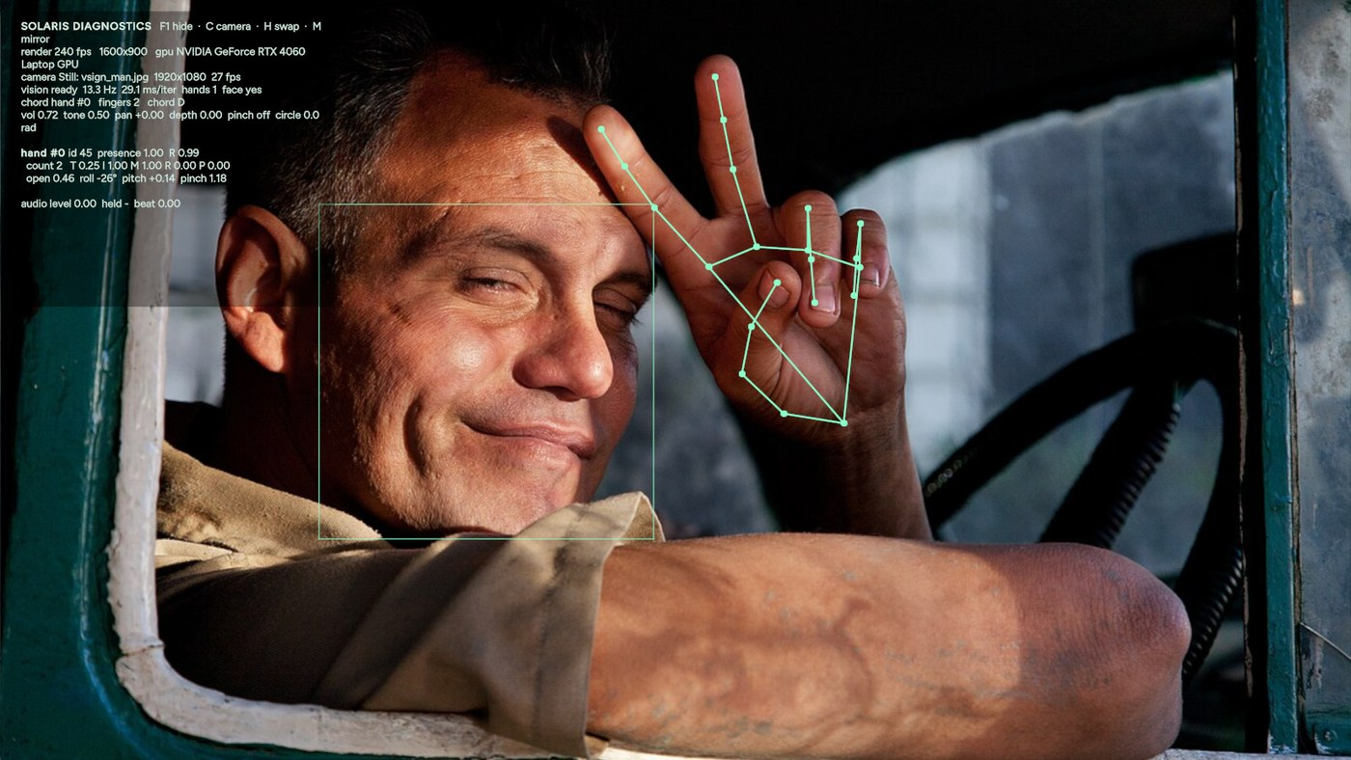
Figure 21. The F1 diagnostics overlay on a test photo: landmarks, face box, finger count (2) and chord (D).

Calling a model from code
The Sentis calls are short. This is a simplified version of what VisionService does for the palm detector:
VisionService.cs (simplified)
var raw = ModelLoader.Load(assets.handDetector); // the .onnx ModelAsset
var graph = new FunctionalGraph(); // lets us add GPU post-processing
var input = graph.AddInput(raw, 0);
var outs = Functional.Forward(raw, input); // run the model
var top = Functional.TopK(outs[1].Reshape(new[] { 2016 }), 6, 0, true, true); // best 6 scores
var palm = graph.Compile(Functional.Sigmoid(top[0]), top[1], Functional.IndexSelect(outs[0], 1, top[1]));

var worker = new Worker(palm, BackendType.GPUCompute); // run on the graphics card
VisionMath.Sample(frame, inputTensor, affine); // camera pixels -> tensor (compute shader)
worker.Schedule(inputTensor); // go
var scores = await (worker.PeekOutput(0) as Tensor<float>).ReadbackAndCloneAsync(); // read without stalling

Model | Input | Output | Runs
Palm detector | 192 x 192 | best 6 boxes | only while fewer than 2 hands are tracked (~1 ms)
Hand landmarker | 224 x 224 crop | 21 points, presence, left/right | every frame, one per hand (~2 ms for two)
Face detector | 128 x 128 | face box | every 2nd pass (~0.3 ms)
Person segmenter | 256 x 144 | a mask texture | Stage screen only (~1 ms); stays on the GPU

Smoothing: the One-Euro filter
Raw points jitter by a pixel or two. A normal smoothing filter would remove the jitter but make the hand feel laggy. The One-Euro filter smooths hard when you are still and lightly when you move fast, so the tracking feels steady and immediate.
VisionMath.cs: OneEuro.Filter
float dx = (x - m_X) / dt; // how fast is it moving?
m_Dx = Mathf.Lerp(m_Dx, dx, Alpha(dCutoff, dt));
float cutoff = minCutoff + beta * Mathf.Abs(m_Dx); // faster -> less smoothing
m_X = Mathf.Lerp(m_X, x, Alpha(cutoff, dt));

8.3 Gestures: from points to meaning
GestureService listens for each new vision result and converts the points into the things the game cares about.

Counting fingers
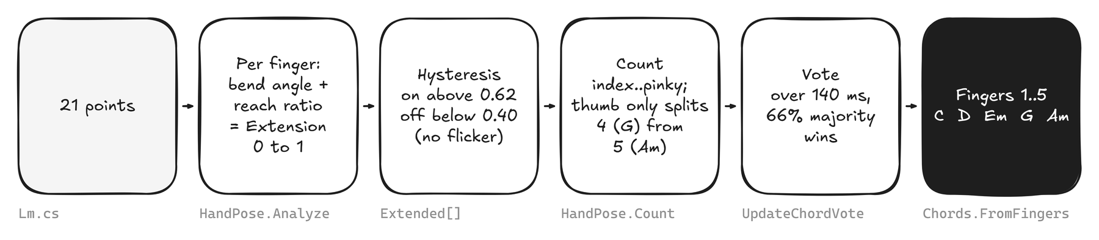
Figure 22. From 21 points to a chord, in six small steps.
HandPose.Analyze (simplified)
float bend = (Angle(mcp, pip, dip) + Angle(pip, dip, tip)) * 0.5f; // 0 degrees = straight finger
float reach = Vector3.Distance(wrist, tip) / Vector3.Distance(wrist, pip); // far from wrist = extended
Extension[f] = 0.45f * Remap(bend, 75f, 22f) + 0.55f * Remap(reach, 1.0f, 1.32f);
Extended[f] = Extended[f] ? Extension[f] > 0.40f : Extension[f] > 0.62f; // hysteresis

Two rules that make it feel solid
Hysteresis. A finger turns "up" only above 0.62 but turns "down" only below 0.40, so a finger hovering near the line cannot flicker.
Thumb rule. People leave the thumb loose when showing 1 to 3 fingers, so only index to pinky count. The thumb only matters to tell four fingers (G) from an open palm (Am).

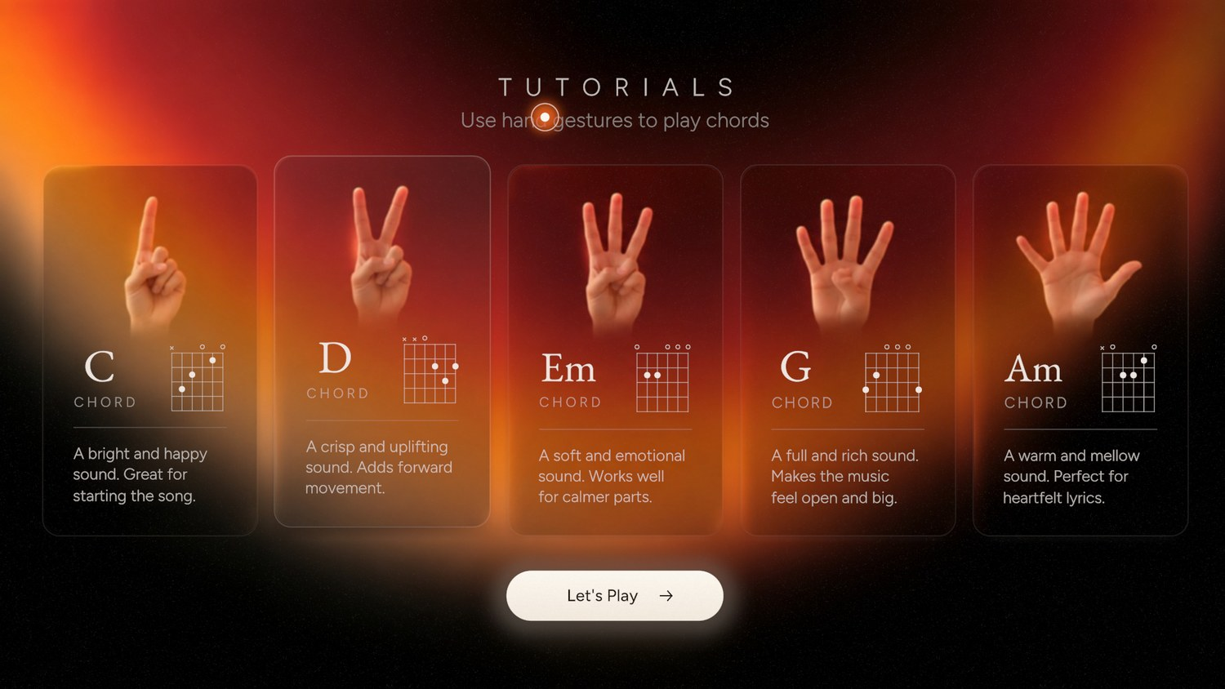
Figure 23. Screen 4. Hold up two fingers: the D card lifts and the chord strums.

Two hands, two jobs
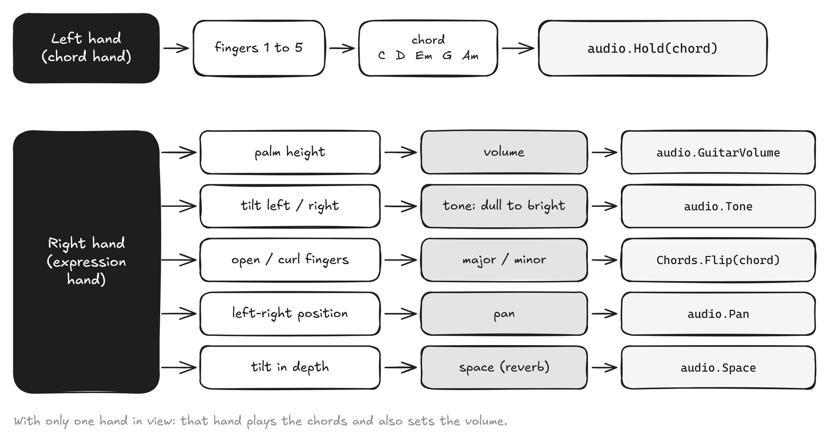
Figure 24. The left hand picks the chord; the right hand shapes the sound.
Measurement | How it is computed | Range
Volume | palm height in the frame, smoothed (80 ms) | 0.18 to 1
Tone | roll angle of the hand (wrist to middle knuckle), clamped to +/-55 degrees | 0 to 1
Major / Minor | openness of the fingers; hysteresis 0.36 / 0.52 | on / off
Pan | horizontal position of the wrist | -1 to 1
Space | tilt in depth: fingers leaning away from the camera (fingertip depth) | 0 to 1

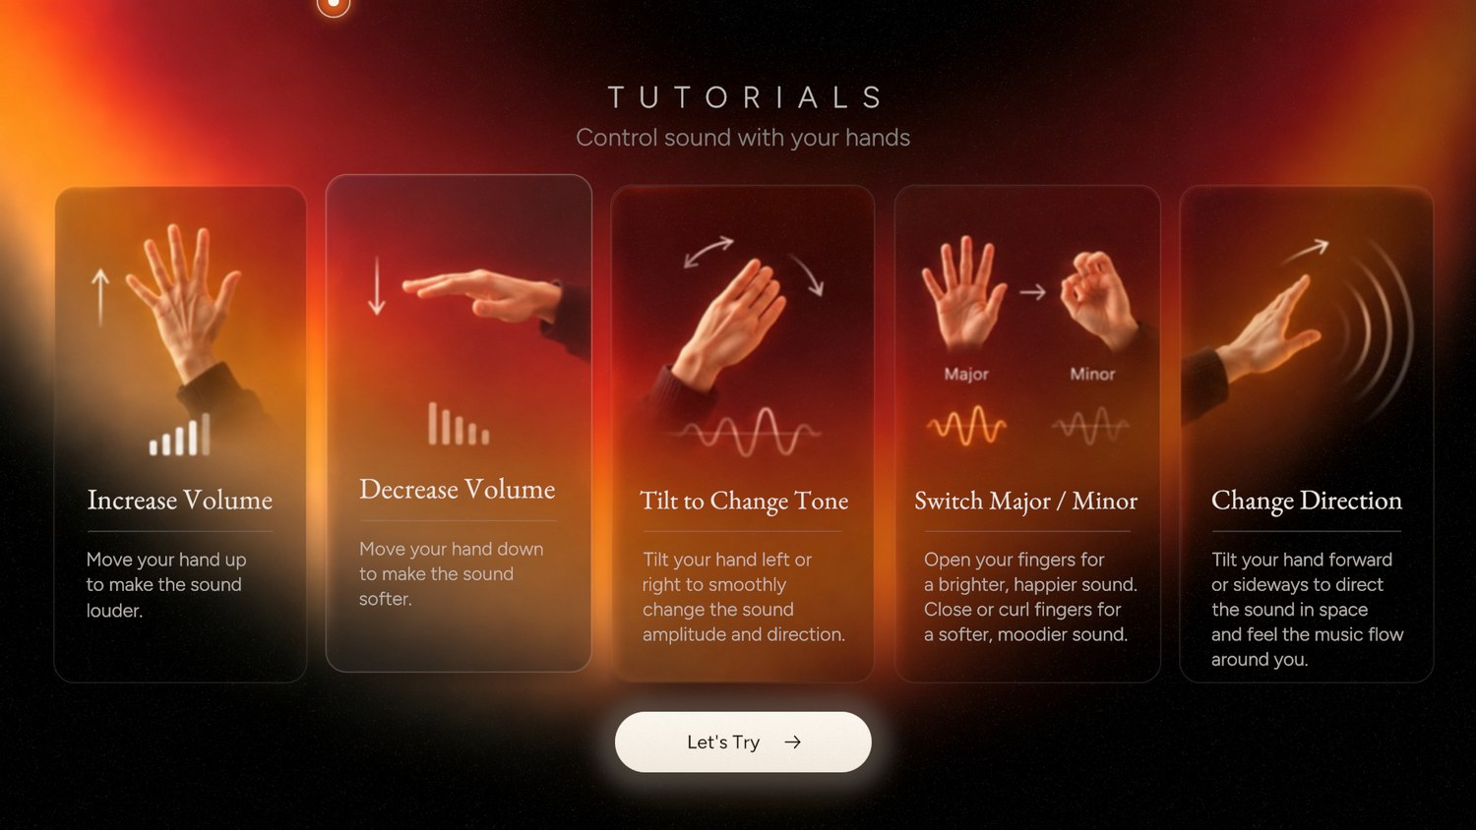
Figure 25. Screen 5. The card of the control you are performing lifts.

Circles and pinches
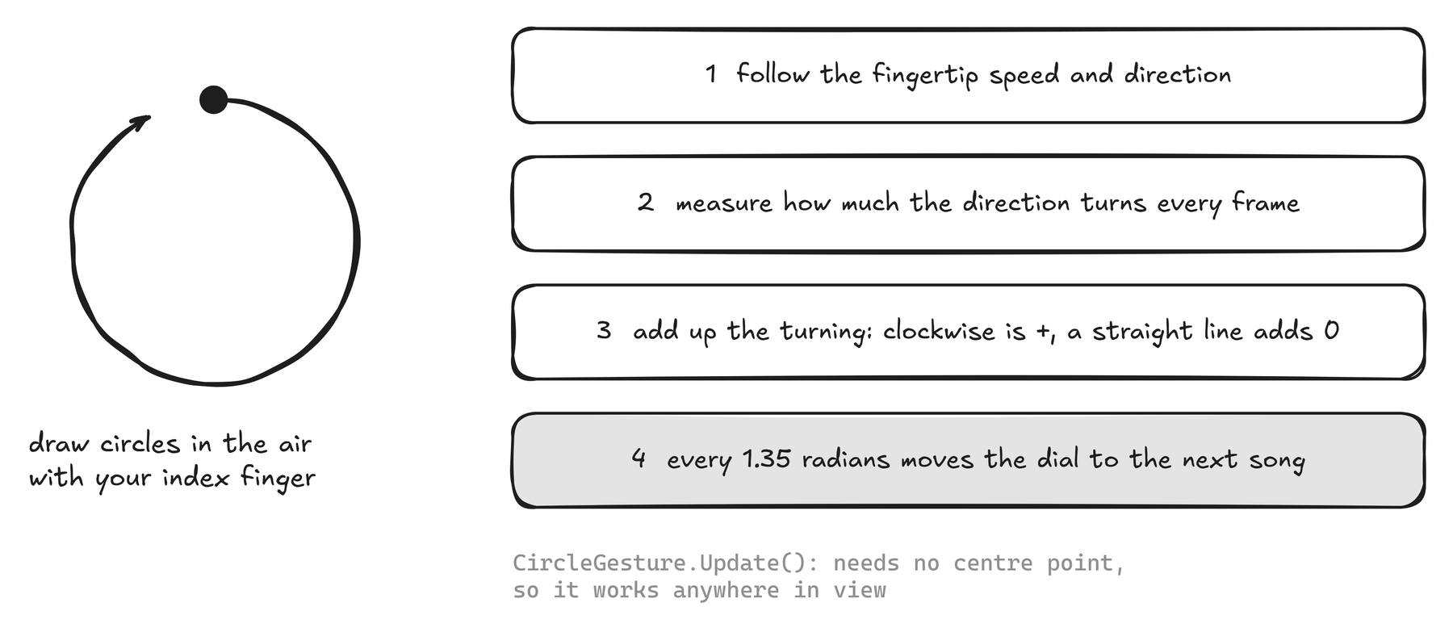
Figure 26. Drawing circles turns the song dial.
Pinch. Thumb tip and index tip closer than 0.30 of the palm length counts as a pinch (it releases above 0.45). On the song dial a pinch held for 0.45 seconds plays the song; a held finger over a button for 1.8 seconds also works ("dwell").
Roles. If two hands are visible, the one on the left of the screen is the chord hand. Press H to swap for left-handed play.

9 Music and sound
There are no audio files. Every note is calculated. That means no licences to buy, perfect timing, and a sound that reacts to your hand in real time.

9.1 Chords
A chord is stored as six numbers, one per string, from low E to high E. A -1 means the string is not played; 0 is open.
Music/Chords.cs
Add("C", new[] { -1, 3, 2, 0, 1, 0 }, 48, false, "A bright and happy sound. Great for starting the song.");
Add("Em", new[] { 0, 2, 2, 0, 0, 0 }, 40, true, "A soft and emotional sound. Works well for calmer parts.");
// frets per string root minor text shown on the tutorial card

Fingers | Chord | Frets (E A D G B E) | Minor/major twin (right hand opens or curls)
1 | C | -1 3 2 0 1 0 | Cm
2 | D | -1 -1 0 2 3 2 | Dm
3 | Em | 0 2 2 0 0 0 | E
4 (thumb in) | G | 3 2 0 0 0 3 | Gm
5 (open palm) | Am | -1 0 2 2 1 0 | A

9.2 Songs are text files
A song is a JSON file in Assets/StreamingAssets/Songs. Unity copies that folder next to the built game, so you can add songs without rebuilding.
twinkle.json
{
"title": "Twinkle Twinkle Little Star",
"bpm": 88, "meter": 4, "pickup": 0,
"chords": "G | C:2 G:2 | C:2 G:2 | D:2 G:2",
"lyrics": [ "Twin-:1 kle:1 twin-:1 kle:1 | lit-:1 tle:1 star,:2" ]
}

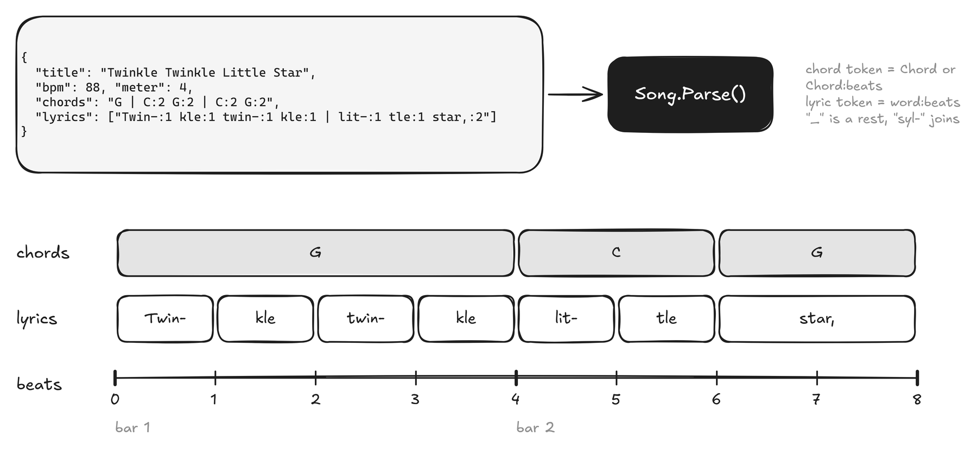
Figure 27. ~Song.Parse~ turns the text into two lanes on a beat timeline.
- chords: one token per bar, or Chord:beats to split a bar. A plain G is one whole bar.
- lyrics: each token is word:beats. _ is a rest. syl- joins the next syllable without a space. one-- keeps a real hyphen.
- pickup shifts the first lyric line earlier than bar 1. Check your files with python Tools/validate_songs.py.

9.3 The audio engine
Unity calls a special method, OnAudioFilterRead, on a separate audio thread every few milliseconds and asks for the next block of samples. Everything audible is calculated inside it. Because it is a different thread from the game, the two never touch the same data directly: the main thread posts orders and sets a few numbers, and the audio thread reads them.
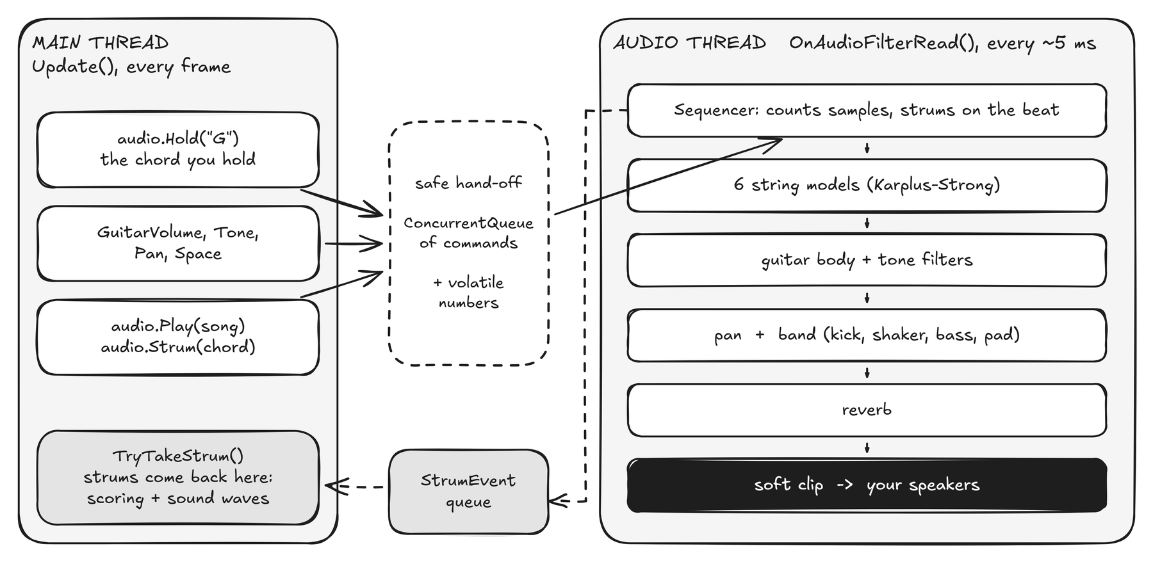
Figure 28. Two threads that never wait for each other.
Audio/AudioEngine.cs (shape)
void OnAudioFilterRead(float[] data, int channels)
{
while (m_Commands.TryDequeue(out var c)) Execute(c); // orders from the main thread
for (int f = 0; f < frames; f++)
{
if (m_Plan != null && !paused) StepSequencer(); // strum when the beat arrives
// add the 6 strings, body + tone filters, pan, the band, reverb, soft clip
data[o] = l; data[o + 1] = r; // the next few milliseconds of sound
}
}

A guitar string from a noise burst
Each string uses the Karplus-Strong method: a burst of noise loops through a delay line and a gentle low-pass filter. The delay length sets the pitch; the filter makes the highs fade first, just like a real plucked string.
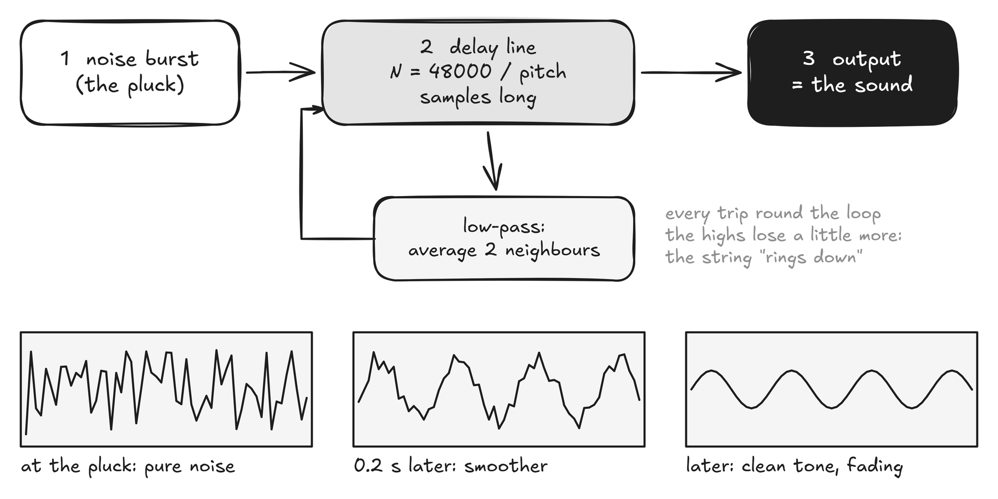
Figure 29. Karplus-Strong in one picture.
A strum plucks the six strings a few milliseconds apart, with slightly different loudness, so it sounds like a hand and not a chord button. The band (soft kick, shaker, bass, warm pad, count-in click) follows the chart and is built from the same ideas in Audio/Band.cs. A Freeverb-style reverb in Dsp.cs glues it together.

Playing with the chord you hold
- The sequencer counts samples, so strums land exactly on the beat.
- At each strum it plays the chord you are holding at that sample (audio.Hold(chord) from the gesture code). A fist or no hand mutes.
- Late-chord correction. If you land the right chord up to 0.16 s after a strum (camera and human delay), the engine re-voices it with a light second strum.
- Right-hand values (volume, tone, pan, space) are plain volatile floats the audio thread reads every block.

9.4 Scoring
The audio thread reports every strum back through a queue. The Stage screen checks whether you were holding the chart’s chord near that moment.
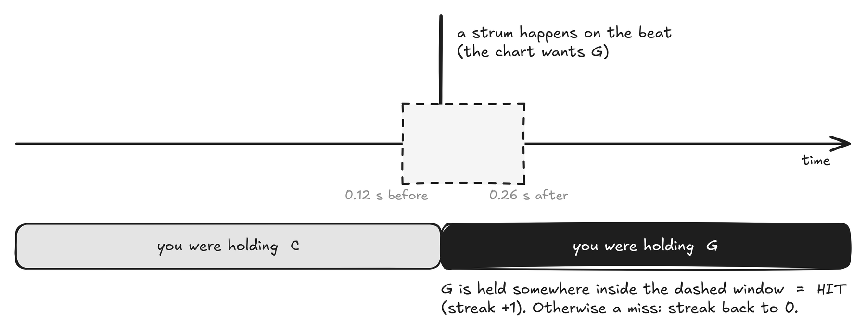
Figure 30. A strum is a hit if the target chord was held anywhere in the window.
Accuracy, streak and a grade appear on the results panel. The window constants are GraceBefore = 0.12 s and GraceAfter = 0.26 s in StageScreen.cs.

10 The Stage: where AR happens
Screen 7 combines everything: your camera image, your hands, your face, the song and the sound.
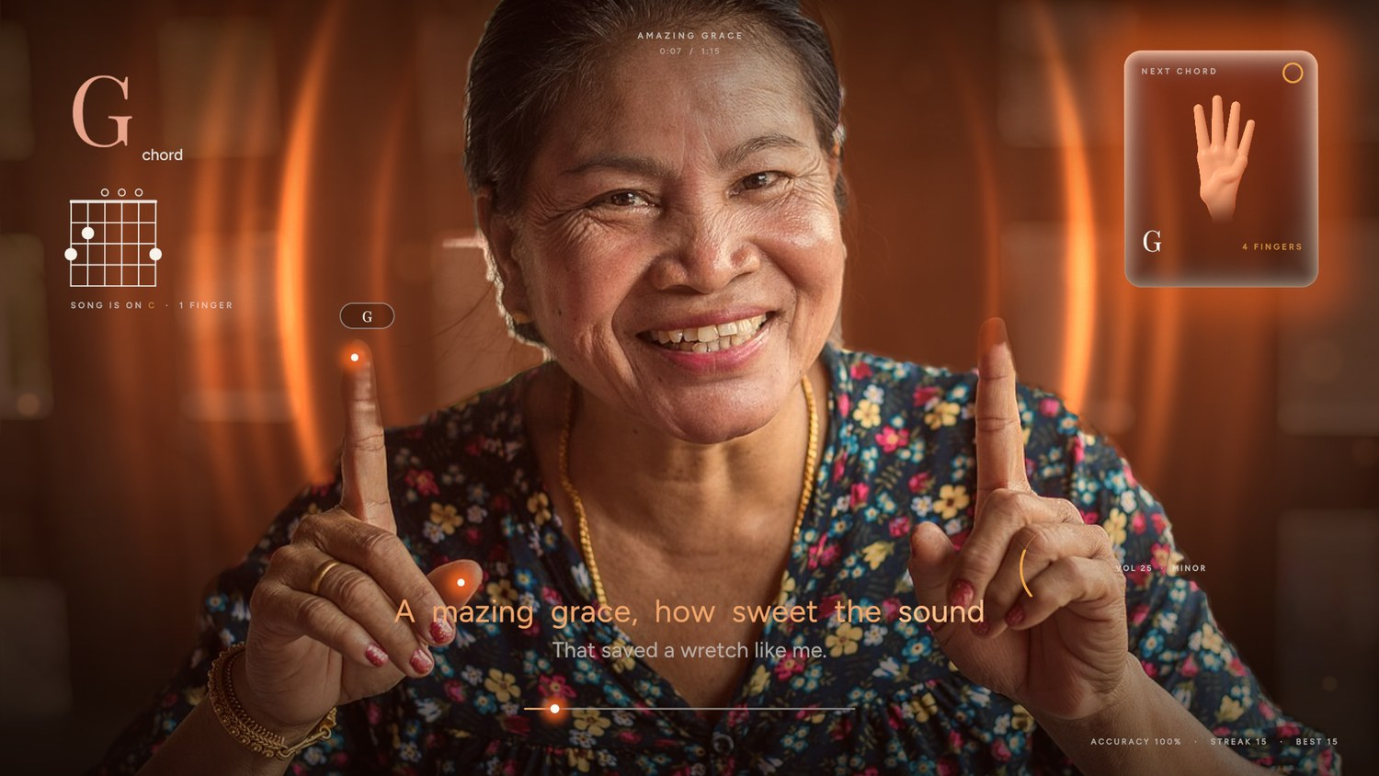
Figure 31. The Stage, running on a test photograph with auto-play on.

10.1 Layers, back to front
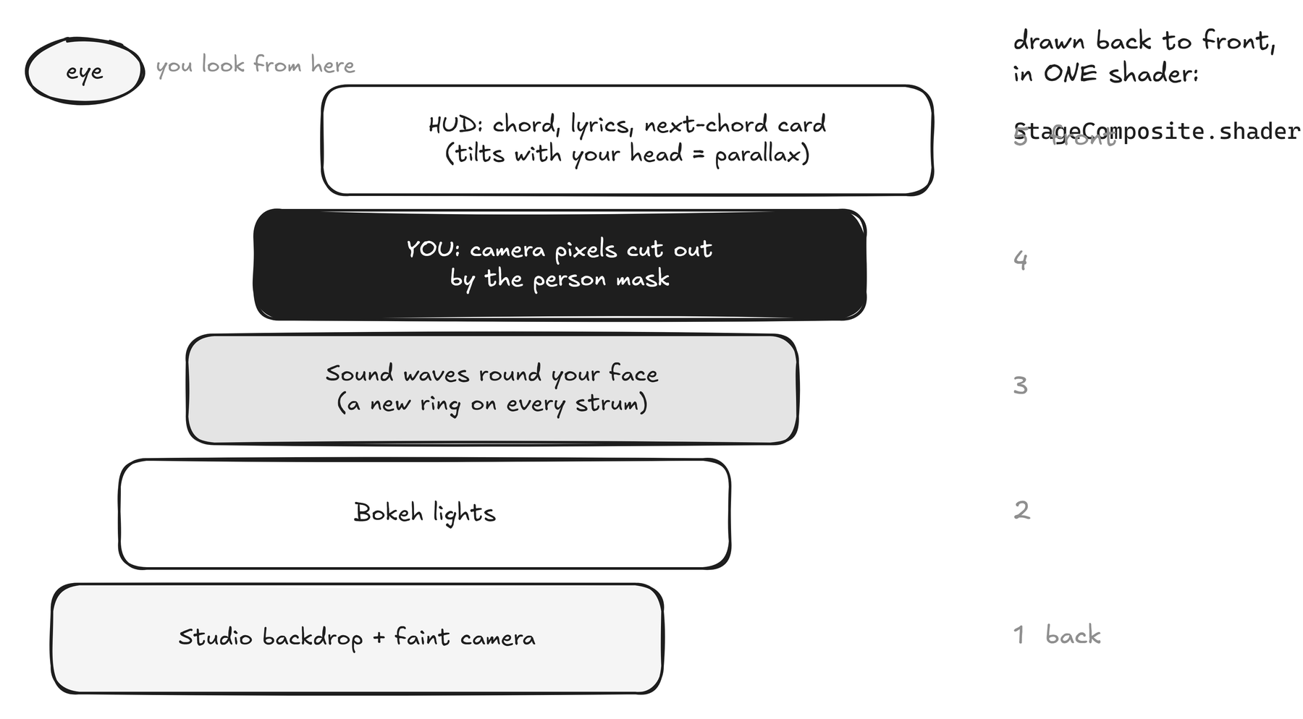
Figure 32. One shader draws the first four layers; the interface sits on top.
The key trick is the person mask. The segmentation model produces a picture where you are white and the room is black. The shader draws the sound waves first and your camera pixels on top, using the mask as stencil, so waves appear to travel behind you. This is the same depth layering that a depth camera would give, from an ordinary webcam.

10.2 What is anchored to what
Virtual thing | Anchored to | Code
Glowing fingertip dots, the "G" tag | Hand landmarks (index tip etc.), in mirrored camera space | StageScreen.UpdateAnchors
Sound-wave rings | The centre of your face (face detector) | StageScreen.UpdateComposite
A new ring per strum | The strum events from the audio thread | SpawnPulse
Rings that breathe | The live audio spectrum (16 bands) | AudioEngine.Spectrum
Chord panel, next-chord card, lyrics | A HUD that tilts and shifts with your head | StageScreen.UpdateParallax

10.3 Mirroring and cover-fit
People expect a mirror. The camera frame is stored un-mirrored, and every place that draws or measures it applies Mirror (x becomes 1 - x). CameraFeed.CoverTransform and FrameToView convert between camera coordinates and screen coordinates when the window is a different shape from the camera.

11 Recipes: "I want to add ..."
Each recipe lists the files to touch, in order. After every recipe, run the tests (chapter 12) and look at the result with the player flags.
I want to add ... | Recipe
A song | 1
A new chord | 2
A different chord per finger | 3
A screen | 4
An instrument card | 5
A font or colour | 6
A gesture | 7
A background shader | 8
A new image or art asset | 9
A different AI model | 10

Recipe 1: add a song
- Make a .json file in Assets/StreamingAssets/Songs (format in 9.2). Use only the ten chords in the table: C, D, Em, G, Am and their twins Cm, Dm, E, Gm, A.
- Check it: python Tools/validate_songs.py. It prints beats per bar and warns about lyrics that run past the chords.
- Press Play. The song appears on the dial alphabetically. No code change needed.
Copyright
Commercial songs (including the Bollywood titles in the design) have copyrighted lyrics. Only add words you are licensed to use. The nine shipped songs are public domain.

Recipe 2: add a chord shape
- In Music/Chords.cs add a line in the static constructor: Add("Fm", new[] {1,3,3,1,1,1}, 41, true, "Mood text"); (name, six frets, root MIDI note, is-minor).
- If it should be reachable by the right-hand open/curl gesture, add its twin to Chords.Base and Chords.Flip.
- Add its name to the ALLOWED set in Tools/validate_songs.py and use it in a song. The diagram is drawn automatically.

Recipe 3: change what each finger count plays
Edit the array in Chords.cs: GestureChords = { "C", "D", "Em", "G", "Am" }. Position 1 is one finger. The tutorial cards read from the same array, so their letters and diagrams follow. The description text per card is in ChordTutorialScreen.k_Body.

Recipe 4: add a screen
- Add a value to enum ScreenId in Core/AppScreen.cs.
- Create Screens/MyScreen.cs from the template in 5.4. Set Vision to Hands if you need gestures.
- Register it in ScreenRouter.k_Types: { ScreenId.My, typeof(Screens.MyScreen) }.
- Go to it from another screen: Go(ScreenId.My);. To test it alone: SolarisStudio.exe -solaris-screen My (the name or a number 1 to 7).

Recipe 5: add an instrument
- Render a picture: blender -b -P Tools/blender/make_instruments.py -- out_dir myinstrument, or draw one, then crop with Tools/crop_instruments.py.
- Save it as Assets/Solaris/Art/Instruments/myinstrument.png and run Solaris > Setup Project (the registry sorts the pictures by file name).
- In InstrumentScreen.cs add a tuple to k_Instruments: ("harp", "Harp", false) (picture file name without ".png", label, is-playable). Playable cards start the Stage; the others show "soon".
- For a new sound, add a voice to AudioEngine next to the six KsStrings and choose it from App.Session.Instrument.

Recipe 6: add a font or change a colour
- Put the .ttf in Assets/Solaris/Art/Fonts.
- In Core/SolarisAssets.cs add public TMP_FontAsset myFont;.
- In Editor/ProjectSetup.cs BuildRegistry add reg.myFont = Font("MyFont-Regular"); and run Solaris > Setup Project.
- In Core/Theme.cs add public static TMP_FontAsset MyFont => SolarisAssets.Get.myFont;. Use it: UIKit.Text(parent, "Hi", Theme.MyFont, 40, Theme.Cream).
- Colours: edit the hex values at the top of Theme.cs.

Recipe 7: add a gesture
Pattern: measure it in HandPose, expose it in GestureService, use it in a screen’s Tick. Example: hold an open palm for one second to pause the song.
a new gesture in four lines
// in StageScreen.Tick (m_Hold is a float field)
var hand = App.Gestures.ChordHand;
if (hand != null && hand.Pose.Count == 5) m_Hold += dt; else m_Hold = 0f; // 5 = open palm
if (m_Hold > 1f) { m_Hold = 0f; SetPaused(true); }

For something the current pose does not measure (a thumbs-up, say), add a property in HandPose.Analyze using the landmark names in Lm, and add a unit test in GestureTests.cs with a synthetic hand so it stays correct.

Recipe 8: add a background
See "Make a new animated background" in chapter 7.

Recipe 9: add a picture, texture or sound file
- Drop the file under Assets/Solaris/Art/.... Select it and check the Inspector:
- Used as a picture (a logo, an instrument): leave sRGB on. Used as data (grain, masks, plates): turn sRGB off, Wrap Mode Mirror, Compression None, Generate Mip Maps off.
- To reach it from code, add a field to SolarisAssets and fill it in BuildRegistry (the same pattern as the fonts).

Recipe 10: swap an AI model
- Replace the file in Assets/Solaris/Models and run Solaris > Inspect Models.
- Compare the printed input shape and output names with VisionService (input size constants at the top, output names found in Load).
- Run the photo self-test (chapter 12) to see finger counts on known photos.

12 Build, test, automate

12.1 Build the game
- Solaris > Build Windows (x64), or File > Build Profiles, choose Windows, press Build.
- The game is written to Builds/SolarisStudio/SolarisStudio.exe. Songs are copied to its StreamingAssets folder.
From a terminal (no window), the three commands are:
setup, test, build
Unity -batchmode -quit -projectPath . -executeMethod Solaris.EditorTools.ProjectSetup.Run
Unity -batchmode -projectPath . -runTests -testPlatform EditMode -testResults Logs/tests.xml
Unity -batchmode -quit -projectPath . -executeMethod Solaris.EditorTools.BuildTool.BuildWindows

12.2 The tests
Open Window > General > Test Runner, choose EditMode, press Run All. The 54 tests need no camera: they build a synthetic hand skeleton and check what the code makes of it.
Group | What is checked
Finger counting | 0 to 5 fingers read correctly when upright, tilted, and with a left hand; a loose thumb does not change 1 to 3
Hand shape | openness separates open from curled; roll follows tilt; pinch detects contact
Circle gesture | clockwise is positive, counter-clockwise negative, straight lines and jitter add nothing
Vision maths | rotated crop maps centre and up; letterbox; One-Euro smooths but follows motion
Music | all songs parse and fit their chart; pickups, syllables, double hyphen; voicings are standard chords
Synth | a string rings at its pitch and decays; the song plan marks chord changes
Text fitting | glyph ink (not layout box) is measured; fitted lines hit their width and baseline

12.3 Run any screen without a camera
The player takes switches that stand in for the webcam and write a screenshot. In these runs the real webcam is never opened.
Switch | Meaning
-solaris-screen <name or 1-7> | Start on that screen
-solaris-camera-image <file> | Use a photo as the camera
-solaris-capture <file.png> -solaris-delay <s> | Wait, save a screenshot, quit
-solaris-capture-frames N -solaris-capture-interval s | Save a numbered frame sequence (for videos)
-solaris-song <id> -solaris-autoplay | Pick a song; play it by itself
-solaris-record-audio <file.wav> | Write the audio output to a file
-solaris-selftest-vision <folder> | Run hand tracking on every photo in a folder and print finger counts
-solaris-debug | Show the diagnostics overlay

one screenshot of the chord tutorial
SolarisStudio.exe -screen-fullscreen 0 -screen-width 1920 -screen-height 1080 ^
-solaris-screen chordtutorial -solaris-camera-image TestData/vsign_man.jpg ^
-solaris-capture shot.png -solaris-delay 6

12.4 Keys while playing
Key | Does
F1 | Diagnostics: landmarks, frame rate, model time, finger count, audio level
H | Swap which hand plays chords
C | Next camera
M | Mirror on/off
F11 or Alt+Enter | Fullscreen / window
1 to 5 | Hold a chord with the keyboard (Stage), preview a chord (tutorial)
Esc or P | Pause

13 When something goes wrong
Each of these cost real time once. They are listed so they cost you none.
Symptom | Cause | Fix
Text shows boxes or nothing | TextMeshPro essentials not imported | Window > TextMeshPro > Import TMP Essential Resources
A shader is "not registered" | New shader not in the registry | Run Solaris > Setup Project
Person cut-out model fails to import | The Google .tflite has a custom operation Sentis cannot read | Use the ONNX version from onnx-community (already in the project)
"Span" error in an async method | C# forbids Span locals in async methods | Decode tensors in a normal (sync) helper method
Camera does not open | Windows privacy blocks desktop apps | Settings > Privacy & security > Camera > Let desktop apps access your camera
Wrong (grey, dark) camera | The infrared Windows Hello camera was chosen | Press C to cycle, or pass -solaris-camera <name>
Everything is a bit dark or too bright | Linear colour space: default grey texture is sRGB; see-through white blends brighter | Use a linear data texture; use Theme.DesignAlpha
Text in the wrong place on some screens | Layout done before the canvas has its final size | Re-run layout when App.CanvasSize changes; never freeze a position at Build time
Python edits garble characters | Windows writes files in cp1252 by default | Open files with encoding="utf-8"
Keys press themselves while testing | The player stole focus and received your typing | Automation switches make the app ignore keyboard and mouse

Before a public release, upgrade the editor to 6000.0.58f2 or later (a security fix, CVE-2025-59489) and rebuild.

14 Why this is AR and not just computer vision
Computer vision answers one question, "what is in this picture?", and then stops. Solaris starts where that ends: the camera is not something we analyse, it is the stage. Your real hands and face are tracked in real time and the virtual guitar is registered to them: fingertips glow where your fingertips are, sound waves ring your actual face, the person cut-out places the virtual layer behind you and the interface in front of you, and the whole thing answers every movement within a few milliseconds, so you and the virtual instrument share one space. Remove the overlay and the music and only detection is left; what this project delivers is the live, spatially anchored blend of virtual and real that defines augmented reality, with tracking as its senses rather than its purpose.

