APB SLAVE
VERIFICATION DOCUMENT

CHAPTER 1: INTRODUCTION AND OBJECTIVES

1.1 Introduction:

APB is low bandwidth and low performance bus. So, the components requiring lower bandwidth like the peripheral devices such as UART, Keypad, Timer and PIO (Peripheral Input Output) devices are connected to the APB. The bridge connects the high performance AHB or ASB bus to the APB bus. So, for APB the bridge acts as the master and all the devices connected on the APB bus acts as the slave.

1.2 Specification
- The DUT is a single APB slave, receiving signals from an APB master.
- Signal priority:
  - PRESETn (active low reset)
  - PSEL
  - PENABLE
  - PREADY
  - PWRITE
- Data width: 32 bits
- Address width: 8 bits
Write: PWRITE=1, PWDATA sent from master to slave
Read: PWRITE=0, PRDATA sent from slave to master
SIGNAL | SOURCE | DESCRIPTION | WIDTH
PCLK | Clock Source | All APB functionality occurs at rising edge | 1
PRESETn | System Bus | Active low reset | 1
PADDR | APB Master | Address bus | 8
PSEL | APB Master | Slave select signal, active high | 1
PENABLE | APB Master | Indicates the second cycle of a data transfer, active high | 1
PWRITE | APB Master | Direction of transfer (1=write, 0=read) | 1
PREADY | Slave | Indicates slave is ready for data transfer | 1
PSLVERR | Slave | Indicates a transfer failure | 1
PRDATA | Slave | Read data output from the slave | 32
PWDATA | APB Master | Write data input to the slave | 32

CHAPTER 2 - VERIFICATION ARCHITECTURE
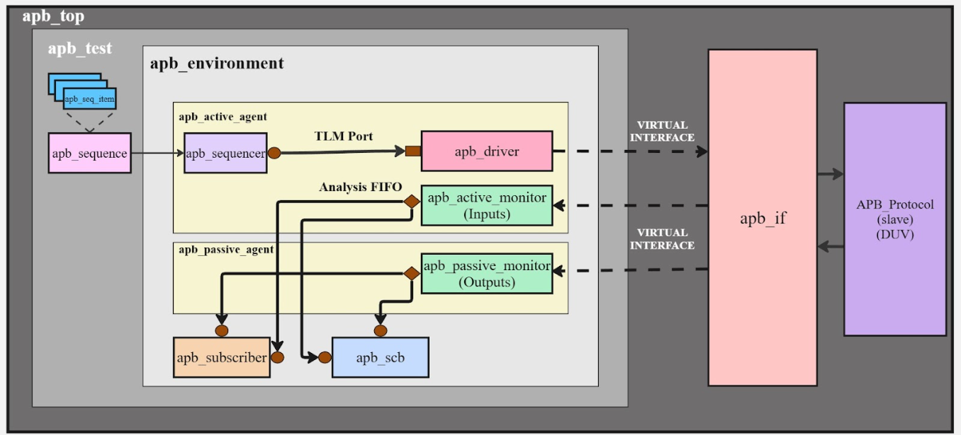

The figure shows the verification architecture for an APB slave built using a UVM testbench approach.

Key Components:
- Sequence Item – A user-defined transaction class that holds all the required fields for a single APB operation, such as address, data, and control information.

- Sequence – Produces a stream of sequence items that serve as stimulus for the DUT. The test triggers the sequence to start generating transactions.

- Sequencer – Serves as the communication channel between the sequence and the driver. It forwards sequence items to the driver using a TLM interface and ensures proper handshaking.

- Driver – Receives transactions from the sequencer and translates them into pin-level APB signal activities. It drives the DUT through the APB interface

- Monitor – Observes DUT signal activity using the virtual interface.
The active monitor captures the APB inputs driven to the DUT.
The passive monitor captures the DUT's output responses.
Both convert observed signal activity back into transaction objects and publish them through TLM analysis ports.
- Agent – A modular UVM component that groups related verification elements.
The active agent contains the sequencer, driver, and an input monitor.
The passive agent contains only the monitor that tracks output responses.
- Scoreboard – Receives monitored transactions and compares the DUT’s output with expected results to detect mismatches.

- Subscriber – Collects functional coverage information. It connects to analysis ports from both active and passive monitors to ensure all required scenarios are covered.

- Environment – A higher-level container that instantiates and connects all verification components, including agents, the scoreboard, and subscriber.

- Test – The top-level UVM class that builds the environment, configures components, and launches sequences that generate stimulus.

- Top Module – Instantiates the DUT and interface, connects everything to the UVM testbench, and starts the UVM phase flow.

- Interface – Provides the connection between the DUT and the testbench elements, exposing the APB signals to the driver and monitors via the virtual interface.

CHAPTER 3 - RESULT
Waveforms:
Write
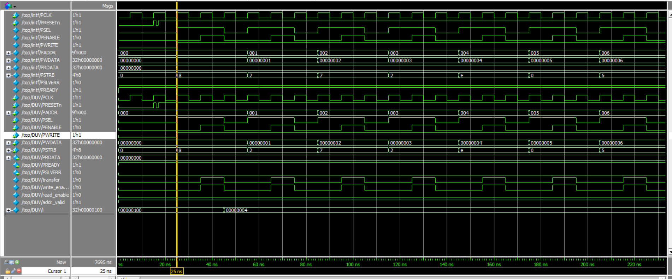
Read
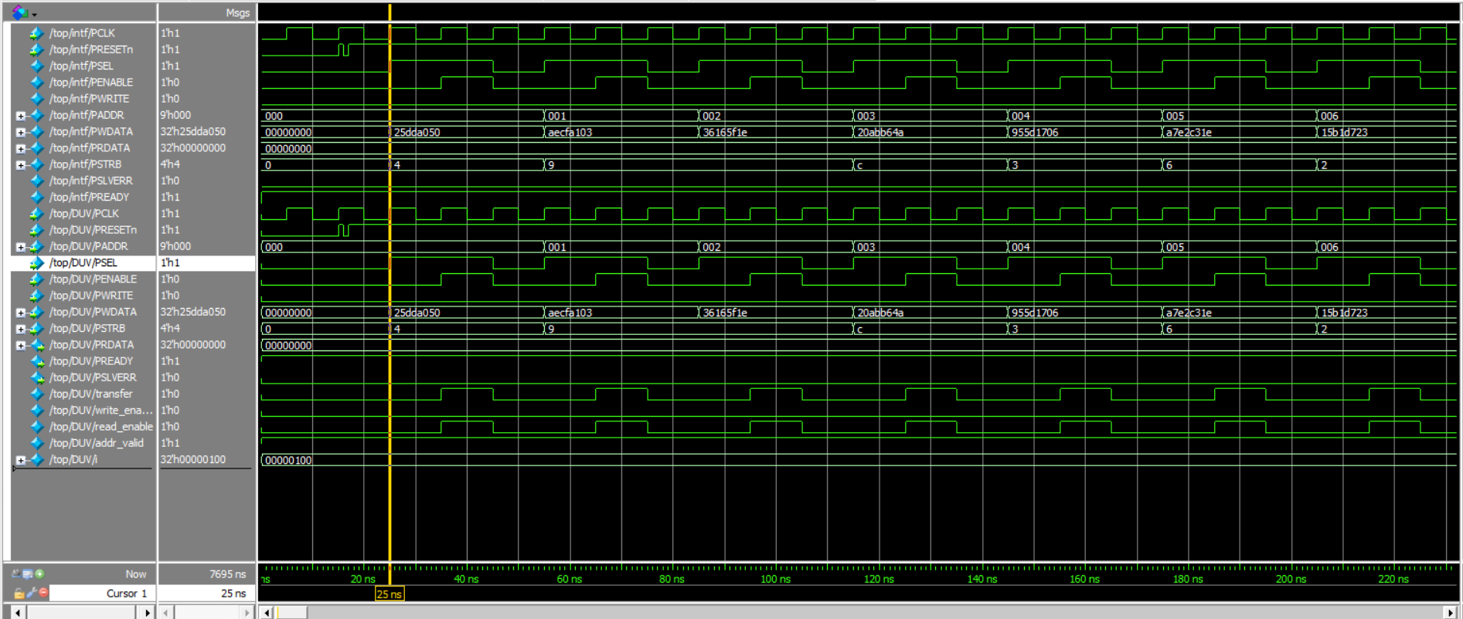
Write_Read
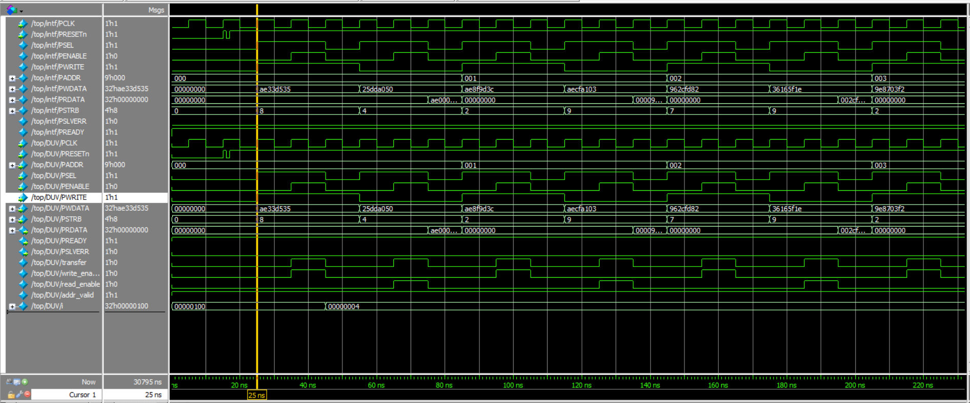
Slave_err
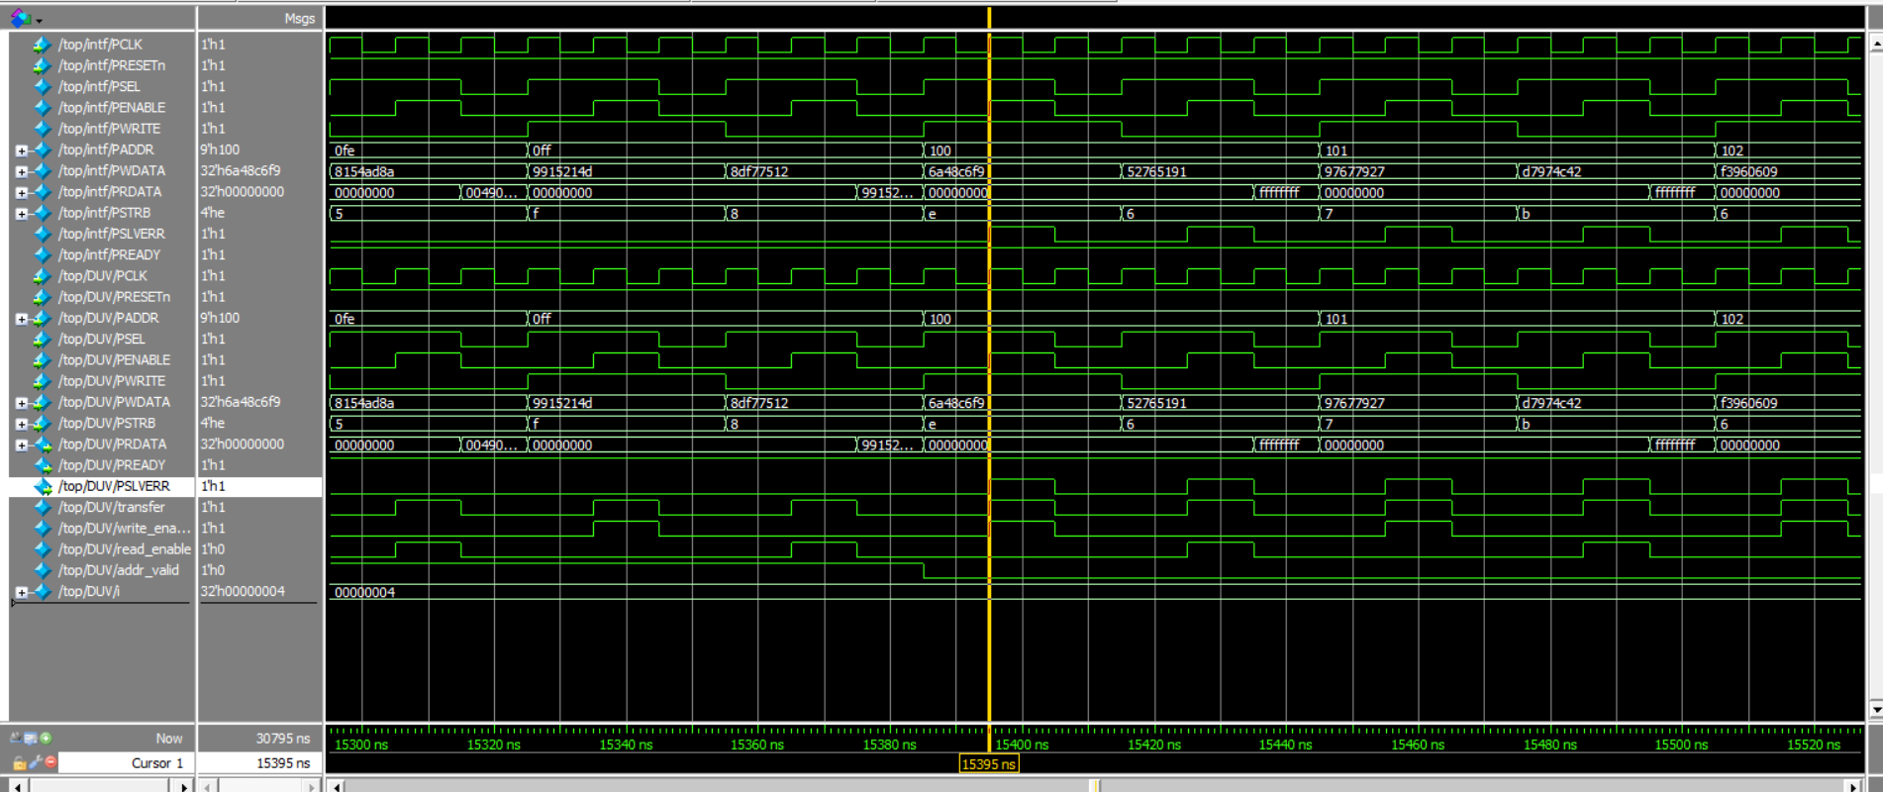

Coverage Report:
Assertions
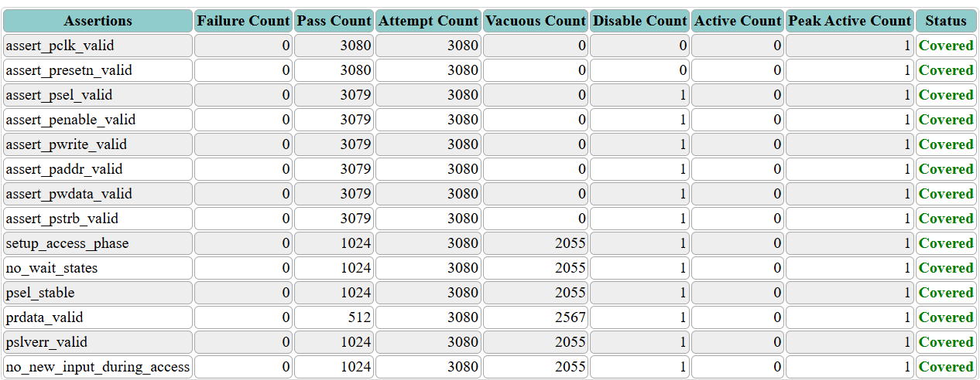

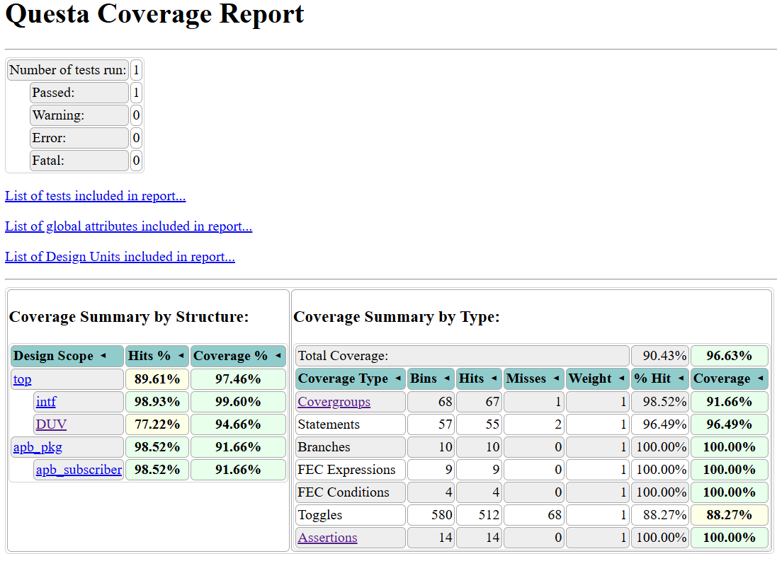

DUT Coverage:

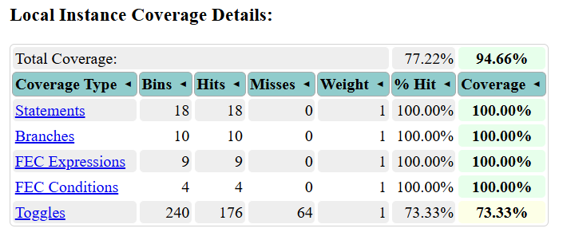

Input coverage:
