**QUBE INRASTRUCTURE CODE TO BRING 3 TIER WEB APPLICATION**

**1)Run the python file (infra.py) and give the input as per requirement. Gave a sample input below.**

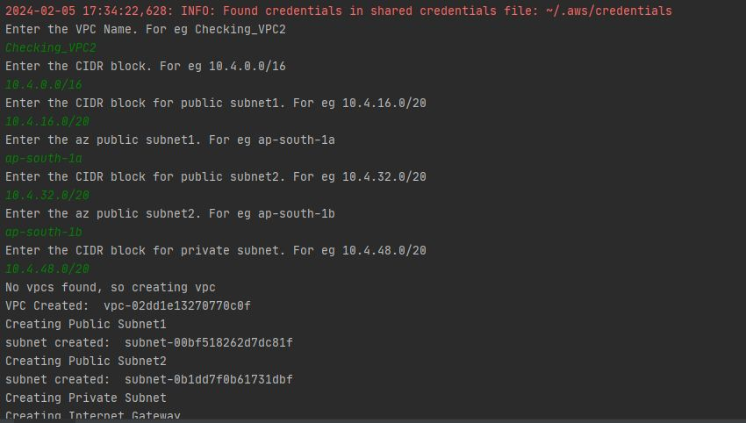

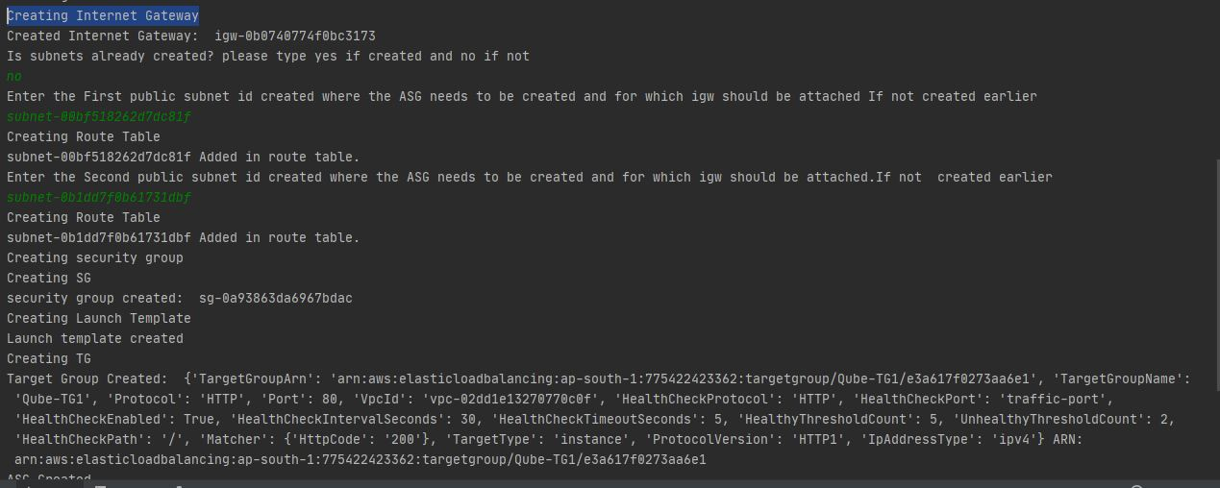

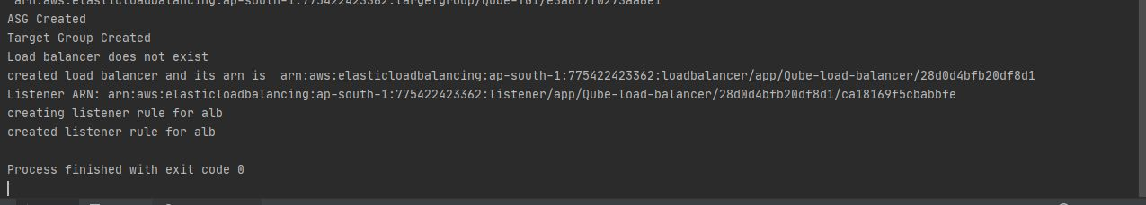

2)VPC created

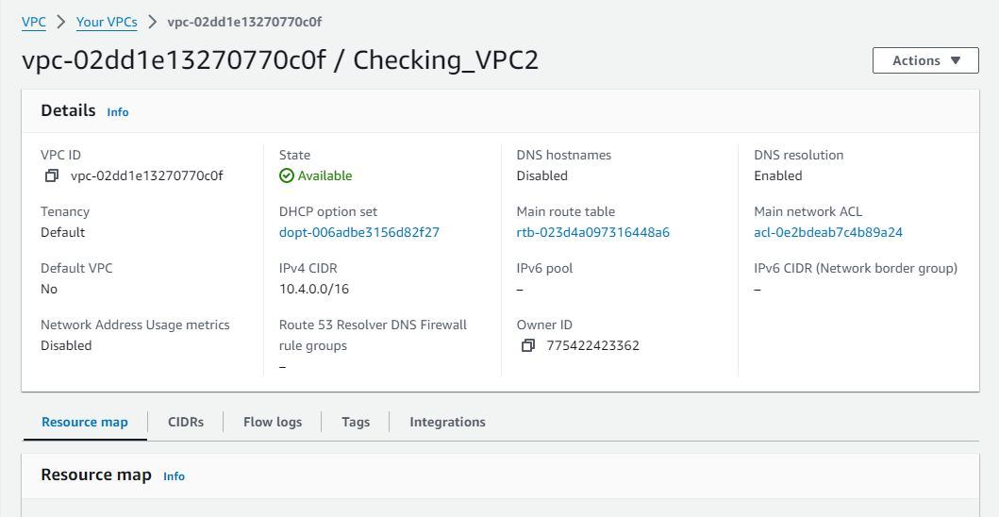

3) Subnets created

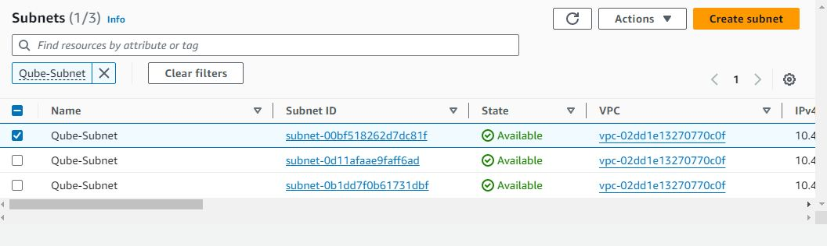

4)Launch template created

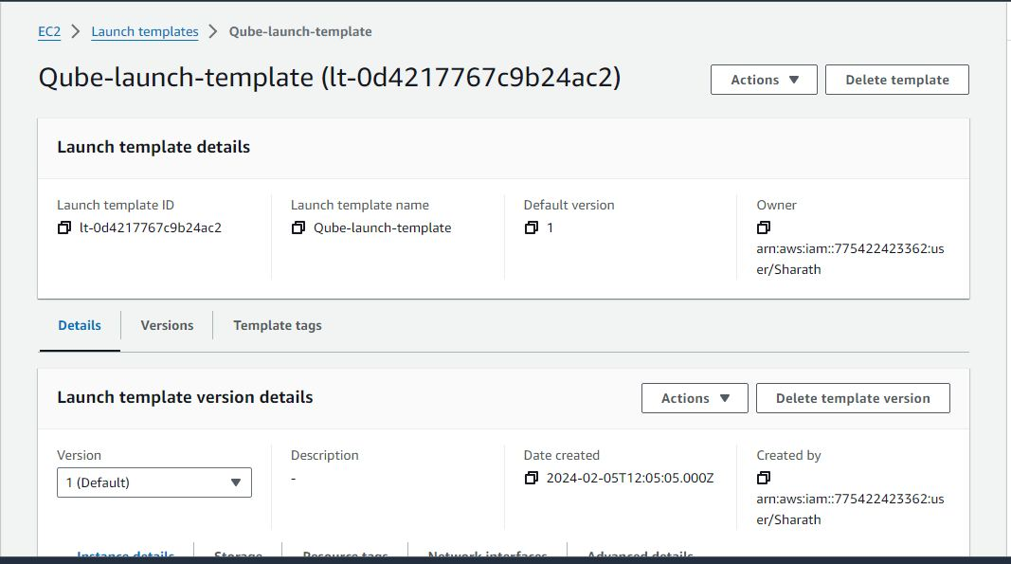

5)Security Group Created.

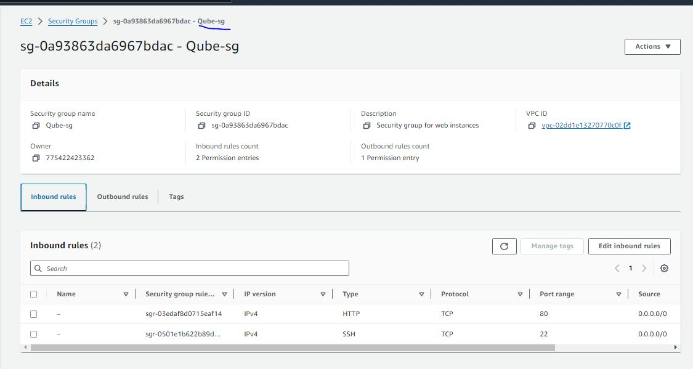

6)ASG created

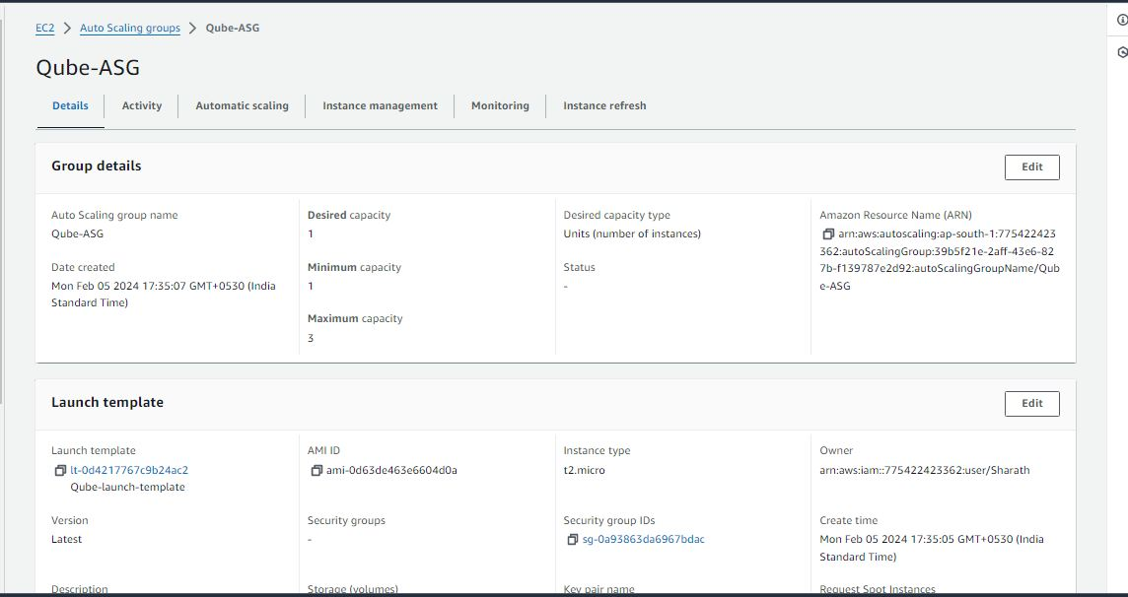

7) Target Group created

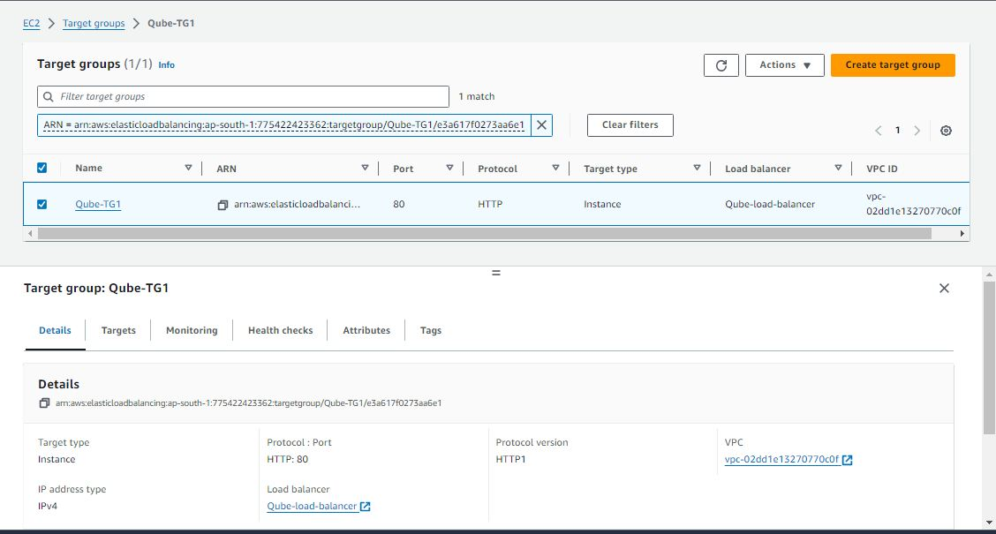

8)Load balancer created

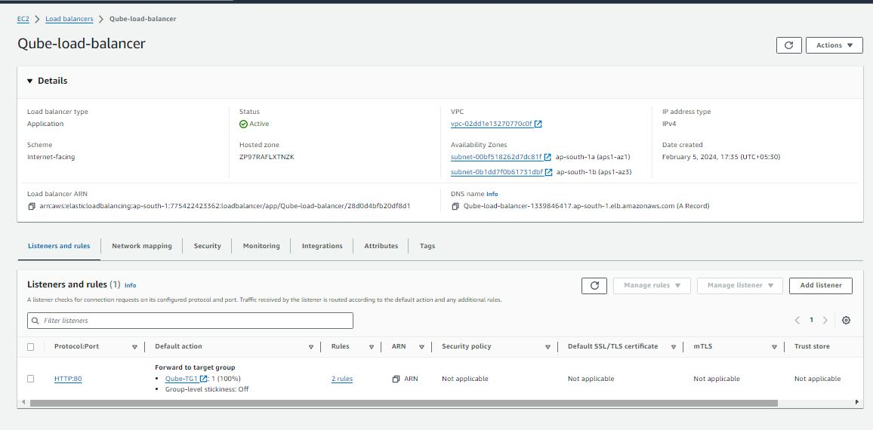

9) Web page   
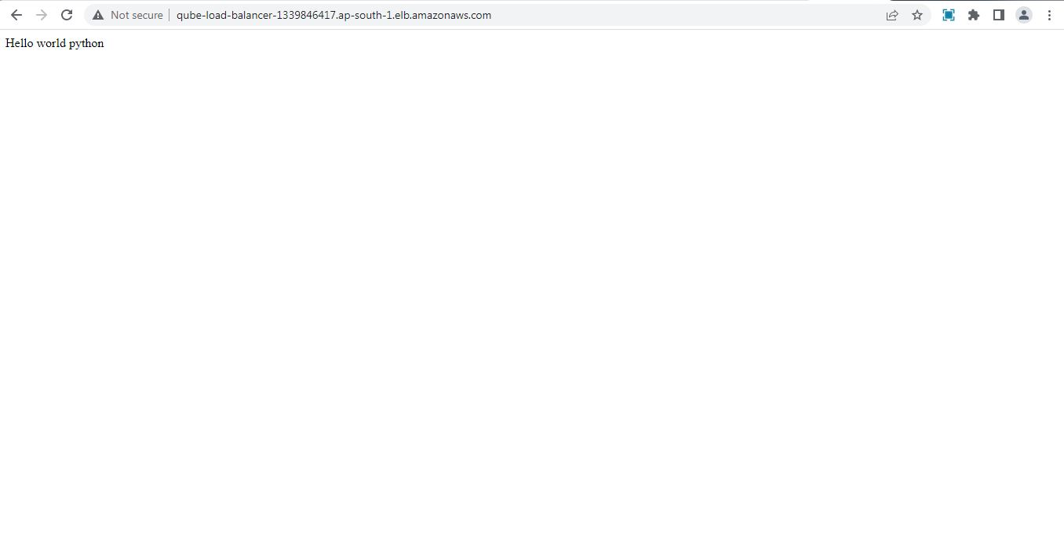

Thank you