In [31]: df Out[31]:

In

[1]:

In

[30]:

In

[32]:

**Unnamed: 0**

**customer id**

**age**

**income**

**spending score**

**0**

0

1

19.0

42.0

NaN

**1**

1

2

20.0

NaN

55.0

**2**

2

3

28.0

NaN

NaN

**3**

3

4

29.0

NaN

NaN

**4**

4

5

23.0

NaN

NaN

**5**

5

6

23.0

NaN

NaN

**6**

6

7

NaN

NaN

NaN

**7**

7

8

32.0

NaN

NaN

**8**

8

9

43.0

NaN

NaN

**9**

9

10

36.0

NaN

NaN

**10**

10

11

NaN

NaN

NaN

**11**

11

12

20.0

NaN

NaN

Out[32]:

Unnamed: 0 26.000

customer id 27.000

Assignment no.- 03

Aim-

. Summary statistics

1

2

. Types of Variables

. Summary statistics of income grouped by the age groups

3

. Display basic statistical details on the iris dataset.

4

**import**

pandas

**as**

pd

**import**

numpy

**as**

np

df

**=**

pd

.

read_csv

(

"C:\\Users\\SSOS03\\Desktop\\data.csv"

)

df

.

mean

()

age 32.425 income 42.000 spending score 55.000 dtype: float64

In

[39]:

df

.

loc

[:

,

'age '

].

mean

()

Out[39]: 32.425

In

[40]:

df

.

mean

(

axis

**=**

1

)[

0

:

4

]

Out[40]: 0 15.5 1 19.5

2 11.0 3 12.0 dtype: float64 Out[41]: Unnamed: 0 26.0 customer id 27.0 age 32.5 income 42.0 spending score 55.0 dtype: float64

In

[43]:

df

.

loc

[:

,

'age '

].

median

()

Out[44]:

[41]:

df

.

median

()

In

[44]:

In

[46]:

Out[43]:

32.5

**Unnamed: 0**

**customer id**

**age**

**income**

**spending score**

**0**

0

1

29.0

42.0

55.0

**1**

1

2

NaN

NaN

NaN

**2**

2

3

NaN

NaN

NaN

**3**

3

4

NaN

NaN

NaN

**4**

4

5

NaN

NaN

NaN

**5**

5

6

NaN

NaN

NaN

**6**

6

7

NaN

NaN

NaN

**7**

7

8

NaN

NaN

NaN

**8**

8

9

NaN

NaN

NaN

**9**

9

10

NaN

NaN

NaN

**10**

10

11

NaN

NaN

NaN

**11**

11

12

NaN

NaN

NaN

Out[46]:

0

29.0

Name: age , dtype: float64

df

.

mode

()

df

.

loc

[:

,

'age '

].

mode

()

In [47]: df.min()

Out[47]: Unnamed: 0 0.0 customer id 1.0 age 19.0 income 42.0 spending score 55.0 dtype: float64

In

[49]:

df

.

loc

[:

,

'age '

].

min

(

skipna

**=**

**False**

)

Out[49]: nan

Out[50]: Unnamed: 0 52.0 customer id 53.0 age 50.0 income 42.0 spending score 55.0 dtype: float64

In

[52]:

df

.

loc

[:

,

'age '

].

max

(

skipna

**=**

**False**

)

Out[52]: nan

In [53]: df.std()

Out[53]: Unnamed: 0 15.443445 customer id 15.443445 age 9.747814 income NaN spending score NaN dtype: float64

[50]:

df

.

max

()

In

[54]:

df

.

loc

[:

,

'age '

].

std

()

Out[54]: 9.747813693073532

In

[55]:

df

.

std

(

axis

**=**

1

)[

0

:

4

]

Out[55]: 0 19.706175 1 25.225648

1. 14.730920
2. 14.730920

In

[57]:

dtype: float64

Out[57]:

customer id

19.0

1

20.0

2

3

28.0

4

29.0

5

23.0

23.0

6

NaN

7

8

32.0

43.0

9

10

36.0

NaN

11

12

20.0

13

19.0

14

23.0

15

49.0

16

43.0

17

NaN

18

47.0

19

49

0

df

.

groupby

([

'customer id '

])[

'age '

].

mean

()

[71]: df_u**=**df.rename(columns**=** {'income)':' new income'},inplace**=False**) df_u.groupby(['age ']).income.mean()

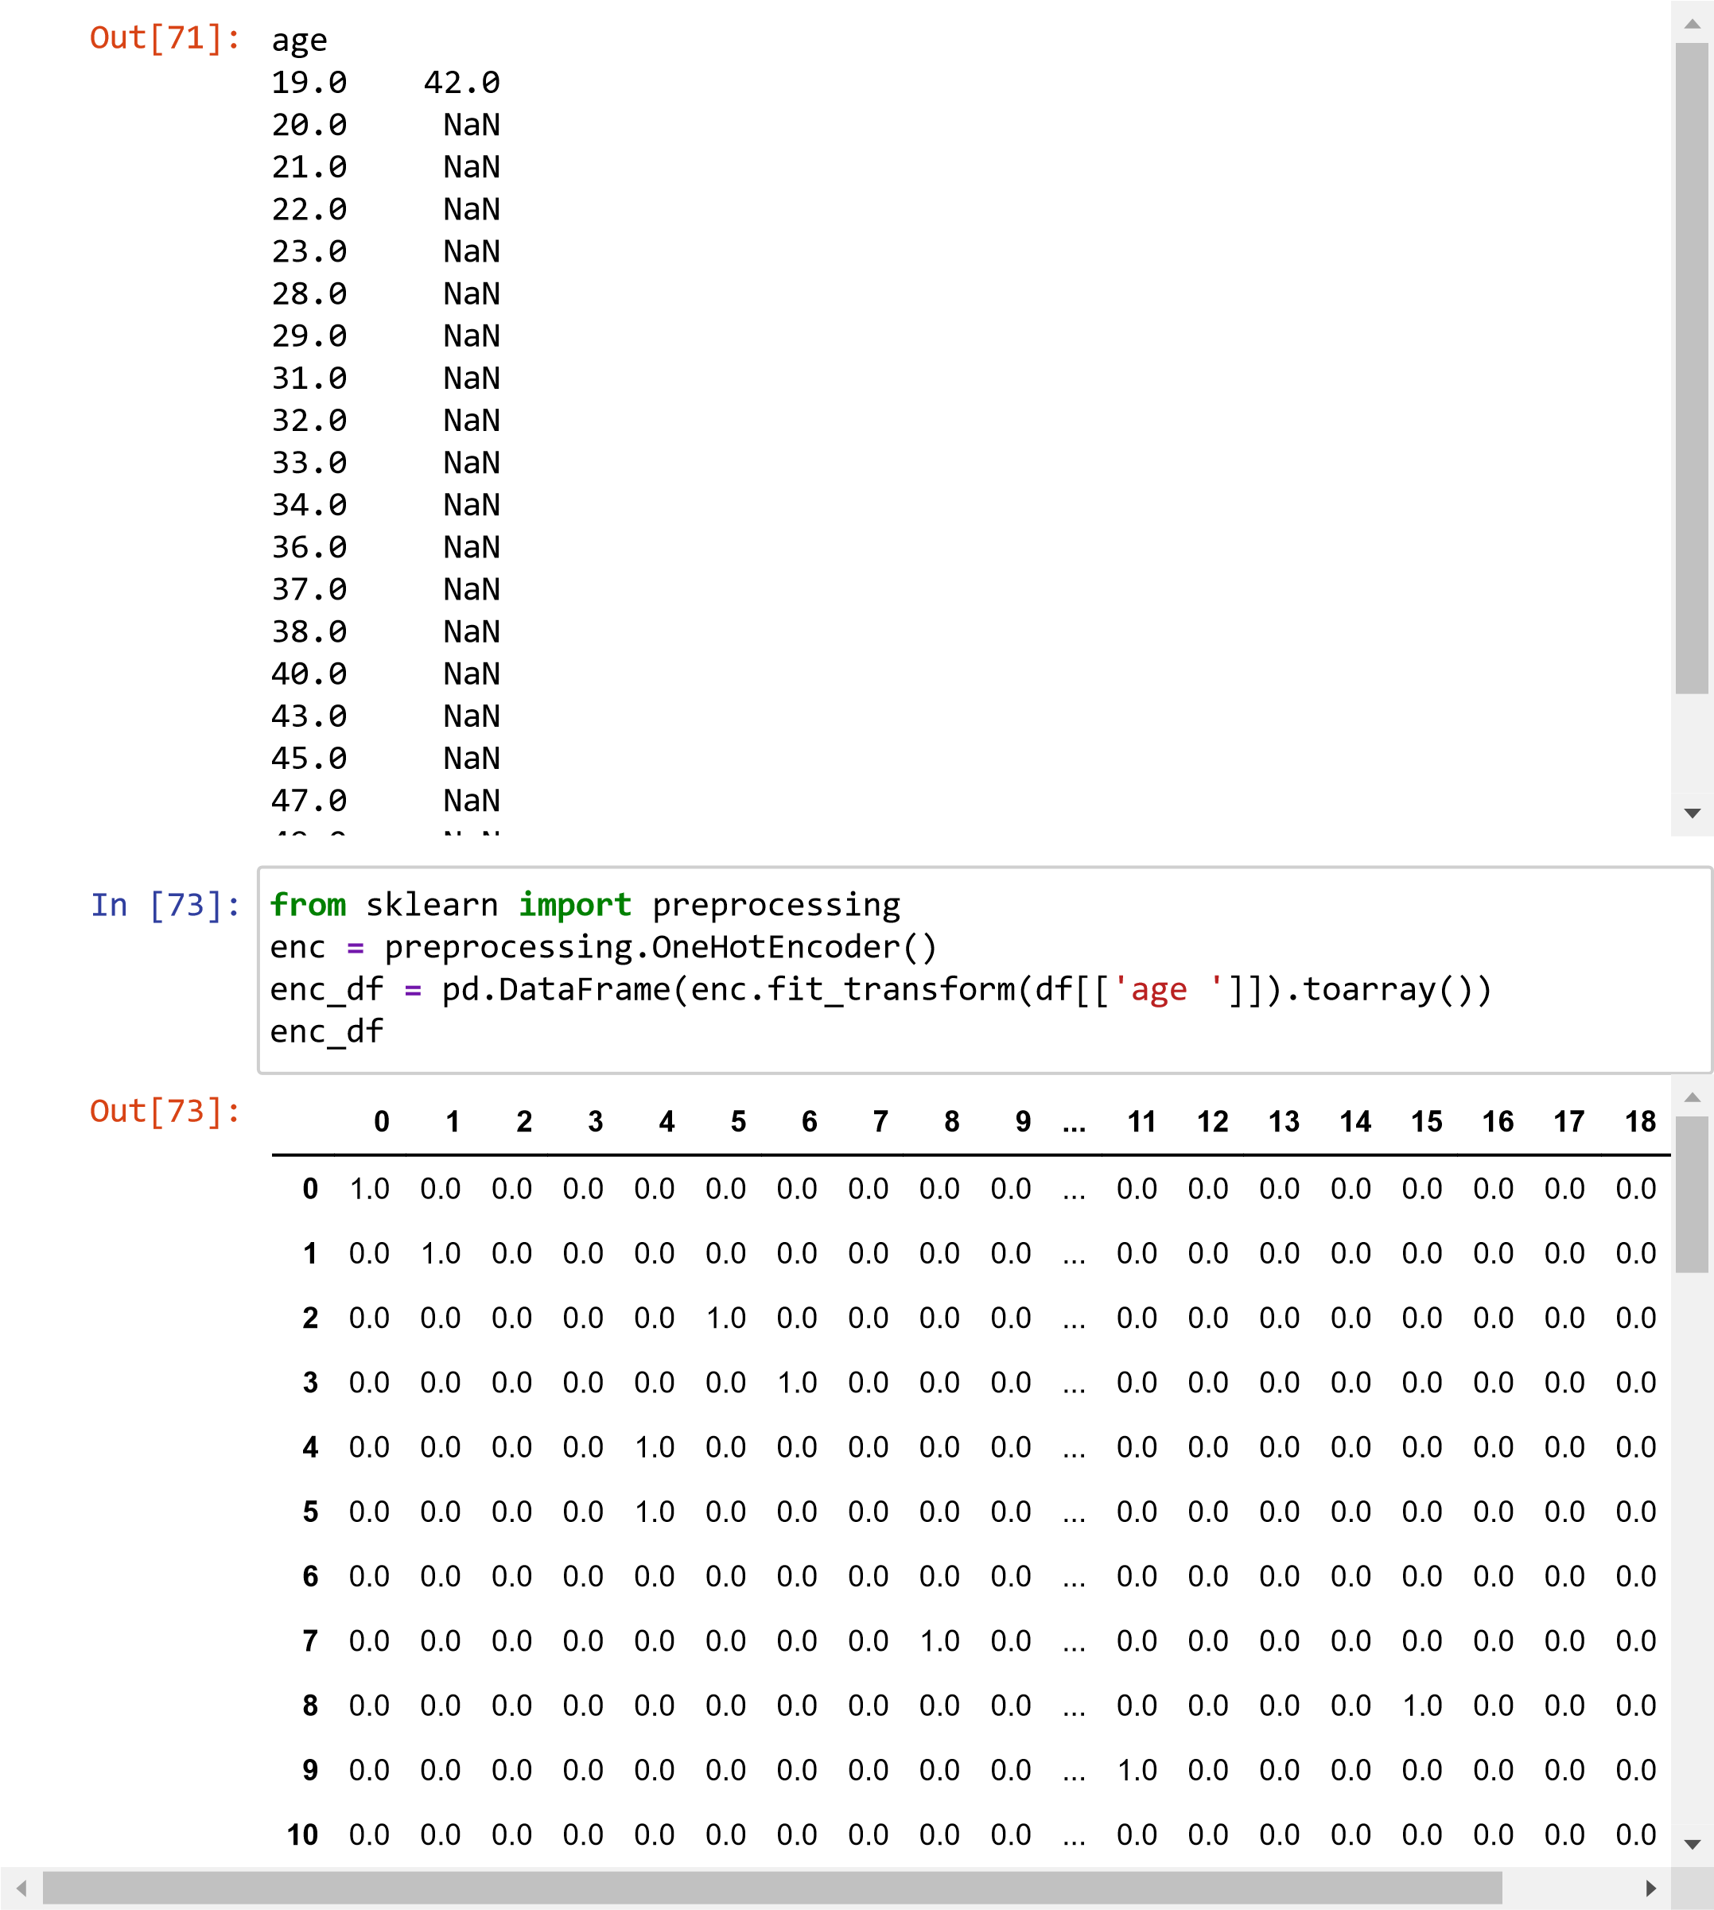

[74]: df_encode **=**df_u.join(enc_df) df_encode

In

[96]:

irisVer

**=**

(

iris

[

'Species'

]

**==**

'Iris-versicolor'

)

|  |  |  |  |  |  |  |  |  |  |  |  |  |  |  |  |  |
| --- | --- | --- | --- | --- | --- | --- | --- | --- | --- | --- | --- | --- | --- | --- | --- | --- |
| Out[74]: | |  | **Unnamed: 0** | **customer id** | **age** | **income** | **spending score** | **0** | **1** | **2** | **3** | **4** | **...** | **11** | **12** | **13** |
| **0** | 0 | 1 | 19.0 | 42.0 | NaN | 1.0 | 0.0 | 0.0 | 0.0 | 0.0 | ... | 0.0 | 0.0 | 0.0 |
|  | | **1** | 1 | 2 | 20.0 | NaN | 55.0 | 0.0 | 1.0 | 0.0 | 0.0 | 0.0 | ... | 0.0 | 0.0 | 0.0 |
|  | | **2** | 2 | 3 | 28.0 | NaN | NaN | 0.0 | 0.0 | 0.0 | 0.0 | 0.0 | ... | 0.0 | 0.0 | 0.0 |
|  | | **3** | 3 | 4 | 29.0 | NaN | NaN | 0.0 | 0.0 | 0.0 | 0.0 | 0.0 | ... | 0.0 | 0.0 | 0.0 |
|  | | **4** | 4 | 5 | 23.0 | NaN | NaN | 0.0 | 0.0 | 0.0 | 0.0 | 1.0 | ... | 0.0 | 0.0 | 0.0 |
|  | | **5** | 5 | 6 | 23.0 | NaN | NaN | 0.0 | 0.0 | 0.0 | 0.0 | 1.0 | ... | 0.0 | 0.0 | 0.0 |
|  | | **6** | 6 | 7 | NaN | NaN | NaN | 0.0 | 0.0 | 0.0 | 0.0 | 0.0 | ... | 0.0 | 0.0 | 0.0 |
|  | | **7** | 7 | 8 | 32.0 | NaN | NaN | 0.0 | 0.0 | 0.0 | 0.0 | 0.0 | ... | 0.0 | 0.0 | 0.0 |
|  | | **8** | 8 | 9 | 43.0 | NaN | NaN | 0.0 | 0.0 | 0.0 | 0.0 | 0.0 | ... | 0.0 | 0.0 | 0.0 |
|  | | **9** | 9 | 10 | 36.0 | NaN | NaN | 0.0 | 0.0 | 0.0 | 0.0 | 0.0 | ... | 1.0 | 0.0 | 0.0 |
|  | | **10** | 10 | 11 | NaN | NaN | NaN | 0 0 | 0 0 | 0 0 | 0 0 | 0 0 |  | 0 0 | 0 0 | 0  0 |
|  |  |  |  |  |  |  |  |  |  |  |
|  |  |  |  |  |  |  |  |  |  |

In

[91]:

In

[93]:

In

[94]:

In

[95]:

col_names

**=**

[

'Sepal_Length'

,

'Sepal_Width'

,

'Petal_Length'

,

'Petal_Width'

,

'Speci

iris

**=**

pd

.

read_csv

(

'https://archive.ics.uci.edu/ml/machine-learning-database

irisSet

**=**

(

iris

[

'Species'

]

**==**

'Iris-setosa'

)

print

(

'Iris-setosa'

)

print

(

iris

[

irisSet

].

describe

())

Iris-setosa

Sepal_Length Sepal_Width Petal_Length Petal_Width count 50.00000 50.000000 50.000000 50.00000 mean 5.00600 3.418000 1.464000 0.24400 std 0.35249 0.381024 0.173511 0.10721 min 4.30000 2.300000 1.000000 0.10000 25% 4.80000 3.125000 1.400000 0.20000

50% 5.00000 3.400000 1.500000 0.20000 75% 5.20000 3.675000 1.575000 0.30000 max 5.80000 4.400000 1.900000 0.60000 [97]: print('Iris-versicolor') print(iris[irisVer].describe())

Iris-versicolor

Sepal_Length Sepal_Width Petal_Length Petal_Width count 50.000000 50.000000 50.000000 50.000000 mean 5.936000 2.770000 4.260000 1.326000 std 0.516171 0.313798 0.469911 0.197753 min 4.900000 2.000000 3.000000 1.000000 25% 5.600000 2.525000 4.000000 1.200000

50% 5.900000 2.800000 4.350000 1.300000 75% 6.300000 3.000000 4.600000 1.500000 max 7.000000 3.400000 5.100000 1.800000

Name- Sharayu Nanaware Rollno.- 13243