Propensity Score Analysis of Antihypertensive Treatment
and Cardiovascular Mortality
A Comparative Effectiveness Study Using NHANES Linked Mortality Data
Sridharan Gopalsamy Ramaswamy | MPH/MBA, Washington University in St. Louis | April 2026

Executive Summary
This study estimates the effect of antihypertensive treatment on cardiovascular mortality in 18,129 hypertensive US adults using propensity score methods applied to NHANES 1999-2018 with linked mortality follow-up through 2019.
- Confounding is massive. The unadjusted HR of 2.86 suggests treatment increases CV death, but this is an artifact of confounding by indication. After PS matching, the HR attenuates to 1.24.
- Method choice changes the conclusion. PS matching finds HR 1.24 (p=0.027), IPTW finds no effect (HR 1.02, p=0.81), and the doubly robust estimate is HR 1.15 (p=0.09).
- The PH assumption is borderline violated (p=0.035), suggesting the treatment effect varies over time, consistent with delayed benefit of BP control.

Data Overview
Metric | Full Cohort | PS-Matched
N | 18,129 | 6,962
Treated | 13,649 (75.3%) | 3,481 (50.0%)
CV Deaths | 1,641 (9.1%) | 577 (8.3%)
Median follow-up | 7.8 years | 9.3 years

1. Propensity Score Distribution
The propensity score model (logistic regression on 12 covariates) achieves 81% accuracy. The score distributions show substantial overlap with clear separation, confirming systematic confounding by indication.
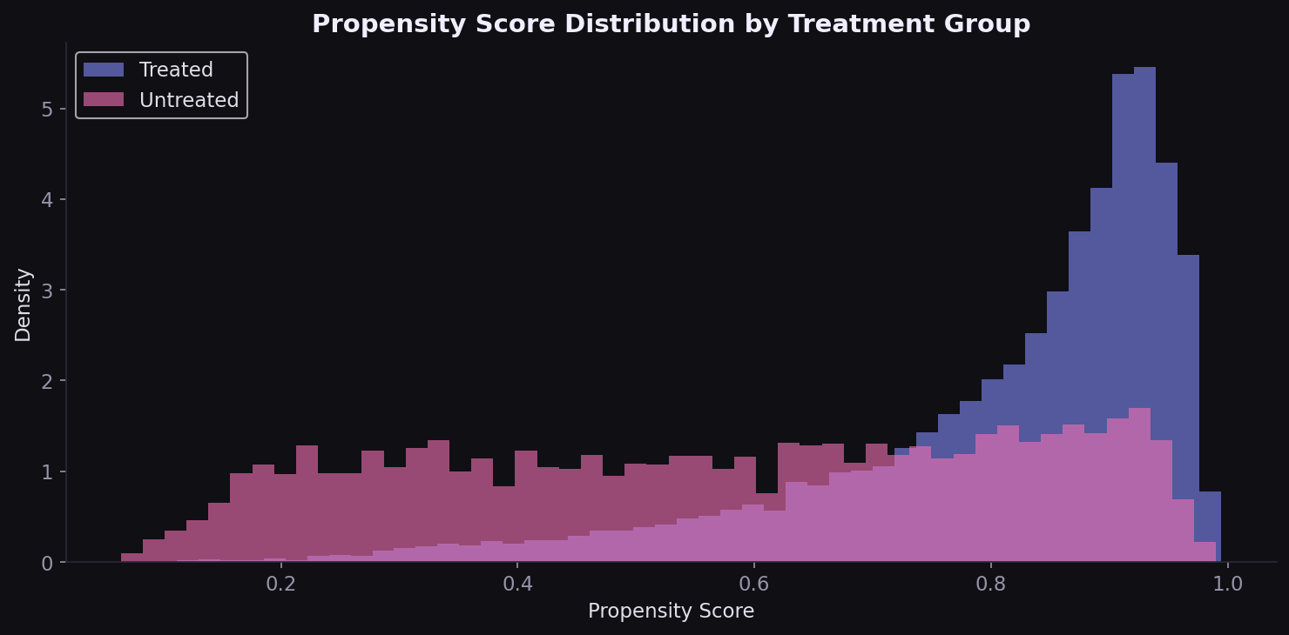
Figure 1. Propensity Score Distribution by Treatment Group

2. Covariate Balance
Both PS matching and IPTW reduce standardized mean differences substantially. Age, the strongest confounder (SMD ~0.70 unadjusted), drops below 0.1 after matching.
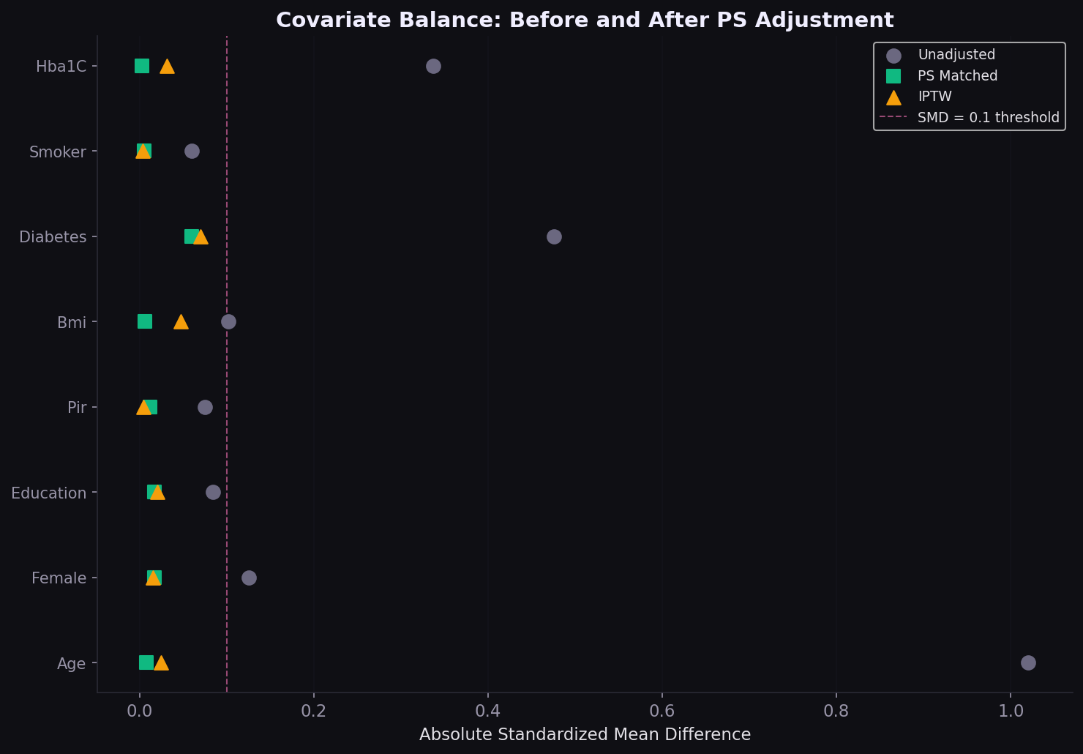
Figure 2. Love Plot: Covariate Balance Before and After Adjustment

3. Survival Analysis
The unadjusted KM shows dramatic separation (treated patients dying faster because they are sicker). After matching, the curves converge substantially.
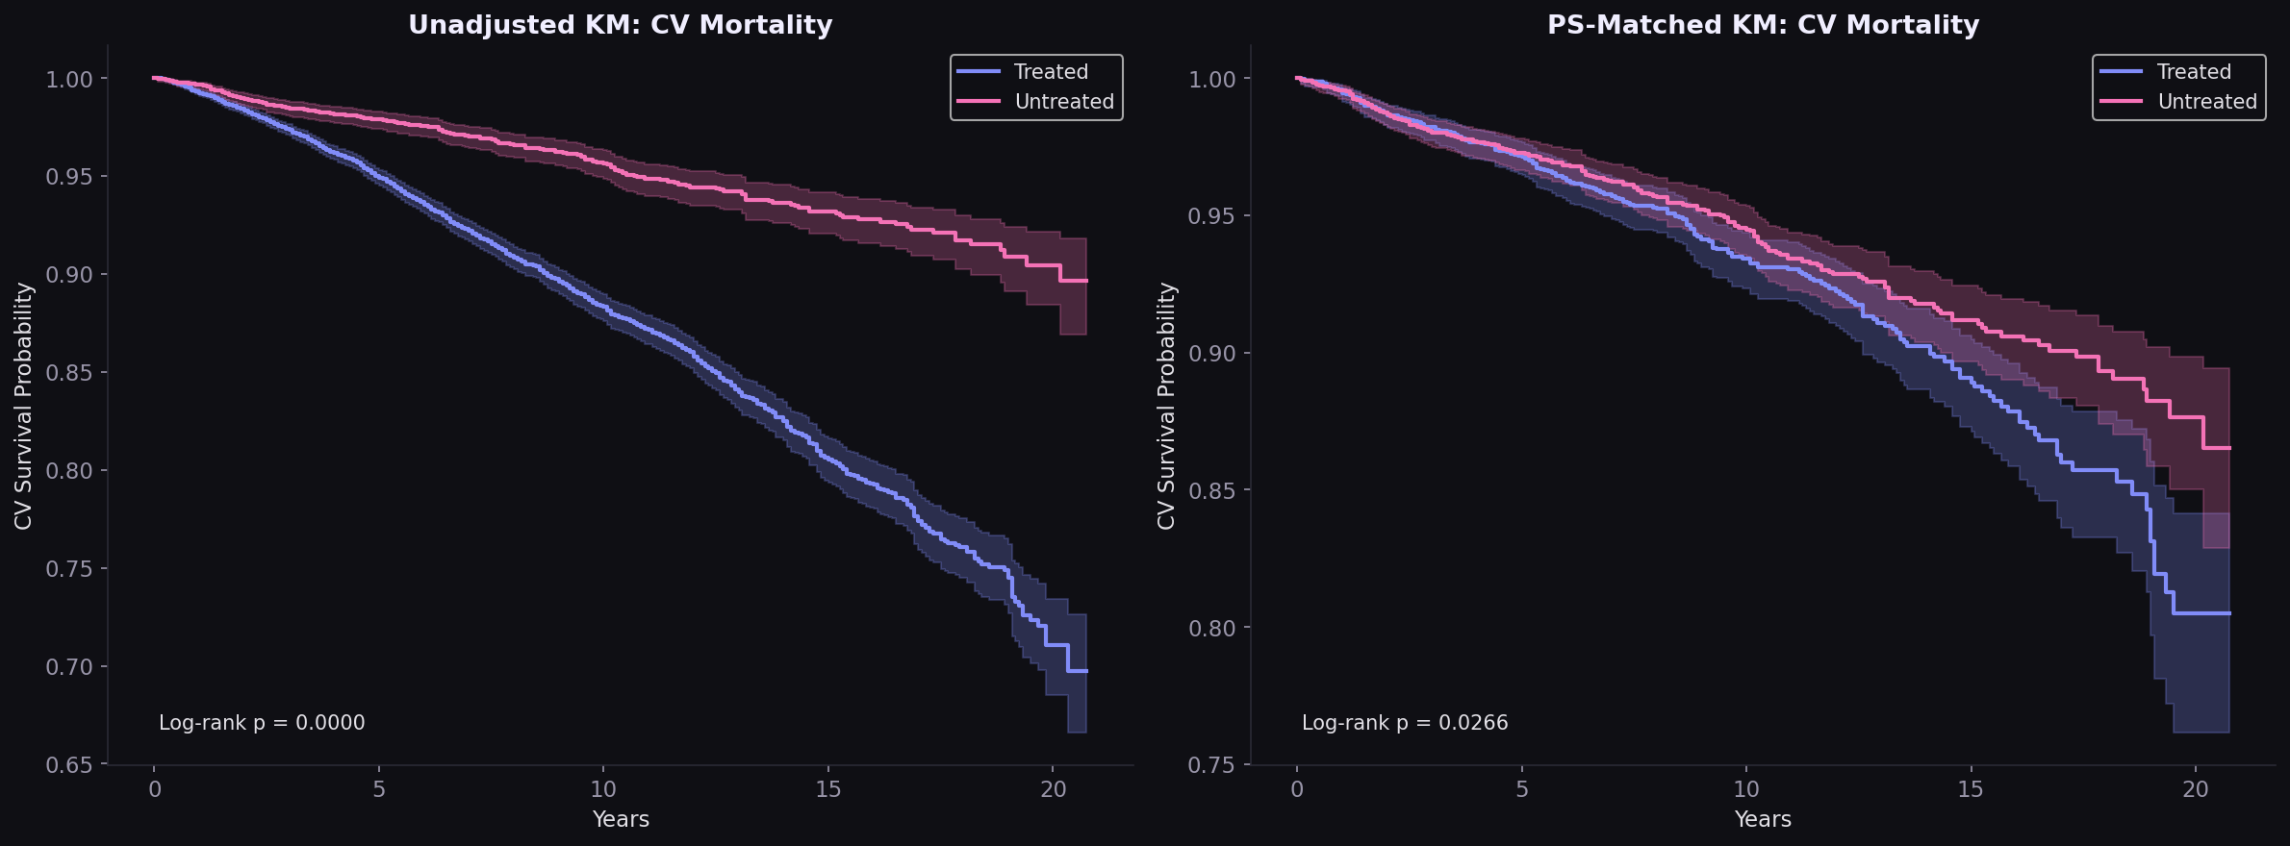
Figure 3. Kaplan-Meier Curves: Unadjusted and PS-Matched

4. Treatment Effect Estimates
Four Cox PH models estimate the treatment hazard ratio under increasingly rigorous confounding control.
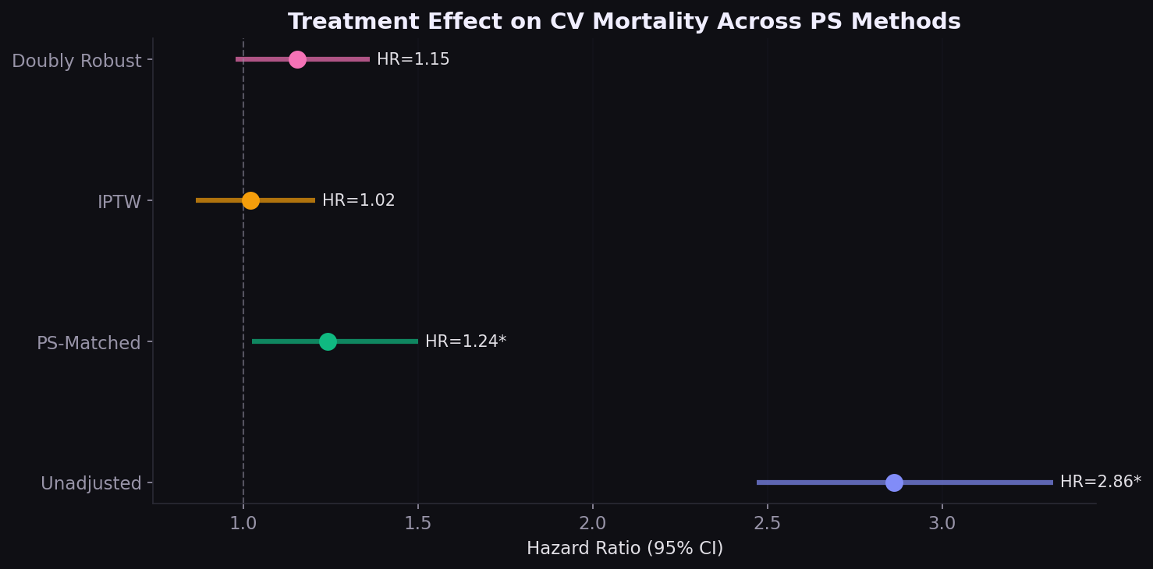
Figure 4. Hazard Ratio Forest Plot Across PS Methods
Model | HR | 95% CI | p | N
Unadjusted | 2.86 | 2.47-3.32 | <0.001 | 18,129
PS-Matched | 1.24 | 1.03-1.50 | 0.027 | 6,962
IPTW | 1.02 | 0.87-1.21 | 0.808 | 18,129
Doubly Robust | 1.15 | 0.98-1.36 | 0.091 | 18,129

The IPTW estimate (HR 1.02) is the most fully adjusted and suggests no net harm or benefit. However, this should not be interpreted as treatment futility. Residual confounding, the healthy-user effect, and limitations of self-reported treatment data are likely explanations.

5. Proportional Hazards Assessment
The HR-over-time plot shows the treatment effect is not constant: higher in early follow-up, attenuating over time. Formal PH test: p=0.035 for treatment.
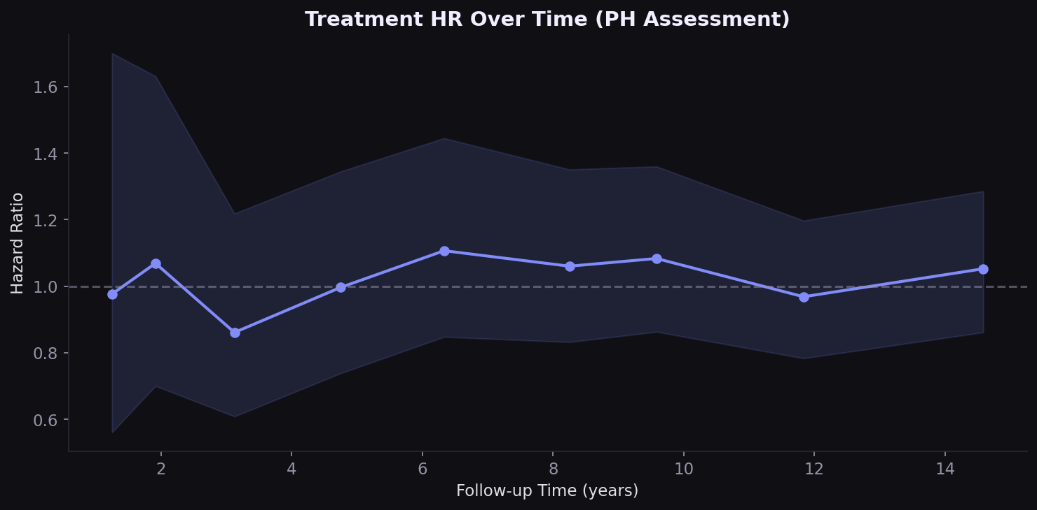
Figure 5. Treatment HR Over Time

6. Subgroup Analysis
The subgroup forest plot tests whether the treatment effect varies by age, sex, diabetes, and smoking status in the PS-matched cohort.
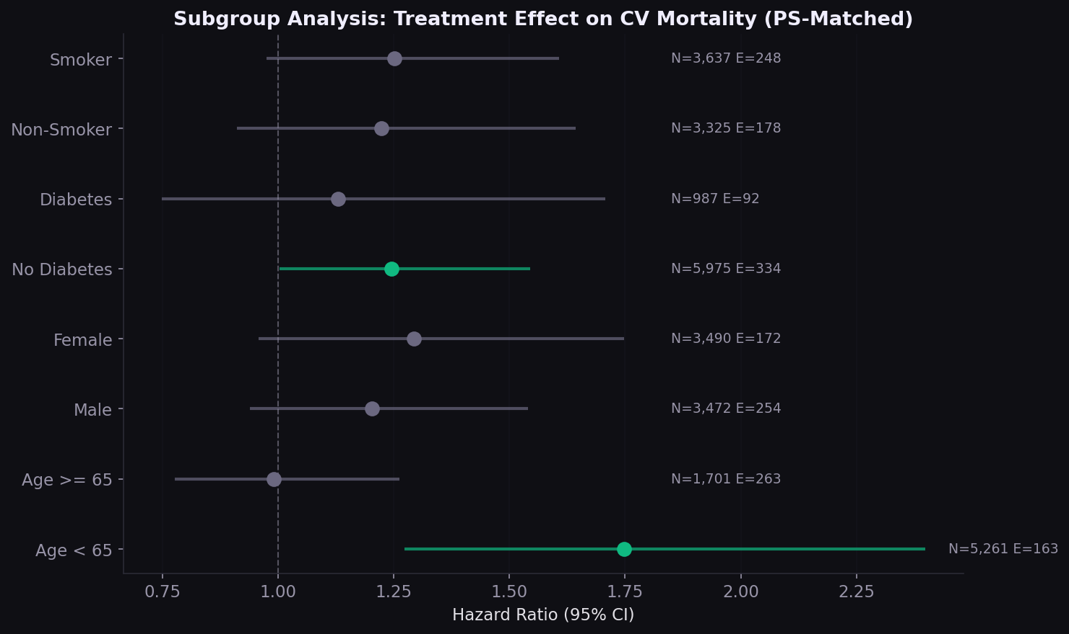
Figure 6. Subgroup Forest Plot (PS-Matched)

Implications for HEOR and Consulting
Finding | Implication
Unadjusted HR reverses after PS adjustment | Observational analyses require rigorous confounding control for formulary/coverage decisions
HR varies 1.02-1.24 across methods | Sensitivity analysis across PS approaches is non-negotiable for HEOR submissions
PH assumption borderline violated | Time-varying treatment effects should be explored; standard Cox may mask delayed benefit
3,481 matched pairs from 18,129 | IPTW preserves the full sample and may be preferable when overlap is limited
Self-reported treatment is a limitation | Claims-based identification (NDC codes, pharmacy fills) would strengthen real-world analyses

Methods
Data: NHANES 1999-2018 (10 cycles) linked to NCHS mortality (follow-up through Dec 2019). Cohort: 18,129 adults 20+ with self-reported hypertension. Treatment: antihypertensive medication use (BPQ050A). Outcome: CV mortality (UCOD heart disease or cerebrovascular disease). PS model: logistic regression on 12 covariates. Matching: 1:1 nearest-neighbor, caliper = 0.2 SD of logit PS. IPTW: ATE weights, trimmed at 99th percentile. Tools: Python, lifelines, scikit-learn, pandas, matplotlib.

Analysis by Sridharan Gopalsamy Ramaswamy | sridharanshri.com

