Role A: Clinical Lead
I2DB Datathon 2025 — Diabetes Risk Prediction

Reference document for the team member leading feature engineering,
clinical narrative, and domain interpretation.

Your responsibilities:
- Explain every feature engineering decision with clinical reasoning
- Own the "clinical story" arc of the presentation
- Handle clinician-facing Q&A (confounding, feature rationale, clinical workflow)
- Connect model outputs to real-world diabetes care

1. Dataset Overview
We worked with electronic health record (EHR) data for 62,425 diabetes patients. Each patient has 12 months of prior data (labs, medications, visits, demographics) and a binary outcome: did their A1c become uncontrolled in the following year?
Property | Value
Total patients | 62,425
Features | 41 columns across 9 clinical domains
Target | a1c 2025 Uncontrolled (True/False)
Class balance | 89.4% Controlled (55,793) / 10.6% Uncontrolled (6,632)
Imbalance ratio | ~1:8 (for every 1 uncontrolled, there are ~8 controlled)

The 9 clinical domains:
Domain | Columns | Missingness | Notes
Demographics | 4 | Near-complete | Birth year, sex, race, ethnicity
A1c Labs | 11 | A1c 1: 0%, A1c 2: 58%, A1c 3: 88%, A1c 4-5: 97% | Up to 5 readings + timing + 1 leakage column
Medications | 6 | 0% (zeros = no orders) | Metformin, insulin, GLP-1, SGLT2, sulfonylurea, DPP4
Utilization | 3 | 0% | ED visits, PCP visits, admissions
Comorbidities | 2 | 0% | CAD count, COPD count
Cholesterol | 6 | 24% | LDL, HDL, total + timing
Weight/Height | 6 | 73-76% | Values, dates, units. All kg/cm.
Insurance | 1 | 67% | 12 raw categories
ADI | 2 | 37-48% | Area Deprivation Index (state + national). Stored as strings.

2. The Data Leakage Finding (Step 4)
This is the single most important data quality issue we discovered, and you need to be able to explain it clearly to judges.
What we found:
The column "a1c 2025-collection date-time-days from reference" records when the 2025 A1c test was collected. This column is 0% missing for uncontrolled patients but 47.7% missing for controlled patients. In other words:
Column status | N patients | Controlled | Uncontrolled
Has a value | 35,808 | 29,176 | 6,632 (all uncontrolled patients)
Missing | 26,617 | 26,617 (100% controlled) | 0
If this column is missing, the patient is always controlled. A model could achieve near-perfect accuracy simply by checking: "Is this value null? → Yes → Controlled."
Why this is leakage:
This column contains information about the future outcome (the 2025 A1c test). In a real-world deployment, you would be making predictions before the 2025 test happens — so you would not have this column available. A model trained with this feature would appear excellent in development but fail completely in production because the "cheat code" would not exist for new patients.
What we did:
We dropped this column as the very first step in data cleaning (clean_data.py, line 18). It was never used in any model.
How to explain this to judges:
"We identified a column that leaked future information into the training data. One hundred percent of patients missing this value were controlled — the model could have exploited this to cheat. We dropped it immediately. This is the kind of data quality issue that separates a model that works in a competition from one that could actually be deployed in a clinic."
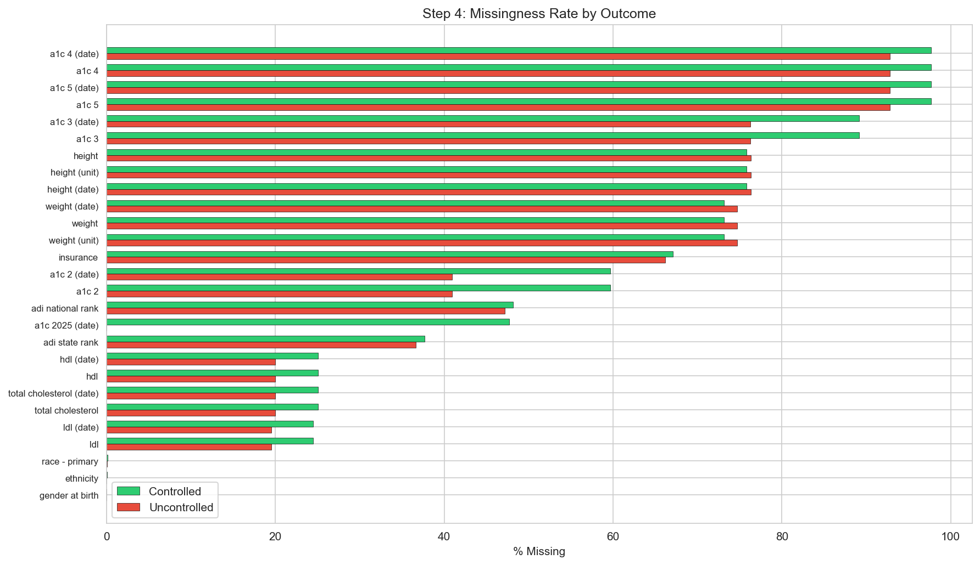
Figure 1: Missingness rates by outcome. Note the a1c 2025 (date) row — 0% missing for uncontrolled, 47.7% for controlled.
Beyond the leakage column, we found that missingness itself is informative. A1c 2 is 18.8 percentage points less missing in the uncontrolled group (40.9% vs 59.7%), and A1c 3 is 12.8pp less missing. This makes clinical sense: patients with poorly controlled diabetes get more frequent A1c monitoring. We captured this signal with the n_a1c_tests feature.

3. Key Clinical Patterns from the Data

3.1 The A1c Risk Curve (Step 2)
The most important clinical finding from our exploration: risk of becoming uncontrolled rises steeply with current A1c, but plateaus above A1c 9.
Current A1c | Risk of becoming uncontrolled | N patients | Clinical interpretation
< 5.7 | 1.0% | 10,469 | Normal range — very low risk
5.7 – 6.5 | 2.3% | 18,684 | Pre-diabetes / well-controlled — low risk
6.5 – 7.0 | 6.5% | 9,676 | At target — some risk begins
7.0 – 8.0 | 15.7% | 11,513 | Above target — 1 in 6 will lose control
8.0 – 9.0 | 27.8% | 5,078 | Poorly controlled — more than 1 in 4
9.0 – 10.0 | 32.1% | 2,591 | Very poorly controlled — risk plateaus
> 10.0 | 32.0% | 4,414 | Severely elevated — same plateau
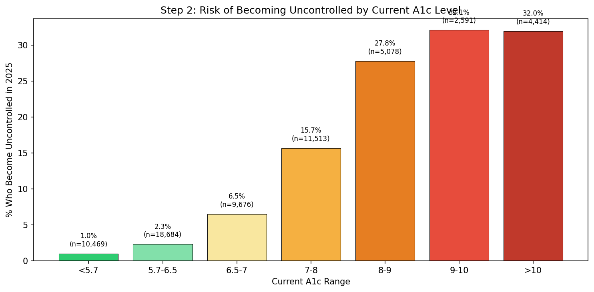
Figure 2: Risk of becoming uncontrolled by current A1c level. Clear dose-response with plateau above 9.
The plateau is clinically significant.
Once a patient is past A1c 9, higher A1c does not mean higher future risk — the risk flattens at ~32%. This suggests that above a certain severity, factors other than the A1c number itself drive outcomes: medication adherence, engagement with care, social determinants, comorbidities. This is why we need a multivariate model — A1c alone cannot distinguish a patient at A1c 10 who will regain control from one who will not.
The 65% problem:
65% of patients who become uncontrolled currently have A1c below 9. If you only intervened on patients with A1c ≥ 9, you would miss nearly two-thirds of future uncontrolled patients. The model catches patients across the entire A1c spectrum by incorporating trajectory, treatment patterns, and demographics.

3.2 Demographic Patterns (Step 3)
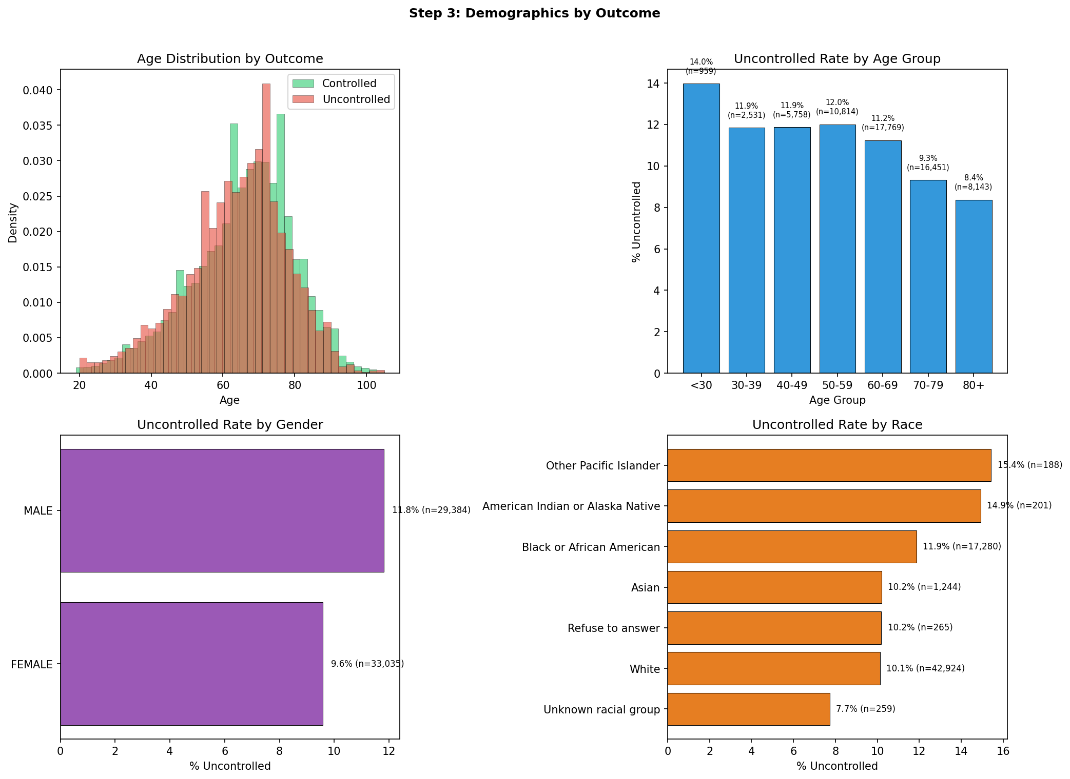
Figure 3: Uncontrolled rates by age, gender, and race.
Age:
Younger patients are harder to control. The under-30 group has a 14.3% uncontrolled rate versus 8.8% for those over 80. Clinically, younger diabetics often have Type 1 or aggressive early-onset Type 2, and may have worse adherence. Older patients tend to be on stable, long-term regimens. The model confirmed this: in SHAP analysis, younger age pushes predictions toward uncontrolled (SHAP = 0.093, rank #5).
Gender:
Males 11.8% uncontrolled versus females 9.6% — a 2.2 percentage-point gap consistent with literature showing men are slightly harder to manage (less likely to attend follow-ups, different metabolic factors). SHAP confirmed: male sex modestly pushes toward uncontrolled (SHAP = 0.055, rank #9).
Race:
Pacific Islander (15.4%) and American Indian/Alaska Native (14.9%) have the highest uncontrolled rates. Black or African American (11.9%) is above White (10.1%). These disparities are well-documented in diabetes literature and reflect both biological and social determinants. Important context for the equity analysis in the presentation: the model actually performs better (higher AUC, higher recall) for Black patients than White patients, meaning it does not amplify these disparities.
Hispanic ethnicity:
Hispanic patients: 12.8% versus non-Hispanic 10.6%. A modest but real disparity that connects to known diabetes epidemiology.

3.3 The Medication Confounding Story (Step 3)
This is the most nuanced clinical finding and the one most likely to come up in Q&A. You need to own this explanation.
The paradox:
Uncontrolled patients use more medications across the board:
Medication | Controlled patients (% with orders) | Uncontrolled patients (% with orders) | Difference
Insulin | 32.8% | 44.7% | +11.9pp
Metformin | 23.8% | 34.3% | +10.5pp
Sulfonylurea | 6.5% | 17.2% | +10.7pp
SGLT2 | 6.6% | 11.9% | +5.2pp
GLP-1 | 6.4% | 10.0% | +3.7pp
DPP4 | 1.7% | 3.1% | +1.4pp
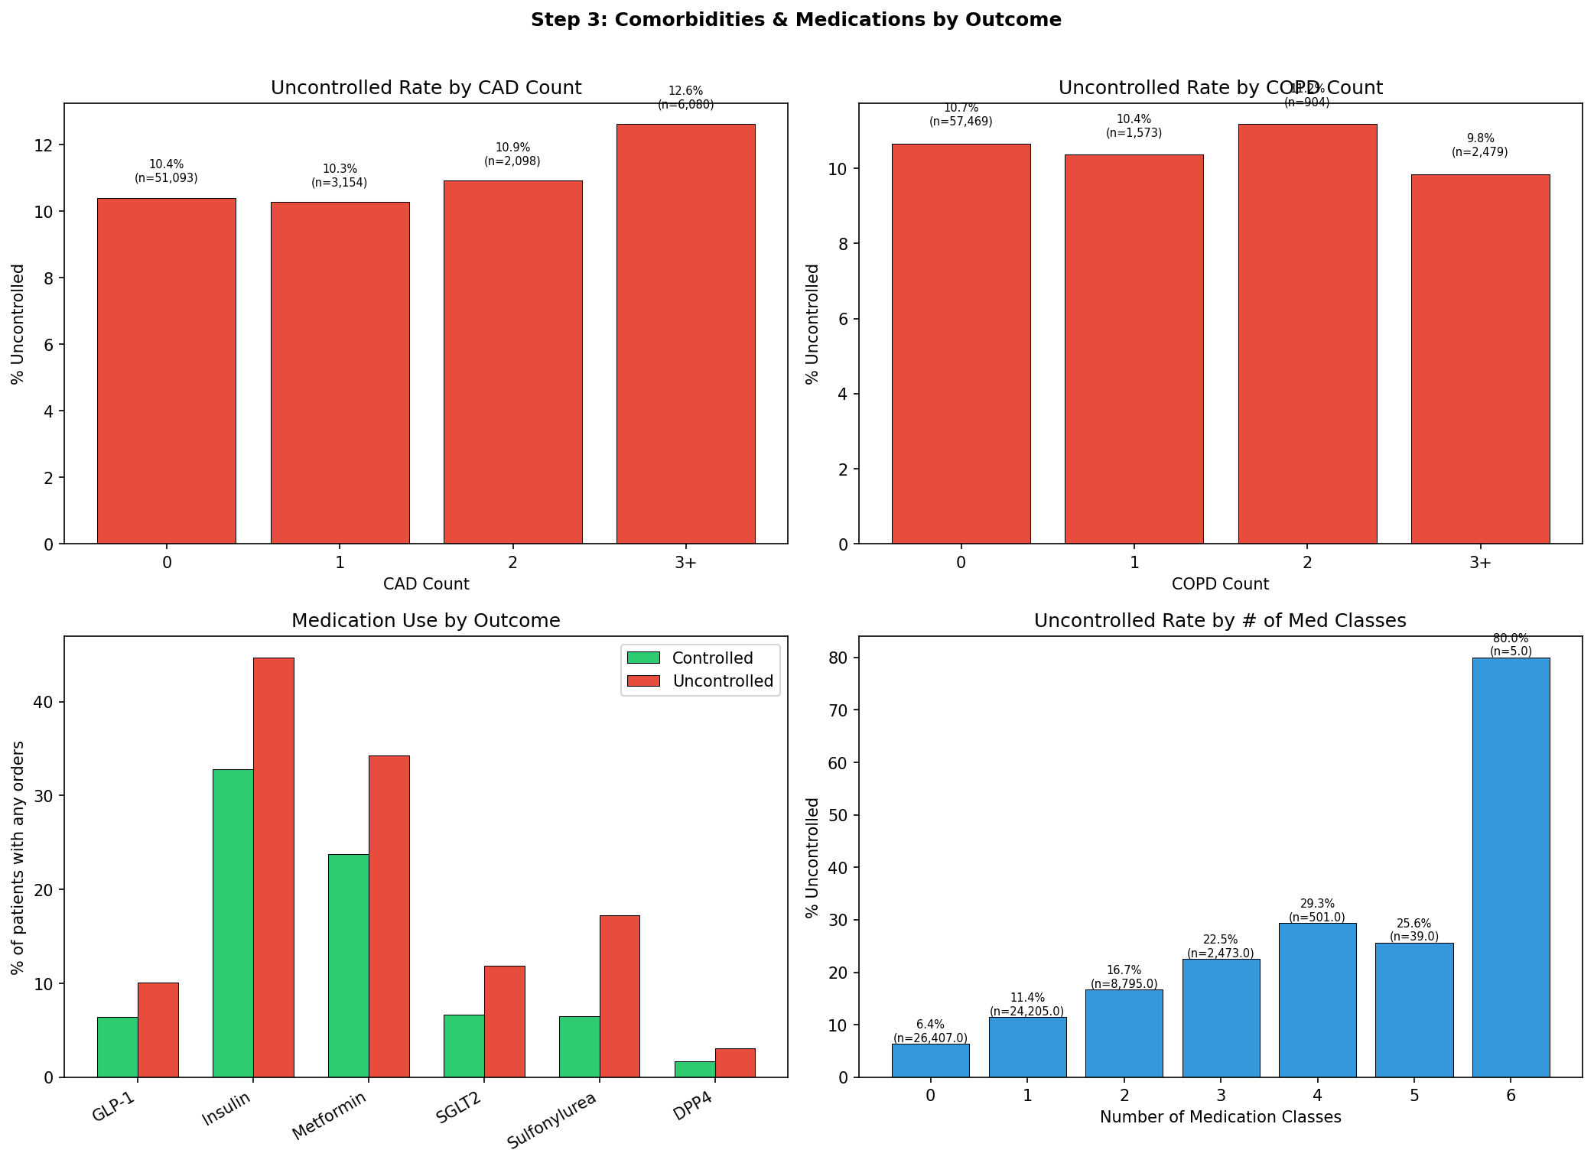
Figure 4: Medication use and comorbidities by outcome. Note higher medication use in the uncontrolled group.
Why this happens — reverse causation:
The medications did not cause the uncontrolled A1c. The uncontrolled A1c caused the medications to be prescribed. The causal chain is:
Patient has high A1c → Doctor prescribes more meds → Patient still has high A1c
It is the same reason ICU patients are on more IV drips than floor patients — the drips did not make them sicker; being sicker got them the drips.
We verified this with stratified analysis:
Among patients with similar current A1c (e.g., A1c 6.5–8), those on more medications still have higher uncontrolled rates: 0 meds = 9.2%, 1 med = 11.1%, 2 meds = 14.5%, 3+ meds = 19.4%. This is not because meds cause poor control — it is because a patient at A1c 7.5 on 3 medications has aggressive, treatment-resistant disease (they needed 3 drug classes just to get down to 7.5), while a patient at A1c 7.5 on 0 medications has mild, diet-controlled disease.
How we addressed it in feature engineering:
Rather than using raw medication counts (which are confounded), we created interaction features that combine A1c level with medication use:
Feature | Definition | Prevalence | Correlation with target | What it captures
treatment_resistant | A1c ≥ 8 AND 2+ med classes | 6.4% (3,988 patients) | +0.195 (strong) | Patients failing despite pharmacologic treatment — the hardest to control
undertreated | A1c ≥ 8 AND 0 med classes | 4.9% (3,051 patients) | +0.128 (moderate) | Patients who should be on meds but are not — possible non-adherence, access barriers, or clinical inertia
no_medication | 0 med classes | 42.3% | -0.118 (moderate, protective) | Mild, diet-controlled patients with inherently lower risk
treatment_resistant (+0.195) became one of the strongest non-A1c predictors in the entire model, confirming that this confounding-aware feature captures a clinically real signal that raw medication counts cannot.

3.4 Weak Signals: Cholesterol, Comorbidities, ADI (Step 3 & 5)
Several feature groups showed near-zero differences between controlled and uncontrolled patients. You should know these so you are not caught off guard when a judge asks "Why didn't cholesterol matter?"
Feature | Controlled mean | Uncontrolled mean | Difference | Why it is weak
LDL | 87.9 | 89.8 | +1.8 | LDL is managed by statins, separate from glycemic control. Well-treated in both groups.
HDL | 112.9 | 118.9 | +6.0 | Same story — lipid management is independent of A1c.
Total cholesterol | 163.8 | 168.3 | +4.5 | Cholesterol is LDL + HDL + triglycerides. Differences are tiny.
ADI national rank | 64.9 | 66.0 | +1.1 | Neighborhood deprivation does not strongly predict A1c control at the individual level in this dataset.
CAD count | ~10.4% → ~12% | — | Flat | Having coronary artery disease does not meaningfully change glycemic risk.
COPD count | ~10% → ~10% | — | Flat | Same — COPD is a comorbidity but not a driver of A1c.
These features are individually weak, but tree-based models can still extract marginal value from them in combination with stronger features. In the final model, ADI national rank had mean |SHAP| of 0.043 (rank #11) — not zero, but far below the A1c features.

4. Feature Engineering — Complete Reference (Step 7)
You are responsible for explaining every feature in the model. We engineered 20 new features from the cleaned data, then combined them with 28 cleaned original columns for a total of 48 model features. Below is the complete catalog grouped by clinical domain.

4.1 A1c-Derived Features (8 features)
These are the most important features by a wide margin. Rather than feeding 5 raw A1c columns (most of which are 58-97% missing) into the model, we summarized them into clinically meaningful metrics.
Feature | How calculated | Clinical reasoning | Corr. with target
a1c_latest | A1c 1 (most recent value, 0% missing) | Current glycemic status — the number the clinician sees first on the chart. | +0.314
a1c_mean | Mean of all available A1c readings | Overall glycemic burden over the observation period. Smooths noise from a single test. The #1 feature by SHAP (0.728). | +0.333
a1c_max | Maximum across all A1c readings | Was the patient ever severely uncontrolled? A past episode of A1c 14 is informative even if current A1c is 7. | +0.351
a1c_change | Most recent A1c − oldest A1c (2+ tests only) | Trajectory. Positive = worsening, negative = improving. Mean +0.20 (slight worsening on average). N=26,399. | -0.026
a1c_variability | Standard deviation of available A1c values (2+ tests) | Glycemic instability. A patient who swings 6→10→7 is different from one stable at 8. N=26,399. | +0.212
n_a1c_tests | Count of non-missing A1c values (1–5) | Monitoring intensity. 58% had 1 test, 30% had 2, 9% had 3, 3% had 4–5. More tests = closer monitoring = higher-risk patient. | +0.145
a1c_above_9 | 1 if a1c_latest ≥ 9, else 0 | Binary threshold for severely uncontrolled diabetes. #1 by XGBoost built-in importance (gain = 0.273). | +0.253
age | 2025 − birth year | Younger patients have higher risk (14.3% for <30 vs 8.8% for 80+). Range: 19–105, mean 65.5. | -0.043

4.2 Medication Features (4 features)
Feature | How calculated | Clinical reasoning | Corr. with target
total_med_classes | Count of med types with orders > 0 (0–6) | Treatment intensity. 42% on 0, 39% on 1, 14% on 2, 5% on 3+. | +0.152
total_med_orders | Sum of all medication order counts | Total prescription volume — captures refills and dose escalation, not just number of drugs. | +0.100
on_insulin | 1 if insulin orders > 0 | 34% of patients. Insulin = more advanced disease requiring injectable therapy. | +0.078
on_newer_drugs | 1 if GLP-1 or SGLT2 orders > 0 | 13% of patients. Newer, expensive agents often reserved for harder-to-treat cases. | +0.071

4.3 Treatment Pattern Features (3 features)
These are the features that address the medication confounding directly. They combine A1c level with medication count to create clinically meaningful categories.
Feature | How calculated | Clinical reasoning | Corr. with target
treatment_resistant | A1c ≥ 8 AND total_med_classes ≥ 2 | The patient on multiple meds who still cannot control their A1c. 6.4% of patients. One of the strongest non-A1c features. XGBoost importance rank #4. | +0.195
undertreated | A1c ≥ 8 AND total_med_classes = 0 | The patient who should be on meds but is not. May indicate non-adherence, access barriers, or clinical inertia. 4.9% of patients. | +0.128
no_medication | total_med_classes = 0 | Mild, diet-controlled patients. 42.3%. These patients have inherently lower risk — being on zero meds is a sign of mild disease, not under-treatment. | -0.118

4.4 Body Metrics (2 features)
Feature | How calculated | Clinical reasoning | Corr. with target
bmi | Weight (kg) / (height in m)². Capped at 10–80. | BMI mean 32.6 (obese range). Only 23.5% of patients have both weight+height. Despite high missingness, SHAP rank #6 (0.081). | -0.002
has_bmi | 1 if BMI can be calculated | Whether vitals were documented. Patients seen more frequently may be more likely to have measurements. | -0.002

4.5 Utilization Features (3 features)
Feature | How calculated | Clinical reasoning | Corr. with target
total_encounters | ED visits + PCP visits + admissions | Combines three correlated utilization columns (PCP and admissions r=0.73). | +0.020
any_admission | 1 if admissions > 0 | 32% hospitalized. Admission is a marker of disease severity. | -0.000
any_comorbidity | 1 if CAD > 0 or COPD > 0 | 23% have at least one comorbidity. Captures overall disease burden. | +0.012

4.6 Original Features Kept (28 columns)
In addition to the 20 engineered features, 28 columns from the cleaned dataset were kept as-is:
Group | Features | Count
Raw medications | glp-1, insulin, metformin, sglt2, sulfonylurea, dpp4 order counts | 6
Raw utilization | ED visit count, PCP visit count, admission count | 3
Comorbidities | cad-count, copd-count | 2
Cholesterol | LDL, HDL, total cholesterol | 3
ADI | ADI national rank | 1
Demographics (encoded) | is_male, is_hispanic | 2
Race (one-hot) | 7 race indicator columns | 7
Insurance (one-hot) | Managed Care, Medicaid, Medicare, Other | 4
Total: 20 engineered + 28 original = 48 features in the final model.

5. What the Model Learned (SHAP Analysis)
SHAP (SHapley Additive exPlanations) shows exactly how each feature pushes each patient's prediction toward "uncontrolled" or "controlled." This is your key slide for the presentation — it proves the model reasons like a clinician.
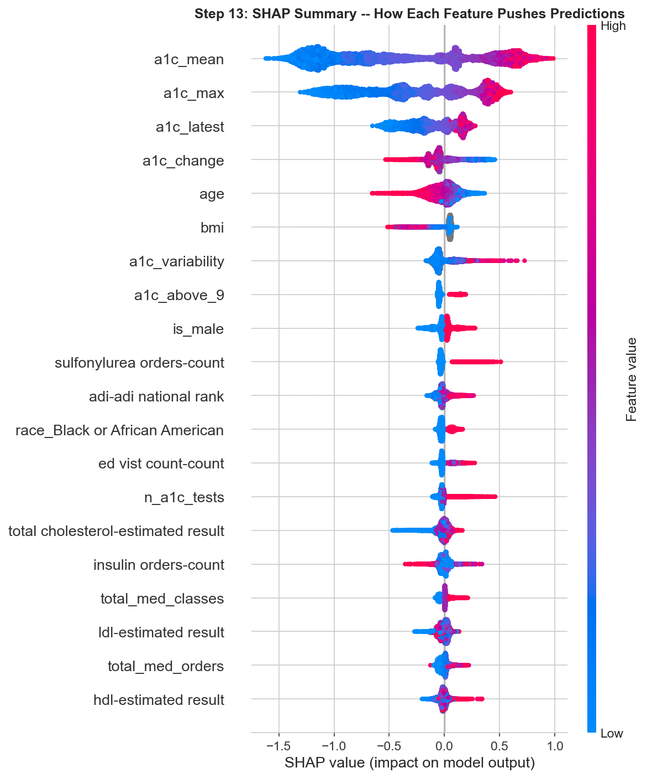
Figure 5: SHAP beeswarm plot. Each dot = one patient. X-axis = push toward uncontrolled (right) or controlled (left). Color = feature value (red = high, blue = low).
How to read this plot (row by row):
Feature | SHAP rank | Pattern | Plain English
a1c_mean | #1 (0.728) | Red right, blue left | Higher average A1c = strong push toward uncontrolled. This is the single most important factor.
a1c_max | #2 (0.501) | Red right, blue left | The worst A1c reading matters — a bad history increases risk even if current A1c has improved.
a1c_latest | #3 (0.218) | Red right, blue left | Most recent A1c. Adds recency information beyond the average.
a1c_change | #4 (0.108) | Red right (A1c went UP) | Worsening trajectory strongly predicts loss of control. Improving trajectory is protective.
age | #5 (0.093) | Blue right (YOUNG) | Younger patients are higher risk — counterintuitive but consistent with aggressive early-onset disease.
bmi | #6 (0.081) | Red right (high BMI) | Higher BMI pushes toward uncontrolled. Works despite 77% missing data.
a1c_variability | #7 (0.078) | Red right (unstable) | Swinging A1c = higher risk. Glycemic stability matters.
a1c_above_9 | #8 (0.057) | Red right | The binary "severely uncontrolled" flag.
is_male | #9 (0.055) | Red right (male) | Being male modestly increases predicted risk.
sulfonylurea | #10 (0.047) | Red right | Sulfonylurea use pushes toward uncontrolled — confounded (prescribed to sicker patients).
The clinical story for judges:
"The model's decision-making mirrors clinical reasoning. It first evaluates A1c history — the average, the worst episode, the most recent reading, and the trajectory. It then considers whether the patient is responding to treatment (treatment_resistant), considers demographics (age, sex), and factors in social context (ADI, insurance). This is not a black box — it reasons the way a clinician would, just faster and at scale."

6. Your Presentation Talking Points
As Clinical Lead, you will likely present or co-present slides 2 (the problem), 4 (A1c risk curve), 5 (feature engineering), 9 (SHAP), and 10 (equity). Below are ready-to-use talking points for each.

Slide 2: The Clinical Problem
"37 million Americans have diabetes, and glycemic control is the cornerstone of management. When A1c becomes uncontrolled, the risk of complications rises sharply — kidney disease, retinopathy, neuropathy, cardiovascular events. Currently, we discover loss of control reactively: the patient comes in, labs are drawn, and the A1c comes back elevated. What if we could identify these patients before it happens? That is what our model does — it flags patients who are likely to lose control in the next year, enabling proactive intervention."

Slide 4: A1c is Necessary but Not Sufficient
"Current A1c is the strongest single predictor, with a clear dose-response from 1% risk at normal levels to 32% at A1c above 9. But there are two key insights. First, risk plateaus above A1c 9 — meaning at that severity, other factors like medication response and engagement matter more than the number itself. Second, 65% of patients who become uncontrolled currently have A1c below 9. If you only intervened on the highest-A1c patients, you would miss two-thirds of the ones who need help. That is why we built a multivariate model."

Slide 5: Feature Engineering
"We engineered 20 features guided by clinical reasoning. The most impactful was treatment_resistant — defined as A1c above 8 despite being on two or more medication classes. Raw medication counts are confounded: sicker patients get more meds. But when you combine A1c level with medication count, you capture a genuinely predictive signal. A patient at A1c 7.5 on 3 medications has aggressive disease that required 3 drug classes just to reach 7.5. A patient at A1c 7.5 on zero medications has mild disease managed by diet. Same A1c, completely different risk profile. Treatment_resistant became one of the strongest non-A1c features in our model."

Slide 9: What the Model Learned
"SHAP analysis shows the model reasons like a clinician. It first checks A1c history — the average, the worst reading, the trend. Then it asks: is this patient responding to treatment? Then demographics and social context. The top 7 features are all clinically interpretable. This is not a black box — every prediction can be traced to specific clinical factors."

Slide 10: Equity
"We tested the model across race, gender, age, insurance, and neighborhood deprivation. AUC ranges from 0.83 to 0.90 across all subgroups — no group is left behind. Notably, the model has higher sensitivity for Black patients and Medicaid patients — the populations facing the greatest diabetes disparities. This means the tool could help close equity gaps rather than widen them."

7. Anticipated Q&A — Your Answers
These are the questions most likely to be directed at the Clinical Lead. Rehearse these answers.
Q: Why not just use A1c as the predictor? Why do you need a model?
A: A1c is the strongest single feature, but 65% of patients who become uncontrolled currently have A1c below 9. A threshold-based rule would miss most of them. The model combines A1c with trajectory (is it getting worse?), treatment response (are meds working?), monitoring intensity (how closely is the patient being watched?), and demographics to catch patients that A1c alone would miss.
Q: How do you handle the medication confounding?
A: We do not use raw medication counts as simple predictors. Instead, we engineered interaction features that combine A1c level with medication use. Treatment_resistant (A1c ≥ 8 despite 2+ drug classes) captures patients failing pharmacologic treatment. Undertreated (A1c ≥ 8 with zero drugs) captures those who may not be adherent or are facing access barriers. These features separate "sick on meds" from "mild off meds" — the distinction the raw counts cannot make.
Q: Why is precision only 27%? Is the model bad?
A: No — 27% precision is expected for screening with a 10.6% base rate. For comparison, mammography flags ~10% of women but only ~0.5% have cancer — that is about 5% precision. Our 27% is actually strong. The clinical cost of a false alarm (a 15-minute chart review) is far less than missing a patient who loses glycemic control. And the NPV is 97% — when the model says a patient is safe, it is right 97% of the time.
Q: What about cholesterol and comorbidities? Did they help?
A: Individually, cholesterol and comorbidities are weak predictors — mean values are nearly identical between groups. Cholesterol is managed by statins independently of A1c. CAD and COPD are comorbidities but not drivers of glycemic control. However, the tree-based model can still extract marginal value from these in combination with stronger features. ADI national rank, for example, had mean |SHAP| of 0.043 — not zero, but far below A1c.
Q: Is the model biased against any demographic group?
A: No. We tested across race, gender, age, insurance, and ADI. AUC ranges from 0.83 to 0.90. The model actually has higher sensitivity for Black patients (85% recall) than White (79%), and highest recall for Medicaid patients (91–93%). If anything, it catches more at-risk patients in underserved populations.
Q: How would this work in a real clinic?
A: Monthly batch scoring on the diabetes panel. The model outputs a risk probability for each patient. Those above the threshold get flagged. A nurse reviews the chart, confirms the risk, and the provider proactively adjusts the treatment plan — medication escalation, closer follow-up, care coordination. The threshold is adjustable: lower for population screening (catch everyone), higher for targeted intervention (fewer flags).
Q: You dropped the leakage column. How did you find it?
A: During missingness analysis (Step 4), we compared missing rates between controlled and uncontrolled groups. The a1c 2025 collection date column was 0% missing for uncontrolled patients but 47.7% missing for controlled patients. That is a perfect signal: if this value is missing, the patient is always controlled. We confirmed with a cross-tabulation and dropped it immediately. This is why careful data exploration matters — without this step, the model would have learned a shortcut that would not work in production.
Q: What does treatment_resistant really capture clinically?
A: It identifies patients with refractory diabetes — those who are on multiple medication classes but still cannot achieve glycemic control. These are the patients who need the most clinical attention: medication optimization, specialist referral, adherence support, or investigation of complicating factors (stress, diet, other medications like steroids). The model correctly identifies them as highest risk beyond what A1c alone would suggest.

Quick Reference Card
Pin this page. These are the numbers you need at your fingertips.
Key numbers:
Metric | Value
Patients | 62,425
Features (final model) | 48
Engineered features | 20
Model | XGBoost (tuned)
AUC-ROC | 0.852
Sensitivity (Recall) | 80.6%
NPV | 97.0%
Precision | 27.0%
Top predictor | a1c_mean (SHAP = 0.728)
Best non-A1c predictor | treatment_resistant (SHAP = ~0.05, built-in rank #4)
Class balance | 10.6% uncontrolled
Leakage column | Dropped (a1c 2025 collection date)

One-liner for each feature group:
Group | Signal strength | One-liner
A1c features | Dominant | Mean, max, latest, trajectory, variability — these carry 70%+ of predictive power
Medications | Strong (confounded) | More meds = sicker patient, not worse treatment. Captured by treatment_resistant.
Demographics | Moderate | Younger, male, minority → modestly higher risk
ED visits | Moderate | Dose-response: more ED visits = higher risk (marker of instability)
Cholesterol | Weak | Managed by statins independently of A1c. Nearly identical between groups.
Comorbidities | Weak | CAD/COPD are present but not drivers of glycemic control
ADI | Weak individually | Neighborhood deprivation adds marginal signal in combination with other features

