Role C: Data Explorer & Presentation
I2DB Datathon 2025 — Diabetes Risk Prediction

Reference document for the team member designing slides,
managing the visual story, and presenting exploratory findings.

Your responsibilities:
- Build the slide deck using the 13-slide structure and presentation-ready plots
- Know every exploration finding well enough to narrate the "data story"
- Manage the plot inventory — which figure goes where
- Design clean, readable slides that communicate findings to a mixed audience

1. Exploration Findings Summary (Steps 1–5)
This section gives you the complete data story from loading to correlations. You need to know this cold — it forms the first half of the presentation narrative.

1.1 Step 1: Loading and Initial Inspection
Finding | Detail
Shape | 62,425 patients × 41 features + 1 target column
ID match | Both files share identical patient IDs in the same order
Feature groups | 9 groups: demographics (4), comorbidities (2), A1c labs (11), weight/height (6), cholesterol (6), utilization (3), insurance (1), medications (6), ADI (2)
Zero-missing columns | 14 columns: all medications, utilization, comorbidities, A1c 1, birth year
Heaviest missingness | A1c 4-5 (97%), height (76%), weight (73%), insurance (67%), A1c 2 (58%)
Type issues | ADI columns stored as strings (e.g., "10.0") — needed numeric conversion
Leakage flag | "a1c 2025-collection date-time-days from reference" — suspicious, investigated in Step 4

1.2 Step 2: Target Variable Analysis
Class balance:
89.4% Controlled (55,793) vs 10.6% Uncontrolled (6,632). Roughly 1:8 ratio. A dummy model predicting "controlled" for everyone would be 89.4% accurate but catch 0% of at-risk patients.
A1c by outcome:
Metric | Controlled | Uncontrolled | Difference
Mean A1c (most recent) | 6.92 | 8.78 | +1.86 points
Median A1c | 6.5 | 8.3 | +1.8 points
% with A1c ≥ 9 | 9.0% | 35.5% | +26.5pp
A1c risk gradient (the most important finding):
A1c range | Risk | N patients
< 5.7 | 1.0% | 10,469
5.7–6.5 | 2.3% | 18,684
6.5–7.0 | 6.5% | 9,676
7.0–8.0 | 15.7% | 11,513
8.0–9.0 | 27.8% | 5,078
9.0–10.0 | 32.1% | 2,591
> 10.0 | 32.0% | 4,414
Two key insights: (1) Risk plateaus above A1c 9 — other factors matter more at that severity. (2) 65% of future-uncontrolled patients currently have A1c < 9 — a threshold rule would miss most.

1.3 Step 3: Feature Group Exploration
Feature signal ranking (from strongest to weakest):
Rank | Feature group | Signal strength | Key evidence
1 | A1c values | Dominant | Mean A1c difference of 1.86 between groups. Correlations +0.31 to +0.43.
2 | Medications | Strong (confounded) | Insulin +12pp, metformin +11pp, sulfonylurea +11pp difference. But sicker patients get more meds.
3 | Demographics | Moderate | Age (<30: 14.3% vs 80+: 8.8%), male (+2.2pp), race disparities (Pacific Islander 15.4% vs White 10.1%).
4 | ED visits | Moderate | Dose-response: 0 visits = 9.7%, 5+ visits = 18.4%.
5 | Cholesterol | Weak | LDL diff +1.8, HDL diff +6.0, total chol diff +4.5. Nearly identical distributions.
6 | Comorbidities | Weak | CAD and COPD show flat rates across counts.
7 | ADI | Weak | National rank diff only +1.1 (64.9 vs 66.0).
The medication confounding (critical to understand):
Uncontrolled patients are on MORE meds, not fewer. This is reverse causation — high A1c causes more prescribing, not the other way around. Verified by stratified analysis: among patients at the same A1c level, those on more meds still have worse outcomes because they have more aggressive underlying disease. This led to the treatment_resistant feature.

1.4 Step 4: Missingness Analysis
Missingness is NOT random:
Column | Controlled % missing | Uncontrolled % missing | Difference | Interpretation
a1c 2025 date (LEAKAGE) | 47.7% | 0.0% | -47.7pp | DROPPED — perfect predictor of outcome, not available in production
A1c 2 | 59.7% | 40.9% | -18.8pp | Uncontrolled patients get more repeat labs
A1c 3 | 89.1% | 76.3% | -12.8pp | Same pattern — more monitoring for sicker patients
Cholesterol (HDL/total) | 25.1% | 20.0% | -5.1pp | More labs drawn overall for uncontrolled
Weight/height | ~73-76% | ~74-76% | ~0 | Similar — missingness not informative here
Insurance | 67.1% | 66.2% | ~0 | Similar
Key insight: the count of non-missing A1c values (n_a1c_tests) becomes a useful feature — more tests = closer monitoring = higher-risk patient.

1.5 Step 5: Correlations
Top correlations with target:
Feature | Correlation | Strength
A1c 5 (oldest reading) | +0.432 | Strong
A1c 4 | +0.404 | Strong
A1c 3 | +0.387 | Strong
A1c 2 | +0.386 | Strong
A1c 1 (most recent) | +0.314 | Strong
Sulfonylurea orders | +0.109 | Moderate
Insulin orders | +0.082 | Moderate
Metformin orders | +0.066 | Moderate
SGLT2 orders | +0.050 | Weak-moderate
Birth year (younger) | +0.043 | Weak
Everything else | < 0.04 | Weak
Redundant feature pairs we addressed:
Pair | Correlation | Action
ADI state vs national | r = 0.964 | Dropped state, kept national
LDL vs total cholesterol | r = 0.772 | Kept both (model handles it)
PCP visits vs admissions | r = 0.733 | Created total_encounters
A1c readings (various) | r = 0.52–0.64 | Aggregated into mean, max, change, variability

2. Complete Plot Inventory
Every PNG file in the plots/ folder, organized by category. Use this as your master reference when building slides.

2.1 Exploration Plots (Steps 2–5)
Filename | Step | What it shows | Best slide for
step2_class_balance.png | 2 | Bar chart: 55,793 controlled vs 6,632 uncontrolled (89.4% vs 10.6%) | Slide 2 (backup) or appendix
step2_a1c1_by_outcome.png | 2 | Histogram + box plot of most recent A1c split by outcome | Slide 4 (backup)
step2_uncontrolled_rate_by_a1c_bin.png | 2 | Bar chart: risk of uncontrolled by A1c bin (<5.7 through >10) | Slide 4 (backup) — pres_2 version is cleaner
step3_demographics.png | 3 | 4-panel: age distribution, age bins, gender, race — all by outcome | Appendix or equity backup
step3_comorbidities_meds.png | 3 | 4-panel: CAD, COPD, medication use, med classes — by outcome | Slide 5 (feature engineering discussion)
step3_util_chol_adi.png | 3 | 6-panel: ED visits, PCP, admissions, LDL, HDL, ADI — by outcome | Appendix
step4_missingness_heatmap.png | 4 | Heatmap of missing values for 500 patients sorted by # missing | Appendix
step4_missingness_by_outcome.png | 4 | Side-by-side bars: missingness rate controlled vs uncontrolled | Leakage discussion (if asked)
step5_correlation_matrix.png | 5 | Full correlation heatmap of all numeric features + target | Appendix
step5_target_correlations.png | 5 | Horizontal bars: correlation of each feature with target, ranked | Appendix or methods backup

2.2 Model Plots (Steps 9–12)
Filename | Step | What it shows | Best slide for
step9_baseline_roc_pr.png | 9 | ROC + PR curves for logistic regression (6 feat vs 48 feat) | Appendix (superseded by step 10/11 plots)
step10_model_comparison.png | 10 | ROC + PR: logistic regression vs Random Forest vs XGBoost (defaults) | Slide 6 (backup) — pres_3 is cleaner
step11_tuned_comparison.png | 11 | ROC + PR: all 4 models (LR, RF, XGB default, XGB tuned) | Slide 6 — shows full model evolution
step12_full_evaluation.png | 12 | 4-panel: confusion matrix, ROC, PR curve, calibration | Slide 7/8 — comprehensive evaluation
step12_probability_distribution.png | 12 | Histogram of predicted probabilities by true outcome | Slide 8 or appendix — shows model separation

2.3 Interpretation Plots (Step 13)
Filename | Step | What it shows | Best slide for
step13_feature_importance.png | 13 | Top 20 features by XGBoost gain (built-in importance) | Appendix (SHAP is better for presentation)
step13_shap_summary.png | 13 | SHAP beeswarm: how each feature pushes predictions, all patients | Slide 9 (backup) — pres_5 is cleaner top-10 version
step13_shap_bar.png | 13 | Mean |SHAP| bar chart: average impact per feature | Slide 9 (alternative to beeswarm)

2.4 Fairness Plots (Step 14)
Filename | Step | What it shows | Best slide for
step14_subgroup_analysis.png | 14 | 6-panel: AUC by race, gender, age, ADI, insurance + recall by race | Slide 10 (backup) — very detailed

2.5 Presentation-Ready Plots (pres_ prefix)
These 7 figures were specifically designed for slides: larger fonts, cleaner layouts, publication-quality styling. Use these as your primary slide content.
Filename | Target slide | What it shows
pres_1_problem.png | Slide 2: The Clinical Problem | Clean bar chart: 55,793 controlled vs 6,632 uncontrolled with counts and percentages
pres_2_risk_by_a1c.png | Slide 4: A1c is the Strongest Signal | Color-gradient bar chart: risk by A1c bin from 1% to 32%
pres_3_model_roc.png | Slide 6: Model Comparison | ROC curves for LR (0.828), RF (0.847), XGBoost tuned (0.852)
pres_4_confusion.png | Slide 8: Understanding Predictions | Confusion matrix with plain-language labels (TN/FP/FN/TP)
pres_5_shap.png | Slide 9: What Drives Predictions | SHAP beeswarm (top 10 features only, cleaner than step13 version)
pres_6_fairness.png | Slide 10: The Model is Equitable | Side-by-side: AUC by race + AUC by gender with overall reference line
pres_7_metrics.png | Slide 7: Final Model Performance | 5 bars: AUC 85.2%, Sensitivity 80.6%, NPV 97.0%, Specificity 74.2%, Precision 27.0%

3. Presentation Figure Gallery
Thumbnails of all 7 presentation-ready figures. Review these to understand what is already built. You can use these directly in PowerPoint — they are 200 DPI PNGs.

Slide 2 — The Clinical Problem
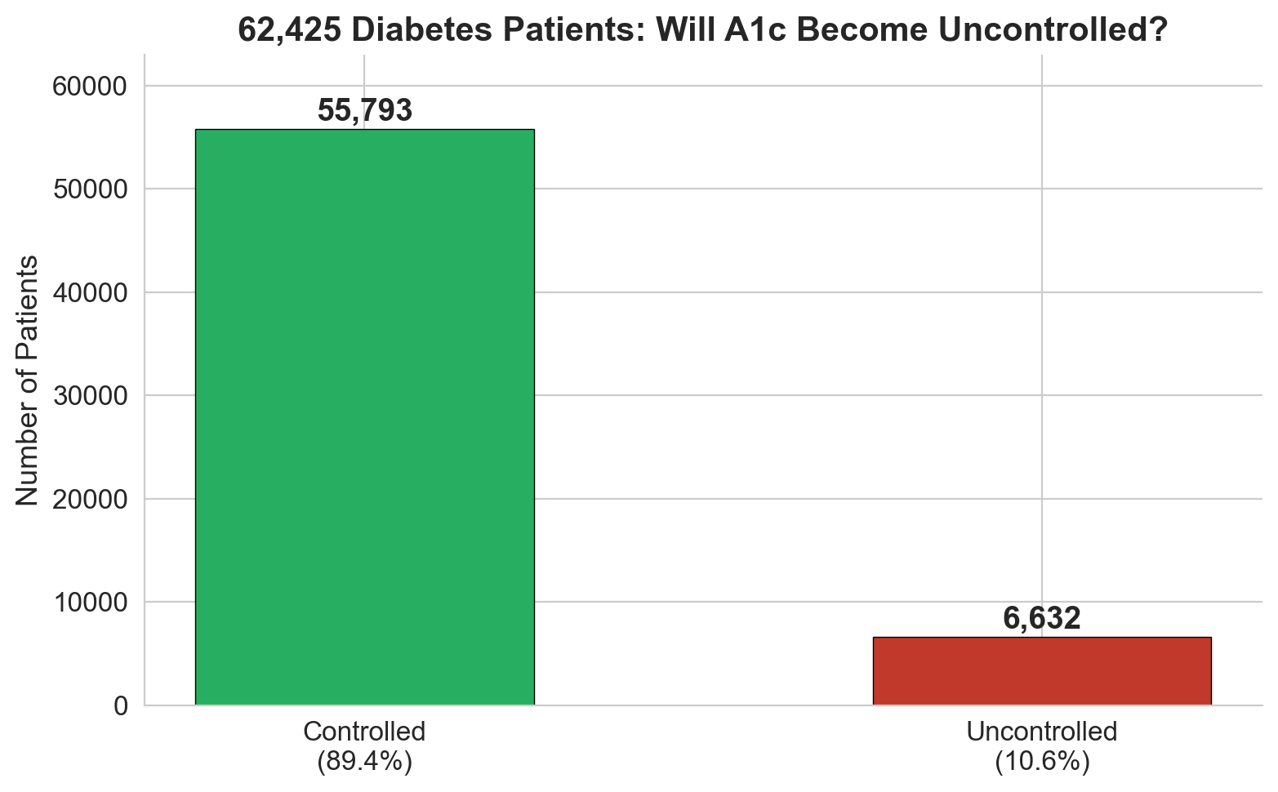
pres_1_problem.png
Design tip: Shows the 1:8 class imbalance. Open with this to frame the challenge.

Slide 4 — A1c Risk Gradient
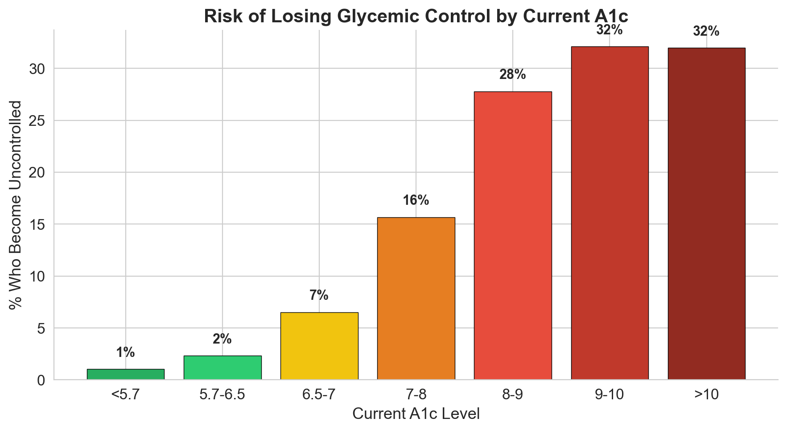
pres_2_risk_by_a1c.png
Design tip: The color gradient from green to red tells the story visually. Point out the plateau above A1c 9.

Slide 6 — Model Comparison
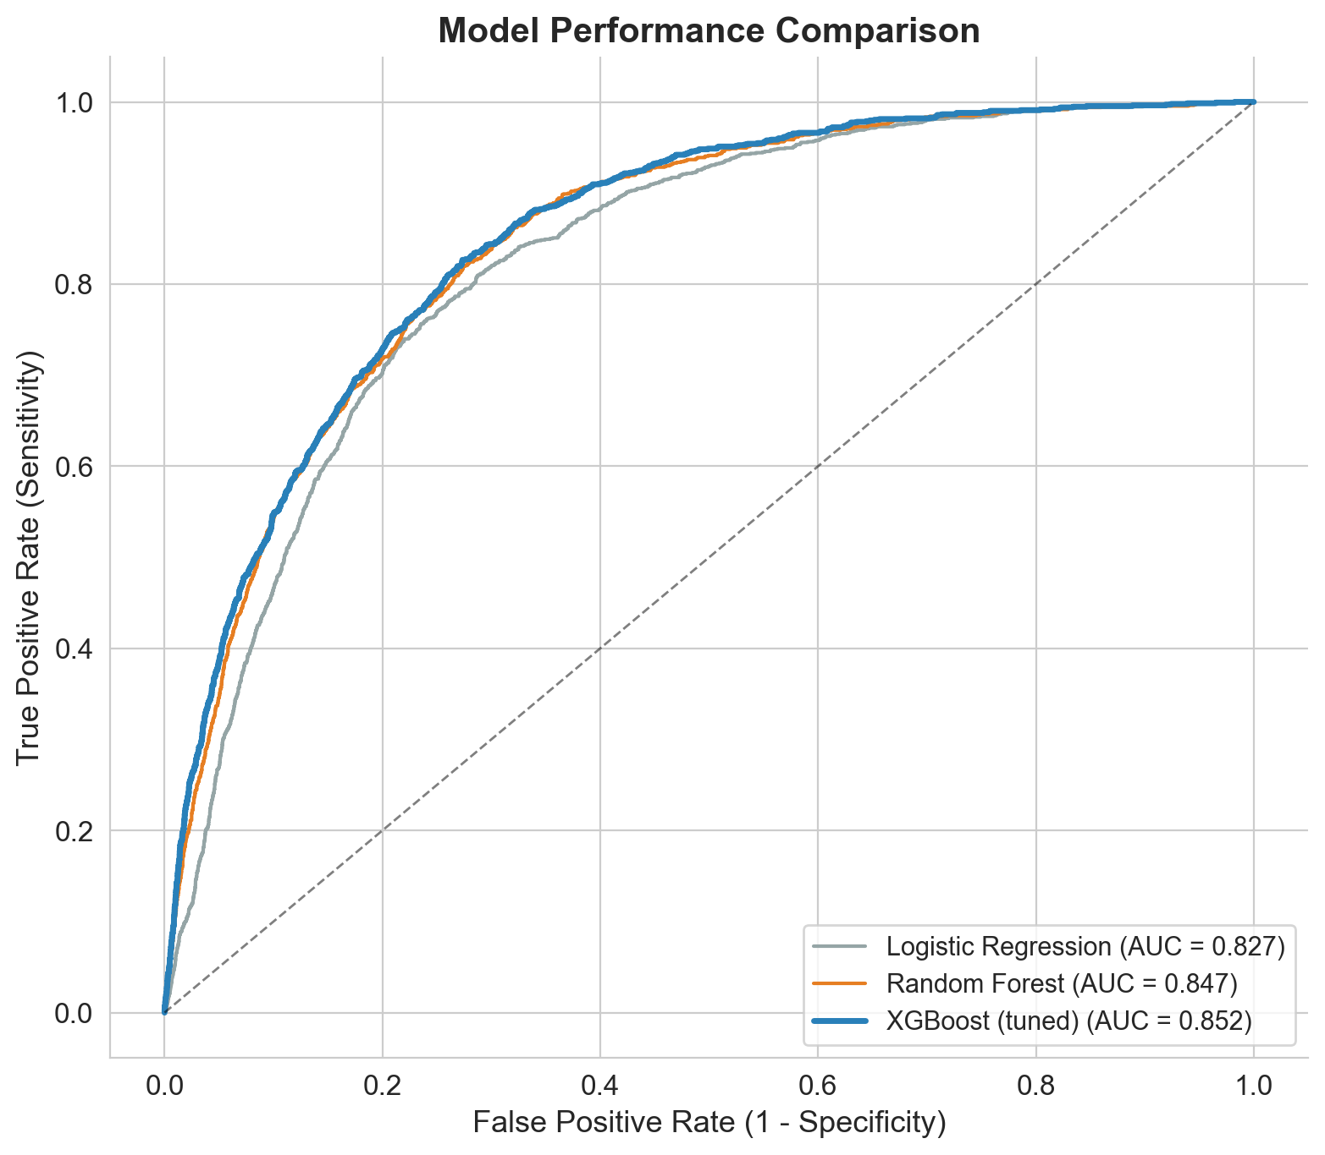
pres_3_model_roc.png
Design tip: Three ROC curves. XGBoost (blue) pulls ahead. Keep it simple — "blue wins."

Slide 8 — Confusion Matrix
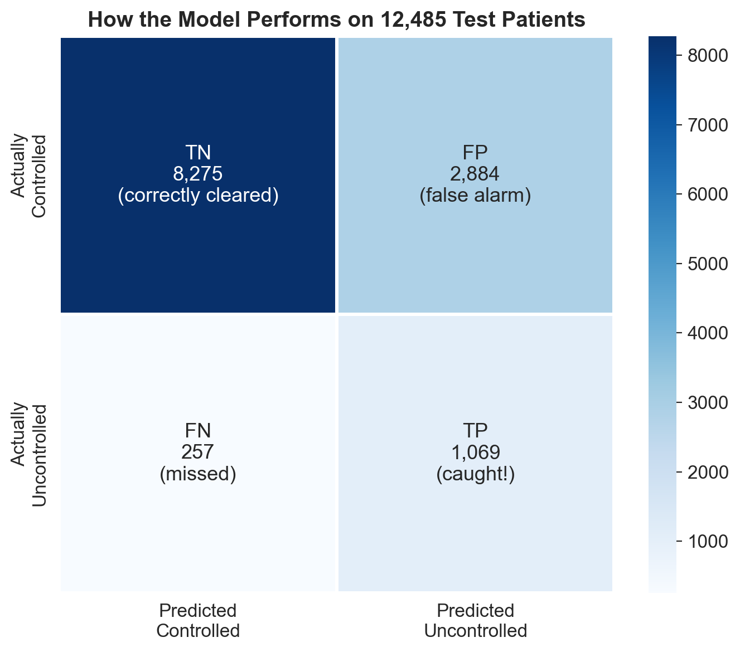
pres_4_confusion.png
Design tip: The labels say "correctly cleared," "false alarm," "missed," and "caught!" — judge-friendly language.

Slide 9 — SHAP Analysis
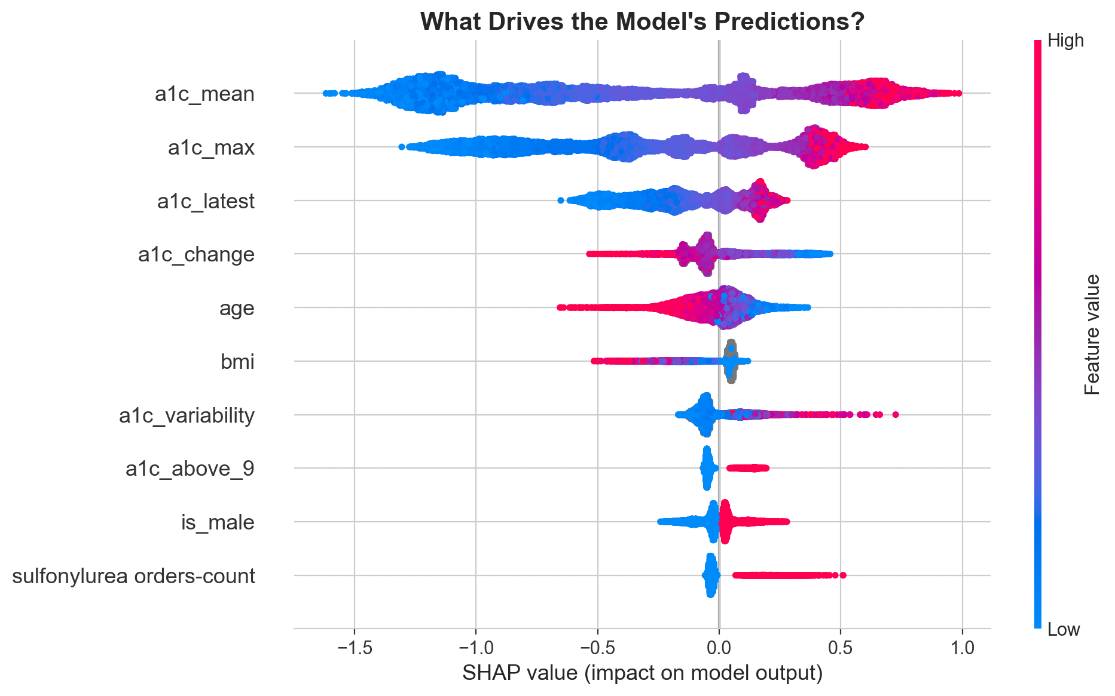
pres_5_shap.png
Design tip: Top 10 features only for readability. Red dots right = high value pushes toward uncontrolled.

Slide 10 — Equity
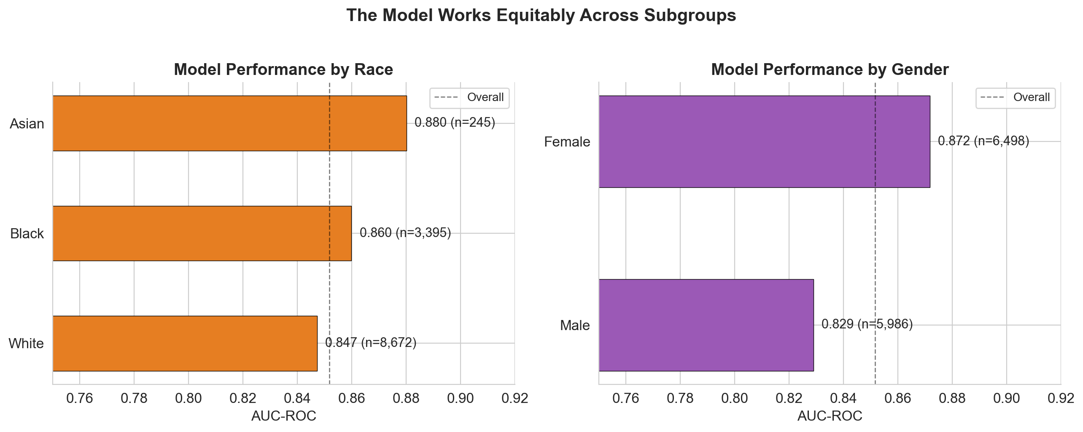
pres_6_fairness.png
Design tip: Side-by-side AUC by race and gender. Dashed line shows overall AUC.

Slide 7 — Key Metrics
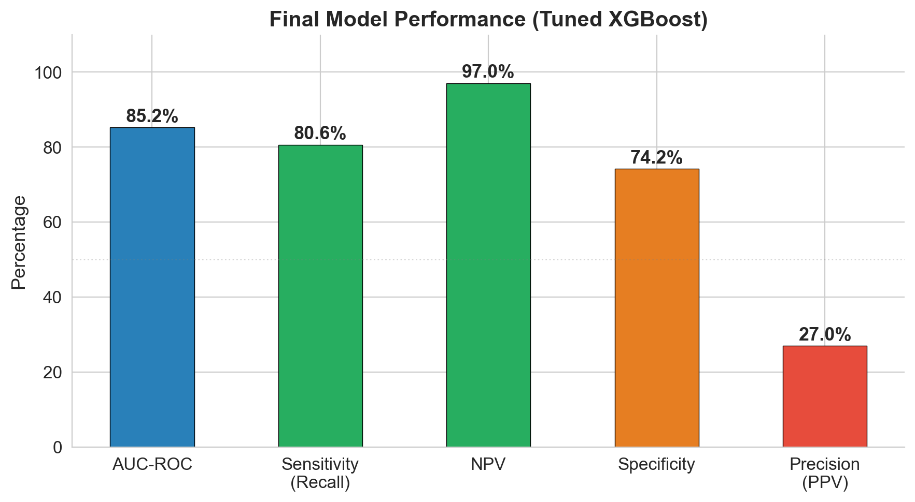
pres_7_metrics.png
Design tip: Five bars color-coded: blue (AUC), green (sensitivity, NPV), orange (specificity), red (precision).

4. Full 13-Slide Presentation Structure
This is the complete slide map. For each slide: the title, the figure(s) to use, and the key message. Aim for 10–15 minutes total (roughly 1 minute per slide, 2 minutes for slides 7–9).
Slide | Figure | Key message (one sentence)
Slide 1: Title | None | "Predicting Loss of Glycemic Control: A Machine Learning Approach Using 12 Months of EHR Data.
Slide 2: The Clinical Problem | pres_1_problem.png | 62,425 patients, 10.
Slide 3: The Data | None — use a clean table/bullets | 41 features across 9 domains.
Slide 4: A1c is the Strongest Signal | pres_2_risk_by_a1c.png | The gradient bar chart tells the story.
Slide 5: Feature Engineering | None — use a table | Table of top engineered features with clinical reasoning.
Slide 6: Model Comparison | pres_3_model_roc.png | Three curves: LR (gray, 0.
Slide 7: Final Model Performance | pres_7_metrics.png | Five bars.
Slide 8: Understanding the Predictions | pres_4_confusion.png | Walk through each quadrant: 8,275 correctly cleared (time saved), 1,069 caught (intervention opportunities), 257 missed (area for improvement), 2,884 false alarms (cost = chart review).
Slide 9: What Drives the Predictions? | pres_5_shap.png | SHAP beeswarm (top 10).
Slide 10: The Model is Equitable | pres_6_fairness.png | AUC 0.
Slide 11: Clinical Application | None — use a table | Threshold table: 0.
Slide 12: Limitations and Future Work | None — bullets | Single-institution data, missing weight (73%), small Pacific Islander/American Indian samples, model predicts risk not causation.
Slide 13: Summary | None — 5 bullet points | (1) 10.

Slide 1: Title
Figure: None
Message: "Predicting Loss of Glycemic Control: A Machine Learning Approach Using 12 Months of EHR Data." Team name, institution, I2DB Datathon 2026. Clean, minimal.

Slide 2: The Clinical Problem
Figure: pres_1_problem.png
Message: 62,425 patients, 10.6% become uncontrolled. Frame it as: "Currently discovered reactively — what if we could predict it?" The bar chart makes the imbalance visceral.

Slide 3: The Data
Figure: None — use a clean table/bullets
Message: 41 features across 9 domains. List the domains with icons if possible. Mention significant missingness (weight 73%, A1c 2 58%, insurance 67%). Keep this slide fast — 30 seconds.

Slide 4: A1c is the Strongest Signal
Figure: pres_2_risk_by_a1c.png
Message: The gradient bar chart tells the story. Two takeaways: (1) plateau above A1c 9, (2) 65% of future-uncontrolled have A1c < 9 now. "A1c is necessary but not sufficient."

Slide 5: Feature Engineering
Figure: None — use a table
Message: Table of top engineered features with clinical reasoning. Highlight treatment_resistant. This is where you show clinical thinking, not just data science. The confounding story lives here.

Slide 6: Model Comparison
Figure: pres_3_model_roc.png
Message: Three curves: LR (gray, 0.828), RF (orange, 0.847), XGBoost tuned (blue, 0.852). "We tested three approaches; XGBoost with tuning won."

Slide 7: Final Model Performance
Figure: pres_7_metrics.png
Message: Five bars. Lead with the green ones: "81% sensitivity — catches 4 out of 5. 97% NPV — when the model clears a patient, it is right 97% of the time." Address precision proactively: "27% is expected for screening at 10.6% base rate."

Slide 8: Understanding the Predictions
Figure: pres_4_confusion.png
Message: Walk through each quadrant: 8,275 correctly cleared (time saved), 1,069 caught (intervention opportunities), 257 missed (area for improvement), 2,884 false alarms (cost = chart review). "Screen 3,953 to find 1,069."

Slide 9: What Drives the Predictions?
Figure: pres_5_shap.png
Message: SHAP beeswarm (top 10). Walk through top 3 rows: a1c_mean, a1c_max, a1c_latest. Note age (younger = riskier). "The model reasons like a clinician: A1c history first, then treatment response, then demographics."

Slide 10: The Model is Equitable
Figure: pres_6_fairness.png
Message: AUC 0.83–0.88 across subgroups. "No group is left behind. Higher sensitivity for Black and Medicaid patients — the most at-risk populations." This slide wins trust with judges.

Slide 11: Clinical Application
Figure: None — use a table
Message: Threshold table: 0.15 catches 96%, 0.30 catches 91%, 0.50 catches 81%. Suggested workflow: monthly scoring → flag → RN review → proactive treatment. Make it feel deployable.

Slide 12: Limitations and Future Work
Figure: None — bullets
Message: Single-institution data, missing weight (73%), small Pacific Islander/American Indian samples, model predicts risk not causation. Future: external validation, medication adherence data, CDS integration.

Slide 13: Summary
Figure: None — 5 bullet points
Message: (1) 10.6% lose control annually. (2) 48 features from routine EHR data. (3) AUC 0.852, 81% recall, 97% NPV. (4) Equitable across subgroups. (5) Enables proactive care.

5. Missingness Patterns — Quick Reference
If asked "how did you handle missing data?" — here is the complete picture.
Column group | % Missing | How handled | Notes
A1c 1 (most recent) | 0% | Used directly as a1c_latest | Fully populated
A1c 2 | 57.7% | Aggregated into mean/max/change/variability | Missing = patient had only 1 test
A1c 3 | 87.8% | Same aggregation | Missing = patient had only 1-2 tests
A1c 4-5 | 97.2% | Same aggregation | Only 2.8% of patients had 4+ tests
Weight | 73.3% | Used to compute BMI (available for 23.5%) | has_bmi feature captures missingness
Height | 75.9% | Used to compute BMI | Same as weight
Insurance | 67.0% | One-hot encoded (missing = all 4 dummies = 0) | Missing insurance is the implicit reference category
ADI national rank | 48.1% | Converted to numeric; XGBoost handles NaN natively | No imputation needed for XGBoost
Cholesterol (LDL/HDL/total) | 24-25% | Kept as-is; XGBoost handles NaN natively | Weak predictors regardless
a1c 2025 date (LEAKAGE) | 42.6% | DROPPED entirely | 100% of missing = controlled. Data leakage.
Medications, utilization, comorbidities | 0% | Used directly | Zeros = no orders/visits/diagnoses
Demographics (gender, race, ethnicity) | 0-0.1% | Encoded; rare missing values preserved as NaN | Only 4 missing gender, 27 missing ethnicity
For logistic regression (Step 9), we used median imputation via SimpleImputer. For XGBoost (Steps 10–12), we used native NaN handling — XGBoost learns which direction to send missing values at each split, which is generally superior to imputation.

6. What Judges Typically Look For
Based on datathon judging norms and the competition description, judges typically evaluate along these dimensions. Design your slides to hit every one.
Dimension | What they want to see | Where we deliver it
Clinical relevance | Does the problem matter? Is the approach clinically sensible? | Slide 2 (problem framing), Slide 5 (feature engineering with clinical reasoning), Slide 11 (clinical workflow)
Technical rigor | Proper train/test split, cross-validation, appropriate metrics for imbalanced data, avoiding leakage | Slide 6 (model comparison), Step 11 (CV tuning), leakage discovery story if asked
Interpretability | Can you explain why the model makes its predictions? | Slide 9 (SHAP), feature engineering rationale, confusion matrix walkthrough
Fairness/equity | Does the model work for everyone? Did you even check? | Slide 10 (subgroup analysis across 5 dimensions). This differentiates us from most teams.
Presentation quality | Clear visuals, confident delivery, time management | Clean pres_ figures, practiced narrative arc, 1 min per slide
Novelty/insight | Did you find something surprising or do something creative? | The confounding story, treatment_resistant feature, leakage discovery, age paradox, NPV as the star metric
Practical deployment | Could this actually be used? | Slide 11 (threshold table, workflow), limitations slide

6.1 Slide Design Tips
- One message per slide. If a slide makes two points, split it into two slides.
- Figures should fill 60-70% of the slide. Titles and a few bullets, no paragraphs.
- Use the pres_ figures — they are already sized and styled for slides. Do not resize the step_ plots into tiny thumbnails.
- For tables (Slides 3, 5, 11), use your software's built-in table formatting. Keep fonts ≥ 18pt.
- Practice the transitions: "We saw that A1c dominates → but it is not enough → so we engineered features → here is how the model uses them."
- Have backup slides ready with step_ exploration plots in case judges ask for more detail.
- Time yourself: 10–12 minutes of content, leaving 3–5 minutes for Q&A.
- End on Slide 13 (Summary) with 5 crisp bullet points. Do not end on limitations.

6.2 Narrative Arc
The presentation tells a story in three acts:
Act 1 — The Challenge (Slides 1–4, ~3 minutes):
"10.6% of diabetes patients lose glycemic control every year. A1c is the strongest predictor but misses 65% of cases. We need a multivariate model."
Act 2 — Our Approach (Slides 5–9, ~5 minutes):
"We engineered 20 clinically-driven features, tested 3 model families, tuned the best one. Tuned XGBoost: AUC 0.852, catches 81%, NPV 97%. SHAP shows it reasons like a clinician."
Act 3 — Impact & Trust (Slides 10–13, ~3 minutes):
"The model is equitable across all subgroups. It can be deployed as a monthly screening tool with adjustable thresholds. This enables proactive care — finding at-risk patients before they lose control."

Quick Reference Card
The 5 numbers you must know:
Metric | Value | What to say
Patients | 62,425 | "Over sixty thousand diabetes patients"
AUC-ROC | 0.852 | "Eighty-five percent discrimination"
Sensitivity | 80.6% | "Catches four out of five at-risk patients"
NPV | 97.0% | "When the model says low risk, it is right 97% of the time"
Features | 48 (20 engineered) | "Forty-eight features, twenty engineered from clinical reasoning"

Plot file quick-reference:
Need | Use this file
Class balance for Slide 2 | pres_1_problem.png
A1c risk gradient for Slide 4 | pres_2_risk_by_a1c.png
ROC comparison for Slide 6 | pres_3_model_roc.png
Key metrics for Slide 7 | pres_7_metrics.png
Confusion matrix for Slide 8 | pres_4_confusion.png
SHAP for Slide 9 | pres_5_shap.png
Equity for Slide 10 | pres_6_fairness.png
Detailed evaluation (backup) | step12_full_evaluation.png
Probability distribution (backup) | step12_probability_distribution.png
Missingness (backup) | step4_missingness_by_outcome.png
Full correlation matrix (backup) | step5_correlation_matrix.png

