Role D: Technical Lead
I2DB Datathon 2025 — Diabetes Risk Prediction

Reference document for the team member who owns code, model training,
SHAP analysis, pipeline architecture, and technical Q&A.

Your responsibilities:
- Explain every modeling decision: why XGBoost, why these hyperparameters, why this threshold
- Defend the pipeline: data leakage prevention, train/test discipline, cross-validation
- Present model results (Slides 6, 7, 8) and handle all technical Q&A
- Know the code: clean_data.py, feature_engineering.py, split_data.py, modeling.py

1. Data Pipeline: Raw → Cleaned → Engineered → Split
This section traces every transformation from the original CSV files to the final model input. You need to be able to walk through this end-to-end if a judge asks "how did the data get from CSV to model?"

1.1 Stage 1: Raw Data (41 columns)
Two CSV files: DM_Features.csv (62,425 × 41) and DM_Control_2025.csv (62,425 × 1). Patient IDs match exactly. Column types: 23 numeric (int64/float64), 6 object (text), 12 float64 with NaN. The ADI columns are strings that need numeric conversion.

1.2 Stage 2: Cleaned Data (36 columns) — clean_data.py
Action | Columns affected | Rationale
Drop leakage column | -1 (a1c 2025 collection date) | 100% of missing = Controlled. Future information leaked into features.
Drop date/timing columns | -10 | When labs were drawn is less useful than the results. Timing captured by n_a1c_tests.
Drop unit-of-measure columns | -2 | All weights kg, all heights cm. Zero information.
Drop ADI state rank | -1 | r = 0.964 with national rank. Redundant.
Convert ADI national rank | 0 (type fix) | String → float64 via pd.to_numeric(errors="coerce").
Encode gender → is_male | net 0 (+1, -1) | Binary 0/1. 4 missing values preserved as NaN.
Encode ethnicity → is_hispanic | net 0 (+1, -1) | Binary 0/1. 27 missing preserved as NaN.
One-hot encode race | net +6 (+7, -1) | 7 indicator columns for 7 race categories.
One-hot encode insurance | net +3 (+4, -1) | 12 raw categories → 4 groups (Medicare, Medicaid, Managed Care, Other) → 4 dummies. Missing insurance = all zeros.
Result: 62,425 × 36, all numeric.

1.3 Stage 3: Engineered Data (56 columns) — feature_engineering.py
20 new features added to the 36 cleaned columns. See Section 5 (Feature Importance) for the full list with SHAP values. Key engineered features: age, a1c_latest, a1c_mean, a1c_max, a1c_change, a1c_variability, n_a1c_tests, a1c_above_9, total_med_classes, total_med_orders, on_insulin, on_newer_drugs, no_medication, bmi, has_bmi, total_encounters, any_admission, any_comorbidity, undertreated, treatment_resistant.

1.4 Stage 4: Final Model Input (48 columns) — split_data.py
Dropped 8 raw columns now captured by engineered features:
Dropped column | Replaced by
a1c 1-estimated result | a1c_latest (identical copy)
a1c 2-estimated result | Aggregated into a1c_mean, a1c_max, a1c_change, a1c_variability
a1c 3-estimated result | Same aggregation
a1c 4-estimated result | Same aggregation
a1c 5-estimated result | Same aggregation
date of birth | age (= 2025 - birth year)
weight-estimated result | bmi, has_bmi
height-estimated result | bmi, has_bmi
Final matrix: 62,425 × 48. Of these, 39 columns have zero missing values. 9 columns have missing values (bmi 76.5%, a1c_change 57.7%, a1c_variability 57.7%, ADI 48.5%, cholesterol 24-25%, is_hispanic 0.04%, is_male 0.006%).

2. Train/Test Split (Step 8)
Set | N | Controlled | Uncontrolled | % Uncontrolled
Train | 49,940 | 44,634 | 5,306 | 10.62%
Test | 12,485 | 11,159 | 1,326 | 10.62%
Implementation:
sklearn.model_selection.train_test_split(X, y, test_size=0.2, random_state=42, stratify=y). Stratified splitting ensures both sets have identical class balance (10.62%). Fixed random state for reproducibility.
Test set discipline:
The test set was used exactly once — in Step 12 for final evaluation. All tuning (Step 11) used 5-fold cross-validation on the training set only. This prevents overfitting to the test set and gives an unbiased performance estimate.

3. Model Comparison (Steps 9–11)

3.1 Step 9: Baseline Logistic Regression
Model variant | AUC-ROC | PR-AUC | Recall | Precision | Imputation | Notes
HIGH features only (6) | 0.8267 | 0.3120 | 72% | 28% | Median | age, a1c_latest, a1c_change, n_a1c_tests, a1c_mean, total_med_classes
ALL features (48) | 0.8275 | 0.3216 | 75% | 28% | Median | class_weight="balanced", StandardScaler, max_iter=1000
Dummy (always Controlled) | 0.5000 | — | 0% | — | N/A | 89.4% accuracy but clinically useless
Key finding: adding 42 features to LR barely improved AUC (+0.001). Linear models cannot capture the interactions (e.g., high A1c + many meds) that tree models discover automatically. Top standardized coefficients: a1c_mean (+0.94), n_a1c_tests (+0.30), a1c_latest (+0.25), total_med_classes (+0.19), a1c_change (-0.14), age (-0.03).
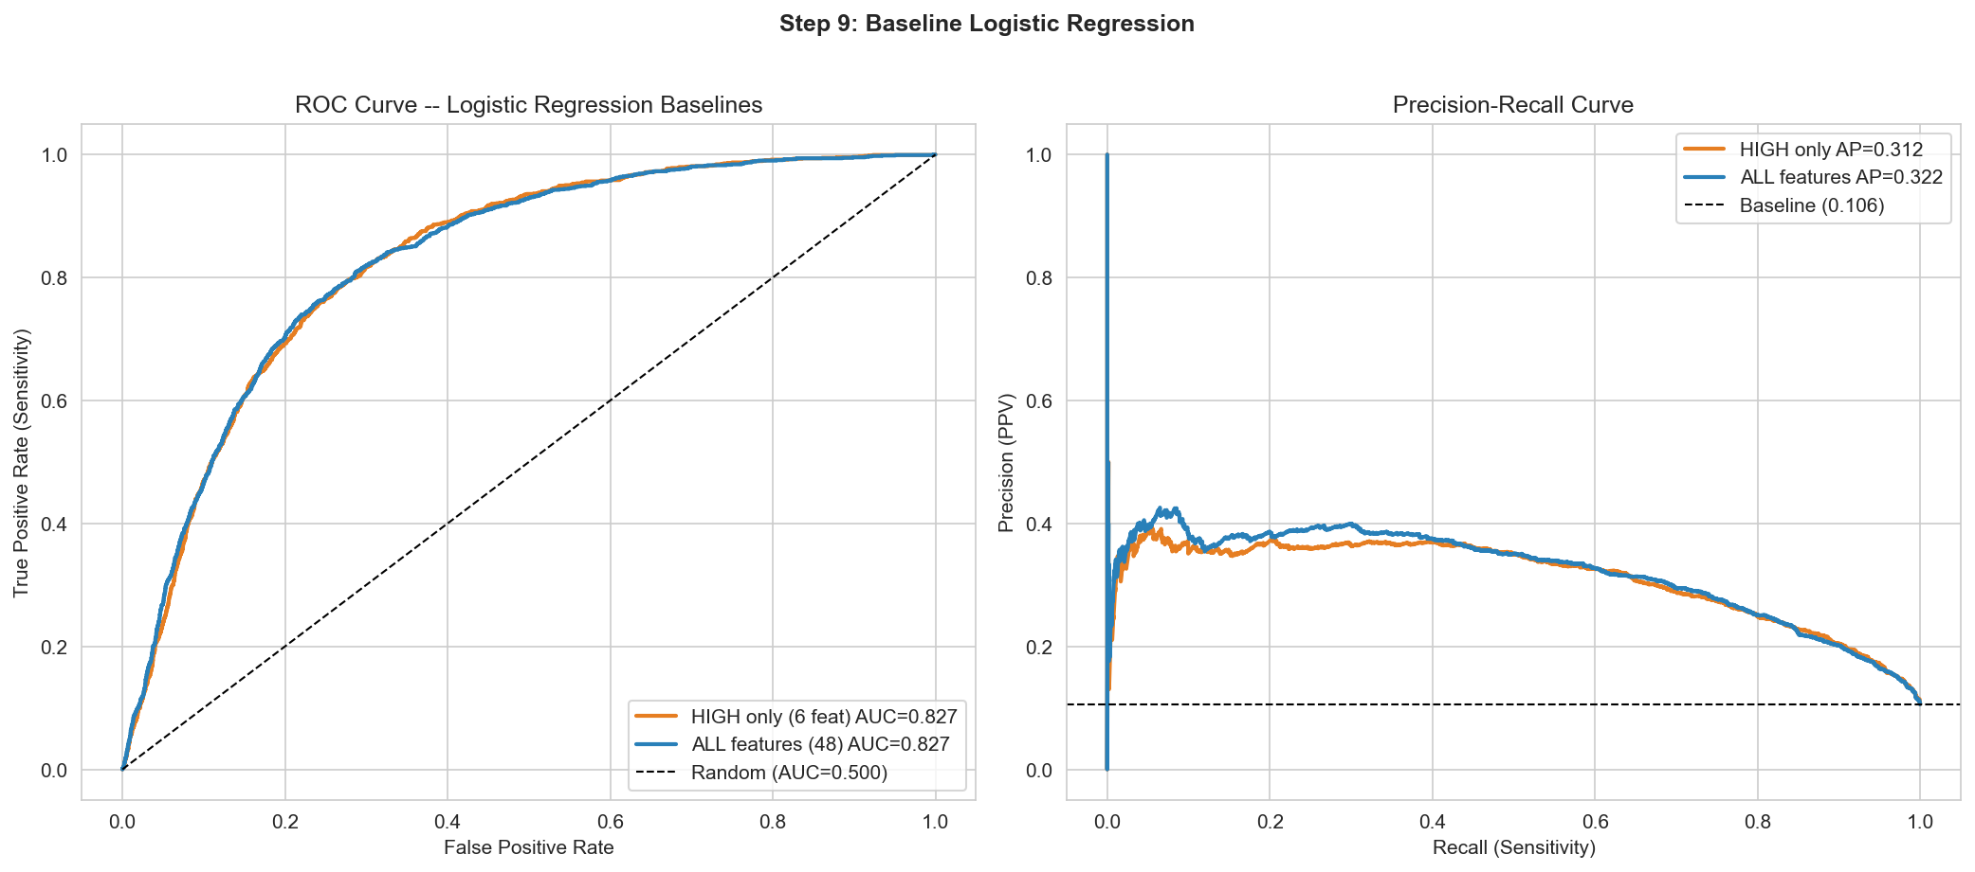
Figure 1: Baseline logistic regression — ROC and PR curves.

3.2 Step 10: Advanced Models (Defaults)
Model | AUC-ROC | PR-AUC | Recall | Precision | Imputation | Class handling
Logistic Regression | 0.8275 | 0.3216 | 75.0% | 27.7% | Median + StandardScaler | class_weight="balanced"
Random Forest | 0.8467 | 0.3923 | 68.9% | 31.5% | Median | class_weight="balanced", 500 trees, min_samples_leaf=10
XGBoost (defaults) | 0.8267 | 0.3596 | 64.8% | 30.4% | Native NaN | scale_pos_weight=8.41, 500 trees, lr=0.1, depth=6
Random Forest won with defaults (AUC 0.847). XGBoost with defaults (0.827) was no better than LR. This is expected — XGBoost is highly sensitive to hyperparameters while RF is more robust out-of-the-box. The PR-AUC improvement from LR to RF (+0.07) was larger than the AUC improvement (+0.02), indicating better handling of the positive (uncontrolled) class.
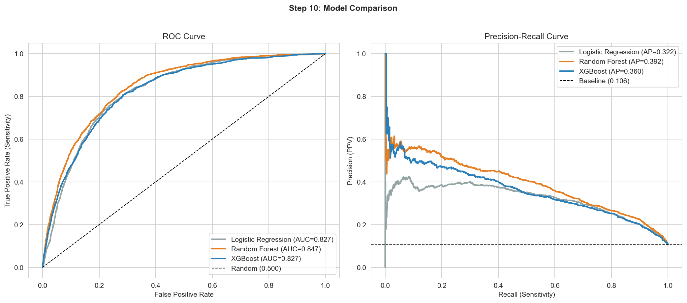
Figure 2: Step 10 model comparison — RF (orange) leads over LR (gray) and XGBoost defaults (blue).

3.3 Step 11: Hyperparameter Tuning
Search strategy:
RandomizedSearchCV: 80 parameter combinations × 5-fold stratified CV = 400 total fits. Scoring metric: roc_auc. Best CV AUC-ROC: 0.8490 ± 0.0069. Top 10 configurations had AUC within 0.001 of each other (0.8483–0.8490), indicating a stable optimum.
Parameter search space:
Parameter | Search range | Best value
n_estimators | [300, 500, 800, 1000] | 800
learning_rate | [0.01, 0.03, 0.05, 0.1] | 0.01
max_depth | [3, 4, 5, 6, 8] | 5
min_child_weight | [1, 3, 5, 10] | 10
subsample | [0.6, 0.7, 0.8, 0.9, 1.0] | 0.7
colsample_bytree | [0.5, 0.6, 0.7, 0.8, 1.0] | 0.5
gamma | [0, 0.1, 0.3, 0.5] | 0.3
reg_alpha | [0, 0.01, 0.1, 1] | 0
reg_lambda | [0.5, 1, 2, 5] | 1
scale_pos_weight | Fixed = 8.41 | 8.41 (= 44634/5306)
What each parameter does:
Parameter | Value | Effect | Analogy
n_estimators = 800 | 800 trees | More trees = more learning capacity | More pages in a textbook
learning_rate = 0.01 | Small steps | Each tree makes a tiny correction → better generalization | Surgeon making 800 precise small cuts vs 500 big ones
max_depth = 5 | 5-level trees | Limits complexity per tree → prevents overfitting | Limiting how many questions you can ask before deciding
min_child_weight = 10 | ≥ 10 patients per leaf | No decisions based on tiny groups | Requiring minimum sample size in a clinical study
subsample = 0.7 | 70% of rows per tree | Each tree sees different patients → diversity | Training residents on rotating patient panels
colsample_bytree = 0.5 | 50% of features per tree | Forces multiple pathways to the answer | Diagnosing without always checking A1c first
gamma = 0.3 | Min gain to split | Prunes splits that do not meaningfully improve predictions | Requiring minimum clinical significance before acting
reg_lambda = 1 | L2 penalty | Discourages extreme weights on single features | Preventing over-reliance on one lab result
scale_pos_weight = 8.41 | Class ratio | Missing uncontrolled patient costs 8.4× more than a false alarm | Triage priority based on severity
Improvement from tuning:
Metric | XGBoost (default) | XGBoost (tuned) | Delta
AUC-ROC | 0.8267 | 0.8517 | +0.025
PR-AUC | 0.3596 | 0.4162 | +0.057
Recall | 64.8% | 80.6% | +15.8pp
Precision | 30.4% | 27.0% | -3.4pp (tradeoff)

3.4 Full Model Evolution Table
Model | AUC-ROC | PR-AUC | Recall | Precision
Logistic Regression (48 feat) | 0.8275 | 0.3216 | 75.0% | 27.7%
Random Forest (500 trees) | 0.8467 | 0.3923 | 68.9% | 31.5%
XGBoost (default) | 0.8267 | 0.3596 | 64.8% | 30.4%
XGBoost (tuned) — FINAL | 0.8517 | 0.4162 | 80.6% | 27.0%
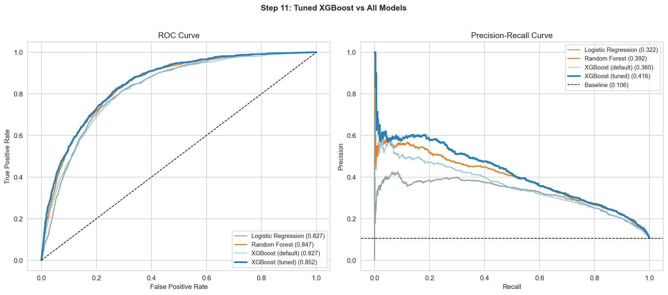
Figure 3: All 4 models — tuned XGBoost (thick blue) separates clearly in both ROC and PR curves.
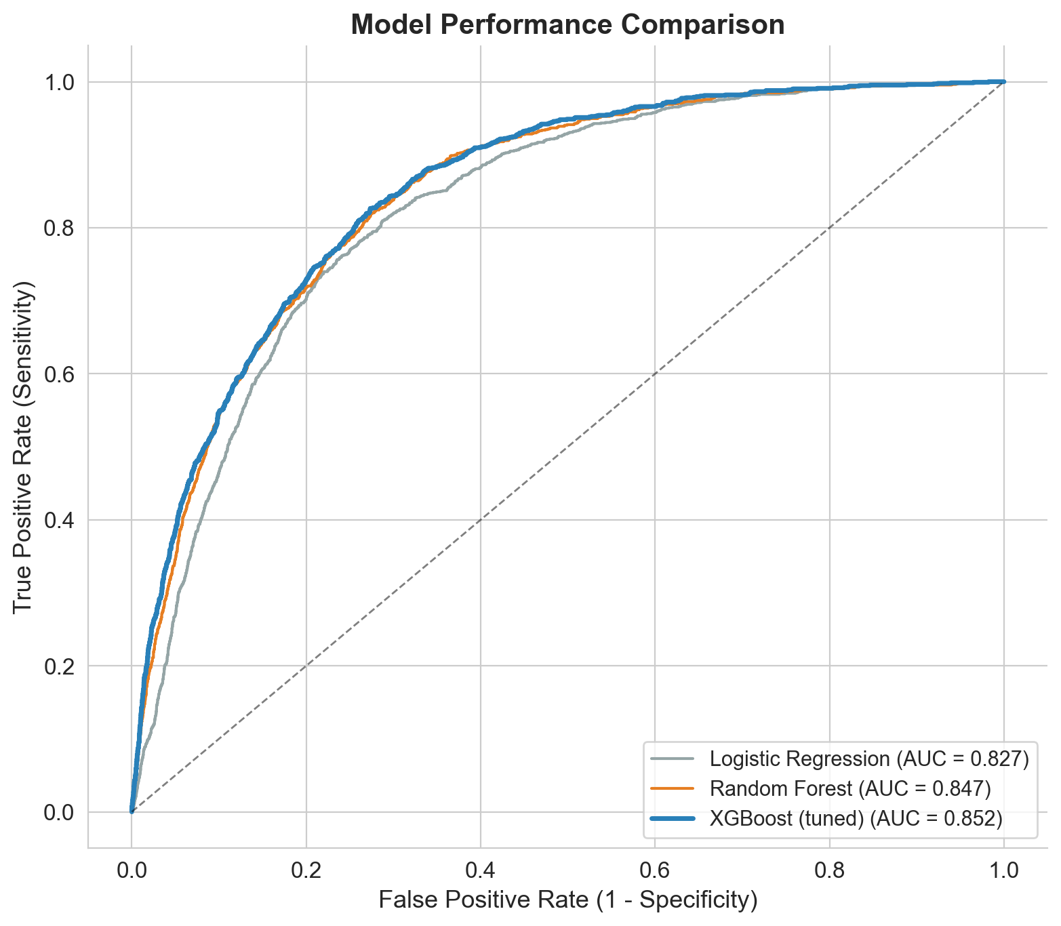
Figure 4: Presentation-ready ROC comparison (3 models for cleaner slide).

4. Test Set Evaluation (Step 12)
Final unbiased evaluation of the tuned XGBoost on 12,485 held-out test patients.

4.1 Core Metrics
Metric | Value | Interpretation
AUC-ROC | 0.8517 | 85% chance of correctly ranking a random uncontrolled above a random controlled patient
PR-AUC (Average Precision) | 0.4162 | ~4× better than random (0.106 baseline)
Brier Score | 0.1592 | Probability calibration measure. Lower = better. 0 = perfect.
Sensitivity (Recall) | 80.6% (1,069 / 1,326) | Catches 4 out of 5 at-risk patients
Specificity | 74.2% (8,275 / 11,159) | Correctly clears 3 out of 4 controlled patients
PPV (Precision) | 27.0% (1,069 / 3,953) | Of flagged patients, 1 in ~3.7 is truly uncontrolled
NPV | 97.0% (8,275 / 8,532) | Of cleared patients, 97% truly stay controlled
F1 Score (Uncontrolled) | 0.405 | Harmonic mean of precision and recall

4.2 Confusion Matrix
 | Predicted Controlled | Predicted Uncontrolled | Row total
Actually Controlled | TN = 8,275 | FP = 2,884 | 11,159
Actually Uncontrolled | FN = 257 | TP = 1,069 | 1,326
Column total | 8,532 | 3,953 | 12,485
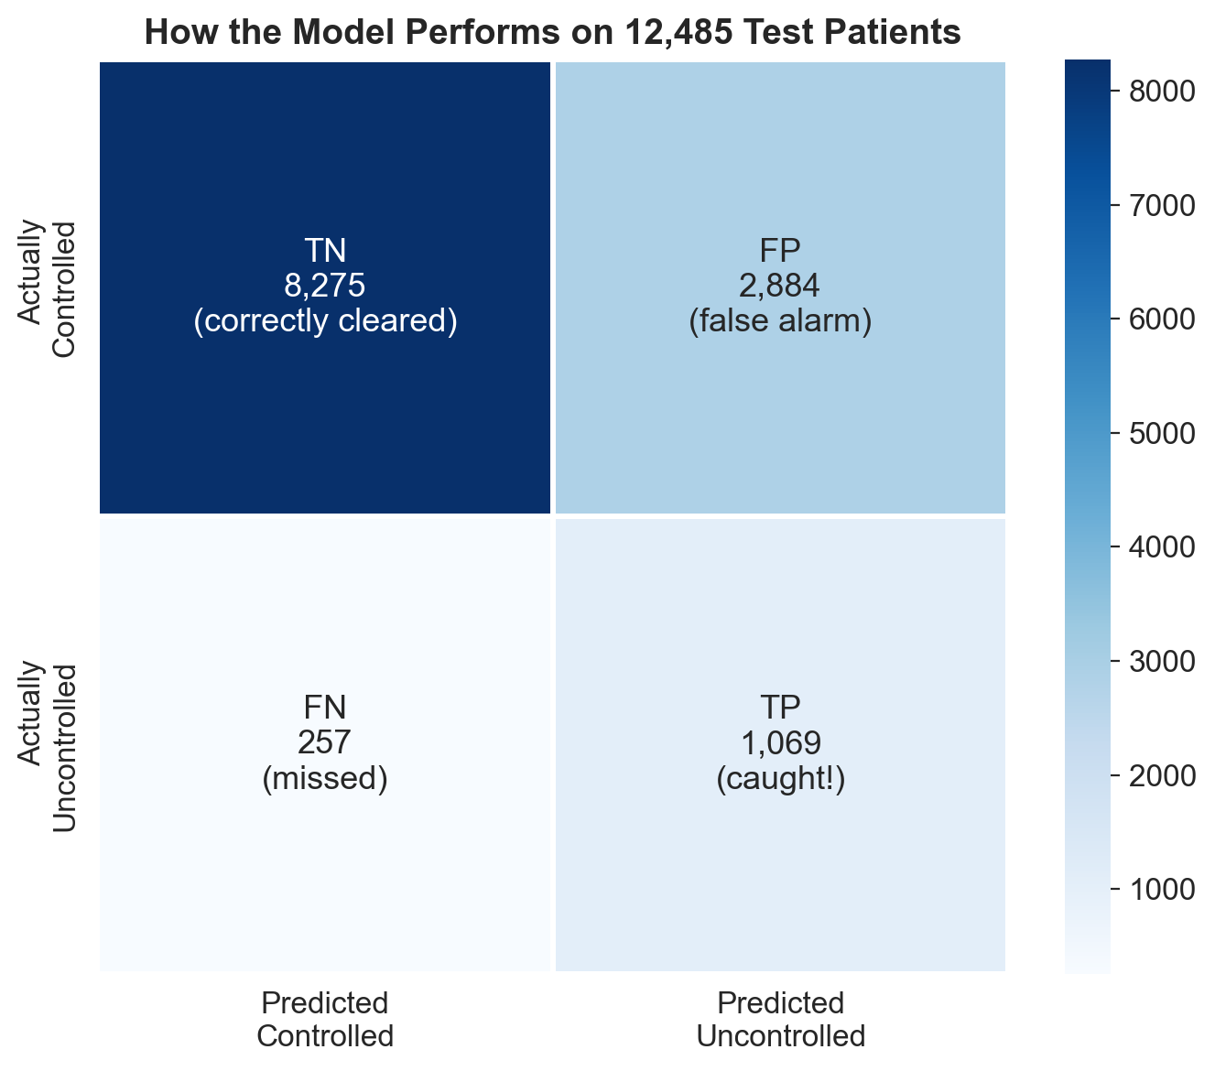
Figure 5: Confusion matrix with plain-language labels.

4.3 Threshold Analysis
The model outputs a probability. The threshold converts it to a binary decision. Adjusting the threshold trades recall for precision.
Threshold | Recall | Precision | Specificity | N flagged | N missed
0.10 | 98.1% | 14.6% | 32.0% | 8,887 | 25
0.15 | 96.4% | 16.6% | 42.5% | 7,697 | 48
0.20 | 94.8% | 18.6% | 50.9% | 6,741 | 69
0.25 | 92.3% | 20.3% | 56.8% | 6,040 | 102
0.30 | 90.6% | 21.6% | 61.0% | 5,552 | 125
0.40 | 87.0% | 24.0% | 67.3% | 4,808 | 172
0.50 (default) | 80.6% | 27.0% | 74.2% | 3,953 | 257

4.4 Calibration
Brier score = 0.1592. The calibration curve (bottom-right panel of Figure 6) shows the model is reasonably well-calibrated for low predicted probabilities (< 0.3) — when the model says "10% risk," approximately 10% of those patients are truly uncontrolled. In the 0.3–0.6 range, the model slightly overestimates risk (the curve dips below the diagonal). Above 0.7, calibration improves again. For a screening tool, this level of calibration is acceptable — the ranking (AUC) matters more than exact probability estimates.
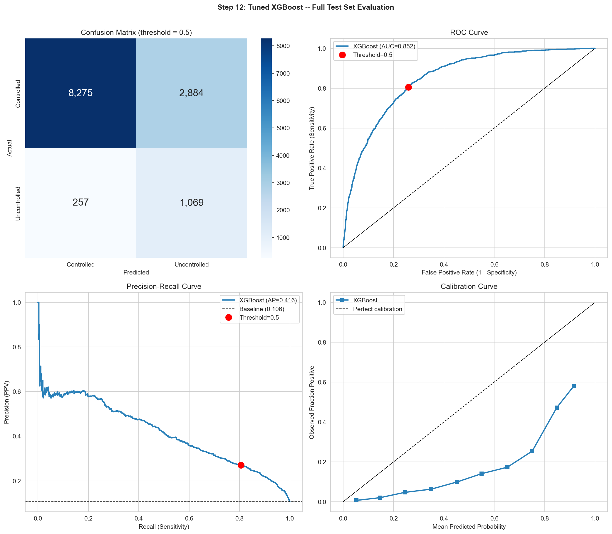
Figure 6: Four-panel evaluation — confusion matrix, ROC, PR curve, calibration curve.

4.5 Probability Distribution
The predicted probability distributions for controlled vs uncontrolled patients show good separation. Controlled patients (green) cluster at low probabilities (peak at 0.03–0.08). Uncontrolled patients (red) cluster at high probabilities (peak at 0.75–0.85). Overlap occurs in the 0.2–0.5 range — these are the uncertain cases.
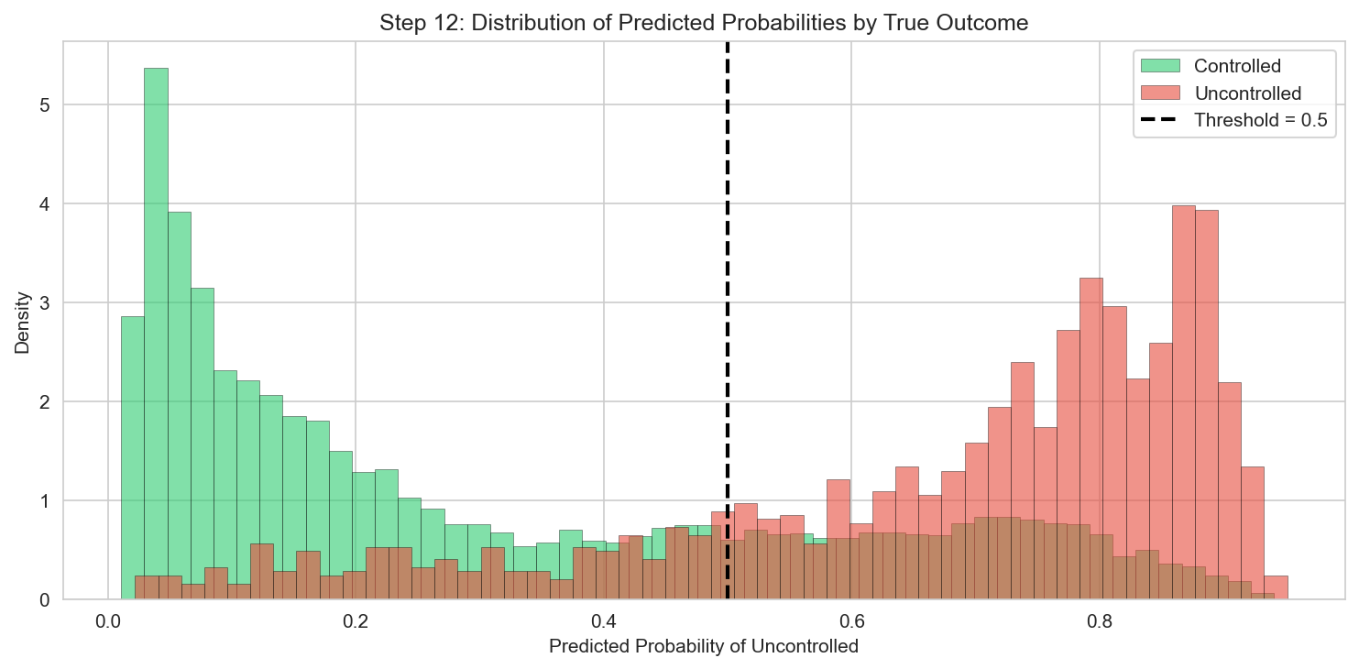
Figure 7: Predicted probability distributions by true outcome. Good separation with overlap in the uncertain zone.
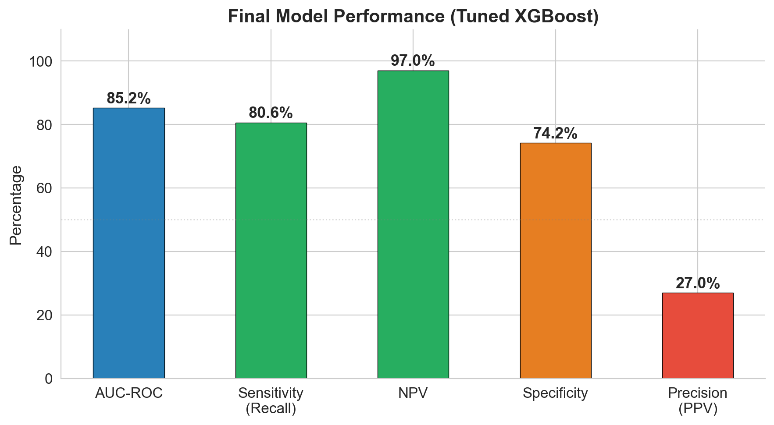
Figure 8: Presentation-ready key metrics summary.

5. Feature Importance (Step 13)

5.1 XGBoost Built-in Importance (Gain)
Gain measures total information gained from all splits on a feature across all trees. Features that are used more often in high-information splits rank higher.
Rank | Feature | Gain | Notes
1 | a1c_above_9 | 0.2733 | Dominant single split — binary threshold at A1c = 9
2 | a1c_max | 0.1072
3 | a1c_mean | 0.1051
4 | treatment_resistant | 0.0484 | Our engineered feature — A1c ≥ 8 + 2+ meds
5 | a1c_latest | 0.0465
6 | undertreated | 0.0458 | Our engineered feature — A1c ≥ 8 + 0 meds
7 | no_medication | 0.0231
8 | a1c_variability | 0.0172
9 | a1c_change | 0.0167
10 | total_med_classes | 0.0145
11 | sulfonylurea orders-count | 0.0137
12 | n_a1c_tests | 0.0124
13 | has_bmi | 0.0112
14 | is_male | 0.0104
15 | insurance_Medicare | 0.0098
— | race_Other Pacific Islander | 0.0000 | Zero importance (never used in splits)
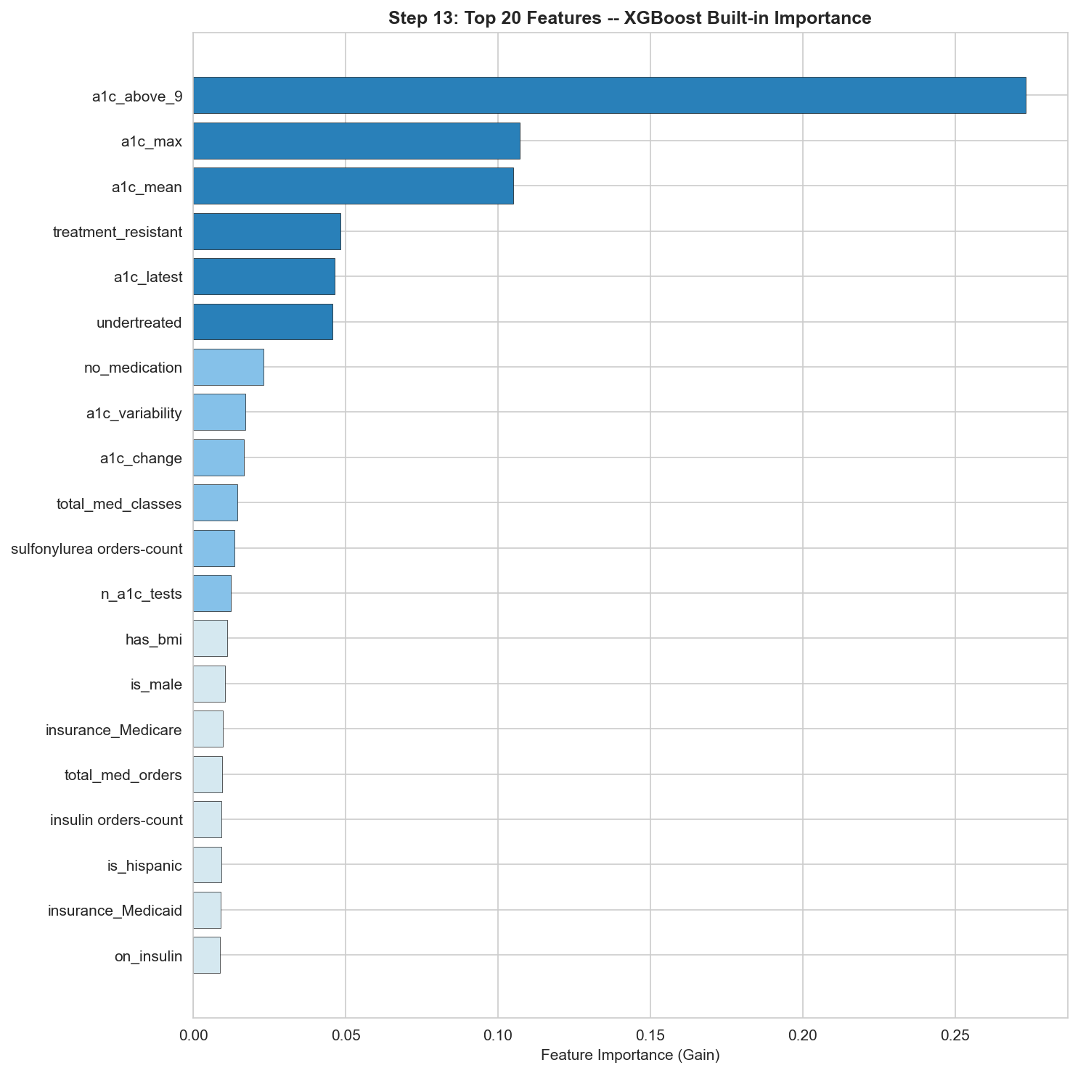
Figure 9: Top 20 features by XGBoost gain.

5.2 SHAP Values (Mean Absolute)
SHAP provides a more faithful importance measure — the average absolute contribution of each feature to individual predictions. Unlike gain, SHAP properly accounts for feature interactions and continuous variable effects.
Rank | Feature | Mean |SHAP| | Notes
1 | a1c_mean | 0.7283 | Dominant — 46% larger than #2
2 | a1c_max | 0.5007
3 | a1c_latest | 0.2184
4 | a1c_change | 0.1079 | Trajectory feature
5 | age | 0.0926 | Younger = higher risk
6 | bmi | 0.0813 | Despite 77% missing
7 | a1c_variability | 0.0781 | Instability signal
8 | a1c_above_9 | 0.0570 | Ranked lower than in gain (binary vs continuous effect)
9 | is_male | 0.0546
10 | sulfonylurea orders-count | 0.0465
11 | adi-adi national rank | 0.0430 | Weak in isolation, useful in combination
12 | race_Black or African American | 0.0417 | Modest positive contribution
13 | ed vist count-count | 0.0396
14 | n_a1c_tests | 0.0383
15 | total cholesterol-estimated result | 0.0367
Why gain and SHAP differ:
a1c_above_9 is #1 by gain but #8 by SHAP. Gain over-weights binary features that create large single splits. SHAP correctly captures that the continuous features (a1c_mean, a1c_max) have much larger cumulative impact across the full range of values. For presentation, use SHAP — it is more faithful to the model's actual decision-making.
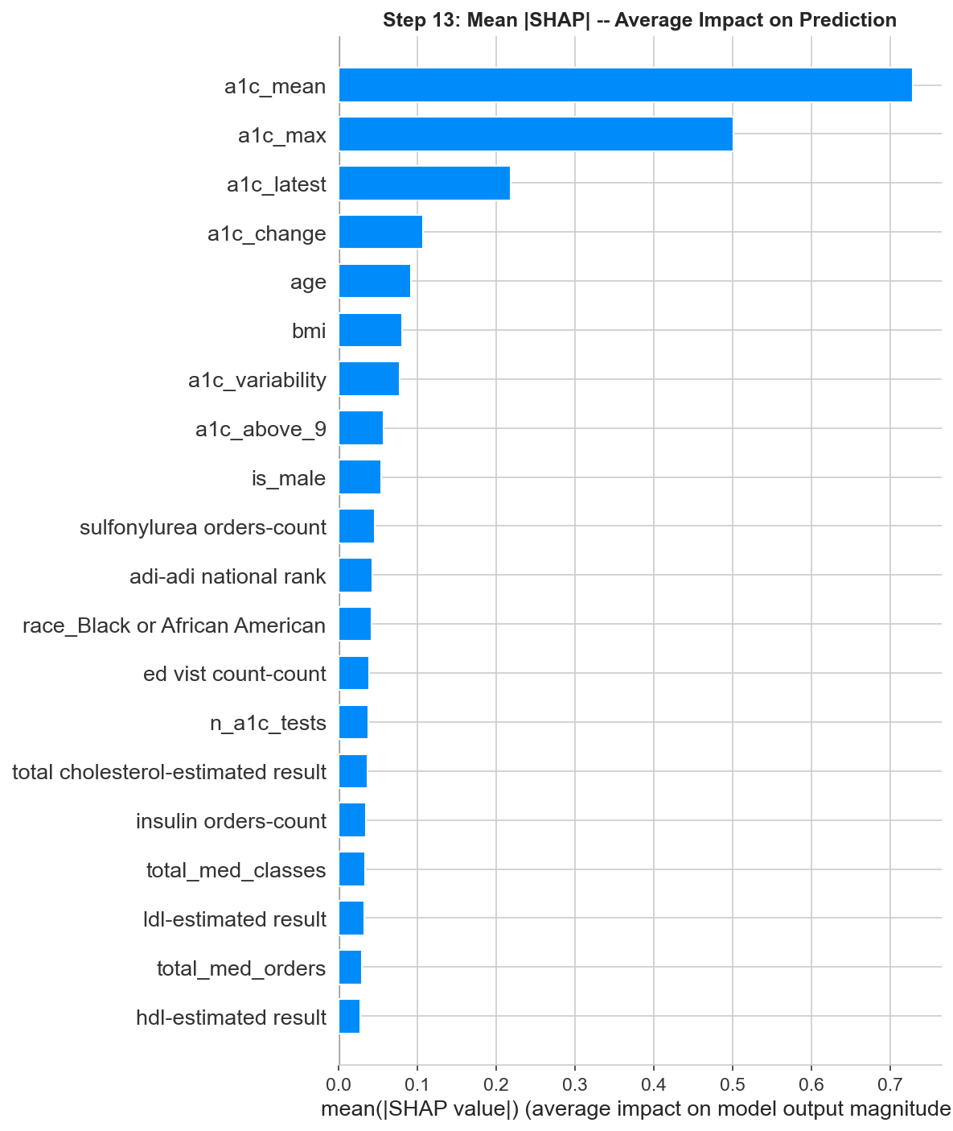
Figure 10: Mean |SHAP| bar chart.

6. Key Technical Decisions
Decision | Rationale | Alternative considered
XGBoost over Random Forest | XGBoost achieved AUC 0.852 vs RF 0.847 after tuning. XGBoost also handles NaN natively (no imputation needed for 9 columns), has more tunable hyperparameters, and produces better-calibrated probabilities. | RF was the leader before tuning. Could ensemble both, but XGBoost alone was sufficient.
scale_pos_weight = 8.41 | Ratio of majority to minority class (44,634/5,306). Penalizes false negatives proportionally to class imbalance. Equivalent to class_weight="balanced" in sklearn. | SMOTE oversampling. Decided against — adds synthetic patients that may not represent real clinical profiles.
Median imputation for LR/RF | SimpleImputer(strategy="median") for logistic regression and random forest. Median is robust to outliers in skewed distributions (which A1c and cholesterol have). | Mean imputation (sensitive to outliers), KNN imputation (too slow for 50K patients), or multiple imputation (overkill for competition).
Native NaN for XGBoost | XGBoost learns which direction to send missing values at each split. Generally superior to imputation because the "missingness direction" is data-driven. | Pre-imputation. Not needed and potentially harmful — imputed values add noise.
Threshold = 0.5 | Standard default for binary classification. Produces a good balance of recall (81%) and specificity (74%). The threshold table lets clinics choose their own operating point. | Optimized threshold (e.g., Youden index or F1-maximizing). Could improve F1 slightly but adds complexity.
5-fold CV for tuning | Stratified 5-fold cross-validation during RandomizedSearchCV. 5 folds balance bias/variance of the CV estimate while keeping computation feasible. | 10-fold (more stable but 2× slower), or a validation hold-out (faster but noisier estimate).
80 random search iterations | Explored 80 of ~312K possible combinations. Sufficient to find near-optimal region — top 10 configurations were within AUC 0.001 of each other. | Grid search (exhaustive but ~4000× slower), Bayesian optimization (better coverage but harder to implement).
Dropping raw A1c columns | The 5 raw A1c columns were replaced by 7 summary features (latest, mean, max, change, variability, n_tests, above_9). Raw columns were 58-97% missing and correlated (r = 0.52-0.64). | Keeping both raw and engineered. Tested implicitly — engineered features carry more signal.

7. Technical Q&A Prep
These are the questions judges will direct at the Technical Lead. Rehearse them.
Q: How do you know the model is not overfitting?
A: Three safeguards. (1) The test set was never used during training or tuning — it was opened exactly once for final evaluation. (2) Hyperparameter tuning used 5-fold cross-validation on the training set only. The best CV AUC (0.849) closely matches the test AUC (0.852), indicating no overfitting. (3) The tuned XGBoost uses aggressive regularization: subsample=0.7, colsample_bytree=0.5, gamma=0.3, min_child_weight=10. Each tree sees only 70% of patients and 50% of features, preventing memorization.
Q: Why XGBoost over Random Forest? RF had similar AUC.
A: Three reasons. (1) After tuning, XGBoost achieved AUC 0.852 vs RF 0.847 — a small but consistent advantage. (2) XGBoost handles missing values natively — the 9 columns with NaN do not need imputation, which avoids introducing artificial values. (3) XGBoost produces better-calibrated probabilities, which matters for the threshold analysis and clinical deployment. The gap is small enough that RF would also be a defensible choice.
Q: How did you handle class imbalance?
A: scale_pos_weight = 8.41, which is the ratio of controlled to uncontrolled patients (44,634 / 5,306). This tells the model that missing an uncontrolled patient is 8.4× more costly than a false alarm. It is mathematically equivalent to replicating each positive example 8.4 times but computationally cheaper. We also evaluated with PR-AUC (not just AUC-ROC), which is more sensitive to positive-class performance in imbalanced settings.
Q: Why not use SMOTE or other oversampling?
A: SMOTE creates synthetic minority-class samples by interpolating between existing ones. For clinical data, this can create unrealistic patient profiles (e.g., a synthetic patient with A1c 7.5 and 0 medications but flagged as treatment-resistant). scale_pos_weight achieves the same rebalancing effect without inventing data. We also tested class_weight="balanced" in logistic regression and RF — same principle, different implementation.
Q: Why is precision only 27%? Isn't that bad?
A: It is expected and appropriate. With a 10.6% base rate, even a perfect ranking model will have low precision at high recall. At threshold 0.5, we catch 81% of uncontrolled patients. The 73% of flags that are false positives cost a 15-minute chart review each. The 19% of uncontrolled patients we miss could face kidney disease or retinopathy. The asymmetric cost justifies the tradeoff. For comparison, mammography has precision of ~5% at the population level.
Q: How did you choose the threshold?
A: We used 0.5 as the default, which is standard for binary classification with scale_pos_weight. However, we provide a full threshold analysis (0.10 to 0.50) so the clinical team can choose based on their capacity. Lower thresholds (0.15) catch 96% but flag more patients; higher thresholds (0.50) catch 81% with fewer flags. The "right" threshold depends on the clinic's staffing for chart reviews and the cost of missing a patient.
Q: What about the calibration issue in the 0.3-0.6 range?
A: The model slightly overestimates risk in the 0.3-0.6 predicted probability range — it says "40% risk" when the actual rate is closer to 30%. This affects the absolute probability estimates but not the ranking (AUC). For clinical use, the ranking is what matters: patients with higher predicted probabilities are genuinely higher risk. If exact probabilities are needed (e.g., for shared decision-making), Platt scaling or isotonic regression could be applied as a post-processing step.
Q: Why did you drop the timing/date columns? Isn't when a test was done important?
A: The timing columns record how many days before the reference date each lab was collected. We considered them but chose not to use them directly because: (1) the number of tests (n_a1c_tests) captures monitoring frequency, which is the clinically meaningful aspect of timing, (2) the raw timing values are on different scales across lab types, and (3) the A1c results themselves are more informative than when they were drawn. The engineered features (a1c_change = trajectory) implicitly capture the temporal dimension.
Q: Could you explain the SHAP analysis to a non-technical audience?
A: SHAP answers: "For this specific patient, how much did each feature push the prediction up or down?" Think of it like itemizing a bill. The model starts at a baseline risk (10.6%, the population average). Then each feature adjusts it: high A1c mean adds +15%, being young adds +3%, being on insulin adds +2%, etc. The sum of all adjustments gives the final predicted risk. SHAP lets us see every line item, making the model transparent.
Q: What was your compute environment?
A: Python 3.9 on macOS. Key libraries: pandas, numpy, scikit-learn, xgboost, shap, matplotlib, seaborn. The full pipeline (data loading through SHAP) runs in under 10 minutes on a laptop. RandomizedSearchCV (80 iterations × 5 folds) was the most expensive step at approximately 5 minutes. No GPU required.

Quick Reference Card
Final model specification:
Component | Value
Algorithm | XGBClassifier (xgboost library)
n_estimators | 800
learning_rate | 0.01
max_depth | 5
min_child_weight | 10
subsample | 0.7
colsample_bytree | 0.5
gamma | 0.3
reg_alpha | 0
reg_lambda | 1
scale_pos_weight | 8.41
eval_metric | logloss
random_state | 42
Missing data | Native NaN handling (no imputation)
Saved as | xgb_tuned_model.pkl

Pipeline files:
File | What it does
clean_data.py | Raw CSV → 36 cleaned numeric columns
feature_engineering.py | Cleaned data → +20 engineered features (56 total)
split_data.py | Engineered data → train/test CSVs (48 features after dropping raw)
modeling.py | Train/test CSVs → model training and evaluation
generate_notebook.py | Generates datathon_notebook.docx
exploration.py | Steps 1–5 exploration (plots + console output)

Key metrics at a glance:
Stage | AUC-ROC | Notes
Logistic regression baseline | 0.8275 | Linear model, all 48 features
Random Forest (defaults) | 0.8467 | Best before tuning
XGBoost (defaults) | 0.8267 | Worse than LR before tuning
XGBoost (tuned) — FINAL | 0.8517 | Best model. CV AUC 0.849 ≈ test AUC 0.852.

