I2DB Datathon 2025
Diabetes Risk Prediction

Technical Notebook

Team: [Your Name(s) Here]
Institution: [Your Institution]
I2DB Symposium — April 13, 2026

Table of Contents
1. Introduction
2. Data Exploration (Steps 1–5)
2.1 Step 1: Loading and Initial Inspection
2.2 Step 2: Target Variable Analysis
2.3 Step 3: Feature Group Exploration
2.4 Step 4: Missingness Analysis
2.5 Step 5: Correlations
3. Data Preparation (Steps 6–8)
3.1 Step 6: Data Cleaning
3.2 Step 7: Feature Engineering
3.3 Step 8: Train-Test Split
4. Modeling (Steps 9–12)
4.1 Step 9: Baseline Logistic Regression
4.2 Step 10: Advanced Models
4.3 Step 11: Hyperparameter Tuning
4.4 Step 12: Test Set Evaluation
5. Interpretation (Steps 13–14)
5.1 Step 13: Feature Importance and SHAP
5.2 Step 14: Subgroup Fairness Analysis
6. Submission and Presentation
7. Key Decisions Log
8. Glossary

1. Introduction

The Clinical Problem
Diabetes affects over 37 million Americans, and glycemic control — measured by hemoglobin A1c — is the cornerstone of diabetes management. When a patient's A1c becomes "uncontrolled" (generally A1c ≥ 9%), the risk of complications rises sharply: kidney disease, retinopathy, neuropathy, and cardiovascular events. Currently, clinicians typically discover loss of glycemic control reactively — the patient comes in for a routine visit, labs are drawn, and the A1c comes back elevated. By then, the patient may have been uncontrolled for months.
What if we could identify patients who are about to lose control before it happens? A predictive model could flag high-risk patients for proactive intervention: closer monitoring, medication adjustment, care coordination, or outreach. This is the clinical problem our project addresses.

Competition Overview
Item | Detail
Competition | I2DB Datathon 2025
Prize | $2,000 (first place)
Submission deadline | April 6, 2026
Symposium presentation | April 13, 2026
Task | Binary classification — predict a1c 2025 Uncontrolled (True/False)
Evaluation | Model performance, clinical reasoning, presentation quality

Our Approach in Plain English
We used 12 months of electronic health record (EHR) data for 62,425 diabetes patients to predict which patients will have uncontrolled A1c in the following year. Our approach followed a systematic 16-step pipeline: explore the data, clean it, engineer clinically meaningful features, train multiple machine learning models, tune the best one, and evaluate it fairly across demographic subgroups. The final model — a tuned XGBoost classifier — achieves an AUC of 0.852 and catches 81% of patients who will become uncontrolled.

Dataset Overview
Property | Value
Patients | 62,425
Feature columns | 41 (demographics, labs, medications, utilization, comorbidities, social determinants)
Target variable | a1c 2025 Uncontrolled (True = 10.6%, False = 89.4%)
Feature file | DM_Features.csv
Target file | DM_Control_2025.csv
Class imbalance | ~1:8 ratio (uncontrolled : controlled)

2. Data Exploration (Steps 1–5)

2.1 Step 1: Loading and Initial Inspection
What we did:
We loaded both CSV files, verified they contained the same 62,425 patients in the same order, examined column names, data types, and missing values across all 41 features.
What we found:
The 41 features fell into 9 clinical groups:
Group | Columns | Key observations
Demographics | 4 | Birth year (integer), sex, race, ethnicity. Near-complete.
Comorbidities | 2 | CAD and COPD counts. Zero missingness.
A1c Labs | 11 | Up to 5 A1c results + timing columns + 1 leakage column. A1c 1 is 100% complete; A1c 4-5 are 97% missing.
Weight / Height | 6 | Values, dates, units. ~73-76% missing.
Cholesterol | 6 | LDL, HDL, total + timing. ~24% missing.
Utilization | 3 | ED visits, PCP visits, admissions. Zero missingness.
Insurance | 1 | 67% missing.
Medications | 6 | Order counts for 6 drug classes. Zero missingness (0 = no orders).
ADI | 2 | Area Deprivation Index. 37-48% missing. Stored as strings — needed type conversion.
What this means:
The data has a clear structure: some features are fully populated (medications, utilization, comorbidities, most demographics) while others are sparse (later A1c values, weight/height, insurance). The missingness pattern itself carries information — we return to this in Step 4. We also flagged the column "a1c 2025-collection date-time-days from reference" as a potential data leakage risk, which we investigate thoroughly in Step 4.

2.2 Step 2: Target Variable Analysis
What we did:
We examined the class balance of the target variable, visualized the distribution of the most recent A1c value (A1c 1) split by outcome, and computed uncontrolled rates across A1c bins.
What we found:
The target is heavily imbalanced: 55,793 patients (89.4%) remain controlled, while only 6,632 (10.6%) become uncontrolled. This is roughly a 1:8 ratio. A model that simply predicts "controlled" for every patient would be 89.4% accurate but clinically useless — it would miss every at-risk patient.
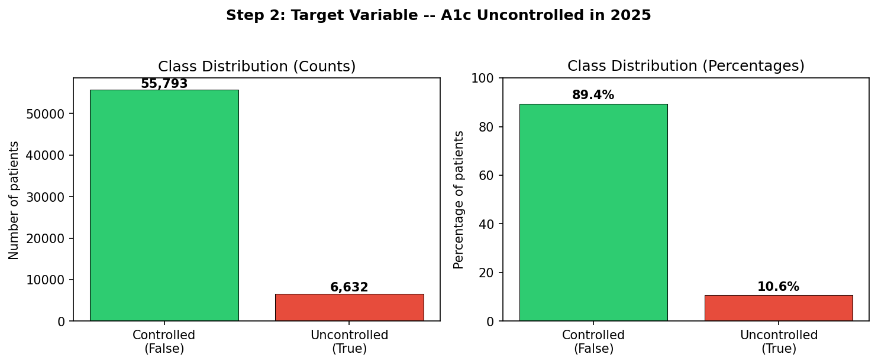
Figure 1: Class distribution showing the 1:8 imbalance between controlled and uncontrolled patients.
The most recent A1c value differs substantially between groups. Controlled patients have a mean A1c of 6.92 (median 6.5), while uncontrolled patients have a mean of 8.78 (median 8.3) — a difference of nearly 2 full A1c points.
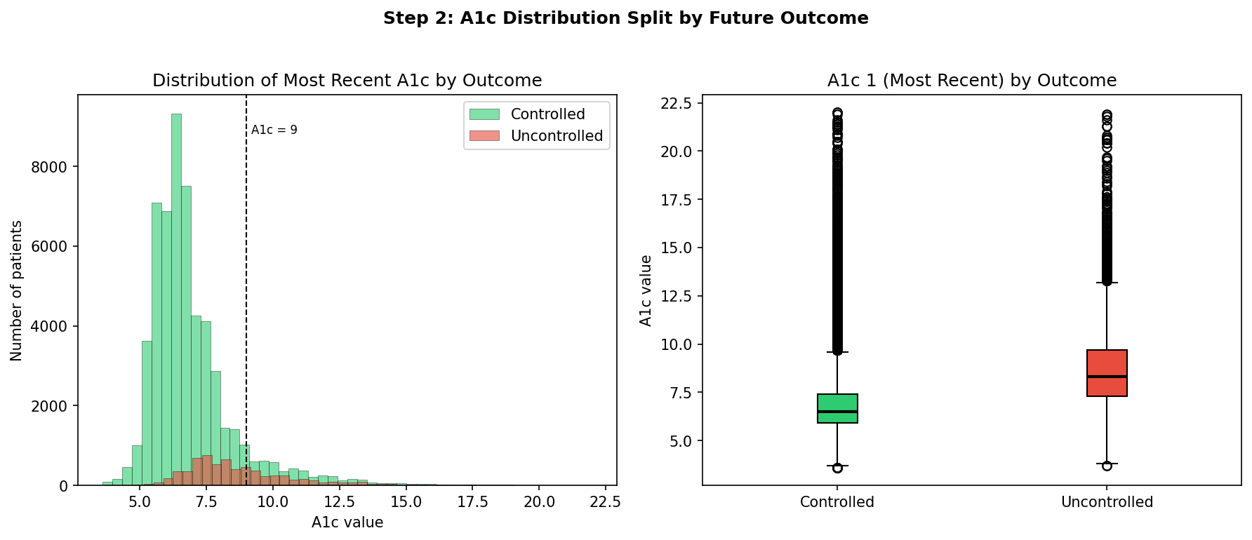
Figure 2: A1c distribution (histogram and box plot) by future outcome. The uncontrolled group has a higher and more spread distribution.
When we binned patients by current A1c level, a clear dose-response emerged:
Current A1c | Risk of becoming uncontrolled | N patients
< 5.7 | 1.0% | 10,469
5.7 – 6.5 | 2.3% | 18,684
6.5 – 7.0 | 6.5% | 9,676
7.0 – 8.0 | 15.7% | 11,513
8.0 – 9.0 | 27.8% | 5,078
9.0 – 10.0 | 32.1% | 2,591
> 10.0 | 32.0% | 4,414
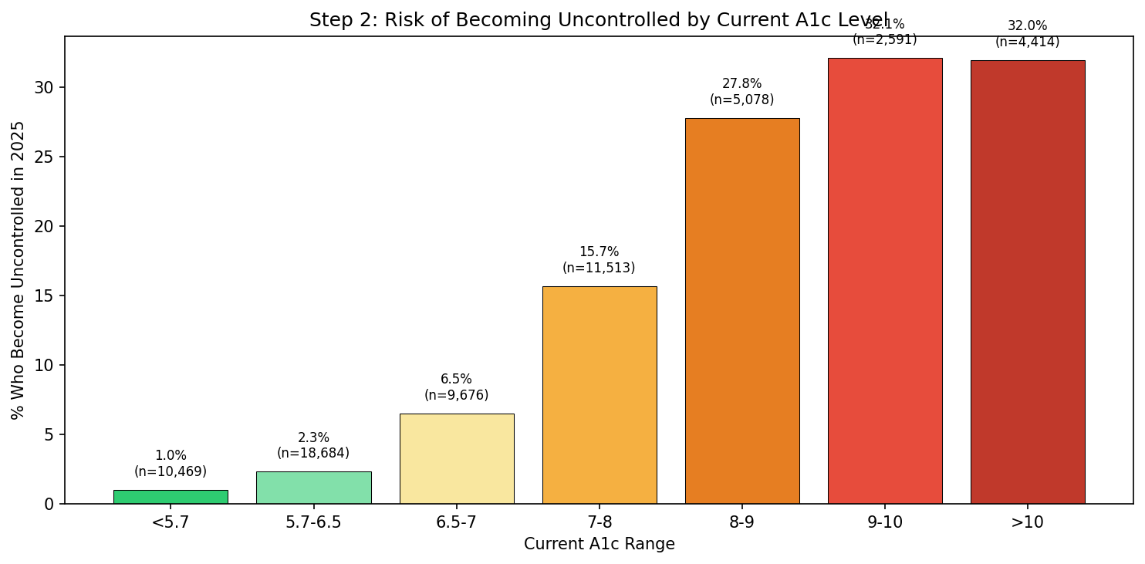
Figure 3: Risk of becoming uncontrolled by current A1c level. Risk plateaus above A1c 9.
What this means:
Current A1c is the single strongest predictor, but it is not sufficient. Risk plateaus above A1c 9, suggesting that once a patient is severely uncontrolled, factors other than the A1c number itself (medications, engagement, comorbidities) determine whether they stay uncontrolled. Critically, 65% of patients who become uncontrolled currently have A1c below 9. The model needs features beyond A1c to catch these patients.

2.3 Step 3: Feature Group Exploration
What we did:
We explored each feature group — demographics, comorbidities, medications, utilization, cholesterol, and ADI — by comparing distributions and uncontrolled rates between groups.
Demographics:
Younger patients have higher uncontrolled rates: 14.3% for patients under 30 versus 8.8% for those over 80. Males (11.8%) are slightly more at risk than females (9.6%). Race shows meaningful disparities: Pacific Islander (15.4%) and American Indian (14.9%) have the highest rates, while White (10.1%) and Asian (10.2%) have the lowest. Hispanic patients (12.8%) are higher than non-Hispanic (10.6%).
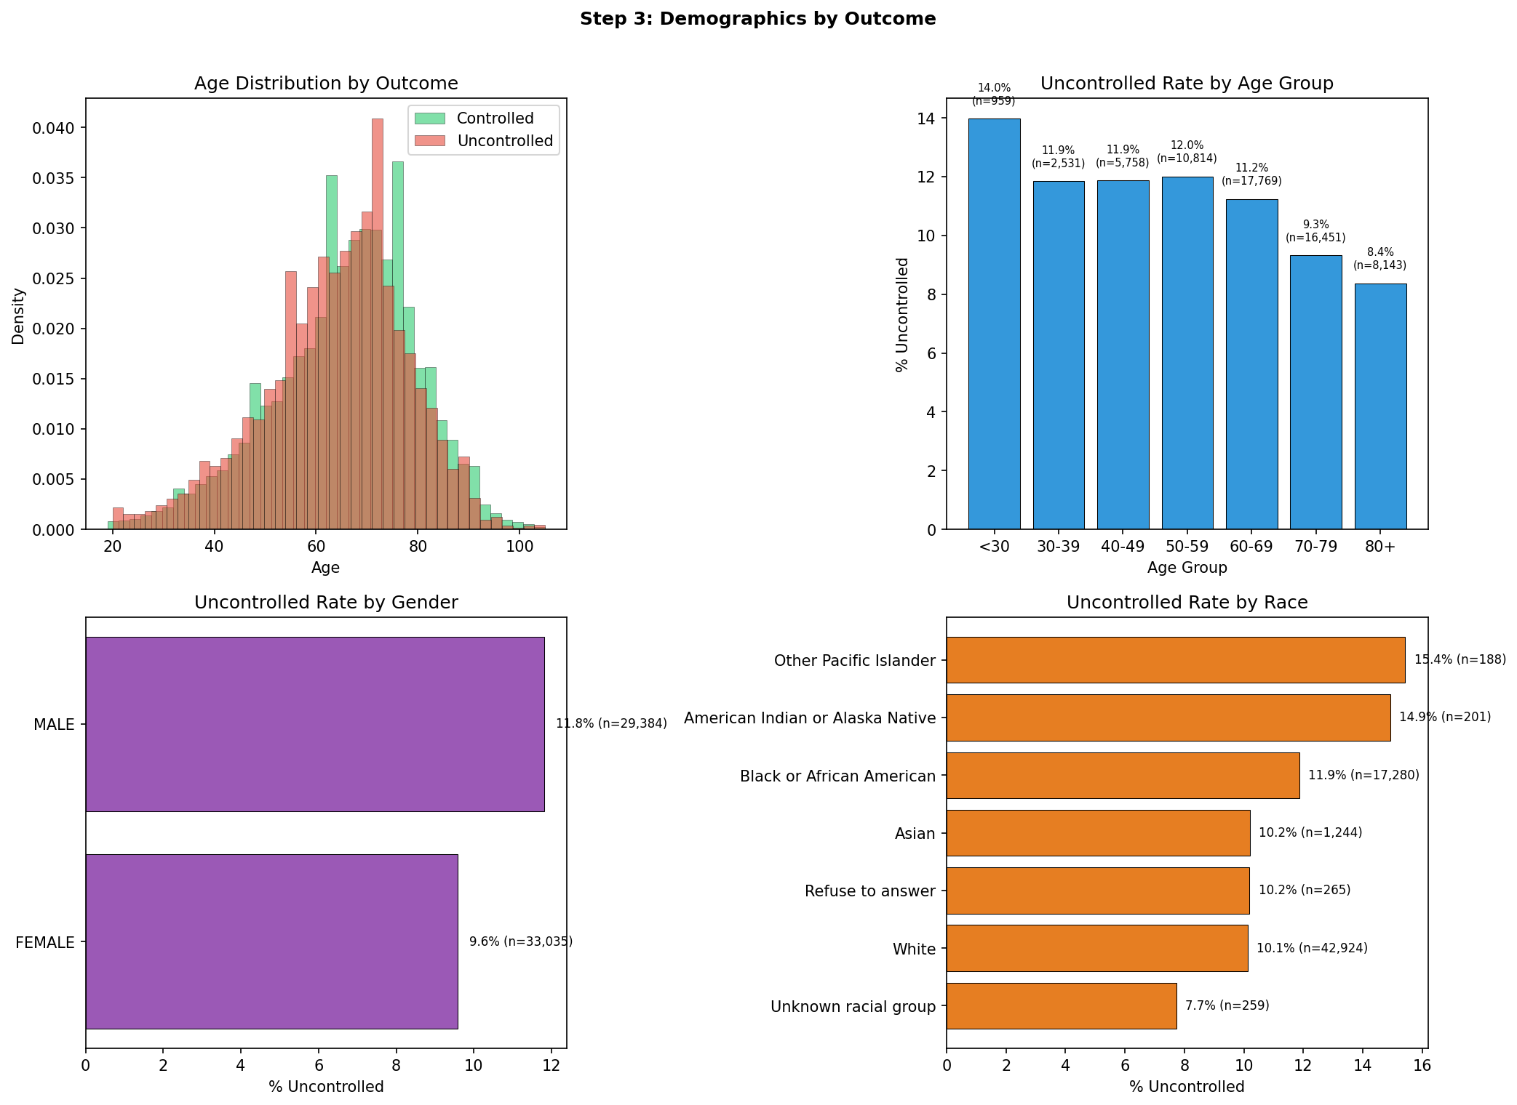
Figure 4: Uncontrolled rates by age group, gender, and race.
Medications (important — confounding):
Uncontrolled patients use more medications, not fewer. Insulin use is 44.7% in uncontrolled versus 32.8% in controlled (+12 percentage points). Metformin and sulfonylurea show similar gaps (+10-11pp). This seems counterintuitive — shouldn't more treatment lead to better control?
This is confounding due to reverse causation. Patients with high A1c get prescribed more medications, not the other way around. A patient on 3 drugs with A1c 7.5 is a fundamentally different patient from one on 0 drugs with A1c 7.5 — the first has aggressive, treatment-resistant disease that required 3 classes to get down to 7.5, while the second has mild disease managed by diet alone. This insight directly informed our feature engineering: we created "treatment_resistant" (high A1c despite multiple medications) to properly capture this signal.
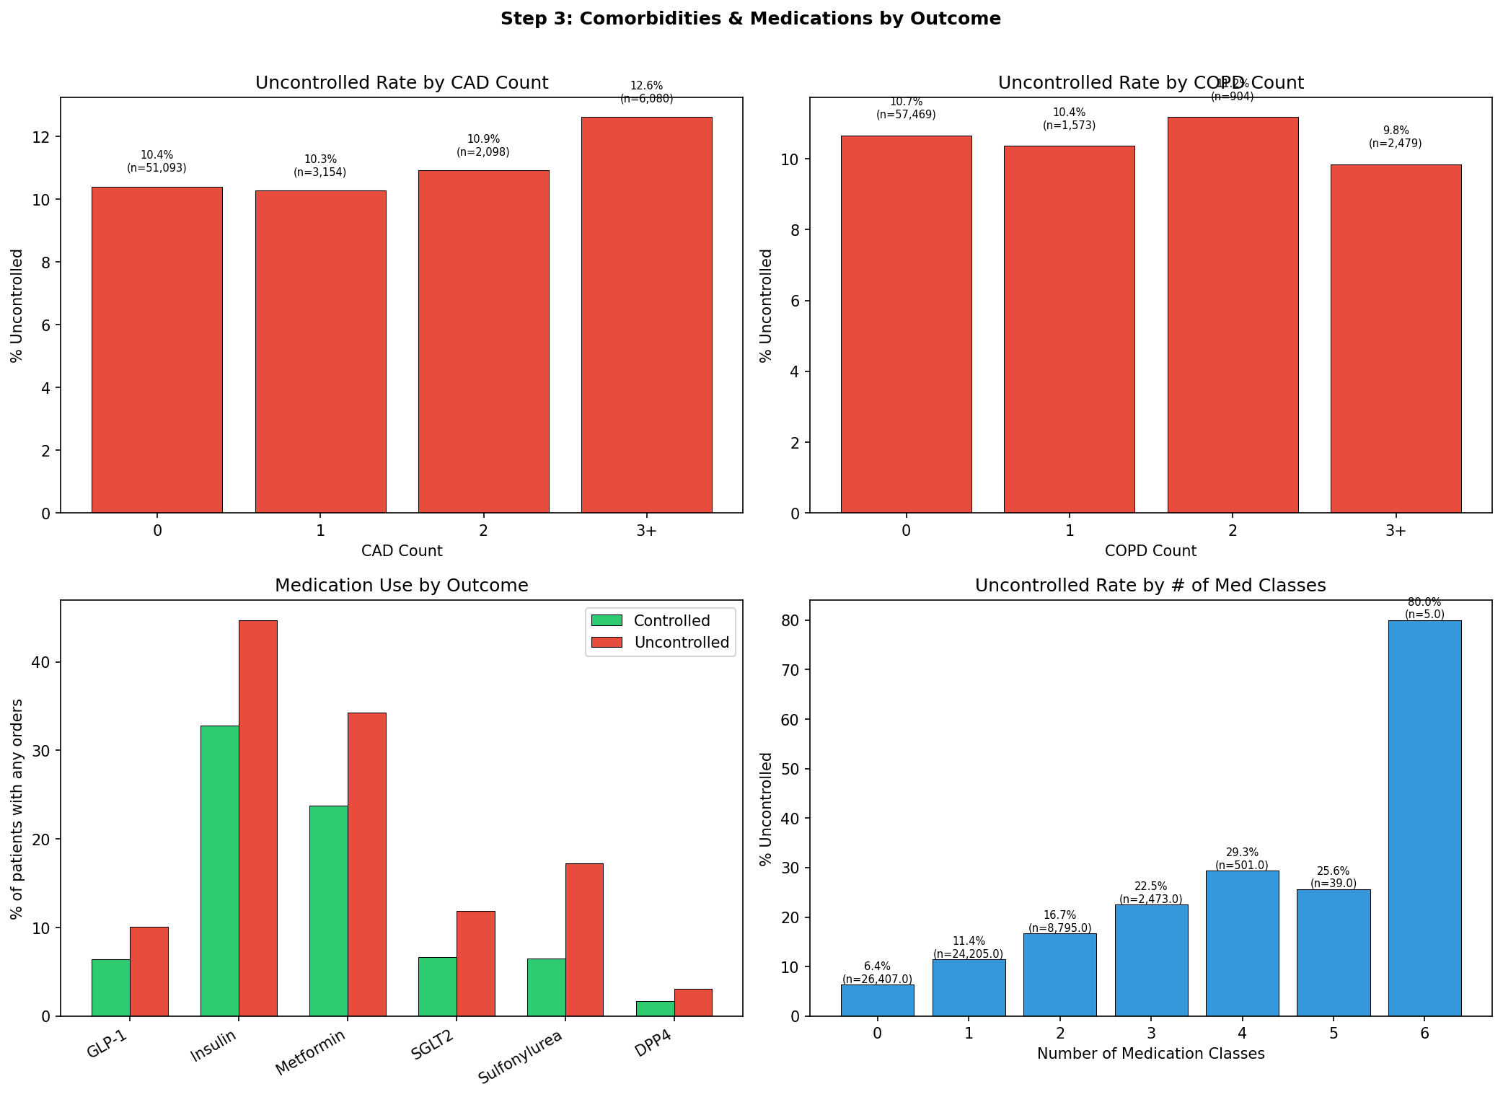
Figure 5: Comorbidities and medication use by outcome. Note higher medication use in the uncontrolled group.
Utilization, Cholesterol, and ADI:
ED visits showed a dose-response: 9.7% uncontrolled at 0 visits rising to 18.4% at 5+ visits. PCP visits and admissions showed minimal differences. Cholesterol (LDL, HDL, total) and ADI national rank were nearly identical between groups — weak individual predictors, though they may contribute in combination with other features inside a tree-based model.
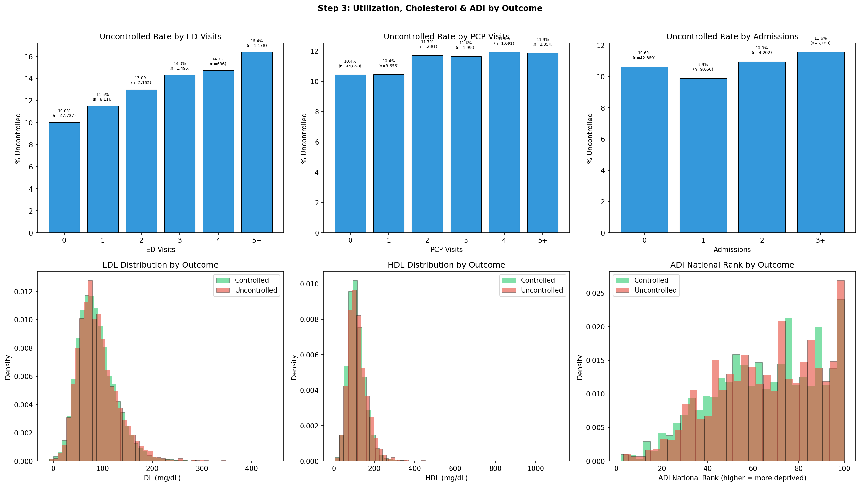
Figure 6: Utilization, cholesterol, and ADI distributions by outcome.
Feature signal ranking:
Based on exploration, we ranked feature groups by predictive signal strength: A1c values (strongest) >> medications (strong, confounded) > demographics (moderate) > ED visits (moderate) >> cholesterol and ADI (weak individually).

2.4 Step 4: Missingness Analysis
What we did:
We mapped which columns have missing data, visualized the missingness pattern, and — crucially — tested whether missingness rates differ between controlled and uncontrolled patients.
What we found:
Missingness is not random. It differs by outcome for several important columns:
Column | Controlled % missing | Uncontrolled % missing | Difference
a1c 2025 (date) — LEAKAGE | 47.7% | 0.0% | -47.7pp
A1c 2 | 59.7% | 40.9% | -18.8pp
A1c 3 | 89.1% | 76.3% | -12.8pp
Cholesterol (HDL/total) | 25.1% | 20.0% | -5.1pp
Weight/height | ~73-76% | ~74-76% | ~0pp (similar)
Insurance | 67.1% | 66.2% | ~0pp (similar)
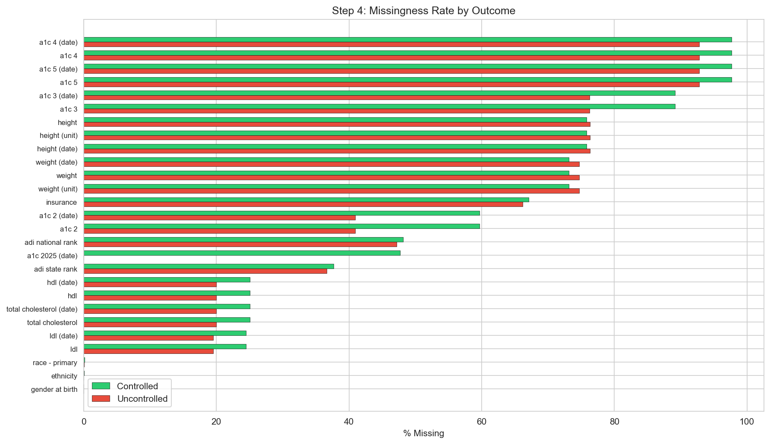
Figure 7: Missingness rates compared between controlled and uncontrolled patients.
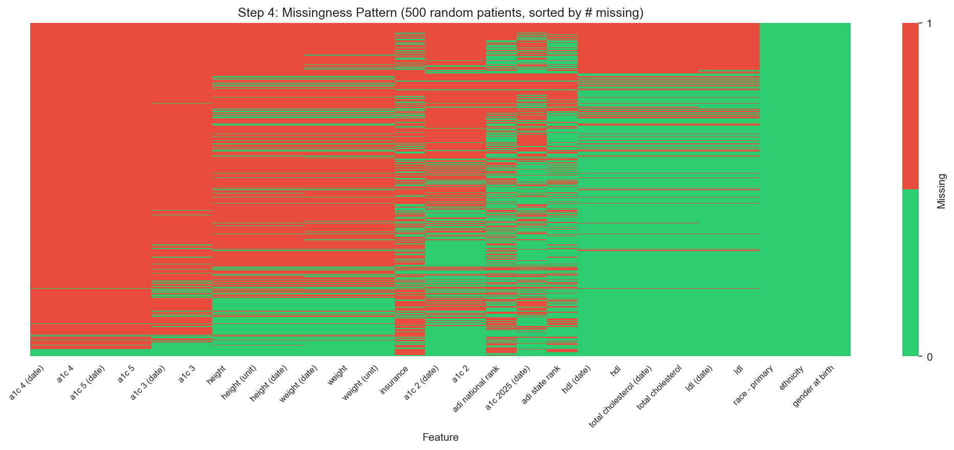
Figure 8: Missingness heatmap for 500 random patients. Red = missing, green = present.
The leakage column:
The column "a1c 2025-collection date-time-days from reference" is 0% missing for uncontrolled patients but 47.7% missing for controlled ones. This means if this column is missing, the patient is always controlled. A model could "cheat" by simply checking whether this column is null. We confirmed this with a cross-tabulation: 100% of the 26,617 patients missing this value are in the controlled group. This column was dropped immediately in data cleaning.
What this means:
Missingness itself carries information. Uncontrolled patients had more A1c tests (A1c 2 and 3 are much less missing), which makes clinical sense — if your A1c is high, your doctor orders repeat labs more frequently. This insight informed our "n_a1c_tests" feature: the count of non-missing A1c values captures monitoring intensity, which is a proxy for disease severity.

2.5 Step 5: Correlations
What we did:
We computed Pearson correlations between all numeric features and the target variable, and identified highly correlated feature pairs that might be redundant.
Correlations with the target:
Feature | Correlation | Strength
A1c 5 (oldest reading) | +0.432 | Strong
A1c 4 | +0.404 | Strong
A1c 3 | +0.387 | Strong
A1c 2 | +0.386 | Strong
A1c 1 (most recent) | +0.314 | Strong
Sulfonylurea orders | +0.109 | Moderate
Insulin orders | +0.082 | Moderate
Metformin orders | +0.066 | Moderate
All others | < 0.05 | Weak
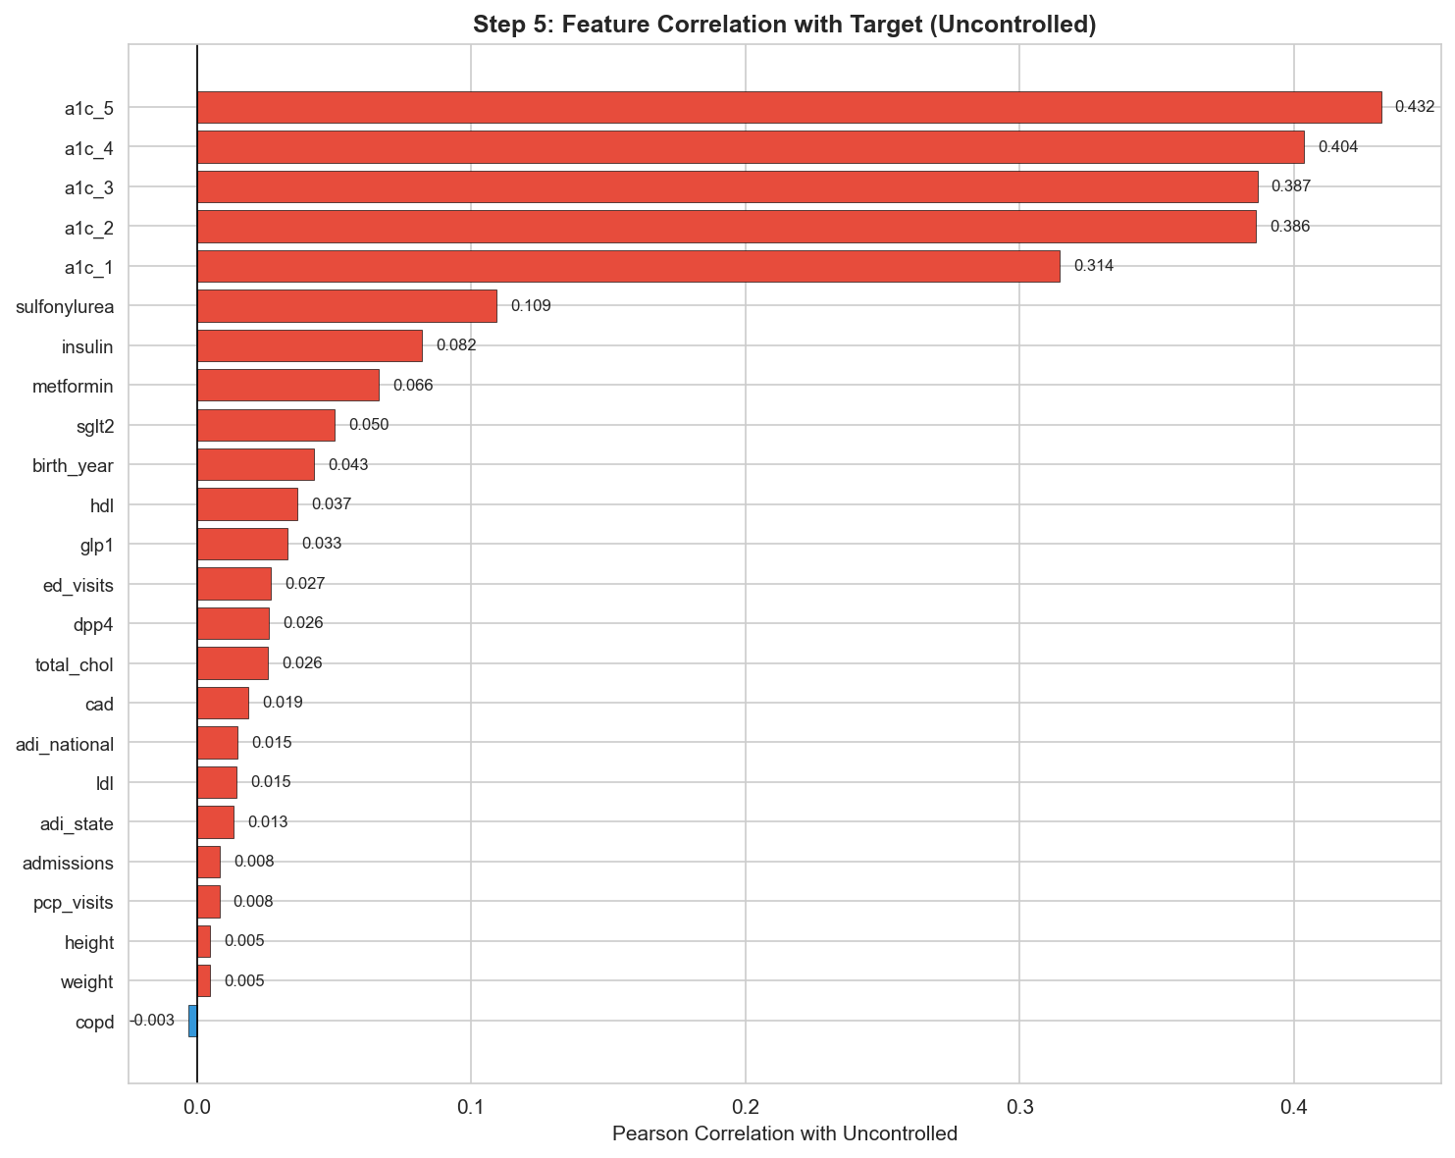
Figure 9: Feature correlations with the target, ranked by magnitude.
Redundant feature pairs (|r| > 0.5):
Feature A | Feature B | Correlation | Action taken
ADI state rank | ADI national rank | +0.964 | Dropped state (kept national)
LDL | Total cholesterol | +0.772 | Kept both (model can sort it out)
PCP visits | Admissions | +0.733 | Engineered total_encounters
A1c 1 | A1c 2 | +0.642 | Aggregated into summary features
Various A1c pairs | Various | 0.52–0.56 | Aggregated into mean, max, change, variability
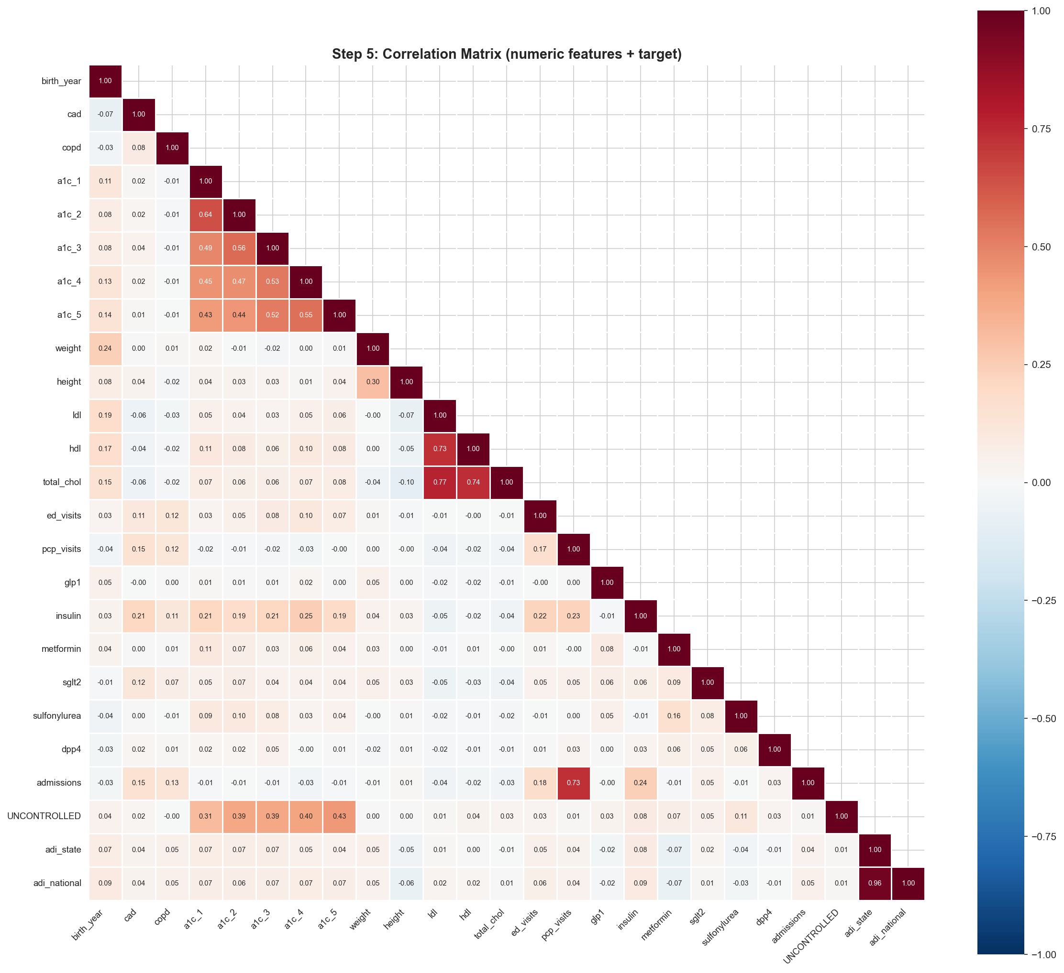
Figure 10: Full correlation matrix. Note the A1c cluster (upper left) and cholesterol cluster.
What this means:
A1c values dominate predictive signal. The five raw A1c columns correlate +0.31 to +0.43 with the target — far stronger than any other feature. Everything else (medications, demographics, utilization) adds marginal signal individually. This guided our decision to aggregate the raw A1c columns into summary features (mean, max, change, variability) rather than using them directly, and to drop the redundant ADI state rank.

3. Data Preparation (Steps 6–8)

3.1 Step 6: Data Cleaning
We transformed the raw 41-column dataset into a clean 36-column numeric dataset ready for feature engineering. Every column is now numeric (int64 or float64).
What we dropped (14 columns removed):
Action | Columns | Reason
Dropped leakage column | 1 | 100% of missing values = Controlled. Would allow the model to cheat.
Dropped date/timing columns | 10 | When a lab was collected is less useful than the result itself. Timing is captured indirectly by n_a1c_tests.
Dropped unit columns | 2 | All weights are kg, all heights are cm. Uniform units = zero information.
Dropped ADI state rank | 1 | 96% correlated with ADI national rank. Keeping both would be redundant.
What we encoded (4 text columns → 13 numeric columns):
Original column | Encoding | Result
Gender at birth | Binary: is_male (0/1) | 1 column
Ethnicity | Binary: is_hispanic (0/1) | 1 column
Race | One-hot encoding | 7 columns (one per category)
Insurance | Simplified from 12 categories to 4, then one-hot | 4 columns (Managed Care, Medicaid, Medicare, Other)
One-hot encoding means creating a separate binary (0/1) column for each category. For example, a patient who is Black and on Medicare would have race_Black_or_African_American = 1 (all other race columns = 0) and insurance_Medicare = 1 (all other insurance columns = 0). This allows the model to learn different effects for each category.
What we fixed:
ADI national rank was stored as a string (e.g., "10.0") instead of a number. We converted it to float64 using pd.to_numeric() with errors="coerce" to handle any non-numeric values.

3.2 Step 7: Feature Engineering
Feature engineering is the process of creating new, more informative variables from the raw data. This was the most impactful step in our pipeline — the engineered features capture clinical reasoning that raw columns cannot express. We created 20 new features organized into 6 categories, guided by both data science best practices and clinical domain knowledge.
A1c-Derived Features (8 features):
These are the most important features in the model. Rather than feeding in up to 5 raw A1c readings (most of which are missing for most patients), we summarized them into meaningful clinical metrics.
Feature | Calculation | Clinical reasoning
age | 2025 − birth year | Younger patients showed higher uncontrolled rates in Step 3 (14.3% for <30 vs 8.8% for 80+).
a1c_latest | A1c 1 (most recent value) | The current A1c is the single strongest raw predictor (r = +0.31 with target).
a1c_mean | Mean of all available A1c readings | Smooths out single-test noise. Captures overall glycemic burden. Strongest engineered feature (SHAP = 0.73).
a1c_max | Maximum A1c across all readings | Was the patient ever severely uncontrolled? A past episode of A1c 12 is informative even if current A1c is 7.
a1c_change | Most recent A1c − oldest A1c | Trajectory: positive means A1c went up (worsening), negative means improving. Only computed for patients with 2+ tests.
a1c_variability | Standard deviation of A1c readings | Glycemic instability. A patient who swings between 6 and 10 is different from one stable at 8, even though both average 8.
n_a1c_tests | Count of non-missing A1c values (1–5) | More monitoring = higher-risk patient. 58% had only 1 test; patients with 3+ tests were being watched closely.
a1c_above_9 | 1 if latest A1c ≥ 9, else 0 | Clinical threshold for severe uncontrolled diabetes. The #1 feature by XGBoost built-in importance.
Medication Features (4 features):
Feature | Calculation | Clinical reasoning
total_med_classes | Count of medication types with orders > 0 | Treatment intensity. Ranges from 0 (diet-controlled) to 6 (on everything).
total_med_orders | Sum of all medication order counts | Total prescription volume, not just number of drug types.
on_insulin | 1 if insulin orders > 0 | 34% of patients. Insulin = more advanced disease requiring injectable therapy.
on_newer_drugs | 1 if GLP-1 or SGLT2 orders > 0 | 13% of patients. These newer, expensive drugs are often reserved for harder-to-treat cases.
Treatment Pattern Features (3 features):
These features capture the relationship between disease severity and treatment — addressing the medication confounding we discovered in Step 3.
Feature | Calculation | Clinical reasoning
no_medication | 1 if total_med_classes = 0 | 42% of patients are on zero diabetes medications. These are typically mild, diet-controlled patients with low risk.
undertreated | 1 if A1c ≥ 8 AND total_med_classes = 0 | The patient who SHOULD be on medication but is not. 4.9% of patients. Could indicate non-adherence, access barriers, or clinical inertia.
treatment_resistant | 1 if A1c ≥ 8 AND total_med_classes ≥ 2 | The patient who IS on multiple meds but still cannot control their A1c. 6.4% of patients. One of the strongest non-A1c predictors (r = +0.20).
Body Metrics (2 features):
Feature | Calculation | Clinical reasoning
bmi | Weight (kg) / (height (m))² | Body mass index. Mean 32.6 (obese range). Only available for 23.5% of patients due to missingness in weight/height.
has_bmi | 1 if BMI can be calculated | Whether weight and height were recorded. Missingness itself may be informative — patients seen more frequently may be more likely to have vitals documented.
Utilization Features (3 features):
Feature | Calculation | Clinical reasoning
total_encounters | ED visits + PCP visits + admissions | Total healthcare utilization. Combines three correlated columns (PCP and admissions were r = 0.73).
any_admission | 1 if admission count > 0 | 32% of patients had at least one hospitalization.
any_comorbidity | 1 if CAD > 0 or COPD > 0 | 23% have at least one comorbidity. Captures overall disease burden.
Feature validation:
After engineering all 20 features, we computed their correlations with the target to confirm they carry signal. The top engineered features by correlation were: a1c_max (+0.35), a1c_mean (+0.33), a1c_latest (+0.31), a1c_above_9 (+0.25), a1c_variability (+0.21), and treatment_resistant (+0.20). The treatment_resistant feature was especially validating — it confirmed our hypothesis from Step 3 that combining A1c level with medication count captures a clinically meaningful signal that neither variable captures alone.

3.3 Step 8: Train-Test Split
We split the 62,425 patients into a training set (80%) and a held-out test set (20%) using scikit-learn's train_test_split with random_state=42 for reproducibility.
Set | Patients | Controlled | Uncontrolled | % Uncontrolled
Train | 49,940 | 44,634 | 5,306 | 10.62%
Test | 12,485 | 11,159 | 1,326 | 10.62%
We used stratified splitting, which ensures the class balance (10.62% uncontrolled) is preserved in both sets. Without stratification, random chance could put more uncontrolled patients in one set than the other, which would make our evaluation unreliable. It is the same principle as ensuring both arms of a clinical trial have the same disease prevalence.
We also dropped 8 raw columns that were now fully captured by engineered features: the 5 raw A1c value columns, birth year (replaced by age), and weight/height (replaced by bmi and has_bmi). The final feature matrix contains 48 columns.
The test set is a sealed envelope.
The test set was not used for any training, feature selection, or tuning decisions. It was only opened once, in Step 12, to get our final unbiased performance estimate. This prevents "overfitting to the test set" — where iteratively tweaking a model to improve test performance gives an overly optimistic estimate that would not generalize to new patients.

4. Modeling (Steps 9–12)

4.1 Step 9: Baseline Logistic Regression
Why start with logistic regression?
Logistic regression is the simplest classification model — it finds a straight line (in high-dimensional space) that separates the two classes. It is the "vital signs check" before ordering advanced imaging. If logistic regression does well, the signal is strong and linear. If it does poorly, we know we need more complex approaches.
We used class_weight="balanced" to handle the 1:8 class imbalance. This tells the model to pay 8× more attention to misclassifying an uncontrolled patient than a controlled one. Without this, the model would simply predict "controlled" for everyone (89.4% accuracy, 0% usefulness).
Results:
Model | AUC-ROC | PR-AUC | Recall | Precision
HIGH features only (6) | 0.8267 | 0.3120 | 72% | 28%
ALL features (48) | 0.8275 | 0.3216 | 75% | 28%
Dummy (always Controlled) | 0.5000 | — | 0% | —
Key finding: adding 42 more features barely improved AUC (+0.001). This tells us that in a linear model, A1c features carry almost all the signal. The medication and demographic features don't help much when you can only add them linearly. Tree-based models, which can discover interactions (e.g., high A1c AND many meds), should do better.
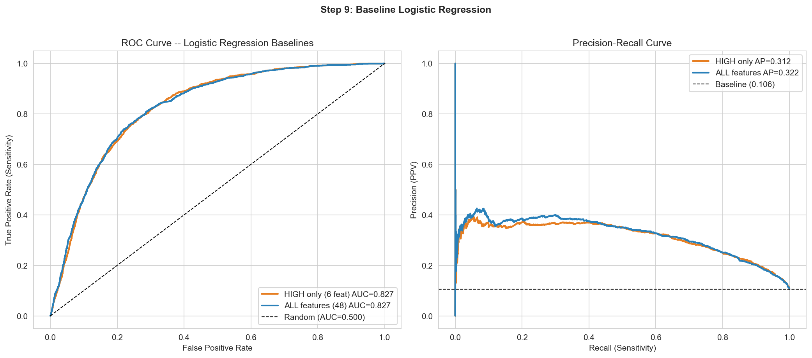
Figure 11: ROC and precision-recall curves for the baseline logistic regression models.

4.2 Step 10: Advanced Models
We trained two tree-based models: Random Forest and XGBoost. Tree-based models work by asking a sequence of yes/no questions about the features (e.g., "Is A1c > 8? → Yes → Is the patient on insulin? → No → High risk"). They naturally capture interactions between features without needing to explicitly engineer every combination.
Results (all using default settings):
Model | AUC-ROC | PR-AUC | Recall | Precision
Logistic Regression | 0.8275 | 0.3216 | 75.0% | 27.7%
Random Forest | 0.8467 | 0.3923 | 68.9% | 31.5%
XGBoost (defaults) | 0.8267 | 0.3596 | 64.8% | 30.4%
Random Forest won with default settings (AUC 0.847), while XGBoost with defaults (AUC 0.827) was no better than logistic regression. This is expected — XGBoost is a more powerful algorithm but requires tuning to reach its potential, like a race car that needs the right setup for each track. Step 11 addresses this.
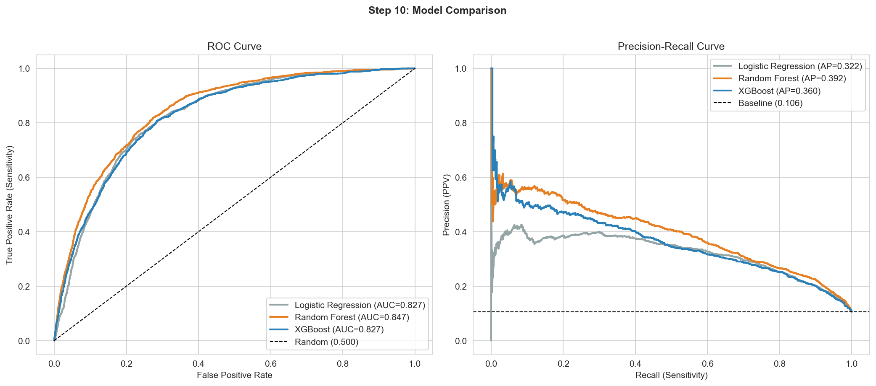
Figure 12: ROC and PR curves comparing all three models. Random Forest (orange) leads with default settings.

4.3 Step 11: Hyperparameter Tuning
Hyperparameters are settings that control how the model learns — they are not learned from the data but set by us before training. Tuning them is like adjusting the settings on a microscope to get the sharpest image.
We used RandomizedSearchCV with 80 parameter combinations × 5-fold cross-validation = 400 total model fits. Each combination was evaluated on its cross-validated AUC-ROC, ensuring we selected parameters that generalize rather than overfit.
Final tuned parameters:
Parameter | Value | Plain English explanation
n_estimators | 800 | Number of trees. More trees = more chances to learn patterns.
learning_rate | 0.01 | How much each tree adjusts the prediction. Small = careful, gradual learning (usually better but slower).
max_depth | 5 | Maximum depth of each tree (how many questions in sequence). Limits complexity to prevent overfitting.
min_child_weight | 10 | A leaf node must contain at least 10 patients. Prevents the model from making decisions based on tiny groups.
subsample | 0.7 | Each tree sees 70% of training patients (randomly sampled). Like training residents on rotating patient panels — prevents memorization.
colsample_bytree | 0.5 | Each tree sees 50% of features. Forces the model to find multiple pathways to the answer, not just rely on A1c every time.
gamma | 0.3 | Minimum improvement required to make a split. Like requiring a minimum clinical significance before acting on a result.
reg_lambda | 1 | L2 regularization penalty. Discourages extreme weights on any single feature.
scale_pos_weight | 8.41 | Ratio of controlled to uncontrolled patients (44,634 / 5,306). Tells the model that missing an uncontrolled patient is 8.4× worse than a false alarm.
Improvement from tuning:
Metric | XGBoost (default) | XGBoost (tuned) | Improvement
AUC-ROC | 0.8267 | 0.8517 | +0.025
PR-AUC | 0.3596 | 0.4162 | +0.057
Recall | 64.8% | 80.6% | +15.8pp
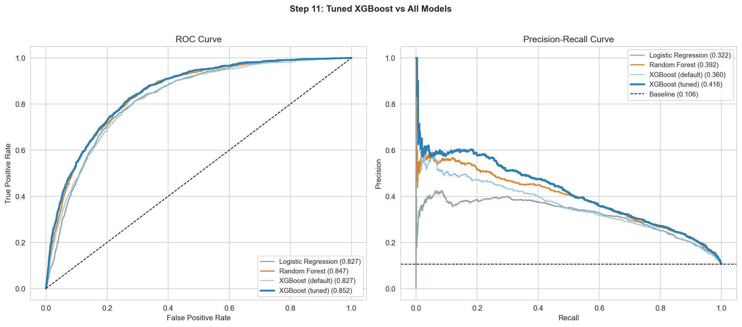
Figure 13: The tuned XGBoost (thick blue) clearly separates from all other models in both ROC and PR curves.

4.4 Step 12: Test Set Evaluation
This is the moment of truth — evaluating our final tuned model on the held-out test set of 12,485 patients that the model has never seen during training or tuning.
Core metrics:
Metric | Value | Clinical interpretation
AUC-ROC | 0.852 | If you pick a random controlled and a random uncontrolled patient, the model correctly ranks the uncontrolled patient as higher risk 85% of the time.
Sensitivity (Recall) | 80.6% | Of 1,326 patients who WILL become uncontrolled, the model catches 1,069 (4 out of 5).
Specificity | 74.2% | Of 11,159 controlled patients, the model correctly clears 8,275.
PPV (Precision) | 27.0% | Of every 4 patients flagged, 1 is truly uncontrolled. Expected for screening with a 10.6% base rate.
NPV | 97.0% | Of patients the model clears as low-risk, 97% truly stay controlled. The strongest clinical metric.
Brier Score | 0.159 | Measures calibration (accuracy of probability estimates). Lower is better; 0 = perfect.
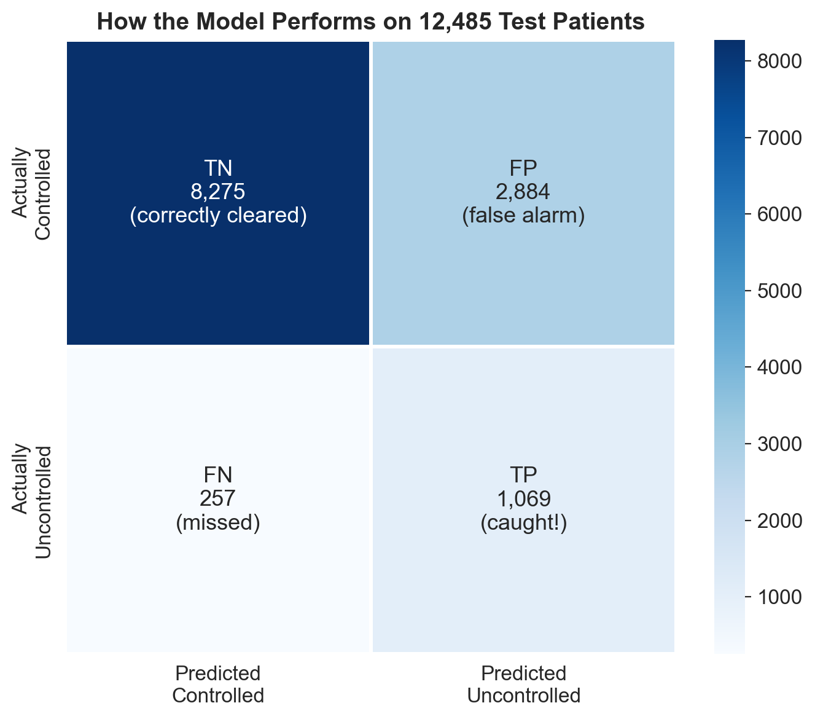
Figure 14: Confusion matrix with plain-language labels for each quadrant.
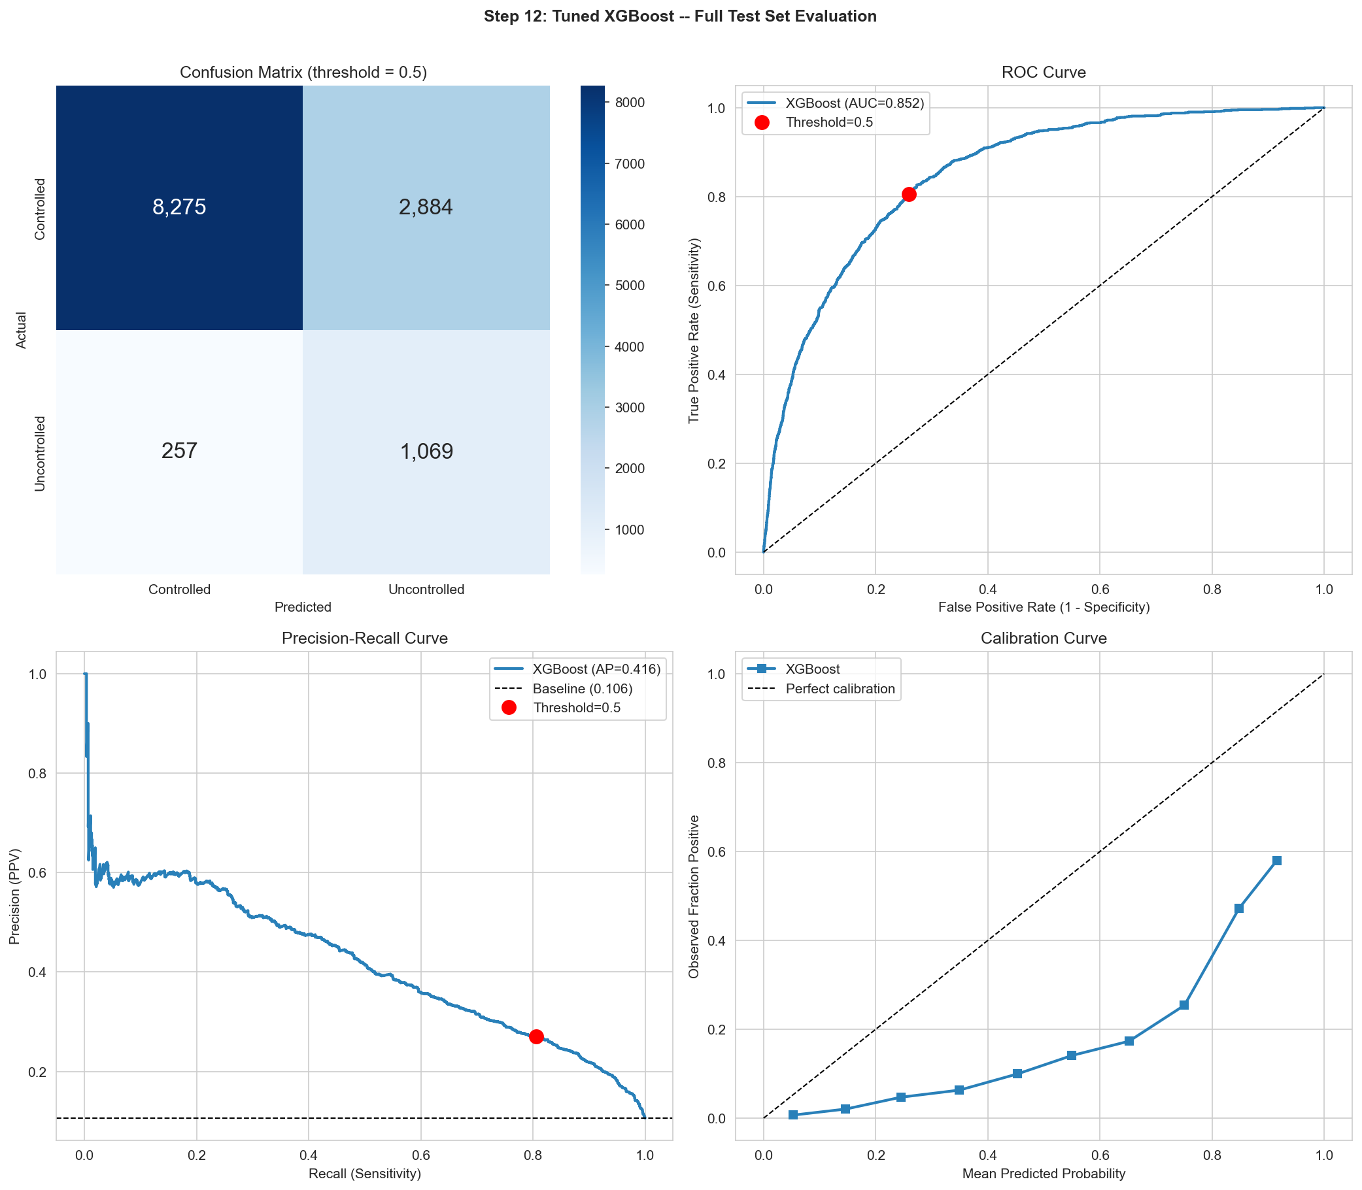
Figure 15: Four-panel evaluation: confusion matrix, ROC curve, PR curve, and calibration curve.
Threshold analysis:
The model outputs a probability (0–100%) for each patient. We choose a threshold to convert this to a yes/no decision. Different thresholds suit different clinical contexts:
Threshold | Recall | Precision | Flagged (per 12,485) | Missed
0.15 (aggressive screening) | 96.4% | 16.6% | 7,697 | 48
0.30 (panel management) | 90.6% | 21.6% | 5,552 | 125
0.50 (default) | 80.6% | 27.0% | 3,953 | 257
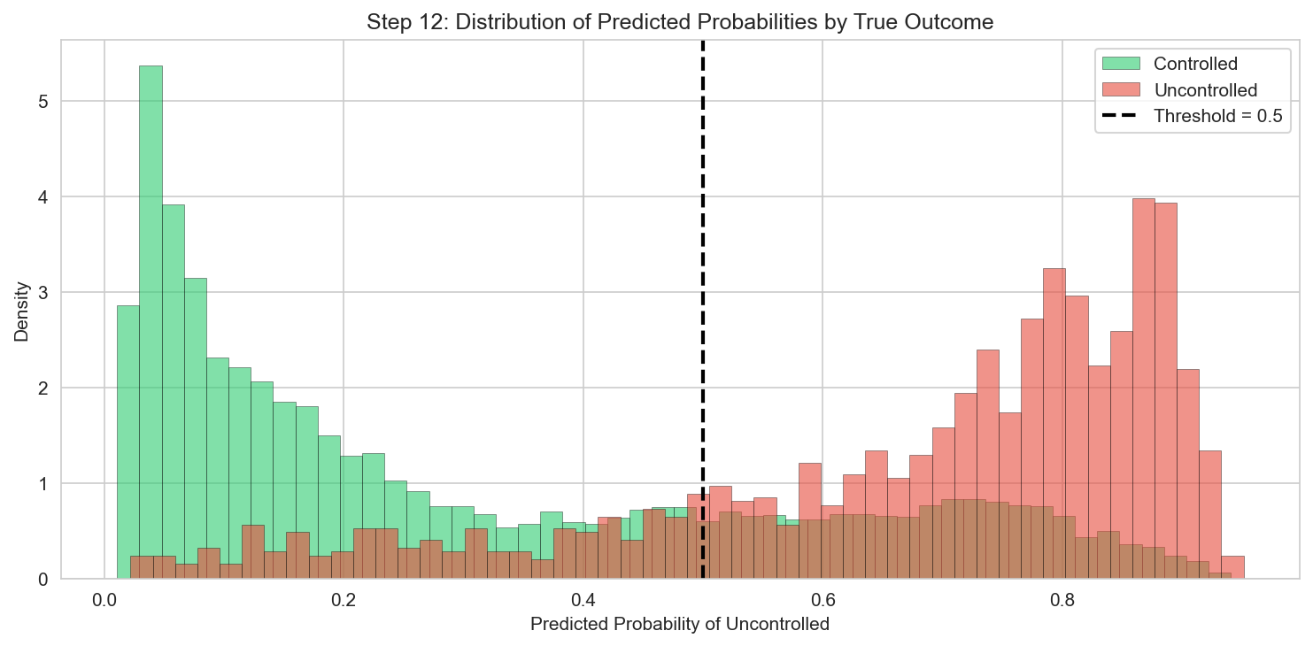
Figure 16: Distribution of predicted probabilities by true outcome. Green (controlled) clusters left, red (uncontrolled) clusters right. Good separation with some overlap in the 0.2–0.5 range.

5. Interpretation (Steps 13–14)

5.1 Step 13: Feature Importance and SHAP
Understanding why a model makes its predictions is as important as the predictions themselves. A "black box" model that flags patients without explanation would not be trusted by clinicians. We used two complementary methods to interpret the model.
Method 1: XGBoost built-in importance (gain)
This measures how much each feature improves predictions when used in a tree split. It answers: "Which feature does the model check most often and benefit from most?"
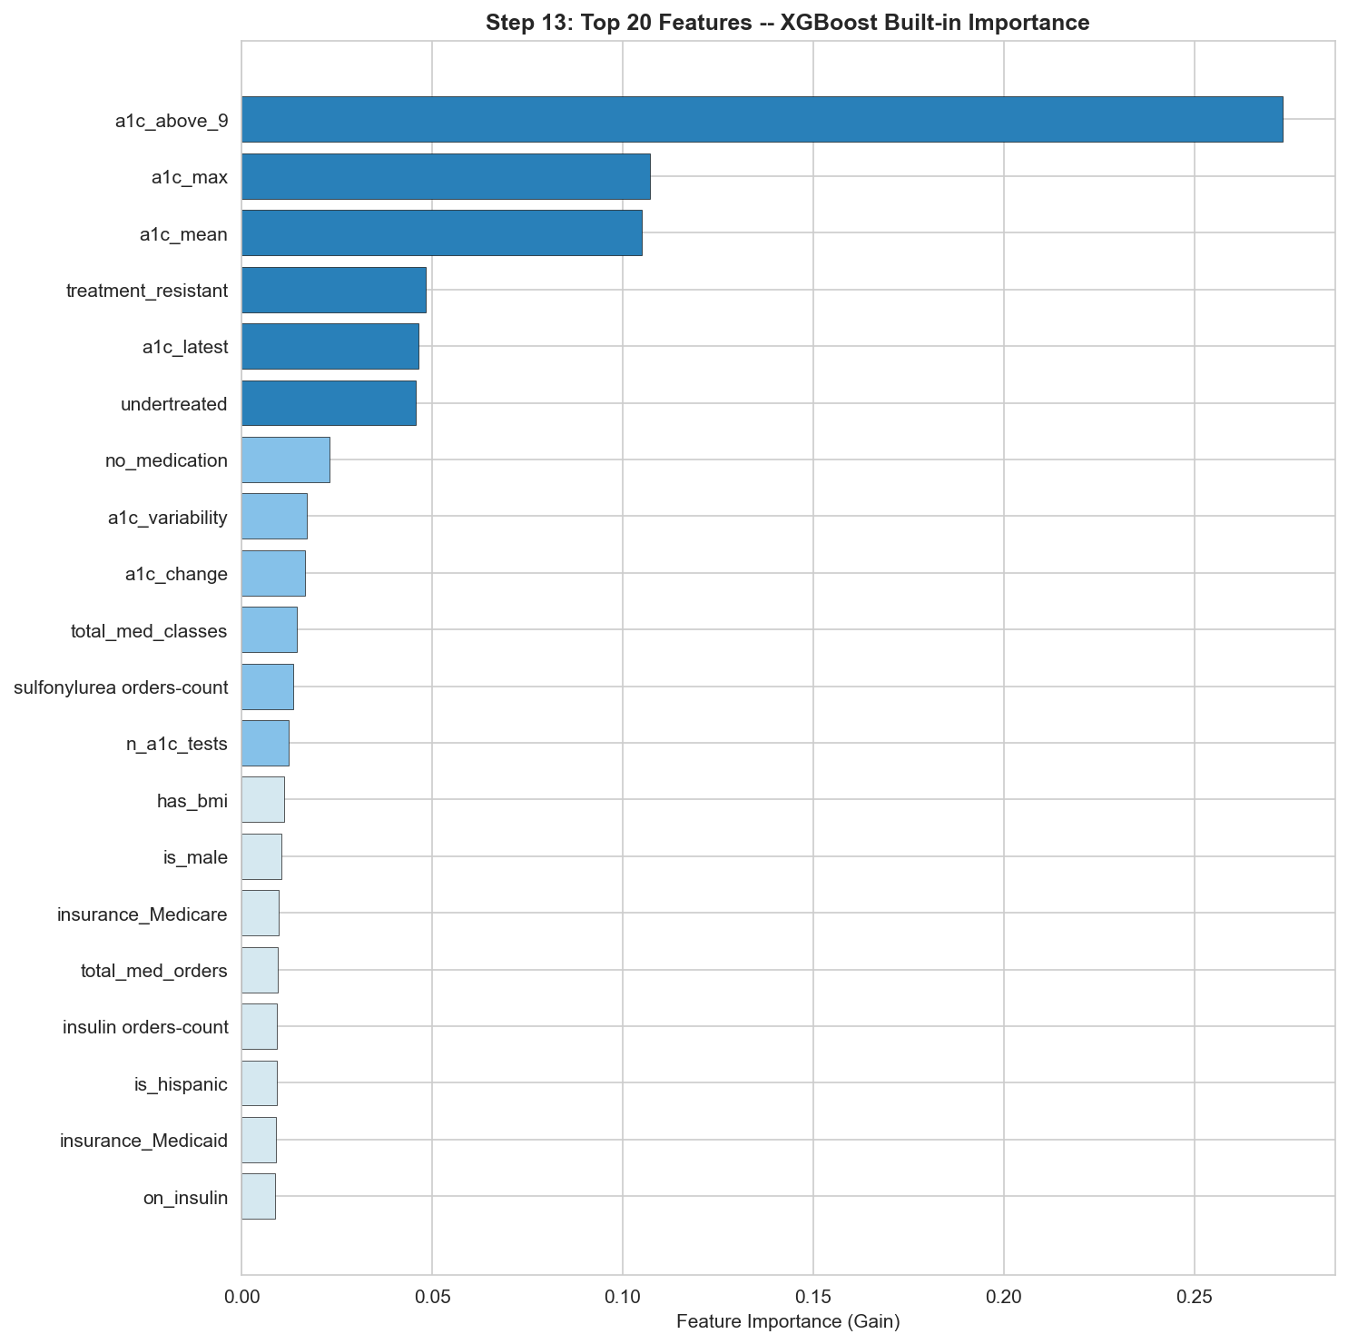
Figure 17: Top 20 features by XGBoost gain. a1c_above_9 dominates as a single high-information split.
Method 2: SHAP values
SHAP (SHapley Additive exPlanations) is a more rigorous method borrowed from game theory. For each patient and each feature, SHAP computes exactly how much that feature pushed the prediction toward "uncontrolled" or toward "controlled." The SHAP beeswarm plot below shows this for all test patients simultaneously.
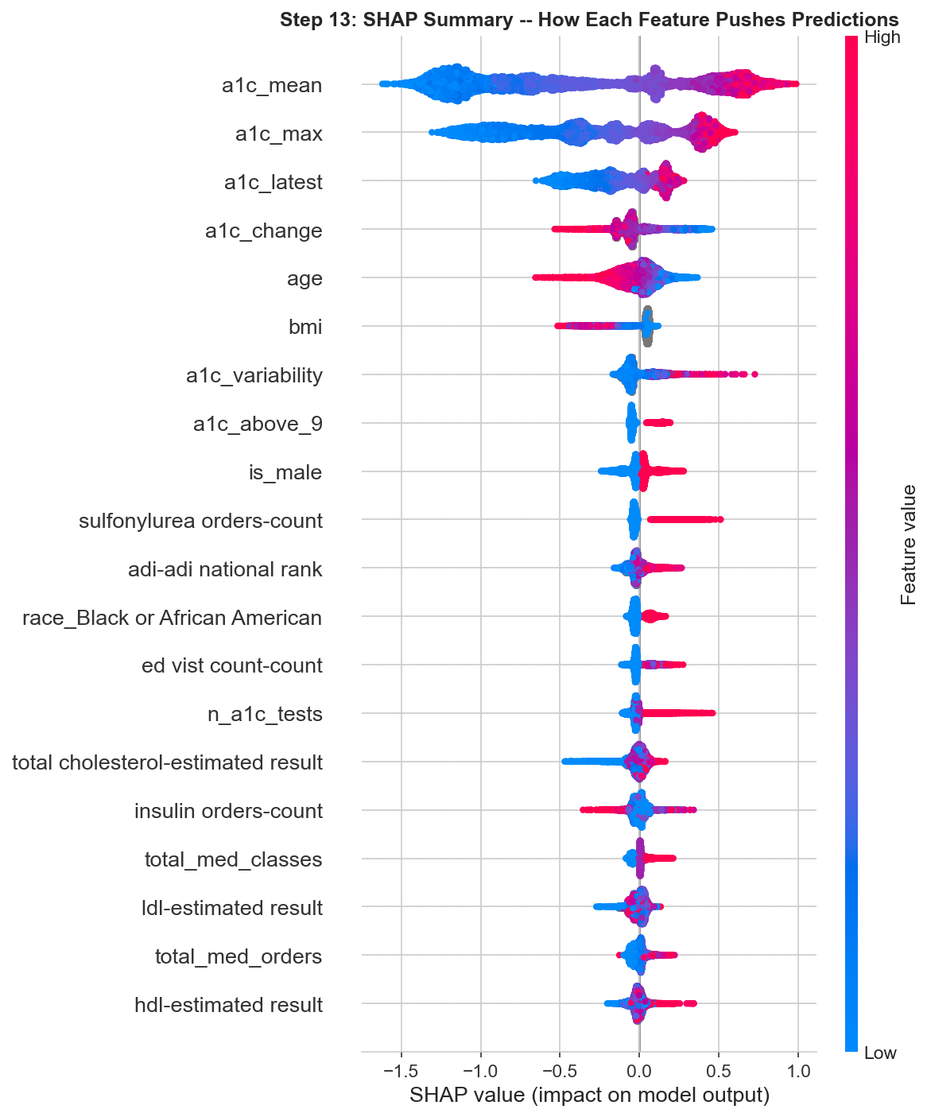
Figure 18: SHAP beeswarm plot. Each dot is one patient. X-axis = impact on prediction. Color = feature value (red = high, blue = low).
How to read the SHAP plot:
Look at the top row (a1c_mean). Red dots (high A1c mean) are pushed to the right (toward uncontrolled). Blue dots (low A1c mean) are pushed to the left (toward controlled). This confirms: high average A1c is the single strongest driver of risk.
Top features and their clinical interpretation:
Rank | Feature | Mean |SHAP| | Clinical interpretation
1 | a1c_mean | 0.728 | Average A1c is the dominant predictor. Higher mean = higher risk. This is the glycemic burden over the observation period.
2 | a1c_max | 0.501 | The worst A1c reading matters — even if current A1c improved, a history of severe episodes increases risk.
3 | a1c_latest | 0.218 | Most recent reading. Adds recency information beyond the mean.
4 | a1c_change | 0.108 | Trajectory. Positive change (A1c went up) pushes toward uncontrolled. Negative (improving) is protective.
5 | age | 0.093 | Younger patients have higher risk — consistent with more aggressive early-onset disease.
6 | bmi | 0.081 | Despite 77% missingness, BMI contributes. Higher BMI pushes toward uncontrolled.
7 | a1c_variability | 0.078 | Unstable A1c (high standard deviation) increases risk.
8 | a1c_above_9 | 0.057 | The binary threshold for severe uncontrolled diabetes.
9 | is_male | 0.055 | Being male modestly increases predicted risk.
10 | sulfonylurea orders | 0.047 | Sulfonylurea use pushes toward uncontrolled — confounded (prescribed to sicker patients).
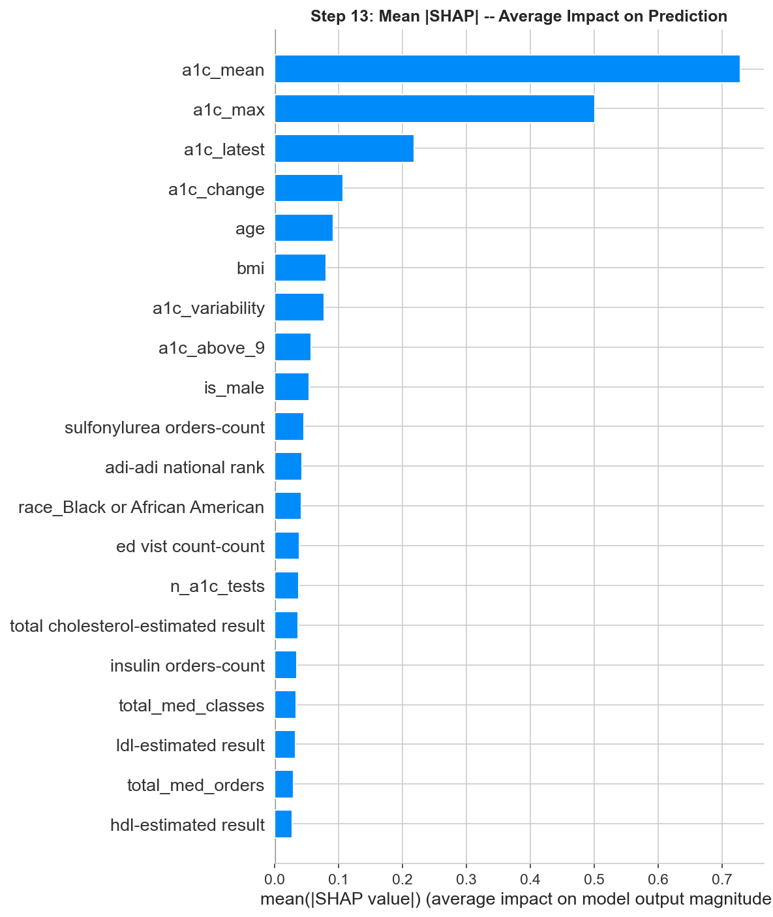
Figure 19: Mean absolute SHAP values — the simplified importance ranking.
The clinical story:
The model's decision-making mirrors clinical reasoning. It first evaluates A1c history — the mean, the worst episode, the most recent reading, and whether things are getting better or worse. It then considers treatment response (medications despite high A1c), demographics (age, sex), and social context (ADI, insurance). This interpretability is a key strength for clinical adoption.

5.2 Step 14: Subgroup Fairness Analysis
A clinical prediction model must work equitably across populations. If a model performs well for White patients but poorly for Black patients, deploying it would worsen health disparities rather than reduce them. We tested model performance across race, gender, age, insurance, and neighborhood deprivation (ADI).
Results by race:
Race | N (test) | AUC-ROC | Recall | Assessment
Asian | 245 | 0.880 | 86.7% | Best performance
Black or African American | 3,395 | 0.860 | 84.8% | Strong — catches MORE than White
White | 8,672 | 0.847 | 78.5% | Solid baseline
Results by gender:
Gender | N (test) | AUC-ROC | Recall
Female | 6,498 | 0.872 | 82.7%
Male | 5,986 | 0.829 | 78.8%
Results by insurance:
Medicaid patients — the most vulnerable population — had the highest recall: 91–93%. The model is especially sensitive for this group. Medicare patients had the highest AUC (0.871–0.895).
Results by ADI (neighborhood deprivation):
AUC ranged from 0.839 to 0.881 across ADI quartiles. The least deprived neighborhoods had slightly better AUC, but the gap is small (0.042). The model does not meaningfully disadvantage patients from deprived areas.
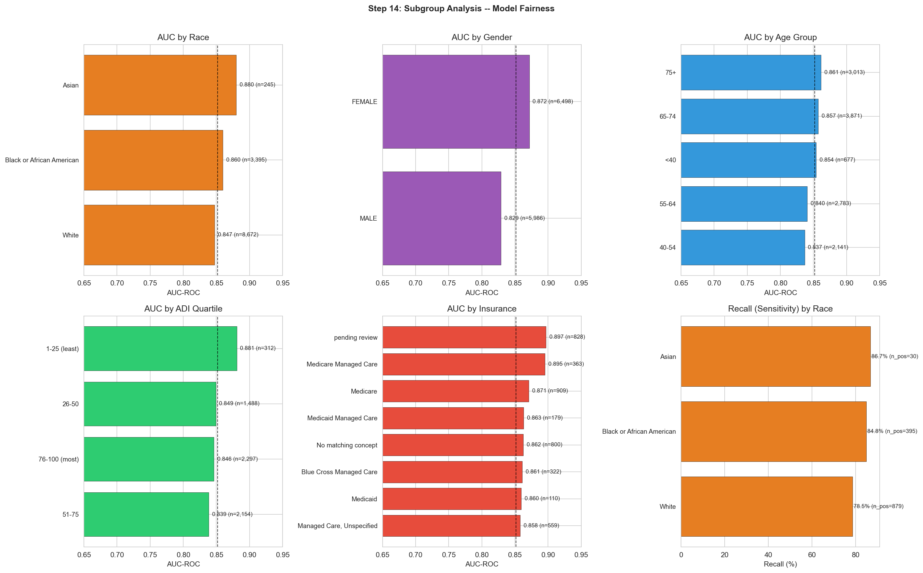
Figure 20: AUC and recall across race, gender, age, insurance, and ADI subgroups.
Fairness assessment:
The model does not disadvantage minority or low-income subgroups. If anything, it has higher sensitivity for Black patients and Medicaid patients — populations that face the greatest diabetes disparities. AUC ranges from 0.83 to 0.90 across all tested subgroups. For real-world deployment, this means the tool could help close equity gaps rather than widen them.

6. Submission and Presentation

Submission
We generated two files. The primary submission file (submission.csv) matches the target file format exactly: patient ID as the index, one column "a1c 2025 Uncontrolled" with True/False values, 62,425 rows. A detailed file (submission_detailed.csv) includes the predicted probability for each patient, the predicted class, and the actual outcome for reference.
At threshold 0.5, the model flags 19,694 patients (31.5%) as uncontrolled while the actual rate is 10.6%. This is by design — the model prioritizes catching at-risk patients over minimizing false alarms, which is the appropriate tradeoff for a screening tool.

Presentation Strategy
The presentation follows a 13-slide arc: clinical problem → data → key insight (A1c risk gradient) → feature engineering → model comparison → final performance → interpretability (SHAP) → equity → clinical application → limitations → summary. Seven publication-ready figures were created with the "pres_" prefix in the plots folder.
Key messages: (1) A1c history is the dominant predictor but insufficient alone. (2) Engineered features like treatment_resistant capture clinically meaningful interactions. (3) The model achieves AUC 0.852 with 81% recall and 97% NPV. (4) Performance is equitable across demographic subgroups.

7. Key Decisions Log
This table documents every major decision we made during the project, the reasoning behind it, and where in the pipeline it occurred.
Step | Decision | Reasoning
Step 4 | Drop the leakage column (a1c 2025 collection date) | 100% of patients missing this value are Controlled. The model could achieve near-perfect accuracy by checking this column — but that would not generalize to new patients where this information is not available.
Step 5 | Drop ADI state rank, keep national rank | The two are 96% correlated (r = 0.964). Keeping both adds no information and introduces multicollinearity. National rank is more standardized.
Step 5 | Aggregate raw A1c columns into summary features | The 5 raw A1c columns are correlated with each other (r = 0.52–0.64) and 58–97% missing. Summary features (mean, max, change, variability) are more complete and clinically interpretable.
Step 6 | Simplify insurance from 12 to 4 categories | Granular plan names (e.g., "Blue Cross Managed Care") add noise. Broader categories (Medicare, Medicaid, Managed Care, Other) capture what matters: public vs private vs managed coverage type.
Step 7 | Create treatment_resistant and undertreated features | Raw medication counts are confounded by disease severity. Combining A1c level with medication count creates a clinically meaningful signal: is the patient failing despite treatment, or untreated despite need?
Step 8 | Use stratified 80/20 split with random_state=42 | Stratification preserves the 10.6% class balance in both sets. Fixed random state ensures reproducibility. 80/20 is standard for datasets of this size.
Step 9 | Use class_weight="balanced" for logistic regression | Without class weighting, the model predicts "controlled" for everyone (89.4% accuracy, 0% recall). Balanced weighting tells the model that missing an uncontrolled patient is 8× worse than a false alarm.
Step 10 | Choose XGBoost for tuning over Random Forest | XGBoost typically outperforms Random Forest once tuned. It supports native NaN handling (no imputation needed) and has more tunable hyperparameters.
Step 11 | Use scale_pos_weight = 8.41 | This is the ratio of controlled to uncontrolled patients (44,634 / 5,306). It serves the same purpose as class_weight="balanced" — penalizes false negatives proportionally to the imbalance.
Step 11 | learning_rate = 0.01 with 800 trees | Slower learning rate + more trees = better generalization. Each tree makes a small correction, reducing overfitting. This is the most impactful tuning choice.
Step 11 | subsample = 0.7, colsample_bytree = 0.5 | Randomness in training prevents overfitting. Each tree sees 70% of patients and 50% of features, forcing the model to learn robust patterns rather than memorizing.
Step 12 | Use threshold = 0.5 as default | Standard threshold for binary classification. Can be adjusted based on clinical context (lower for screening, higher for intervention). The threshold table provides options.

8. Glossary
Every machine learning term used in this document, defined in plain English with a clinical analogy where applicable.
AUC-ROC (Area Under the Receiver Operating Characteristic Curve)
A single number (0 to 1) that measures how well the model separates the two classes. An AUC of 0.85 means: pick a random uncontrolled and a random controlled patient — 85% of the time, the model gives the uncontrolled patient a higher risk score. Clinical analogy: like the sensitivity/specificity tradeoff of a diagnostic test, but summarized across all possible thresholds at once. 0.5 = random, 0.7–0.8 = acceptable, 0.8–0.9 = good, 0.9+ = excellent.
Sensitivity (Recall)
Of all patients who ARE uncontrolled, what percentage does the model correctly identify? Our model's sensitivity of 80.6% means it catches 4 out of 5 at-risk patients. Clinical analogy: like the sensitivity of a rapid strep test — does it find the cases?
Specificity
Of all patients who ARE controlled, what percentage does the model correctly clear? Our specificity of 74.2% means it correctly identifies 3 out of 4 healthy patients. Clinical analogy: like the specificity of a pregnancy test — does a negative mean you're really not pregnant?
Precision (Positive Predictive Value / PPV)
Of all patients the model FLAGS as uncontrolled, what percentage actually are? Our precision of 27% means 1 in 4 flagged patients is truly uncontrolled. This depends heavily on the base rate (prevalence). With only 10.6% truly uncontrolled, even a good model generates many false alarms — the same reason mammography has low PPV.
NPV (Negative Predictive Value)
Of all patients the model CLEARS as low-risk, what percentage truly stay controlled? Our NPV of 97% means: if the model says you're safe, there's a 97% chance it's right. This is the model's strongest clinical metric — its "rule-out" power.
F1 Score
The harmonic mean of precision and recall — a single number that balances both. Useful when you want a simple summary of the precision/recall tradeoff. Ranges from 0 to 1.
PR-AUC (Precision-Recall Area Under Curve)
Like AUC-ROC but focuses on the positive class (uncontrolled patients). More informative than AUC-ROC for imbalanced datasets because it measures how well the model finds the rare positive cases without too many false alarms.
Brier Score
Measures calibration — how accurate the probability estimates are. If the model says "70% chance of uncontrolled," how often is that actually true? Ranges from 0 (perfect) to 1 (worst). Our score of 0.159 indicates reasonable calibration.
Overfitting
When a model memorizes the training data instead of learning general patterns. An overfit model performs well on training data but poorly on new patients. Clinical analogy: a medical student who memorizes practice questions word-for-word but cannot handle rephrased questions on the exam.
Train-Test Split
Dividing data into a training set (used to build the model) and a test set (used to evaluate it on unseen data). The test set is like a sealed exam — if you peek during studying, your score does not reflect real knowledge.
Cross-Validation (CV)
A technique where the training data is split into K folds. The model is trained on K-1 folds and evaluated on the remaining fold, rotating K times. This gives a more reliable performance estimate than a single split. We used 5-fold CV during hyperparameter tuning.
Feature Engineering
Creating new variables from raw data that better capture the underlying signal. Example: instead of using 5 raw A1c values (most missing), we computed a1c_mean, a1c_max, and a1c_change — features that are more complete and clinically meaningful.
One-Hot Encoding
Converting a categorical variable (like race) into multiple binary (0/1) columns — one per category. Patient is Asian → race_Asian = 1, all other race columns = 0. Necessary because most ML models require numeric input.
XGBoost (Extreme Gradient Boosting)
An ensemble method that builds many small decision trees sequentially. Each tree corrects the mistakes of the previous ones. Known for high accuracy on tabular data. Clinical analogy: like a tumor board where each specialist adds a correction to the diagnosis, building on the previous specialists' assessments.
Random Forest
An ensemble of many decision trees, each trained on a random subset of data and features. The final prediction is the majority vote. Simpler than XGBoost but often nearly as good. Clinical analogy: getting opinions from many independent doctors and going with the consensus.
Logistic Regression
The simplest classification model. Finds a linear combination of features that predicts the probability of the positive class. Highly interpretable but limited to linear relationships. Clinical analogy: a risk score calculator where each factor adds or subtracts points.
SHAP Values (SHapley Additive exPlanations)
A method from game theory that explains each individual prediction. For each patient, SHAP shows exactly how much each feature pushed the prediction toward "uncontrolled" or "controlled." Clinical analogy: like breaking down a diagnosis into contributing factors — "your high A1c contributes +3 points of risk, your young age contributes +1, your medication contributes −0.5."
Hyperparameter Tuning
The process of finding the best model settings (hyperparameters) by systematically trying different combinations and evaluating each with cross-validation. Clinical analogy: titrating a drug dose — trying different levels to find the sweet spot between efficacy and side effects.
Class Imbalance
When one class is much more common than the other. In our data, 89.4% are controlled and only 10.6% are uncontrolled. Without special handling, models learn to always predict the majority class. We addressed this with class_weight="balanced" and scale_pos_weight.
scale_pos_weight
An XGBoost parameter that sets the cost ratio between missing a positive (uncontrolled) case and raising a false alarm. Our value of 8.41 means: missing an uncontrolled patient costs 8.41× more than incorrectly flagging a controlled patient. This matches the ~1:8 class imbalance ratio.

