Medicare Rate and Utilization Analysis
A Case Study in Payment Variation Across Providers, Procedures, and Geographies
Sridharan Gopalsamy Ramaswamy | MPH/MBA, Washington University in St. Louis | April 2026

Executive Summary
This analysis examines Medicare payment patterns across 3,015 inpatient hospitals and 1.15 million physician providers using CMS public use files for Calendar Year 2022. Three findings stand out for anyone working in payer strategy, provider contracting, or health economics:
- Hospitals charge 5.4x what Medicare pays (median), but this ratio varies from 1.2x in Maryland to 10.7x in Nevada, a 9.5x spread that reflects state-level regulatory and market dynamics.
- Septicemia dominates inpatient volume, accounting for 550K discharges (11% of all Medicare inpatient stays), while heart transplants lead in cost at ~$295K per case.
- Physician markup ratios vary sharply by specialty, with certain specialties billing 4-5x the Medicare allowed amount, signaling where payer-provider rate negotiations have the most room to move.

Data Overview
Metric | Inpatient | Physician
Records | 145,742 | 9,755,020
Providers | 3,015 hospitals | 1,148,808 NPIs
Procedures | 533 DRGs | 6,326 HCPCS
States | 51 | 61
Median markup | 5.37x | 2.79x

1. Where the Volume Is: Top DRGs
Septicemia without MV >96 hours leads all DRGs with 550,306 discharges, followed by heart failure (324,750) and respiratory infections (275,104). The top 5 DRGs account for a disproportionate share of Medicare inpatient volume.
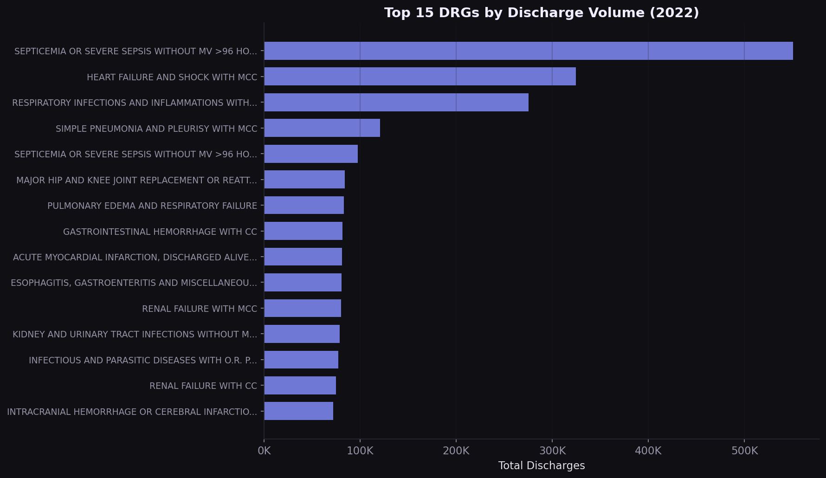
Figure 1. Top 15 DRGs by Discharge Volume (2022)
Strategic implication: Any value-based contract that does not explicitly address septicemia, heart failure, and respiratory infections is leaving the highest-volume conditions unmanaged. Bundled payment and readmission reduction programs should prioritize these pathways.

2. Where the Money Goes: Costliest DRGs
Heart transplants and ECMO cases average $295K and $178K per case respectively. For commercial payers benchmarking against Medicare, these are the DRGs where a 10% rate difference translates to $20K-$30K per case.
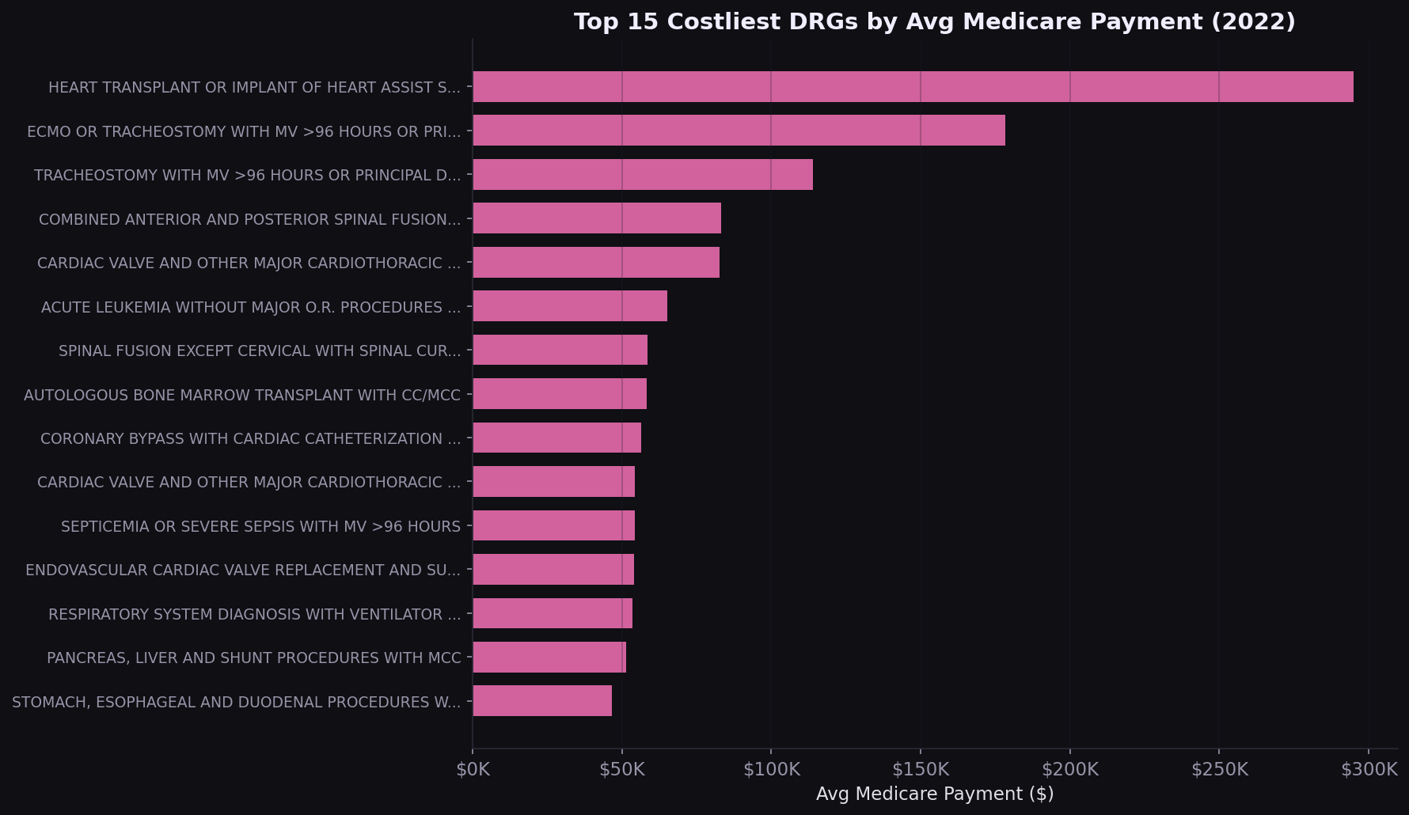
Figure 2. Top 15 Costliest DRGs by Avg Medicare Payment (2022)

3. The Markup Gap: Charges vs. Medicare Payment
Nationally, the median hospital charges 5.4x what Medicare ultimately pays. The scatter plot reveals a nonlinear relationship: for higher-cost DRGs, the markup ratio compresses, while lower-cost procedures show the widest spread. The distribution is right-skewed, with a minority of hospitals charging 8-12x Medicare rates.
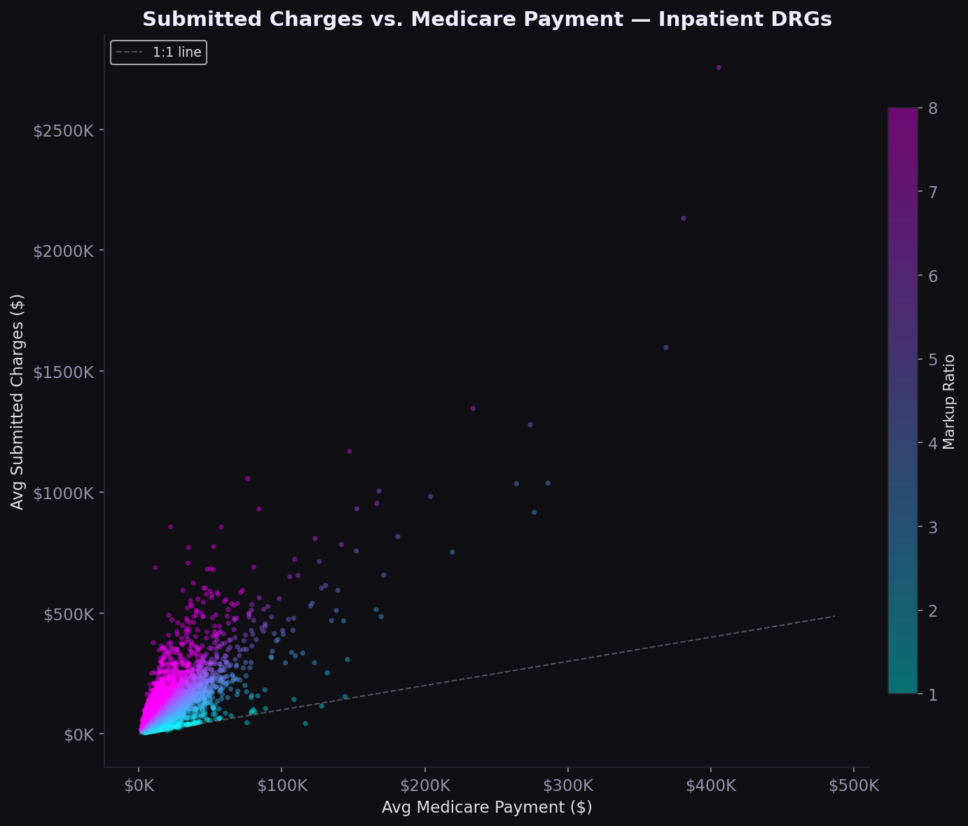
Figure 3. Submitted Charges vs. Medicare Payment (Inpatient)
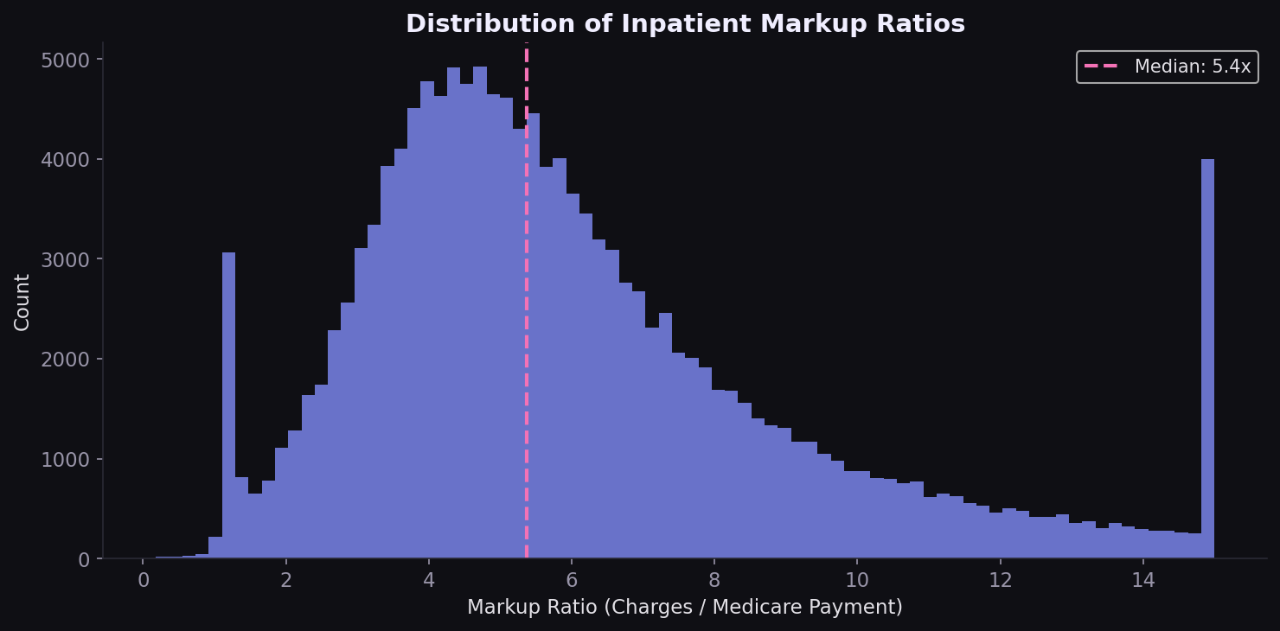
Figure 4. Distribution of Inpatient Markup Ratios
Strategic implication: Chargemaster-based contracts systematically overpay relative to Medicare. Percent-of-Medicare benchmarks are more defensible for payer contracting.

4. Geographic Rate Variation
The 9.5x spread in median markup between Maryland (1.2x) and Nevada (10.7x) is not random. Maryland operates an all-payer rate-setting system, compressing the charge-to-payment gap by design. States without rate regulation show far higher markups.
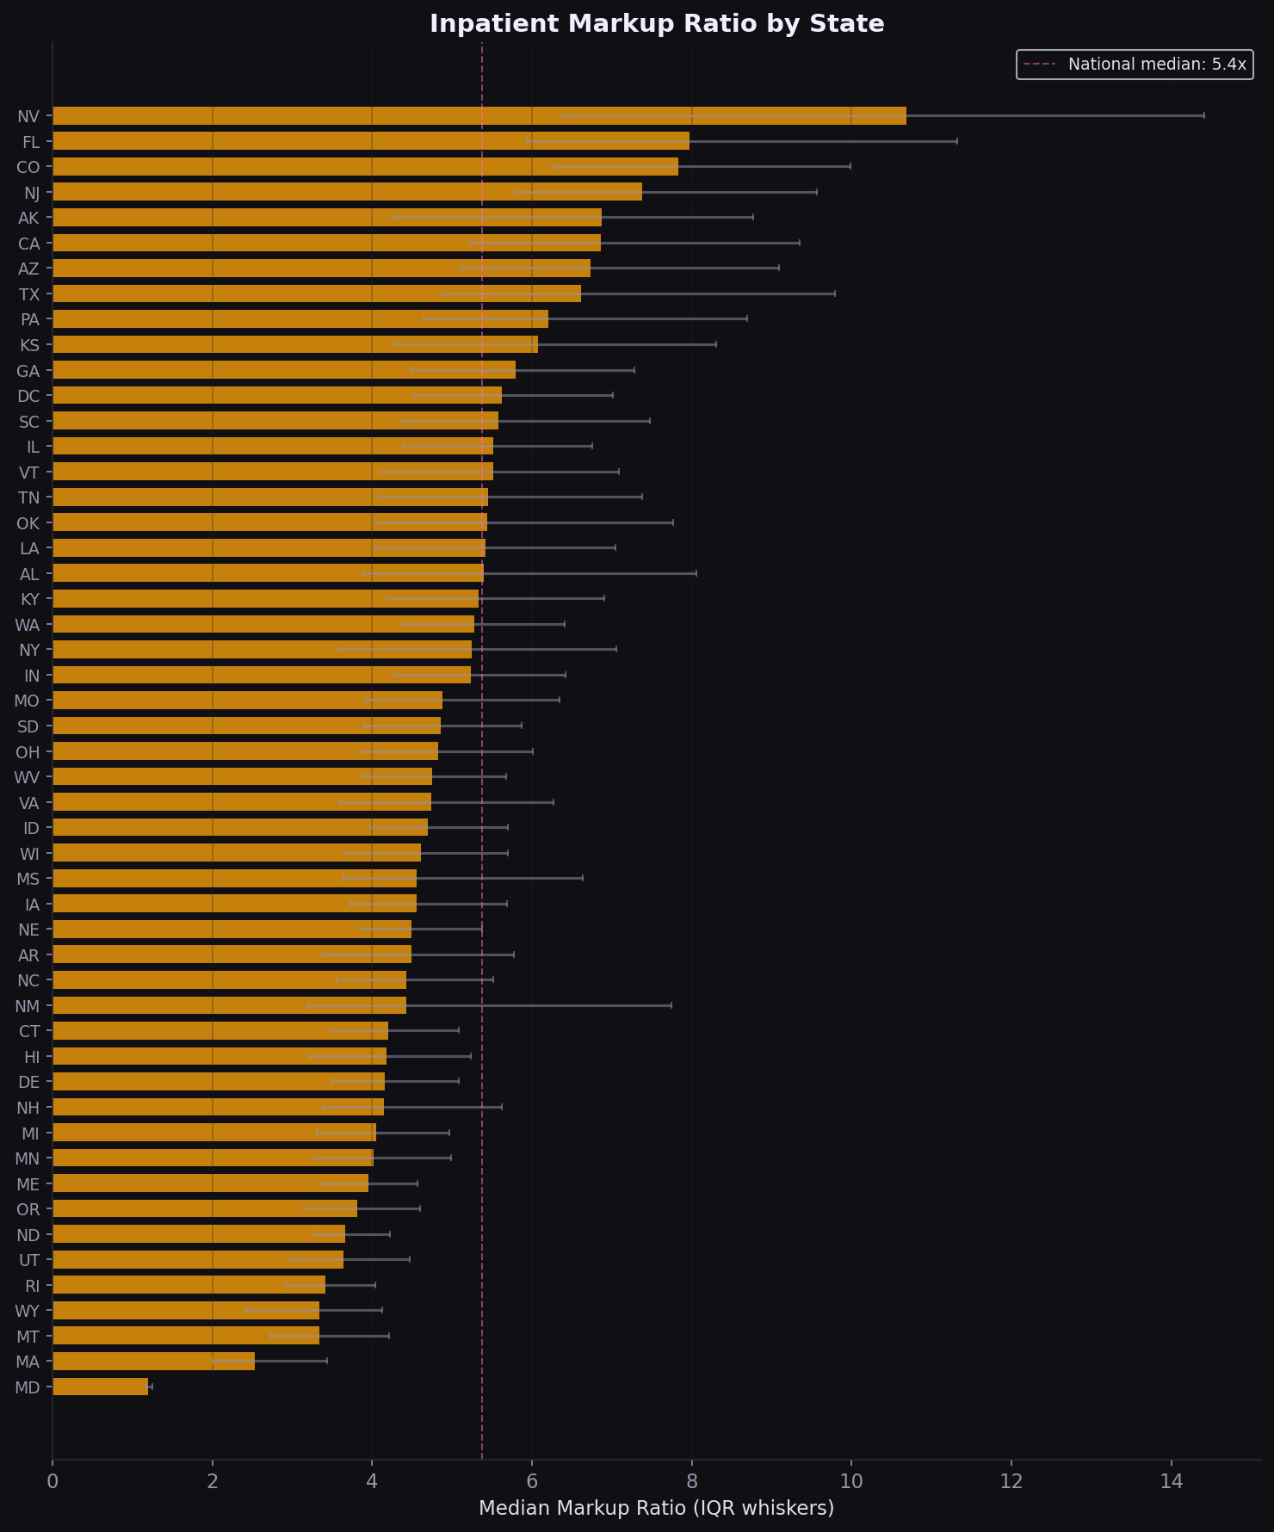
Figure 5. Inpatient Markup Ratio by State (Median with IQR)
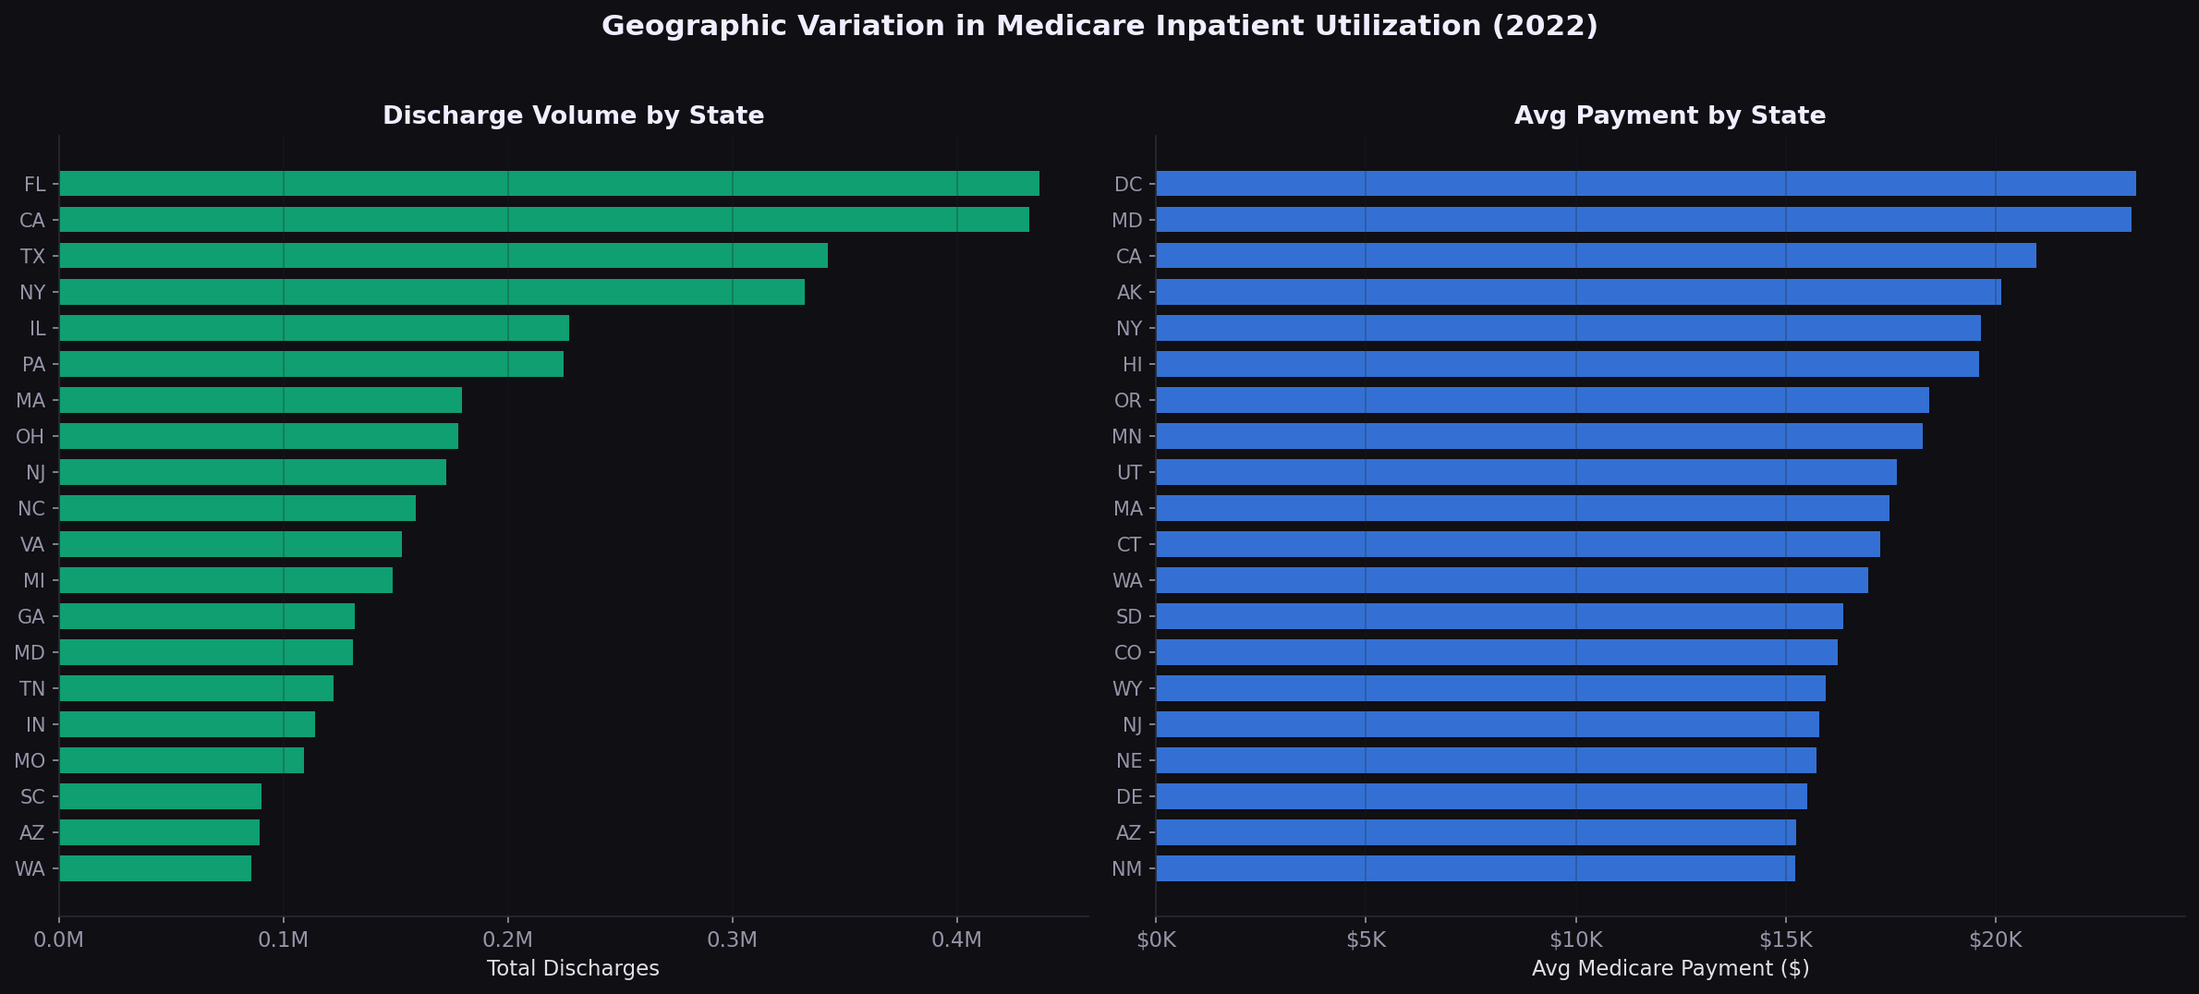
Figure 6. Discharge Volume and Avg Payment by State
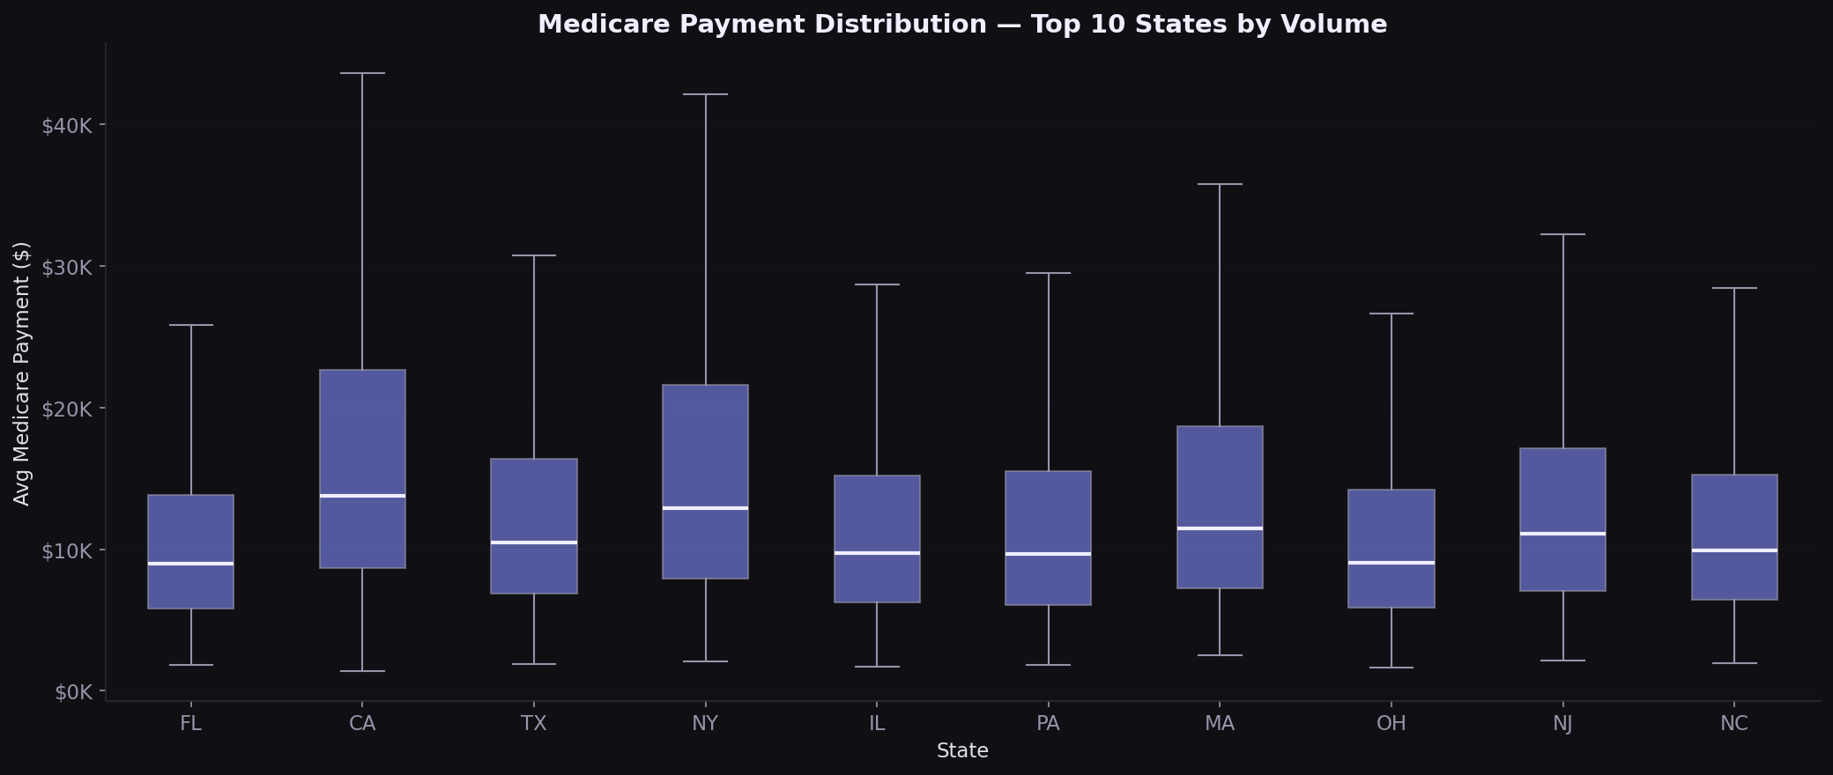
Figure 7. Medicare Payment Distribution in Top 10 States by Volume
Strategic implication: Multi-state payers need state-specific rate playbooks. States like California, Texas, and Florida have high volume and above-median markups, making them priority markets for rate renegotiation.

5. Physician Services: Volume and Cost Patterns
Clinical laboratory and hematology-oncology dominate service volume, while ambulatory surgical centers and cardiac surgery lead in per-service cost. The volume-cost mismatch by specialty is a signal for payers: high-volume specialties drive spend through utilization, high-cost specialties drive it through unit price.
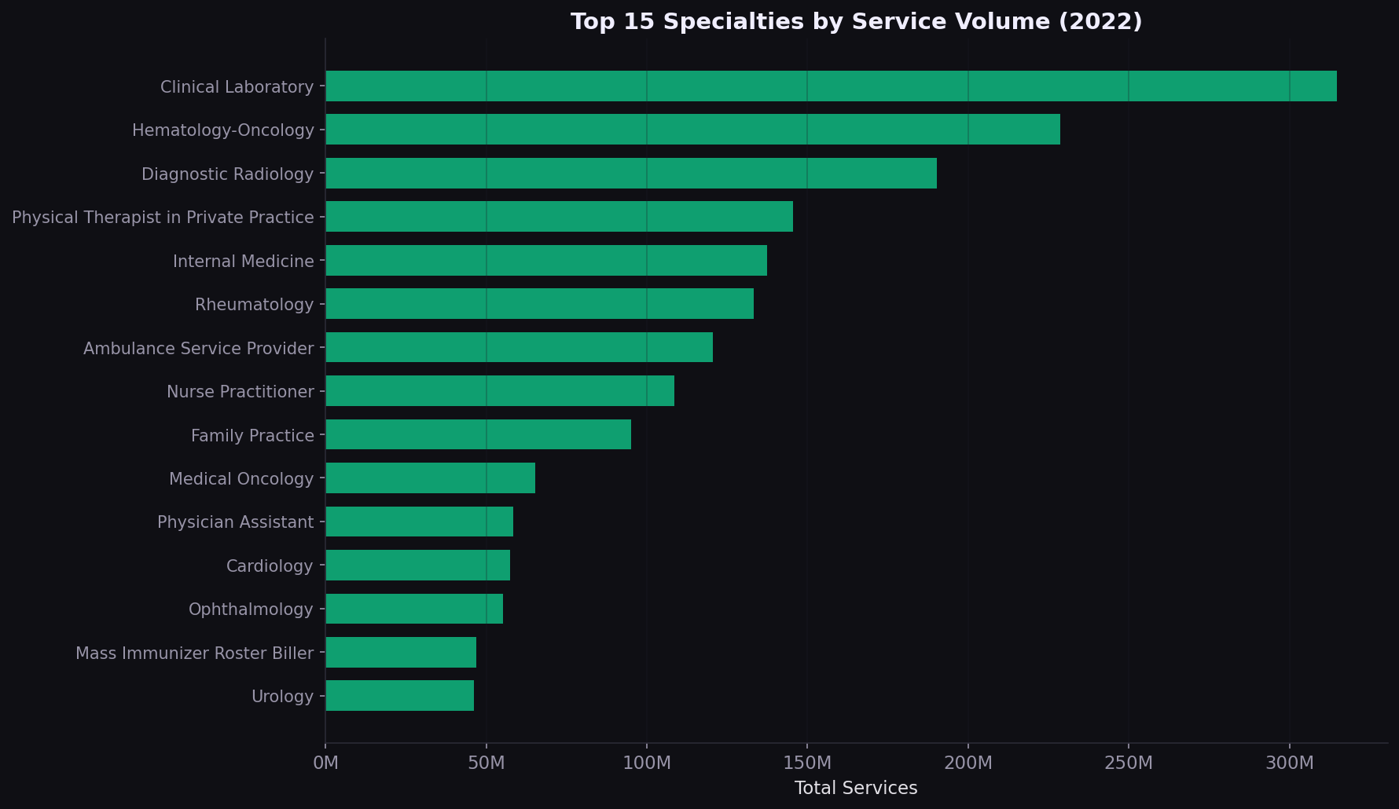
Figure 8. Top 15 Specialties by Service Volume
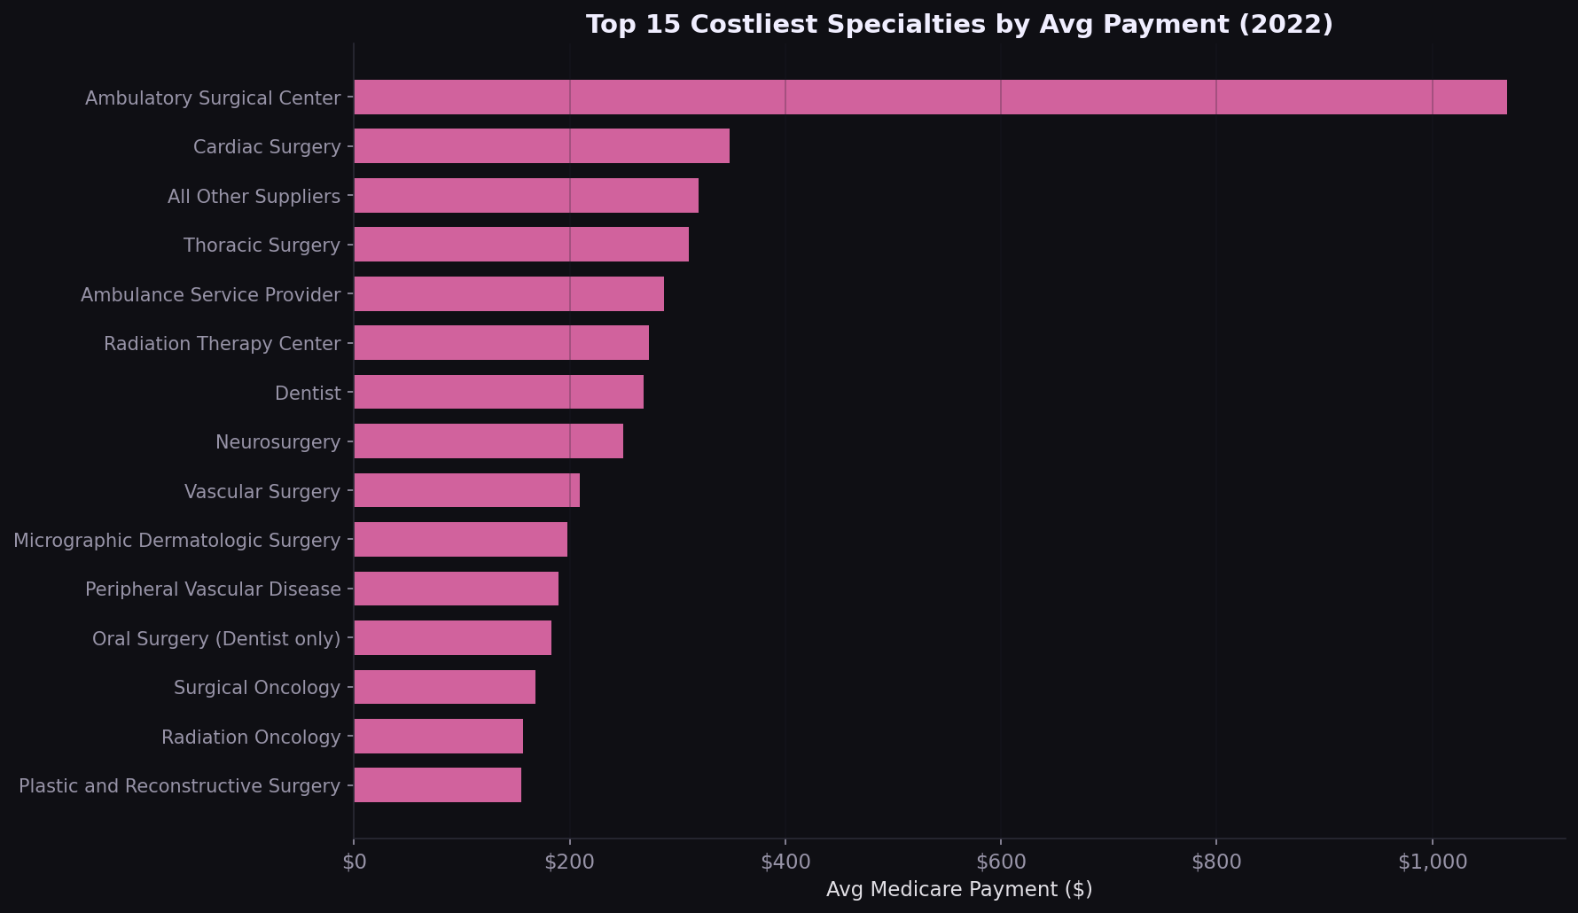
Figure 9. Top 15 Costliest Specialties by Avg Payment

6. Physician Markup and Rate Variation
Physician-level analysis shows a median markup of 2.8x (submitted charge / Medicare allowed). Certain specialties bill 4-5x the allowed amount. The HCPCS-level coefficient of variation chart identifies specific procedures where payment varies most across providers.
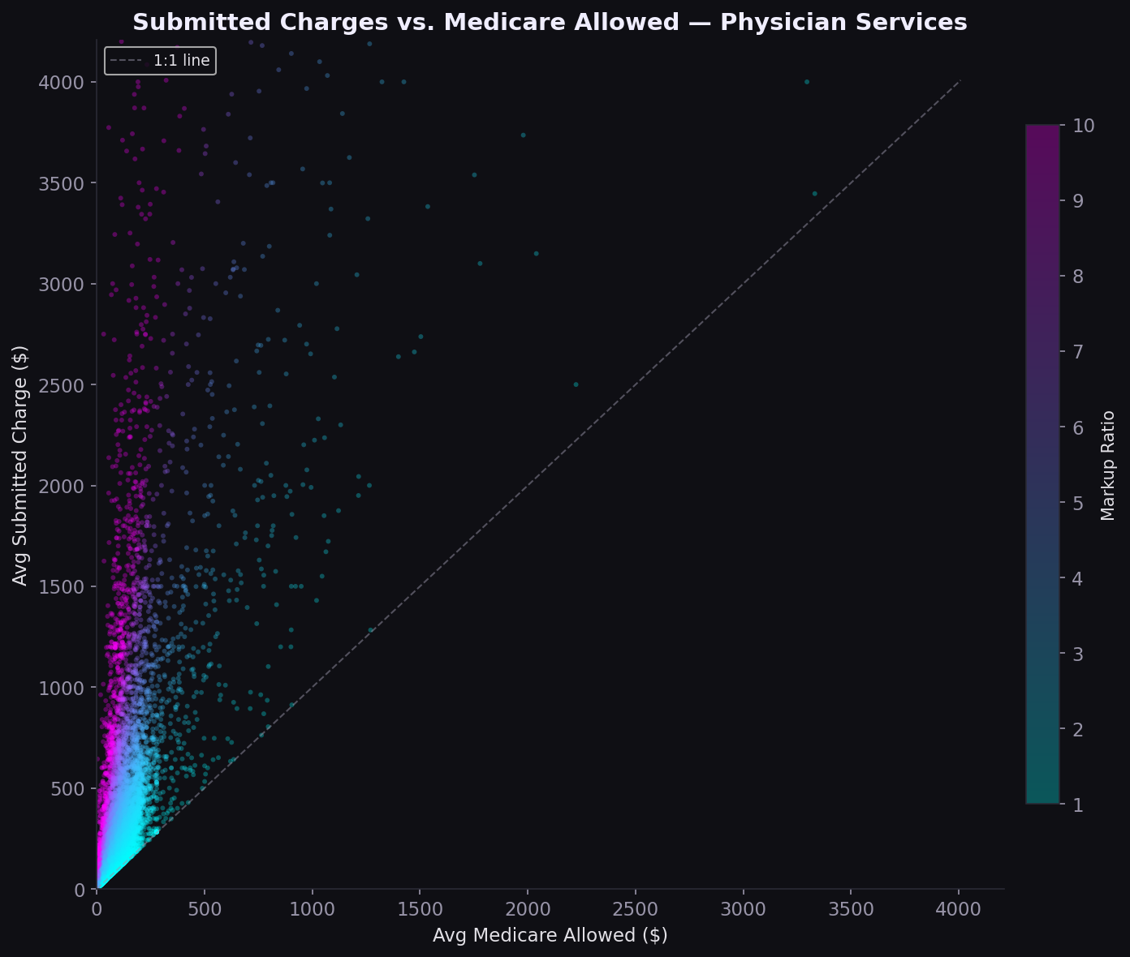
Figure 10. Submitted Charges vs. Medicare Allowed (Physician)
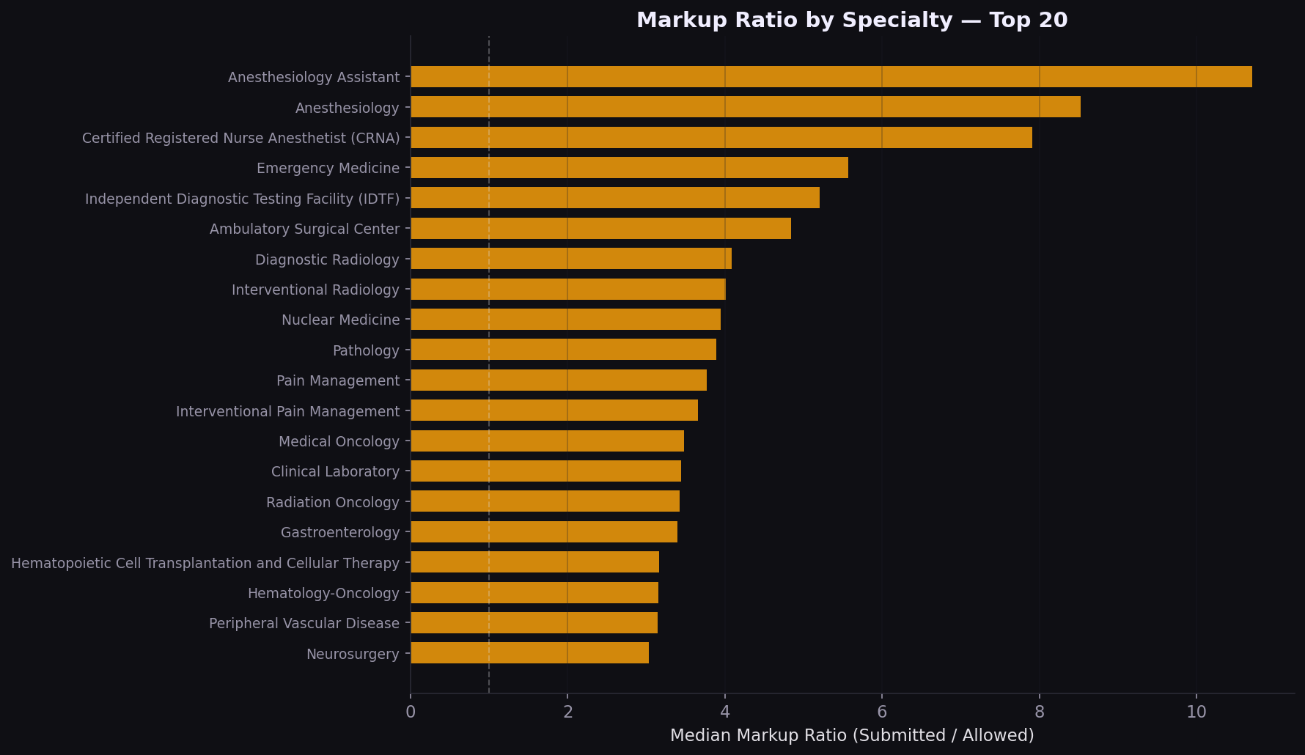
Figure 11. Markup Ratio by Specialty (Top 20)
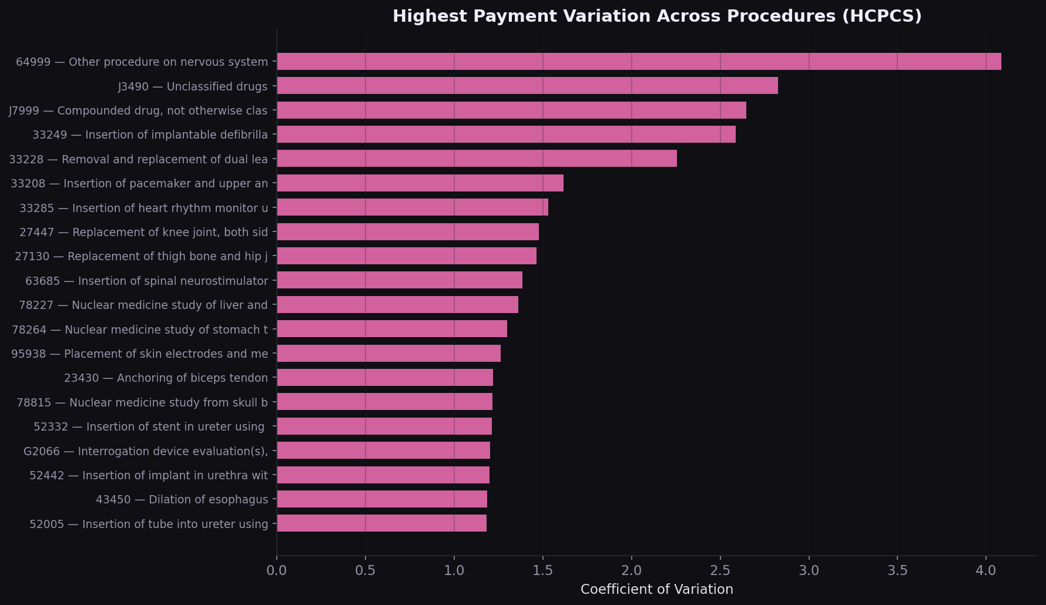
Figure 12. Highest Payment Variation Across Procedures (HCPCS)
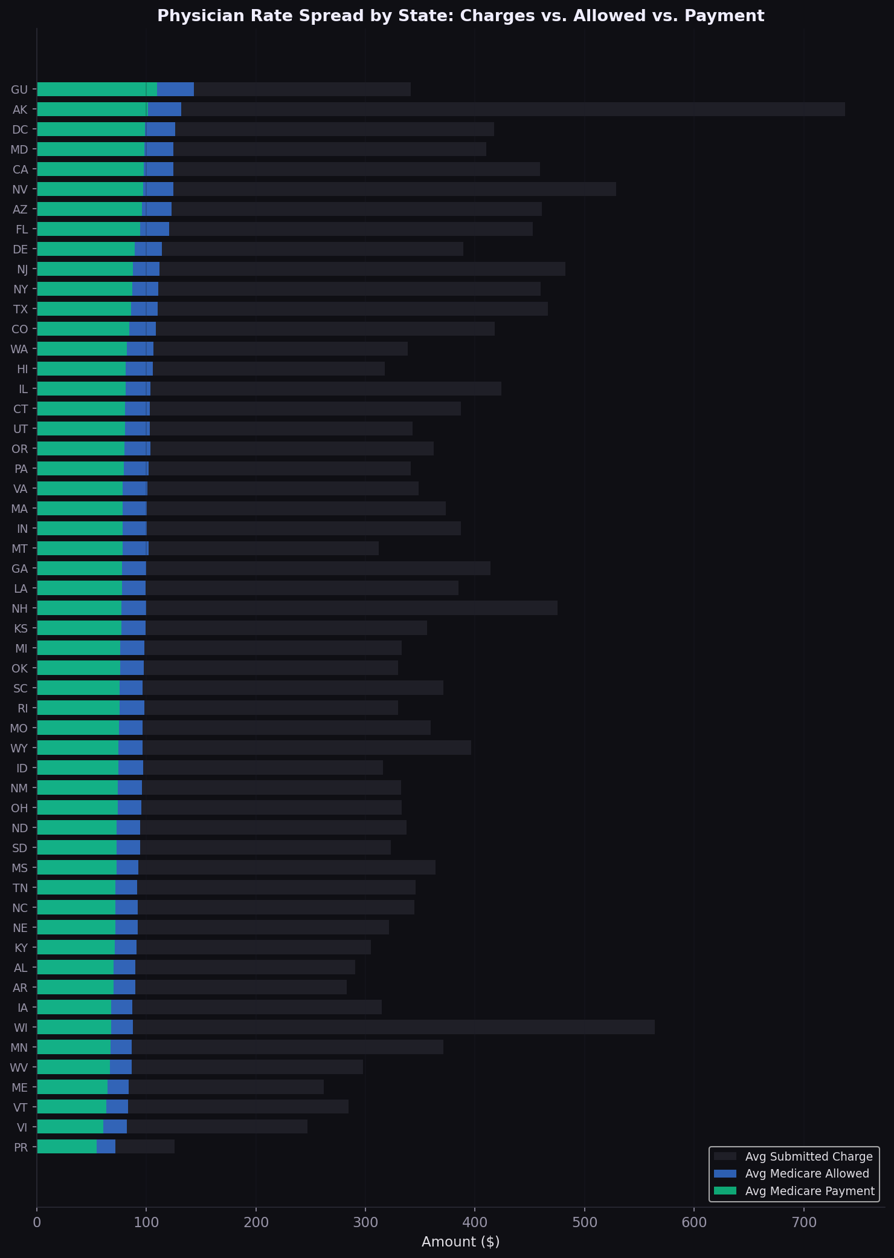
Figure 13. Physician Rate Spread by State

Strategic Implications
Finding | Strategic Implication
Septicemia = 11% of inpatient volume | Bundled payment and readmission reduction programs should prioritize sepsis pathways
Median inpatient markup = 5.4x | Chargemaster-based contracts systematically overpay; percent-of-Medicare benchmarks are more defensible
MD vs. NV markup spread = 9.5x | State regulatory environment is a first-order variable; multi-state payers need state-specific playbooks
High-variation HCPCS codes identified | Procedure-level rate benchmarking can surface outlier providers billing 3-5x peers
Volume-cost specialty mismatch | Utilization management for high-volume specialties; rate negotiation for high-cost specialties

Methods
Data: CMS Medicare Provider Utilization and Payment PUF, Calendar Year 2022. Inpatient file: 145,742 provider-DRG records across 3,015 hospitals and 533 DRGs. Physician file: 9.76M provider-HCPCS records across 1.15M NPIs and 6,326 procedure codes. Cleaning: deduplication on natural keys, encoding normalization (Latin-1), US-only filter for physician file. Derived variable: markup ratio = submitted charges / Medicare payment (inpatient) or submitted charges / Medicare allowed (physician). Tools: Python, pandas, matplotlib.

Analysis by Sridharan Gopalsamy Ramaswamy | sridharanshri.com

