Name=Rakesh Kumar Rana

Roll no=4373,Div=A

Subject=Andorid practical (1-9)

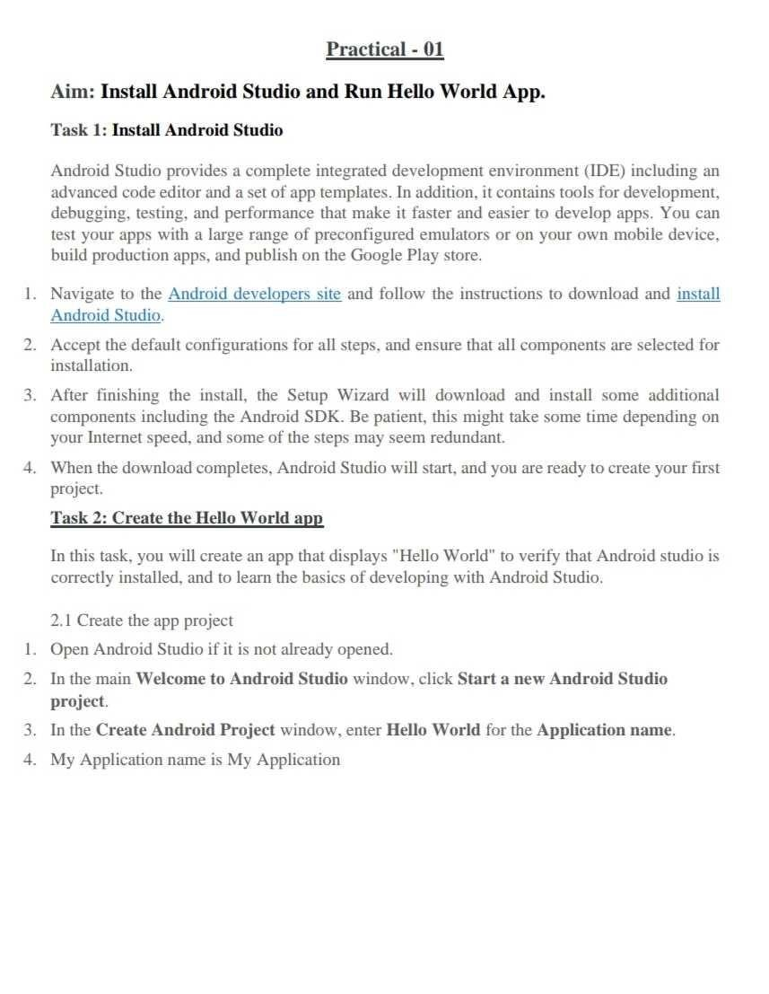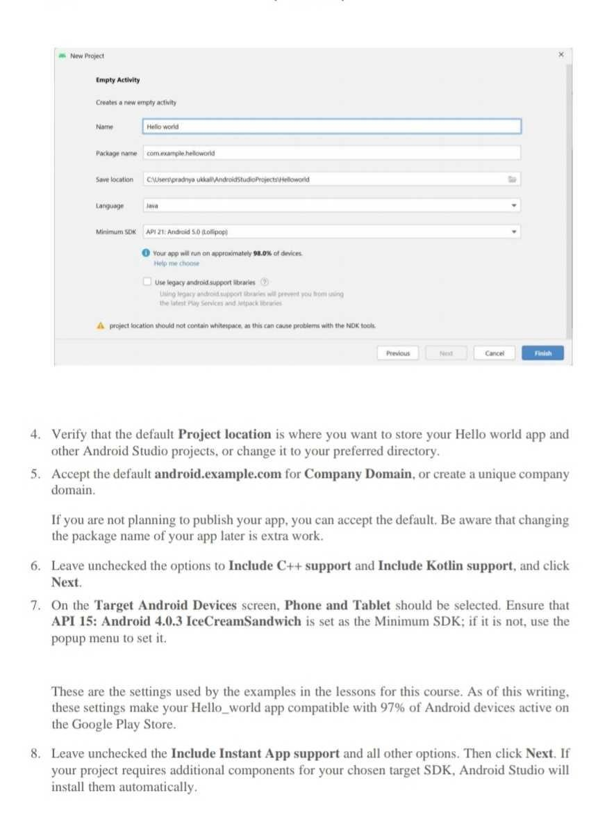

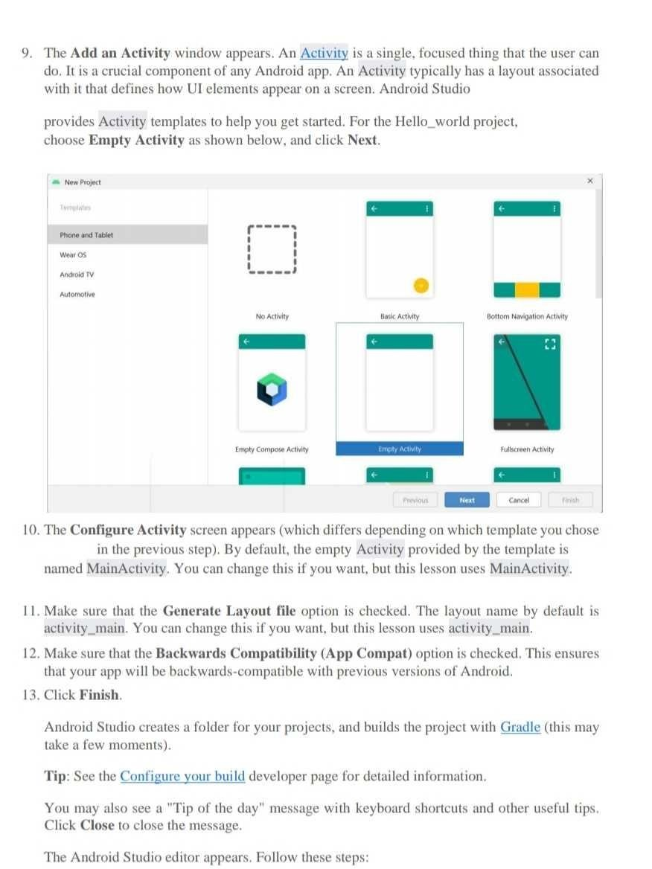

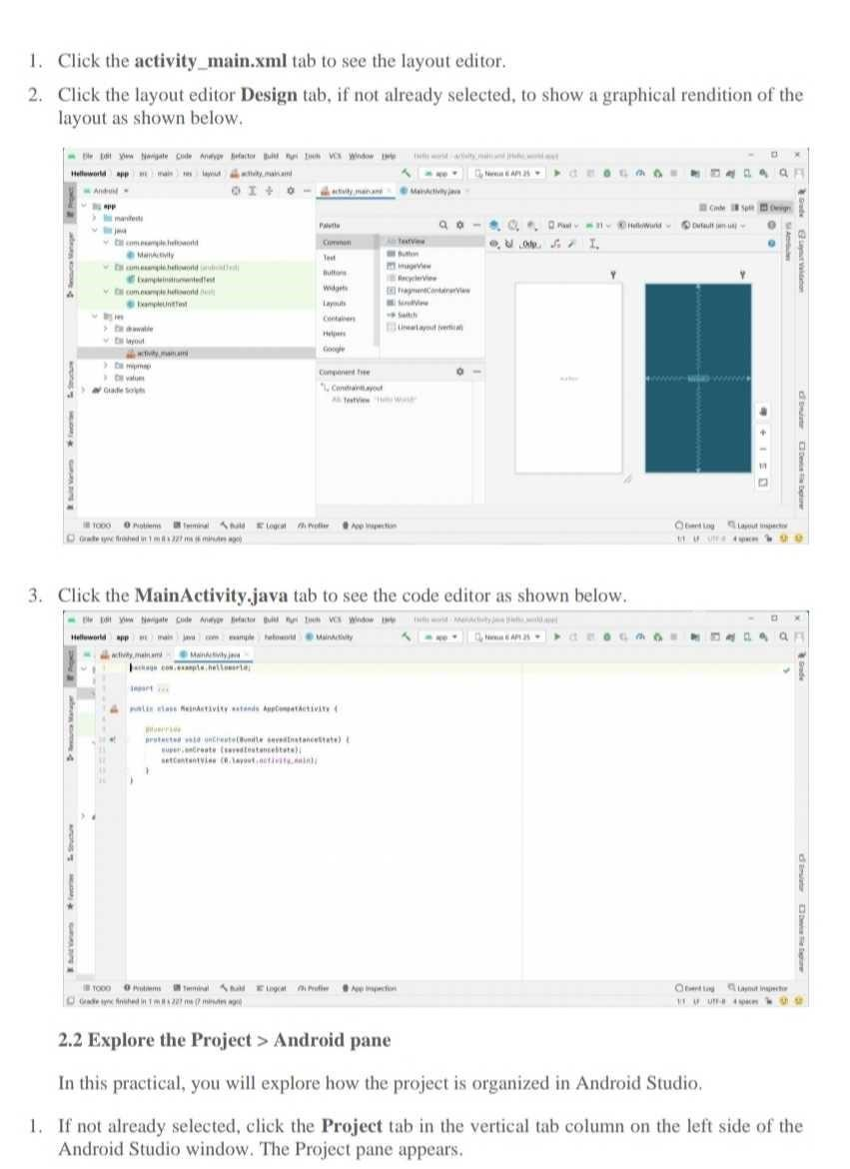

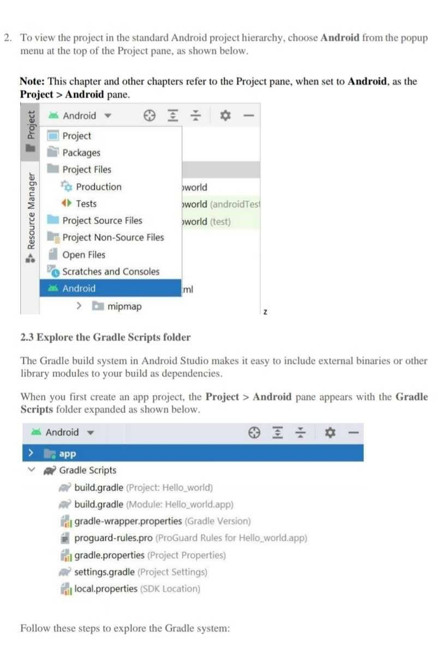

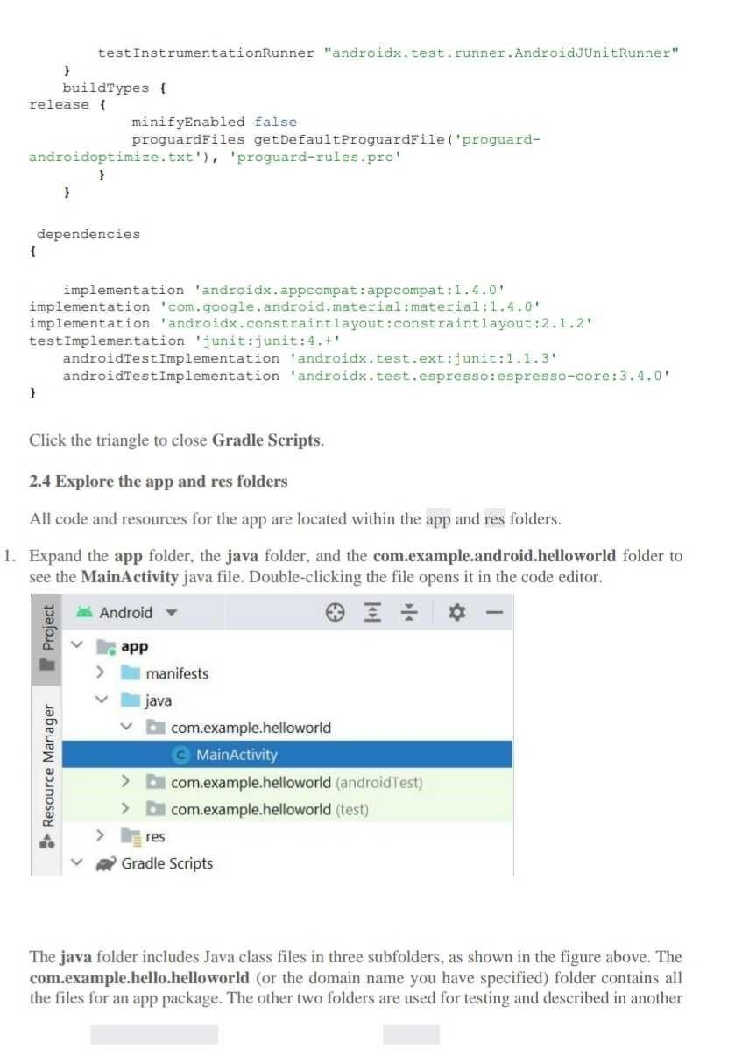

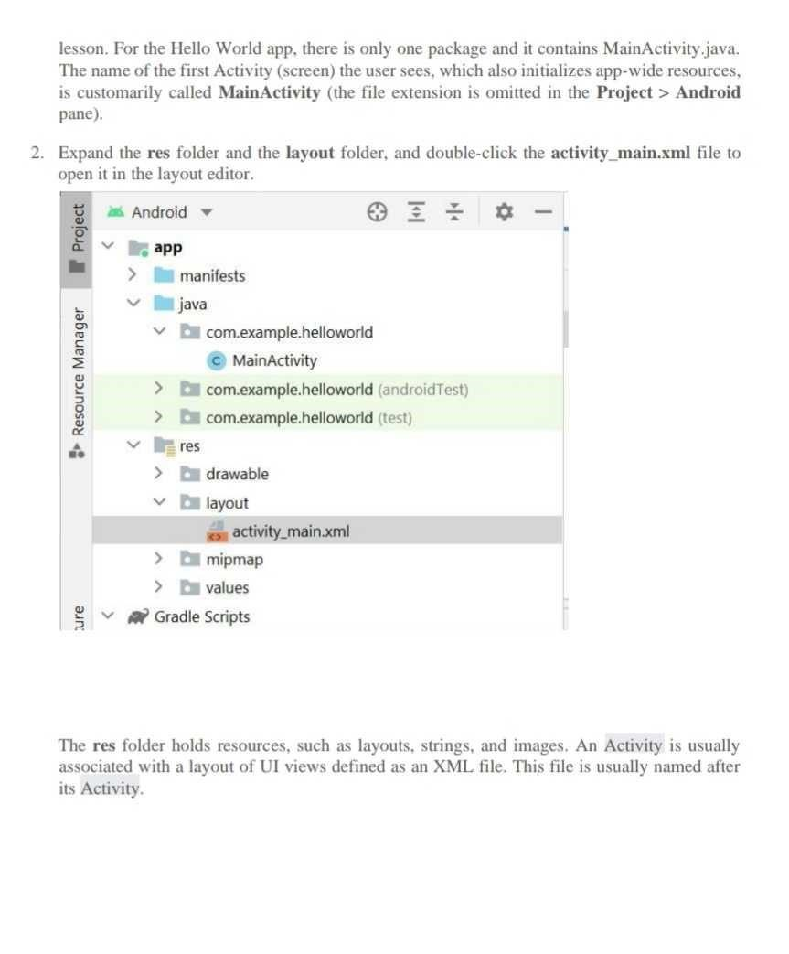

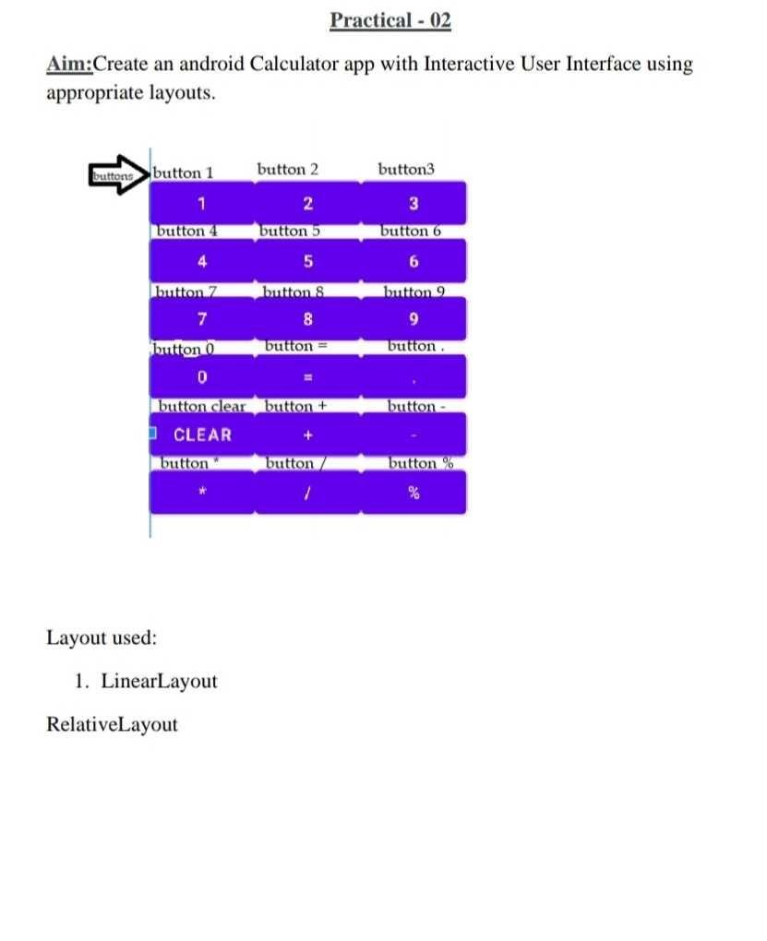

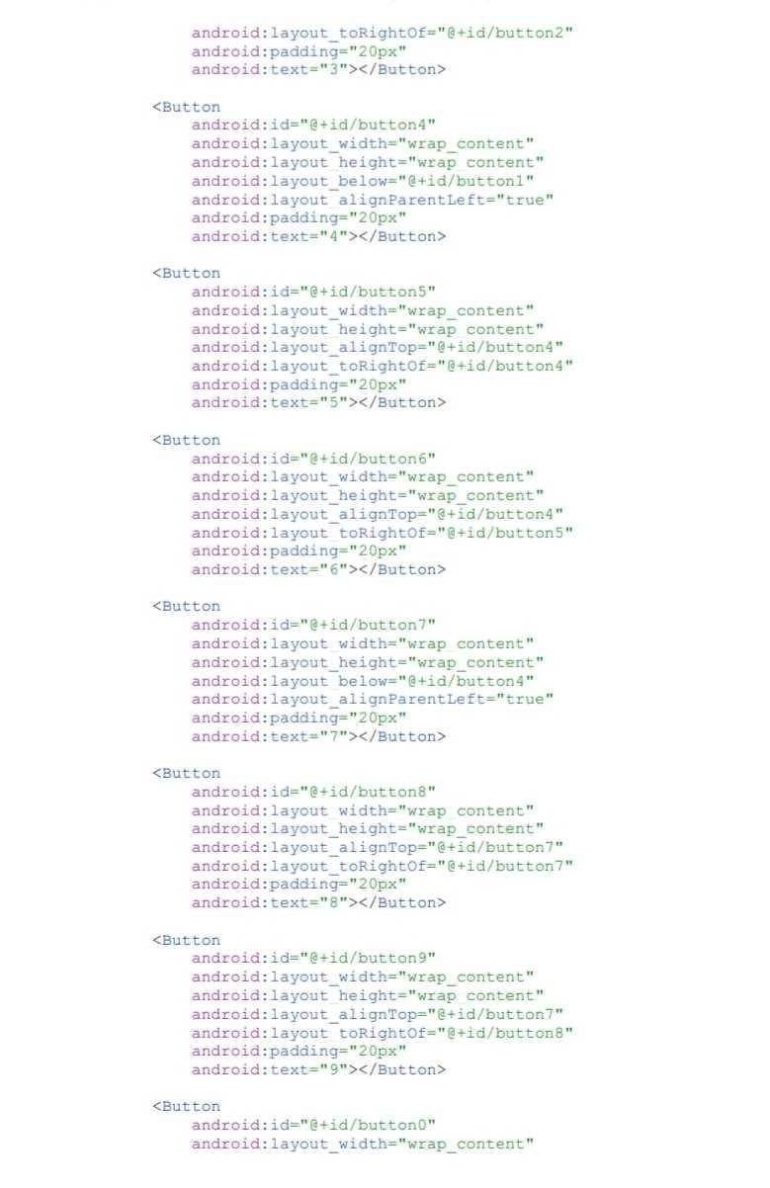

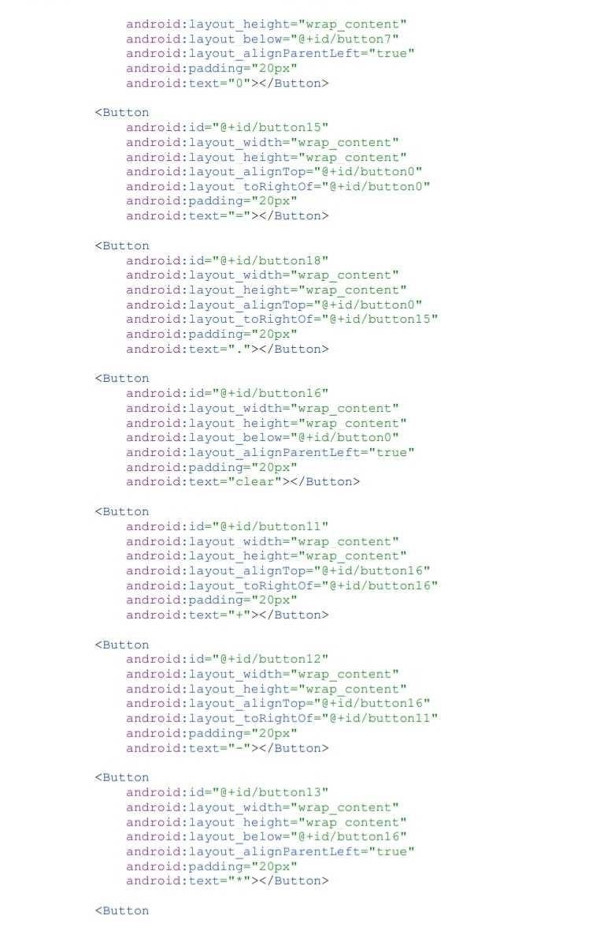

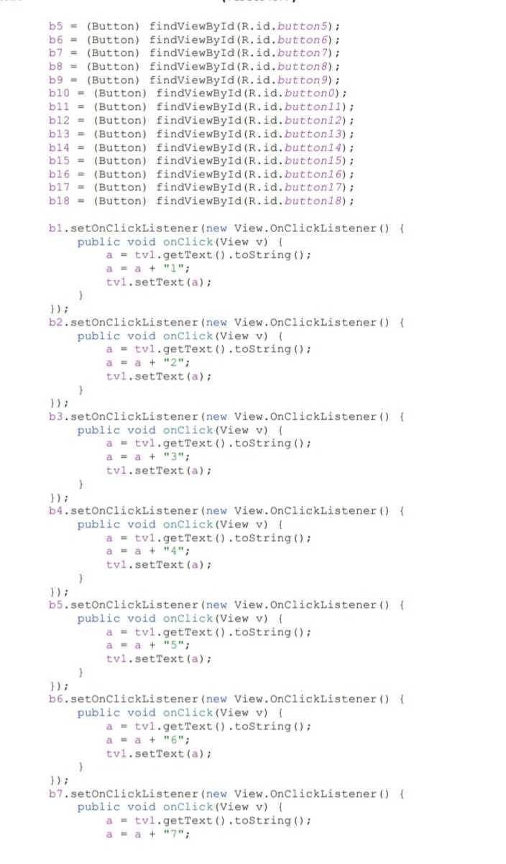

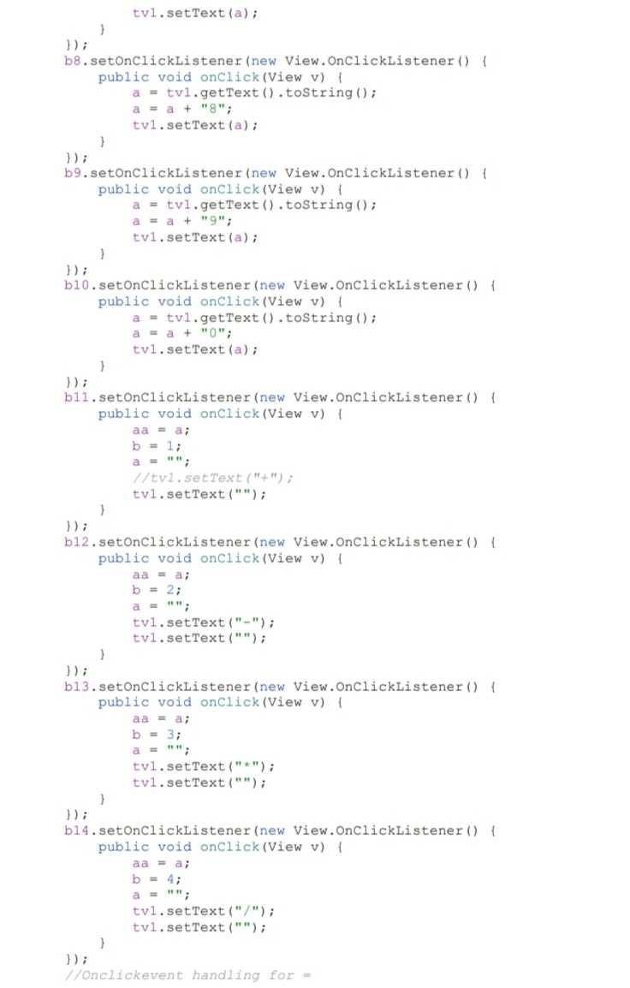

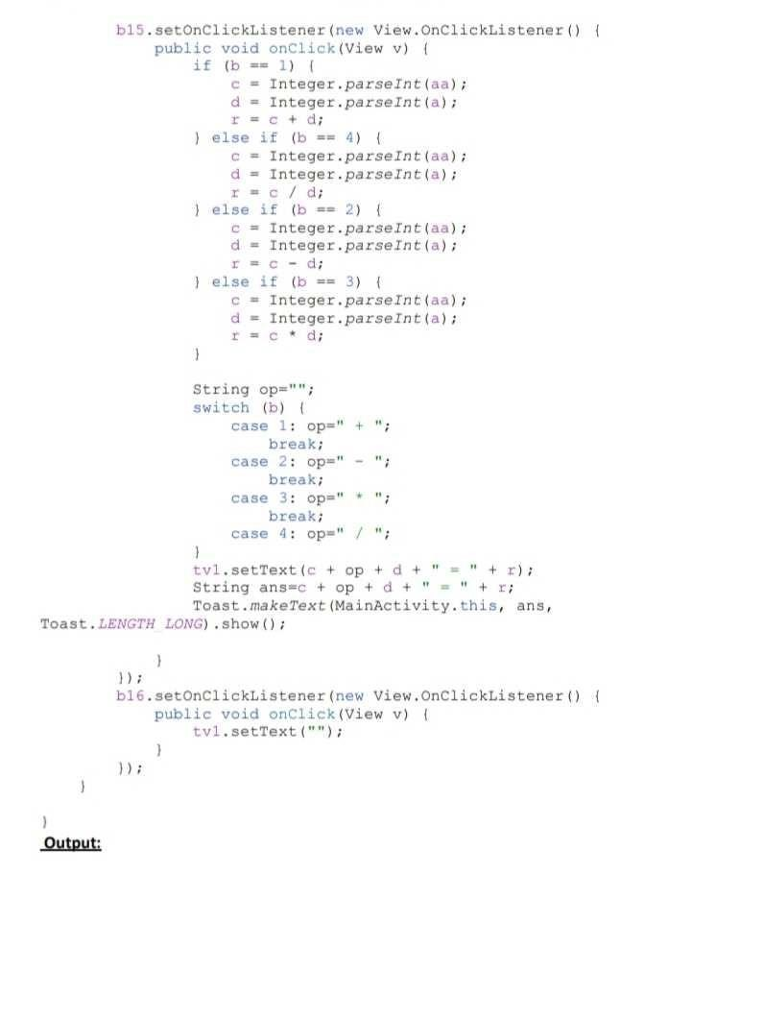

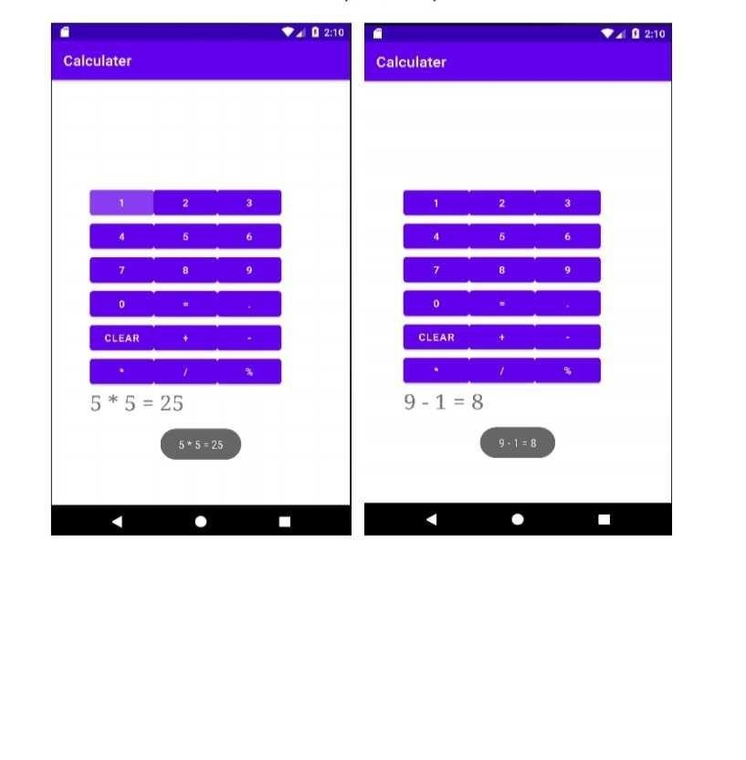

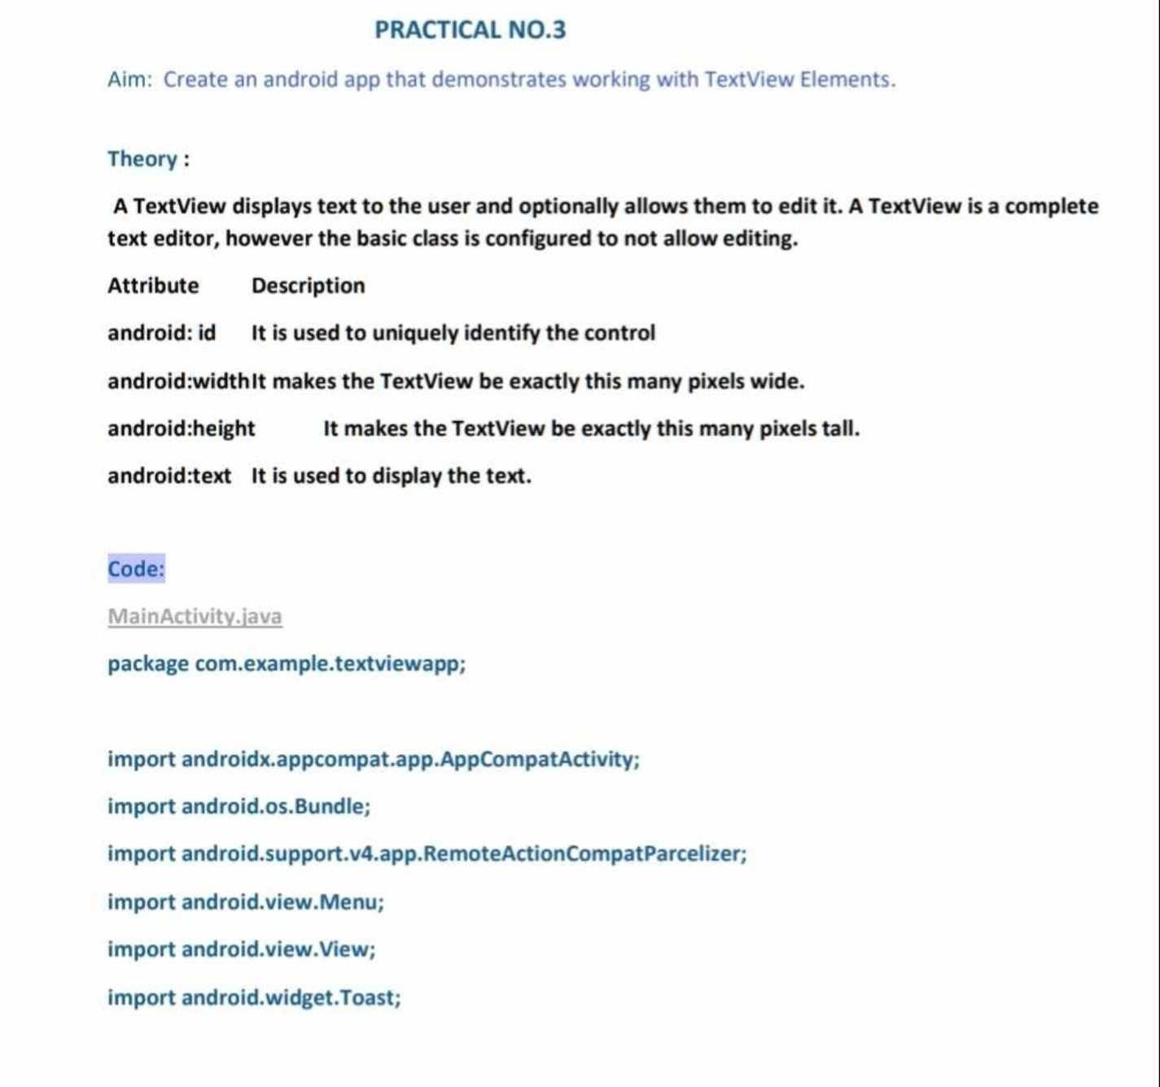

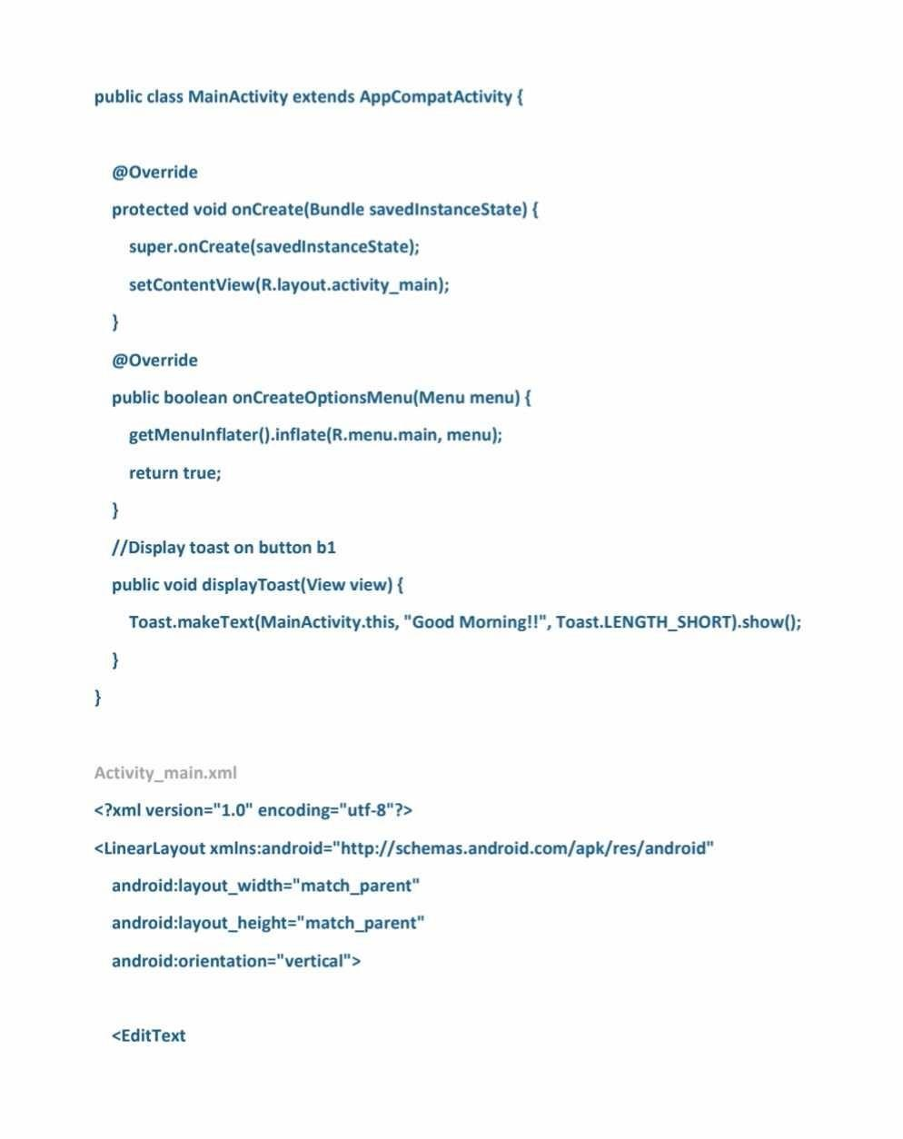

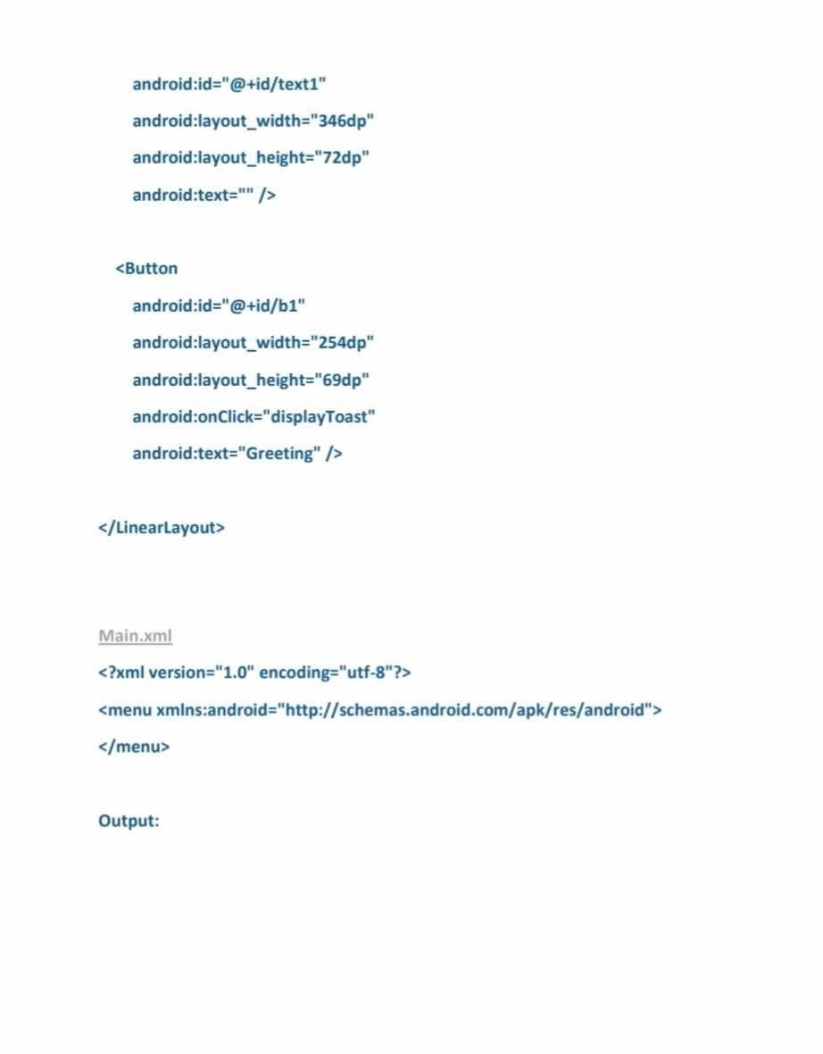

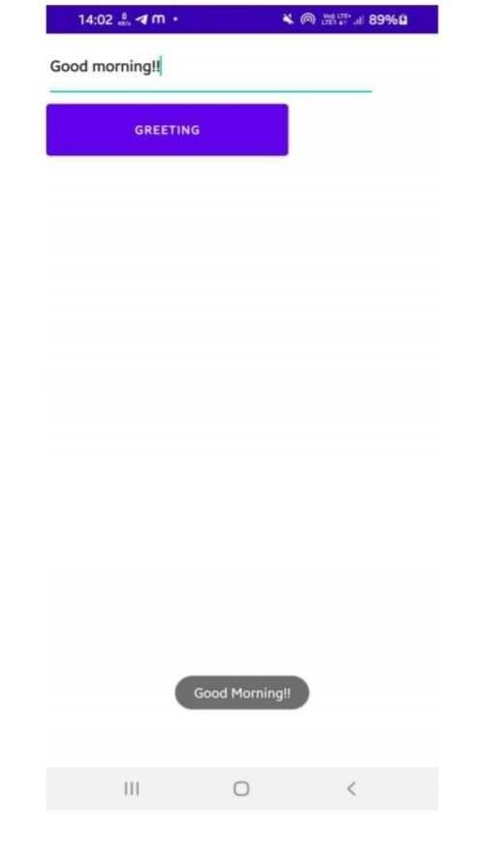

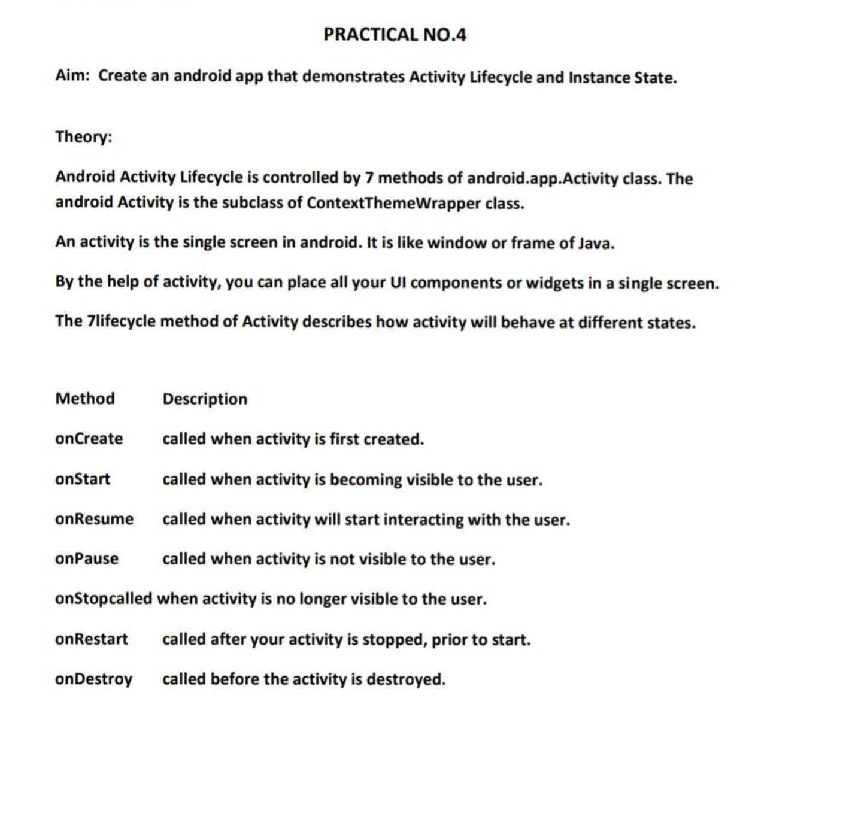

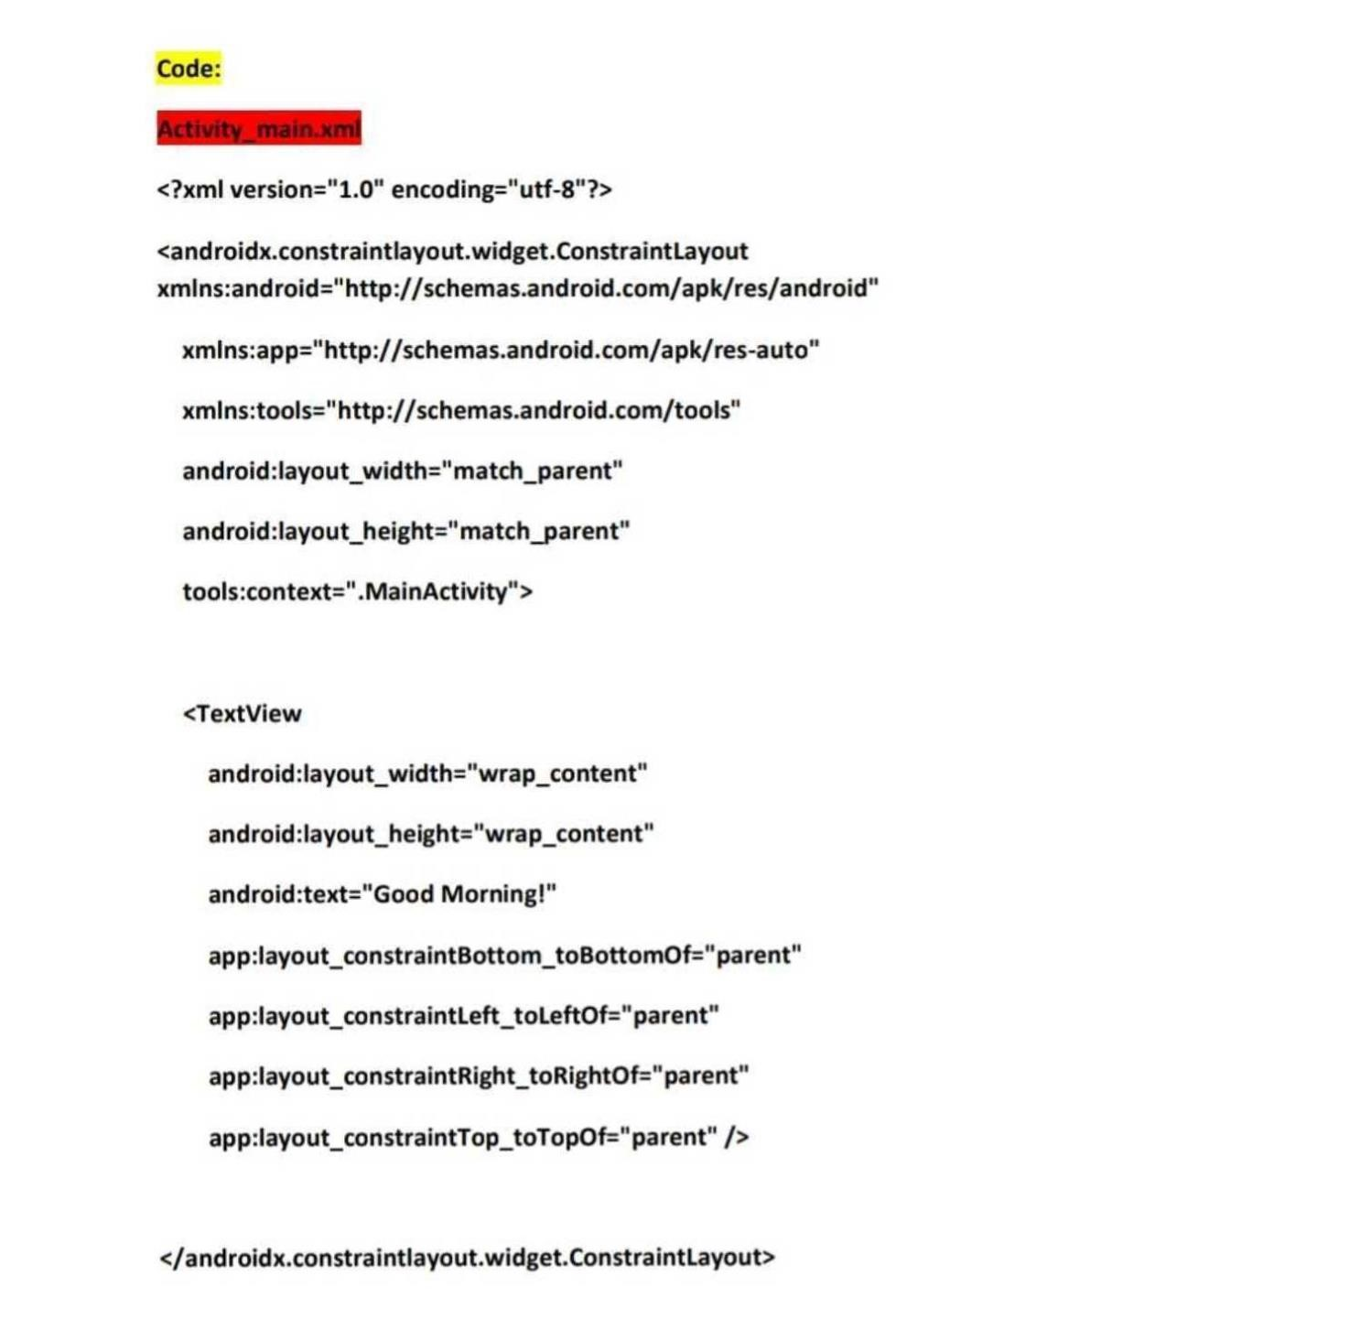

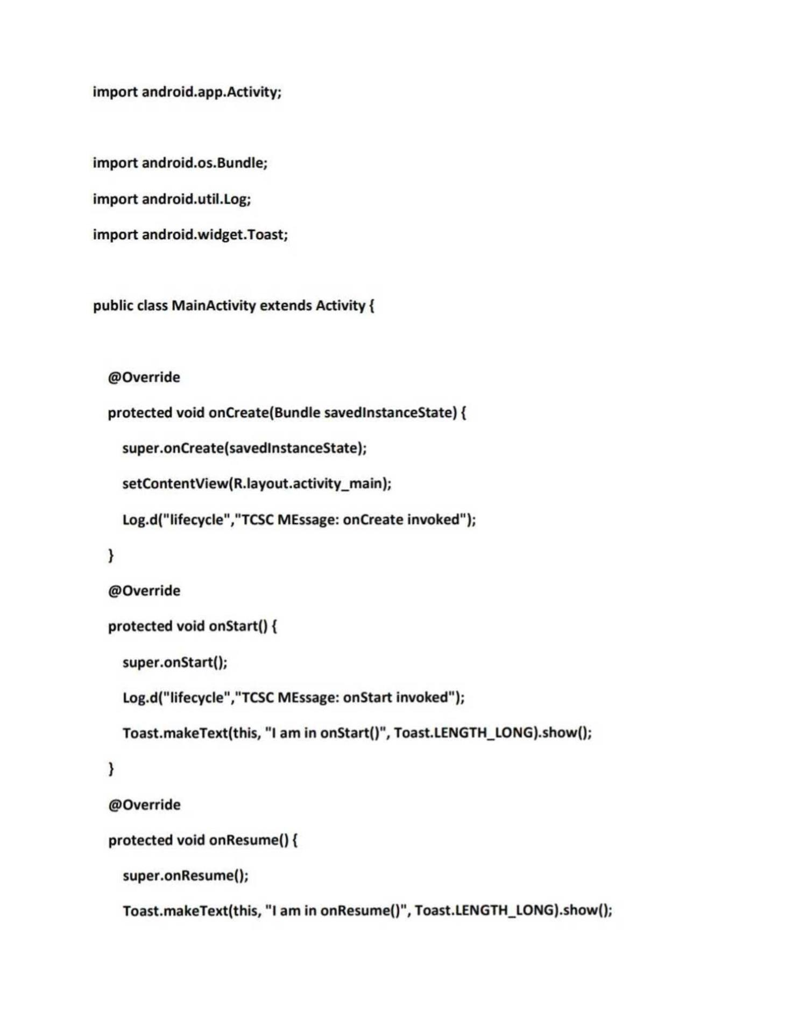

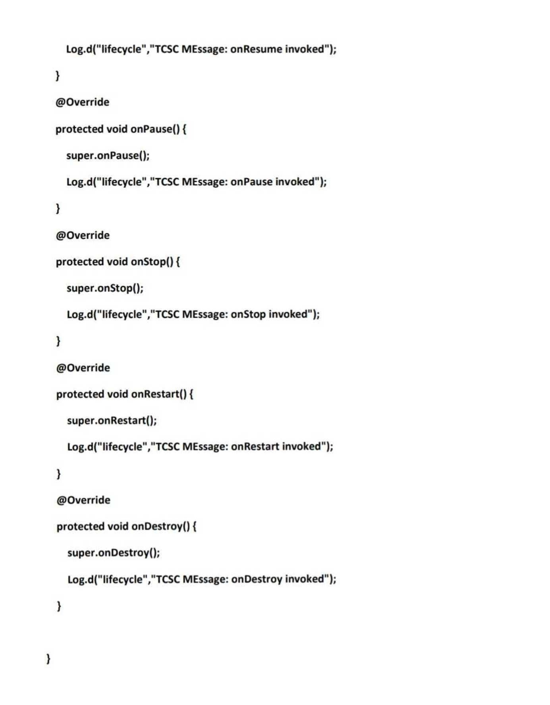

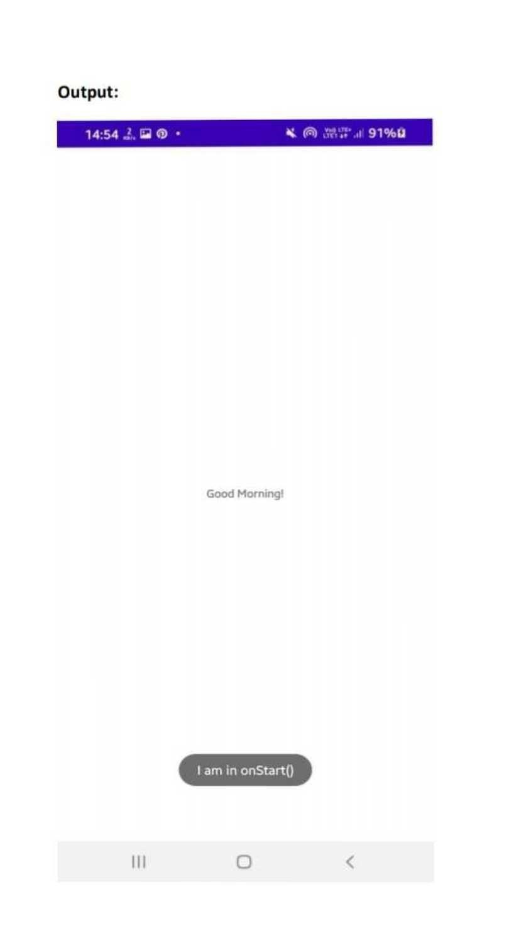

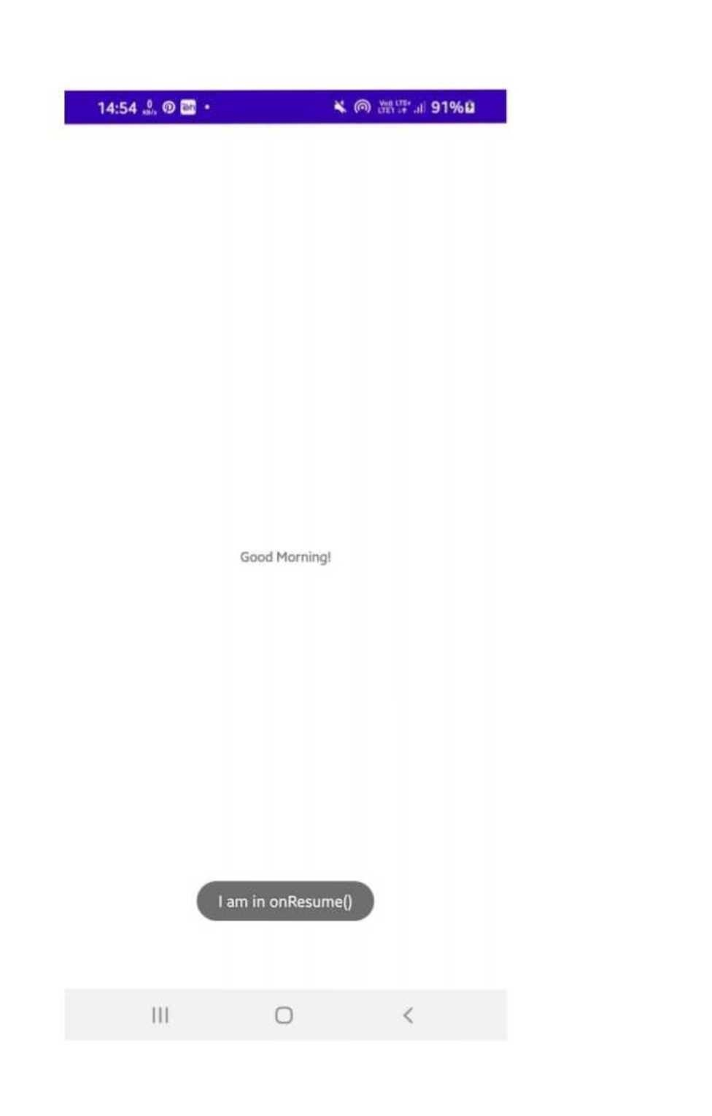

# DroidCafeOptions App

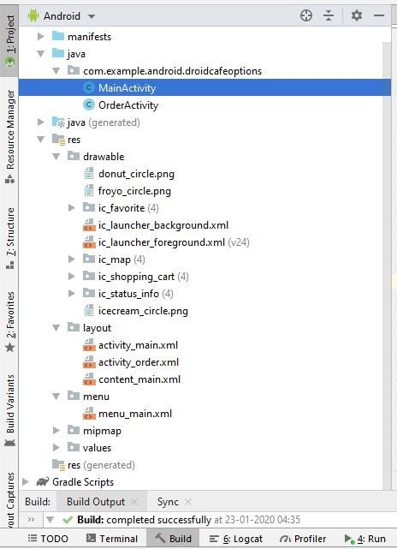

# activity_main.xml

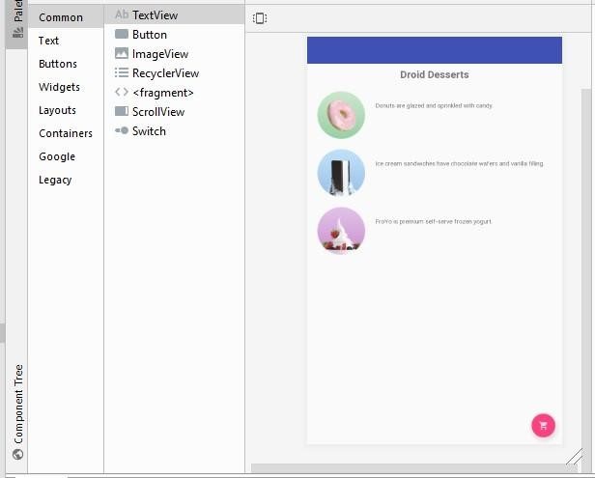

**<?xml version="1.0" encoding="utf-8"?>**

**<android.support.design.widget.CoordinatorLayout xmlns:android="http://schemas.android.com/apk/res/android" xmlns:app="http://schemas.android.com/apk/res-auto" xmlns:tools="http://schemas.android.com/tools" android:layout_width="match_parent" android:layout_height="match_parent"**

**tools:context="com.example.android.droidcafeoptions.MainActivity">**

**<android.support.design.widget.AppBarLayout android:layout_width="match_parent" android:layout_height="wrap_content" android:theme="@style/AppTheme.AppBarOverlay">**

**<android.support.v7.widget.Toolbar android:id="@+id/toolbar" android:layout_width="match_parent" android:layout_height="?attr/actionBarSize" android:background="?attr/colorPrimary" app:popupTheme="@style/AppTheme.PopupOverlay" />**

**</android.support.design.widget.AppBarLayout>**

**<include layout="@layout/content_main" />**

**<android.support.design.widget.FloatingActionButton android:id="@+id/fab" android:layout_width="wrap_content"**

**android:layout_height="wrap_content" android:layout_gravity="bottom|end" android:layout_margin="16dp"**

**app:srcCompat="@drawable/ic_shopping_cart" />**

**</android.support.design.widget.CoordinatorLayout>**

# content_main.xml

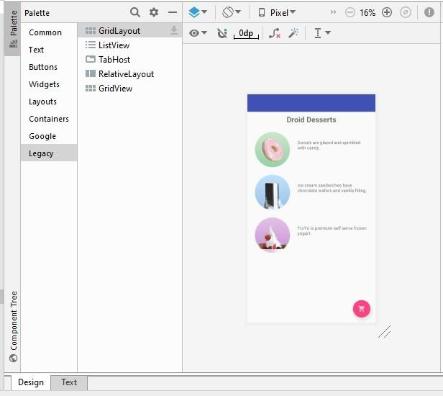

**<?xml version="1.0" encoding="utf-8"?>**

**<android.support.constraint.ConstraintLayout**   **xmlns:android="http://schemas.android.com/apk/res/android"**

**xmlns:app="http://schemas.android.com/apk/res-auto" xmlns:tools="http://schemas.android.com/tools" android:layout_width="match_parent" android:layout_height="match_parent"**

**app:layout_behavior="@string/appbar_scrolling_view_behavior"**

**tools:context="com.example.android.droidcafeoptions.MainActivity"**

**tools:showIn="@layout/activity_main">**

**<TextView**

**android:id="@+id/textintro" android:layout_width="wrap_content" android:layout_height="wrap_content" android:layout_marginTop="8dp" android:text="@string/intro_text"**

**android:textSize="24sp" android:textStyle="bold"**

**app:layout_constraintLeft_toLeftOf="parent"**

**app:layout_constraintRight_toRightOf="parent" app:layout_constraintTop_toTopOf="parent" />**

**<ImageView**

**android:id="@+id/donut"**

**android:layout_width="wrap_content" android:layout_height="wrap_content" android:layout_marginLeft="24dp" android:layout_marginStart="24dp" android:layout_marginTop="24dp" android:contentDescription="@string/donuts" android:onClick="showDonutOrder" app:layout_constraintStart_toStartOf="parent" app:layout_constraintTop_toBottomOf="@+id/textintro" app:srcCompat="@drawable/donut_circle" />**

**<ImageView**

**android:id="@+id/ice_cream" android:layout_width="wrap_content" android:layout_height="wrap_content" android:layout_marginLeft="24dp" android:layout_marginStart="24dp" android:layout_marginTop="24dp"**

**android:contentDescription="@string/ice_cream_sandwiches"**

**android:onClick="showIceCreamOrder" app:layout_constraintStart_toStartOf="parent" app:layout_constraintTop_toBottomOf="@+id/donut" app:srcCompat="@drawable/icecream_circle" />**

**<ImageView**

**android:id="@+id/froyo"**

**android:layout_width="wrap_content" android:layout_height="wrap_content" android:layout_marginLeft="24dp" android:layout_marginStart="24dp" android:layout_marginTop="24dp" android:contentDescription="@string/froyo" android:onClick="showFroyoOrder" app:layout_constraintStart_toStartOf="parent" app:layout_constraintTop_toBottomOf="@+id/ice_cream" app:srcCompat="@drawable/froyo_circle" />**

**<TextView**   **android:id="@+id/donut_description"**

**android:layout_width="0dp" android:layout_height="wrap_content" android:layout_marginEnd="24dp" android:layout_marginStart="24dp" android:layout_marginTop="24dp" android:text="@string/donuts" app:layout_constraintEnd_toEndOf="parent" app:layout_constraintStart_toEndOf="@+id/donut" app:layout_constraintTop_toTopOf="@+id/donut" />**

**<TextView**   **android:id="@+id/ice_cream_description" android:layout_width="0dp" android:layout_height="wrap_content" android:layout_marginEnd="24dp" android:layout_marginStart="24dp" android:layout_marginTop="24dp" android:text="@string/ice_cream_sandwiches" app:layout_constraintEnd_toEndOf="parent" app:layout_constraintStart_toEndOf="@+id/ice_cream" app:layout_constraintTop_toTopOf="@+id/ice_cream" />**

**<TextView**   **android:id="@+id/froyo_description" android:layout_width="0dp" android:layout_height="wrap_content" android:layout_marginEnd="24dp" android:layout_marginStart="24dp" android:layout_marginTop="24dp" android:text="@string/froyo" app:layout_constraintEnd_toEndOf="parent" app:layout_constraintStart_toEndOf="@+id/froyo" app:layout_constraintTop_toTopOf="@+id/froyo" />**

**</android.support.constraint.ConstraintLayout>**

# activity_order.xml

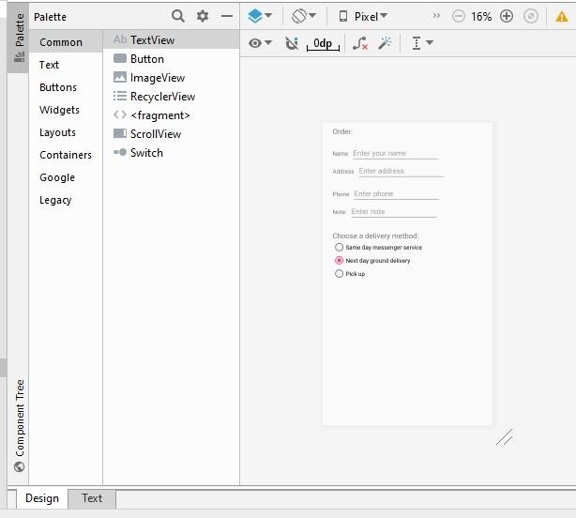

**<?xml version="1.0" encoding="utf-8"?>**

**<android.support.constraint.ConstraintLayout**

**xmlns:android="http://schemas.android.com/apk/res/android"**

**xmlns:app="http://schemas.android.com/apk/res-auto" xmlns:tools="http://schemas.android.com/tools" android:layout_width="match_parent" android:layout_height="match_parent"**

**tools:context="com.example.android.droidcafeoptions.OrderActivity">**

**<TextView**

**android:id="@+id/order_textview"**

**android:layout_width="wrap_content" android:layout_height="wrap_content" android:layout_marginLeft="24dp" android:layout_marginStart="24dp" android:layout_marginTop="8dp" android:text="@string/order_label_text" android:textSize="18sp"**

**app:layout_constraintStart_toStartOf="parent"**

**app:layout_constraintTop_toTopOf="parent" />**

**<TextView**

**android:id="@+id/name_label" android:layout_width="wrap_content" android:layout_height="wrap_content" android:layout_marginLeft="24dp" android:layout_marginStart="24dp" android:layout_marginTop="32dp" android:text="@string/name_label_text" app:layout_constraintStart_toStartOf="parent"**

**app:layout_constraintTop_toBottomOf="@+id/order_textview" />**

**<EditText**

**android:id="@+id/name_text" android:layout_width="wrap_content" android:layout_height="wrap_content" android:layout_marginLeft="8dp"**

**android:layout_marginStart="8dp" android:ems="10"**

**android:hint="@string/enter_name_hint"**

**android:inputType="textPersonName"**

**app:layout_constraintBaseline_toBaselineOf="@+id/name_label"**

**app:layout_constraintStart_toEndOf="@+id/name_label" />**

**<TextView**   **android:id="@+id/address_label"**

**android:layout_width="wrap_content" android:layout_height="wrap_content" android:layout_marginLeft="24dp" android:layout_marginStart="24dp" android:layout_marginTop="24dp" android:text="@string/address_label_text" app:layout_constraintStart_toStartOf="parent"**

**app:layout_constraintTop_toBottomOf="@+id/name_label" />**

**<EditText**

**android:id="@+id/address_text" android:layout_width="wrap_content" android:layout_height="wrap_content" android:layout_marginLeft="8dp"**

**android:layout_marginStart="8dp" android:ems="10"**

**android:hint="@string/enter_address_hint"**

**android:inputType="textMultiLine"**

**app:layout_constraintBaseline_toBaselineOf="@+id/address_label"**

**app:layout_constraintStart_toEndOf="@+id/address_label" />**

**<TextView**

**android:id="@+id/phone_label" android:layout_width="wrap_content" android:layout_height="wrap_content" android:layout_marginLeft="24dp" android:layout_marginStart="24dp" android:layout_marginTop="24dp" android:text="@string/phone_label_string" app:layout_constraintStart_toStartOf="parent"**

**app:layout_constraintTop_toBottomOf="@+id/address_text" />**

**<EditText**

**android:id="@+id/phone_text" android:layout_width="wrap_content" android:layout_height="wrap_content" android:layout_marginLeft="8dp"**

**android:layout_marginStart="8dp" android:ems="10"**

**android:hint="@string/enter_phone_hint"**

**android:inputType="phone"**

**app:layout_constraintBaseline_toBaselineOf="@+id/phone_label"**

**app:layout_constraintStart_toEndOf="@+id/phone_label" />**

**<TextView**   **android:id="@+id/note_label" android:layout_width="wrap_content" android:layout_height="wrap_content" android:layout_marginLeft="24dp" android:layout_marginStart="24dp" android:layout_marginTop="24dp" android:text="@string/note_label_text" app:layout_constraintStart_toStartOf="parent"**

**app:layout_constraintTop_toBottomOf="@+id/phone_label" />**

**<EditText**

**android:id="@+id/note_text" android:layout_width="wrap_content" android:layout_height="wrap_content" android:layout_marginLeft="8dp"**

**android:layout_marginStart="8dp" android:ems="10"**

**android:hint="@string/enter_note_hint"**

**android:inputType="textCapSentences|textMultiLine" app:layout_constraintBaseline_toBaselineOf="@+id/note_label" app:layout_constraintStart_toEndOf="@+id/note_label" />**

**<TextView**

**android:id="@+id/delivery_label"**

**android:layout_width="wrap_content" android:layout_height="wrap_content" android:layout_marginLeft="24dp" android:layout_marginStart="24dp" android:layout_marginTop="24dp"**

**android:text="@string/choose_delivery_method" android:textSize="18sp"**   **app:layout_constraintStart_toStartOf="parent"**

**app:layout_constraintTop_toBottomOf="@+id/note_text" />**

**<RadioGroup**

**android:layout_width="wrap_content" android:layout_height="wrap_content" android:layout_marginLeft="24dp" android:layout_marginStart="24dp" android:orientation="vertical"**

**app:layout_constraintStart_toStartOf="parent"**   **app:layout_constraintTop_toBottomOf="@id/delivery_label">**

**<RadioButton**

**android:id="@+id/sameday" android:layout_width="wrap_content" android:layout_height="wrap_content" android:onClick="onRadioButtonClicked"**

**android:text="@string/same_day_messenger_service" />**

**<RadioButton**

**android:id="@+id/nextday" android:layout_width="wrap_content" android:layout_height="wrap_content" android:onClick="onRadioButtonClicked" android:text="@string/next_day_ground_delivery" android:checked="true"/>**

**<RadioButton**

**android:id="@+id/pickup" android:layout_width="wrap_content" android:layout_height="wrap_content" android:onClick="onRadioButtonClicked" android:text="@string/pick_up" />**

**</RadioGroup>**

**</android.support.constraint.ConstraintLayout>**

# menu_main.xml

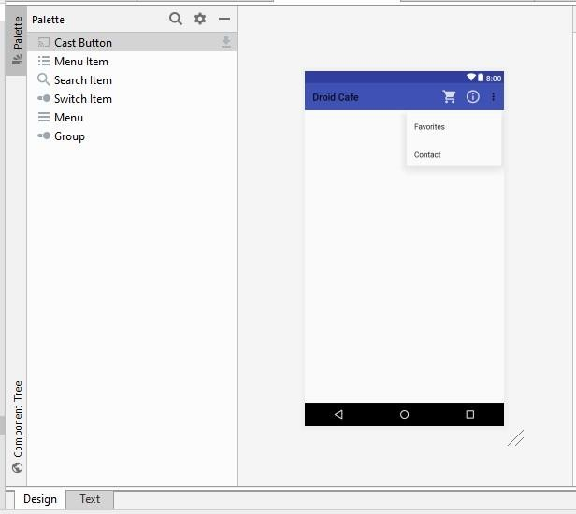

**<menu xmlns:android="http://schemas.android.com/apk/res/android" xmlns:app="http://schemas.android.com/apk/res-auto" xmlns:tools="http://schemas.android.com/tools"**

**tools:context="com.example.android.droidcafeoptions.MainActivity">**

**<item**

**android:id="@+id/action_contact" android:orderInCategory="100" android:title="@string/action_contact" app:showAsAction="never" />**

**<item**

**android:id="@+id/action_order"**

**android:icon="@drawable/ic_shopping_cart" android:orderInCategory="10" android:title="@string/action_order" app:showAsAction="always" />**

**<item**

**android:id="@+id/action_status"**

**android:icon="@drawable/ic_status_info" android:orderInCategory="20" android:title="@string/action_status" app:showAsAction="always" />**

**<item**

**android:id="@+id/action_favorites" android:icon="@drawable/ic_favorite" android:orderInCategory="30" android:title="@string/action_favorites" app:showAsAction="ifRoom" />**

**</menu>**

# OrderActivity.java

**package com.example.android.droidcafeoptions;**

**import android.content.Intent; import**

**android.os.Bundle;**  **import android.support.v7.app.AppCompatActivity; import android.view.View; import android.widget.RadioButton; import android.widget.TextView; import android.widget.Toast;**

**/\*\***

* **This activity handles radio buttons for choosing a delivery method for an**
* **order, and EditText input controls.**

**\*/ public class OrderActivity extends**

**AppCompatActivity {**

**/\*\***

* **Sets the content view to activity_order, and gets the intent and its * data.**

**\***

* **@param savedInstanceState Saved instance state bundle.**

**\*/ @Override protected void onCreate(Bundle savedInstanceState) { super.onCreate(savedInstanceState); setContentView(R.layout.activity_order);**

**// Get the intent and its data.**

**Intent intent = getIntent(); String message =**

**intent.getStringExtra(MainActivity.EXTRA_MESSAGE);**

**TextView textView = findViewById(R.id.order_textview); textView.setText(message);**

**}**

**/\*\***

* **Checks which radio button was clicked and displays a toast message to**
* **show the choice.**

**\***

* **@param view The radio button view.**

**\*/**

**public void onRadioButtonClicked(View view) { //**

**Is the button now checked? boolean checked = ((RadioButton) view).isChecked(); // Check which radio button was clicked. switch (view.getId()) {**

**case R.id.sameday:**

**if (checked)**

**// Same day service**

**displayToast(getString(R.string.same_day_messenger_service)**

**); break; case R.id.nextday: if (checked)**

**// Next day delivery**

**displayToast(getString(R.string.next_day_ground_delivery)) ; break; case R.id.pickup:**   **if (checked) // Pick up displayToast(getString(R.string.pick_up)); break; default:**

**// Do nothing.**

**break;**

**}**

**}**

**/\*\***

* **Displays the actual message in a toast message.**

**\***

* **@param message Message to display.**

**\*/**   **public void displayToast(String message) {**

**Toast.makeText(getApplicationContext(), message,**

**Toast.LENGTH_SHORT).show();**

**}**

**}**

# MainActivity.java

**package**

**com.example.android.droidcafeoptions;**

**import android.content.Intent; import**

**android.os.Bundle;**

**import android.support.design.widget.FloatingActionButton;**

**import android.support.v7.app.AppCompatActivity; import android.support.v7.widget.Toolbar; import android.view.Menu; import android.view.MenuItem; import android.view.View; import android.widget.Toast;**

**/\*\***

* **This app demonstrates images used as buttons and a floating action button to**
* **use an intent to launch a second activity. The app lets a user tap an image**
* **to make a choice. The app displays a Toast message showing the** user’s choice,
* **and sends the choice as data with an intent to launch the second activity.**

**\***

* **This version includes options in the options menu, in which some of the**
* **options appear as icons in the app bar.**

**\*/ public class MainActivity extends**

**AppCompatActivity {**

**// Tag for the intent extra. public static final String EXTRA_MESSAGE =**

**"com.example.android.droidcafeoptions.extra.MESSAGE";**   **// The order message, displayed in the Toast and sent to the new Activity. private String mOrderMessage;**

**/\*\***

* **Creates the content view, the toolbar, and the floating action button.**
* **This method is provided in the Basic Activity template.**

**\***

* **@param savedInstanceState Saved instance state bundle.**

**\*/ @Override protected void onCreate(Bundle savedInstanceState) { super.onCreate(savedInstanceState);**

**setContentView(R.layout.activity_main); Toolbar toolbar = findViewById(R.id.toolbar); setSupportActionBar(toolbar);**

**FloatingActionButton fab = findViewById(R.id.fab); fab.setOnClickListener(new View.OnClickListener() {**

**@Override**   **public void onClick(View view) {**

**Intent intent = new Intent(MainActivity.this, OrderActivity.class);**   **intent.putExtra(EXTRA_MESSAGE, mOrderMessage);**

**startActivity(intent);**

**}**

**});**

**}**

**/\*\***

* **Inflates the menu, and adds items to the action bar if it is present.**

**\***

* **@param menu Menu to inflate.**
* **@return Returns true if the menu inflated.**

**\*/ @Override public boolean onCreateOptionsMenu(Menu menu) {**

**// Inflate the menu; this adds items to the action bar if it is present. getMenuInflater().inflate(R.menu.menu_main, menu);**

**return true;**

**}**

**/\*\***

* **Handles app bar item clicks.**

**\***

* **@param item Item clicked.**
* **@return True if one of the defined items was clicked.**

**\*/ @Override public boolean onOptionsItemSelected(MenuItem item) { switch (item.getItemId()) { case R.id.action_order:**

**Intent intent = new Intent(MainActivity.this,**

**OrderActivity.class);**

**intent.putExtra(EXTRA_MESSAGE, mOrderMessage); startActivity(intent); return true; case R.id.action_status:**

**displayToast(getString(R.string.action_status_message)) ; return true; case R.id.action_favorites:**

**displayToast(getString(R.string.action_favorites_message)) ; return true; case**

**R.id.action_contact:**

**displayToast(getString(R.string.action_contact_message))**

**; return true; default: // Do nothing**   **}**

**return super.onOptionsItemSelected(item);**

**}**

**/\*\***

* **Displays a Toast with the message. \***  **\* @param message Message to display.**

**\*/**   **public void displayToast(String message) {**

**Toast.makeText(getApplicationContext(), message,**

**Toast.LENGTH_SHORT).show();**

**}**

**/\*\***

* **Shows a message that the donut image was clicked.**

**\*/**

**public void showDonutOrder(View view) {**   **mOrderMessage = getString(R.string.donut_order_message);**

**displayToast(mOrderMessage);**

**}**

**/\*\***

* **Shows a message that the ice cream sandwich image was clicked.**

**\*/**   **public void showIceCreamOrder(View view) {**   **mOrderMessage =**

**getString(R.string.ice_cream_order_message); displayToast(mOrderMessage);**

**}**

**/\*\***

* **Shows a message that the froyo image was clicked.**

**\*/**

**public void showFroyoOrder(View view) {**   **mOrderMessage = getString(R.string.froyo_order_message);**

**displayToast(mOrderMessage);**

**}**

**}**

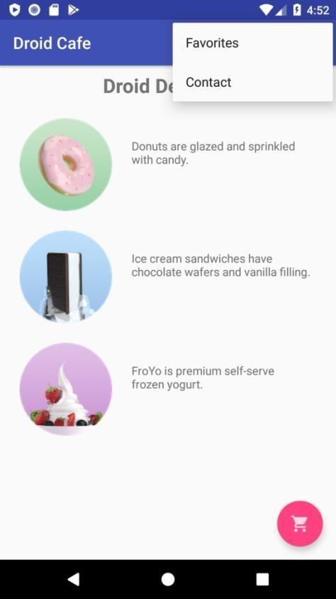

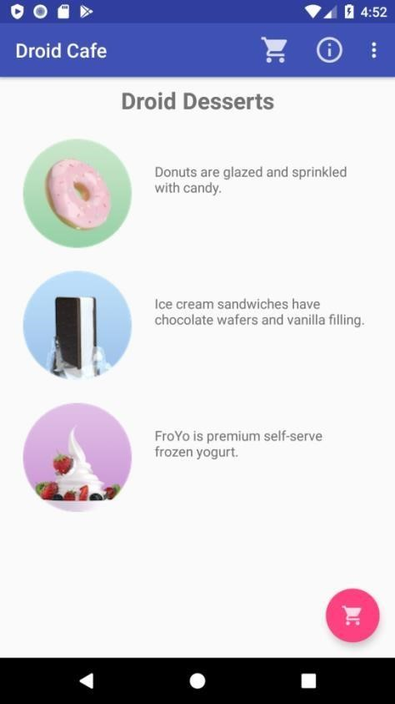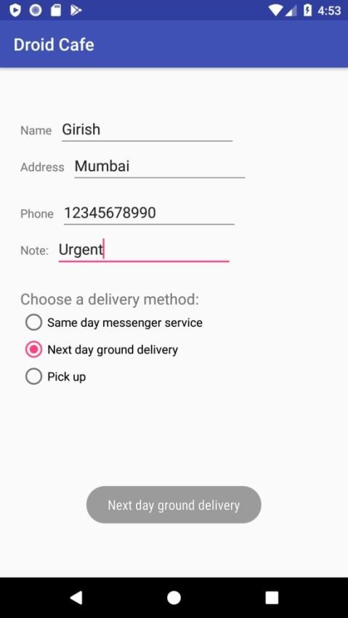

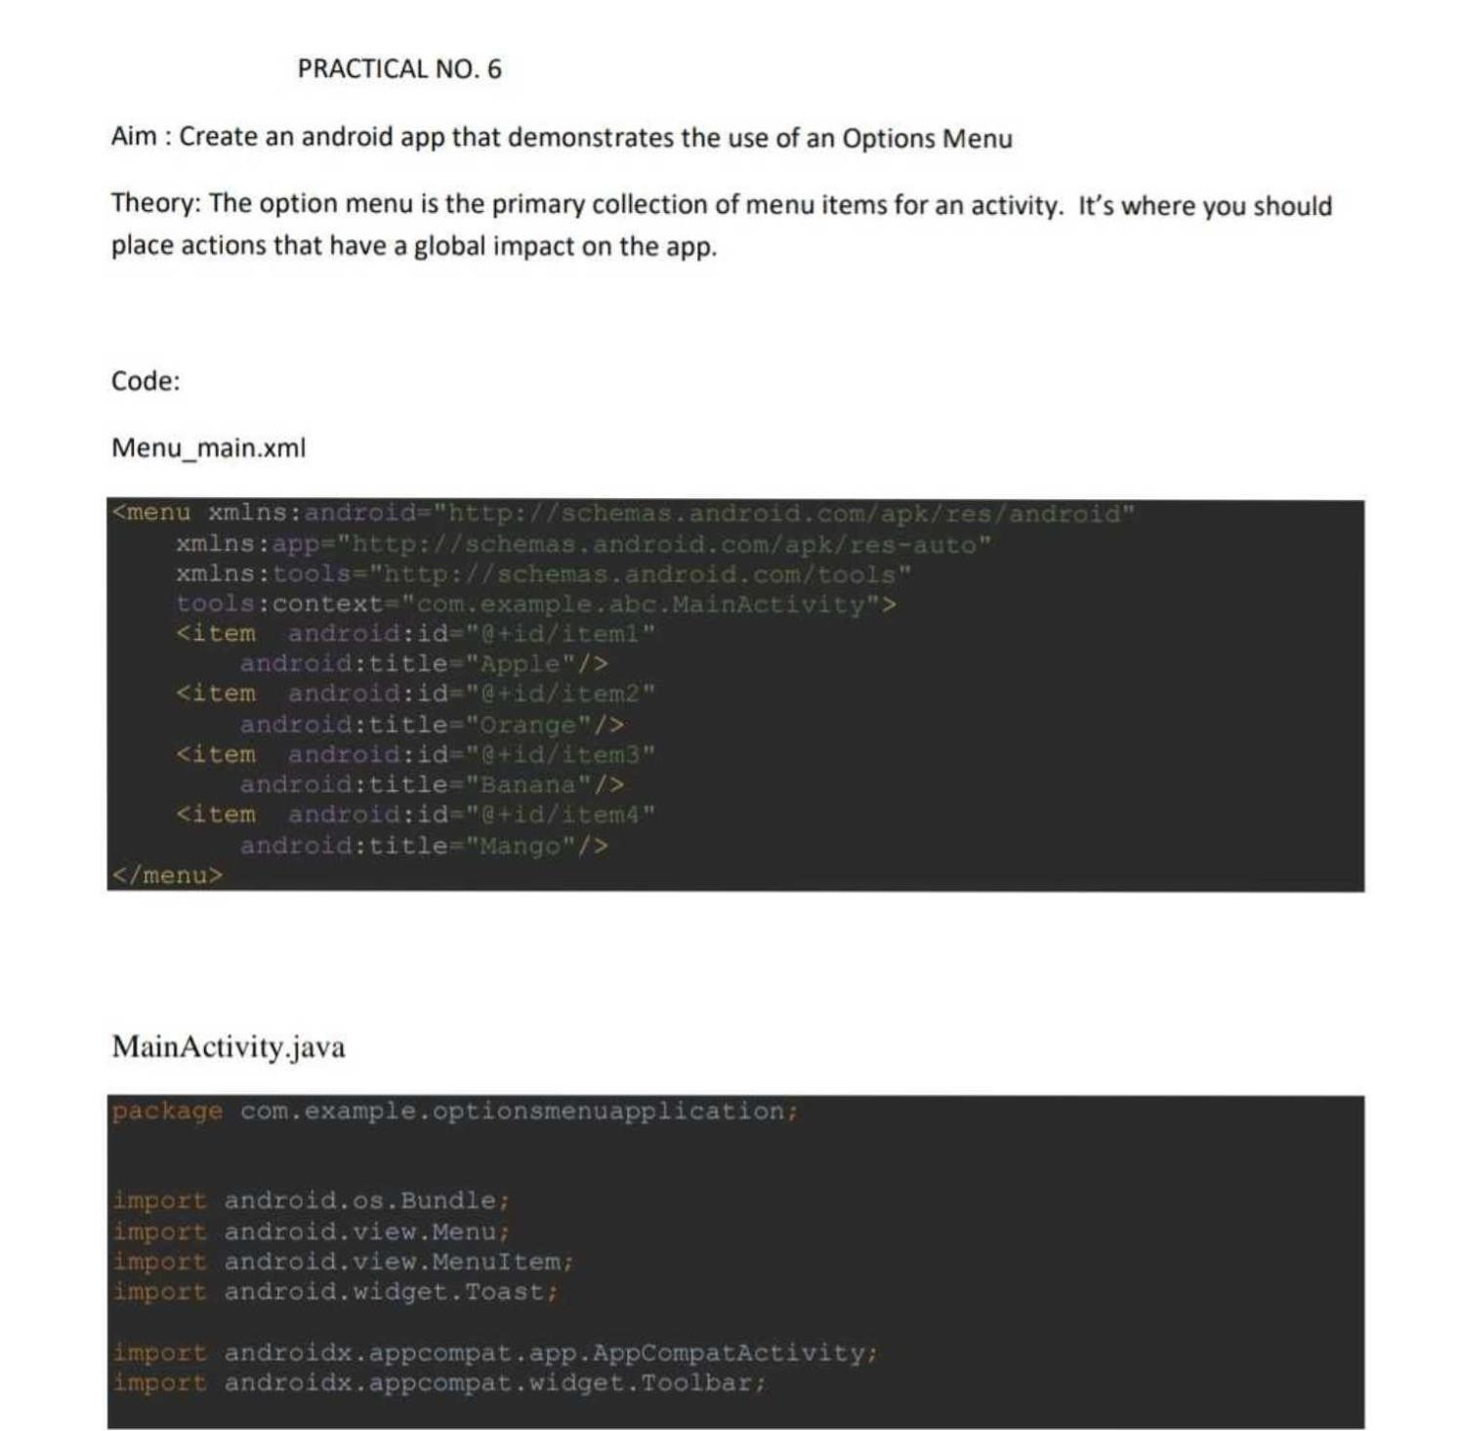

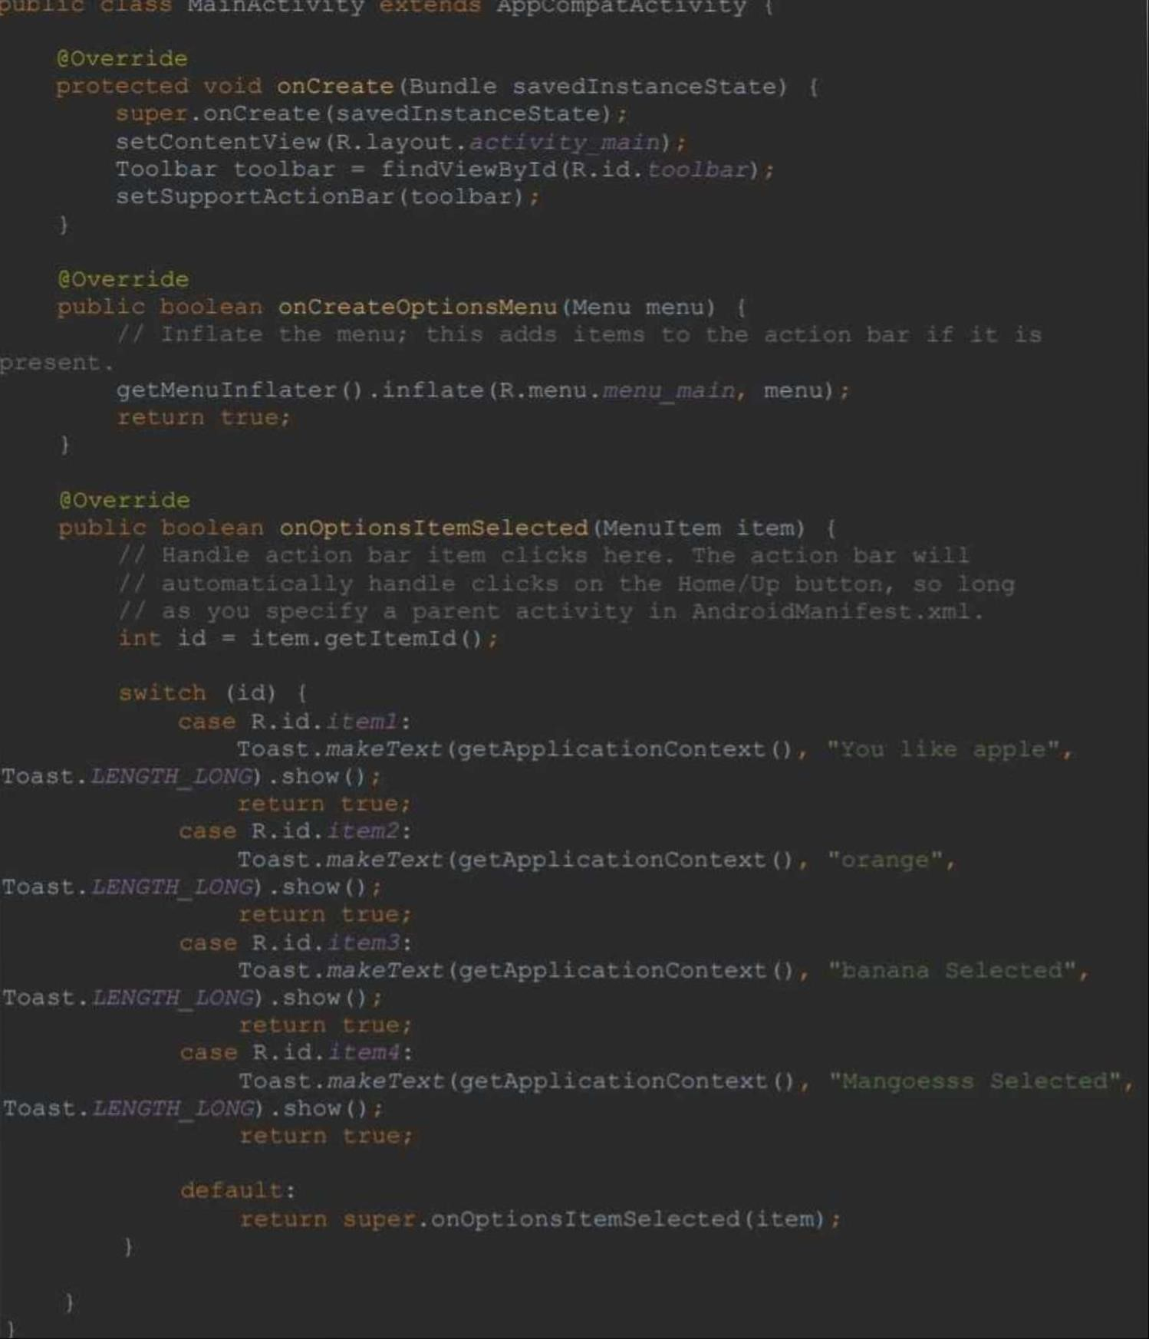

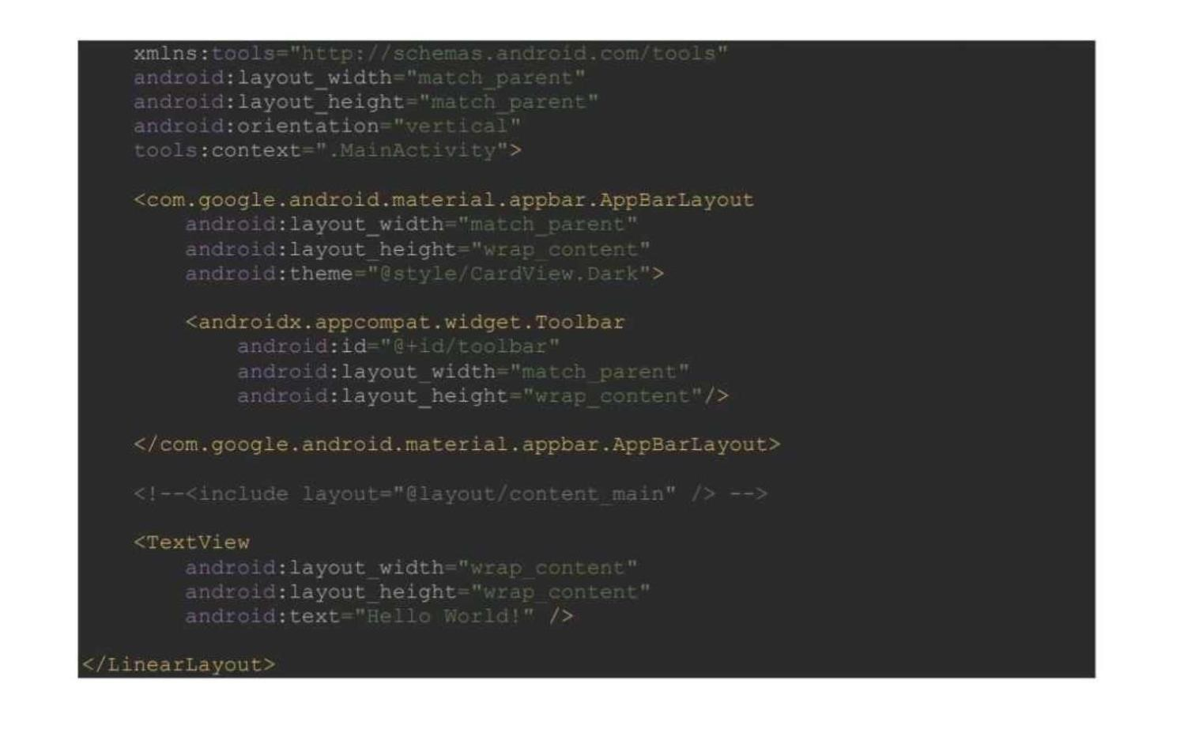

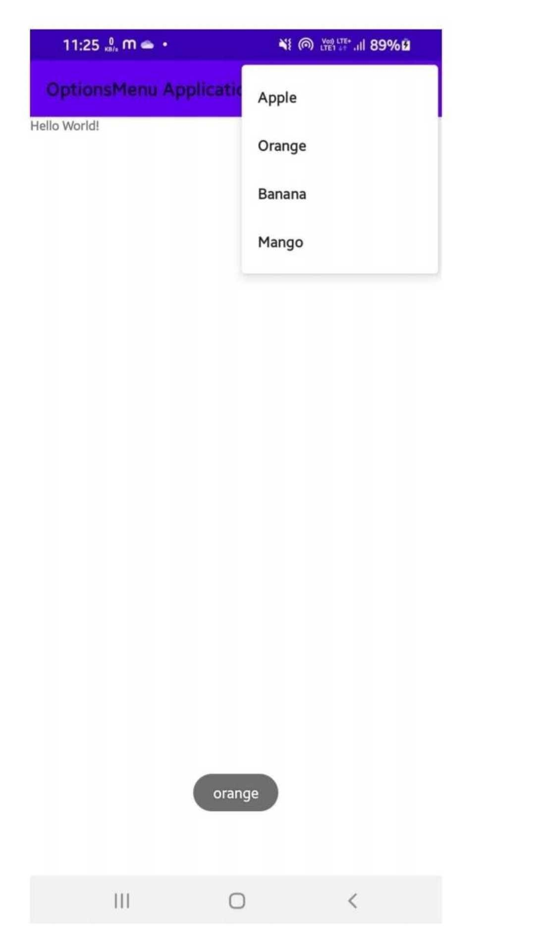

# Practical No – 7

## **Aim:** Create an android app that demonstrate Screen Navigation Using the App Bar and Tabs

**Theory:**  App for tab navigation that shows two tabs to navigate to sibling screens. When the user taps a tab, the screen shows a content screen, depending on which tab the user tapped. The user can also swipe left and right to visit the content screens. The ViewPager class automatically handles user swipes to screens or View elements.

Following is the pictorial representation of android app to demonstrate screen navigation using the app bar and tabs

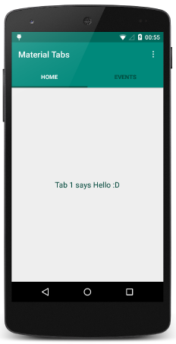

**Source Code:**

**activity_main.xml:**

<?xml version="1.0" encoding="utf-8"?>

<LinearLayout xmlns:android="http://schemas.android.com/apk/res/android" xmlns:app="http://schemas.android.com/apk/res-auto" xmlns:tools="http://schemas.android.com/tools" android:layout_width="match_parent" android:layout_height="match_parent" android:orientation="vertical" tools:context=".MainActivity">

<com.google.android.material.tabs.TabLayout android:layout_width="match_parent" android:layout_height="50dp" android:id="@+id/tabLayout" app:tabMode="fixed" app:tabGravity="fill" app:tabIndicatorGravity="stretch" app:tabSelectedTextColor="@color/white" app:tabIndicatorAnimationMode="elastic" app:tabIndicator="@drawable/tab_indicator"/>

<androidx.viewpager2.widget.ViewPager2 android:layout_width="match_parent" android:layout_height="match_parent" android:id="@+id/viewPager2"/>

</LinearLayout>

**fragment_sign_in.xml**

<androidx.constraintlayout.widget.ConstraintLayout xmlns:android="http://schemas.android.com/apk/res/android" xmlns:app="http://schemas.android.com/apk/res-auto" xmlns:tools="http://schemas.android.com/tools" android:layout_width="match_parent" android:layout_height="match_parent" android:background="#E2E5DE" tools:context=".SignInFragment">

<androidx.cardview.widget.CardView android:layout_width="match_parent" android:layout_height="0dp" android:layout_marginVertical="10dp" app:cardCornerRadius="30dp" app:layout_constraintBottom_toTopOf="@+id/signInBtn" app:layout_constraintTop_toTopOf="parent">

<androidx.constraintlayout.widget.ConstraintLayout android:layout_width="match_parent" android:layout_height="match_parent">

<TextView android:id="@+id/textView" android:layout_width="wrap_content" android:layout_height="wrap_content" android:layout_marginStart="24dp" android:layout_marginTop="24dp" android:text="@string/sign_in_account" android:textColor="@color/red" android:textSize="20sp"

app:layout_constraintStart_toStartOf="parent"

app:layout_constraintTop_toTopOf="parent" />

<TextView android:id="@+id/textview2" android:layout_width="wrap_content" android:layout_height="wrap_content" android:layout_marginStart="26dp" android:layout_marginTop="16dp" android:text="Email ID" android:textColor="@color/black" android:textSize="12sp" app:layout_constraintStart_toStartOf="parent" app:layout_constraintTop_toBottomOf="@+id/textView3" />

<EditText android:id="@+id/editEmailSignIN"

android:layout_width="0dp" android:layout_height="50dp" android:layout_marginStart="24dp" android:layout_marginEnd="24dp" android:backgroundTint="@color/dark_red" android:drawableRight="@drawable/ic_baseline_person" android:ems="10" android:inputType="textEmailAddress" android:textColor="#8c8c8c" app:layout_constraintEnd_toEndOf="parent" app:layout_constraintHorizontal_bias="0.0" app:layout_constraintStart_toStartOf="parent" app:layout_constraintTop_toBottomOf="@+id/textview2" />

<TextView

android:id="@+id/textView3" android:layout_width="wrap_content" android:layout_height="wrap_content" android:layout_marginStart="24dp" android:text="Account" android:textColor="@color/dark_red" android:textSize="20sp" app:layout_constraintStart_toStartOf="parent" app:layout_constraintTop_toBottomOf="@+id/textView" />

<TextView android:id="@+id/textView4" android:layout_width="wrap_content" android:layout_height="wrap_content" android:layout_marginStart="26dp" android:layout_marginTop="8dp" android:text="Password" android:textColor="@color/black" android:textSize="12sp"

app:layout_constraintStart_toStartOf="parent" app:layout_constraintTop_toBottomOf="@+id/editEmailSignIN" />

<EditText

android:id="@+id/editPassSignIn"

android:layout_width="0dp" android:layout_height="50dp" android:layout_marginStart="24dp" android:layout_marginEnd="24dp" android:backgroundTint="@color/dark_red" android:drawableRight="@drawable/ic_baseline_lock_ope n"

android:ems="10" android:inputType="textPassword" android:textColor="#8c8c8c" app:layout_constraintEnd_toEndOf="parent" app:layout_constraintHorizontal_bias="0.0" app:layout_constraintStart_toStartOf="parent" app:layout_constraintTop_toBottomOf="@+id/textView4" /> <TextView android:id="@+id/textView5" android:layout_width="wrap_content" android:layout_height="wrap_content" android:layout_marginTop="8dp"

android:layout_marginEnd="24dp" android:text="Forgot Password ?" android:textColor="@color/dark_red" android:textSize="14sp" app:layout_constraintEnd_toEndOf="parent"

app:layout_constraintTop_toBottomOf="@+id/editPassSignIn" />

<ImageView android:id="@+id/fbLoginBtn"

android:layout_width="30dp" android:layout_height="30dp" android:layout_marginStart="140dp" android:layout_marginTop="8dp" android:src="@drawable/facebook" app:layout_constraintStart_toStartOf="parent" app:layout_constraintTop_toBottomOf="@+id/textView6" />

<ImageView android:id="@+id/googleLoginBtn" android:layout_width="40dp" android:layout_height="40dp" android:layout_marginStart="48dp" android:layout_marginTop="5dp" android:src="@drawable/googlelogo"

app:layout_constraintStart_toEndOf="@+id/fbLoginBtn"

app:layout_constraintTop_toBottomOf="@+id/textView6" />

<TextView

android:id="@+id/textView6" android:layout_width="wrap_content" android:layout_height="wrap_content" android:layout_marginStart="160dp" android:layout_marginTop="8dp" android:text="Login with" android:textColor="@color/black" app:layout_constraintStart_toStartOf="parent" app:layout_constraintTop_toBottomOf="@+id/textView5" />

<TextView android:id="@+id/textView7" android:layout_width="wrap_content" android:layout_height="wrap_content" android:layout_marginStart="80dp" android:layout_marginTop="8dp" android:text="Don't have an account?" android:textColor="@color/black" app:layout_constraintStart_toStartOf="parent"

app:layout_constraintTop_toBottomOf="@+id/fbLoginBtn" />

<TextView android:id="@+id/signUpText" android:layout_width="wrap_content" android:layout_height="wrap_content" android:layout_marginStart="8dp" android:text="@string/register_text" android:textColor="@color/red"

app:layout_constraintStart_toEndOf="@+id/textView7"

app:layout_constraintTop_toTopOf="@+id/textView7" />

<ImageView

android:id="@+id/imageView5"

android:layout_width="wrap_content" android:layout_height="wrap_content" android:layout_marginTop="16dp" android:src="@drawable/signup" app:layout_constraintEnd_toEndOf="parent" app:layout_constraintHorizontal_bias="0.5" app:layout_constraintStart_toStartOf="parent" app:layout_constraintTop_toBottomOf="@+id/textView7" />

</androidx.constraintlayout.widget.ConstraintLayout>

</androidx.cardview.widget.CardView>

<Button android:id="@+id/signInBtn" android:layout_width="0dp" android:layout_height="wrap_content" android:text="Sign In" android:background="@drawable/btn_background" app:layout_constraintBottom_toBottomOf="parent" app:layout_constraintEnd_toEndOf="parent" app:layout_constraintHorizontal_bias="0.5" app:layout_constraintStart_toStartOf="parent" />

</androidx.constraintlayout.widget.ConstraintLayout>

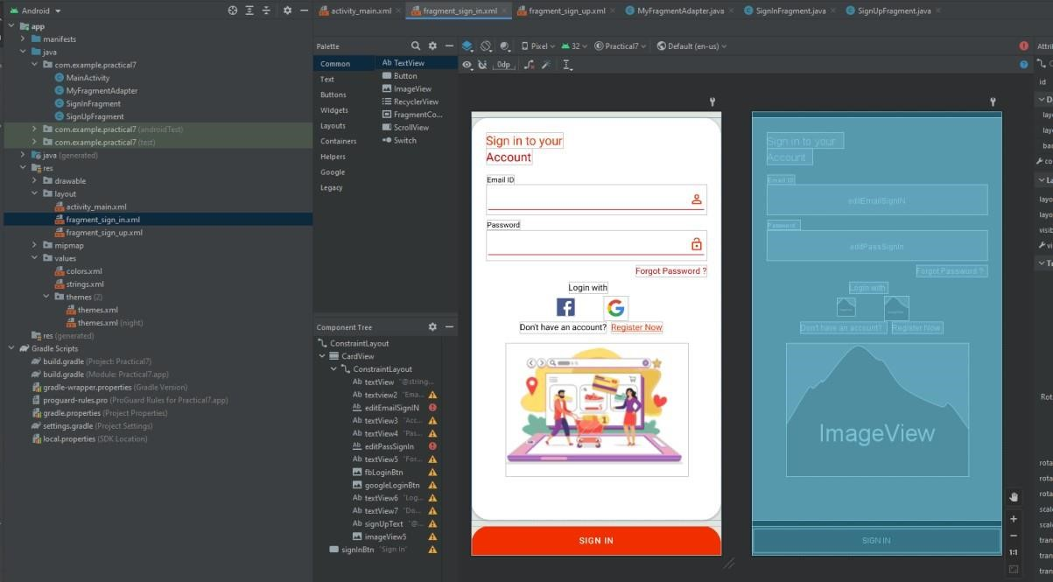

**fragment_sign_up.xml**

<?xml version="1.0" encoding="utf-8"?>

<androidx.constraintlayout.widget.ConstraintLayout xmlns:android="http://schemas.android.com/apk/res/android" xmlns:app="http://schemas.android.com/apk/res-auto" xmlns:tools="http://schemas.android.com/tools" android:layout_width="match_parent" android:layout_height="match_parent" android:background="#E2E5DE" tools:context=".SignInFragment">

<androidx.cardview.widget.CardView android:layout_width="match_parent" android:layout_height="0dp" android:layout_marginVertical="10dp" app:cardCornerRadius="30dp"

app:layout_constraintBottom_toTopOf="@+id/signUpBtn"

app:layout_constraintTop_toTopOf="parent">

<androidx.constraintlayout.widget.ConstraintLayout android:layout_width="match_parent" android:layout_height="match_parent"> <TextView android:id="@+id/textView" android:layout_width="wrap_content" android:layout_height="wrap_content" android:layout_marginStart="24dp" android:layout_marginTop="24dp" android:text="Create an" android:textColor="@color/red" android:textSize="20sp" app:layout_constraintStart_toStartOf="parent" app:layout_constraintTop_toTopOf="parent" />

<TextView

android:id="@+id/textview2" android:layout_width="wrap_content" android:layout_height="wrap_content" android:layout_marginStart="26dp" android:layout_marginTop="16dp" android:text="Name" android:textColor="@color/black" android:textSize="12sp" app:layout_constraintStart_toStartOf="parent" app:layout_constraintTop_toBottomOf="@+id/textView3" />

<EditText android:id="@+id/editNameSignUp" android:layout_width="0dp" android:layout_height="50dp" android:layout_marginStart="24dp" android:layout_marginEnd="24dp" android:backgroundTint="@color/dark_red" android:drawableRight="@drawable/ic_baseline_person" android:ems="10"

android:inputType="textEmailAddress"

android:textColor="#8c8c8c" app:layout_constraintEnd_toEndOf="parent" app:layout_constraintHorizontal_bias="0.0" app:layout_constraintStart_toStartOf="parent" app:layout_constraintTop_toBottomOf="@+id/textview2" />

<TextView android:id="@+id/textView3" android:layout_width="wrap_content"

android:layout_height="wrap_content"

android:layout_marginStart="24dp" android:text="Account" android:textColor="@color/dark_red" android:textSize="20sp" app:layout_constraintStart_toStartOf="parent" app:layout_constraintTop_toBottomOf="@+id/textView" />

<TextView android:id="@+id/textView4" android:layout_width="wrap_content" android:layout_height="wrap_content" android:layout_marginStart="26dp" android:layout_marginTop="8dp" android:text="Email ID" android:textColor="@color/black" android:textSize="12sp" app:layout_constraintStart_toStartOf="parent"

app:layout_constraintTop_toBottomOf="@+id/editNameSignUp" />

<EditText

android:id="@+id/editEmailSignUp"

android:layout_width="0dp" android:layout_height="50dp" android:layout_marginStart="24dp" android:layout_marginEnd="24dp" android:backgroundTint="@color/dark_red" android:drawableRight="@drawable/ic_baseline_email_24" android:ems="10" android:inputType="textEmailAddress"

android:textColor="#8c8c8c"

app:layout_constraintEnd_toEndOf="parent" app:layout_constraintHorizontal_bias="0.0" app:layout_constraintStart_toStartOf="parent" app:layout_constraintTop_toBottomOf="@+id/textView4" />

<TextView android:id="@+id/textView7" android:layout_width="wrap_content" android:layout_height="wrap_content" android:layout_marginStart="68dp" android:layout_marginTop="12dp" android:text="Already have an account ?" android:textColor="@color/black" app:layout_constraintStart_toStartOf="parent" app:layout_constraintTop_toBottomOf="@+id/checkBox" />

<TextView android:id="@+id/signInText" android:layout_width="wrap_content" android:layout_height="wrap_content" android:layout_marginStart="8dp" android:text="Sign in

!" android:textColor="@color/dark_red" app:layout_constraintStart_toEndOf="@+id/textView7" app:layout_constraintTop_toTopOf="@+id/textView7" />

<EditText

android:id="@+id/editNumberSignUp" android:layout_width="0dp"

android:layout_height="50dp"

android:layout_marginStart="24dp" android:layout_marginEnd="24dp" android:backgroundTint="@color/dark_red" android:drawableRight="@drawable/ic_baseline_call_24" android:ems="10" android:inputType="number" android:textColor="#8c8c8c" app:layout_constraintEnd_toEndOf="parent" app:layout_constraintHorizontal_bias="0.5" app:layout_constraintStart_toStartOf="parent" app:layout_constraintTop_toBottomOf="@+id/textView9" />

<TextView android:id="@+id/textView9" android:layout_width="wrap_content" android:layout_height="wrap_content" android:layout_marginStart="24dp" android:layout_marginTop="8dp" android:text="Contact no"

android:textColor="@color/black"

android:textSize="12sp"

app:layout_constraintStart_toStartOf="parent"

app:layout_constraintTop_toBottomOf="@+id/editEmailSignUp" /> <EditText

android:id="@+id/editPassSignUp" android:layout_width="0dp"

android:layout_height="50dp"

android:layout_marginStart="24dp" android:layout_marginEnd="24dp" android:backgroundTint="@color/dark_red"

android:drawableRight="@drawable/ic_baseline_lock_open"

android:ems="10"

android:inputType="textPassword" android:textColor="#8c8c8c" app:layout_constraintEnd_toEndOf="parent" app:layout_constraintHorizontal_bias="0.5" app:layout_constraintStart_toStartOf="parent" app:layout_constraintTop_toBottomOf="@+id/textvieww" />

<TextView

android:id="@+id/textvieww" android:layout_width="wrap_content" android:layout_height="wrap_content" android:layout_marginStart="24dp" android:layout_marginTop="8dp" android:text="Password" android:textColor="@color/black" android:textSize="12sp"

app:layout_constraintStart_toStartOf="parent"

app:layout_constraintTop_toBottomOf="@+id/editNumberSignUp" />

<CheckBox

android:id="@+id/checkBox"

android:layout_width="wrap_content" android:layout_height="wrap_content"

android:layout_marginStart="24dp"

android:layout_marginTop="16dp" android:text="Accept terms and conditions" android:textColor="@color/dark_red" app:layout_constraintStart_toStartOf="parent" app:layout_constraintTop_toBottomOf="@+id/editPassSignUp" />

<ImageView android:id="@+id/imageView9" android:layout_width="wrap_content" android:layout_height="wrap_content" android:src="@drawable/signin" app:layout_constraintEnd_toEndOf="parent" app:layout_constraintHorizontal_bias="0.5" app:layout_constraintStart_toStartOf="parent" app:layout_constraintTop_toBottomOf="@+id/textView7" />

<ProgressBar android:id="@+id/progressBar"

style="?android:attr/progressBarStyle" android:layout_width="wrap_content" android:layout_height="wrap_content" android:visibility="invisible"

app:layout_constraintBottom_toBottomOf="parent"

app:layout_constraintEnd_toEndOf="parent" app:layout_constraintHorizontal_bias="0.5" app:layout_constraintStart_toStartOf="parent" app:layout_constraintTop_toTopOf="parent" />

</androidx.constraintlayout.widget.ConstraintLayout>

</androidx.cardview.widget.CardView>

<Button android:id="@+id/signUpBtn" android:layout_width="0dp" android:layout_height="wrap_content" android:background="@drawable/btn_background" android:text="Sign up" app:layout_constraintBottom_toBottomOf="parent" app:layout_constraintEnd_toEndOf="parent" app:layout_constraintHorizontal_bias="0.5" app:layout_constraintStart_toStartOf="parent" />

</androidx.constraintlayout.widget.ConstraintLayout>

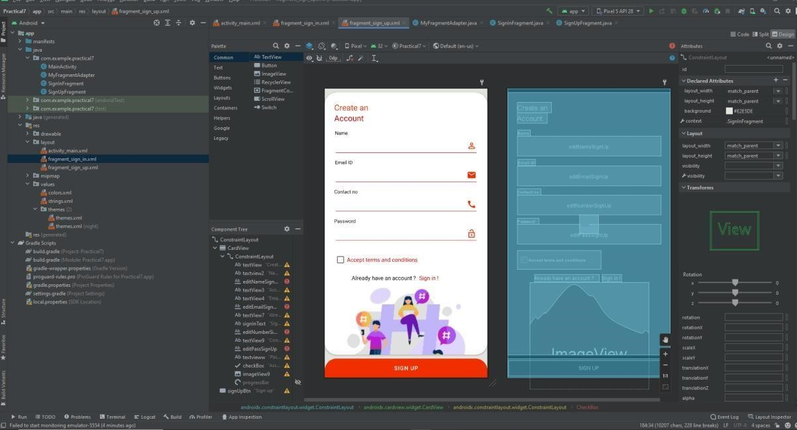

## **SignUpFragment.java**

package com.example.practical7;

import android.os.Bundle;

import androidx.fragment.app.Fragment;

import android.view.LayoutInflater;

import android.view.View; import android.view.ViewGroup;

/**

* A simple {@link Fragment} subclass.
* Use the {@link SignUpFragment#newInstance} factory method to * create an instance of this fragment.

*/

public class SignUpFragment extends Fragment {

// TODO: Rename parameter arguments, choose names that match // the fragment initialization parameters, e.g. ARG_ITEM_NUMBER private static final String ARG_PARAM1 = "param1"; private static final String ARG_PARAM2 = "param2";

// TODO: Rename and change types of parameters private String mParam1; private String mParam2;

public SignUpFragment() {

// Required empty public constructor

}

/**

* Use this factory method to create a new instance of * this fragment using the provided parameters.

*

* @param param1 Parameter 1.
* @param param2 Parameter 2.
* @return A new instance of fragment SignUpFragment.

*/

// TODO: Rename and change types and number of parameters public static SignUpFragment newInstance(String param1, String param2) {

SignUpFragment fragment = new SignUpFragment(); Bundle args = new Bundle(); args.putString(ARG_PARAM1, param1); args.putString(ARG_PARAM2, param2); fragment.setArguments(args); return fragment;

}

@Override public void onCreate(Bundle savedInstanceState) {

super.onCreate(savedInstanceState); if (getArguments() != null) { mParam1 = getArguments().getString(ARG_PARAM1); mParam2 = getArguments().getString(ARG_PARAM2);

}

}

@Override

public View onCreateView(LayoutInflater inflater, ViewGroup container,

Bundle savedInstanceState) { // Inflate the layout for this fragment return

inflater.inflate(R.layout.fragment_sign_up, container, false); }

}

## **SignInFragment.java**

package com.example.practical7;

import android.os.Bundle;

import androidx.fragment.app.Fragment;

import android.view.LayoutInflater;

import android.view.View; import android.view.ViewGroup;

/**

* A simple {@link Fragment} subclass.
* Use the {@link SignInFragment#newInstance} factory method to * create an instance of this fragment.

*/

public class SignInFragment extends Fragment {

// TODO: Rename parameter arguments, choose names that match // the fragment initialization parameters, e.g. ARG_ITEM_NUMBER private static final String ARG_PARAM1 = "param1"; private static final String ARG_PARAM2 = "param2";

// TODO: Rename and change types of parameters private String mParam1; private String mParam2;

public SignInFragment() {

// Required empty public constructor

}

/**

* Use this factory method to create a new instance of * this fragment using the provided parameters.

*

* @param param1 Parameter 1.
* @param param2 Parameter 2.
* @return A new instance of fragment SignInFragment.

*/

// TODO: Rename and change types and number of parameters public static SignInFragment newInstance(String param1, String param2) {

SignInFragment fragment = new SignInFragment(); Bundle args = new Bundle(); args.putString(ARG_PARAM1, param1); args.putString(ARG_PARAM2, param2); fragment.setArguments(args); return fragment;

}

@Override public void onCreate(Bundle savedInstanceState) {

super.onCreate(savedInstanceState); if

(getArguments() != null) { mParam1 = getArguments().getString(ARG_PARAM1); mParam2 = getArguments().getString(ARG_PARAM2);

}

}

@Override

public View onCreateView(LayoutInflater inflater, ViewGroup container,

Bundle savedInstanceState) {

// Inflate the layout for this fragment return inflater.inflate(R.layout.fragment_sign_in, container, false);

}

}

## **MyFragmnetAdapter.java**

package com.example.practical7;

import androidx.annotation.NonNull; import androidx.fragment.app.Fragment; import androidx.fragment.app.FragmentManager; import androidx.lifecycle.Lifecycle;

import androidx.viewpager2.adapter.FragmentStateAdapter;

public class MyFragmentAdapter extends FragmentStateAdapter {

public MyFragmentAdapter(@NonNull FragmentManager fragmentManager, @NonNull Lifecycle lifecycle) { super(fragmentManager, lifecycle);

}

@NonNull @Override public Fragment createFragment(int position) {

if (position == 1){

return new SignUpFragment();

}

return new SignInFragment();

}

@Override public int getItemCount() { return

2;

}

}

**MainActivity.java**

package com.example.practical7;

import androidx.appcompat.app.AppCompatActivity;

import androidx.fragment.app.FragmentManager; import androidx.viewpager2.widget.ViewPager2;

import android.os.Bundle;

import com.google.android.material.tabs.TabLayout;

public class MainActivity extends AppCompatActivity {

private TabLayout tabLayout; private ViewPager2 viewPager2; private MyFragmentAdapter adapter;

@Override protected void onCreate(Bundle savedInstanceState) { super.onCreate(savedInstanceState); setContentView(R.layout.activity_main);

tabLayout = findViewById(R.id.tabLayout);

viewPager2 = findViewById(R.id.viewPager2);

tabLayout.addTab(tabLayout.newTab().setText("Sign In"));

tabLayout.addTab(tabLayout.newTab().setText("Sign Up"));

FragmentManager fragmentManager = getSupportFragmentManager(); adapter = new MyFragmentAdapter(fragmentManager , getLifecycle()); viewPager2.setAdapter(adapter);

tabLayout.addOnTabSelectedListener(new TabLayout.OnTabSelectedListener() { @Override public void onTabSelected(TabLayout.Tab tab) { viewPager2.setCurrentItem(tab.getPosition());

}

@Override public void

onTabUnselected(TabLayout.Tab tab) {

}

@Override public void onTabReselected(TabLayout.Tab tab) {

}

});

viewPager2.registerOnPageChangeCallback(new ViewPager2.OnPageChangeCallback()

{

@Override public void onPageSelected(int position) {

tabLayout.selectTab(tabLayout.getTabAt(position));

}

});

}

}

**Output:**

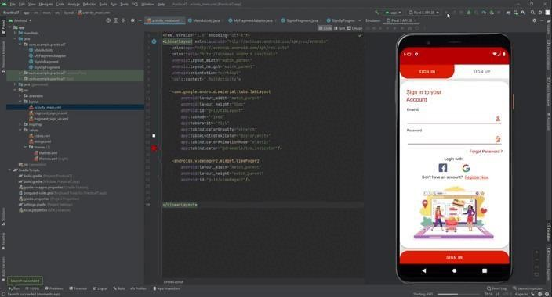

**Conclusion:**  Thus we have created an android app that demonstrates screen navigation using the app bar and tabs

# Practical No – 8

## **Aim:** Create an android app to Connect to the Internet and use BroadcastReceiver

**Theory:** Broadcast receiver is a medium through which communication is done with the registered app and the outside OS system. We needs to register and unregister this functionality according to our requirement. At first we have to register each broadcast receiver to get appropriate notification during desired situations. Broadcast receiver receives notification for a small span of time so we can’t do any kind of long running process over here and we need to unregister the same when app goes to background specifically when app is going to pause mode.

It is very easy method to check all the time internet connectivity through Broadcast receiver. It will notify at any point of time when network connection is discontinued or network status changed.

Following is the pictorial representation of app to Connect to the Internet and use

BroadcastReceiver

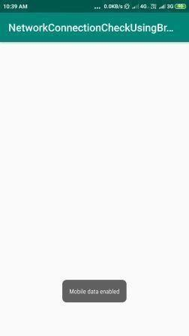

**activity_main.xml:**

<?xml version="1.0" encoding="utf-8"?>

<androidx.constraintlayout.widget.ConstraintLayout xmlns:android="http://schemas.android.com/apk/res/android" xmlns:app="http://schemas.android.com/apk/res-auto" xmlns:tools="http://schemas.android.com/tools" android:layout_width="match_parent" android:layout_height="match_parent" tools:context=".MainActivity">

<TextView android:layout_width="wrap_content"

android:layout_height="wrap_content" android:text="Broadcast Receiver by checking internet connection" app:layout_constraintBottom_toBottomOf="parent" app:layout_constraintLeft_toLeftOf="parent" app:layout_constraintRight_toRightOf="parent" app:layout_constraintTop_toTopOf="parent" />

</androidx.constraintlayout.widget.ConstraintLayout>

**MainActivity.java:**

package com.example.internet;

import androidx.appcompat.app.AppCompatActivity;

import android.content.BroadcastReceiver; import android.content.IntentFilter; import android.net.ConnectivityManager; import android.os.Bundle;

public class MainActivity extends AppCompatActivity {

BroadcastReceiver broadcastReceiver = null; @Override protected void onCreate(Bundle savedInstanceState) { super.onCreate(savedInstanceState); setContentView(R.layout.activity_main);

broadcastReceiver = new InternetReceiver();

Internetstatus();

}

public void Internetstatus(){ registerReceiver(broadcastReceiver,new IntentFilter(ConnectivityManager.CONNECTIVITY_ACTION));

}

@Override protected void onPause() { super.onPause();

unregisterReceiver(broadcastReceiver);

}

}

**CheckInternet.java:**

package com.example.internet;

import android.content.Context; import android.net.ConnectivityManager; import android.net.NetworkInfo;

public class CheckInternet {

public static String getNetworkInfo(Context context){

String status = null;

ConnectivityManager connectivityManager = (ConnectivityManager) context.getSystemService(Context.CONNECTIVITY_SERVICE);

NetworkInfo networkInfo = connectivityManager.getActiveNetworkInfo(); if (networkInfo!=null){ status = "connected"; return status;

} else {

status = "disconnected"; return status;

}

}

}

**InternetReceiver.java:**

package com.example.internet;

import android.content.BroadcastReceiver; import android.content.Context; import

android.content.Intent; import android.widget.Toast;

public class InternetReceiver extends BroadcastReceiver {

@Override

public void onReceive(Context context, Intent intent) {

String status = CheckInternet.getNetworkInfo(context); if

(status.equals("connected")){

Toast.makeText(context, "Internet is Connected",Toast.LENGTH_LONG).show();

}

else if (status.equals("disconnected")){

Toast.makeText(context, " Internet is not connected",Toast.LENGTH_LONG).show();

}

}

}

**Output:**

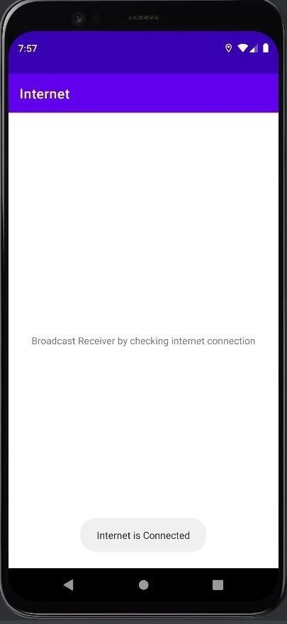

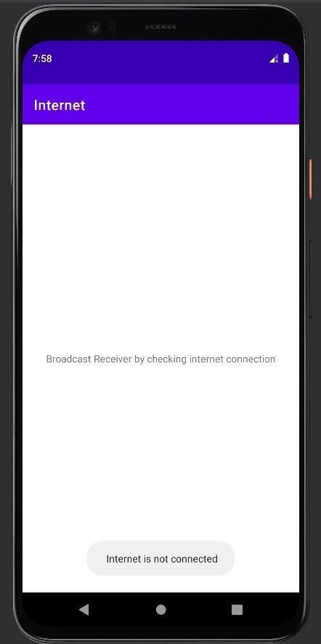

**Conclusion:** Thus we have created an android app to Connect to the Internet and use BroadcastReceiver Practical No – 9

## **Aim:** Create an android app to show Notifications and Alarm manager

**Theory:** By the help of Android AlarmManager in android, you can schedule your application to run at a specific time in the future. It works whether your phone is running or not.

The Android AlarmManager holds a CPU wake lock that provides guarantee not to sleep the phone until broadcast is handled.

Following is the pictorial image of an android app to show Notifications and

Alarm manager

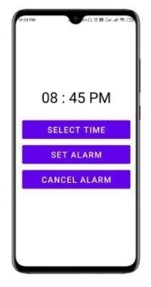

**activity_main.xml:**

<?xml version="1.0" encoding="utf-8"?>

<LinearLayout xmlns:android="http://schemas.android.com/apk/res/android" xmlns:app="http://schemas.android.com/apk/res-auto" xmlns:tools="http://schemas.android.com/tools" android:layout_width="match_parent" android:layout_height="match_parent" android:orientation="vertical" tools:context=".MainActivity">

<TextView android:layout_width="match_parent"

android:layout_height="wrap_content"

android:id="@+id/selectedTime" android:layout_marginTop="200dp" android:text="08

: 45 PM" android:textAlignment="center"

android:textColor="@color/black" android:textSize="46dp"/>

<Button android:id="@+id/selectTimeBtn" android:layout_width="match_parent" android:layout_height="70dp" android:layout_marginTop="36dp" android:layout_marginHorizontal="26dp" android:text="Select Time" android:textSize="26dp"/>

<Button android:id="@+id/setAlarmBtn" android:layout_width="match_parent" android:layout_height="70dp" android:layout_marginTop="8dp" android:layout_marginHorizontal="26dp" android:text="Set Alarm" android:textSize="26dp"/>

<Button

android:id="@+id/cancelAlarmBtn" android:layout_width="match_parent" android:layout_height="70dp" android:layout_marginTop="8dp" android:layout_marginHorizontal="26dp" android:text="Cancel Alarm" android:textSize="26dp"/>

</LinearLayout>

**activity_destination.xml:**

<androidx.constraintlayout.widget.ConstraintLayout xmlns:android="http://schemas.android.com/apk/res/android" android:layout_width="match_parent" android:layout_height="match_parent">

</androidx.constraintlayout.widget.ConstraintLayout>

**DestinationActivity.java:**

package com.example.alarmmanager;

import androidx.appcompat.app.AppCompatActivity;

import android.os.Bundle;

public class DestinationActivity extends AppCompatActivity {

@Override protected void onCreate(Bundle savedInstanceState) {

super.onCreate(savedInstanceState); setContentView(R.layout.activity_destination);

}

}

**AlarmReceiver.java:**

package com.example.alarmmanager;

import android.app.PendingIntent; import android.content.BroadcastReceiver; import android.content.Context; import

android.content.Intent;

import androidx.core.app.NotificationCompat; import androidx.core.app.NotificationManagerCompat; public class AlarmReceiver extends BroadcastReceiver {

@Override public void onReceive(Context context,

Intent intent) {

|  |  |
| --- | --- |
| Intent i = new Intent(context,DestinationActivity.class); |  |
| intent.setFlags(Intent.FLAG_ACTIVITY_NEW_TASK Intent.FLAG_ACTIVITY_CLEAR_TASK);  PendingIntent pendingIntent = PendingIntent.getActivity(context,0,i,0); | | |
| NotificationCompat.Builder builder =  NotificationCompat.Builder(context,"sumitsingh")  .setSmallIcon(R.drawable.ic_launcher_background)  .setContentTitle("Alarm Manager")  .setContentText("Your alarm has started")  .setStyle(new NotificationCompat.BigTextStyle()  .bigText("Your Alarm has started"))  .setAutoCancel(true)  .setDefaults(NotificationCompat.DEFAULT_ALL)  .setPriority(NotificationCompat.PRIORITY_HIGH) .setContentIntent(pendingIntent); | new |
| NotificationManagerCompat notificationManagerCompat  NotificationManagerCompat.from(context); | = |

notificationManagerCompat.notify(123,builder.build());

} }

**MainActivity.java:**

package com.example.alarmmanager;

import androidx.appcompat.app.AppCompatActivity;

import android.app.AlarmManager; import android.app.NotificationChannel;

import android.app.NotificationManager; import android.app.PendingIntent; import android.content.Context; import android.content.Intent; import android.os.Build; import android.os.Bundle; import android.view.View; import android.widget.Toast;

import com.example.alarmmanager.databinding.ActivityMainBinding; import com.google.android.material.timepicker.MaterialTimePicker; import

com.google.android.material.timepicker.TimeFormat;

import java.util.Calendar;

public class MainActivity extends AppCompatActivity {

private ActivityMainBinding binding; private MaterialTimePicker picker;

private Calendar calendar; private

AlarmManager alarmManager; private

PendingIntent pendingIntent;

@Override protected void onCreate(Bundle savedInstanceState) {

super.onCreate(savedInstanceState); binding = ActivityMainBinding.inflate(getLayoutInflater()); setContentView(binding.getRoot()); createNotificationChannel();

binding.selectTimeBtn.setOnClickListener(new View.OnClickListener() { @Override public void onClick(View v) {

showTimePicker();

}

});

binding.setAlarmBtn.setOnClickListener(new View.OnClickListener() {

@Override public void onClick(View v) {

setAlarm();

}

});

binding.cancelAlarmBtn.setOnClickListener(new View.OnClickListener() { @Override public void onClick(View v) {

cancelAlarm();

}

});

}

private void cancelAlarm() {

Intent intent = new Intent(this,AlarmReceiver.class);

pendingIntent = PendingIntent.getBroadcast(this,0,intent,0);

if (alarmManager == null){

alarmManager = (AlarmManager) getSystemService(Context.ALARM_SERVICE);

}

alarmManager.cancel(pendingIntent);

Toast.makeText(this, "Alarm Cancelled", Toast.LENGTH_SHORT).show();

}

private void setAlarm() { alarmManager = (AlarmManager)

getSystemService(Context.ALARM_SERVICE);

Intent intent = new Intent(this,AlarmReceiver.class);

pendingIntent = PendingIntent.getBroadcast(this,0,intent,0);

alarmManager.setRepeating(AlarmManager.RTC_WAKEUP,calendar.getTimeInMillis(), AlarmManager.INTERVAL_DAY,pendingIntent);

Toast.makeText(this, "Alarm set Successfully", Toast.LENGTH_SHORT).show();

}

private void showTimePicker() {

picker = new MaterialTimePicker.Builder()

.setTimeFormat(TimeFormat.CLOCK_12H)

.setHour(12)

.setMinute(0)

.setTitleText("Select Alarm Time")

.build();

picker.show(getSupportFragmentManager(),"sumitsingh"); picker.addOnPositiveButtonClickListener(new View.OnClickListener() {

@Override public void onClick(View v) {

if (picker.getHour() > 12){

binding.selectedTime.setText(

String.format("%02d",(picker.getHour()-12))+" :

"+String.format("%02d",picker.getMinute())+" PM"

);

}else {

binding.selectedTime.setText(picker.getHour()+" : " + picker.getMinute() + " AM");

}

calendar = Calendar.getInstance();

calendar.set(Calendar.HOUR_OF_DAY,picker.getHour());

calendar.set(Calendar.MINUTE,picker.getMinute());

calendar.set(Calendar.SECOND,0); calendar.set(Calendar.MILLISECOND,0);

}

});

}

|  |  |  |
| --- | --- | --- |
| private void createNotificationChannel() { if  (Build.VERSION.SDK_INT >= Build.VERSION_CODES.O){ |  |  |
| CharSequence name = "alarmReminderChannel"; String description = "Channel For Alarm Manager"; int importance = NotificationManager.IMPORTANCE_HIGH; |  |  |
| NotificationChannel channel  NotificationChannel("sumitsingh",name,importance); channel.setDescription(description); | = | new |
| NotificationManager notificationManager getSystemService(NotificationManager.class); notificationManager.createNotificationChannel(channel); |  | = |

}

} }

**Output:**

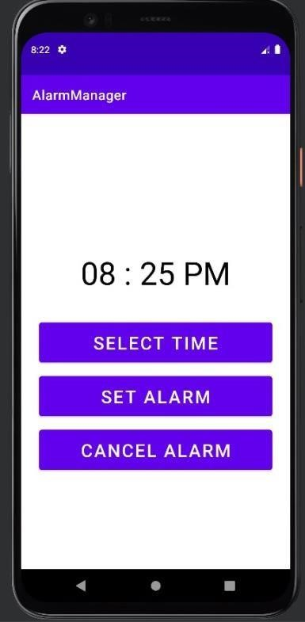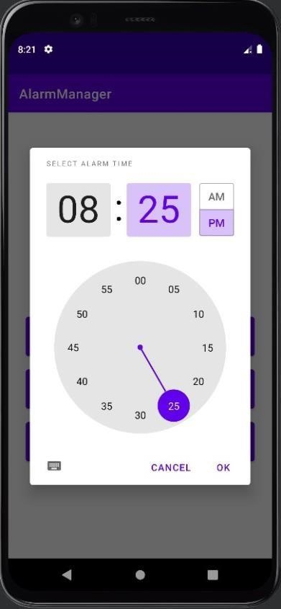

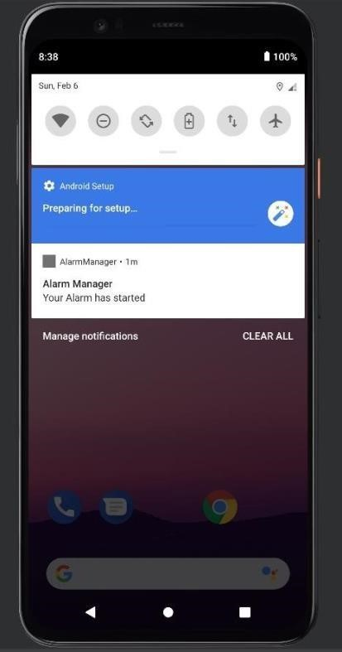

## **Conclusion:** Thus we have created an android app to show Notifications and Alarm manager