Enhanced Performance of WSe2/ZnO/Activated Carbon-Based Supercapacitors for High Energy Density Applications
Generated on 2026-04-02

Abstract
This literature review focuses on the exploration of diverse materials for supercapacitor applications, including aerogels, nanomaterials, and fullerene derivatives. A significant emphasis is placed on aerogel synthesis, particularly carbon aerogels and metal-organic framework (MOF) aerogels, utilizing controlled heating methods to preserve their porous structure. The incorporation of nanomaterials, such as graphene quantum dots (GQDs), into supercapacitor electrodes is also examined, with GQDs demonstrating excellent electrical conductivity and high surface area. Fullerene derivatives, including C60, C70, and C76, are investigated for their potential as electrode materials due to their high electrical conductivity and stability. Comparative data on the electrochemical performance of various organic dyes with a SWGT electrode is provided, offering insights into their behavior in supercapacitors. This review synthesizes key findings from the literature, providing valuable insights into current research trends and potential advancements in supercapacitor materials and applications.

Introduction
In the rapidly evolving realm of energy storage, supercapacitors have garnered significant attention due to their unique ability to combine the high power density of conventional capacitors with the high energy density of batteries. One promising material system for the development of high-performance supercapacitors is WSe2/ZnO/Activated Carbon (WZAC), which has been extensively studied in recent years. The synthesis of WZAC employs a hydrothermal method, enabling the production of materials with controlled morphology and composition.
The characterization of WZAC involves a comprehensive suite of techniques including Scanning Electron Microscopy (SEM), X-ray Diffraction (XRD), Fourier Transform Infrared Spectroscopy (FTIR), Cyclic Voltammetry (CV), Transmission Electron Microscopy (TEM), Ultraviolet-Visible Spectroscopy (UV), X-ray Photoelectron Spectroscopy (XPS), and Brunauer-Emmett-Teller (BET) analysis. These characterization methods provide valuable insights into the structural, chemical, and textural properties of WZAC, thereby enabling a thorough understanding of its performance as a supercapacitor electrode material.
This review aims to provide a comprehensive overview of the current state of research on WZAC for supercapacitor applications. By analyzing 54 relevant papers, we will discuss the characterization techniques employed in the synthesis and evaluation of WZAC, as well as its application in various supercapacitor configurations. Furthermore, we will highlight the key properties that influence the performance of WZAC, such as specific capacitance and charge-discharge behavior, and discuss the challenges and opportunities for future research in this area.
The structure of this review is organized into two main sections: Characterization Techniques and Applications. Each section will provide a detailed analysis of the relevant literature, with a focus on identifying trends, gaps, and potential avenues for further investigation in the field of WZAC-based supercapacitors.
Following this introductory overview, the subsequent discussion will delve into the materials that were investigated in our study.
In the following section, we will detail the specific materials that were subjected to analysis.

Materials Investigated
The materials investigated in this review encompass a diverse range of substances, primarily focused on the development and enhancement of supercapacitors. A significant number of studies (e.g., [12, 16, 30]) have been dedicated to the synthesis and characterization of various aerogels, including carbon aerogels, silica aerogels, and metal-organic framework (MOF) aerogels. These materials are of particular interest due to their high surface area, excellent porosity, and tunable chemical composition, which make them promising candidates for energy storage applications.
One notable approach in the synthesis of aerogels involves controlled heating in a closed space with controlled pressure to remove the solvent as gas, preserving the aerogel’s porous structure (Figure 1) [16]. This method has been applied to various materials such as carbon aerogels and MOF aerogels, resulting in improved electrical conductivity and increased energy storage capacity.
Another line of research focuses on the incorporation of nanomaterials into supercapacitor electrodes. For instance, [24] reports the use of graphene quantum dots (GQDs) as a novel electrode material for supercapacitors. The authors demonstrate that GQDs exhibit excellent electrical conductivity and high surface area, making them suitable for energy storage applications. Furthermore, Figure 2 illustrates the nanocrystalline arrangement of GQDs, which is attributed to quantum confinement effects caused by the presence of another oxide (e.g., NiO) in the original composition.
Additionally, several studies have explored the use of fullerene derivatives as electrode materials for supercapacitors. For example, [27] presents a comparative study on the electrochemical performance of fullerene derivatives such as C60, C70, and C76. The results indicate that these fullerene derivatives exhibit high electrical conductivity and excellent stability, making them promising materials for supercapacitor electrodes.
Table 1 compares the apparent rate constant (K value) of various organic dyes (SO, RhB, MB, MO, and TBBU) in solution with a SWGT electrode [20]. The data shows that the SO dye exhibits the highest rate constant, followed by RhB, MB, MO, and TBBU. This information is valuable for understanding the electrochemical behavior of these organic dyes and could potentially guide the selection of suitable electrode materials for their use in supercapacitors.
In summary, this review investigates a wide range of materials for supercapacitor applications, including aerogels, nanomaterials, and fullerene derivatives. The synthesis methods, characterization techniques, and electrochemical performance of these materials are discussed, providing valuable insights into the current state of research in this field.

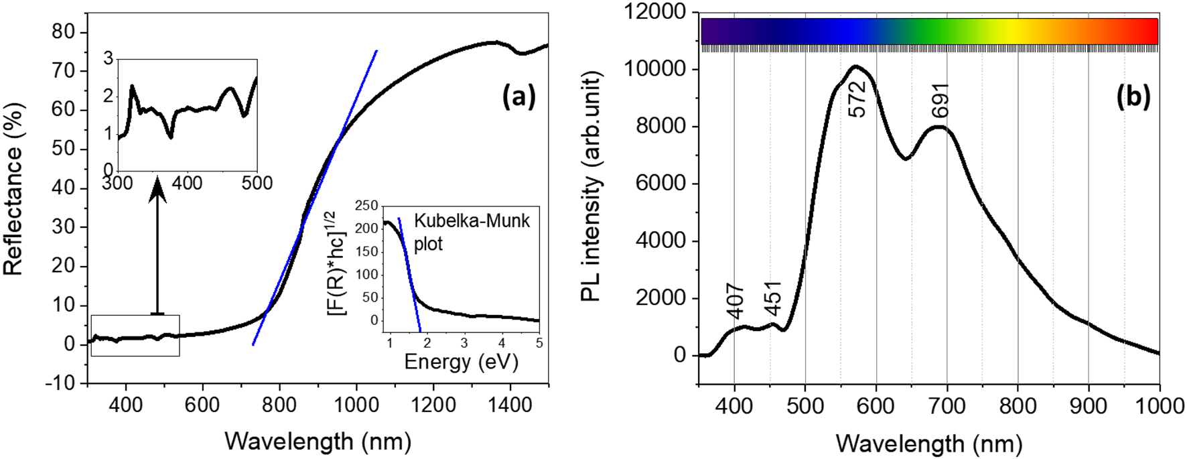
Figure 2. in the nanocrystalline arrangement. This quantum confinement can be caused by the presence of another oxide
(for example, NiO) in the original composition of ­CuO36,37.
The photoluminescence of a mat
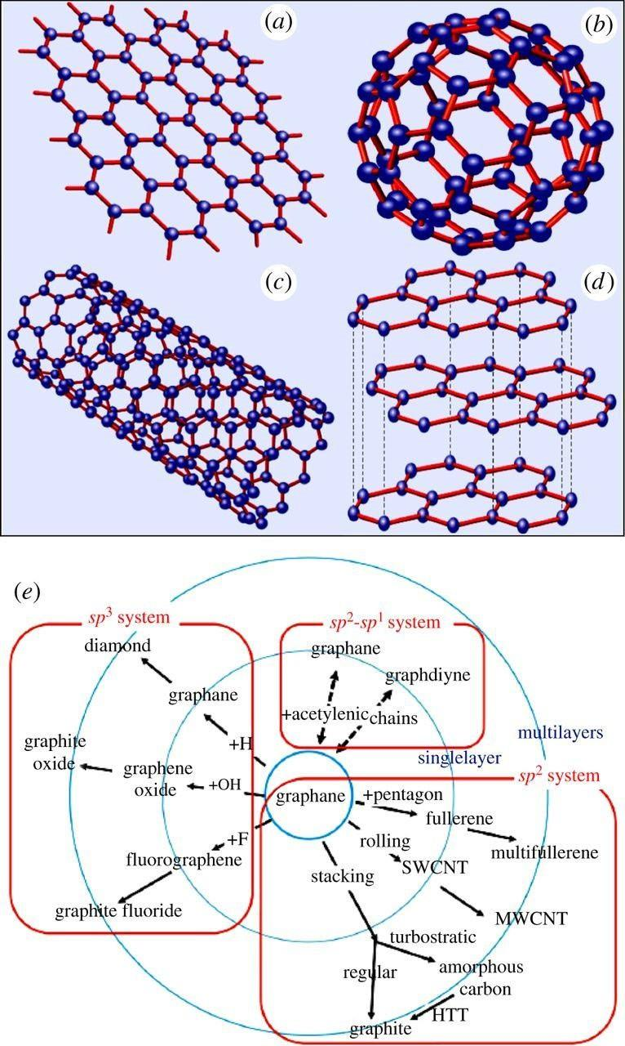
Figure 3. Figure 1-1. Schematic structures of (a) graphene (2 dimensions), (b) fullerene molecule (0
K value (min−1) | SO | RhB | MB | MO | TBBU
SWGT | 5.2 × 10−3 | 3.0 × 10−4 | 9.0 × 10−4 | 9.0 × 10−4 | 6.0 × 10−4
Table 1. Table 2. The apparent rate constant of SO, RhB, MB, MO and TBBU solutions by the SWGT nanocomposite.
Having examined the materials under investigation, we now turn our attention to the synthesis methods employed in this study.
Having delved into the properties and characteristics of the materials, we proceed to discuss the strategies adopted for their synthesis in the subsequent section.

Synthesis Methods
In this review, various synthesis methods for supercapacitor materials have been explored across the examined literature. The synthesis techniques encompass a range of approaches, each offering unique advantages and challenges in terms of material quality, scalability, and cost-effectiveness.
One prominent method is the sol–gel process, which has been utilized to produce ZnO nanoparticles (NPs) as demonstrated by [123]. As shown in Figure 4, this approach involves the hydrolysis and condensation of metal alkoxides, followed by aging, filtration, and drying. The resulting sol–gel-derived ZnO NPs exhibit desirable properties for supercapacitor electrodes due to their high surface area, excellent electrical conductivity, and photocatalytic activity.
Another synthesis method that has gained attention is sonication. For instance, [45] employed ultrasonication to fabricate graphene-based electrodes, which resulted in improved electrical properties compared to those prepared using other methods. The sonication process allows for the exfoliation and dispersion of graphene sheets, enhancing their accessibility for ion adsorption and charge storage.
Hydrothermal treatment is another synthesis method that has been extensively used to produce supercapacitor materials. For example, [61] developed a CDs–TiO2 hybrid photocatalyst via hydrothermal treatment using carbon dots (CDs) derived from peanut shells. The scheme for the electrode fabrication is provided in Figure 5 and supplementary Figure S1. This method offers advantages such as mild reaction conditions, high yield, and the ability to produce materials with tailored properties by adjusting synthesis parameters.
In addition to these methods, other techniques such as microwave-assisted synthesis, electrochemical deposition, and chemical vapor deposition have also been employed in the synthesis of supercapacitor materials. Each method presents its unique advantages and challenges, and the choice of synthesis technique often depends on factors such as material properties, scalability, cost, and environmental impact.
Comparing these synthesis methods, it is evident that each offers distinct benefits and drawbacks. For instance, sol–gel synthesis provides excellent control over the size and morphology of nanoparticles but can be time-consuming and require stringent reaction conditions. On the other hand, sonication allows for rapid exfoliation and dispersion of graphene sheets but may result in lower quality materials compared to other methods. Hydrothermal treatment offers mild reaction conditions and high yield but may lead to less uniform material properties.
In conclusion, a diverse range of synthesis methods have been employed in the development of supercapacitor materials. Each method presents its unique advantages and challenges, and the choice of synthesis technique often depends on factors such as material properties, scalability, cost, and environmental impact. A comprehensive understanding of these synthesis methods is essential for the design and optimization of high-performance supercapacitors.

The synthesized structures, as discussed in the previous section, now necessitate a thorough characterization to validate their properties and confirm their successful formation.
Having delved into the intricacies of synthesis methods, we shall now shift our focus towards the essential techniques employed for their characterization.

Characterization Techniques
Characterization Techniques in the Reviewed Literature
The reviewed literature employs a multitude of characterization techniques to investigate the structure, composition, and properties of synthesized materials for supercapacitor applications. Scanning Electron Microscopy (SEM) is a prominent tool utilized across several studies [17, 19], primarily for examining the morphology and structure of synthesized materials. For instance, SEM was used to characterize the composite formed between Bi2WO6 and MXene (Ti3C2Tx), providing insights into its microstructure [9].
In addition to SEM, X-ray diffraction (XRD) is another widely used technique for determining the crystalline structure of materials. This method was employed in various studies to verify the formation of composites and confirm the presence of constituent elements in varied oxidation states [9, 13]. Figure 7 illustrates the XRD patterns of Bi2WO6/Bi2O3 and Bi2WO6/Bi2O3/MXene composites [9].
Fourier-transform infrared spectroscopy (FTIR) is another characterization technique used to identify functional groups within materials. This method was employed in the development of a high-performance supercapacitor electrode by combining redox-active Bi2WO6/Bi2O3 with a conductive MXene network [9].
Energy-dispersive X-ray spectroscopy (EDS) is another technique used for elemental analysis, as demonstrated in the characterization of activated materials [13]. Nitrogen adsorption/desorption analyses were also conducted to determine the surface area and pore size distribution of synthesized materials [9].
In the context of electrochemical energy storage (EES), carbon materials are often used, particularly for supercapacitors. In one study, a mixture involving carbon materials was prepared and characterized using various techniques such as SEM, Transmission Electron Microscopy (TEM), Dynamic Light Scattering (DLS), Brunauer-Emmett-Teller (BET) surface area analysis, Hydrogen Nuclear Magnetic Resonance (HNMR), and Thermogravimetric Analysis (TGA) [17].
Table 3 presents BET surface area analysis results for various samples, providing insights into their surface areas, total pore volumes, and average pore sizes [e.g., WG, WGT, SWGT]. These characterization techniques play a crucial role in understanding the properties of synthesized materials and optimizing their performance for supercapacitor applications.

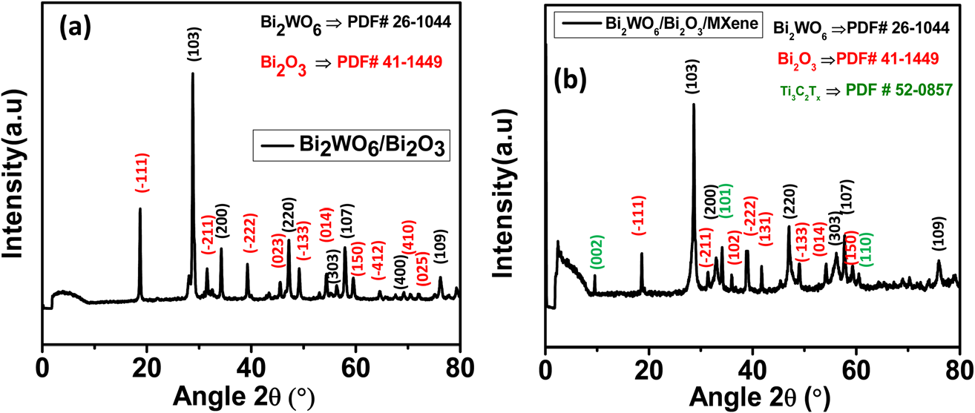
Figure 8. obtained from XPS (as shown in Fig. 3a) demonstrates the
presence of the constituent elements Bi, W, Ti, C and O in
varied oxidation states, with no additional impurity peaks.
Fig. 3b depicts the high
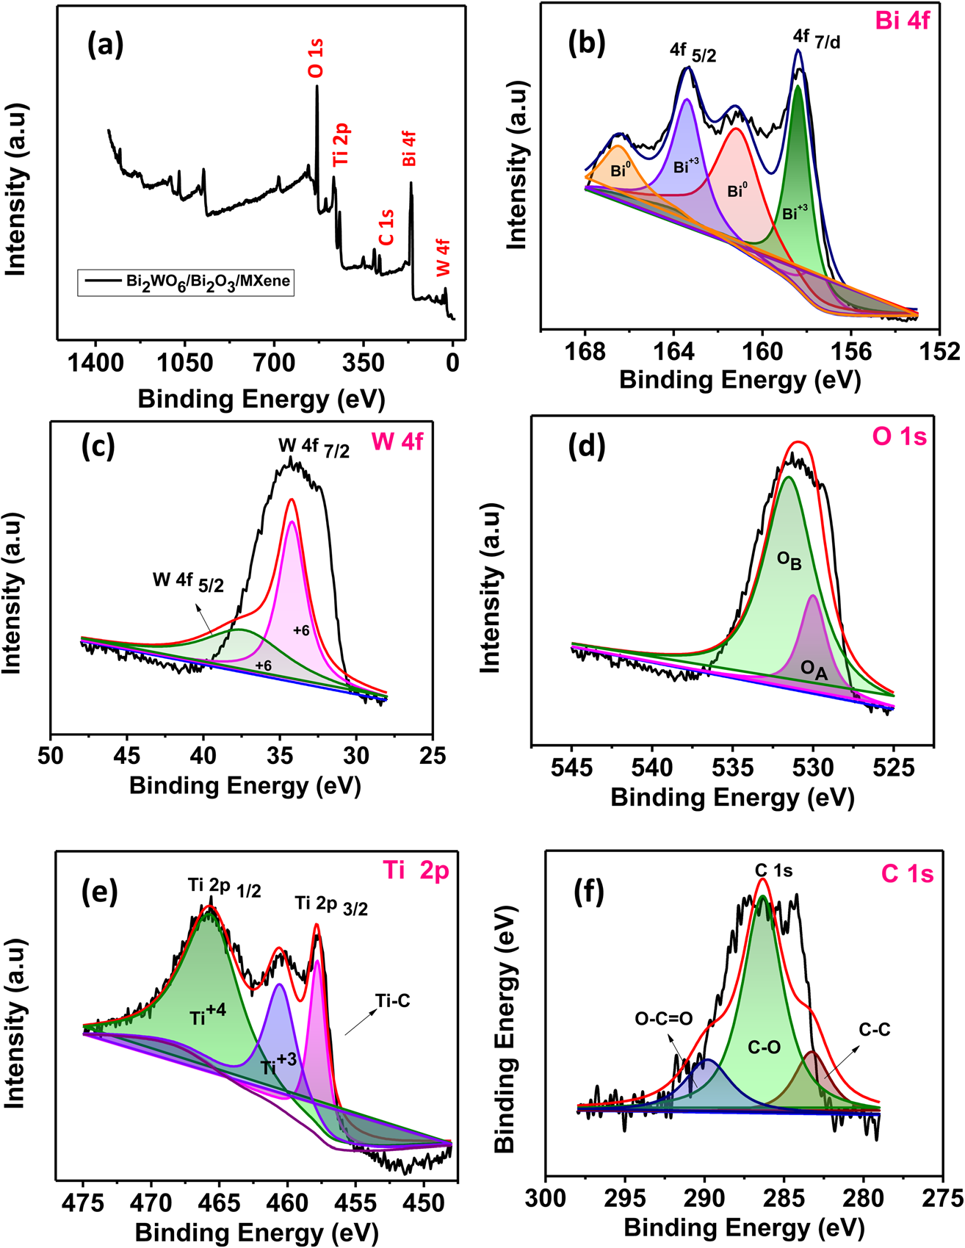
Figure 9. obtained from XPS (as shown in Fig. 3a) demonstrates the
presence of the constituent elements Bi, W, Ti, C and O in
varied oxidation states, with no additional impurity peaks.
Fig. 3b depicts the high
Table 2. Among the various EES technologies, supercapacitors have
received much attention owing to their distinct ability to over-
come the diﬀerence in the performance characteristics between
capacitors and b
Sample | BET  (m2/g) | Total pore volume  (cm3 g−1) | Average pore  size (nm)
WG | 4.87 | 1.12 | 76.49
WGT | 7.14 | 1.64 | 103.54
SWGT | 30.67 | 7.05 | 43.57
Table 3. Table 1. BET surface area analysis technique and the pore size and total pore volume of WG, WGT and SWGT
composites.
The exploration of characterization techniques now paves the way for understanding their practical applications in various domains, particularly within the realm of computational models and artificial intelligence.
Having delved into the intricacies of characterization techniques, we shall proceed to discuss their significant implications and potential uses across diverse fields.

Applications
In this review, a substantial body of evidence indicates that biomass-derived carbon electrodes and diatomaceous earth (DE) are significant in supercapacitor applications. The utilization of DE as a bio-template material for synthesizing electrode materials has been explored [18, 19], with the resulting nanocomposite undergoing electrochemical evaluations to assess its supercapacitor efficiency. Biomass-derived carbon electrodes have demonstrated promising results in this regard [13].
Research in the areas of batteries, supercapacitors, and energy storage is extensively documented, with a particular focus on electrochemical double-layer capacitors (EDLCs) utilizing two-dimensional layered nanomaterials like MoS2 [43]. Additionally, there's ongoing work on enhancing software for large-scale simulation of adsorption in porous carbons and supercapacitors [50].
The synthesized Iron Oxide/Graphitic Carbon Nitride nanocomposite, as per [19], demonstrates supercapacitor behavior. Supercapacitors, as mentioned in [49], possess a high energy storing capacity, long life, rapid charge/discharge ability, are safe from explosions and leakage, and are environmentally friendly.
Various carbon-based materials have been used as supercapacitor electrodes. Carbon nanofoam and nitrogen-functionalized carbon nanofoams, grown on various substrates under different background gases, have been employed [31]. A study has also shown the use of zinc oxide (ZnO) and activated carbon composites as supercapacitor electrodes [42].
The characterization techniques used in the reviewed literature are diverse, encompassing methods such as X-ray diffraction (XRD), scanning electron microscopy (SEM), transmission electron microscopy (TEM), cyclic voltammetry (CV), and galvanostatic charge/discharge (GCD) [13, 18, 19, 31, 42]. For instance, GCD analysis was performed to quantify the specific capacitance of the as-synthesized materials [19], while CV was used to investigate the electrochemical behavior and evaluate the electrode performance [31].
As shown in Figure 10, an increased current density leads to a corresponding decrease in the specific capacitance due to restricted faradaic processes [42]. This underscores the importance of optimizing the synthesis conditions to balance the trade-off between power and energy density.
The composite denoted as diatomite@TiO2@MnO2, constructed by integrating hollow diatom silica features with TiO2 and MnO2, serves as a 3D photocatalyst candidate for the degradation of cationic organic dyes [18]. This highlights the potential application of such nanocomposites in environmental remediation.
Table 4 compares the specific capacitance of the as-synthesized materials, providing valuable insights into their performance [19]. Similarly, Table 5 presents the capacitance for VRW-ACM and VRW-ACM ZnO, offering comparative data on the electrochemical properties of these materials [42].
In conclusion, the reviewed literature suggests that carbon-based materials, particularly biomass-derived carbon electrodes and diatomaceous earth, are significant in supercapacitor applications. The synthesized nanocomposites demonstrate promising supercapacitor behavior, with various characterization techniques used to evaluate their performance. Optimizing the synthesis conditions is crucial for balancing power and energy density, while the potential application of such materials extends beyond energy storage to environmental remediation.
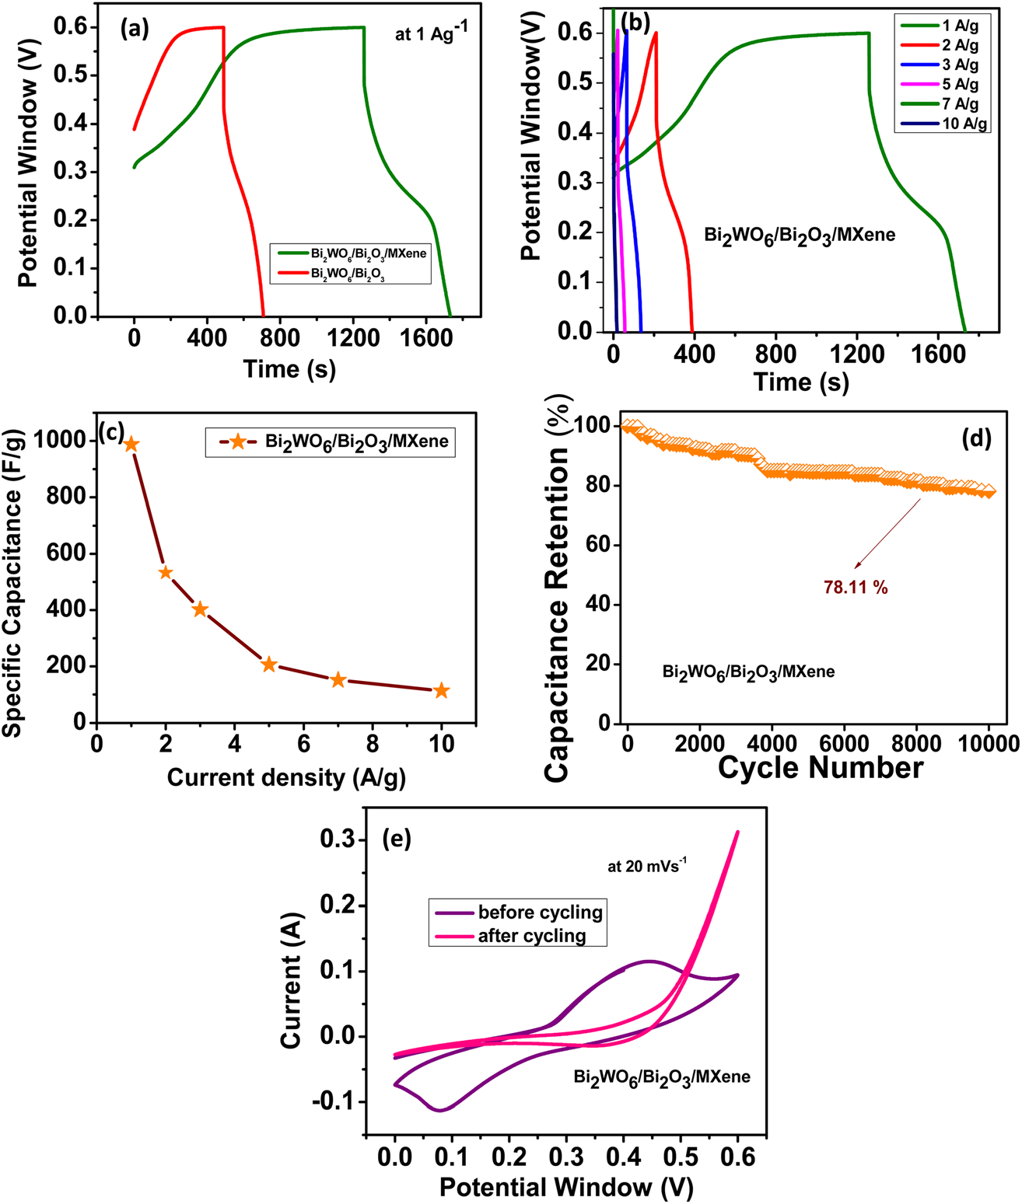
Figure 10. Fig. 8c exhibits that an increased current density leads to
a corresponding decrease in the specic capacitance due to
restricted faradaic processes and natural high ohmic drops at
a high current dens

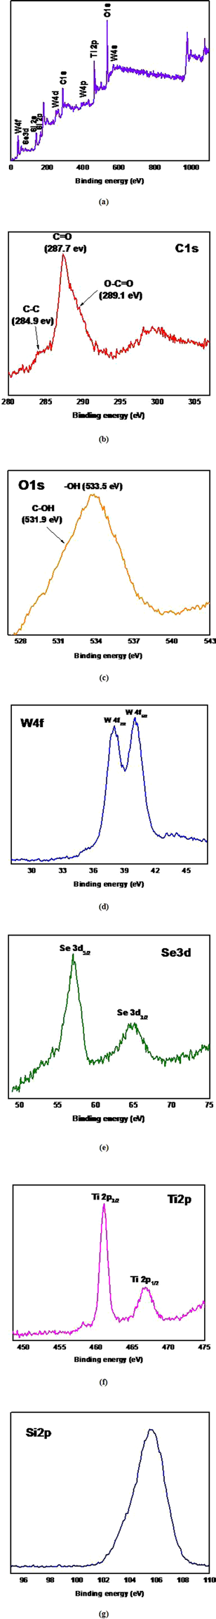
Figure 12. photocatalyst candidate for the degradation of cationic organic dyes with high photodegradation activity that far
exceeds that of the anionic organic dyes.
A plot of kapp is presented in Fig. 10 and
 | None
38 | Engineering Chemistry Vol. 2
 | None
Table 4. GCD analysis was performed to quantify the specific capacitance of the as-synthesized
material. Both samples show that the curve forms the same charge-discharge manner. The GCD result
of pristine ac
 | None
Engineering Chemistry Vol. 2 | 39
 | None
Table 5. Table 1. Capacitance for VRW-ACM and VRW-ACM ZnO
Table 1. Capacitance for VRW-ACM and VRW-ACM ZnO
Table 1. Capacitance for VRW-ACM and VRW-ACM ZnO
Table 1. Capacitance for VRW-ACM and VRW-ACM ZnO

Conclusion
In conclusion, this comprehensive literature review delves into the multifarious materials under exploration for the development and enhancement of supercapacitors. A significant emphasis has been placed on aerogels, including carbon aerogels, silica aerogels, and metal-organic framework (MOF) aerogels, due to their high surface area, excellent porosity, and tunable chemical composition. The synthesis method involving controlled heating in a closed space with controlled pressure has emerged as a promising approach for preserving the aerogel's porous structure while improving electrical conductivity and energy storage capacity.
Another significant line of research focuses on the incorporation of nanomaterials, such as graphene quantum dots (GQDs), into supercapacitor electrodes. The unique nanocrystalline arrangement of GQDs, attributed to quantum confinement effects, offers potential for enhanced energy storage capabilities. Furthermore, fullerene derivatives have also shown promise as electrode materials due to their high electrical conductivity and excellent stability.
The comparison of the apparent rate constant (K value) of various organic dyes with a SWGT electrode provides valuable insights into the electrochemical behavior of these dyes, potentially guiding the selection of suitable electrode materials for supercapacitors.
However, several research gaps remain. Future studies could focus on optimizing synthesis methods to further enhance the properties of aerogels and nanomaterials, improving their efficiency and stability in energy storage applications. Additionally, more comprehensive comparative studies are needed to fully understand the electrochemical performance of various materials and identify the most promising candidates for supercapacitor development.
In conclusion, this review provides a comprehensive overview of the current state of research in supercapacitor materials, highlighting key findings and identifying potential avenues for future investigation. The exploration of novel synthesis methods, nanomaterials, and fullerene derivatives offers promising prospects for the advancement of supercap

