Image Sequence Analysis Lab 3
Shardul Joshi (10082118)
Pranit Vartak ()

Bounding Box Visualisation:
The generated video visualises the predicted bounding boxes for each frame of the image sequence. Overall, the detections are reasonably accurate when objects are clearly visible, well-lit, and sufficiently separated from one another. In these cases, bounding boxes tend to tightly enclose the objects and remain stable across consecutive frames, indicating that the detector is able to localise targets reliably under favourable conditions.
However, several common failure cases can be observed.
One frequent issue is missed detections. In some frames, objects that are visible to the human eye are not detected at all. This typically occurs when objects are partially occluded, very small in the image, or appear in challenging lighting conditions. Occlusions reduce the amount of visual information available, while small object size limits the number of informative pixels, both of which make detection more difficult for the model.
Finally, inconsistent detections over time can be observed, where an object is detected in one frame but missed in the next, even though it remains visible. This temporal instability is expected, as the detection model processes each frame independently and does not use motion or tracking information to enforce continuity.
In summary, the bounding box quality is generally good under clear conditions but degrades in the presence of occlusions, small object sizes and challenging lighting. These failure cases are typical for frame-based object detectors and highlight the limitations of relying solely on per-frame detection without incorporating temporal information or tracking mechanisms.

Tracking by Detection
The tracks captured by tracking by detection for different tau values looks like:
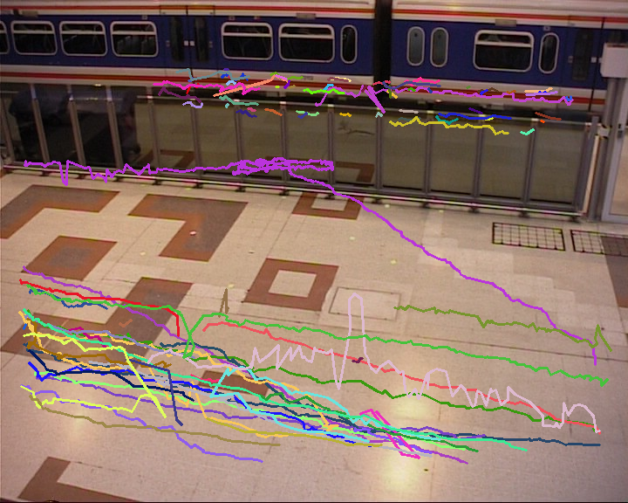
Figure 1: Tracks for τ=2
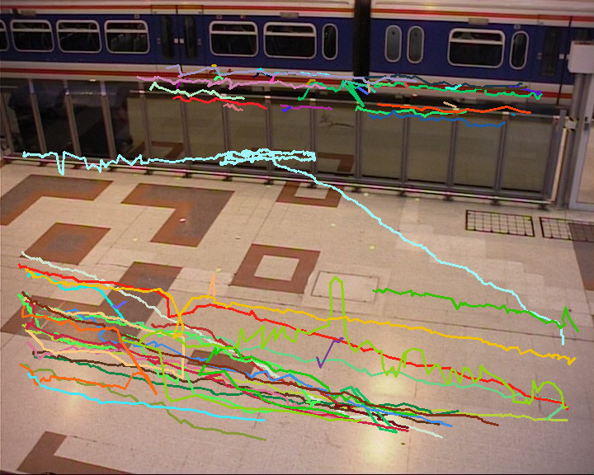
Figure 2: Tracks for τ=5

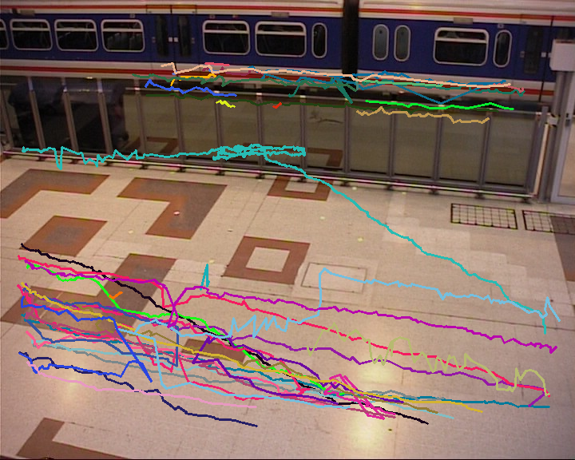
Figure 3: Tracks for τ=10

