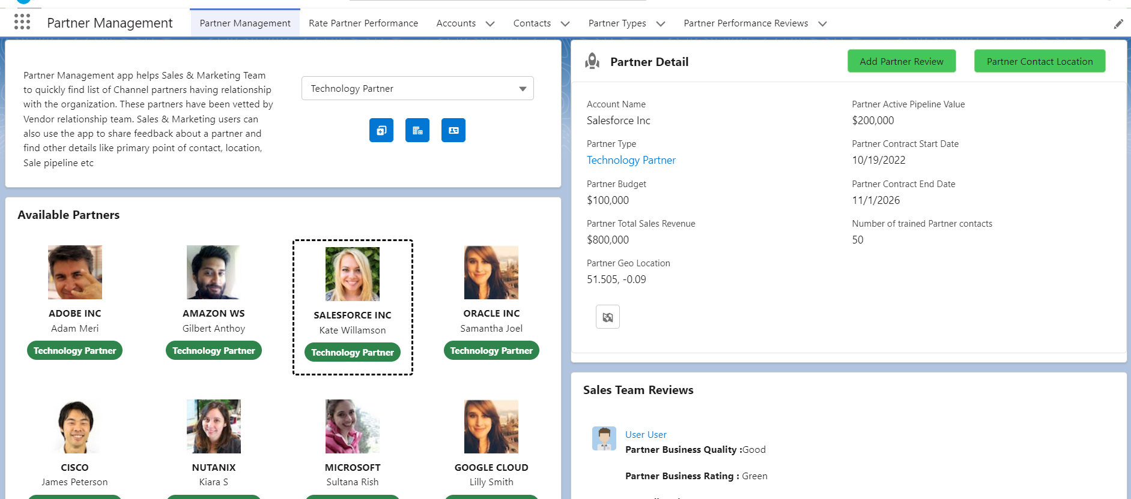

**PRM App Part I - Components Design**

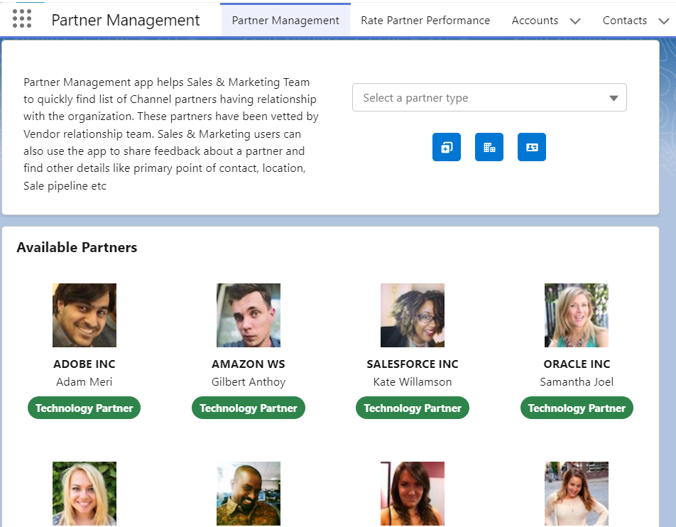

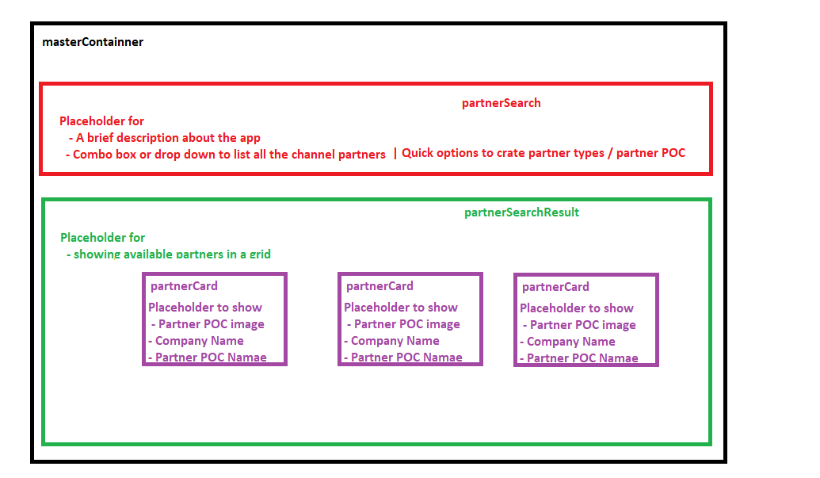

**Partner Search:**

Combo Box:

* Ensure each option to bind in combo box has label and value as keys

APEX Method to use in LWC:

* Ensure @auraenabled annotation is used
* Set cacheable = true to cache SOQL query output and avoid multiple DB round trips

Call APEX Method:

Step 1: Import wire decorator

Step 2: Import wire decorator > Import APEX method

Step 3: Import wire decorator > Import APEX method > Make a call to the method

Step 3.1: Use system properties to process the output {data, error}

Navigation MixIn Service:

Short Note:

Use the lightning-navigation service wire adapters and functions to generate a URL or navigate to a page reference like app page, record page , tab etc

Step 1: Import NaviagationMixin from Lightning Navigation module

Step 2: Apply NaviagationMixin to components base class (LightningElement) to gain access to API methods define in NaviagationMixin

Step 3: Use this[NavigationMixin.Navigate](<input params in JS object format>) API to navigate to another page in the application

**Partner Card:**

**Child component that receives data from partnerSearchResult**

Step 1: Import api decorator from lwc module

Step 2: Expose public property in partnerCard

Step 3: Refer the public property as attribute in partnerSearchResult (parent component) and pass the data

**Partner Search Result:**

**Parent component that sends data to partnerCard**

Short Note:

**@wire**

To read Salesforce data, Lightning web components use a reactive wire service. When the wire service provisions data, the component rerenders. Components use @wire in their JavaScript class to specify a [wire adapter](https://developer.salesforce.com/docs/component-library/documentation/en/lwc/reference_ui_api.html) or an Apex method.

Step 1: Import wire decorator from lwc module

Step 2: Create an APEX method and import the same using salesforce apex package module

Step 4: Use @wire(APEX Method’, <input params in JS object format>) to invoke the method from LWC JS controller file

Step 5: Use {data, error} default system properties from result object to access retrieved data

**Partner Search Result:**

**Part I - Bringing all components together**

Design steps:

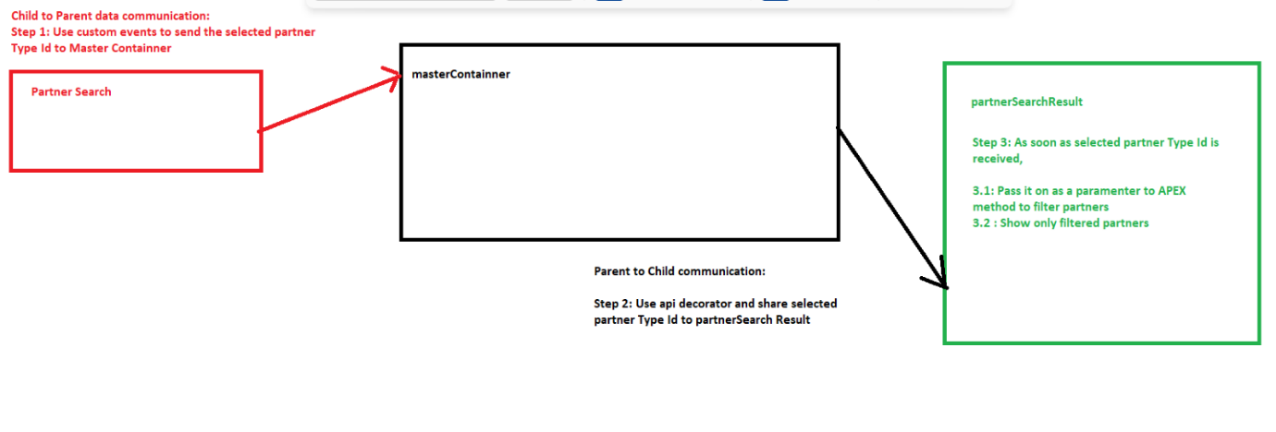

**PRM App Part II - Components Design**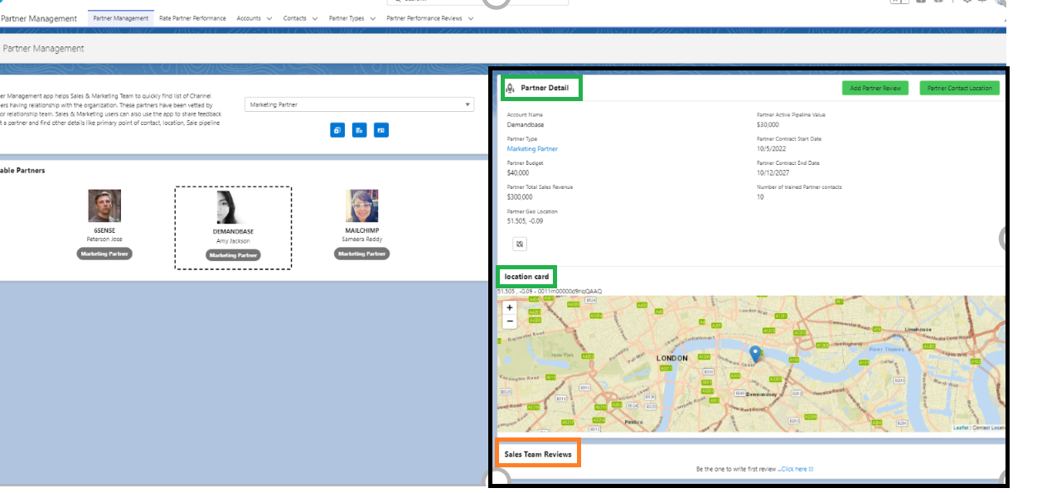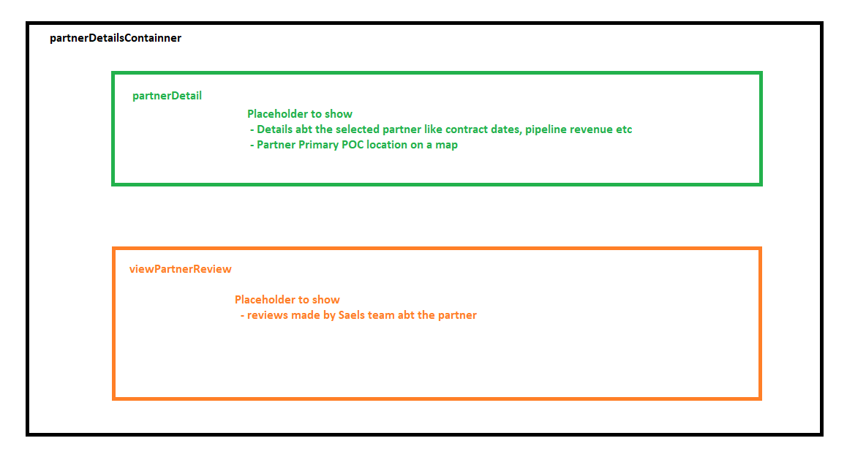

**Partner Details Container:**

**Wrapper component to keep partner detail & view partner review components**

**Partner Detail:**

Step 1: Use lightning record view base component to show detail for the given record Id (partner Account)

Step 2: Import Fields to retrieve from org DB using ‘@salesforce/schema’ package module

Step 3: Bind imported fields value in lighting record view component via properties

**Partner Contact Location:**

Step 1: Upload leaflet.zip JS external library in static resources

Step 2: Import leaflet to using ‘@salesforce/resourceUrl’ package module

Step 3: Import loadScript & loadStyle functions from ‘lightning/platformResourceLoader’ module

Step 4: Use loadScript & loadStyle function to load scripts and styles from leaflet library

Step 5: Use getRecord method to get latitude and longitude data from DB

Step 6: Plot the map using leaflet library function by passing lat and long coordinates

**View Partner Reviews:**

APEX Method to use in LWC:

* Ensure @auraenabled annotation is used
* Set cacheable = true to cache SOQL query output and avoid multiple DB round trips

Call APEX Method:

Step 1: Import wire decorator

Step 2: Import wire decorator > Import APEX method

Step 3: Import wire decorator > Import APEX method > Make a call to the method to get partner reviews

Step 3.1: Use system properties to process the output {data, error}

**Part II - Bringing all components together**

#1: Partner Card

* Highlight the selected Partner Account

#2: Partner Card

* To send selected Partner Account Id to partner Detail & View Partner Review components

Short Note:

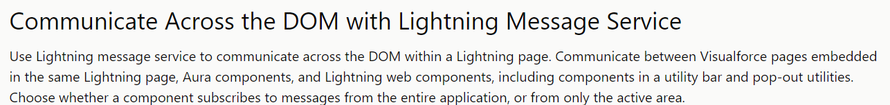

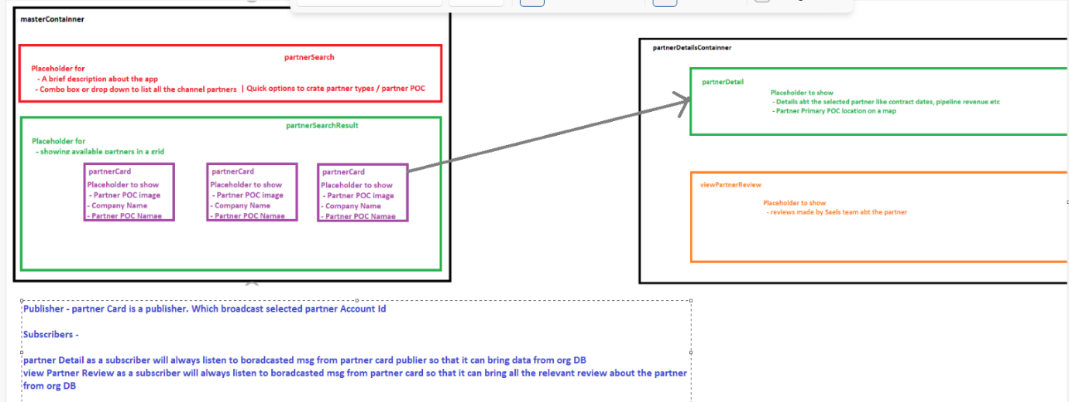

Step 1: Create a message channel

Step 2: Partner card component will act as publisher. Use publish method from ‘lightning/messageService’ module and broadcast selected Partner Account Id

Step 3: Partner Detail & View Partner Review components will act as subscribers. Use subscribe method from ‘lightning/messageService’ module and receive selected Partner Account Id