ECOM APPLICATION

It is an Ecommerce application where the user will be able to buy certain products ,Place them in his/her cart and when he his done he can proceed to checkout his order .The user will also be able to Signup if he is not already a registered user. Update his profile and also look at all the past orders he has placed through our said application

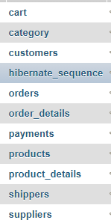Database Tables:

|  |
| --- |
| When the user adds items inside the cart it will be inserted in this table. |
| This table consists of all the different categories of products in our app. |
| This table consists of the user details |
| It is a generation type recommended by hibernate.The generated values are unique per sequence |
| It will contain the list of past orders of all the users |
| It will contain the order details of all the orders |
| This table will generally contain the list of payment types that are allowed |
| This table consists of all the products which are available in or app. |
| This table consists of the properties of those products(Specifications) |
| This table consists of all the shippers(Delivery Guys Details) |
| This table consists of supplier details of the products |

Below are the properties of each of the tables in our database:

**CART TABLE**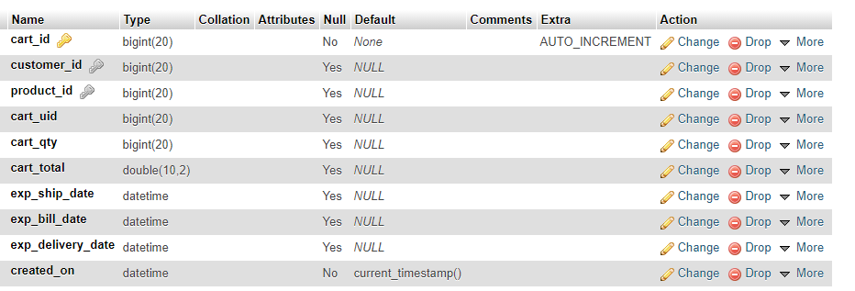

**CATEGORY TABLE:**

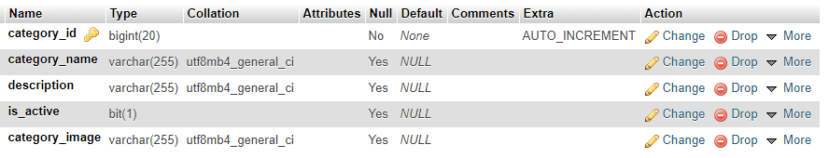

**CUSTOMERS TABLE:**

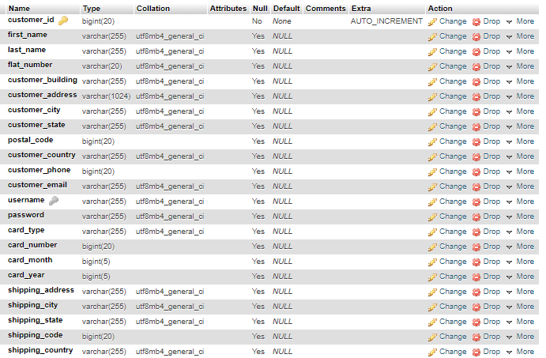

**ORDERS TABLE:**

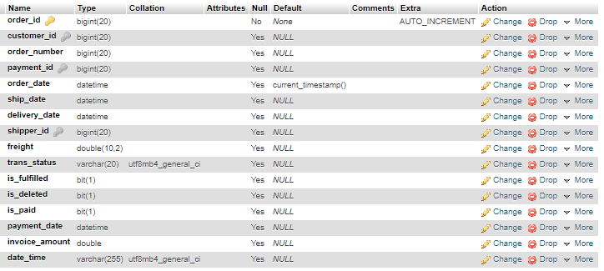

**ORDER DETAILS TABLE:**

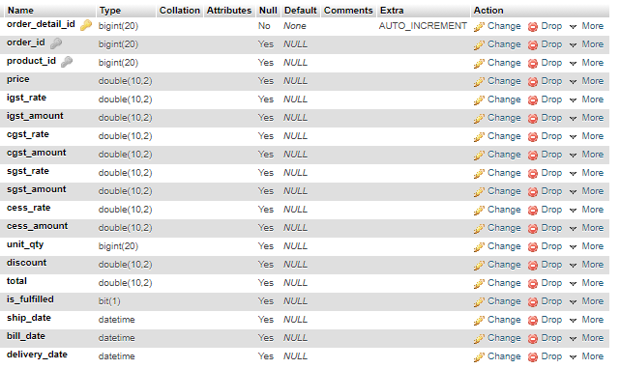

**PAYMENTS TABLE:**

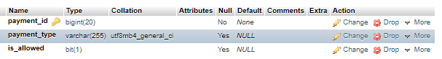

**PRODUCTS TABLE:**

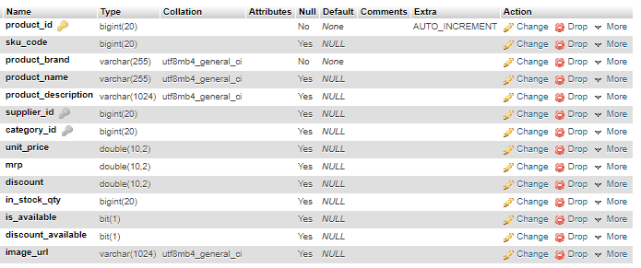

**SHIPPERS TABLE:**

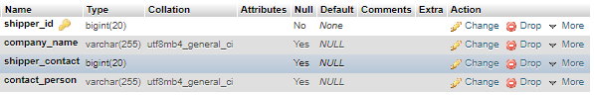

**PRODUCT_DETAILS TABLE:**

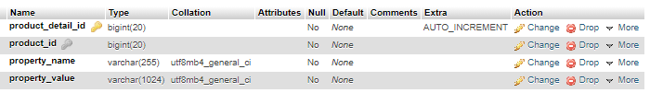

**SUPPLIERS TABLE:**

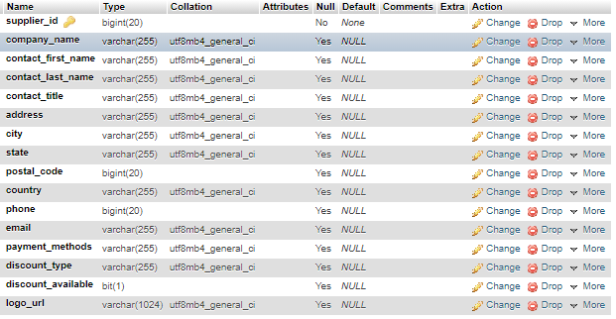

**Components in our Application(Angular)**

* **Home**
* **Auth**
* **Cart**
* **Navbar**
* **Order-List**
* **Product-Details**
* **Update Profile**
* **Sign-In**
* **Sign-Up**

**Components in our Application(Spring)**

* AuthController
* CartController
* CategoryController
* OrderController
* OrderDetailsController
* ProductController
* ProductDetailsController

**Future Scope:**

* Forgot Password
* JWT Based Authentication
* Payments Integration
* Delivery Tracking Updates