Documentation

Shark Emulator
(svn revision 1123)

author: zsawyer
date: 2011-03-30

Table of Contents
Installation with NetBeans: 2
Method 1: Using Netbeans-Project from SVN
Method 2: Creating new NetBeans-Project
Usage: 3
Running the Application:
Interpretation of Console-Output:
Using the GUI:
Overview of main classes:
Functional Principle: 6
Know Issues: 6

Installation with NetBeans:

Method 1: Using Netbeans-Project from SVN

- Check out “emulator“ from svn repo: https://sharkfw.svn.sourceforge.net/svnroot/sharkfw/ide/netbeans/

- Check out sources from svn repo:
https://sharkfw.svn.sourceforge.net/svnroot/sharkfw/src
into emulator/src

- Check out libraries from svn repo:
https://sharkfw.svn.sourceforge.net/svnroot/sharkfw/lib
into emulator/lib

Method 2: Creating new NetBeans-Project

- Create new Project “Java Application“ (empty, no main)

- Check out sources from svn repo:
https://sharkfw.svn.sourceforge.net/svnroot/sharkfw/src
into emulator/src

- Check out libraries from svn repo:
https://sharkfw.svn.sourceforge.net/svnroot/sharkfw/lib
into emulator/lib

- In NetBeans Project Properties
  - Sources: Source Package Folders, Add Folders:
    - code\src\java\aspects
    - additionalCP
    - code\src\java\j2se
    - code\src\java\core
    - code\src\java\j2seApps
    - code\src\java\j2se_androidWrapper
    - code\src\java\coreApps
    - code\src\java\j2se_android
  - Test Package Folders, Add Folders:
    - code\src\java\coreTests
    - code\src\java\j2seTests
  - Source/Binary Format: JDK 6
  - Libraries: Add JAR/Folder:
    - code/lib/aspectjrt.jar
    - code/lib/aspectjweaver.jar

  - Run:
    - Main Class: net.sharkfw.emulator.EmulatorEngine
    - VM Options: -javaagent:dist/lib/aspectjweaver.jar

Usage:

Running the Application:
After importing the project into NetBeans “Run“ or “Debug“ to execute the emulator and start the GUI.

Interpretation of Console-Output:
Note that Logging-Output by the emulater will be returned to “stderr“. The output will be indicated by “[EMULATOR]“ preceeding the log message.

By default, if AspectJ is correctly setup, “BasicAspect“ will trace all function calls of methods belonging to classes of the net.sharkfw.emulator package.

Additional log messages not generated by “BasicAspect” will also be routed to “stderr”.

Using the GUI:
Upon starting a single GUI window will appear. The upper half will display a tree view of data retrieved using Java-Reflections. The lower panel is a visual representation of the virtual environment. Peers will be shown here and their virtual location in relation to each other is visible.

Clicking the “new Peer” button will spawn an addition window “Create New Peers”. A drop down menu will display the classes listed in “registered-engines.xml” and allow selection. The “Owner” text field allows to specify the required field owner of a SharkKB.

Clicking “Create” will cause the emulator to attempt instantiate selected class while passing it a default SharkKB which has the specified owner.
Once created the changes will be visible in the main window. Peers will show as gray dots surrounded by a green circle and a text naming the current address (uses TCP).

Additionally a window “PeerInfo - <URL>” will appear for each peer. This window will output information passed on the initial KnowledgePorts (an instance of EmulatorKP) of the SharkEngine.
Once closed this window can be reopened by double clicking on a peer in the main window.

Dragging of peers in the main window is possible. This way the peers can be linked and separated by the user. A peer will be connected to another one if the other's green radius (transmission range) is enclosing the peer. Connections are generally unidirectional as different transmission ranges would allow a peer to be “heard” while at the same time not being able to “hear”. By default all peers start with the same transmission range and connections therefore appear bi-directional.
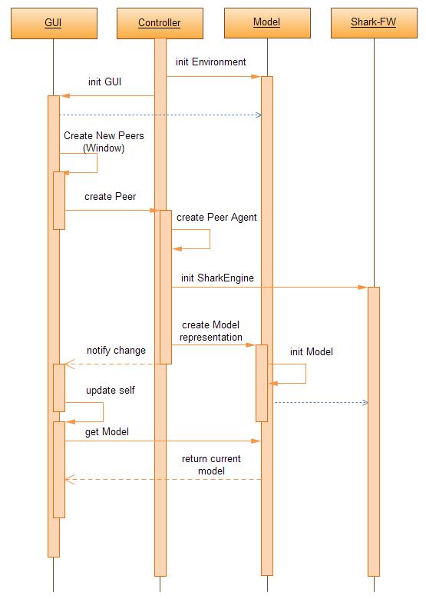Diagram 1: Sequence Diagram of creating a peer

Overview of main classes:
net.sharkfw.emulator
- controller package

EmulatorEngine
- main controller class and entry point of the program
- class is singleton and should be accessed using getInstance()
- the GUI will call upon this class to create a peer

PeerAgent
- controller class for a single associated peer
- supplies access to modify a peer (i.e. location, connection)
- handles change events and reacts to changes in the environment

AgentFactory
- Factory to create PeerAgents
- class is singleton and should be accessed using getInstance()
- creates associated Peer- and SharkEngine-Objects
- enables instantiation of different SharkEngine subclasses
- registers agents at the AgentRegistry

AgentRegistry
- container class to hold all PeerAgents
- also stores a list of subscribers (PeerListeners) for each Agent
- class is singleton and should be accessed using getInstance()
- notifies listeners of events relating to a PeerAgent

net.sharkfw.emulator.gui
- view package

EmulatorWindow
- main window

EnvironmentPanel
- Panel which represents a location map with peers
- each peer is represented by a gray circle

net.sharkfw.emulator.model
- model package

Peer
- model class for a SharkEngine
- supplies access to the associated SharkEngine
- supplies access to emulator specific data (i.e. current location)

net.sharkfw.emulator.aspects
- aspects package (for AspectJ)

BasicAspect
- main tracing aspect for all emulator method calls

Functional Principle:
SharkEngines are each encapsulated by a Peer-Object and governed by their respective PeerAgents.
PeerAgents are instantiated by the AgentFactory. The AgentFactory will also create a new SharkEngine-Instance and a new Peer instance as required for the PeerAgent. Furthermore it will register the new PeerAgent at the AgentRegistry.

PeerAgents will notify the AgentRegistry of its changes. The AgentRegistry will propagate this information towards all other PeerAgents as well as all PeerListeners that have subscribed for this changed PeerAgent.

A PeerAgent will react to a change of another PeerAgent by comparing locations and initiating or terminating a connecting if in- or out-of-range.
A connection in this context is adding the appropriate PeerSemanticTag to the SharkEngine's EmulatorPeerSensor.
At this point SharkEngine is being informed by EmulatorPeerSensor and starts an internal update cycle.

The order of functions being called is traced and print to console using AspectJ and the “BasicAspect”.

For detailed documentation of each class, function and member please refer to the JavaDoc code comments.

Know Issues:
- SharkEngine subclasses not expecting a standard SharkKB will not be instantiated
- this could be fixed by enforcing class specific configuration files

- Logging of the peer's KnowledgePort does not continue
- SharkEngine appears to copy the EmulatorKP instead of proceeding to use it therefore the no further output is generated
- this can either be considered a bug in SharkFW and thus should be changed there
- alternatively KnowledgePorts sould be hooked into using AspectJ

