Electricity can be used in many aspects like:

* Electric Motors
* Drip irrigation
* Sprinke irrigation
* Solar Panels

Electric motors**:**

Electric motors are used in agriculture for:

- Irrigation systems and lighting: Electric pumps are used for irrigation and lighting of crops to increase growth and productivity.

- Electric fencing: Electric fencing is used to protect crops from pests and for animal control.

- Plowing, tilling, and harvesting: Electric motors are used to power machines for plowing, tilling, and harvesting crops.

- Automatic farm equipment: Electric motors are used to power automatic feeders, spreaders, and harvesters.

- Electric tools: Electric tools such as lawn mowers, weeders, pruners, and harvesters are used to automate various tasks within the farm.

- Tractors: Electric tractors are used for planting and tilling with pinpoint accuracy and for fertilizer delivery.

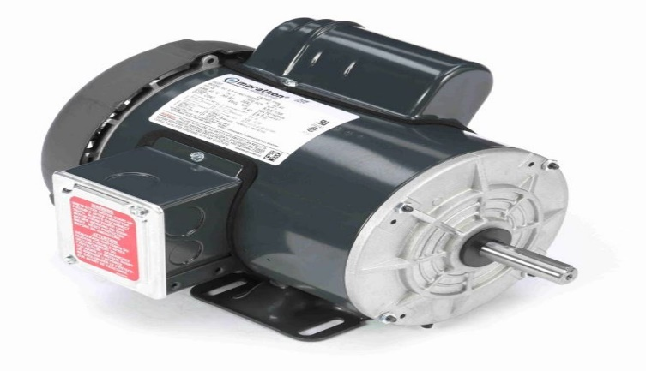

Drip Irrigation:

Drip irrigation, also known as trickle irrigation, is a method of irrigation that saves water and increases crop yields by delivering water directly to the roots of plants, drop by drop. Its usage in agriculture includes:

1. Water conservation: Reduces water evaporation and runoff, saving up to 70% of water compared to traditional flood irrigation.

2. Increased crop yields: Plants receive exact amounts of water, promoting healthy growth and higher yields.

3. Reduced soil erosion: Water is applied slowly, reducing soil erosion and nutrient loss.

4. Improved crop quality: Drip irrigation helps maintain optimal soil moisture, leading to better crop quality.

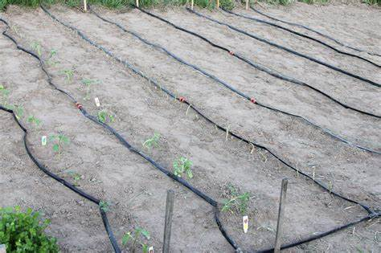 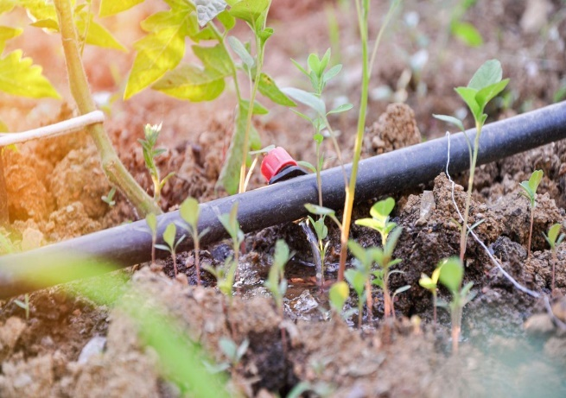

Sprinkle irrigation:

Sprinkle irrigation, also known as sprinkler irrigation, is a method of irrigation that distributes water over the soil surface through a network of pipes and sprinklers, simulating natural rainfall. Its usage in agriculture includes:

1. Uniform water distribution: Sprinklers distribute water evenly, ensuring all plants receive equal amounts.

2. Water conservation: Sprinkle irrigation reduces water loss due to evaporation and runoff.

3. Increased crop yields: Proper water distribution promotes healthy growth and higher yields.

4. Reduced soil erosion: Water is applied gently, reducing soil erosion and nutrient loss.

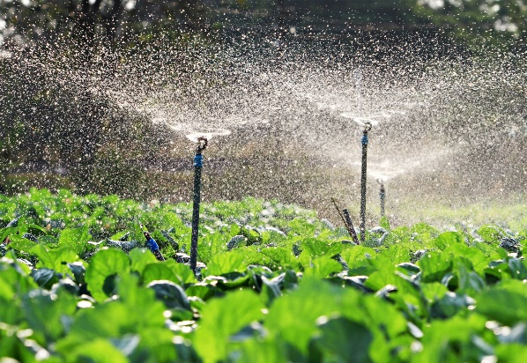 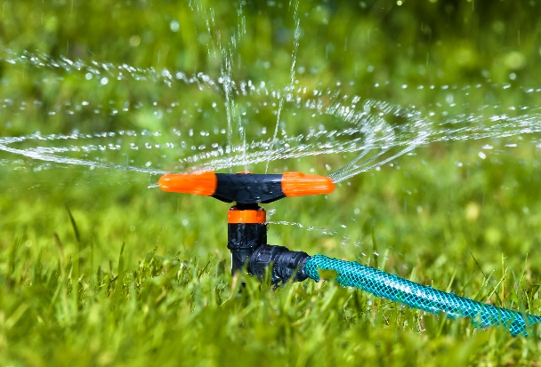

Solar Panels:

Here are some uses and benefits of solar panels in agriculture:

1.Sustainability: Solar panels reduce carbon footprint by harnessing sunlight and converting it into energy.

2.Cost-Efficiency: Solar panels reduce operational costs by providing a cheaper alternative to electricity and diesel.

3.Energy Independence: Solar panels provide a reliable source of energy and reduce dependence on erratic power grids.

4.Solar Agri-feeders: Solar panels can be used to power agri-feeders, reducing operational costs and ensuring the welfare of livestock.

