MINI PROJECT

(From 20-06-2024 to 04-07-2024)

Title of the Project: A webpage designed on “Utilization of electricity to farmers and related issues"

Report of the Mini-project work done in the related subject w.r.t the habitation/village:

Over the past six weeks I participated in a community service project focused on utilization of electricity to farmers. our goal was to promote utilization of electricity and educate the community about the benefits of using efficient electricity in farming. Through hands-on experiences and guided leraning, we explored various aspects of using electricity in farming such as solar panels, sprinkle irrigation, drip irrigation, and electric motors. During the project, we conducted a site assessment and developed a detail plan for effective execution. We learned about the importance of electricity in agriculture.

As a part of our community service project we went to rajupalem village. Rajupalem is a small village where there are many crops. In rajupalem, we found more related information about our community service project. We went to nearby places in rajupalem, we interacted with farmers about the usage of electricity in there farming. Farmers utilize electricity in various ways to enhance their agricultural productivity and efficiency. They use electricity to power irrigation systems, lighting for farm buildings and outdoor areas, and machinery like tractors and harvesters. Additionally, electricity enables refrigeration for storing perishable produce and dairy products, automation of farm processes like feeding and milking, and water management systems for efficient water distribution. Furthermore, electricity facilitates communication through phones, radios, and internet connectivity, allowing farmers to access market information and manage their operations effectively. Finally, electricity powers value-added activities like sorting, grading, and packaging of farm produce, helping farmers to increase their income and competitiveness. By leveraging electricity in these ways, farmers can improve their overall productivity, reduce costs, and contribute to sustainable agricultural development.

Main objectives :

The main objectives of utilizing electricity by farmers are:

1. Improved irrigation management: Electricity powers irrigation systems, enabling efficient water distribution and reduced labor.

2. Enhanced farm productivity: Electricity-powered machinery and equipment increase farm productivity and reduce manual labor.

3. Better lighting and safety: Electricity provides lighting for farm buildings and outdoor areas, ensuring safety and security.

4. Effective water management: Electricity powers water treatment, pumping, and distribution systems, ensuring optimal water use.

5. Increased efficiency in farm processes: Electricity automates tasks like feeding, milking, and egg collection, reducing labor and improving efficiency.

6. Improved produce storage and preservation: Electricity powers refrigeration systems, enabling farmers to store perishable produce and dairy products effectively.

7. Enhanced communication and market access: Electricity facilitates communication through phones, radios, and internet connectivity, connecting farmers to markets and essential services.

8. Value addition and income growth: Electricity powers processing and value-added activities, enabling farmers to increase their income and competitiveness.

Introduction

"Electricity is a vital input in modern agriculture, transforming the way farmers cultivate, produce, and market their crops. The utilization of electricity by farmers has revolutionized agricultural practices, increasing efficiency, productivity, and profitability. With electricity, farmers can power essential systems and equipment, such as irrigation pumps, lighting, machinery, and communication tools. This enables them to:

- Enhance crop yields and quality

- Reduce labor and energy costs

- Improve farm safety and security

- Access market information and services

- Increase value addition and income

The effective use of electricity in agriculture is crucial for sustainable farming practices, food security, and rural development. In this context, we will explore the various aspects of electricity utilization by farmers, including its benefits, challenges, and future directions.

Moreover, electricity facilitates farm-to-market connectivity, enabling farmers to access vital information, market services, and value-added processing and packaging capabilities. This connectivity also enables farmers to participate in e-commerce platforms, expanding their market reach and improving their income. Furthermore, the adoption of renewable energy sources, like solar and biogas, is increasingly being adopted by farmers to power their operations, reducing reliance on grid electricity and mitigating climate change impacts. Overall, the strategic use of electricity in agriculture is critical for sustainable farming practices, rural development, and ensuring global food security.

Benefits:

1. Increased efficiency: Electricity-powered equipment and automation reduce labor and energy costs.

2. Improved crop yields: Electricity-powered irrigation, lighting, and heating/cooling systems enhance crop growth and quality.

3. Enhanced safety: Electricity-powered lighting and security systems improve farm safety and security.

4. Access to information: Electricity-powered communication tools connect farmers to market information, weather updates, and agricultural expertise.

5. Value addition: Electricity-powered processing and packaging equipment enable farmers to add value to their produce.

Challenges:

1. Access to electricity: Many rural areas lack reliable electricity supply, hindering farmers' ability to adopt electricity-dependent technologies.

2. Cost: Electricity can be expensive, especially for small-scale farmers.

3. Maintenance: Electricity-powered equipment requires regular maintenance, which can be time-consuming and costly.

4. Grid reliability: Frequent power outages can disrupt farm operations and damage equipment.

Future directions:

1. Renewable energy: Farmers are increasingly adopting solar, wind, and biogas energy sources to reduce reliance on grid electricity.

2. Energy efficiency: Farmers are adopting energy-efficient equipment and practices to minimize energy consumption.

3. Smart agriculture: Electricity-powered precision agriculture technologies, such as drones and sensors, optimize crop management and reduce waste.

4. Rural electrification: Governments and organizations are working to expand electricity access to rural areas, promoting agricultural development.

By understanding these aspects, we can better appreciate the critical role electricity plays in modern agriculture and work towards sustainable and efficient farming practices.

General principles:

1. Reliability: Electricity supply should be reliable and consistent to ensure uninterrupted farm operations.

2. Safety: Electrical installations and equipment should be installed and maintained to ensure the safety of people and animals.

3. Cost-effectiveness: Farmers should optimize energy use to reduce costs and improve profitability.

4. Sustainability: Farmers should consider using renewable energy sources like solar, wind, and biogas to reduce their carbon footprint.

5. Productivity: Electricity should be used to enhance farm productivity, quality, and yield.

6. Innovation: Farmers should stay updated on new technologies and innovations in electrical equipment and practices.

7. Training: Farmers should receive training on safe and effective use of electrical equipment and technologies.

8. Grid connection: Farmers should explore opportunities to connect to the grid or mini-grids to access stable and reliable electricity supply.

Electricity can be used in many aspects like:

* Electric Motors
* Drip irrigation
* Sprinke irrigation
* Solar Panels

Electric motors**:**

Electric motors are used in agriculture for:

- Irrigation systems and lighting: Electric pumps are used for irrigation and lighting of crops to increase growth and productivity.

- Electric fencing: Electric fencing is used to protect crops from pests and for animal control.

- Plowing, tilling, and harvesting: Electric motors are used to power machines for plowing, tilling, and harvesting crops.

- Automatic farm equipment: Electric motors are used to power automatic feeders, spreaders, and harvesters.

- Electric tools: Electric tools such as lawn mowers, weeders, pruners, and harvesters are used to automate various tasks within the farm.

- Tractors: Electric tractors are used for planting and tilling with pinpoint accuracy and for fertilizer delivery.

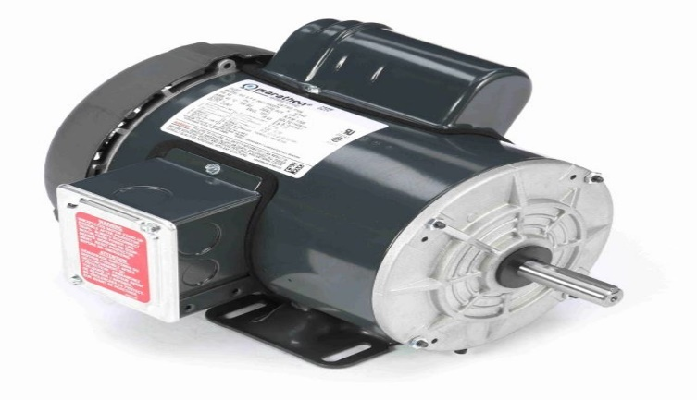

Drip Irrigation:

Drip irrigation, also known as trickle irrigation, is a method of irrigation that saves water and increases crop yields by delivering water directly to the roots of plants, drop by drop. Its usage in agriculture includes:

1. Water conservation: Reduces water evaporation and runoff, saving up to 70% of water compared to traditional flood irrigation.

2. Increased crop yields: Plants receive exact amounts of water, promoting healthy growth and higher yields.

3. Reduced soil erosion: Water is applied slowly, reducing soil erosion and nutrient loss.

4. Improved crop quality: Drip irrigation helps maintain optimal soil moisture, leading to better crop quality.

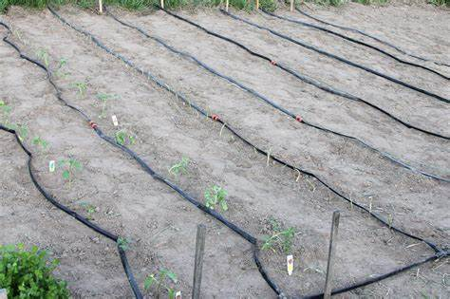 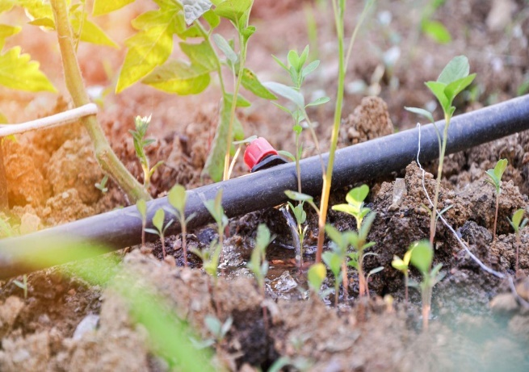

Sprinkle irrigation:

Sprinkle irrigation, also known as sprinkler irrigation, is a method of irrigation that distributes water over the soil surface through a network of pipes and sprinklers, simulating natural rainfall. Its usage in agriculture includes:

1. Uniform water distribution: Sprinklers distribute water evenly, ensuring all plants receive equal amounts.

2. Water conservation: Sprinkle irrigation reduces water loss due to evaporation and runoff.

3. Increased crop yields: Proper water distribution promotes healthy growth and higher yields.

4. Reduced soil erosion: Water is applied gently, reducing soil erosion and nutrient loss.

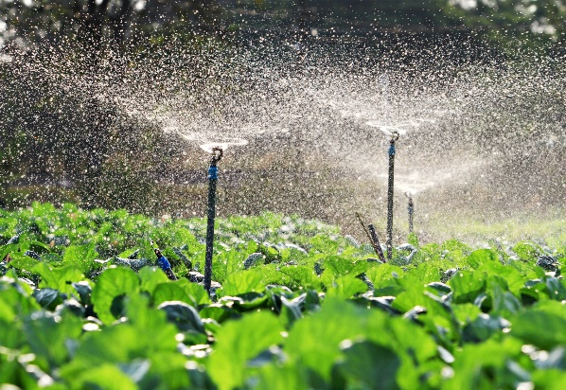 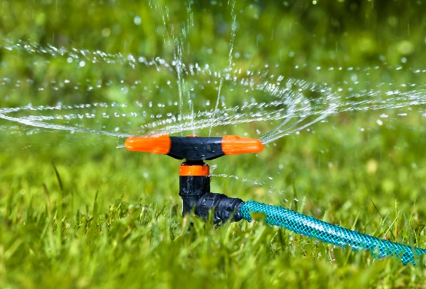

Solar Panels:

Here are some uses and benefits of solar panels in agriculture:

1.Sustainability: Solar panels reduce carbon footprint by harnessing sunlight and converting it into energy.

2.Cost-Efficiency: Solar panels reduce operational costs by providing a cheaper alternative to electricity and diesel.

3.Energy Independence: Solar panels provide a reliable source of energy and reduce dependence on erratic power grids.

4.Solar Agri-feeders: Solar panels can be used to power agri-feeders, reducing operational costs and ensuring the welfare of livestock.

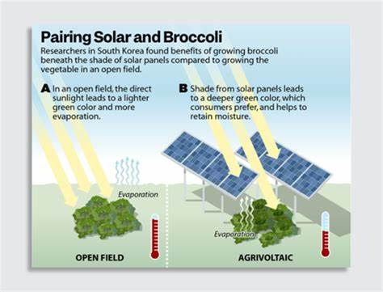 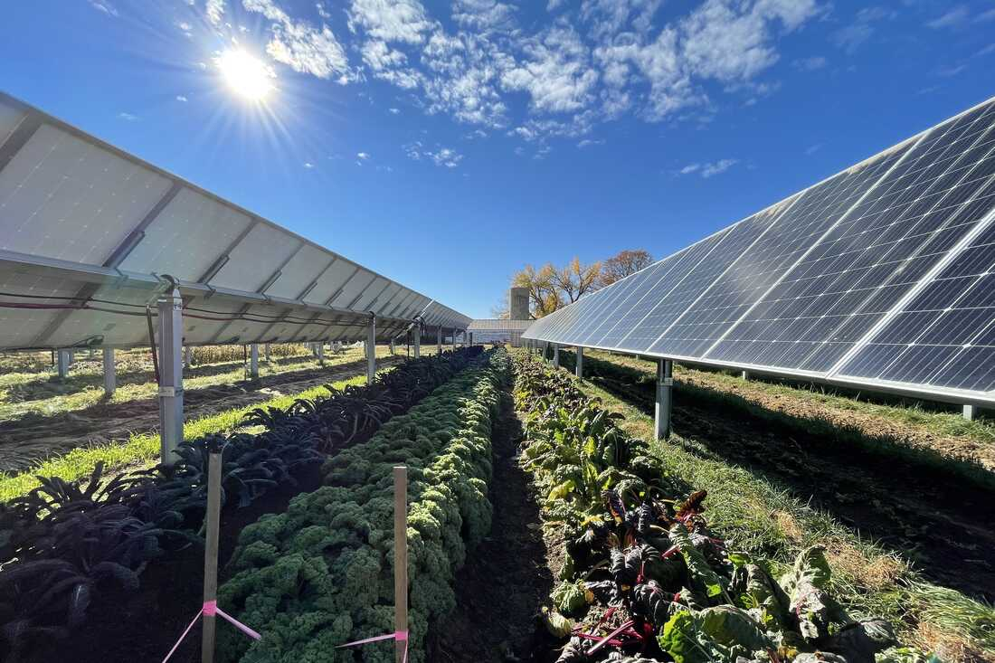

CHAPTER-6

RECOMMENDATIONS AND CONCLUSIONS OF THE MINI PROJECT:

RECOMMENDATIONS:

1. Conduct an energy audit to identify areas of energy inefficiency and opportunities for improvement.

2. Install energy-efficient lighting and equipment, such as LED bulbs and motor controls.

3. Use renewable energy sources like solar, wind, or biogas to reduce reliance on grid electricity.

4. Implement precision agriculture technologies like drones, sensors, and automation to optimize crop management and reduce energy waste.

5. Optimize irrigation systems using timers, sensors, and efficient pumps to reduce energy consumption.

6. Use energy-efficient water pumps and motors to reduce energy consumption.

7. Install energy-efficient fans and ventilation systems in livestock housing to improve air quality and reduce energy consumption.

8. Use electricity-powered equipment like tractors, ploughs, and harvesters to improve efficiency and reduce labor costs.

9. Implement energy-saving practices like turning off lights and equipment when not in use.

10. Regularly maintain electrical equipment to ensure efficiency and safety.

CONCLUSIONS:

1. Electricity is a vital input in modern agriculture, enhancing productivity, efficiency, and profitability.

2. Farmers adoption of electricity-dependent technologies has transformed agricultural practices, improving crop yields and quality.

3. Electricity enables farmers to access vital information, market services, and value-added processing and packaging capabilities.

4. Renewable energy sources, like solar and biogas, offer promising alternatives to grid electricity, reducing reliance on non-renewable energy sources.

5. Energy efficiency and conservation practices are essential to minimize energy waste and reduce costs.

6. Regular maintenance and training are crucial to ensure the safe and effective use of electrical equipment and technologies.

7. Grid connection or mini-grids can provide reliable and stable electricity supply, supporting farmers' productivity and income growth.

8. Policy support and incentives can encourage farmers to adopt electricity-dependent technologies and renewable energy sources.

9. Electricity utilization in agriculture has significant potential for sustainable development, food security, and rural livelihood improvement.

10. Future agricultural development will rely heavily on the strategic use of electricity and innovative technologies to drive productivity, efficiency, and sustainability.

Student self-evaluation for the community service project

|  |
| --- |
| Student Name:  Registration No:  Period of CSP: From:20-6-24 To:04-07-24  Date of evaluation:  Name of the Person in-charge: Mrs. M. Hymavathi  Adress with mobile number: |

**Please rate your performance in the following areas:**

|  |  |  |  |  |  |
| --- | --- | --- | --- | --- | --- |
| **1) Oral communication** | **1** | **2** | **3** | **4** | **5** |
| **2) Written communication** | **1** | **2** | **3** | **4** | **5** |
| **3) Proactiveness** | **1** | **2** | **3** | **4** | **5** |
| **4) Interaction ability with community** | **1** | **2** | **3** | **4** | **5** |
| **5) Positive Attitude** | **1** | **2** | **3** | **4** | **5** |
| **6) Self-confidence** | **1** | **2** | **3** | **4** | **5** |
| **7) Ability to learn** | **1** | **2** | **3** | **4** | **5** |
| **8) Work Plan and organization** | **1** | **2** | **3** | **4** | **5** |
| **9) Professionalism** | **1** | **2** | **3** | **4** | **5** |
| **10) Creativity** | **1** | **2** | **3** | **4** | **5** |
| **11) Quality of work done** | **1** | **2** | **3** | **4** | **5** |
| **12) Time Management** | **1** | **2** | **3** | **4** | **5** |
| **13) Understanding the Community** | **1** | **2** | **3** | **4** | **5** |
| **14) Achievement of Desired Outcomes** | **1** | **2** | **3** | **4** | **5** |
| **15) OVERALL PERFORMANCE** | **1** | **2** | **3** | **4** | **5** |

**Rating Scale: 1 is lowest and 5 is highest rank**

**Date: Signature of the Student**

**Evaluation by the Person in-charge in the Community/Habitation**

|  |
| --- |
| Student Name:  Registration No:  Period of CSP: From:20-6-24 To:04-07-24  Date of evaluation:  Name of the Person in-charge: Mrs. M. Hymavathi  Adress with mobile number: |

**Please rate the student’s performance in the following areas:**

**Please note that your evaluation shall be done independent of the Student’s self-evaluation Rating Scale: 1 is lowest and 5 is highest rank**

|  |  |  |  |  |  |
| --- | --- | --- | --- | --- | --- |
| **1) Oral communication** | **1** | **2** | **3** | **4** | **5** |
| **2) Written communication** | **1** | **2** | **3** | **4** | **5** |
| **3) Proactiveness** | **1** | **2** | **3** | **4** | **5** |
| **4) Interaction ability with community** | **1** | **2** | **3** | **4** | **5** |
| **5) Positive Attitude** | **1** | **2** | **3** | **4** | **5** |
| **6) Self-confidence** | **1** | **2** | **3** | **4** | **5** |
| **7) Ability to learn** | **1** | **2** | **3** | **4** | **5** |
| **8) Work Plan and organization** | **1** | **2** | **3** | **4** | **5** |
| **9) Professionalism** | **1** | **2** | **3** | **4** | **5** |
| **10) Creativity** | **1** | **2** | **3** | **4** | **5** |
| **11) Quality of work done** | **1** | **2** | **3** | **4** | **5** |
| **12) Time Management** | **1** | **2** | **3** | **4** | **5** |
| **13) Understanding the Community** | **1** | **2** | **3** | **4** | **5** |
| **14) Achievement of Desired Outcomes** | **1** | **2** | **3** | **4** | **5** |
| **15) OVERALL PERFORMANCE** | **1** | **2** | **3** | **4** | **5** |

**Date: Signature of the Supervisor**

**PHOTOS**

