Principal Components Analysis

Principal components analysis is concerned with explaining the variance-covariance structure of a set of variables.

This explanation comes from a few linear combinations of the original variables.

Generally speaking, PCA has two objectives:
- “Data” reduction - moving from many original variables down to a few “composite” variables (linear combinations of the original variables).
- Interpretation - which variables play a larger role in the explanation of total variance.

Think of the new variables, called the principal components, as composite variables consisting of a mixture of the original variables.

In PCA, the goal is to find a set of k principal components (composite variables) that:
- Is much smaller than the original set of p variables, and
- Accounts for nearly all of the total sample variance.

If these two goals can be accomplished, then the set of k principal components contains almost as much information as the original p variables.

This means that the k principal components can then replace the p original variables.

The original data set is thereby reduced, from n measurements on p variables to n measurements on k variables.

PCA often reveals relationships between variables that were not previously suspected.

Because of such relationships, new interpretations of the data and variables often stem from PCA.

PCA usually serves a more of a means to an end rather than an end in themselves in that the composite variables (the principal components) are often used in larger investigations
or in other statistical techniques such as:
- Multiple regression
- Cluster analysis.

Technique quite old: Pearson (1901) and Hotelling (1933), but still one of the most used
multivariate techniques today. Here is the main idea:

- Start with mean-centered variables X₁, . . . ,X_{p}
- Find a linear combination of these variables, say Y₁, . . . , Y_{p} (called principal components), so that:
  - Y₁, . . . , Y_{p} are uncorrelated. Idea: they measure different dimensions of the data.
  - Var(Y₁) ≥ Var(Y₂) ≥ . . . Var(_{Yp}). Idea: Y₁ is most important, then Y₂, etc.

What are the Linear Combinations?

Principal components depend solely on the covariance matrix or the correlation matrix.

Linear combination weights in PCA aren’t typically either ones or zeros

Rather, all the linear combination weights for each principal component come directly from the eigenvectors of the covariance matrix or the correlation matrix.

Recall that for p variables, the p × p covariance/correlation matrix has a set of:

- p eigenvalues - {λ₁, λ₂, . . . , λ_{p}}.
- p eigenvectors - {e₁, e₂, . . . , e_{p}}

Each principal component is formed by taking the values of the elements of the eigenvalues as the weights of the linear combination.

If the k-th eigenvector e_{k} = (e_{1k}, e_{2k}, . . ., e_{pk}), then the principal components Y₁, … are formed by:

Y₁ = e₁₁X₁ + e₂₁X₂ + . . . + e_{p1}X_{p}
Y₂ = e₁₂X₁ + e₂₂X₂ + . . . + e_{p2}X_{p}
...
Y_{p} = e_{1p}X₁ + e_{2p}X₂ + . . . + e_{pp}X_{p}

Principal Component Interpretation

Interpretation of principal components can be with respect to two possible types of information:
- The importance of each component, measured by the proportion of total sample variance accounted for by the component.
- The importance of each original variable within each component.
  - The weight of the component for each variable (for interpretation of the relative importance of the original variables).
  - The correlation between each of the original variables and the new principal components.

The variance of each principal component is equal to the corresponding eigenvalue of that component, i.e., var(Y_{k}) = λ_{k}

The sum of the eigenvalues is equal to the total sample variance:

Possible uses of PCA

- Example: How to combine the scores on 5 different examinations to a total score? One could simply take the average. But it may be better to use the first principal component. Since the first principal component maximizes the variance, it spreads out the scores as much as possible.
- Example: How to combine different cost factors into a cost of living index? Use first principal component. (Same rationale as above.)
- When all measurements are positively correlated, the first principal component is often some kind of average of the measurements (e.g., size of birds, severity index of psychiatric symptoms)
- Then the other principal components give important information about the remaining pattern (e.g., shape of birds, pattern of psychiatric symptoms)
- Interest in first few principal components:
  - Dimension reduction: summarize the data with a smaller number of variables, losing as little information as possible.
  - Can be used for graphical representations of the data.
- Use PCA as input for regression analysis:
  - Highly correlated explanatory variables are problematic in regression analysis.
  - One can replace them by their principal components, which are uncorrelated by definition.

1. Eigenvalues and Eigenvectors

options(digits=4)

A = matrix(c(1,7,9,8,2,5,4,3,6), nrow=3)
A
[,1] [,2] [,3]
[1,] 1 8 4
[2,] 7 2 3
[3,] 9 5 6

A.e = eigen(A)
A.e
$values
[1] 14.6736 -6.2713 0.5977

$vectors
[,1] [,2] [,3]
[1,] -0.4811 -0.7735 -0.2862
[2,] -0.4446 0.5267 -0.4170
[3,] -0.7555 0.3527 0.8627

A %*% A.e$vectors[,1]
[,1]
[1,] -7.060
[2,] -6.524
[3,] -11.086
A.e$values[1] * A.e$vectors[,1]
[1] -7.060 -6.524 -11.086

A %*% A.e$vectors[,2]
[,1]
[1,] 4.851
[2,] -3.303
[3,] -2.212
A.e$values[2] * A.e$vectors[,2]
[1] 4.851 -3.303 -2.212

A %*% A.e$vectors[,3]
[,1]
[1,] -0.1711
[2,] -0.2492
[3,] 0.5156
A.e$values[3] * A.e$vectors[,3]
[1] -0.1711 -0.2492 0.5156

Note that the eigenvectors are not orthogonal because A is not symmetric. Try a symmetric matrix (say, A+t(A)) and check that the eigenvectors are orthogonal, i.e., t(v)%*%v = I where v= A.e$vectors.
2. Principal Components Analysis Example

2a. Sample data – correlated trivariate normal

X=read.table("http://www.uidaho.edu/~stevel/519/Data/PCA_EXAMPLE.txt")

mean(X)
V1 V2 V3
-0.000020000 -0.000020000 -0.000006667
sd(X)
V1 V2 V3
1 1 1
pairs(X)
library(rgl)
plot3d(X, type="s", radius=.1, col=rainbow(300)[rank(X[,1])])
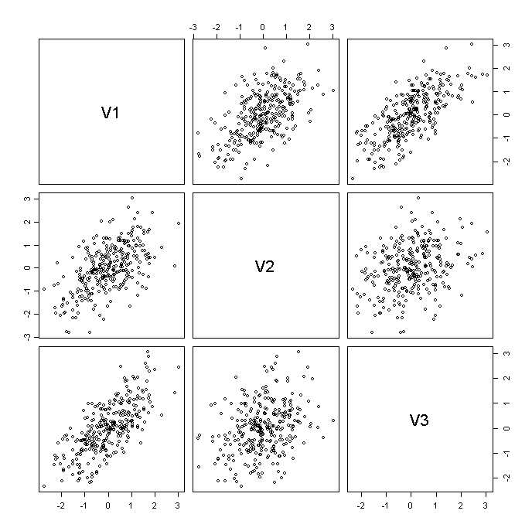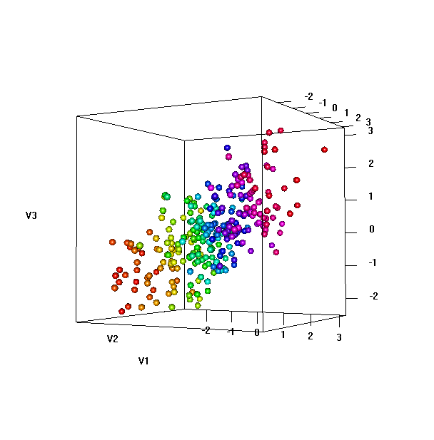
X.cor = cor(X)
X.cor
V1 V2 V3
V1 1.0000 0.5619 0.7043
V2 0.5619 1.0000 0.3042
V3 0.7043 0.3042 1.0000

2b. Eigen analysis of X.cor

X.e = eigen(X.cor)
X.e
$values
[1] 2.0633 0.7055 0.2311

$vectors
[,1] [,2] [,3]
[1,] 0.6460 0.0950 0.7574
[2,] 0.5051 -0.7972 -0.3308
[3,] 0.5724 0.5962 -0.5630

X.svd = svd(X.cor)
X.svd
$d
[1] 2.0633 0.7055 0.2311
$u
[,1] [,2] [,3]
[1,] -0.6460 0.0950 -0.7574
[2,] -0.5051 -0.7972 0.3308
[3,] -0.5724 0.5962 0.5630
$v
[,1] [,2] [,3]
[1,] -0.6460 0.0950 -0.7574
[2,] -0.5051 -0.7972 0.3308
[3,] -0.5724 0.5962 0.5630

U = X.e$vectors # Get rotation matrix of eigenvectors
t(U) %*% U
[,1] [,2] [,3]
[1,] 1.000e+00 -6.611e-17 -2.629e-17
[2,] -6.611e-17 1.000e+00 7.066e-17
[3,] -2.629e-17 7.066e-17 1.000e+00
zapsmall(t(U) %*% U)
[,1] [,2] [,3]
[1,] 1 0 0
[2,] 0 1 0
[3,] 0 0 1

2c. Rotated (uncorrelated) data matrix

Z = X %*% U
Error in X %*% U : requires numeric matrix/vector arguments
Z = as.matrix(X) %*% U
pairs(Z)
zapsmall(cor(Z))
[,1] [,2] [,3]
[1,] 1 0 0
[2,] 0 1 0
[3,] 0 0 1
plot3d(Z, type="s", radius=.1, col=rainbow(300)[rank(X[,1])])
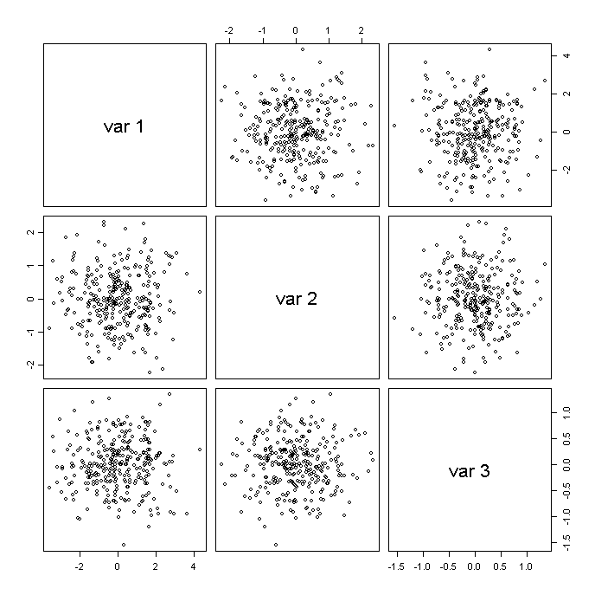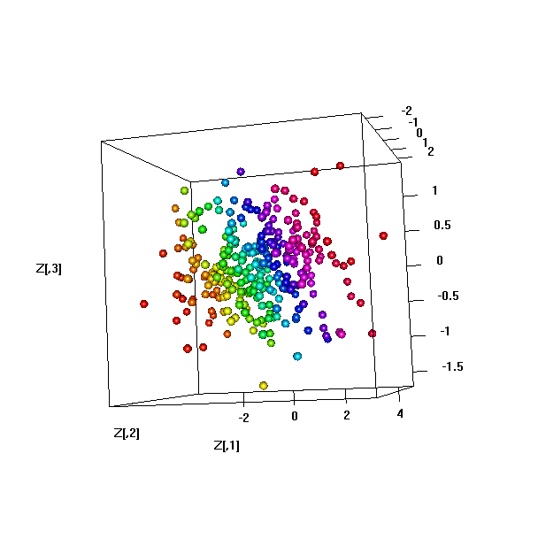
2d. Dimension reduction – discarding higher components

plot3d(Z[,1], Z[,2], rep(0,300), type="s", radius=.1,
col=rainbow(300)[rank(X[,1])]) # First two principal components
plot3d(Z[,1], rep(0,300), rep(0,300), type="s", radius=.1,
col=rainbow(300)[rank(X[,1])]) # First principal component
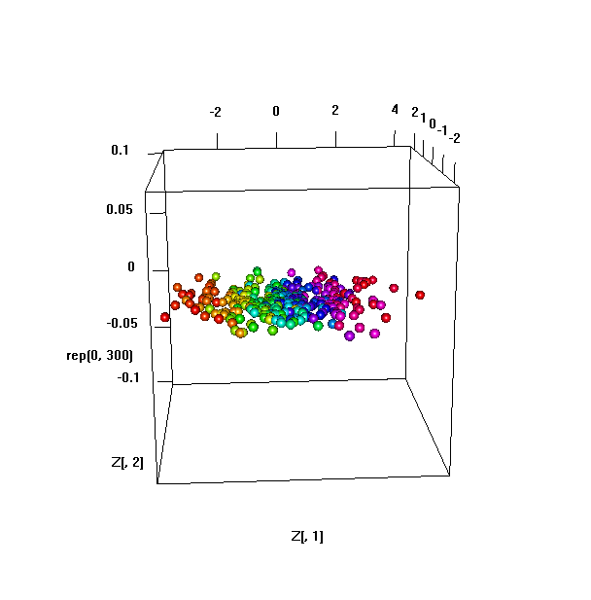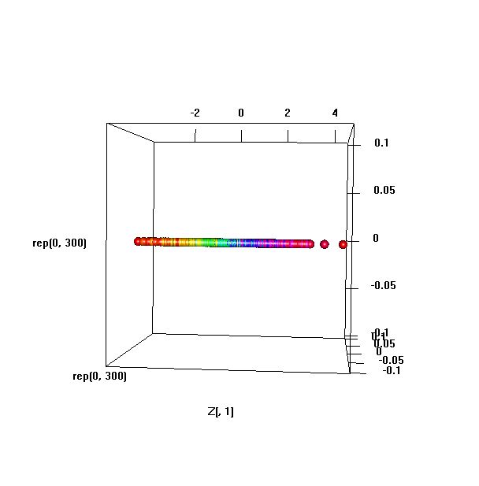
2e. Projection back into X-space

Z1 = cbind(Z[,1], rep(0,300), rep(0,300))
X1 = Z1 %*% t(U)
plot3d(X, type="s", radius=.1, col=rainbow(300)[rank(X[,1])],
alpha=.3) # Original data
spheres3d(X1[,1],X1[,2],X1[,3], radius=.1,
color=rainbow(300)[rank(X[,1])]) # First PC

Z2 = cbind(rep(0,300), Z[,2], rep(0,300))
X2 = Z2 %*% t(U)
spheres3d(X2[,1],X2[,2],X2[,3], radius=.1,
color=rainbow(300)[rank(X[,1])]) # Second PC
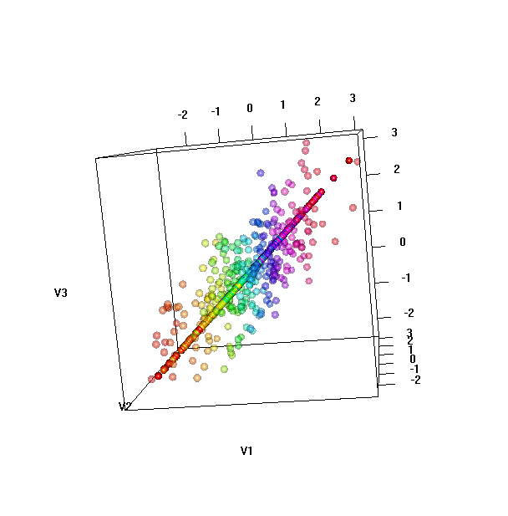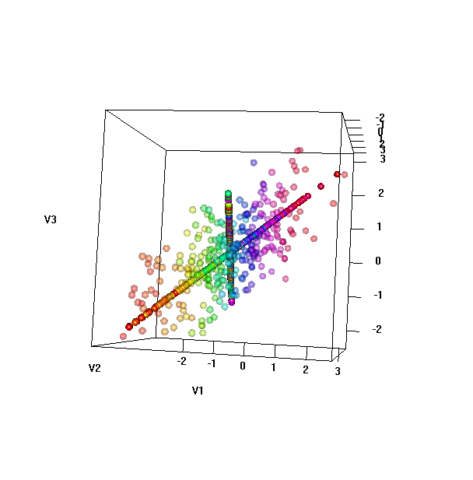
Z3 = cbind(rep(0,300),rep(0,300), Z[,3])
X3 = Z3 %*% t(U)
spheres3d(X3[,1],X3[,2],X3[,3], radius=.1,
color=rainbow(300)[rank(X[,1])]) # Third PC

Z12 = cbind(Z[,1:2],rep(0, 300))
X12 = Z12 %*% t(U)
plot3d(X, type="s", radius=.07, col=rainbow(300)[rank(X[,1])],
alpha=.3) # Original data
spheres3d(X12[,1],X12[,2],X12[,3], radius=.1,
color=rainbow(300)[rank(X[,1])]) # First two PCs
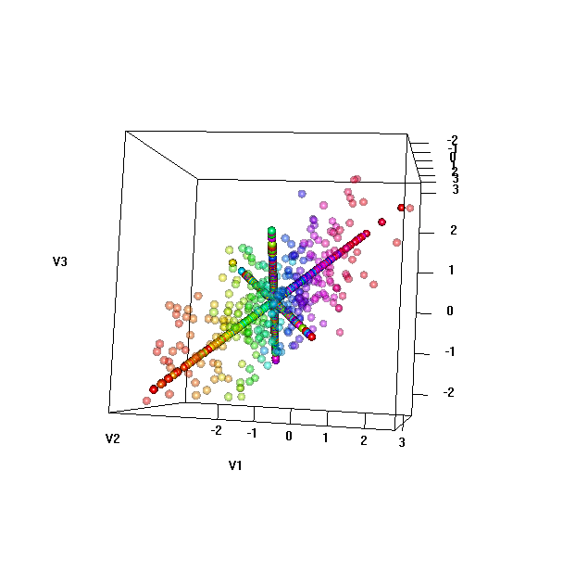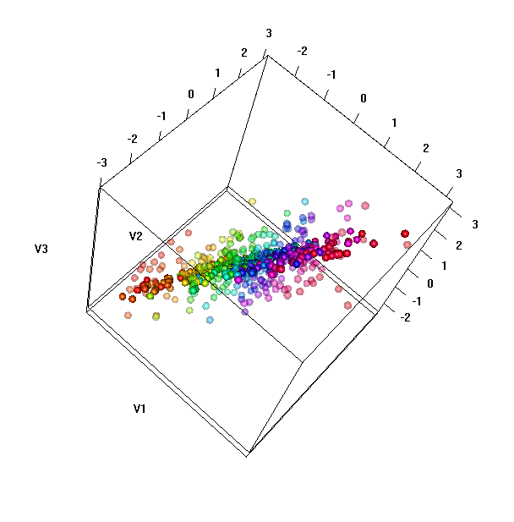

#Reproducing Figures 4.5 and 4.9 from text

Z1.adj= cbind(rep(0,300), Z[,2:3])
X.Z1.adj=Z1.adj %*% t(U)
pairs(X.Z1.adj); pairs(X)
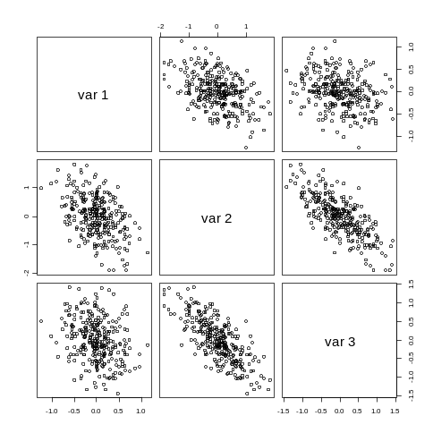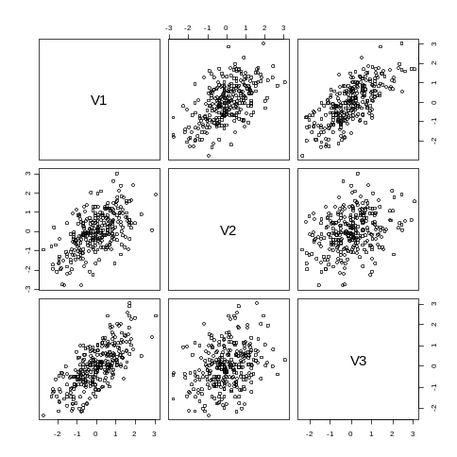

2f. Fractions of Variance

lambda = X.e$values# Eigenvalues of cor(X) = variances of PCs
lambda
[1] 2.0633 0.7055 0.2311

zapsmall(cov(Z))
[,1] [,2] [,3]
[1,] 2.063 0.0000 0.0000
[2,] 0.000 0.7055 0.0000
[3,] 0.000 0.0000 0.2311

zapsmall(cor(Z))
[,1] [,2] [,3]
[1,] 1 0 0
[2,] 0 1 0
[3,] 0 0 1

diag(cov(Z))
[1] 2.0633 0.7055 0.2311

sum(diag(cov(Z))) # Note: sum = number of dimensions = sum of
original correlations
[1] 3

2g. Principle component loadings
# PC loadings are correlations between PCs and original variables V1, V2, and V3

F=cor(X,Z)

[,1] [,2] [,3]
V1 0.9279238 0.07980886 0.3641036
V2 0.7255018 -0.66958677 -0.1590330
V3 0.8221616 0.50081578 -0.2706650

F^2 has interesting properties/interpretations as follows:

apply(F^2,1,sum)

V1 V2 V3
0.9999835 0.9999907 1.0000257

The sum of all square loadings for each variable V1, V2, and V3 is exactly 1.00 theoretically (rounding errors above). This is called the communality of V’s in Factor Analysis, which is always less than 1.

apply(F^2,2,sum)
[1] 2.0633452 0.7055323 0.2311225

The sum of all square loadings for each principal components PC1, PC2, PC3 is the variance of the corresponding PC, or equivalently, its eigenvalue.

D=diag(X.svd$d) # diag matrix of var(Z)

F=cor(X,Z)

#
# Check that F = U%*%sqrt(D) # Equation (4.11) of the text
# This explains why the column sum of F^2 = eigenvalue
#
# Furthermore, F%*%t(F) = U%*%sqrt(D)%*%sqrt(t(D))%*%t(U)
# = U%*%D%*%t(U)
# = X.cor
# This explains why the row sum of F^2 = 1
#

3. The prcomp() function

X.pc = prcomp(X, scale=T)
X.pc
Standard deviations:
[1] 1.4364 0.8400 0.4808

Rotation:
PC1 PC2 PC3
V1 0.6460 -0.0950 -0.7574
V2 0.5051 0.7972 0.3308
V3 0.5724 -0.5962 0.5630

X.pc$rotation # Compare to U above - same except for possible sign
reversal
PC1 PC2 PC3
V1 0.6460 -0.0950 -0.7574
V2 0.5051 0.7972 0.3308
V3 0.5724 -0.5962 0.5630

U
[,1] [,2] [,3]
[1,] 0.6460 0.0950 0.7574
[2,] 0.5051 -0.7972 -0.3308
[3,] 0.5724 0.5962 -0.5630

X.pc$sdev # Component sds
[1] 1.4364 0.8400 0.4808
X.pc$sdev^2 # Component Variances - compare to lambda above
[1] 2.0633 0.7055 0.2311
lambda
[1] 2.0633 0.7055 0.2311

pairs(X.pc$x) # Same as Z above, again except for possible sign
change
pairs(Z)
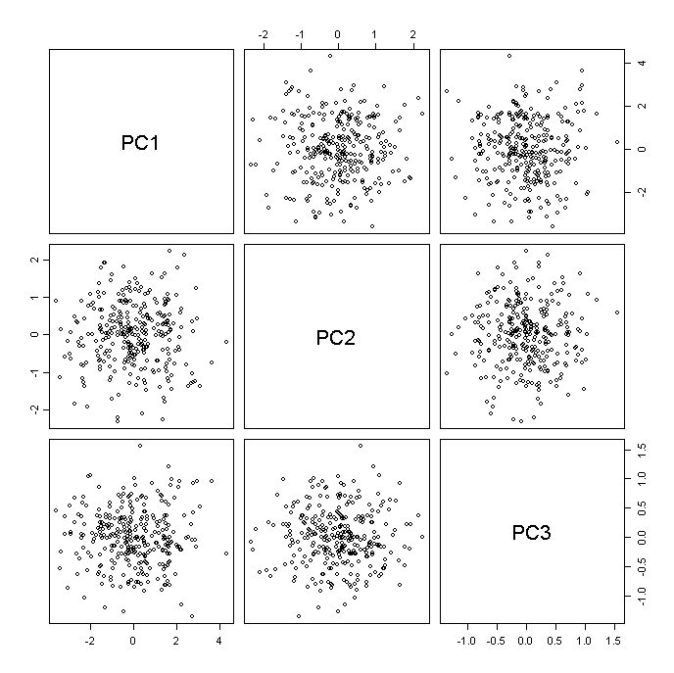

4. State Economic Data

4a. Raw Data

data(state)

gsp.raw=read.table("http://www.uidaho.edu/~stevel/519/Data/GSP_RAW.txt", header=T)
rownames(gsp.raw) = state.abb
pairs(gsp.raw)

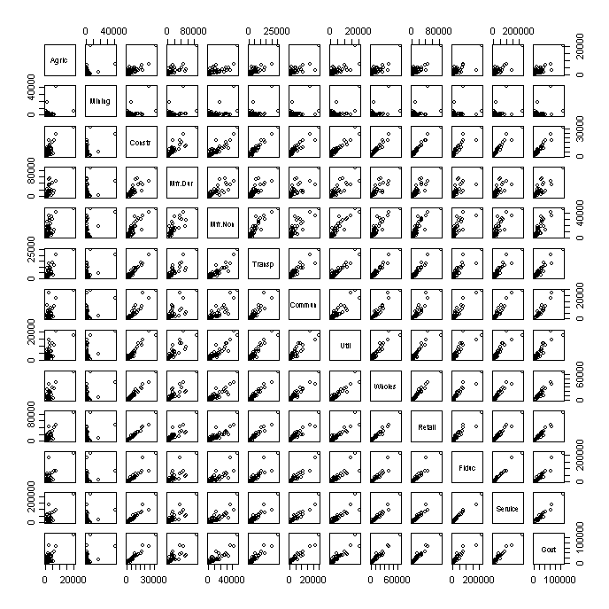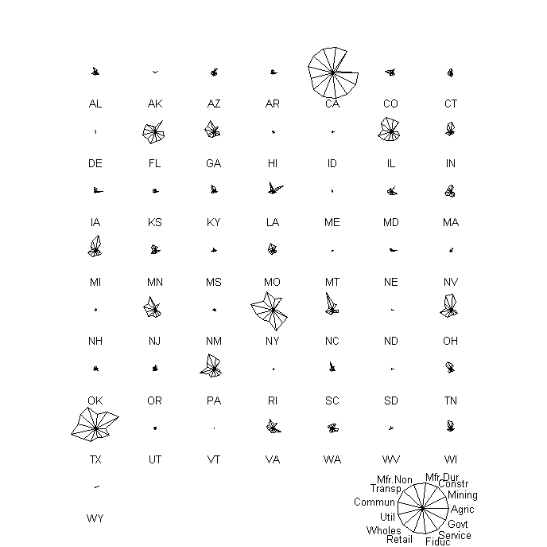
cor(gsp.raw) # Strong correlations
Agric Mining Constr Mfr.Dur Mfr.Non Transp Commun Util Wholes
Agric 1.0000 0.2477 0.8039 0.7491 0.6622 0.8126 0.7164 0.6738 0.8148
Mining 0.2477 1.0000 0.4153 0.2619 0.3914 0.4582 0.3563 0.5249 0.3464
: : : : : : : : : :
Retail Fiduc Service Govt
Agric 0.8480 0.7397 0.8041 0.8144
Mining 0.3429 0.1900 0.2687 0.3442
: : : : :

gsp.raw.pc = prcomp(gsp.raw, scale=T)
gsp.raw.pc$sdev^2 # Variances - almost everything in PC 1
[1] 10.944317 0.979435 0.400057 0.342677 0.139213 0.069394 0.040148
[8] 0.033343 0.025092 0.010548 0.007488 0.006057 0.002230
gsp.raw.pc$rotation[,1:2]
# this is the linear combinations of the original variables
PC1 PC2
Agric 0.2492 -0.14659
Mining 0.1200 0.91291
Constr 0.2984 0.03271
Mfr.Dur 0.2684 -0.08813
Mfr.Non 0.2731 0.09136
Transp 0.2963 0.08562
Commun 0.2871 -0.02304
Util 0.2873 0.19687
Wholes 0.2999 -0.05347
Retail 0.2993 -0.06426
Fiduc 0.2831 -0.22046
Service 0.2949 -0.14864
Govt 0.2975 -0.06012

The linear combinations of the original variables for PC 1 are almost all equal, thus PC 1 is simply a measure of economic size.

4b. Share data

To look beyond size of economy, we rescale so each sector is represented as a percentage of state economy.

gsp.share = gsp.raw/apply(gsp.raw, 1, sum)*100

pairs(gsp.share)
stars(gsp.share, key.loc=c(15, 1.5))
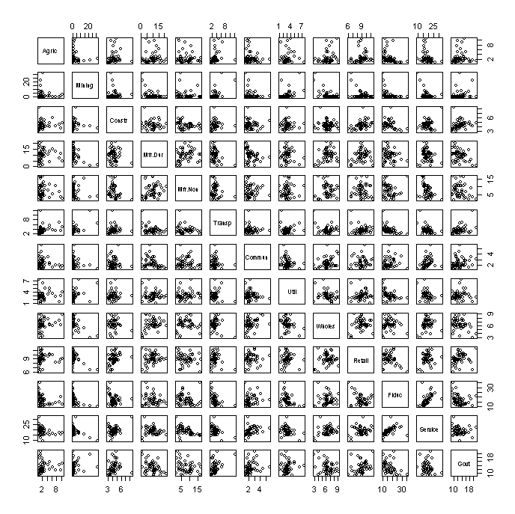
cor(gsp.share)
Agric Mining Constr Mfr.Dur Mfr.Non Transp Commun
Agric 1.00000 -0.06077 0.08309 0.02968 -0.14543 0.27811 -0.18182
Mining -0.06077 1.00000 -0.02528 -0.42290 -0.13795 0.61535 -0.19498
: : : : : : : :
Util Wholes Retail Fiduc Service Govt
Agric 0.04424 0.24525 0.09197 -0.29997 -0.3258 0.11345
Mining 0.39641 -0.54818 -0.39219 -0.40669 -0.4615 0.22945
: : : : : : :

gsp.share.pc = prcomp(gsp.share, scale=T)

names(gsp.share.pc)
[1] "sdev" "rotation" "center" "scale" "x"

summary(as.matrix(scale(gsp.share))%*%gsp.share.pc$rotation-gsp.share.pc$x)
PC1 PC2 PC3 PC4 PC5
Min. :0 Min. :0 Min. :0 Min. :0 Min. :0
1st Qu.:0 1st Qu.:0 1st Qu.:0 1st Qu.:0 1st Qu.:0
Median :0 Median :0 Median :0 Median :0 Median :0
Mean :0 Mean :0 Mean :0 Mean :0 Mean :0
3rd Qu.:0 3rd Qu.:0 3rd Qu.:0 3rd Qu.:0 3rd Qu.:0
Max. :0 Max. :0 Max. :0 Max. :0 Max. :0
PC6 PC7 PC8 PC9 PC10
Min. :0 Min. :0 Min. :0 Min. :0 Min. :0
1st Qu.:0 1st Qu.:0 1st Qu.:0 1st Qu.:0 1st Qu.:0
Median :0 Median :0 Median :0 Median :0 Median :0
Mean :0 Mean :0 Mean :0 Mean :0 Mean :0
3rd Qu.:0 3rd Qu.:0 3rd Qu.:0 3rd Qu.:0 3rd Qu.:0
Max. :0 Max. :0 Max. :0 Max. :0 Max. :0
PC11 PC12 PC13
Min. :0 Min. :0 Min. :0
1st Qu.:0 1st Qu.:0 1st Qu.:0
Median :0 Median :0 Median :0
Mean :0 Mean :0 Mean :0
3rd Qu.:0 3rd Qu.:0 3rd Qu.:0
Max. :0 Max. :0 Max. :0

# cor(X1,PC1)
cor(as.matrix(scale(gsp.share)[,1]), gsp.share.pc$x[,1])
[,1]
[1,] 0.2469082

# cor(X1, PC1), cor(X2, PC1), …
cor(as.matrix(scale(gsp.share)), gsp.share.pc$x[,1])
[,1]
Agric 0.24690822
Mining 0.84357906
Constr 0.06618081
Mfr.Dur -0.32643503
Mfr.Non -0.01794627
Transp 0.75317521
Commun -0.27803033
Util 0.45478373
Wholes -0.56245112
Retail -0.15412104
Fiduc -0.65632481
Service -0.68438955
Govt 0.51833497

gsp.share.pc.loadings=cor(as.matrix((gsp.share)), gsp.share.pc$x)

gsp.share.pc.loadings[,1:3]
PC1 PC2 PC3
Agric 0.24690822 -0.008920553 -0.529471093
Mining 0.84357906 -0.006679738 0.365279887
Constr 0.06618081 0.587520333 -0.369241064
Mfr.Dur -0.32643503 -0.557641421 -0.536056281
Mfr.Non -0.01794627 -0.686105148 -0.050528407
Transp 0.75317521 0.212912443 0.004345768
Commun -0.27803033 0.471591083 0.136805682
Util 0.45478373 -0.189775243 -0.105819926
Wholes -0.56245112 -0.041614105 -0.400509512
Retail -0.15412104 0.403484940 -0.708196904
Fiduc -0.65632481 0.040684412 0.621203940
Service -0.68438955 0.572195187 0.172002425
Govt 0.51833497 0.557086297 -0.106047305

apply(gsp.share.pc.loadings[,1:3]^2,2,sum)
PC1 PC2 PC3
3.243180 2.234693 1.958626

zapsmall(gsp.share.pc$sdev^2) # Variances - much more balanced
[1] 3.243 2.235 1.959 1.373 1.151 0.862 0.724 0.613 0.320 0.235 0.150 0.135
[13] 0.000

pairs(gsp.share.pc$x[,1:6]) # First 6 PCs
plot(gsp.share.pc$x[,1:2], type='n')
text(gsp.share.pc$x[,1:2], state.abb)
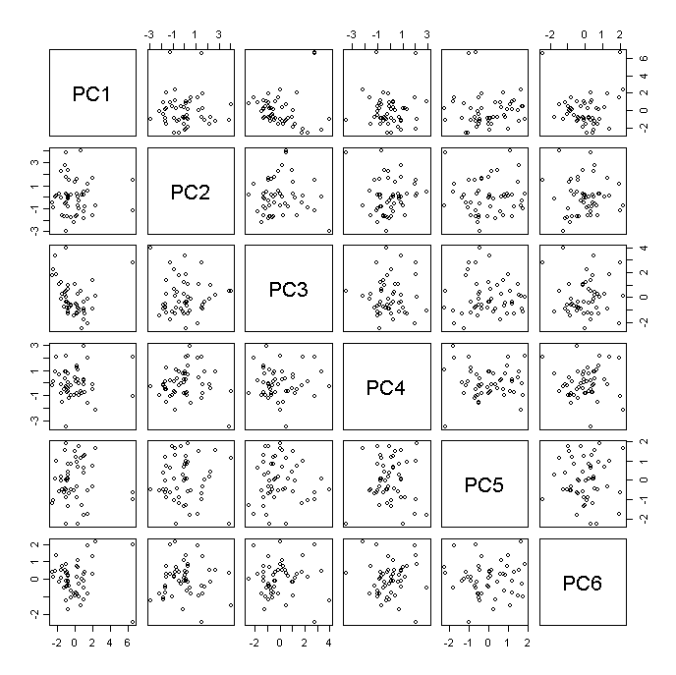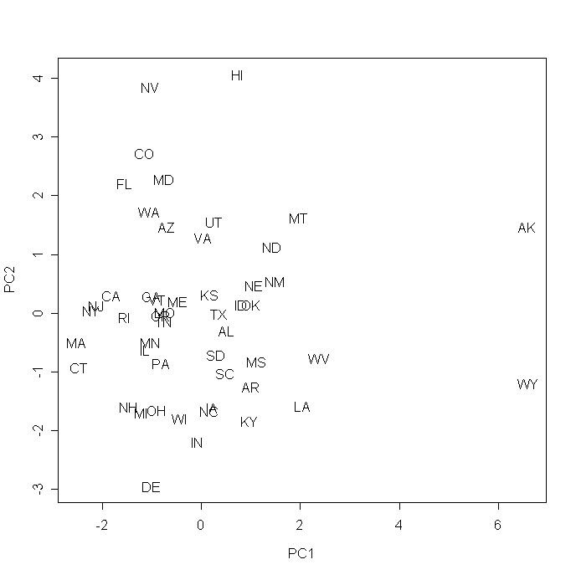
gsp.share.pc$rotation[,1:6]
PC1 PC2 PC3 PC4 PC5 PC6
Agric 0.137104 -0.005967 -0.378326 0.383700 -0.40373 0.24264
Mining 0.468425 -0.004468 0.261006 -0.067147 -0.06866 0.16683
Constr 0.036749 0.393019 -0.263836 -0.343443 -0.19477 -0.03677
Mfr.Dur -0.181264 -0.373032 -0.383032 -0.144035 -0.11215 -0.20095
Mfr.Non -0.009965 -0.458967 -0.036104 0.041855 0.47231 -0.21313
Transp 0.418225 0.142427 0.003105 0.359913 -0.14680 -0.17265
Commun -0.154386 0.315469 0.097753 0.350301 0.54237 0.25310
Util 0.252534 -0.126949 -0.075612 -0.408044 0.21097 0.69021
Wholes -0.312320 -0.027838 -0.286179 0.448490 0.01020 0.35181
Retail -0.085581 0.269910 -0.506032 -0.215611 0.25684 -0.13458
Fiduc -0.364446 0.027216 0.443873 0.001280 -0.17635 -0.05128
Service -0.380030 0.382768 0.122902 -0.186079 -0.12521 0.10814
Govt 0.287823 0.372661 -0.075775 0.082513 0.29261 -0.31569

eigen(cor(scale(gsp.share)))
$values
[1] 3.243180e+00 2.234693e+00 1.958626e+00 1.373480e+00
[5] 1.151385e+00 8.622254e-01 7.237538e-01 6.129357e-01
[9] 3.197567e-01 2.347687e-01 1.503278e-01 1.348683e-01
[13] -3.129611e-17

$vectors
[,1] [,2] [,3] [,4]
[1,] -0.13710396 -0.005967369 0.378326276 0.383699800
[2,] -0.46842521 -0.004468384 -0.261005712 -0.067147368
[3,] -0.03674909 0.393019416 0.263836116 -0.343443271
[4,] 0.18126386 -0.373032036 0.383031632 -0.144034892
[5,] 0.00996526 -0.458967341 0.036104377 0.041855473
[6,] -0.41822548 0.142426942 -0.003105209 0.359913140
[7,] 0.15438555 0.315469001 -0.097752616 0.350300925
[8,] -0.25253372 -0.126949403 0.075612170 -0.408043717
[9,] 0.31231961 -0.027837592 0.286178555 0.448489721
[10,] 0.08558081 0.269909664 0.506032343 -0.215611315
[11,] 0.36444608 0.027215677 -0.443872719 0.001280192
[12,] 0.38002996 0.382767720 -0.122901963 -0.186078699
[13,] -0.28782266 0.372660688 0.075774641 0.082513107

…

svd(cor(scale(gsp.share)))
$d
[1] 3.243180e+00 2.234693e+00 1.958626e+00 1.373480e+00
[5] 1.151385e+00 8.622254e-01 7.237538e-01 6.129357e-01
[9] 3.197567e-01 2.347687e-01 1.503278e-01 1.348683e-01
[13] 2.346011e-16

$u
[,1] [,2] [,3] [,4]
[1,] -0.13710396 0.005967369 0.378326276 0.383699800
[2,] -0.46842521 0.004468384 -0.261005712 -0.067147368
[3,] -0.03674909 -0.393019416 0.263836116 -0.343443271
[4,] 0.18126386 0.373032036 0.383031632 -0.144034892
[5,] 0.00996526 0.458967341 0.036104377 0.041855473
[6,] -0.41822548 -0.142426942 -0.003105209 0.359913140
[7,] 0.15438555 -0.315469001 -0.097752616 0.350300925
[8,] -0.25253372 0.126949403 0.075612170 -0.408043717
[9,] 0.31231961 0.027837592 0.286178555 0.448489721
[10,] 0.08558081 -0.269909664 0.506032343 -0.215611315
[11,] 0.36444608 -0.027215677 -0.443872719 0.001280192
[12,] 0.38002996 -0.382767720 -0.122901963 -0.186078699
[13,] -0.28782266 -0.372660688 0.075774641 0.082513107
…

$v
[,1] [,2] [,3] [,4]
[1,] -0.13710396 0.005967369 0.378326276 0.383699800
[2,] -0.46842521 0.004468384 -0.261005712 -0.067147368
[3,] -0.03674909 -0.393019416 0.263836116 -0.343443271
[4,] 0.18126386 0.373032036 0.383031632 -0.144034892
[5,] 0.00996526 0.458967341 0.036104377 0.041855473
[6,] -0.41822548 -0.142426942 -0.003105209 0.359913140
[7,] 0.15438555 -0.315469001 -0.097752616 0.350300925
[8,] -0.25253372 0.126949403 0.075612170 -0.408043717
[9,] 0.31231961 0.027837592 0.286178555 0.448489721
[10,] 0.08558081 -0.269909664 0.506032343 -0.215611315
[11,] 0.36444608 -0.027215677 -0.443872719 0.001280192
[12,] 0.38002996 -0.382767720 -0.122901963 -0.186078699
[13,] -0.28782266 -0.372660688 0.075774641 0.082513107

gsp.share[c(2,8,11,28,50),] # Values of some outliers in
original units
Agric Mining Constr Mfr.Dur Mfr.Non Transp Commun Util Wholes Retail
AK 1.4692 22.44847 4.068 1.1464 3.659 12.089 2.024 1.490 2.938 6.523
DE 1.0236 0.02118 3.424 4.5286 16.625 1.631 1.338 2.358 3.967 5.993
HI 1.2253 0.07710 4.827 0.7517 2.343 4.452 3.095 2.731 3.981 11.542
NV 0.7562 3.66749 8.372 3.1422 1.680 2.896 1.790 3.036 4.616 9.412
WY 2.1429 31.59801 3.692 1.3950 4.339 6.429 1.389 6.423 3.223 6.536
Fiduc Service Govt
AK 10.69 11.882 19.568
DE 35.39 14.267 9.435
HI 21.39 22.240 21.345
NV 18.40 32.290 9.944

5. Biplot

The biplot shows
- a plot of cases of observations on the first two principal components, overlaid on
- a plot of variables showing the loadings on those same two components.

Figure 1 from John Aitchison and Michael Greenacre: ‘Biplots of Compositional Data’, Applied Statistics (2002) pp. 375-392, provides a good summary of biplots as follows:
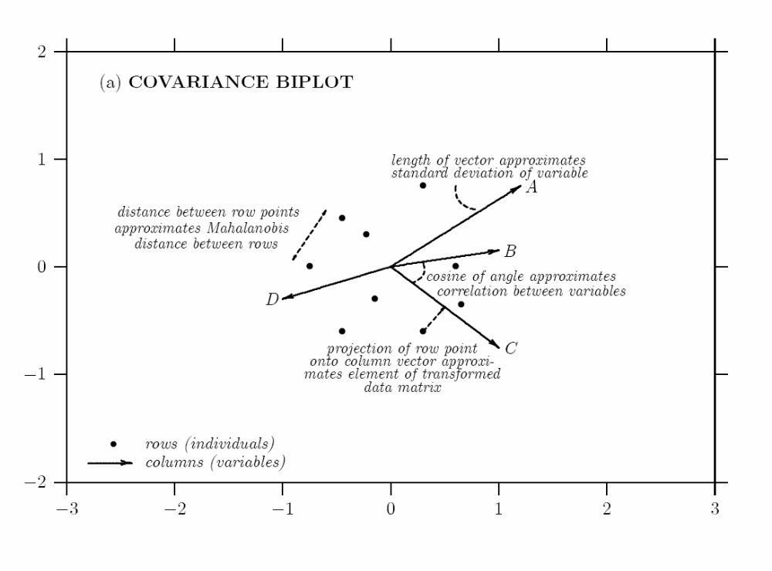

biplot(gsp.share.pc)

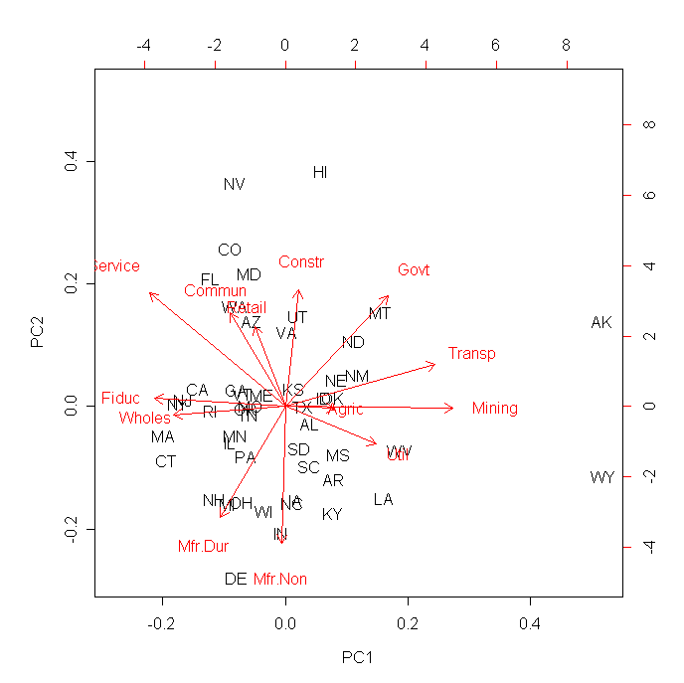
gsp.share.pc.loadings[,c(1:2)]
PC1 PC2
Agric 0.24690822 -0.008920553
Mining 0.84357906 -0.006679738
Constr 0.06618081 0.587520333
Mfr.Dur -0.32643503 -0.557641421
Mfr.Non -0.01794627 -0.686105148
Transp 0.75317521 0.212912443
Commun -0.27803033 0.471591083
Util 0.45478373 -0.189775243
Wholes -0.56245112 -0.041614105
Retail -0.15412104 0.403484940
Fiduc -0.65632481 0.040684412
Service -0.68438955 0.572195187
Govt 0.51833497 0.557086297

plot(gsp.share.pc.loadings[,c(1:2)])
#plot(gsp.share.pc.loadings[,c(1:2)],xlim=c(-.8,.8),ylim=c(-.8,.8))
text(gsp.share.pc.loadings[,c(1:2)],labels=row.names(gsp.share.pc.loadings),col='red')
points(0,0,col='red',pch='*')
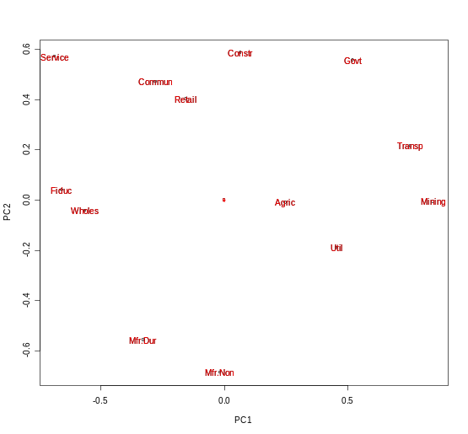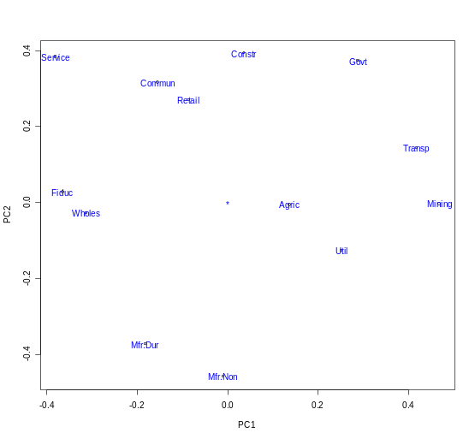
gsp.share.pc$rotation[,c(1:2)]
PC1 PC2
Agric 0.13710396 -0.005967369
Mining 0.46842521 -0.004468384
Constr 0.03674909 0.393019416
Mfr.Dur -0.18126386 -0.373032036
Mfr.Non -0.00996526 -0.458967341
Transp 0.41822548 0.142426942
Commun -0.15438555 0.315469001
Util 0.25253372 -0.126949403
Wholes -0.31231961 -0.027837592
Retail -0.08558081 0.269909664
Fiduc -0.36444608 0.027215677
Service -0.38002996 0.382767720
Govt 0.28782266 0.372660688

plot(gsp.share.pc$rotation[,c(1:2)], xlim=c(-.8,.8),ylim=c(-.8,.8))
text(gsp.share.pc$rotation[,c(1:2)],labels=row.names(gsp.share.pc$rotation),col='blue')
points(0,0,col='blue',pch='*')

# PC loadings = PC-eigenvector * sqrt(PC-eigenvalue)
gsp.share.pc.loadings[,c(1:2)]/gsp.share.pc$rotation[,c(1:2)]
PC1 PC2
Agric 1.800883 1.494889
Mining 1.800883 1.494889
Constr 1.800883 1.494889
Mfr.Dur 1.800883 1.494889
Mfr.Non 1.800883 1.494889
Transp 1.800883 1.494889
Commun 1.800883 1.494889
Util 1.800883 1.494889
Wholes 1.800883 1.494889
Retail 1.800883 1.494889
Fiduc 1.800883 1.494889
Service 1.800883 1.494889
Govt 1.800883 1.494889

gsp.share.pc$sdev[1:2]
[1] 1.800883e+00 1.494889e+00

6. How many components?

6a. Scree plot (keep components above the "elbow").

plot(gsp.share.pc)
plot(gsp.share.pc$sdev^2, type="o", pch=16, col=="red") # Alternate Version

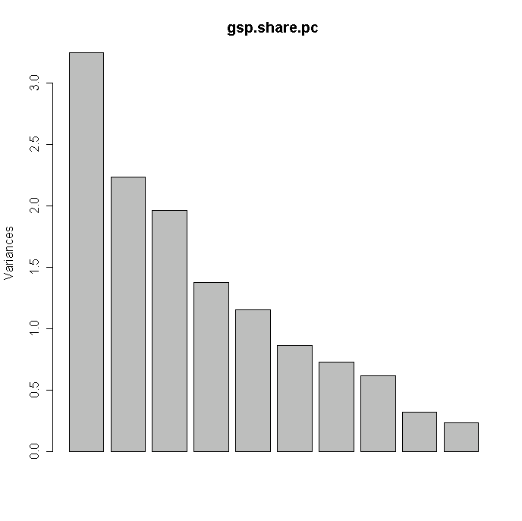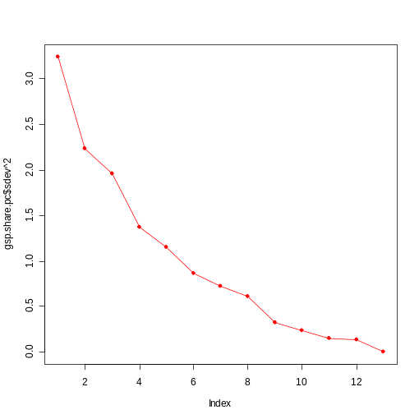
6b. Kaiser's Rule - keep components with variance 1

zapsmall(gsp.share.pc$sdev^2)
[1] 3.243 2.235 1.959 1.373 1.151 0.862 0.724 0.613 0.320 0.235 0.150 0.135
[13] 0.000
sum(gsp.share.pc$sdev>1) # Kaiser's Rule - keep components with
variance 1
[1] 5
abline(h=1,col="grey")
summary(gsp.share.pc)
Importance of components:
PC1 PC2 PC3 PC4 PC5 PC6 PC7 PC8 PC9 PC10 PC11
Standard deviation 1.8 1.5 1.4 1.2 1.07 0.93 0.85 0.78 0.57 0.48 0.39
Proportion of Variance 0.2 0.2 0.2 0.1 0.09 0.07 0.06 0.05 0.02 0.02 0.01
Cumulative Proportion 0.2 0.4 0.6 0.7 0.77 0.83 0.89 0.94 0.96 0.98 0.99
PC12 PC13
Standard deviation 0.37 2e-16
Proportion of Variance 0.01 0e+00
Cumulative Proportion 1.00 1e+00

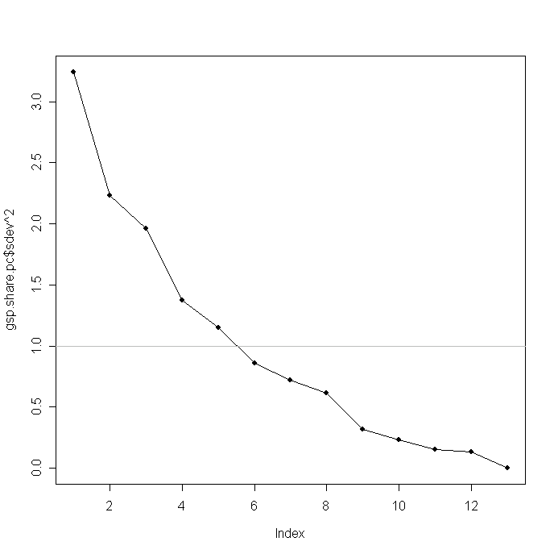
6c. Horn's procedure - compare to randomly permuted (bootstrapped) data

plot(gsp.share.pc$sdev^2, type="o", pch=16, col="red")

many.times=50

for(j in 1:many.times){
gsp.boot = gsp.share
for (i in 1:13) {
gsp.boot[,i] = sample(gsp.share[,i], replace=T) }
gsp.boot.pc = prcomp(gsp.boot, scale=T)
points(gsp.boot.pc$sdev^2, type="o")
}

Repeat many times. Keep components which are better than random.

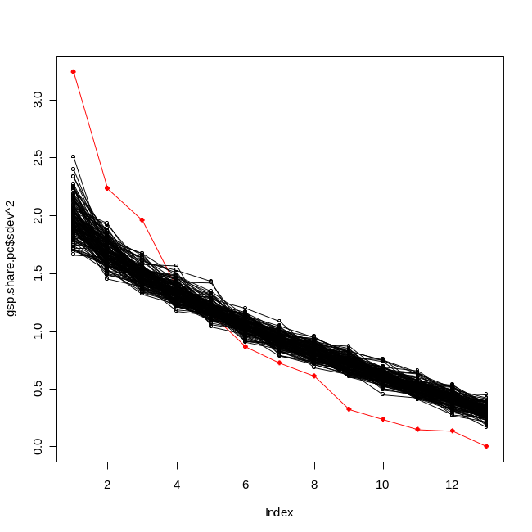
7. Bootstrap Validation

Question: Can the PC analysis result generalize well outside the original sample data?

With the lack of a holdout sample, let us consider bootstrapping the original data to assess the validity of the PC analysis.

Resample 50 observations with replacement and form the linear combination of the bootstrapped data using the 1st PC direction of the original data set (i.e., scale(gsp.share)). Compute the variance of this linear combination. Compare this variance with the variance of the 1st PC from the boostrapped data sample. Repeat this process 1000 times to get Figure 4.18.

Conslusion: As seen in Figure 4.18, the linear combination formed using the weights from a principal components analysis of the original data captures approx 90% of the variance in the average as the first PC from the bootstrapped sample data, this seems to suggest that the results do generalize reasonably well outside the original sample.

Exercise: Produce Figure 4.18 by yourself using the above description.

8. bpca - a R package for Biplot of Multivariate Data Based on Principal Components Analysis
Implements biplot (2d and 3d) of multivariate data based on principal components analysis and diagnostic tools of the quality of the reduction.
library(bpca)

##
## Example 4
## Computing and ploting a bpca object with 'rgl' package - 3d
##

plot(bpca(gabriel1971, lambda.end=3),
rgl.use=TRUE, var.factor=2)

# Suggestion: Interact with the graphic with the mouse
# left button: press, maintain and movement it to interactive rotation;
# right button: press, maintain and movement it to interactive zoom.
# Enjoy it!

##
## Example 5
## Grouping objects with different symbols and colors - 2d and 3d
##

# 2d
plot(bpca(iris[-5]),
var.factor=.3, var.cex=.7,
obj.names=FALSE, obj.cex=1.5,
obj.col=c('red', 'green3', 'blue')[unclass(iris$Species)],
obj.pch=c('+', '*', '-')[unclass(iris$Species)])

# 3d static
plot(bpca(iris[-5], lambda.end=3),
var.factor=.2, var.color=c('blue', 'red'), var.cex=1,
obj.names=FALSE, obj.cex=1,
obj.col=c('red', 'green3', 'blue')[unclass(iris$Species)],
obj.pch=c('+', '*', '-')[unclass(iris$Species)])

# 3d dinamic
plot(bpca(iris[-5], method='hj', lambda.end=3), rgl.use=TRUE,
var.col='brown', var.factor=.3, var.cex=1.2,
obj.names=FALSE, obj.cex=.8,
obj.col=unclass(iris$Species),
simple.axes=FALSE, box=TRUE)

devAskNewPage(oask)
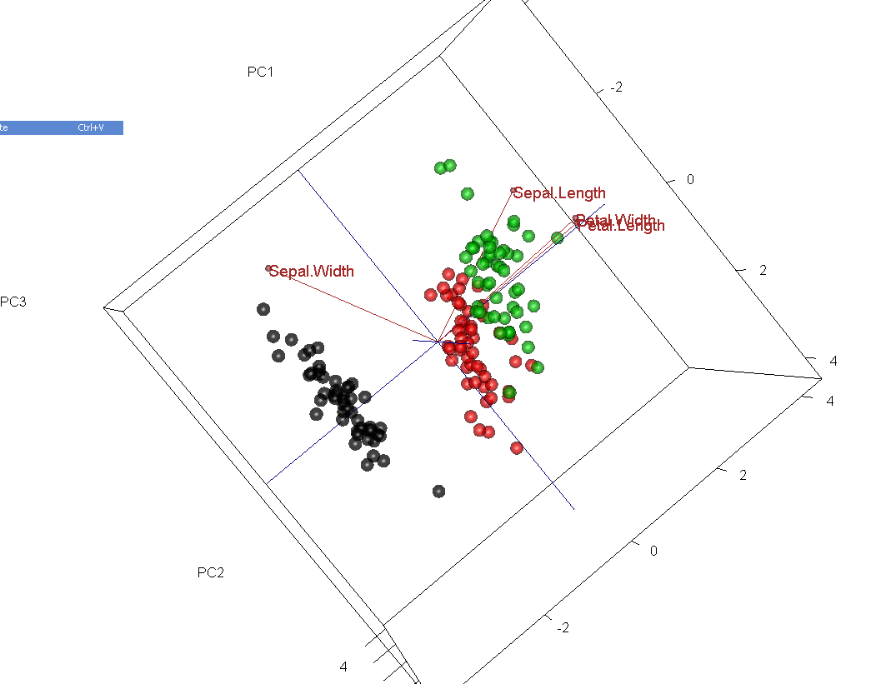

9. Some limitations of PCA

- The directions with largest variance are assumed to be of most interest.
- We only consider orthogonal transformations (rotations) of the original variables. i.e., PCA allows only linear combinations of the original variables.
- PCA is based only on the correlation (or covariance matrix for non-standardized data) of the data. Some distributions (e.g. multivariate normal) are completely characterized by this, but others are not.
- Dimension reduction can only be achieved if the original variables were correlated. If the original variables were uncorrelated, PCA does nothing, except for ordering them according to their variance.
- PCA is not scale invariant.

# Principal Components Analysis

options(digits=4)

# Eigenvalues and eigenvectors

A <- matrix(sample(9), nrow=3)
A

A.e <- eigen(A)
A.e

A %*% A.e$vectors[,1]
A.e$values[1] * A.e$vectors[,1]

A %*% A.e$vectors[,2]
A.e$values[2] * A.e$vectors[,2]

A %*% A.e$vectors[,3]
A.e$values[3] * A.e$vectors[,3]

# PCA Example

#X<-read.table("PCA_EXAMPLE.txt")

mean(X)
sd(X) # already standardized

pairs(X)

library(rgl)
plot3d(X, type="s", radius=.1, col=rainbow(300)[rank(X[,1])])
rgl.snapshot("pca1.png")

X.cor <- cor(X)
X.cor

X.e <- eigen(X.cor)

X.e

X.svd <- svd(X.cor)
X.svd

U <- X.e$vectors # Get rotation matrix of eigenvectors
t(U) %*% U
zapsmall(t(U) %*% U)

Z <- X %*% U # Rotated data matrix
Z <- as.matrix(X) %*% U
pairs(Z)
zapsmall(cor(Z))

plot3d(Z, type="s", radius=.1, col=rainbow(300)[rank(X[,1])])
rgl.snapshot("pca2.png")

plot3d(Z[,1], Z[,2], rep(0,300), type="s", radius=.1, col=rainbow(300)[rank(X[,1])]) # First two principal components
rgl.snapshot("pca3.png")

plot3d(Z[,1], rep(0,300), rep(0,300), type="s", radius=.1, col=rainbow(300)[rank(X[,1])]) # First principal component
rgl.snapshot("pca4.png")

# Rotate back to X-space

Z1 <- cbind(Z[,1], rep(0,300), rep(0,300))
X1 <- Z1 %*% t(U)

plot3d(X, type="s", radius=.1, col=rainbow(300)[rank(X[,1])], alpha=.3) # Original data
spheres3d(X1[,1],X1[,2],X1[,3], radius=.1, color=rainbow(300)[rank(X[,1])]) # First PC
rgl.snapshot("pca5.png")

Z2 <- cbind(rep(0,300), Z[,2], rep(0,300))
X2 <- Z2 %*% t(U)

spheres3d(X2[,1],X2[,2],X2[,3], radius=.1, color=rainbow(300)[rank(X[,1])]) # Second PC
rgl.snapshot("pca6.png")

Z3 <- cbind(rep(0,300),rep(0,300), Z[,3])
X3 <- Z3 %*% t(U)

spheres3d(X3[,1],X3[,2],X3[,3], radius=.1, color=rainbow(300)[rank(X[,1])]) # Third PC
rgl.snapshot("pca7.png")

Z12 <- cbind(Z[,1:2],rep(0, 300))
X12 <- Z12 %*% t(U)

plot3d(X, type="s", radius=.1, col=rainbow(300)[rank(X[,1])], alpha=.3) # Original data
spheres3d(X12[,1],X12[,2],X12[,3], radius=.1, color=rainbow(300)[rank(X[,1])]) # First two PCs
rgl.snapshot("pca8.png")

# Fractions of variance

lambda <- X.e$values # Eigenvalues of cor(X) = variances of PCs
lambda

zapsmall(cov(Z))

zapsmall(cor(Z))

diag(cov(Z))
sum(diag(cov(Z))) # Note: sum = number of dimensions = sum of original correlations

# The prcomp( ) function

X.pc <- prcomp(X, scale=T)
X.pc

X.pc$rotation # Compare to U above - same except for possible sign reversal

U

X.pc$sdev # Component sds
X.pc$sdev^2 # Component Variances - compare to lambda above
lambda

pairs(X.pc$x) # Same as Z above, again except for possible sign change

# New example: State economic data
data(state)

gsp.raw=read.table("http://www.uidaho.edu/~stevel/519/Data/GSP_RAW.txt", header=T)

rownames(gsp.raw) <- state.abb
pairs(gsp.raw)
stars(gsp.raw, key.loc=c(15, 1.5))
cor(gsp.raw) # Strong correlation

gsp.raw.pc <- prcomp(gsp.raw, scale=T)
gsp.raw.pc$sdev^2 # Variances - almost everything in PC 1

gsp.raw.pc$rotation[,1:2] # Loadings for PCs 1 and 2
# Loadings for PC 1 almost all equal - simply a measure of economic size

# COnvert each state's earnings into a percentage for each sector

gsp.share <- gsp.raw/apply(gsp.raw, 1, sum)*100

pairs(gsp.share)
stars(gsp.share, key.loc=c(15, 1.5))
cor(gsp.share)

gsp.share.pc <- prcomp(gsp.share, scale=T)
zapsmall(gsp.share.pc$sdev^2) # Variances - much more balanced

pairs(gsp.share.pc$x[,1:6]) # First 6 PCs
plot(gsp.share.pc$x[,1:2], pch=16) # First 2
plot(gsp.share.pc$x[,1:2], type='n')
text(gsp.share.pc$x[,1:2], state.abb)

# Loadings - first 6 PCs

gsp.share.pc$rotation[,1:6]

# Values of some outliers in original units

gsp.share[c(2,8,11,28,50),]

# biplot - loadings on 1st 2 PCs and plot of first 2 PCs

biplot(gsp.share.pc)

# How many components?

plot(gsp.share.pc) # Scree plot
plot(gsp.share.pc$sdev^2, type="o", pch=16) # Alternate Version

zapsmall(gsp.share.pc$sdev^2)
sum(gsp.share.pc$sdev>1) # Kaiser's Rule - keep components with variance > 1
abline(h=1,col="grey")

summary(gsp.share.pc)

# Horn's procedure - compare to randomly permuted (bootstrapped) data

gsp.boot <- gsp.share
for (i in 1:13) {
gsp.boot[,i] <- sample(gsp.share[,i], replace=T) }
gsp.boot.pc <- prcomp(gsp.boot, scale=T)
points(gsp.boot.pc$sdev^2, type="o") # Add to alternate scree plot; compare
# Repeat; add different runs in different colors

# Another example - planetary data

#planets1<-read.table("planets.txt")
planets1
pairs(planets1)

# Log transform values except rings (add one to number Moons)

planets <- cbind(logDist=log(planets1$Dist), logRadius = log(planets1$Radius),
logMass =log(planets1$Mass), logDensity=log(planets1$Density), logMoons=log(planets1$Moons+1), Rings=unclass(planets1$Rings)-1)
rownames(planets)<-rownames(planets1)
planets
pairs(planets)

planets.pc <- prcomp(planets, scale=T)
planets.pc$sdev^2

plot(planets.pc$sdev^2, type="o", pch=16)
abline(h=1,col="grey")

plot(planets.pc$x[,1:2], pch=16)

text(planets.pc$x[,1], planets.pc$x[,2], rownames(planets))
# Note the three clusters

planets.pc$rotation[,1:2]

biplot(planets.pc)

