

Design of an AM receiver

ECSE 434

Micro Electronics Lab

4.2 Lab Preparation - Preamplifier

Sharhad Bashar, *260519664*

Chrouk Kassem, *260512917*

Zixuan Yin, *260502051*

Wednesday, 11th November, 2015

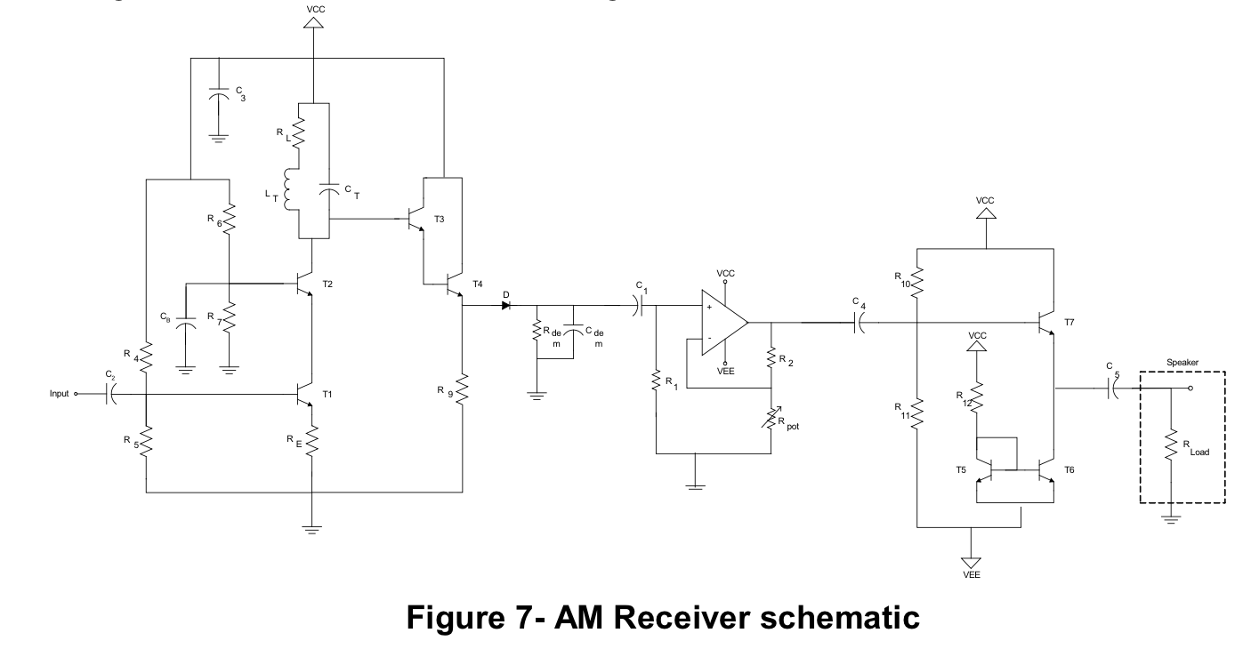

**5.1.1. Simulate the whole system in SPICE using a multiplier to create your AM modulated input. Provide a plot of the output signal and of the input signal, so that the modulation and demodulation are apparent.**

Upon completion of the simulation, the following graphs were produced:

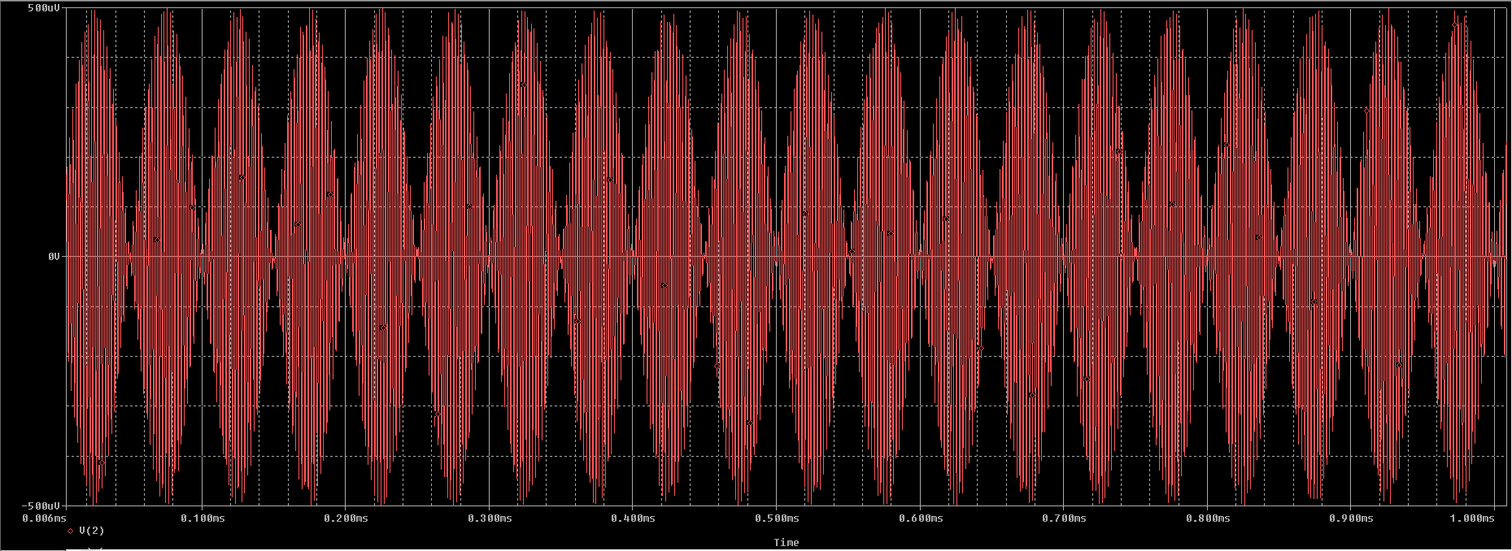

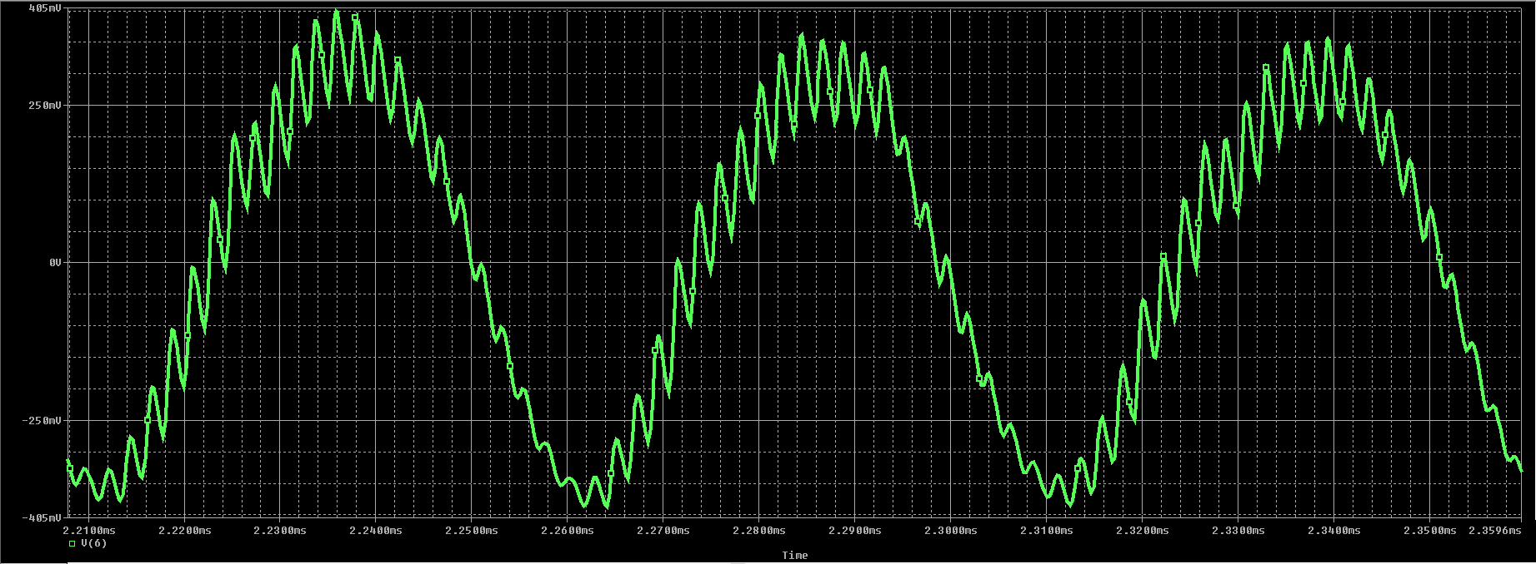

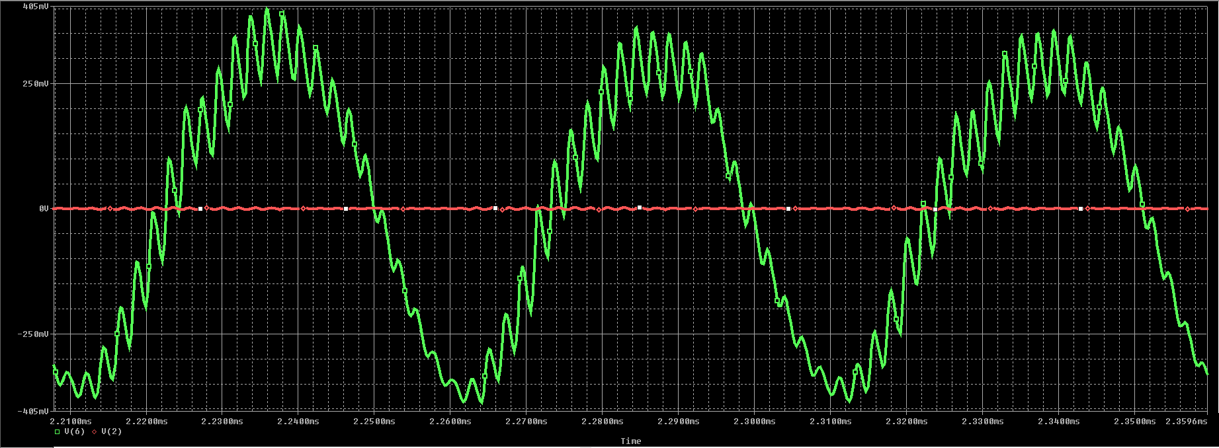

The first diagram in red shows the input, a modulated signal, with amplitude of 500uV.

The second graph shows the output, with amplitude of 500mV

And lastly, the third image shows the input and the output together.

The gain of the circuit is therefore 500mV/500µV = 1000 V/V

**5.1.2. Discuss the effect of loading between each sub-system in the receiver path on performance.**

When connecting all circuits, the loading effect of each individual circuit must be considered. The loading effect is the input impedance of the subsequent stage, which acts as a load for the current stage. This changes output resistance of each stage from Rout to Rout ||Rin, where Rin is the input resistance of the next stage, which decreases the gain. Theoretically, it would be ideal to have a high input impedance and a low output impedance for each of the different systems.

For each stage, if the input resistance of the next stage is considerably larger than the output resistance of stage itself, the loading effect will not have significant effects. Thus the loading effect at each stage must be analyzed.

***Loading effect at first stage:***

If the input resistance of the next stage, Rin|stage2, isn’t large enough then the output resistance, Rout|stage1, will have an added resistance. The output voltage will decrease which in turn decreases the gain of the stage.

vout = iout ×( Rin|stage2 || Rout|stage1)

However, if the input resistance of the next stage is much larger than output resistance, then its effect on the gain should be minimal.

***Loading effect at the second stage:***

The input resistance of the baseband amplifier is:

Rin|baseband = R1 = 150kΩ

This changes output resistance of second stage to:

Rout|stage2 = Rout|demod || Rin|baseband

The gain at the second stage is 1V/V. The added resistance at the output resistance will decrease the gain minimally.

The added impedance at the output will affect the time constant, ꞇ. Initially, time constant was:

ꞇ = Rdem × Cdem

With added impedance, the time constant changes to:

ꞇ = Cdem × (Rdem || Rin|baseband)

This decreases the time constant of the demodulator, thus resistance at the demodulator, Rdem, must be increased to compensate for this decrease.

***Loading effect at the third stage:***

The input resistance of Class A output stage is very high, and output resistance of the baseband amplifier is 0Ω. Thus, there will be no significant loading effect.

***Loading effect at the fourth stage:***

The load of this stage is an 8Ω speaker. This was taken into account when designing the output stage. Thus, no further considerations should be taken.