Design of an AM receiver

ECSE 434

Micro Electronics Lab

2.2 Lab Preparation- Demodulator

Sharhad Bashar, *260519664*

Chrouk Kassem, *260512917*

Zixuan Yin, *260502051*

Wednesday, 30th September 2015

**2.2.1 In your own style, briefly explain the operation of the circuit shown in Figure 4, and indicate the factors to consider when selecting the resistor and capacitor values**.

Demodulator is the second stage of the AM Receiver. Amplitude modulation transmits signals by multiplying the baseband signal by the sine function (carrier signal). This AM signal is sent through this circuit to be demodulated. Demodulator reconstructs the original baseband signal by detecting the positive envelope of input signal (received AM signal). The diode-capacitor configuration represents a half-wave rectifier that filters the upper half of the circuit. By using a resistor, the envelope of the circuit can be detected.

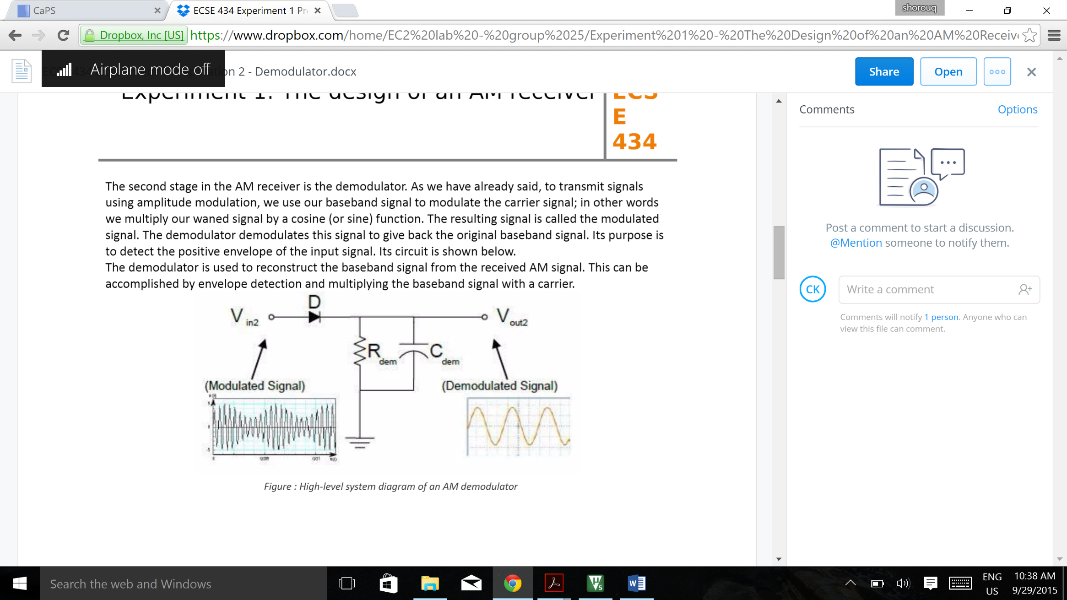

When the input voltage is positive, diode is forward biased, the signal follows the AM signal until it reaches the peak of the first wave while the capacitor Cdem charges. After the peak of first wave of input signal, the voltage of input signal decreases and diode becomes reverse biased. The capacitor Cdem discharges through Resistor Rdem. The capacitor discharges until the input voltage exceeds voltage of the capacitor, where diode becomes forward biased again. It follows the input signal again and Cdem charges until it reaches the peak. Once again, the Cdem discharges through Rdem until voltage difference across diode makes it forward biased. This cycle repeats to extract envelope of input signal. The signal produced is ragged but it’s carried over large frequency such that the noise is minimal and almost negligible. A factor to consider is the discharge rate of the capacitor such that:

* The time constant of capacitor, *τ*=RC must be greater than period of carrier signal to minimize the ripple in output signal. The reduction in the output voltage will be kept small during discharge of capacitor.
* The time constant of capacitor, *τ*=RC must be less than period of baseband signal to ensure that the rate of voltage drop is not too low and it follows envelope of input signal.

Thus it has to be: *τ*carrier < *τ*RC < *τ*Baseband and fBaseband < fRC < fcarrier

**2.2.2 Select appropriate values for Cdem and Rdem, knowing that the wanted baseband signal is in the 0-20kHz range, and the unwanted carrier signal is in the 200 kHz – 1.2 MHz range.**

Baseband signal: = 50 µs

Lowest carrier signal: = 5 µs

Relationship of peak output voltage VpOut, to peak input voltage Vpin is given by: Vpout= Vpin e

After 5µs, the output must not decrease by a substantial amount in order to filter out carrier signal. Taking that it decreases by 20%:

0.8Vpin = Vpin e

ln (0.8) =

RC = 22.41 × 10-6­ s = 22.41 µs

If Rdem is 10kΩ then Cdem has to be 2.24nF.

For our given frequency of 0.48 MHz,

Carrier signal: = 2.1 µs

0.8Vpin = Vpin e

ln (0.8) =

RC = 9.34 × 10-6­ s = 9.34 µs

If Rdem is 10kΩ then Cdem has to be 0.934 nF

**2.2.3 What are the constraints on the DC point at the input of the demodulator for correct operation? How can loading effect impact this circuit?**

The dc point needs to be high enough that the diode can turn on at all peaks.

VDC > - (Vcarrier - Vbaseband - 0.7V).

There's a preamplifier and baseband amplifier that come before and after the circuit, which could cause loading effects. This would create undesirable effects at both input and output.

**2.2.4 Simulate your circuit to ensure correct operation using an appropriately modulated input signal. This signal can be generated using a multiplier, which multiplies two sine waves.**

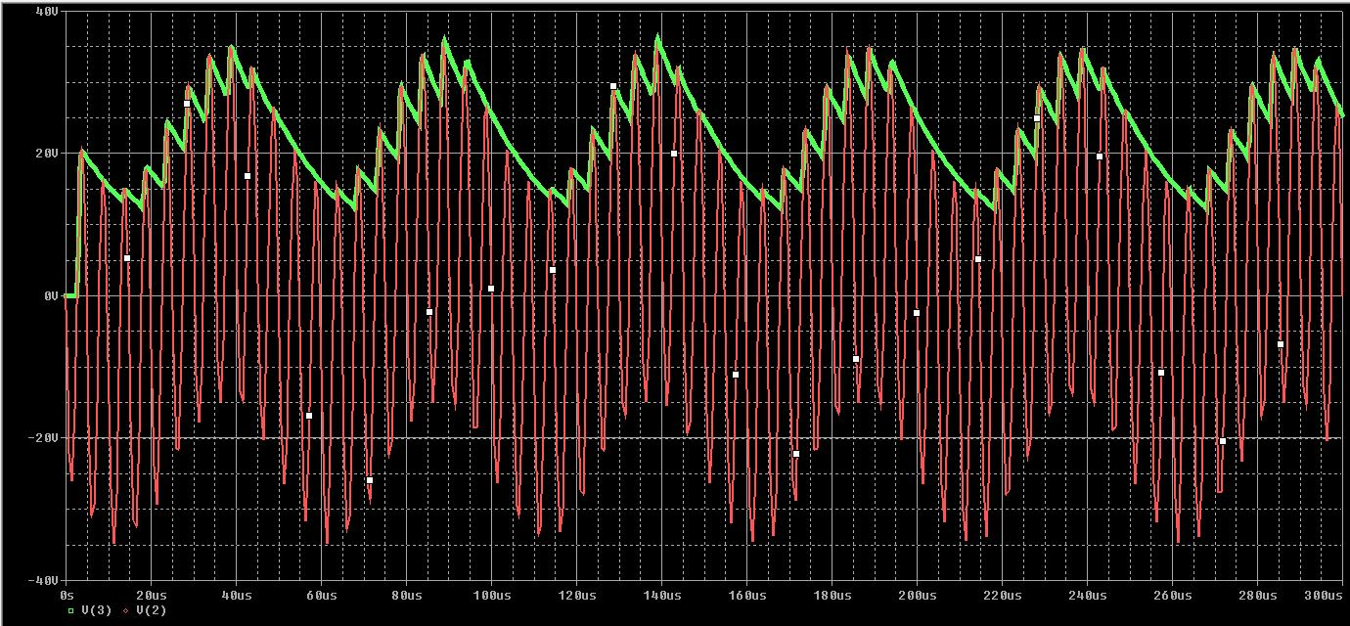

The red signal is the modulated input signal. The green signal on the top is the demodulated output signal.