Design of an AM receiver

ECSE 434

Micro Electronics Lab

3.2 Lab Preparation- Class A output Stage

Sharhad Bashar, *260519664*

Chrouk Kassem, *260512917*

Zixuan Yin, *260502051*

Wednesday, 14th October 2015

1. Find the values of R10, R11 and R12.

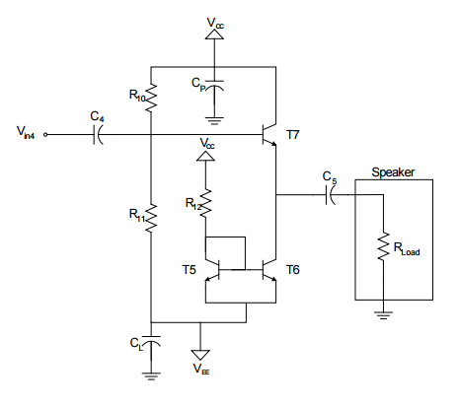

iL

I

iT7

I

IR10

iR11

iB

*Vo* = 1 V *pk-pk; Vo = 0.5 V*

Gain = $\frac{V_{o}}{V_{in}}=1$

*Vo* = *Vin* = 0.5

*Vo* = iLRL = 0.5

$$i_{L}= \frac{0.5 V}{8 ohm}=62.5 mA$$

Assuming *iB* = 0 A

$$R_{10}= \frac{V_{CC}-0.7}{i_{R10}}$$

$$R_{11}= \frac{0.7-V_{EE}}{i_{R11}}$$

*iR10* = *iR11*

Therefore, suggested values for *R10* and *R11* are:

*R10* = 4.3 KΩ

*R11* = 5.7 KΩ

*iL* = *iT7* + *I*

*I* = 61.5 *mA*

*R12*  = 160 Ω

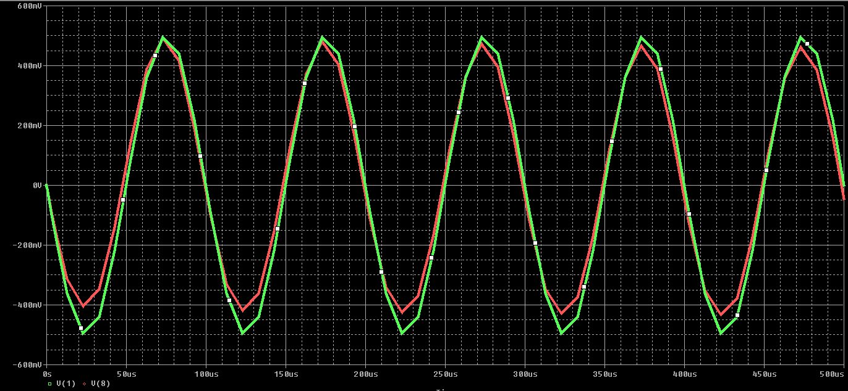Above is the ciruit result after it was designed and simulated in Orcad Pspice. The red trace is *Vo* and the green trace is *Vin*.

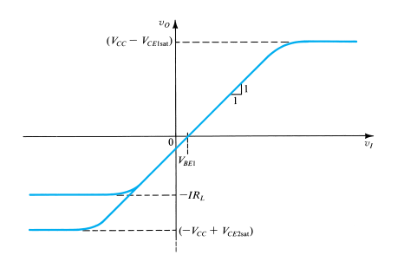

2. What are the limitations of this circuit?

$$V_{O}≤V_{CC}-V_{CE_{SAT}}$$

$$V_{O}≤5 V-0.3 V$$

$$V_{O}≤4.7 V$$

$$V_{O}≥-V_{CC}+V_{CE_{SAT}}$$

$$V_{O}≥-4.7 V$$

Due to the requirement that the output voltage should be 1 V peak-to-peak, the lowest bound for the output voltage should be -0.5 V.

$$-IR_{L}=-0.5 V$$

$$IR_{L}=0.5 V$$

$$I=\frac{0.5 V}{R_{L}}=\frac{0.5 V}{8 Ω}$$

$$I=62.5 mA$$

Due to the drastic nature of the half-waves produced by the half-wave rectifier, the transistors may burn. Therefore, more than one transistor should be grouped in parallel to prevent the transistors from burning.

Furthermore, allowing the output current to flow upwards in the Class A amplifier can cause the upper transistor to turn off. Therefore, it is important to add emitter resistors to the lower current mirror to allow the current to flow downwards; thus leavening the upper transistor on.