

Design of an AM receiver

ECSE 434

Micro Electronics Lab

4.2 Lab Preparation - Preamplifier

Sharhad Bashar, *260519664*

Chrouk Kassem, *260512917*

Zixuan Yin, *260502051*

Wednesday, 28th October 2015

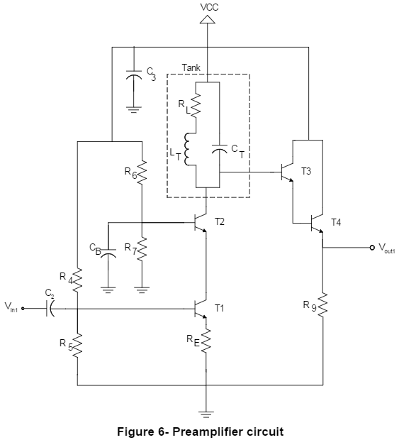

TA assigned fres = 0.48 MHz

1. **Using equation 2, choose an inductor LT and a capacitor CT, to obtain the desired resonant frequency, fres. Why do you need to readjust these values in SPICE to get correct fres? Suggest an improvement to Equation 2 in order to make it more faithful to SPICE simulations.**

$$f_{res}= \frac{1}{2π\sqrt{L_{T}C_{T}}}$$

Using fres = 0.48 MHz, we get $LC=1.099*{10}^{-13}$

Letting CT = 100 nF, we get LT = 1.099 uH

CT = 100 nF

LT = 1.099 uH

We need to readjust the values in SPICE because the inductor has a parasitic resistance in series. This gives us the following circuit:

The equivalent impedance of the above circuit is $Z_{eq}=\left(R_{L}+jωL_{T}\right)||\frac{1}{jωC_{T}}$

The resonant frequency is the frequency for which the equivalent impedance is real. So setting the imaginary component to 0, we get the improved frequency equation:

$$f_{res}= \frac{1}{2π\sqrt{L_{T}C_{T}}}\sqrt{1- \frac{{R_{L}}^{2}C_{T}}{L_{T}}}$$

Simplifying, we get:

$$f_{res}= \frac{1}{2π}\sqrt{\frac{1}{L_{T}C_{T}}-{(\frac{R_{T}}{L_{T}})}^{2}}$$

Using fres = 0.48 MHz and RL = 10 Ω, and simplifying for C, we get:

$C_{T}= \frac{1}{{L_{T}(2πf_{res}+ \frac{10}{L_{T}})}^{2}}$

If we choose LT = 100 uH, we get CT = 1 nF

CT = 1 nF

LT = 100 uH

1. **Briefly explain the purpose of R4, R5, R6 and R7?**

R4 and R5 are used to bias the input, and R6 and R7 are used to bias T2, the current follower.

1. **Briefly explain the purpose of RE?**

RE is emitter degeneration resistor. It is used to increase the output resistance of the amplifier.

1. **Capacitors have many role in electronic circuits; can you guess what the purpose of C3 and CB are?**

These capacitors are used as decoupling capacitors for noise isolation.

1. **Design the resistor values so that the output swing is maximized.**

Maximum output swing voltage is 2.5 V. In order to maximize the output swing, we need to set the values of R4, R5, R6 and R7. The minimum voltage at the base of T2 has to be 2V. Therefore, Voltage at emitter of T1 is:

VET1 = 2 – 0.7 – 0.3 = 1V

Assuming RE = 10 Ω, we get iE = 1V/10 Ω = 10 mA

For the transistors to always be in saturation, we need the base voltage at T2 to be more than 2.

Assuming VBT2 = 2.5V

Therefore, $\frac{R_{7}}{R_{7}+ R_{6}}*5= 2.5$

Letting R7 = 2.5K Ω, we get R6 + R7 = 5K Ω, and R6 = 2.5K Ω

VBT1 = 2.2 V

Therefore,

Letting R5 = 2.2K Ω, we get R5 + R4 = 5K Ω, and R4 = 2.8K Ω

RE = 10Ω

R4 = 2.8KΩ

R5 = 2.2KΩ

R6 = 2.5KΩ

R7 = 2.5KΩ

1. **What are the disadvantages of your preamplifier having a very wide bandwidth? What if it has a very narrow bandwidth?**

Wide bandwidth decreases the frequency selectivity of the amplifier. Therefore we could pick up signals in other bands. Narrow bandwidth makes the amplifier more selective.

1. **Derive the gain of this circuit**
2. **What frequency related reason can you think of for the need for a buffer in this circuit?**

Buffer increases the base resistance of the output transistor. Higher base resistance minimizes the energy loss of the LC circuit, therefore giving the circuit a high Q-factor and low bandwidth.