**About:**

**IEEE BUP Student Branch**

IEEE Student Branch of Bangladesh University of Professionals (IEEE BUP SB) under IEEE Region 10 started its journey back in October, 2017 with only 25 members with the objective of advancing technology for the betterment of humanity with valuable resources from the IEEE. IEEE BUP SB is the only internationally recognized student organization of BUP. It provides an opportunity for student members to begin networking in field of Engineering.

IEEE BUP SB has proven itself as one of the most active and vibrant student branches in the region by mainly focusses on **interactive learning, various projects/workshops, technical visits and field trips that will help them to gain a better understanding of the professional environment and technical progress and enable their careers.**

IEEE BUP Member: 108 IEEE Executive Members: 17

**IEEE:**

Since 2018, IEEE is the world's largest association of technical professionals with more than 423,000 members in over 160 countries around the world. Its objectives are the educational and technical advancement of electrical and electronics engineering, telecommunication, computer science, information and communication engineering and allied disciplines.

Benefits of IEEE Membership:

Community

•Attend any IEEE sponsored technical conference at a substantial discount

•Networking opportunities via IEEE Section, Chapter & Branch activities

•IEEE e-mail alias with virus and spam protection

•IEEE memberNet

•IEEE Women in Engineering events

•The Institute newsletter

•myIEEE

us here

Contact with us

**EXCOM:**

**Branch Couselor:**

**Md. Maynul Islam**

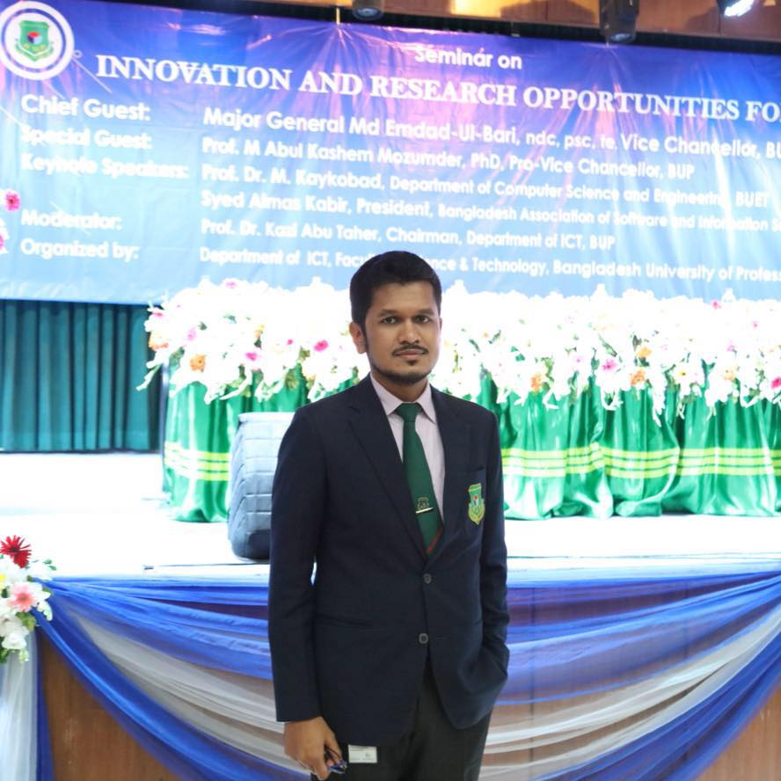

Branch Counselor

maynul@bup.edu.bd

**ExCom (2019-2020):**

**Abdullah Al Shabab**

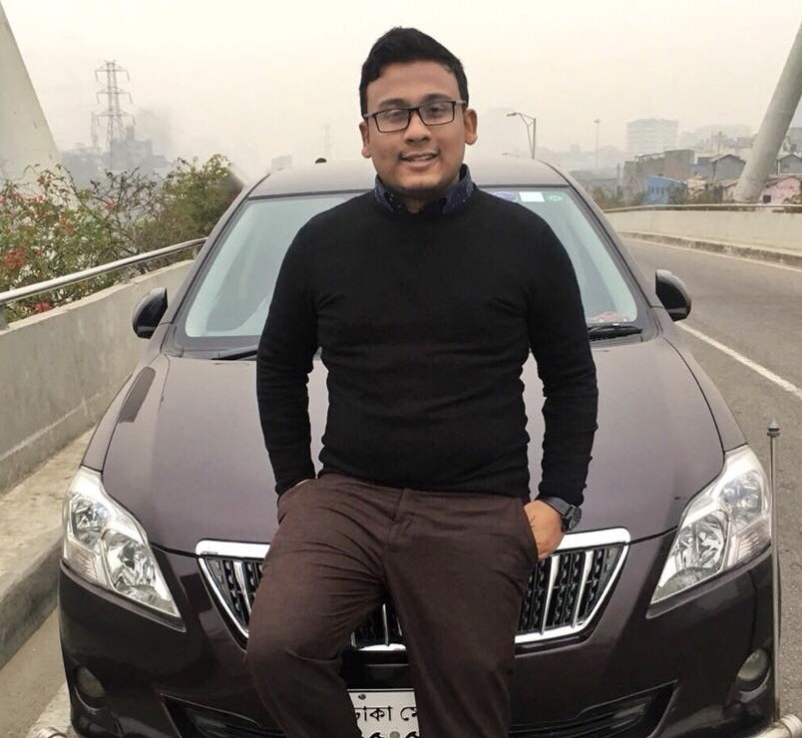

Chair, IEEE BUPSB

abdullahalshabab@ieee.org

**Sifat Nawrin Nova**

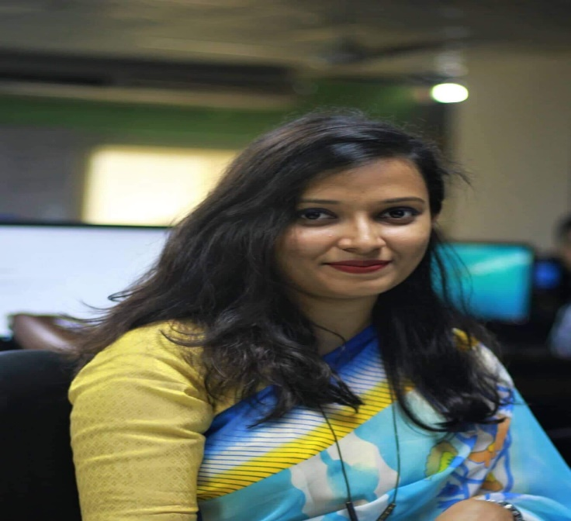

Secretary General, IEEE BUP SB

Nova.nawrin82@ieee.org

**Afsana Nowreem**

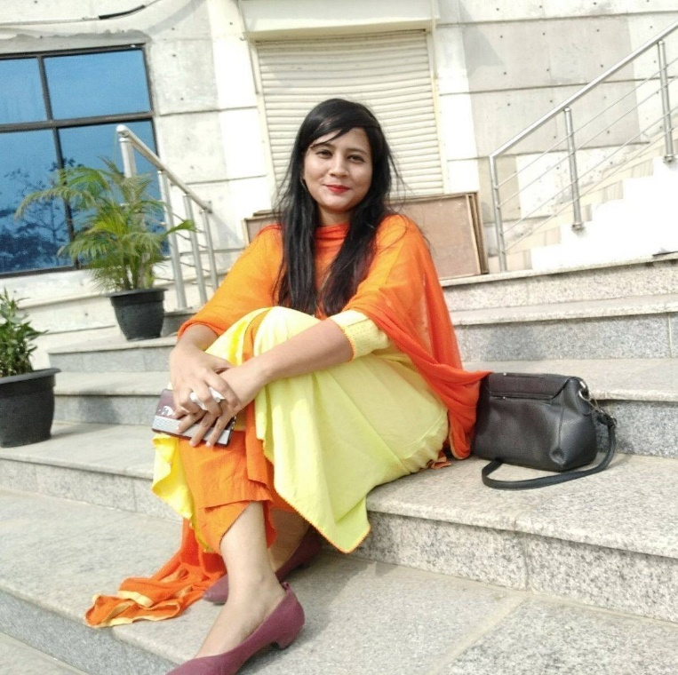

Vice Chair

Nowreen.afsana96@ieee.org

**Md. Abdullah Zobayer**

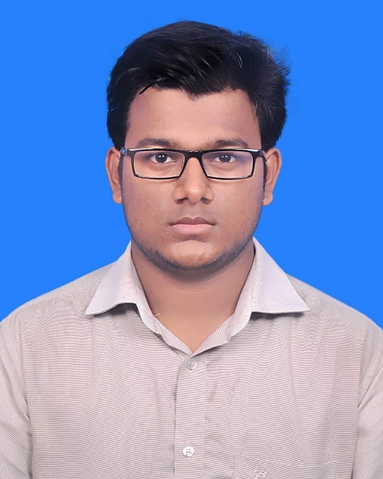

Treasurer, IEEE BUP SB

abzobayer54@gmail.com

**HOME**

 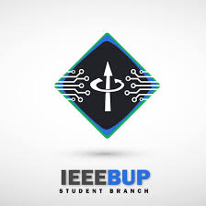

**WELCOME TO IEEE BUP STUDENT BRANCH**

**Testimonials**

For me IEEE BUP Student Branch has been a family, inseparable through ups and downs. Among seniors I have found the role models who made me embrace the concept of becoming a good decision maker. I have found people in all batches from whom I can seek support or knowledge about anything. IEEE BUP SB has given me the experience of four years of fun times, challenging times and everything in between.

Abdullah Al Shabab

Chair, IEEE BUP Student Branch

IEEE BUp SB has always been an inspiration to me. IEEE has provided a wide platform to prove, judge and connect oneself throughout the world. IEEE BUP SB has always been helpful for me to work, think and make decisions for the enhancing opportunities. I am totally grateful for being a part of this arena.

Sifat Nawrin Nova

Secretary General, IEEE BUP Student Branch