ADAPTIVE THREAT RESPONSE BASED NETWORK INTRUSION DETECTION SYSTEM USING GRAPH TRANSFORMER AND AUTOENCODER

A PROJECT REPORT
Submitted by

SHARICK AHMED A
VIGNESH A
SIVASANKARAN K
In partial fulfillment for the award of the degree
of
BACHELOR OF ENGINEERING
IN
COMPUTER SCIENCE AND ENGINEERING



P.A. COLLEGE OF ENGINEERING AND TECHNOLOGY
(An Autonomous Institution)
Pollachi, Coimbatore Dt. – 642 002

NOVEMBER 2026
P.A. COLLEGE OF ENGINEERING AND TECHNOLOGY
BONAFIDE CERTIFICATE
Certified that this project report “ADAPTIVE THREAT RESPONSE BASED NETWORK INTRUSION DETECTION SYSTEM USING GRAPH TRANSFORMER AND AUTOENCODER” is the bonafide work of “SHARICK AHMED A (721723104129), VIGNESH A (721723104153), SIVASANKARAN K (721723104135)” who carried out the project work under our supervision.

_____________________________ _____________________________
SIGNATURE | SIGNATURE
Dr. D. CHITRA, M.E., Ph.D., | Mr. T. DINESH KUMAR, M.TECH.,
Professor and Head | Assistant Professor
HEAD OF THE DEPARTMENT | SUPERVISOR
Department of Computer Science and  Engineering | Department of Computer Science and Engineering
P. A. College of Engineering and  Technology | P. A. College of Engineering and  Technology
Pollachi – 642 002 | Pollachi – 642 002

Submitted to the Viva-voce Examination held on _______________________

_______________________ ________________________
INTERNAL EXAMINER EXTERNAL EXAMINER

ACKNOWLEDGEMENT
First and foremost, we thank the GOD ALMIGHTY for blessing us with the mental strength that was needed to carry out the project work. We thank our Chairman Dr. P. APPUKUTTY, M.E., FIE., FIV., for his extensive support to successfully carry out this project.
We take privilege in expressing our sincere and heartfelt thanks and gratitude to our beloved Principal Dr. T. MANIGANDAN, M.E., Ph.D., for providing us an opportunity to carry out this project work
We express our heartfelt thanks to Dr. D. CHITRA, M.E., Ph.D., Professor and Head, Department of Computer Science and Engineering, for her technical guidance and constructive suggestions provided throughout the project work.
We take conceit in express our sincere and deepest thanks to the project guide Mr. T. DINESH KUMAR, M.TECH., Assistant Professor, Department of Computer Science and Engineering, for his technical guidance, constructive criticism and many valuable suggestions provided throughout the project work.
We take this opportunity to thank and pay gratitude to our project Coordinator Mrs. G. HARIKRISHNAVENI M.E., Associate Professor, Department of Computer Science and Engineering and all teaching and non-teaching staff members of our department, for their encouragement and valuable suggestion.
We take this opportunity to express our gratitude to our parents, friends, family and other members whose belongings and love have always been with us to carry out this project work successfully.

ABSTRACT
Web applications are constantly targeted by attacks like automated bots, password brute-forcing, SQL injection, and traffic floods. Most existing firewalls rely on fixed rules and static signatures, which easily miss new attack techniques and often end up blocking real users by mistake.
In this project, we built GTAE-ATRA, a real-time security system that monitors web traffic and responds to threats automatically. A lightweight middleware sits in the web app to safely collect request details without touching private data like passwords. We use a Graph Transformer Autoencoder (GTAE) trained on normal user behavior to understand how genuine visitors navigate the site. When suspicious or unusual activity occurs, the model detects the deviation, and a machine learning ensemble verifies the threat.
Instead of blindly banning IPs right away, our response algorithm (ATRA) checks how dangerous the action is and whether the IP has a track record of suspicious behavior. It then takes proportional action—letting safe traffic pass, keeping an eye on suspicious users, warning administrators, or completely blocking repeat offenders. Everything is streamed live to an interactive dashboard so administrators can watch threats unfold and see defenses trigger in real time.

TABLE OF CONTENTS

CHAPTER NO | TITLE |  | PAGE NO
 |  | ABSTRACT | IV
 |  | LIST OF FIGURES | VII
 |  | LIST OF TABLES | VIII
 |  | LIST OF ABBREVIATIONS | IX
1 |  | INTRODUCTION | 1
 | 1.1 | NETWORK SECURITY AND CYBER ATTACKS | 2
 | 1.2 | INTRUSION DETECTION SYSTEMS | 2
 | 1.3 | GRAPH LEARNING FOR INTRUSION DETECTION | 3
 | 1.4 | MOTIVATION OF THE PROJECT | 3
2 |  | SURVEY ON INTRUSION DETECTION AND RELATED SYSTEMS | 5
3 |  | GRAPH TRANSFORMER AUTOENCODER BASED INTRUSION DETECTION | 8
 | 3.1 | METHODOLOGY OF THE GTAE-IDS | 8
 | 3.2 | GTAE MODEL ARCHITECTURE | 9
 | 3.3 | ANOMALY DETECTION ON THE LATENT SPACE | 10
 | 3.4 | LIMITATIONS OF THE EXISTING SYSTEM | 11
4 |  | ADAPTIVE THREAT RESPONSE BASED NETWORK INTRUSION DETECTION SYSTEM | 12
 | 4.1 | MODEL OVERVIEW | 12
 | 4.2 | MODEL ARCHITECTURE | 13
 | 4.3 | WORKING OF THE PROPOSED SYSTEM | 14
 | 4.4 | BLOCK DIAGRAM | 15
 | 4.5 | WEB SECURITY MONITORING MODE | 16
 | 4.6 | ADAPTIVE THREAT RESPONSE ALGORITHM (ATRA) | 19

5 |  | SYSTEM SPECIFICATION | 22
 | 5.1 | HARDWARE SPECIFICATION | 22
 | 5.2 | SOFTWARE SPECIFICATION | 22
 | 5.3 | PURPOSE AND SCOPE OF DOCUMENT | 23
 | 5.4 | NON-FUNCTIONAL REQUIREMENTS | 24
6 |  | SYSTEM IMPLEMENTATION AND RESULT | 25
 | 6.1 | MODULE DISCUSSION | 25
 | 6.1.1 | DATA ACQUISITION MODULE | 25
 | 6.1.2 | DATA PROCESSING MODULE | 25
 | 6.1.3 | GRAPH CONSTRUCTION MODULE | 25
 | 6.1.4 | GTAE MODULE | 26
 | 6.1.5 | DETECTION AND CLASSIFICATION MODULE | 26
 | 6.1.6 | ATRA AND RESPONSE MODULE | 26
 | 6.2 | ALGORITHM AND TECHNIQUES | 26
 | 6.3 | SOURCE CODE | 28
 | 6.4 | RESULT | 36
7 |  | CONCLUSION AND FUTURE ENHANCEMENT | 40
 | 7.1 | CONCLUSION | 40
 | 7.2 | FUTURE ENHANCEMENT | 41
 |  | REFERENCES | 42

LIST OF FIGURES

FIGURE  NO | TITLE | PAGE  NO
3.1 | METHODOLOGY OF THE GTAE-IDS | 9
3.2 | ARCHITECTURE OF THE GTAE MODEL | 10
4.1 | MODEL ARCHITECTURE OF GTAE-ATRA-NIDS | 14
4.2 | WORKFLOW OF THE PROPOSED SYSTEM | 15
4.3 | BLOCK DIAGRAM OF THE PROPOSED SYSTEM | 16
4.4 | DATA FLOW OF THE WEB SECURITY MONITORING MODE | 17
4.5 | COMPONENTS AND RESPONSE TIERS OF ATRA | 20
6.1 | OVERVIEW TAB OF THE SOC DASHBOARD DURING NORMAL USE | 36
6.2 | ALERT DISTRIBUTION AND RECENT SECURITY EVENTS | 37
6.3 | ALERTS TAB WITH THE REASON, RISK AND ATTACK TYPE OF EACH ALERT | 38
6.4 | LOGS TAB LISTING ALL SECURITY EVENTS OF THE PROTECTED SITES | 38

LIST OF TABLES

TABLE NO | TITLE | PAGE NO
3.1 | COMPONENTS OF THE EXISTING GTAE-IDS | 10
4.1 | MODULES OF THE PROPOSED SYSTEM AND THEIR FUNCTIONS | 12
4.2 | THE 20 WEB TELEMETRY FEATURES | 17
4.3 | ATRA RESPONSE TIERS | 21
5.1 | HARDWARE REQUIREMENTS | 22
5.2 | SOFTWARE REQUIREMENTS | 22
5.3 | NON-FUNCTIONAL REQUIREMENTS | 24
6.1 | EVALUATION METRICS OF THE WEB SECURITY MODE | 39

LIST OF ABBREVIATION

AE | Autoencoder
API | Application Programming Interface
ATRA | Adaptive Threat Response Algorithm
CIC-IDS2017 | Canadian Institute for Cybersecurity Intrusion Detection Dataset 2017
CNN | Convolutional Neural Network
CPU | Central Processing Unit
CSV | Comma Separated Values
DDoS | Distributed Denial of Service
DNN | Deep Neural Network
DoS | Denial of Service
FN | False Negative
FP | False Positive
FPR | False Positive Rate
GNN | Graph Neural Network
GTAE | Graph Transformer Autoencoder
HBOS | Histogram Based Outlier Score
HIDS | Host based Intrusion Detection System
HTTP | Hypertext Transfer Protocol
IDS | Intrusion Detection System
IF | Isolation Forest
IP | Internet Protocol
JSONL | JSON Lines
LPE | Laplacian Positional Encoding

ML | Machine Learning
MSE | Mean Squared Error
NAT | Network Address Translation
NIDS | Network based Intrusion Detection System
OCSVM | One Class Support Vector Machine
RF | Random Forest
SOC | Security Operations Center
SQLi | Structured Query Language Injection
TN | True Negative
TP | True Positive
TPR | True Positive Rate

CHAPTER 1
INTRODUCTION
Computer networks are the backbone of communication, banking, healthcare, cloud computing and online services. As more services are exposed to the Internet, they become targets for attacks such as DoS/DDoS, brute force, SQL injection, XSS and port scanning.
An Intrusion Detection System (IDS) monitors network traffic and identifies suspicious activities. Traditional IDSs mainly depend on known attack signatures, so they may fail against new or unknown attacks. Machine learning and deep learning can detect unusual traffic patterns, but they usually stop after generating an alert, leaving the response to a human.
This project, Adaptive Threat Response Based Network Intrusion Detection System Using Graph Transformer and Autoencoder, addresses this limitation. It uses a Graph Transformer Autoencoder (GTAE) to detect unknown anomalies without requiring labelled attack data and an Adaptive Threat Response Algorithm (ATRA) to assess risk and automatically choose responses such as logging, monitoring, alerting or blocking.

1.1 NETWORK SECURITY AND CYBER ATTACKS
Network security is the practice of protecting the network, the devices connected to it and the data that travels over it. Attacks can be grouped by their goal. Availability attacks such as DoS Hulk, GoldenEye, Slowloris and DDoS exhaust the bandwidth, connections or processing power of a server. Reconnaissance attacks such as port scans and directory scans collect information about open services and hidden paths. Credential attacks such as brute force and credential stuffing try many passwords against a login service. Injection attacks such as SQL injection and cross site scripting send crafted input to make an application run commands that its developer never intended. Exploitation attacks such as Heartbleed read memory or take control of a vulnerable service.
These attacks leave different traces in traffic. A flood produces a very high request rate, a scan touches many different endpoints and returns many 404 or 403 errors, a brute force attack repeats the same login request with failures, and an injection attack carries unusual characters and keywords in the URL or the query string. A detection system that can learn all these traces together, and not only a single threshold, is needed.
1.2 INTRUSION DETECTION SYSTEMS
Intrusion detection systems are classified by where they are placed and how they decide. A Network based IDS (NIDS) observes packets or flows on the network, while a Host based IDS (HIDS) observes logs and system calls of one machine. By decision method there are two families.
- Signature (misuse) based detection matches traffic with stored patterns of known attacks. It gives few false alarms but cannot detect zero day attacks and needs continuous rule updates.
- Anomaly based detection builds a model of normal behaviour and flags what deviates from it. It can detect unknown attacks, but it may raise false alarms when legitimate behaviour changes.
Web Application Firewalls (WAF) and tools such as Fail2ban and CrowdSec add a response step, but they are mostly rule based. The proposed system keeps the advantage of anomaly detection and adds an adaptive response step on top of it.
1.3 GRAPH LEARNING FOR INTRUSION DETECTION
Network traffic is naturally a graph. Hosts, ports or endpoints are the nodes and communication between them forms the edges. A single flow looked at alone can appear harmless, but its position in the communication structure may reveal an attack, for example one source connected to a large number of destinations, or many sources converging on a single server. Graph Neural Networks (GNN) and graph transformers can learn this structural information in addition to the features of each flow.
An autoencoder is a neural network trained to compress its input into a small representation and then reconstruct it. When it is trained only on normal data, it reconstructs normal data with a small error, and it reconstructs data it has never seen, such as an attack, with a large error. This reconstruction error is therefore a natural anomaly score that needs no labelled attacks. The GTAE joins the two ideas: a graph transformer encoder produces the compressed representation and a deep neural network decoder reconstructs the original edge features.
1.4 MOTIVATION OF THE PROJECT
The base work, GTAE-IDS, shows that a graph transformer autoencoder detects attacks effectively, but, like most research detectors, it ends with an alert and gives no automatic response or self healing. The following observations motivated this project.
- Attackers can finish their work in seconds, whereas manual investigation takes minutes or hours, so the response must be automatic.
- A binary allow or block decision is risky. Blocking a legitimate user causes business loss, and ignoring a persistent attacker causes damage. A graded response is needed.
- A repeat offender is more dangerous than a first time suspect, so the response must remember history, and old history must fade with time.
- Small web developers do not have the budget for large commercial security suites, so a lightweight and open system that can protect an ordinary web application is valuable.

CHAPTER 2
SURVEY ON INTRUSION DETECTION AND RELATED SYSTEMS
Ghadermazi et al. (2025) proposed GTAE-IDS, a Graph Transformer-Based Autoencoder framework for real-time network intrusion detection. The framework represents network traffic as a graph and uses Graph Transformer, Laplacian positional encoding and an autoencoder to learn normal traffic behaviour. Although it provides effective intrusion detection, it does not include an adaptive automatic response mechanism. This work forms the base paper for the present project.
Bilot et al. (2023) presented a survey on Graph Neural Networks for intrusion detection. The study discussed graph construction methods, different GNN architectures and their applications in cybersecurity. However, it is a survey paper and does not propose a new detection or automated response system.
Pujol-Perich et al. (2023) studied the use of Graph Neural Networks for robust intrusion detection. Their work focuses on improving detection performance and robustness using graph-based learning. However, it does not provide an automated mechanism for responding to detected threats.
Li et al. (2023) proposed an Edge-Directed Graph Multi-Head Attention Network for intrusion detection. The method uses edge information and attention mechanisms to capture important network relationships. However, the approach mainly focuses on attack detection and does not provide adaptive threat response.
Wang et al. (2023) introduced BS-GAT, a Behaviour Similarity-Based Graph Attention Network for network intrusion detection. The model uses graph attention and behavioural similarity to identify malicious activities. However, it does not consider attacker history or automatically select a response based on threat severity.
Manavalasundaram et al. (2023) combined Graph Neural Networks with ensemble learning for network intrusion detection. The combination improves intrusion analysis, but the use of multiple models increases computational complexity and the system does not include an integrated automatic response mechanism.
Gorricho-Segura et al. (2023) analysed network intrusions using an edge-based Graph Neural Network approach. Their work is closely related to the edge-level representation used in the proposed system. However, it mainly focuses on detection and does not provide automatic threat response.
Hieu and Son (2025) compared Transformer and Convolutional Neural Network architectures for cyber attack detection. The study shows the usefulness of Transformer-based models for detecting complex cyber attacks. However, it focuses only on detection and does not address adaptive response or risk-based decision making.
Guerra et al. (2025) proposed GraphIDS, a self-supervised graph representation learning method using a masked autoencoder and Transformer. The approach reduces dependence on labelled data and learns useful network representations. However, its multiple learning components can increase computational requirements, and it mainly focuses on detection rather than automated response.
Gharib et al. (2021) proposed AutoIDS, an autoencoder-based intrusion detection method that learns normal network traffic and identifies abnormal behaviour. However, its performance depends on the normal traffic used for training and may be limited when attack patterns evolve. It also does not provide an adaptive response mechanism.
Zhou et al. (2018) presented a broad review of Graph Neural Network methods and applications. The study provides the theoretical foundation for graph-based learning used in network intrusion detection. However, it is a general GNN review rather than a specific intrusion detection or response system.

CHAPTER 3
GRAPH TRANSFORMER AUTOENCODER BASED INTRUSION DETECTION
The existing system on which this project builds is GTAE-IDS. This chapter explains its methodology, its model and its limitations, because the detection part of the proposed system is a re-implementation of the same idea.
3.1 METHODOLOGY OF THE GTAE-IDS
GTAE-IDS treats every network flow as an edge of a graph. The source and the destination of the flow (IP address and port) are the two nodes and the packet based features of the flow are the edge attributes. For each flow, the first p = 8 packets are used, and every packet is described by 25 normalised byte level features. A forward packet is placed in the first half of a 50 value placeholder and a backward packet in the second half, so that direction is preserved. The eight placeholders are concatenated into one edge vector of 400 values.
Nodes do not have features of their own, so structural information is added with Laplacian positional encoding. The normalised Laplacian of the graph is decomposed, the eigenvectors of the k smallest non trivial eigenvalues describe the position of each node, and the encodings of the source and the destination node are concatenated for each edge. The graph transformer encoder then processes the edge vectors, the decoder reconstructs them and the model is trained only on benign flows. The reconstruction error and the latent vectors are finally used by anomaly detectors.
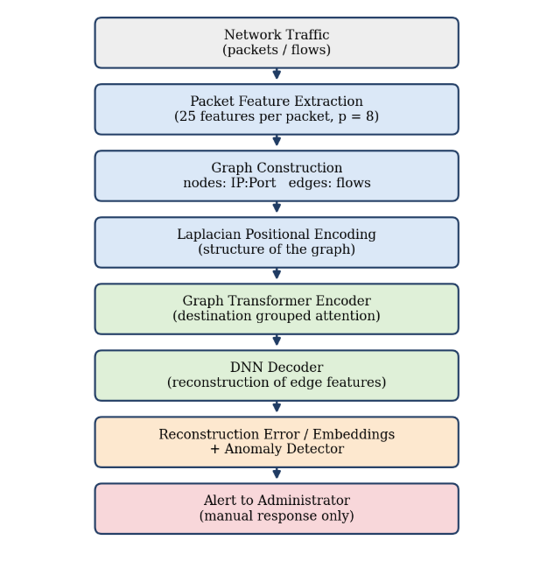
Figure No. 3.1: METHODOLOGY OF THE GTAE-IDS
3.2 GTAE MODEL ARCHITECTURE
The encoder first projects the 400 dimensional edge vector and the positional encoding to the model dimension d = 64 and adds them. Three graph transformer layers follow. Each layer has four attention heads, and the attention of an edge is computed only among the edges that share the same destination node, which keeps the computation local and focused on the victim. The layer uses residual connections, layer normalisation and a feed forward network. The output of the encoder is the 64 dimensional bottleneck vector z. A three layer deep neural network decoder (64, 128, 256, 400) reconstructs the original edge features from z.
Training minimises the mean squared error between the input edge vector and its reconstruction using only benign flows. At inference time benign flows are reconstructed well, and attack flows have a larger error and a different latent representation.
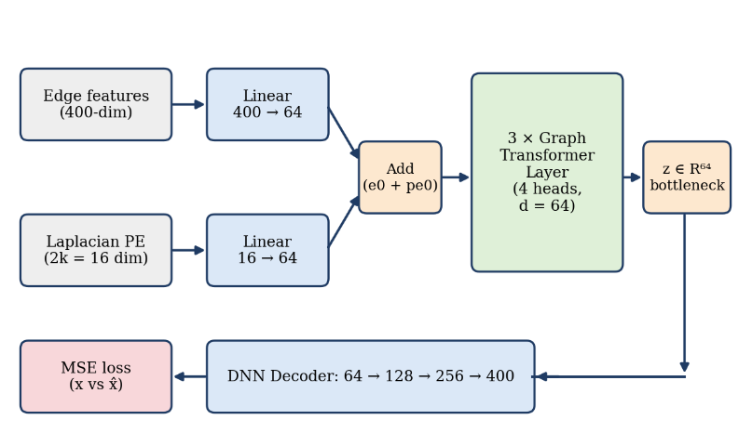
Figure No. 3.2: ARCHITECTURE OF THE GTAE MODEL
3.3 ANOMALY DETECTION ON THE LATENT SPACE
After training, the latent vectors z are standardised and given to unsupervised detectors that were fitted on benign embeddings only. Isolation Forest isolates points with random splits, and a point that is isolated with few splits is an outlier. One Class SVM learns a boundary around benign data in a kernel space. A flow is declared anomalous when the detectors, used as an ensemble, flag it. Table 3.1 lists the components of the existing system.
Table 3.1: COMPONENTS OF THE EXISTING GTAE-IDS
Component | Description
Edge features | 8 packets x 25 features, fwd/bwd placeholder scheme, 400 values per flow
Positional encoding | Laplacian eigenvectors of the traffic graph, k = 8 for each node
Encoder | Linear projection, 3 graph transformer layers, 4 heads, d = 64, attention grouped by destination node
Decoder | DNN 64 - 128 - 256 - 400
Training | Unsupervised, benign flows only, mean squared error, Adam optimiser
Detection | Reconstruction error and latent space detectors (Isolation Forest, One Class SVM)
Output | Alert to the administrator

3.4 LIMITATIONS OF THE EXISTING SYSTEM
- The system detects intrusions but does not provide any automatic threat response or self healing; blocking an IP or isolating an attacker must be done manually.
- It depends on administrators for handling incidents, so the response is delayed and the impact of an attack increases.
- There is no risk assessment or prioritisation of attacks, so an important event and a harmless anomaly look the same.
- The system has no memory of earlier behaviour, so a persistent attacker is treated like a first time suspect.
- Attack type is not reported, and there is no live monitoring interface for a web application.

CHAPTER 4
ADAPTIVE THREAT RESPONSE BASED NETWORK INTRUSION DETECTION SYSTEM
4.1 MODEL OVERVIEW
The proposed system, named GTAE-ATRA-NIDS, extends the detection power of the GTAE with a decision and response engine. It replaces conventional signature based IDS and shallow machine learning with a dual engine architecture. The first engine is the Graph Transformer Autoencoder with Laplacian positional encoding that captures the structural and behavioural dependencies between IP addresses and endpoints. The second engine is ATRA, which avoids a binary allow or block decision and calculates a dynamic time decayed risk score that selects a proportional action.
The system has two operating modes. In the Web Security Monitoring Mode (live mode) a Node.js Express application sends HTTP telemetry to a Python monitor. The telemetry of each source IP is collected in a 30 second window, converted into a 20 dimensional feature vector, analysed in real time and the events are streamed to a React dashboard. In the Network Flow Mode (research mode) the system is trained and evaluated on the CIC-IDS2017 benchmark, which has 78 flow features and eight days of attacks, and it can also read live packets using Npcap.
Table 4.1: MODULES OF THE PROPOSED SYSTEM AND THEIR FUNCTIONS
Module | Function
Data acquisition | Collects live packets, CIC-IDS2017 flows and HTTP telemetry from the Express monitor middleware
Feature extraction | Creates the 20 web features per IP window or the flow features, with normalisation
Graph builder | Builds the IP to endpoint (or flow) graph and the Laplacian positional encoding
GTAE model | Graph transformer encoder and DNN decoder, reconstruction error as anomaly score
Anomaly ensemble | Isolation Forest, One Class SVM and HBOS with union or majority voting
Attack classifier | Random Forest that names the attack category
ATRA engine | Risk score, time decayed IP history, tiered action selection
Logger and blocklist | JSONL and CSV event logs, persistent blocklist with time to live
SOC dashboard | React and Socket.IO interface with live events, gauge, charts and manual unblock

4.2 MODEL ARCHITECTURE
The system is organised as seven layers. Each layer passes its result to the next one, so that a packet or a request at the input is finally turned into a decision, a log entry and a visible event on the dashboard. The data acquisition layer feeds the pre-processing and graph layer, the GTAE layer produces the anomaly signal, the detection layer confirms and classifies it, ATRA converts it into a risk score, the response layer acts and the dashboard layer shows the result to the operator.
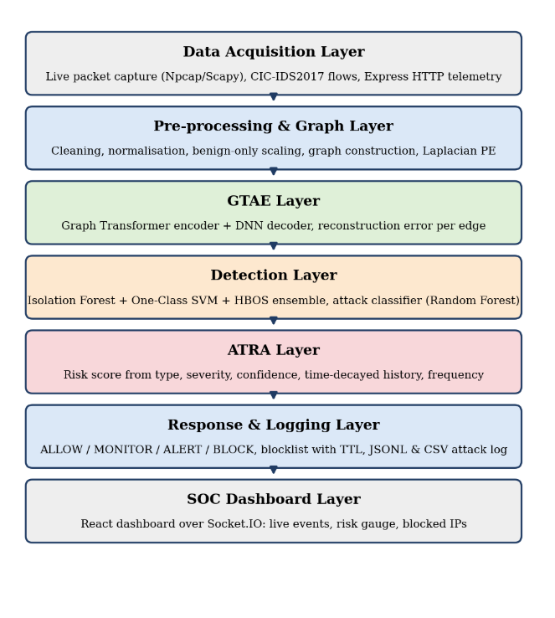
Figure No. 4.1: MODEL ARCHITECTURE OF GTAE-ATRA-NIDS

4.3 WORKING OF THE PROPOSED SYSTEM
The working of the system follows the pipeline of Figure 4.2. Traffic is captured and converted into features. The features are placed on a graph, and the trained GTAE encodes the graph and reconstructs the features. The reconstruction error and the latent vector are examined by the ensemble of detectors. When the ensemble flags the event, the Random Forest names the attack type and ATRA calculates the risk score using the type, the severity, the confidence and the history of the source IP. The selected action is executed, logged and sent to the dashboard. Every flagged event is also written into the history tracker of the IP, so the next event from the same source will receive a higher risk score. This feedback is the adaptive property of the system.
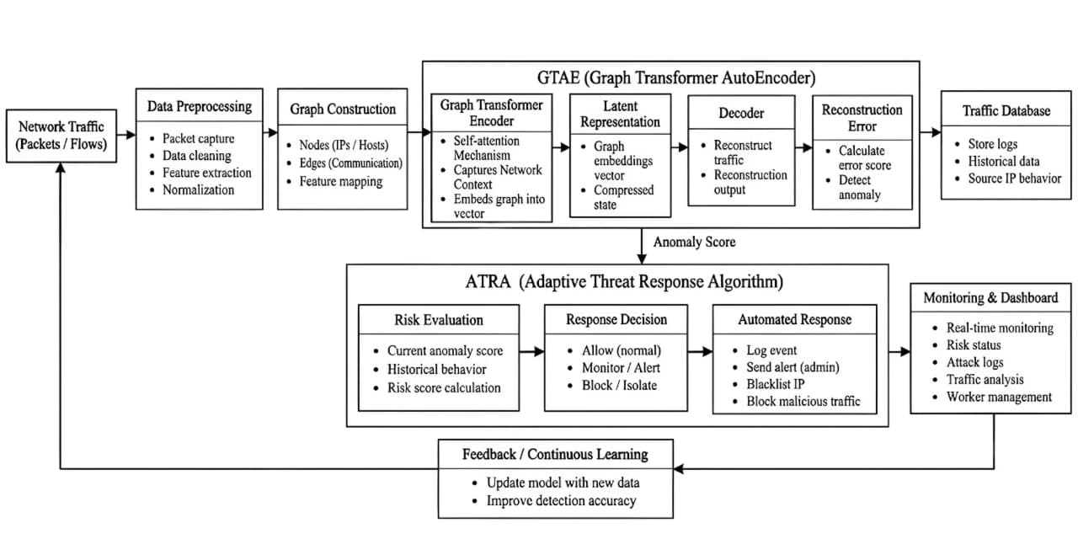
Figure No. 4.2: WORKFLOW OF THE PROPOSED SYSTEM
4.4 BLOCK DIAGRAM
Figure 4.3 shows the block diagram in its simplest form. Each block corresponds to one group of source files of the implementation: data loaders and feature extractors, the graph builder, the GTAE model with the detectors, the ATRA module, the logger with the blocklist and the dashboard.
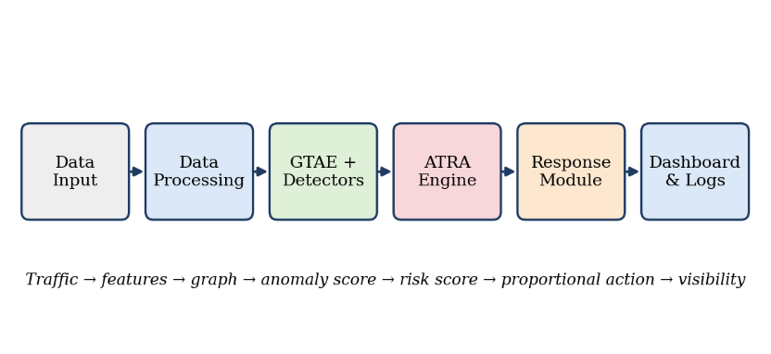
Figure No. 4.3: BLOCK DIAGRAM OF THE PROPOSED SYSTEM

4.5 WEB SECURITY MONITORING MODE
In the live mode the target web application runs on Port 3000. A non-intrusive middleware, monitor.js, taps every request and records the timestamp, method, path, query, status code, response time, request size, response size, user agent and client IP. The records are buffered and posted every few seconds to the Python monitor (Flask with Socket.IO, Port 8765). The monitor keeps a sliding queue for each IP, checks the blocklist and, when a window is complete, runs the feature extraction, GTAE inference, the ensemble and ATRA. The result is broadcast as a security_event over WebSocket to the React dashboard on Port 3001, and the Express application reads the blocklist to reject traffic from blocked IP addresses.
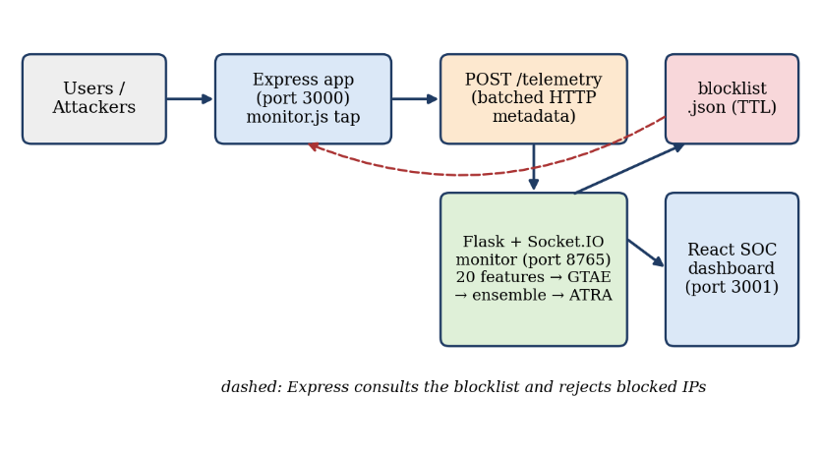
Figure No. 4.4: DATA FLOW OF THE WEB SECURITY MONITORING MODE
The telemetry of an IP in a 30 second window is converted into 20 features, each normalised into the range 0 to 1 by an empirical upper bound. Table 4.2 lists the features and the attack that each one helps to reveal.
Table 4.2: THE 20 WEB TELEMETRY FEATURES
No | Feature | Raw range | Attack indicator
0 | request_rate | 0 - 300 req/min | Layer 7 DoS, fuzzing, scraping
1 | unique_endpoint_count | 0 - 50 | Directory scanning, reconnaissance
2 | failed_login_count | 0 - 100 | Brute force, credential stuffing
3 | status_4xx_rate | 0.0 - 1.0 | Unauthorised probing (401, 403, 404)
4 | status_5xx_rate | 0.0 - 1.0 | Crashes, exceptions, SQLi exploitation
5 | avg_response_time_ms | 0 - 30,000 | Slowloris, ReDoS, database locking
6 | avg_path_length | 0 - 200 | Overflow attempts, deep traversal
7 | avg_query_length | 0 - 500 | Long SQLi payloads, encoded XSS
8 | post_ratio | 0.0 - 1.0 | Automated form submission, spraying
9 | get_ratio | 0.0 - 1.0 | Resource exhaustion, large downloads
10 | sensitive_endpoint_count | 0 - 100 | Probes of /admin, /.env, /config
11 | repeated_endpoint_ratio | 0.0 - 1.0 | Flooding of a single URL
12 | suspicious_pattern_count | 0 - 50 | Regex hits for SQL keywords, script tags, ../
13 | abnormal_method_count | 0 - 30 | TRACE, TRACK, PROPFIND, CONNECT
14 | avg_request_size | 0 - 2 MB | Large payload injection, XML/JSON bombs
15 | max_request_rate_burst | 0 - 100 req/s | Micro-bursts in any 5 s sub-window
16 | error_404_count | 0 - 200 | Forced browsing, route discovery
17 | error_403_count | 0 - 200 | Access control bypass attempts
18 | user_agent_entropy | 0.0 - 1.0 | Randomised bot user agents
19 | req_per_minute | 0 - 300 | Scaled volume indicator

The monitored sensitive endpoints are /admin, /admin/, /login, /api/auth, /api/admin, /.env, /config, /wp-admin, /phpmyadmin, /api/users and /api/keys.
4.6 ADAPTIVE THREAT RESPONSE ALGORITHM (ATRA)
ATRA is the novel contribution of the project. Detection answers the question “is this abnormal?”. ATRA answers the questions “how dangerous is it, and what should be done now?”. The risk score R, in the range 0 to 100, is a weighted combination of five components, each normalised to a 0 to 10 scale before weighting.
- Attack type weight (25%). The inherent danger of the attack family, for example SQL injection, Heartbleed and Infiltration are 9, DoS Hulk, brute force and path traversal are 8, XSS, Slowloris and rate limit abuse are 7, bot scan is 6 and port scan is 4.
- Severity (25%). The expected impact rating of the attack.
- Confidence (25%). The agreement between the GTAE reconstruction error and the votes of the ensemble. The error of a flagged event is min-max normalised among the flagged events of the window.
- Historical offence score (15%). The sum of exponentially decayed weights of earlier flagged events of the same IP. The weight of an event falls to one half after the half life of 300 seconds, so old offences fade and repeated offences accumulate.
- Frequency score (10%). The number of flagged events of the IP in the last 600 seconds, scaled and capped at 10.
The five weights add up to one, so R is the weighted mean of the components expressed as a percentage. The score selects one of four tiers.
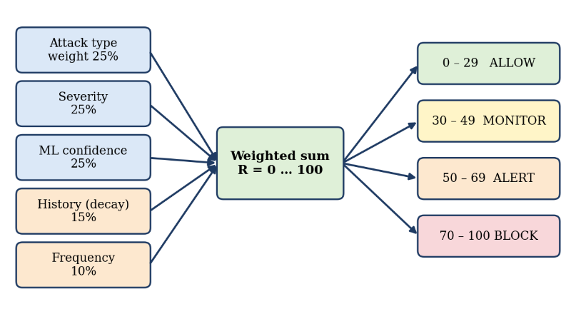
Figure No. 4.5: COMPONENTS AND RESPONSE TIERS OF ATRA

Table 4.3: ATRA RESPONSE TIERS
Risk score | Level | Action | Description
0 - 29 | Low | ALLOW | Telemetry is logged and normal browsing is permitted
30 - 49 | Medium | MONITOR | Logging resolution is increased and the event is flagged on the dashboard
50 - 69 | High | ALERT | A high priority alert is pushed to the security operators
70 - 100 | Critical | BLOCK | The IP is added to blocklist.json with a time to live of 3600 seconds

Because every response is graded, a first time low confidence anomaly only leads to monitoring, and the system blocks only when strong evidence or repeated behaviour has raised the score. The time to live of the blocklist and a whitelist of trusted addresses protect legitimate users from a permanent block.
CHAPTER 5
SYSTEM SPECIFICATION
5.1 HARDWARE SPECIFICATION
The system is designed to run on an ordinary laptop without a GPU. The training of the GTAE on the sampled data and the real time inference are done on the CPU.
Table 5.1: HARDWARE REQUIREMENTS
Component | Minimum requirement
Processor | Intel Core i5 or equivalent, 4 cores
RAM | 8 GB (16 GB recommended for the full CIC-IDS2017 data)
Storage | 10 GB free space on an SSD
Network | Ethernet or Wi-Fi adapter supported by Npcap for live capture
Display | 1366 x 768 or higher for the SOC dashboard

5.2 SOFTWARE SPECIFICATION
Table 5.2: SOFTWARE REQUIREMENTS
Software | Purpose
Windows 10/11 | Operating system (Npcap packet capture)
Python 3.10 or above | Model, ATRA, feature extraction and monitor server
PyTorch | Graph transformer autoencoder
scikit-learn, NumPy, Pandas, SciPy | Isolation Forest, One Class SVM, Random Forest, data handling
NetworkX | Graph construction and Laplacian computation
Flask and Flask-SocketIO | Real time inference server and WebSocket events
Scapy with Npcap | Live packet capture
Node.js and Express.js | Target web application and monitor middleware
React.js and Socket.IO client | SOC dashboard
Matplotlib | Evaluation plots
Visual Studio Code and Git | Development environment and version control

5.3 PURPOSE AND SCOPE OF DOCUMENT
This document describes the design, implementation and evaluation of GTAE-ATRA-NIDS. It is meant for the project evaluators and for developers who want to understand or extend the system. The scope covers anomaly detection with a graph transformer autoencoder, attack classification, adaptive risk based response and live monitoring of a web application. The scope does not include deep packet inspection of encrypted payloads or integration with a hardware firewall.
5.4 NON-FUNCTIONAL REQUIREMENTS
Table 5.3: NON-FUNCTIONAL REQUIREMENTS
Requirement | Description
Performance | A 30 second window of requests is analysed within a few seconds on a CPU, so the response stays near real time
Accuracy | False positive rate kept below the usual industry threshold of 15%
Reliability | The monitor keeps running when a window is empty or malformed, and the blocklist survives restarts
Usability | The dashboard shows throughput, active threats, a risk gauge, attack distribution and allows one click unblock
Safety | Auto blocking has a time to live, private and whitelisted addresses are never blocked
Maintainability | All paths, hyperparameters, weights and thresholds are kept in one configuration file
Portability | Runs on a laptop CPU and needs no special hardware

CHAPTER 6
SYSTEM IMPLEMENTATION AND RESULT
6.1 MODULE DISCUSSION
6.1.1 Data Acquisition Module
This module collects network data from three sources: CIC-IDS2017 dataset, live packet capture, and web telemetry. CIC-IDS2017 data is cleaned and normalised before use. Live packets are captured using Scapy and Npcap and grouped into flows. The web application collects request information through monitor.js and sends it to the Python monitoring system.
6.1.2 Data Processing Module
This module converts the collected traffic into useful features. For web traffic, requests from each IP are collected within a 30-second window and converted into 20 features. The features are cleaned, limited to suitable ranges, and scaled between 0 and 1. Network flow features are also normalised before further processing.
6.1.3 Graph Construction Module
This module represents network communication as a graph. Source IPs and destination endpoints are treated as nodes, while their communication is represented as edges. The system also generates Laplacian positional encodings using the graph structure. This helps the Graph Transformer understand the relationships between network entities.

6.1.4 GTAE Module
The GTAE module is the main part of the proposed system. It contains a Graph Transformer Encoder and a DNN Decoder. The encoder learns normal network communication patterns and creates a compressed representation. The decoder then reconstructs the original features. The difference between the original and reconstructed data is used as the anomaly score.
6.1.5 Detection and Classification Module
This module identifies whether the traffic is normal or anomalous. The latent features from GTAE are analysed using Isolation Forest, One-Class SVM, and HBOS. Their results are combined using a voting mechanism. For detected threats, the Random Forest classifier identifies the attack type, such as BruteForce, SQL Injection, XSS, BotScan, or DoS.
6.1.6 ATRA and Response Module
The ATRA module decides how the system should respond to a detected threat. It considers the current anomaly score, attack severity, confidence, previous behaviour, and attack frequency to calculate the risk score. Based on the risk level, it can Allow, Monitor, Alert, or Block the traffic. Detected events and blocked IP details are also stored for future reference.
6.2 ALGORITHM AND TECHNIQUES
1. Laplacian positional encoding
L = I − D^(−1/2) · A · D^(−1/2)Eq (6.1)
A is the adjacency matrix and D the degree matrix. The eigenvectors of the k smallest non trivial eigenvalues form the position of every node.
2. Destination grouped attention
Attention(Q, K, V) = softmax(Q·Kᵀ / √d_k) · V Eq (6.2)
Q, K and V are the query, key and value projections of the edge vectors, and softmax is taken only over edges that share the same destination node. With d = 64 and four heads, d_k = 16.
3. Reconstruction loss and anomaly score
MSE = (1/F) · Σ (x_i − x̂_i)²Eq (6.3)
F is the number of features. The model minimises this value on benign data, and the same value is the anomaly score at inference.
4. Time decayed history
S_hist = Σ exp(−λ · Δt_i), λ = ln 2 / T_halfEq (6.4)
Δt_i is the age of the i-th earlier event of the IP and T_half = 300 seconds, so one event is worth 1.0 now, 0.5 after five minutes and 0.25 after ten minutes (Figure 6.4). The sum is capped at 10.
5. ATRA risk score
R = 10 × (0.25·S_type + 0.25·S_sev + 0.25·S_conf + 0.15·S_hist + 0.10·S_freq) Eq (6.5)
All components are on the 0 to 10 scale and the weights add up to one, so the factor 10 expresses the weighted mean as a percentage. S_type is the attack type weight, S_sev is the severity, S_conf is the normalised confidence, S_hist is the decayed history and S_freq is the frequency score (events in 600 seconds multiplied by 2 and capped at 10).
6. Ensemble detectors and classifier
Isolation Forest isolates observations by random splits and gives short path lengths to outliers. One Class SVM finds a boundary that encloses benign embeddings in an RBF kernel space. HBOS builds a histogram for each feature and scores a point by the inverse of the densities of its bins. The Random Forest is a set of 100 decision trees that vote for the attack category.
6.3 SOURCE CODE
Selected parts of the implementation are shown here. The complete project contains the modules listed in Chapter 5.
- Graph Transformer Autoencoder (src/gtae_model.py)
class GraphTransformerLayer(nn.Module):
"""Graph Transformer layer, attention grouped by shared destination node."""
def __init__(self, d_model, num_heads, ffn_hidden_mult=2):
super().__init__()
self.d_model, self.num_heads = d_model, num_heads
self.d_k = d_model // num_heads
self.q_proj = nn.Linear(d_model, d_model)
self.k_proj = nn.Linear(d_model, d_model)
self.v_proj = nn.Linear(d_model, d_model)
self.out_proj = nn.Linear(d_model, d_model)
self.norm1 = nn.LayerNorm(d_model)
self.norm2 = nn.LayerNorm(d_model)
self.ffn = nn.Sequential(
nn.Linear(d_model, d_model * ffn_hidden_mult), nn.ReLU(),
nn.Linear(d_model * ffn_hidden_mult, d_model))

def forward(self, e, dst_idx):
E = e.size(0)
Q = self.q_proj(e).view(E, self.num_heads, self.d_k)
K = self.k_proj(e).view(E, self.num_heads, self.d_k)
V = self.v_proj(e).view(E, self.num_heads, self.d_k)
groups = defaultdict(list) # edges sharing a destination node
for edge_i, d in enumerate(dst_idx.tolist()):
groups[d].append(edge_i)
attn_out = torch.zeros(E, self.num_heads, self.d_k, device=e.device)
for _, edge_ids in groups.items():
idx = torch.tensor(edge_ids, dtype=torch.long, device=e.device)
scores = torch.einsum("qhd,khd->qkh", Q[idx], K[idx]) / (self.d_k ** 0.5)
w = F.softmax(scores, dim=1)
attn_out[idx] = torch.einsum("qkh,khd->qhd", w, V[idx])
attn_out = self.out_proj(attn_out.reshape(E, self.d_model))
e = self.norm1(e + attn_out) # residual + norm
e = self.norm2(e + self.ffn(e)) # FFN + residual + norm
return e
class GraphTransformerEncoder(nn.Module):
def __init__(self, in_features, pe_dim, d_model=64, num_heads=4, num_layers=3):
super().__init__()
self.input_proj = nn.Linear(in_features, d_model)
self.pe_proj = nn.Linear(pe_dim, d_model)
self.layers = nn.ModuleList(
[GraphTransformerLayer(d_model, num_heads) for _ in range(num_layers)])
def forward(self, edge_attr, edge_pe, dst_idx):
e = self.input_proj(edge_attr) + self.pe_proj(edge_pe)
for layer in self.layers:
e = layer(e, dst_idx)
return e # bottleneck z
class DNNDecoder(nn.Module):
def __init__(self, d_model, out_features):
super().__init__()
h = GTAE_CONFIG.get("decoder_hidden", [128, 256])
self.net = nn.Sequential(
nn.Linear(d_model, h[0]), nn.ReLU(),
nn.Linear(h[0], h[1]), nn.ReLU(),
nn.Linear(h[1], out_features))
def forward(self, z):
return self.net(z)
class GTAE(nn.Module):
def __init__(self, in_features, pe_dim, d_model=64, num_heads=4, num_layers=3):
super().__init__()
self.encoder = GraphTransformerEncoder(
in_features, pe_dim, d_model, num_heads, num_layers)
self.decoder = DNNDecoder(d_model, in_features)
def forward(self, edge_attr, edge_pe, dst_idx):
z = self.encoder(edge_attr, edge_pe, dst_idx)
return self.decoder(z), z
def train_gtae(model, edge_attr, edge_pe, dst_idx, edge_labels):
"""Train on BENIGN-ONLY flows (edge_labels == 0)."""
optimizer = torch.optim.Adam(model.parameters(), lr=0.001)
loss_fn = nn.MSELoss()
m = (edge_labels == 0)
x, pe, d = edge_attr[m], edge_pe[m], dst_idx[m]
best, best_state, patience_counter = float("inf"), None, 0
model.train()
for epoch in range(1, 101):
optimizer.zero_grad()
x_hat, _ = model(x, pe, d)
loss = loss_fn(x_hat, x)
loss.backward()
optimizer.step()
if loss.item() < best:
best, best_state, patience_counter = loss.item(), model.state_dict().copy(), 0
else:
patience_counter += 1
if patience_counter >= 15: # early stopping
break
model.load_state_dict(best_state)
return model
def compute_reconstruction_errors(model, edge_attr, edge_pe, dst_idx):
model.eval()
with torch.no_grad():
x_hat, z = model(edge_attr, edge_pe, dst_idx)
errors = torch.mean((x_hat - edge_attr) ** 2, dim=1)
return errors, z
- Laplacian Positional Encoding (src/graph_builder.py)
def compute_laplacian_pe(edge_index, num_nodes, k):
"""k-dim Laplacian PE from the BENIGN-ONLY graph (no topological leakage)."""
G = nx.Graph()
G.add_nodes_from(range(num_nodes))
G.add_edges_from([(int(u), int(v)) for u, v in edge_index.t().tolist()])
L = nx.normalized_laplacian_matrix(G).toarray().astype(np.float64)
eigvals, eigvecs = np.linalg.eigh(L) # ascending eigenvalues
pe = eigvecs[:, 1:k + 1] # skip the trivial eigenvector
if pe.shape[1] < k: # zero-pad small graphs
pe = np.concatenate([pe, np.zeros((num_nodes, k - pe.shape[1]))], axis=1)
return torch.tensor(pe, dtype=torch.float32)
def attach_pe_to_edges(edge_index, node_pe):
src_pe = node_pe[edge_index[0]]
dst_pe = node_pe[edge_index[1]]
return torch.cat([src_pe, dst_pe], dim=1) # [E, 2k]
- Ensemble Anomaly Detector (src/anomaly_detector.py)
class HBOSDetector:
"""Histogram-Based Outlier Score, pure NumPy."""
def __init__(self, n_bins=40, contamination=0.05):
self.n_bins, self.contamination = n_bins, contamination
self._bin_edges, self._bin_densities, self._threshold = [], [], 0.0
def fit(self, X):
for j in range(X.shape[1]):
counts, edges = np.histogram(X[:, j], bins=self.n_bins, density=True)
counts = np.where(counts == 0, 1e-10, counts) # avoid log(0)
self._bin_edges.append(edges)
self._bin_densities.append(counts)
train_scores = self._score(X)
self._threshold = np.percentile(train_scores, 100 * (1 - self.contamination))
return self
def _score(self, X):
scores = np.zeros(X.shape[0])
for j in range(X.shape[1]):
idx = np.digitize(X[:, j], self._bin_edges[j][:-1]) - 1
idx = np.clip(idx, 0, len(self._bin_densities[j]) - 1)
scores += -np.log(self._bin_densities[j][idx])
return scores
def predict(self, X):
return (self._score(X) >= self._threshold).astype(int)
def train_detectors(emb_benign):
c = ANOMALY_CONFIG["contamination"]
iso = IsolationForest(n_estimators=150, contamination=c, random_state=42)
ocsvm = OneClassSVM(kernel="rbf", nu=0.05, gamma="scale")
hbos = HBOSDetector(n_bins=40, contamination=c)
return {"IF": iso.fit(emb_benign), "OCSVM": ocsvm.fit(emb_benign),
"HBOS": hbos.fit(emb_benign)}
def predict_all(detectors, emb_scaled):
preds = {}
for name, model in detectors.items():
raw = model.predict(emb_scaled)
preds[name] = (raw == -1).astype(int) if name in ("IF", "OCSVM") else raw
votes = sum(preds.values())
if ANOMALY_CONFIG.get("voting", "union") == "majority":
preds["ensemble"] = (votes >= max(2, (len(detectors) + 1) //2)).astype(int)
else:
preds["ensemble"] = (votes >= 1).astype(int) # union voting
return preds
- Adaptive Threat Response Algorithm (src/atra.py)
class IPHistoryTracker:
"""Past attack timestamps per source IP with exponential time decay."""
def __init__(self, half_life_seconds=300):
self.history = {}
self.decay_rate = math.log(2) / half_life_seconds
def get_decayed_history_score(self, ip, current_time):
score = 0.0
for past_time in self.history.get(ip, []):
dt = (current_time - past_time).total_seconds()
if dt >= 0:
score += math.exp(-self.decay_rate * dt)
return score
def get_frequency_last_window(self, ip, current_time, window_seconds=600):
return sum(1 for t in self.history.get(ip, [])
if 0 <= (current_time - t).total_seconds() <= window_seconds)
def record_attack(self, ip, timestamp):
self.history.setdefault(ip, []).append(timestamp)
def normalize(value, min_val, max_val, out_max=10.0):
if max_val - min_val == 0:
return 0.0
scaled = (value - min_val) / (max_val - min_val)
return max(0.0, min(1.0, scaled)) * out_max
def compute_risk_score(attack_weight, severity, confidence,
history_score, frequency_score):
raw = (WEIGHT_ATTACK_TYPE * attack_weight + WEIGHT_SEVERITY * severity +
WEIGHT_CONFIDENCE * confidence + WEIGHT_HISTORY * history_score +
WEIGHT_FREQUENCY * frequency_score)
max_possible = (WEIGHT_ATTACK_TYPE + WEIGHT_SEVERITY + WEIGHT_CONFIDENCE +
WEIGHT_HISTORY + WEIGHT_FREQUENCY) * 10
return (raw / max_possible) * 100
def get_risk_level(score):
if score >= RISK_THRESHOLDS.get("Critical", 80):
return "Critical"
elif score >= RISK_THRESHOLDS.get("High", 60):
return "High"
elif score >= RISK_THRESHOLDS.get("Medium", 35):
return "Medium"
6.4 RESULT
The system was connected to two websites (ai-research-paper-explainer and fitfuel-store) and tested live. The dashboard of the Overview tab (Figure 6.1) shows 99 requests, 29 of them counted as normal events, no active alert at that moment and a current anomaly score of 20.0, which is the cap of a window without threat evidence. The anomaly score chart is flat at this cap during normal use and the request rate chart follows the real visits.
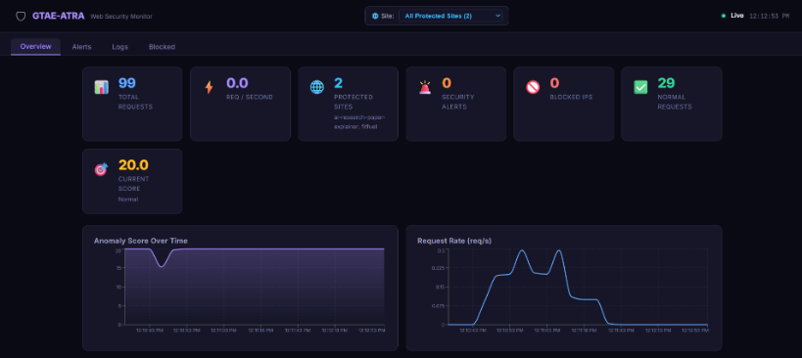
Figure 6.1 Overview tab of the SOC dashboard during normal use
Figure 6.2 shows the alert distribution and the recent events. Ordinary requests for /index.html and /api/explain received risk Low and the action ALLOW with scores between 20.9 and 25.0. Requests for the hidden file /.env received an anomaly score of 100, and the same source was first handled with ALERT and then with BLOCK.
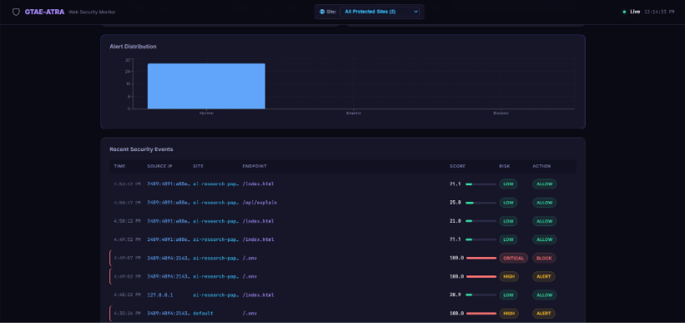
Figure 6.2 Alert distribution and recent security events
The Alerts tab (Figure 6.3) lists 52 alerts and gives the reason and the numbers of every one. For the blocked event the reason is a high 4xx error rate, the anomaly score is 100.0, the risk is 70.5 out of 100, the type is Sensitive Endpoint, two requests were in the window, and the inference took 84.1 ms. The preceding event of the same source, five seconds earlier, had a risk of 65.0 and the action ALERT. The rise from 65.0 to 70.5 crosses the Critical threshold of 70 and shows the escalation of ATRA on a repeat offender. The inference times in the screenshot are between 53 and 84 ms. Events recorded earlier for the default site show risks of 73.0 to 75.0 with the tier High, because they were recorded with an earlier threshold setting before the Critical threshold was calibrated to 70.
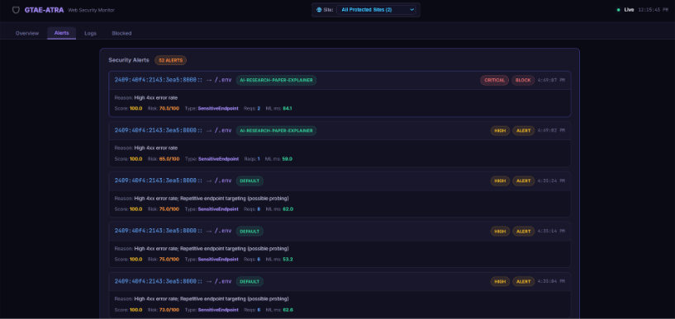
Figure 6.3 Alerts tab with the reason, risk and attack type of each alert
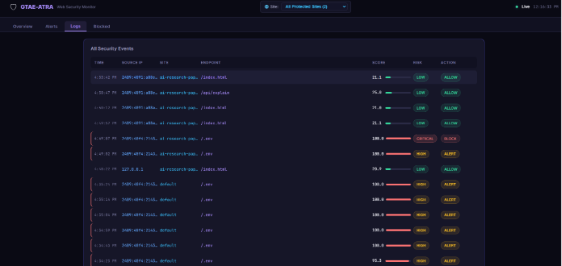
Figure 6.4 Logs tab listing all security events of the protected sites
The Logs tab (Figure 6.4) lists every event with its time, source IP, site, endpoint, score, risk and action. Normal events of the same visitor stay Low and ALLOW, while the repeated probes of /.env form a visible sequence of ALERT events. The test confirms the complete chain from the middleware to the dashboard on real websites, but it is a small functional test with a few hundred events and not a statistical evaluation.
Table 6.1 Evaluation metrics of the web security mode
Metric | Value
True positives / false negatives | 200 / 0
False positives / true negatives | 70 / 730
True positive rate (recall) | 100.00 %
False positive rate | 8.75 %
Precision | 74.07 %
F1-score | 0.8511
Accuracy | 93.00 %

CHAPTER 7
CONCLUSION AND FUTURE ENHANCEMENT
7.1 CONCLUSION
The proposed GTAE-ATRA-NIDS system provides an effective approach for analysing network traffic and identifying abnormal communication by combining Graph Transformer, Autoencoder, anomaly detection, and adaptive threat response techniques. The system processes network and web traffic, converts communication into graph structures, and learns normal traffic behaviour using benign data.
The GTAE model captures relationships between network entities and uses reconstruction error to identify anomalous behaviour. Additional detection techniques such as Isolation Forest, One-Class SVM, and HBOS improve the analysis of suspicious traffic, while the Random Forest classifier helps identify different attack categories.
The ATRA module further improves the system by considering anomaly severity, historical behaviour, and attack frequency before selecting an appropriate response. Based on the calculated risk, the system can allow, monitor, alert, or block suspicious traffic. Overall, the proposed system provides a more adaptive, automated, and practical approach to network intrusion detection and threat response

7.2 FUTURE ENHANCEMENT
- Collect real attack traffic against deliberately vulnerable applications such as DVWA and OWASP Juice Shop in an isolated lab, and retrain and test on separate sessions.
- Improve the recall of low rate attacks with a small supervised head, semi-supervised learning or request level features such as payload tokens.
- Learn the weights and the thresholds of ATRA from data or from the feedback of operators instead of fixing them by hand.
- Add automatic expiry to the live blocklist, a persistent store, and integration with a firewall, a reverse proxy and iptables.
- Evaluate the live monitor with real graph context, by keeping the recent graph of the site and using real positional encodings at inference.
- Identify clients with session or device attributes in addition to the IP address, and add e-mail and chat notifications for the ALERT tier.

REFERENCES

[1] J. Ghadermazi, S. Hore, A. Shah and N. D. Bastian, “GTAE-IDS: Graph Transformer-Based Autoencoder Framework for Real-Time Network Intrusion Detection,” IEEE Transactions on Information Forensics and Security, 2025.
[2] T. Bilot, N. El Madhoun, K. Al Agha and A. Zouaoui, “Graph Neural Networks for Intrusion Detection: A Survey,” IEEE Access, 2023.
[3] D. Pujol-Perich, J. Suarez-Varela, A. Cabellos-Aparicio and P. Barlet-Ros, “Unveiling the Potential of Graph Neural Networks for Robust Intrusion Detection,” 2023.
[4] X. Li, J. Zhang, Y. Yuan and C. Zhou, “Network Intrusion Detection with Edge-Directed Graph Multi-Head Attention Networks,” 2023.
[5] Y. Wang, Z. Han, J. Li and X. He, “BS-GAT: Behavior Similarity Based Graph Attention Network for Network Intrusion Detection,” 2023.
[6] M. Gharib, B. Mohammadi, S. H. Dastgerdi and M. Sabokrou, “AutoIDS: Auto-Encoder Based Method for Intrusion Detection System,” 2021.
[7] J. Zhou, G. Cui, S. Hu, Z. Zhang, C. Yang, Z. Liu, L. Wang, C. Li and M. Sun, “Graph Neural Networks: A Review of Methods and Applications,” 2018.
[8] V. K. Manavalasundaram, M. Namitha, M. A. Muhamudha Aqsa, V. Priyadharshini and R. Sudharsan, “Network Intrusion Detection Based on Graph Neural Network and Ensemble Learning,” 2023.
[9] M. Gorricho-Segura, X. Echeberria-Barrio and L. Segurola-Gil, “Edge-Based Analysis for Network Intrusion Detection Using a GNN Approach,” 2023.
[10] N. T. Hieu and N. H. Son, “Deep Learning-Based Cyber Attack Detection: A Comparative Study of Transformer and Convolutional Neural Network Architectures,” 2025.
[11] L. Guerra, T. Chapuis, G. Duc, P. Mozharovskyi and V.-T. Nguyen, “Self-Supervised Learning of Graph Representations for Network Intrusion Detection (GraphIDS),” 2025.
[12] I. Sharafaldin, A. H. Lashkari and A. A. Ghorbani, “Toward Generating a New Intrusion Detection Dataset and Intrusion Traffic Characterization,” Proc. 4th International Conference on Information Systems Security and Privacy (ICISSP), 2018.
[13] A. Vaswani et al., “Attention Is All You Need,” Advances in Neural Information Processing Systems (NeurIPS), 2017.
[14] V. P. Dwivedi and X. Bresson, “A Generalization of Transformer Networks to Graphs,” arXiv:2012.09699, 2020.
[15] F. T. Liu, K. M. Ting and Z.-H. Zhou, “Isolation Forest,” Proc. IEEE International Conference on Data Mining (ICDM), 2008.
[16] B. Scholkopf, J. C. Platt, J. Shawe-Taylor, A. J. Smola and R. C. Williamson, “Estimating the Support of a High-Dimensional Distribution,” Neural Computation, vol. 13, no. 7, 2001.
[17] M. Goldstein and A. Dengel, “Histogram-based Outlier Score (HBOS): A fast Unsupervised Anomaly Detection Algorithm,” KI-2012 Poster and Demo Track, 2012.
[18] L. Breiman, “Random Forests,” Machine Learning, vol. 45, no. 1, pp. 5-32, 2001.
[19] E. Caville, W. W. Lo, S. Layeghy and M. Portmann, “Anomal-E: A Self-Supervised Network Intrusion Detection System Based on Graph Neural Networks,” Knowledge-Based Systems, vol. 258, 2022.
[20] M. Zhong, M. Lin, C. Zhang and Z. Xu, “A Survey on Graph Neural Networks for Intrusion Detection Systems: Methods, Trends and Challenges,” Computers & Security, vol. 141, 2024.
[21] R. Xu, G. Wu, W. Wang, X. Gao, A. He and Z. Zhang, “Applying Self-Supervised Learning to Network Intrusion Detection for Network Flows with Graph Neural Network,” Computer Networks, vol. 248, 2024.
[22] A. Zhang, Y. Zhao, C. Zhou and T. Zhang, “ResACAG: A Graph Neural Network Based Intrusion Detection,” Computers & Electrical Engineering, vol. 122, 2025.
[23] S. Gamage and J. Samarabandu, “Deep Learning Methods in Network Intrusion Detection: A Survey and an Objective Comparison,” Journal of Network and Computer Applications, vol. 169, 2020.
[24] Z. Ahmad, A. S. Khan, C. W. Shiang, J. Abdullah and F. Ahmad, “Network Intrusion Detection System: A Systematic Study of Machine Learning and Deep Learning Approaches,” Transactions on Emerging Telecommunications Technologies, vol. 32, no. 1, 2021.
[25] A. Khraisat, I. Gondal, P. Vamplew and J. Kamruzzaman, “Survey of Intrusion Detection Systems: Techniques, Datasets and Challenges,” Cybersecurity, vol. 2, 2019.
[26] M. Ring, S. Wunderlich, D. Scheuring, D. Landes and A. Hotho, “A Survey of Network-Based Intrusion Detection Data Sets,” Computers & Security, vol. 86, pp. 147–167, 2019.
[27] N. Moustafa and J. Slay, “UNSW-NB15: A Comprehensive Data Set for Network Intrusion Detection Systems (UNSW-NB15 Network Data Set),” 2015 Military Communications and Information Systems Conference (MilCIS), 2015.
[28] A. Alsaedi, N. Moustafa, Z. Tari, A. N. Mahmood and A. Anwar, “TON_IoT Telemetry Dataset: A New Generation Dataset of IoT and IIoT for Data-Driven Intrusion Detection Systems,” IEEE Access, 2020.
[29] T. N. Kipf and M. Welling, “Semi-Supervised Classification with Graph Convolutional Networks,” International Conference on Learning Representations (ICLR), 2017.
[30] P. Veličković, G. Cucurull, A. Casanova, A. Romero, P. Liò and Y. Bengio, “Graph Attention Networks,” International Conference on Learning Representations (ICLR), 2018.
[31] W. L. Hamilton, R. Ying and J. Leskovec, “Inductive Representation Learning on Large Graphs,” Advances in Neural Information Processing Systems (NeurIPS), vol. 30, 2017.
[32] K. Xu, W. Hu, J. Leskovec and S. Jegelka, “How Powerful Are Graph Neural Networks?,” International Conference on Learning Representations (ICLR), 2019.
[33] T. N. Kipf and M. Welling, “Variational Graph Auto-Encoders,” NIPS Workshop on Bayesian Deep Learning, 2016.
[34] P. Veličković, W. Fedus, W. L. Hamilton, P. Liò, Y. Bengio and R. D. Hjelm, “Deep Graph Infomax,” International Conference on Learning Representations (ICLR), 2019.
[35] B. Zong, Q. Song, M. R. Min, W. Cheng, C. Lumezanu, D. Cho and H. Chen, “Deep Autoencoding Gaussian Mixture Model for Unsupervised Anomaly Detection,” International Conference on Learning Representations (ICLR), 2018.
[36] R. Chalapathy and S. Chawla, “Deep Learning for Anomaly Detection: A Survey,” arXiv preprint arXiv:1901.03407, 2019.
[37] M. M. Breunig, H.-P. Kröger, R. T. Ng and J. Sander, “LOF: Identifying Density-Based Local Outliers,” Proceedings of the 2000 ACM SIGMOD International Conference on Management of Data, pp. 93–104, 2000.
[38] N. Shone, T. N. Ngoc, V. D. Phai and Q. Shi, “A Deep Learning Approach to Network Intrusion Detection,” IEEE Transactions on Emerging Topics in Computational Intelligence, vol. 2, no. 1, pp. 41–50, 2018.
[39] S. Axelsson, “Intrusion Detection Systems: A Survey and Taxonomy,” 2000.
[40] A. Venturi, D. Stabili and M. Marchetti, “Problem Space Structural Adversarial Attacks for Network Intrusion Detection Systems Based on Graph Neural Networks,” arXiv preprint arXiv:2403.11830, 2024.

