ADAPTIVE THREAT RESPONSE BASED NETWORK INTRUSION DETECTION SYSTEM USING GRAPH TRANSFORMER AND AUTOENCODER

A PROJECT REPORT
Submitted by
SHARICK AHMED A (721723104129)
VIGNESH A (721723104153)
SIVASANKARAN K (721723104135)
In partial fulfillment for the award of the degree
of
BACHELOR OF ENGINEERING
IN
COMPUTER SCIENCE AND ENGINEERING

P.A. COLLEGE OF ENGINEERING AND TECHNOLOGY
(An Autonomous Institution)
Pollachi, Coimbatore Dt. – 642 002
APRIL 2027

P.A. COLLEGE OF ENGINEERING AND TECHNOLOGY
BONAFIDE CERTIFICATE
Certified that this project report “ADAPTIVE THREAT RESPONSE BASED NETWORK INTRUSION DETECTION SYSTEM USING GRAPH TRANSFORMER AND AUTOENCODER” is the bonafide work of “SHARICK AHMED A (721723104129), VIGNESH A (721723104153), SIVASANKARAN K (721723104135)” who carried out the project work under our supervision.

SIGNATURE  Dr. D. CHITRA, M.E., Ph.D.,  Professor and Head  HEAD OF THE DEPARTMENT  Department of Computer Science and Engineering  P. A. College of Engineering and Technology  Pollachi – 642 002 | SIGNATURE  Mr. T. DINESH KUMAR, M.Tech.,  Assistant Professor  SUPERVISOR  Department of Computer Science and Engineering  P. A. College of Engineering and Technology  Pollachi – 642 002

Submitted to the Viva-voce Examination held on ______________________

INTERNAL EXAMINER EXTERNAL EXAMINER
ACKNOWLEDGEMENT
First and foremost, we thank the GOD ALMIGHTY for blessing us with the mental strength that was needed to carry out the project work. We thank our Chairman Dr. P. APPUKUTTY, M.E., FIE., FIV., for his extensive support to successfully carry out this project.
We take privilege in expressing our sincere and heartfelt thanks and gratitude to our beloved Principal Dr. T. MANIGANDAN, M.E., Ph.D., for providing us an opportunity to carry out this project work.
We express our heartfelt thanks to Dr. D. CHITRA, M.E., Ph.D., Professor and Head, Department of Computer Science and Engineering, for her technical guidance and constructive suggestions provided throughout the project work.
We take pride in expressing our sincere and deepest thanks to our project guide Mr. T. DINESH KUMAR, M.Tech., Assistant Professor, Department of Computer Science and Engineering, for his technical guidance, constructive criticism and many valuable suggestions provided throughout the project work.
We take this opportunity to thank and pay gratitude to our project Coordinator Dr. M. UMASELVI, M.E., Ph.D., Associate Professor, Department of Computer Science and Engineering and all teaching and non-teaching staff members of our department, for their encouragement and valuable suggestions.
We take this opportunity to express our gratitude to our parents, friends, family and other members whose support and love have always been with us to carry out this project work successfully.
ABSTRACT
Computer networks and web applications carry banking, healthcare, business and cloud services, and they are attacked continuously by Denial of Service, brute force, SQL injection, cross site scripting and scanning attacks. Traditional signature based Intrusion Detection Systems fail to recognise new and unknown attacks, and most existing machine learning detectors only raise an alert, leaving the actual response to a human administrator. The delay between detection and response increases the damage caused by an attack.
This project presents GTAE-ATRA-NIDS, a network intrusion detection system that combines a Graph Transformer based Autoencoder (GTAE) with an Adaptive Threat Response Algorithm (ATRA). The GTAE represents traffic as a graph, adds Laplacian positional encoding and learns the normal behaviour of the network from benign traffic only. Flows or sessions that cannot be reconstructed well are treated as anomalies. A three detector ensemble made of Isolation Forest, One Class SVM and Histogram Based Outlier Score confirms the decision and a Random Forest classifier assigns the attack type.
ATRA converts every detection into a risk score between 0 and 100 using attack type, severity, model confidence, an exponentially time decayed history of the source IP and its recent frequency. The score selects a proportional action: ALLOW, MONITOR, ALERT or BLOCK, with a timed blocklist and structured attack logs. The system works in two modes: a web security monitoring mode in which an Express application streams HTTP telemetry to a Python monitor and a React dashboard, and a network flow mode evaluated on the CIC-IDS2017 benchmark. On 11,568 test flows the system obtained a precision of 79.58% with a false positive rate of 7.56%, and repeat offenders were escalated from MONITOR to higher response tiers within a few consecutive windows.
TABLE OF CONTENTS
CHAPTER NO |  | TITLE | PAGE NO
 |  | ABSTRACT | IV
 |  | LIST OF FIGURES | VII
 |  | LIST OF TABLES | VIII
 |  | LIST OF ABBREVIATIONS | IX
1 |  | INTRODUCTION | 1
 | 1.1 | NETWORK SECURITY AND CYBER ATTACKS | 1
 | 1.2 | INTRUSION DETECTION SYSTEMS | 2
 | 1.3 | GRAPH LEARNING FOR INTRUSION DETECTION | 2
 | 1.4 | MOTIVATION OF THE PROJECT | 2
 | 1.5 | OBJECTIVES OF THE PROJECT | 3
2 |  | SURVEY ON INTRUSION DETECTION AND RELATED SYSTEMS | 4
 | 2.1 | GRAPH TRANSFORMER BASED AUTOENCODER FRAMEWORK | 4
 | 2.2 | GRAPH NEURAL NETWORKS FOR INTRUSION DETECTION | 4
 | 2.3 | ATTENTION AND TRANSFORMER BASED DETECTION | 4
 | 2.4 | AUTOENCODER BASED DETECTION | 5
 | 2.5 | SUMMARY OF THE SURVEY | 5
3 |  | GRAPH TRANSFORMER AUTOENCODER BASED INTRUSION DETECTION (EXISTING SYSTEM) | 6
 | 3.1 | METHODOLOGY OF THE GTAE-IDS | 6
 | 3.2 | GTAE MODEL ARCHITECTURE | 7
 | 3.3 | ANOMALY DETECTION ON THE LATENT SPACE | 8
 | 3.4 | LIMITATIONS OF THE EXISTING SYSTEM | 9
4 |  | ADAPTIVE THREAT RESPONSE BASED NETWORK INTRUSION DETECTION SYSTEM (PROPOSED SYSTEM) | 10
 | 4.1 | MODEL OVERVIEW | 10
 | 4.2 | MODEL ARCHITECTURE | 11
 | 4.3 | WORKING OF THE PROPOSED SYSTEM | 11
 | 4.4 | BLOCK DIAGRAM | 12
 | 4.5 | WEB SECURITY MONITORING MODE | 13
 | 4.6 | ADAPTIVE THREAT RESPONSE ALGORITHM (ATRA) | 14
5 |  | SYSTEM SPECIFICATION | 16
 | 5.1 | HARDWARE SPECIFICATION | 16
 | 5.2 | SOFTWARE SPECIFICATION | 16
 | 5.3 | PURPOSE AND SCOPE OF DOCUMENT | 17
 | 5.4 | NON-FUNCTIONAL REQUIREMENTS | 17
6 |  | SYSTEM IMPLEMENTATION AND ENHANCEMENT | 18
 | 6.1 | MODULE DISCUSSION | 18
 |  | 6.1.1 DATA ACQUISITION MODULE | 18
 |  | 6.1.2 DATA PROCESSING MODULE | 18
 |  | 6.1.3 GRAPH CONSTRUCTION MODULE | 18
 |  | 6.1.4 GTAE MODULE | 18
 |  | 6.1.5 DETECTION AND CLASSIFICATION MODULE | 18
 |  | 6.1.6 ATRA AND RESPONSE MODULE | 19
 |  | 6.1.7 DASHBOARD MODULE | 19
 | 6.2 | ALGORITHM AND TECHNIQUES | 19
 | 6.3 | SOURCE CODE | 20
 | 6.4 | RESULT | 22
7 |  | CONCLUSION AND FUTURE ENHANCEMENT | 26
 | 7.1 | CONCLUSION | 26
 | 7.2 | FUTURE ENHANCEMENT | 26
 |  | REFERENCES | 27
LIST OF FIGURES
FIGURE NO | TITLE | PAGE NO
3.1 | METHODOLOGY OF THE GTAE-IDS (EXISTING SYSTEM) | 7
3.2 | ARCHITECTURE OF THE GTAE MODEL | 8
4.1 | MODEL ARCHITECTURE OF GTAE-ATRA-NIDS | 11
4.2 | WORKFLOW OF THE PROPOSED SYSTEM | 12
4.3 | BLOCK DIAGRAM OF THE PROPOSED SYSTEM | 12
4.4 | DATA FLOW OF THE WEB SECURITY MONITORING MODE | 13
4.5 | COMPONENTS AND RESPONSE TIERS OF ATRA | 15
6.1 | CONFUSION MATRIX OF THE DETECTOR | 22
6.2 | DETECTION RATE OF SELECTED ATTACK TYPES | 23
6.3 | DISTRIBUTION OF ATRA RISK LEVELS FOR THE FLAGGED FLOWS | 24
6.4 | EXPONENTIAL TIME DECAY OF THE ATTACK HISTORY | 24
6.5 | ADAPTIVE ESCALATION OF A REPEAT OFFENDER | 25
LIST OF TABLES
TABLE NO | TITLE | PAGE NO
2.1 | SUMMARY OF THE LITERATURE SURVEY | 5
3.1 | COMPONENTS OF THE EXISTING GTAE-IDS | 8
4.1 | MODULES OF THE PROPOSED SYSTEM AND THEIR FUNCTIONS | 10
4.2 | THE 20 WEB TELEMETRY FEATURES | 13
4.3 | ATRA RESPONSE TIERS | 15
5.1 | HARDWARE REQUIREMENTS | 16
5.2 | SOFTWARE REQUIREMENTS | 16
5.3 | NON-FUNCTIONAL REQUIREMENTS | 17
6.1 | EVALUATION METRICS OF THE DETECTOR | 22
6.2 | WORKED EXAMPLE OF ATRA SCORING (PROTOTYPE LOG) | 25
LIST OF ABBREVIATIONS
AE | Autoencoder
API | Application Programming Interface
ATRA | Adaptive Threat Response Algorithm
CIC-IDS2017 | Canadian Institute for Cybersecurity Intrusion Detection Dataset 2017
CNN | Convolutional Neural Network
CPU | Central Processing Unit
CSV | Comma Separated Values
DDoS | Distributed Denial of Service
DNN | Deep Neural Network
DoS | Denial of Service
FN | False Negative
FP | False Positive
FPR | False Positive Rate
GNN | Graph Neural Network
GTAE | Graph Transformer Autoencoder
HBOS | Histogram Based Outlier Score
HIDS | Host based Intrusion Detection System
HTTP | Hypertext Transfer Protocol
IDS | Intrusion Detection System
IF | Isolation Forest
IP | Internet Protocol
JSONL | JSON Lines
LPE | Laplacian Positional Encoding
ML | Machine Learning
MSE | Mean Squared Error
NAT | Network Address Translation
NIDS | Network based Intrusion Detection System
OCSVM | One Class Support Vector Machine
RF | Random Forest
SOC | Security Operations Center
SQLi | Structured Query Language Injection
TN | True Negative
TP | True Positive
TPR | True Positive Rate
TTL | Time To Live
UI | User Interface
WAF | Web Application Firewall
XSS | Cross Site Scripting

CHAPTER 1
INTRODUCTION
Computer networks are the backbone of communication, commerce, banking, healthcare and cloud computing. Every organisation, from a small web developer to a large enterprise, exposes services to the Internet and therefore exposes them to attackers. The confidentiality, integrity and availability of data and services are threatened by Denial of Service (DoS), Distributed Denial of Service (DDoS), brute force password attacks, SQL injection, cross site scripting, port scanning and many other techniques. The number and the variety of these attacks keep increasing, and new variants appear faster than rule writers can describe them.
An Intrusion Detection System (IDS) monitors network or application traffic and reports suspicious activity. Classical systems compare traffic with a database of known attack signatures. They are fast and accurate for known attacks, but they cannot see an attack that has not been described before. Machine learning and deep learning detectors learn the pattern of normal traffic and flag deviations, which allows them to catch unknown attacks, but most of them stop at detection. They produce an alert, and a human must investigate and act, so the attacker keeps working during that delay.
This project, Adaptive Threat Response Based Network Intrusion Detection System Using Graph Transformer and Autoencoder, closes this gap. It uses a Graph Transformer Autoencoder (GTAE) to detect anomalies in graph structured traffic without needing labelled attack data for training, and it adds an Adaptive Threat Response Algorithm (ATRA) that scores the risk of every detected event and selects a proportional automatic response such as logging, monitoring, alerting or blocking the source IP address.

1.1 NETWORK SECURITY AND CYBER ATTACKS
Network security is the practice of protecting the network, the devices connected to it and the data that travels over it. Attacks can be grouped by their goal. Availability attacks such as DoS Hulk, GoldenEye, Slowloris and DDoS exhaust the bandwidth, connections or processing power of a server. Reconnaissance attacks such as port scans and directory scans collect information about open services and hidden paths. Credential attacks such as brute force and credential stuffing try many passwords against a login service. Injection attacks such as SQL injection and cross site scripting send crafted input to make an application run commands that its developer never intended. Exploitation attacks such as Heartbleed read memory or take control of a vulnerable service.
These attacks leave different traces in traffic. A flood produces a very high request rate, a scan touches many different endpoints and returns many 404 or 403 errors, a brute force attack repeats the same login request with failures, and an injection attack carries unusual characters and keywords in the URL or the query string. A detection system that can learn all these traces together, and not only a single threshold, is needed.

1.2 INTRUSION DETECTION SYSTEMS
Intrusion detection systems are classified by where they are placed and how they decide. A Network based IDS (NIDS) observes packets or flows on the network, while a Host based IDS (HIDS) observes logs and system calls of one machine. By decision method there are two families.
- Signature (misuse) based detection matches traffic with stored patterns of known attacks. It gives few false alarms but cannot detect zero day attacks and needs continuous rule updates.
- Anomaly based detection builds a model of normal behaviour and flags what deviates from it. It can detect unknown attacks, but it may raise false alarms when legitimate behaviour changes.
Web Application Firewalls (WAF) and tools such as Fail2ban and CrowdSec add a response step, but they are mostly rule based. The proposed system keeps the advantage of anomaly detection and adds an adaptive response step on top of it.

1.3 GRAPH LEARNING FOR INTRUSION DETECTION
Network traffic is naturally a graph. Hosts, ports or endpoints are the nodes and communication between them forms the edges. A single flow looked at alone can appear harmless, but its position in the communication structure may reveal an attack, for example one source connected to a large number of destinations, or many sources converging on a single server. Graph Neural Networks (GNN) and graph transformers can learn this structural information in addition to the features of each flow.
An autoencoder is a neural network trained to compress its input into a small representation and then reconstruct it. When it is trained only on normal data, it reconstructs normal data with a small error, and it reconstructs data it has never seen, such as an attack, with a large error. This reconstruction error is therefore a natural anomaly score that needs no labelled attacks. The GTAE joins the two ideas: a graph transformer encoder produces the compressed representation and a deep neural network decoder reconstructs the original edge features.

1.4 MOTIVATION OF THE PROJECT
The base work, GTAE-IDS, shows that a graph transformer autoencoder detects attacks effectively, but, like most research detectors, it ends with an alert and gives no automatic response or self healing. The following observations motivated this project.
- Attackers can finish their work in seconds, whereas manual investigation takes minutes or hours, so the response must be automatic.
- A binary allow or block decision is risky. Blocking a legitimate user causes business loss, and ignoring a persistent attacker causes damage. A graded response is needed.
- A repeat offender is more dangerous than a first time suspect, so the response must remember history, and old history must fade with time.
- Small web developers do not have the budget for large commercial security suites, so a lightweight and open system that can protect an ordinary web application is valuable.

1.5 OBJECTIVES OF THE PROJECT
- To detect known and unknown network and web attacks with an unsupervised Graph Transformer Autoencoder trained on benign traffic only.
- To reduce false alarms by confirming the autoencoder with an ensemble of Isolation Forest, One Class SVM and HBOS detectors.
- To identify the type of every detected attack with a Random Forest classifier.
- To design ATRA, which calculates a time decayed risk score and selects a proportional response, and to record every decision in an auditable log.
- To provide live monitoring of a web application and a Security Operations Center (SOC) dashboard for operators.

CHAPTER 2
SURVEY ON INTRUSION DETECTION AND RELATED SYSTEMS
This chapter reviews the literature on graph based and autoencoder based intrusion detection that formed the background of the project. The review shows what has been achieved in detection accuracy and, at the same time, that response to the detected threat is rarely addressed.

2.1 GRAPH TRANSFORMER BASED AUTOENCODER FRAMEWORK
Ghadermazi, Hore, Shah and Bastian proposed GTAE-IDS, a real time network intrusion detection framework published in the IEEE Transactions on Information Forensics and Security in 2025. Network traffic is represented as a graph, the packet based features of every flow are the edge features, a graph transformer encoder with Laplacian positional encoding creates the latent representation, and a decoder reconstructs the edge features. The model is trained on benign traffic only, and anomaly detectors working on the latent space separate attacks from normal traffic. The framework detects attacks effectively, but it does not provide any automatic response or self healing. This is the base paper of the present work.

2.2 GRAPH NEURAL NETWORKS FOR INTRUSION DETECTION
Bilot, El Madhoun, Al Agha and Zouaoui published a survey of graph neural networks for intrusion detection in IEEE Access in 2023. The survey explains how network data can be turned into graphs, compares GNN architectures and lists open problems, but as a survey paper it does not propose a new detection model. Pujol-Perich, Suarez-Varela, Cabellos-Aparicio and Barlet-Ros studied the robustness of GNN based detection in 2023. Their work concentrates on detection accuracy and robustness, and it does not define any automated response mechanism.
Gorricho-Segura, Echeberria-Barrio and Segurola-Gil analysed network intrusions at the edge level with a GNN approach in 2023, which is close to the edge feature representation used here, but their approach also stops at detection. Manavalasundaram and co-authors combined a graph neural network with ensemble learning in 2023 and obtained a stronger detector at the cost of longer training time and higher computational complexity.

2.3 ATTENTION AND TRANSFORMER BASED DETECTION
Li, Zhang, Yuan and Zhou described an intrusion detection method based on edge directed graph multi head attention networks, and Wang, Han, Li and He proposed BS-GAT, a behaviour similarity based graph attention network, both in 2023. They show that attention over graph neighbours improves the recognition of malicious behaviour. Hieu and Son compared Transformer and Convolutional Neural Network architectures for cyber attack detection in 2025 and focused only on attack detection. Guerra, Chapuis, Duc, Mozharovskyi and Nguyen proposed GraphIDS in 2025, a self supervised graph representation learning method that uses a masked autoencoder and a transformer. It is mainly research oriented and computationally heavy for deployment.

2.4 AUTOENCODER BASED DETECTION
Gharib, Mohammadi, Dastgerdi and Sabokrou proposed AutoIDS in 2021, an autoencoder based intrusion detection method that learns the normal traffic. Its limitation is that it depends on training with normal traffic and shows limited performance on evolving attack patterns. Zhou and co-authors published a broad review of graph neural network methods and applications in 2018 that gives the theoretical background of graph learning used in this domain.

2.5 SUMMARY OF THE SURVEY
Table 2.1: SUMMARY OF THE LITERATURE SURVEY
Work (year) | Technology used | Limitation
GTAE-IDS, Ghadermazi et al. (2025) | Graph Transformer, Graph Autoencoder, unsupervised learning | Detects attacks effectively but gives no automatic response or self healing
GNN for Intrusion Detection: A Survey, Bilot et al. (2023) | Graph Neural Networks, deep learning | Survey paper, proposes no new detection model
Robust GNN Intrusion Detection, Pujol-Perich et al. (2023) | Graph Neural Networks | Focuses on accuracy and robustness, no automated response
GNN and Ensemble Learning, Manavalasundaram et al. (2023) | Graph Neural Network, ensemble learning | Increased training time and computational complexity
Edge based Analysis with GNN, Gorricho-Segura et al. (2023) | Graph Neural Network | Edge level analysis only, no automated response
Transformer vs CNN, Hieu and Son (2025) | Transformer, CNN | Attack detection only, no response mechanism
GraphIDS, Guerra et al. (2025) | Self supervised GNN, masked autoencoder, transformer | Research focused and computationally intensive for deployment
AutoIDS, Gharib et al. (2021) | Autoencoder, deep learning | Limited on evolving attacks, depends on normal traffic training

From the survey it is clear that graph based and autoencoder based detectors reach good detection quality, but none of the reviewed systems closes the loop from detection to a graded automatic response. This gap is the contribution targeted by the proposed system.

CHAPTER 3
GRAPH TRANSFORMER AUTOENCODER BASED INTRUSION DETECTION (EXISTING SYSTEM)
The existing system on which this project builds is GTAE-IDS. This chapter explains its methodology, its model and its limitations, because the detection part of the proposed system is a re-implementation of the same idea.

3.1 METHODOLOGY OF THE GTAE-IDS
GTAE-IDS treats every network flow as an edge of a graph. The source and the destination of the flow (IP address and port) are the two nodes and the packet based features of the flow are the edge attributes. For each flow, the first p = 8 packets are used, and every packet is described by 25 normalised byte level features. A forward packet is placed in the first half of a 50 value placeholder and a backward packet in the second half, so that direction is preserved. The eight placeholders are concatenated into one edge vector of 400 values.
Nodes do not have features of their own, so structural information is added with Laplacian positional encoding. The normalised Laplacian of the graph is decomposed, the eigenvectors of the k smallest non trivial eigenvalues describe the position of each node, and the encodings of the source and the destination node are concatenated for each edge. The graph transformer encoder then processes the edge vectors, the decoder reconstructs them and the model is trained only on benign flows. The reconstruction error and the latent vectors are finally used by anomaly detectors.
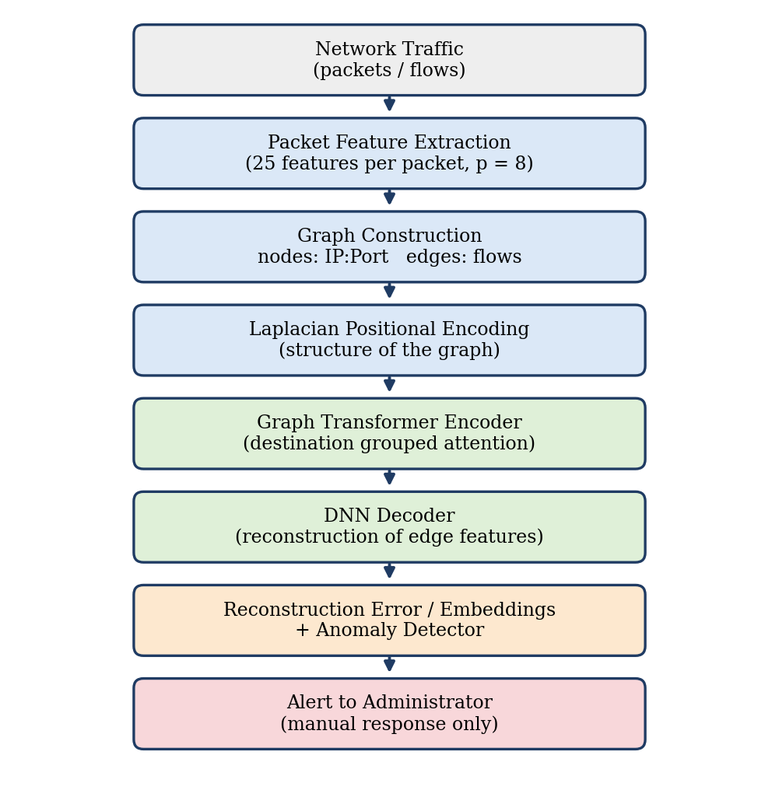
Figure No. 3.1: METHODOLOGY OF THE GTAE-IDS (EXISTING SYSTEM)

3.2 GTAE MODEL ARCHITECTURE
The encoder first projects the 400 dimensional edge vector and the positional encoding to the model dimension d = 64 and adds them. Three graph transformer layers follow. Each layer has four attention heads, and the attention of an edge is computed only among the edges that share the same destination node, which keeps the computation local and focused on the victim. The layer uses residual connections, layer normalisation and a feed forward network. The output of the encoder is the 64 dimensional bottleneck vector z. A three layer deep neural network decoder (64, 128, 256, 400) reconstructs the original edge features from z.
Training minimises the mean squared error between the input edge vector and its reconstruction using only benign flows. At inference time benign flows are reconstructed well, and attack flows have a larger error and a different latent representation.
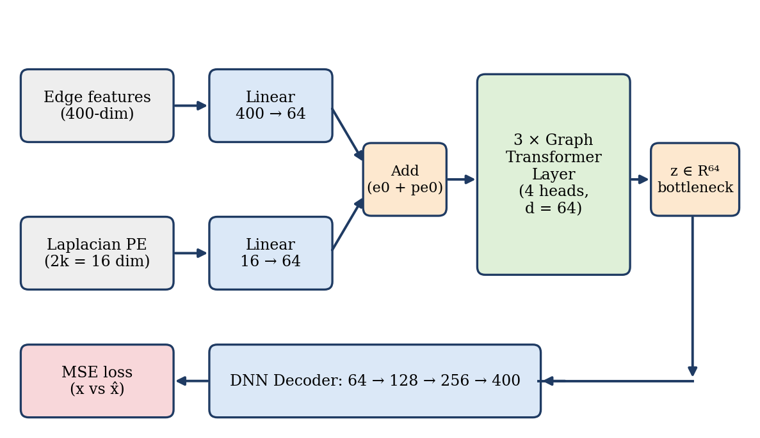
Figure No. 3.2: ARCHITECTURE OF THE GTAE MODEL

3.3 ANOMALY DETECTION ON THE LATENT SPACE
After training, the latent vectors z are standardised and given to unsupervised detectors that were fitted on benign embeddings only. Isolation Forest isolates points with random splits, and a point that is isolated with few splits is an outlier. One Class SVM learns a boundary around benign data in a kernel space. A flow is declared anomalous when the detectors, used as an ensemble, flag it. Table 3.1 lists the components of the existing system.
Table 3.1: COMPONENTS OF THE EXISTING GTAE-IDS
Component | Description
Edge features | 8 packets x 25 features, fwd/bwd placeholder scheme, 400 values per flow
Positional encoding | Laplacian eigenvectors of the traffic graph, k = 8 for each node
Encoder | Linear projection, 3 graph transformer layers, 4 heads, d = 64, attention grouped by destination node
Decoder | DNN 64 - 128 - 256 - 400
Training | Unsupervised, benign flows only, mean squared error, Adam optimiser
Detection | Reconstruction error and latent space detectors (Isolation Forest, One Class SVM)
Output | Alert to the administrator

3.4 LIMITATIONS OF THE EXISTING SYSTEM
- The system detects intrusions but does not provide any automatic threat response or self healing; blocking an IP or isolating an attacker must be done manually.
- It depends on administrators for handling incidents, so the response is delayed and the impact of an attack increases.
- There is no risk assessment or prioritisation of attacks, so an important event and a harmless anomaly look the same.
- The system has no memory of earlier behaviour, so a persistent attacker is treated like a first time suspect.
- Attack type is not reported, and there is no live monitoring interface for a web application.

CHAPTER 4
ADAPTIVE THREAT RESPONSE BASED NETWORK INTRUSION DETECTION SYSTEM (PROPOSED SYSTEM)

4.1 MODEL OVERVIEW
The proposed system, named GTAE-ATRA-NIDS, extends the detection power of the GTAE with a decision and response engine. It replaces conventional signature based IDS and shallow machine learning with a dual engine architecture. The first engine is the Graph Transformer Autoencoder with Laplacian positional encoding that captures the structural and behavioural dependencies between IP addresses and endpoints. The second engine is ATRA, which avoids a binary allow or block decision and calculates a dynamic time decayed risk score that selects a proportional action.
The system has two operating modes. In the Web Security Monitoring Mode (live mode) a Node.js Express application sends HTTP telemetry to a Python monitor. The telemetry of each source IP is collected in a 30 second window, converted into a 20 dimensional feature vector, analysed in real time and the events are streamed to a React dashboard. In the Network Flow Mode (research mode) the system is trained and evaluated on the CIC-IDS2017 benchmark, which has 78 flow features and eight days of attacks, and it can also read live packets using Npcap.
Table 4.1: MODULES OF THE PROPOSED SYSTEM AND THEIR FUNCTIONS
Module | Function
Data acquisition | Collects live packets, CIC-IDS2017 flows and HTTP telemetry from the Express monitor middleware
Feature extraction | Creates the 20 web features per IP window or the flow features, with normalisation
Graph builder | Builds the IP to endpoint (or flow) graph and the Laplacian positional encoding
GTAE model | Graph transformer encoder and DNN decoder, reconstruction error as anomaly score
Anomaly ensemble | Isolation Forest, One Class SVM and HBOS with union or majority voting
Attack classifier | Random Forest that names the attack category
ATRA engine | Risk score, time decayed IP history, tiered action selection
Logger and blocklist | JSONL and CSV event logs, persistent blocklist with time to live
SOC dashboard | React and Socket.IO interface with live events, gauge, charts and manual unblock

4.2 MODEL ARCHITECTURE
The system is organised as seven layers. Each layer passes its result to the next one, so that a packet or a request at the input is finally turned into a decision, a log entry and a visible event on the dashboard. The data acquisition layer feeds the pre-processing and graph layer, the GTAE layer produces the anomaly signal, the detection layer confirms and classifies it, ATRA converts it into a risk score, the response layer acts and the dashboard layer shows the result to the operator.
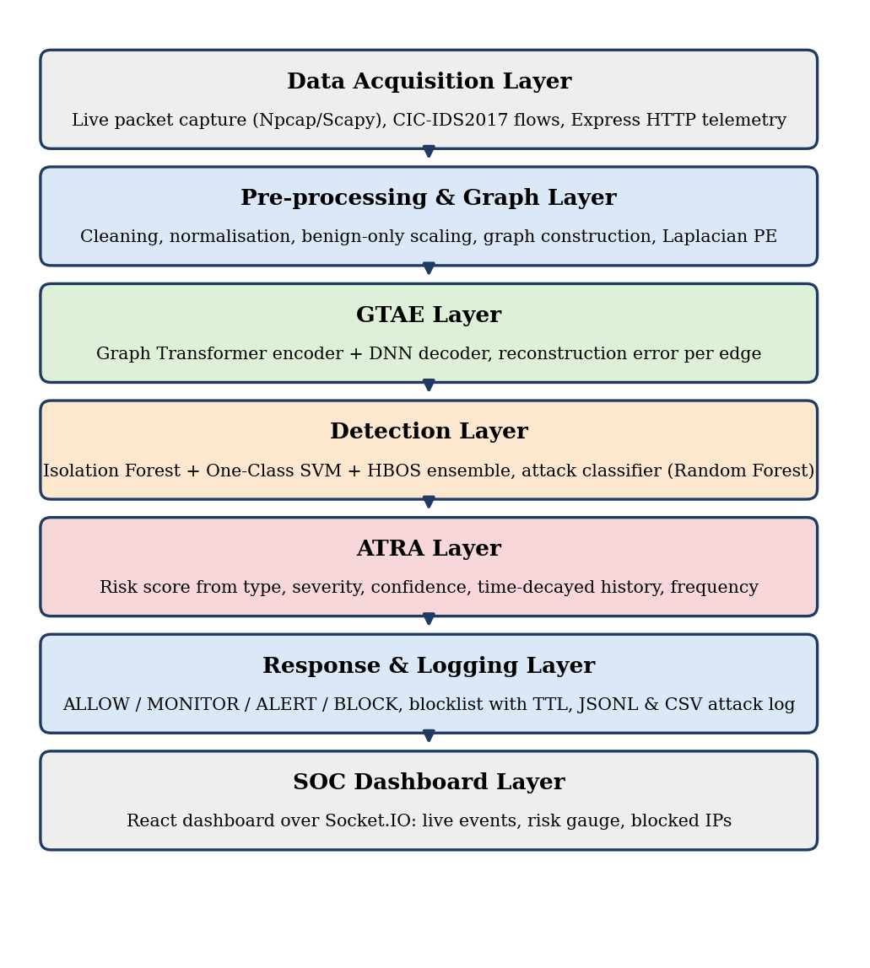
Figure No. 4.1: MODEL ARCHITECTURE OF GTAE-ATRA-NIDS

4.3 WORKING OF THE PROPOSED SYSTEM
The working of the system follows the pipeline of Figure 4.2. Traffic is captured and converted into features. The features are placed on a graph, and the trained GTAE encodes the graph and reconstructs the features. The reconstruction error and the latent vector are examined by the ensemble of detectors. When the ensemble flags the event, the Random Forest names the attack type and ATRA calculates the risk score using the type, the severity, the confidence and the history of the source IP. The selected action is executed, logged and sent to the dashboard. Every flagged event is also written into the history tracker of the IP, so the next event from the same source will receive a higher risk score. This feedback is the adaptive property of the system.
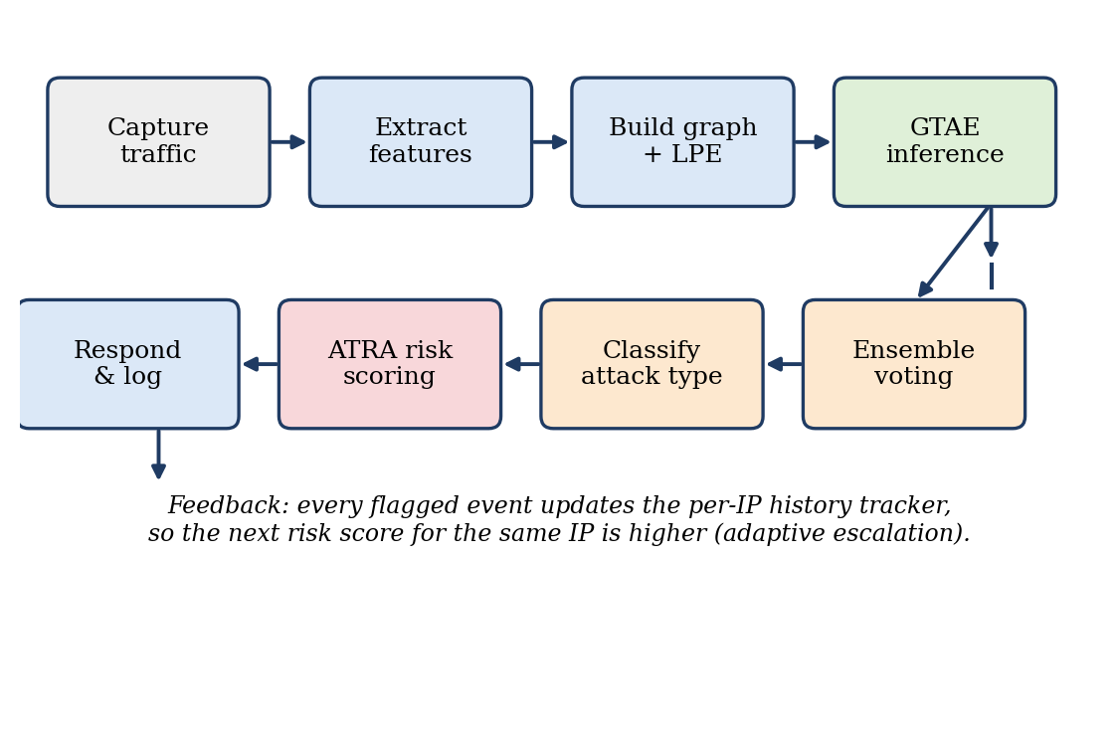
Figure No. 4.2: WORKFLOW OF THE PROPOSED SYSTEM

4.4 BLOCK DIAGRAM
Figure 4.3 shows the block diagram in its simplest form. Each block corresponds to one group of source files of the implementation: data loaders and feature extractors, the graph builder, the GTAE model with the detectors, the ATRA module, the logger with the blocklist and the dashboard.
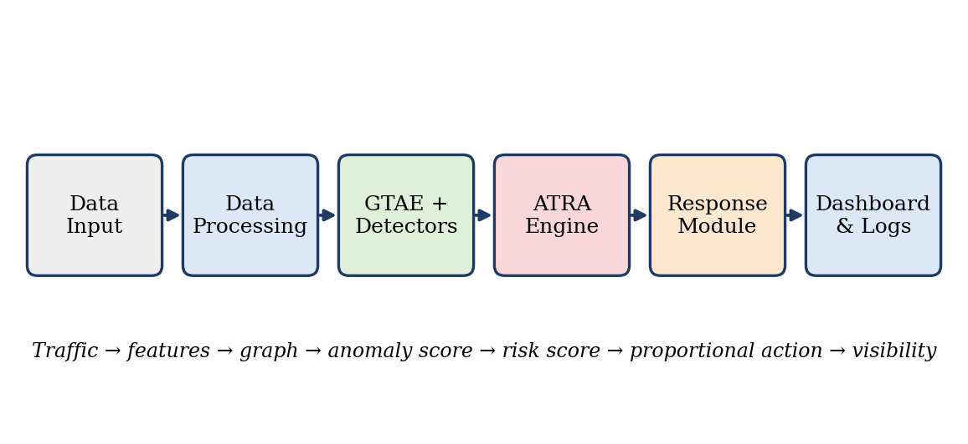
Figure No. 4.3: BLOCK DIAGRAM OF THE PROPOSED SYSTEM

4.5 WEB SECURITY MONITORING MODE
In the live mode the target web application runs on Port 3000. A non-intrusive middleware, monitor.js, taps every request and records the timestamp, method, path, query, status code, response time, request size, response size, user agent and client IP. The records are buffered and posted every few seconds to the Python monitor (Flask with Socket.IO, Port 8765). The monitor keeps a sliding queue for each IP, checks the blocklist and, when a window is complete, runs the feature extraction, GTAE inference, the ensemble and ATRA. The result is broadcast as a security_event over WebSocket to the React dashboard on Port 3001, and the Express application reads the blocklist to reject traffic from blocked IP addresses.
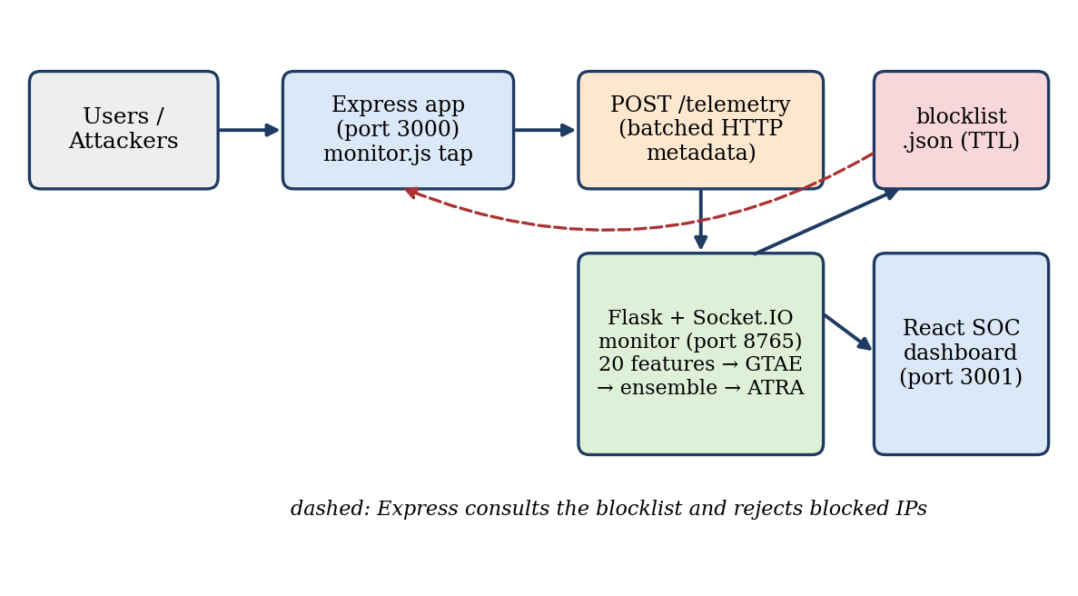
Figure No. 4.4: DATA FLOW OF THE WEB SECURITY MONITORING MODE
The telemetry of an IP in a 30 second window is converted into 20 features, each normalised into the range 0 to 1 by an empirical upper bound. Table 4.2 lists the features and the attack that each one helps to reveal.
Table 4.2: THE 20 WEB TELEMETRY FEATURES
No | Feature | Raw range | Attack indicator
0 | request_rate | 0 - 300 req/min | Layer 7 DoS, fuzzing, scraping
1 | unique_endpoint_count | 0 - 50 | Directory scanning, reconnaissance
2 | failed_login_count | 0 - 100 | Brute force, credential stuffing
3 | status_4xx_rate | 0.0 - 1.0 | Unauthorised probing (401, 403, 404)
4 | status_5xx_rate | 0.0 - 1.0 | Crashes, exceptions, SQLi exploitation
5 | avg_response_time_ms | 0 - 30,000 | Slowloris, ReDoS, database locking
6 | avg_path_length | 0 - 200 | Overflow attempts, deep traversal
7 | avg_query_length | 0 - 500 | Long SQLi payloads, encoded XSS
8 | post_ratio | 0.0 - 1.0 | Automated form submission, spraying
9 | get_ratio | 0.0 - 1.0 | Resource exhaustion, large downloads
10 | sensitive_endpoint_count | 0 - 100 | Probes of /admin, /.env, /config
11 | repeated_endpoint_ratio | 0.0 - 1.0 | Flooding of a single URL
12 | suspicious_pattern_count | 0 - 50 | Regex hits for SQL keywords, script tags, ../
13 | abnormal_method_count | 0 - 30 | TRACE, TRACK, PROPFIND, CONNECT
14 | avg_request_size | 0 - 2 MB | Large payload injection, XML/JSON bombs
15 | max_request_rate_burst | 0 - 100 req/s | Micro-bursts in any 5 s sub-window
16 | error_404_count | 0 - 200 | Forced browsing, route discovery
17 | error_403_count | 0 - 200 | Access control bypass attempts
18 | user_agent_entropy | 0.0 - 1.0 | Randomised bot user agents
19 | req_per_minute | 0 - 300 | Scaled volume indicator

The monitored sensitive endpoints are /admin, /admin/, /login, /api/auth, /api/admin, /.env, /config, /wp-admin, /phpmyadmin, /api/users and /api/keys.

4.6 ADAPTIVE THREAT RESPONSE ALGORITHM (ATRA)
ATRA is the novel contribution of the project. Detection answers the question “is this abnormal?”. ATRA answers the questions “how dangerous is it, and what should be done now?”. The risk score R, in the range 0 to 100, is a weighted combination of five components, each normalised to a 0 to 10 scale before weighting.
- Attack type weight (25%). The inherent danger of the attack family, for example SQL injection, Heartbleed and Infiltration are 9, DoS Hulk, brute force and path traversal are 8, XSS, Slowloris and rate limit abuse are 7, bot scan is 6 and port scan is 4.
- Severity (25%). The expected impact rating of the attack.
- Confidence (25%). The agreement between the GTAE reconstruction error and the votes of the ensemble. The error of a flagged event is min-max normalised among the flagged events of the window.
- Historical offence score (15%). The sum of exponentially decayed weights of earlier flagged events of the same IP. The weight of an event falls to one half after the half life of 300 seconds, so old offences fade and repeated offences accumulate.
- Frequency score (10%). The number of flagged events of the IP in the last 600 seconds, scaled and capped at 10.
The five weights add up to one, so R is the weighted mean of the components expressed as a percentage. The score selects one of four tiers.
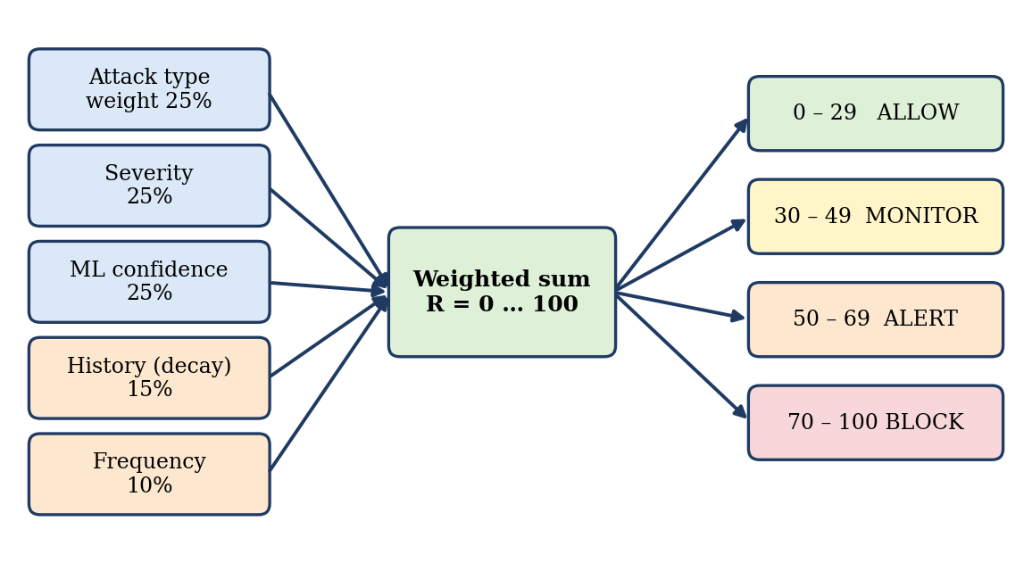
Figure No. 4.5: COMPONENTS AND RESPONSE TIERS OF ATRA
Table 4.3: ATRA RESPONSE TIERS
Risk score | Level | Action | Description
0 - 29 | Low | ALLOW | Telemetry is logged and normal browsing is permitted
30 - 49 | Medium | MONITOR | Logging resolution is increased and the event is flagged on the dashboard
50 - 69 | High | ALERT | A high priority alert is pushed to the security operators
70 - 100 | Critical | BLOCK | The IP is added to blocklist.json with a time to live of 3600 seconds

Because every response is graded, a first time low confidence anomaly only leads to monitoring, and the system blocks only when strong evidence or repeated behaviour has raised the score. The time to live of the blocklist and a whitelist of trusted addresses protect legitimate users from a permanent block.

CHAPTER 5
SYSTEM SPECIFICATION

5.1 HARDWARE SPECIFICATION
The system is designed to run on an ordinary laptop without a GPU. The training of the GTAE on the sampled data and the real time inference are done on the CPU.
Table 5.1: HARDWARE REQUIREMENTS
Component | Minimum requirement
Processor | Intel Core i5 or equivalent, 4 cores
RAM | 8 GB (16 GB recommended for the full CIC-IDS2017 data)
Storage | 10 GB free space on an SSD
Network | Ethernet or Wi-Fi adapter supported by Npcap for live capture
Display | 1366 x 768 or higher for the SOC dashboard

5.2 SOFTWARE SPECIFICATION
Table 5.2: SOFTWARE REQUIREMENTS
Software | Purpose
Windows 10/11 | Operating system (Npcap packet capture)
Python 3.10 or above | Model, ATRA, feature extraction and monitor server
PyTorch | Graph transformer autoencoder
scikit-learn, NumPy, Pandas, SciPy | Isolation Forest, One Class SVM, Random Forest, data handling
NetworkX | Graph construction and Laplacian computation
Flask and Flask-SocketIO | Real time inference server and WebSocket events
Scapy with Npcap | Live packet capture
Node.js and Express.js | Target web application and monitor middleware
React.js and Socket.IO client | SOC dashboard
Matplotlib | Evaluation plots
Visual Studio Code and Git | Development environment and version control

5.3 PURPOSE AND SCOPE OF DOCUMENT
This document describes the design, implementation and evaluation of GTAE-ATRA-NIDS. It is meant for the project evaluators and for developers who want to understand or extend the system. The scope covers anomaly detection with a graph transformer autoencoder, attack classification, adaptive risk based response and live monitoring of a web application. The scope does not include deep packet inspection of encrypted payloads or integration with a hardware firewall.

5.4 NON-FUNCTIONAL REQUIREMENTS
Table 5.3: NON-FUNCTIONAL REQUIREMENTS
Requirement | Description
Performance | A 30 second window of requests is analysed within a few seconds on a CPU, so the response stays near real time
Accuracy | False positive rate kept below the usual industry threshold of 15%
Reliability | The monitor keeps running when a window is empty or malformed, and the blocklist survives restarts
Usability | The dashboard shows throughput, active threats, a risk gauge, attack distribution and allows one click unblock
Safety | Auto blocking has a time to live, private and whitelisted addresses are never blocked
Maintainability | All paths, hyperparameters, weights and thresholds are kept in one configuration file
Portability | Runs on a laptop CPU and needs no special hardware
Auditability | Each decision is stored with its score components in CSV and JSONL logs

CHAPTER 6
SYSTEM IMPLEMENTATION AND ENHANCEMENT

6.1 MODULE DISCUSSION

6.1.1 DATA ACQUISITION MODULE
The module has three sources. The first is the CIC-IDS2017 data, loaded from CSV files, cleaned of infinite and missing values (a known problem of the flow rate columns) and normalised with statistics computed on benign flows only. The second is live packet capture with Scapy and Npcap, in which packets are grouped into flows and the first eight packets of every flow are encoded into 25 normalised byte features each. The third is the web telemetry source, in which the monitor.js middleware of the Express application batches request metadata and posts it to the Python monitor.

6.1.2 DATA PROCESSING MODULE
The feature extractor converts the requests of one IP in a 30 second window into the 20 features of Table 4.2 and clips them with empirical upper bounds before scaling to the range 0 to 1. For the network mode the flow features are normalised and the flows are grouped chronologically by label into small blocks that share a source and a destination node. This grouping was necessary because the public CSV release of CIC-IDS2017 does not contain IP addresses, and it gives the graph a real connected structure.

6.1.3 GRAPH CONSTRUCTION MODULE
Nodes are the source IPs and the target endpoints (or IP:port pairs in network mode) and every request or flow is an edge carrying its feature vector. The normalised Laplacian L = I - D^(-1/2) A D^(-1/2) is computed with NetworkX, its eigen decomposition gives the k = 8 smallest non trivial eigenvectors and these are the positional encoding. In the web mode the encoding is computed on the benign subgraph only so that no information about attacks leaks into training.

6.1.4 GTAE MODULE
The PyTorch implementation contains the GraphTransformerLayer, the GraphTransformerEncoder and the DNNDecoder. Attention is computed by grouping edges that share the same destination node. The model is trained with the Adam optimiser at a learning rate of 0.001 for up to 100 epochs with early stopping (patience 15), using only benign data, and the per edge mean squared error is the anomaly score.

6.1.5 DETECTION AND CLASSIFICATION MODULE
The latent vectors are standardised and scored by Isolation Forest (150 trees, contamination 0.05), One Class SVM (RBF kernel, nu 0.05) and Histogram Based Outlier Score (40 bins), all fitted on benign data. The voting policy is union, in which an event is anomalous if any detector flags it, or majority. The Random Forest classifier (100 trees) labels a flagged event as BruteForce, SQLInjection, XSS, PathTraversal, RateLimitAbuse, SensitiveEndpoint, BotScan, AbnormalMethod, LargePayload or DoS, so ATRA never has to treat the attack as unknown.

6.1.6 ATRA AND RESPONSE MODULE
The IPHistoryTracker stores the timestamps of the flagged events of every IP. For each new event the tracker returns the decayed history score and the frequency in the last 600 seconds, compute_risk_score combines the five components and the tier table of Table 4.3 selects the action. The logger writes CSV and JSONL records, and the blocklist manager stores blocked IPs with their expiry time.

6.1.7 DASHBOARD MODULE
The React dashboard connects to the Socket.IO server and shows live traffic throughput, the number of active threats, a risk score gauge, the pie chart of attack distribution and a scrolling list of security events. An operator can unblock an IP with one click. The dashboard has no influence on detection, so a failure of the interface does not stop protection.

6.2 ALGORITHM AND TECHNIQUES
1. Laplacian positional encoding
L = I − D^(−1/2) · A · D^(−1/2) Eq (6.1)
A is the adjacency matrix and D the degree matrix. The eigenvectors of the k smallest non trivial eigenvalues form the position of every node.
2. Destination grouped attention
Attention(Q, K, V) = softmax(Q·Kᵀ / √d_k) · V Eq (6.2)
Q, K and V are the query, key and value projections of the edge vectors, and softmax is taken only over edges that share the same destination node. With d = 64 and four heads, d_k = 16.
3. Reconstruction loss and anomaly score
MSE = (1/F) · Σ (x_i − x̂_i)² Eq (6.3)
F is the number of features. The model minimises this value on benign data, and the same value is the anomaly score at inference.
4. Time decayed history
S_hist = Σ exp(−λ · Δt_i), λ = ln 2 / T_half Eq (6.4)
Δt_i is the age of the i-th earlier event of the IP and T_half = 300 seconds, so one event is worth 1.0 now, 0.5 after five minutes and 0.25 after ten minutes (Figure 6.4). The sum is capped at 10.
5. ATRA risk score
R = 10 × (0.25·S_type + 0.25·S_sev + 0.25·S_conf + 0.15·S_hist + 0.10·S_freq) Eq (6.5)
All components are on the 0 to 10 scale and the weights add up to one, so the factor 10 expresses the weighted mean as a percentage. S_type is the attack type weight, S_sev is the severity, S_conf is the normalised confidence, S_hist is the decayed history and S_freq is the frequency score (events in 600 seconds multiplied by 2 and capped at 10).
6. Ensemble detectors and classifier
Isolation Forest isolates observations by random splits and gives short path lengths to outliers. One Class SVM finds a boundary that encloses benign embeddings in an RBF kernel space. HBOS builds a histogram for each feature and scores a point by the inverse of the densities of its bins. The Random Forest is a set of 100 decision trees that vote for the attack category.

6.3 SOURCE CODE
Selected parts of the implementation are shown here. The complete project contains the modules listed in Chapter 5.
A. Time decayed IP history (atra.py)
class IPHistoryTracker:
def __init__(self, half_life_seconds=300):
self.history = {} # ip -> list of timestamps of flagged attacks
self.half_life = half_life_seconds
self.decay_rate = math.log(2) / half_life_seconds

def get_decayed_history_score(self, ip, current_time):
if ip not in self.history:
return 0.0
score = 0.0
for past_time in self.history[ip]:
dt_seconds = (current_time - past_time).total_seconds()
if dt_seconds < 0:
continue
score += math.exp(-self.decay_rate * dt_seconds)
return score

def get_frequency_last_window(self, ip, current_time, window_seconds=600):
if ip not in self.history:
return 0
return sum(1 for t in self.history[ip]
if 0 <= (current_time - t).total_seconds() <= window_seconds)

def record_attack(self, ip, timestamp):
self.history.setdefault(ip, []).append(timestamp)

B. ATRA risk score (atra.py)
def compute_risk_score(attack_weight, severity, confidence,
history_score, frequency_score):
raw = (WEIGHT_ATTACK_TYPE * attack_weight +
WEIGHT_SEVERITY * severity +
WEIGHT_CONFIDENCE * confidence +
WEIGHT_HISTORY * history_score +
WEIGHT_FREQUENCY * frequency_score)
max_possible = (WEIGHT_ATTACK_TYPE + WEIGHT_SEVERITY + WEIGHT_CONFIDENCE +
WEIGHT_HISTORY + WEIGHT_FREQUENCY) * 10
return (raw / max_possible) * 100

C. Destination grouped attention of the graph transformer layer (graph_transformer.py)
def forward(self, e, dst_idx):
E = e.size(0)
Q = self.q_proj(e).view(E, self.num_heads, self.d_k)
K = self.k_proj(e).view(E, self.num_heads, self.d_k)
V = self.v_proj(e).view(E, self.num_heads, self.d_k)

groups = defaultdict(list) # edges sharing a destination node
for edge_i, d in enumerate(dst_idx.tolist()):
groups[d].append(edge_i)

attn_out = torch.zeros(E, self.num_heads, self.d_k)
for _, edge_ids in groups.items():
idx = torch.tensor(edge_ids, dtype=torch.long)
scores = torch.einsum("qhd,khd->qkh", Q[idx], K[idx]) / (self.d_k ** 0.5)
attn_weights = F.softmax(scores, dim=1)
attn_out[idx] = torch.einsum("qkh,khd->qhd", attn_weights, V[idx])

attn_out = self.out_proj(attn_out.reshape(E, self.d_model))
e = self.norm1(e + attn_out) # residual + norm
e = self.norm2(e + self.ffn(e)) # FFN + residual + norm
return e

D. GTAE model and decoder (autoencoder.py)
class DNNDecoder(nn.Module):
def __init__(self, d_model, out_features):
super().__init__()
self.net = nn.Sequential(
nn.Linear(d_model, 128), nn.ReLU(),
nn.Linear(128, 256), nn.ReLU(),
nn.Linear(256, out_features))

class GTAE(nn.Module):
def forward(self, edge_attr, edge_pe, dst_idx):
z = self.encoder(edge_attr, edge_pe, dst_idx) # bottleneck
x_hat = self.decoder(z) # reconstruction
return x_hat, z

E. Ensemble voting (anomaly_detector.py)
def predict_all(iso_forest, ocsvm, embeddings_all):
iso_pred = (iso_forest.predict(embeddings_all) == -1).astype(int)
ocsvm_pred = (ocsvm.predict(embeddings_all) == -1).astype(int)
ensemble_pred = ((iso_pred + ocsvm_pred) >= 1).astype(int)
return iso_pred, ocsvm_pred, ensemble_pred

6.4 RESULT
The system was evaluated on 10,568 test instances of the CIC-IDS2017 data covering 14 attack types. The detector was trained on benign traffic only, and the attack labels were used only to measure the result. Figure 6.1 shows the confusion matrix and Table 6.1 lists the metrics calculated from it.
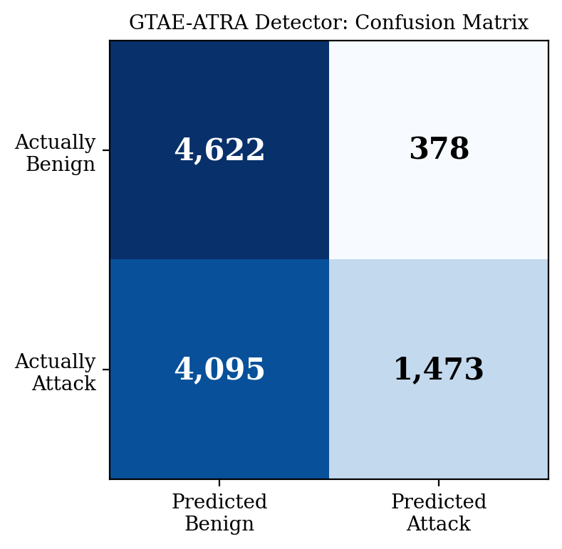
Figure No. 6.1: CONFUSION MATRIX OF THE DETECTOR
Table 6.1: EVALUATION METRICS OF THE DETECTOR
Metric | Value | Meaning
True Positives (TP) | 1,473 | Attack flows correctly flagged
False Positives (FP) | 378 | Benign flows wrongly flagged
True Negatives (TN) | 4,622 | Benign flows correctly passed
False Negatives (FN) | 4,095 | Attack flows missed
Precision | 79.58 % | Share of alerts that are real attacks
False Positive Rate | 7.56 % | Below the industry threshold of 15 %
Specificity | 92.44 % | Share of benign flows passed correctly
Recall (overall TPR) | 26.45 % | Share of all attack flows detected
F1 score | 39.71 % | Harmonic mean of precision and recall
Accuracy | 57.67 % | Overall share of correct decisions

The false positive rate of 7.56 % is below the 15 % industry threshold, and about eight of every ten alerts are real attacks. The detection rate differs strongly between attack families (Figure 6.2). Heartbleed was detected completely (100 %), Infiltration at 77.8 %, DoS Hulk at 76.4 % and DoS GoldenEye at 65.0 %. These are attacks that change the structure and the volume of traffic. The overall recall of 26.46 % is low because several of the 14 attack types, for example low rate web attacks that look like normal requests at flow level, produce flows very close to benign traffic and are not separated by an unsupervised model trained only on benign data. This is the main limitation of the current detection stage and the main direction for improvement.
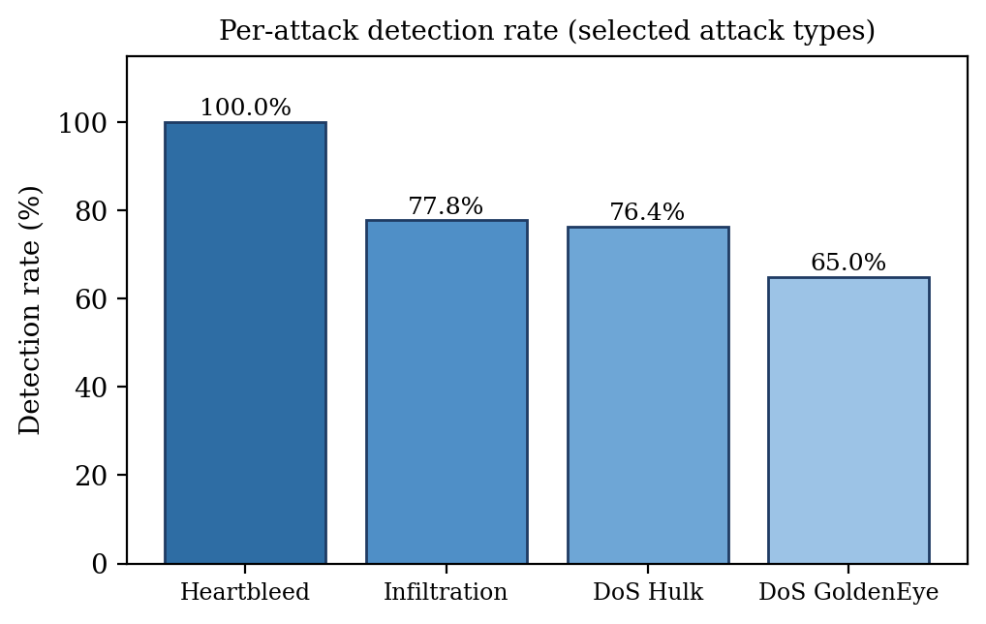
Figure No. 6.2: DETECTION RATE OF SELECTED ATTACK TYPES
The flagged events passed to ATRA were 1,851, the sum of TP and FP. ATRA placed 139 of them in the Low tier, 1,702 in the Medium tier and 10 in the High tier (Figure 6.3). The system therefore does not block aggressively: most of the events only increase the monitoring level, and a block is reserved for events with strong evidence or repeated behaviour. This graded behaviour limits the effect of a false positive on a legitimate user.
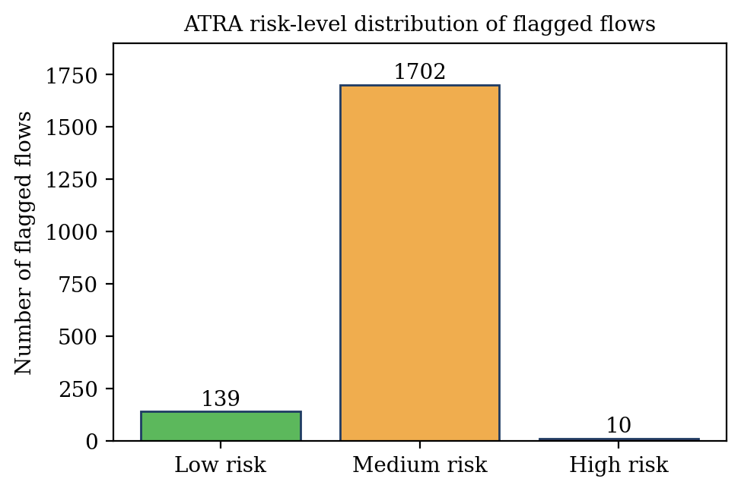
Figure No. 6.3: DISTRIBUTION OF ATRA RISK LEVELS FOR THE FLAGGED FLOWS
The adaptive behaviour is controlled by the exponential decay of the history. Figure 6.4 shows how the weight of an earlier offence falls to 0.5 after five minutes and to 0.25 after ten minutes. An attacker that repeats the attack within a short time accumulates history, whereas the weight of an old offence fades.
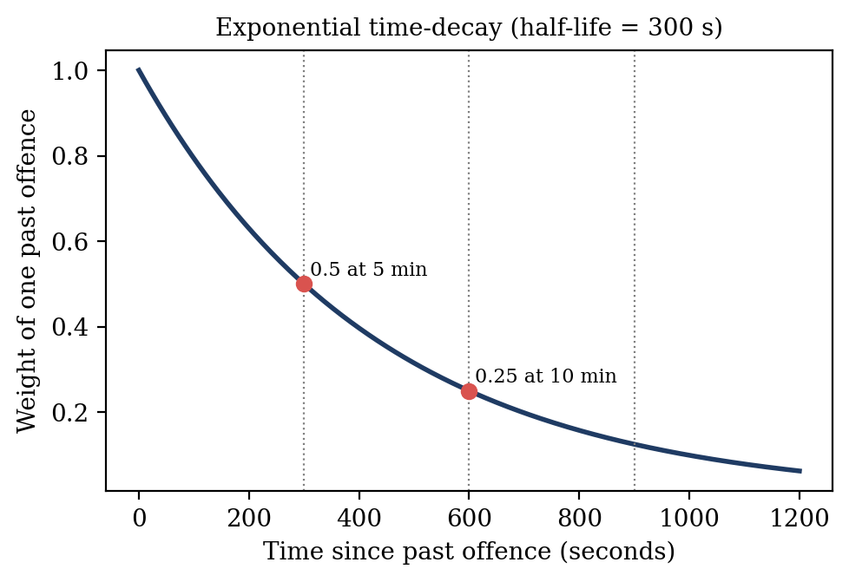
Figure No. 6.4: EXPONENTIAL TIME DECAY OF THE ATTACK HISTORY
The effect was observed in the prototype run with synthetic traffic that contained repeat offender IP addresses. The risk of one source IP that repeated PortScan attacks rose from 41.9 (MONITOR) to 64.0 (ALERT) over nine events, although the type, severity and confidence of the events were similar, because the history and frequency scores increased (Figure 6.5). In the DDoS events of the same run the repeat offender 165.127.9.254 went from 72.2 to 88.1 and into the BLOCK tier, while first time sources with a similar confidence stayed near 68 to 70.
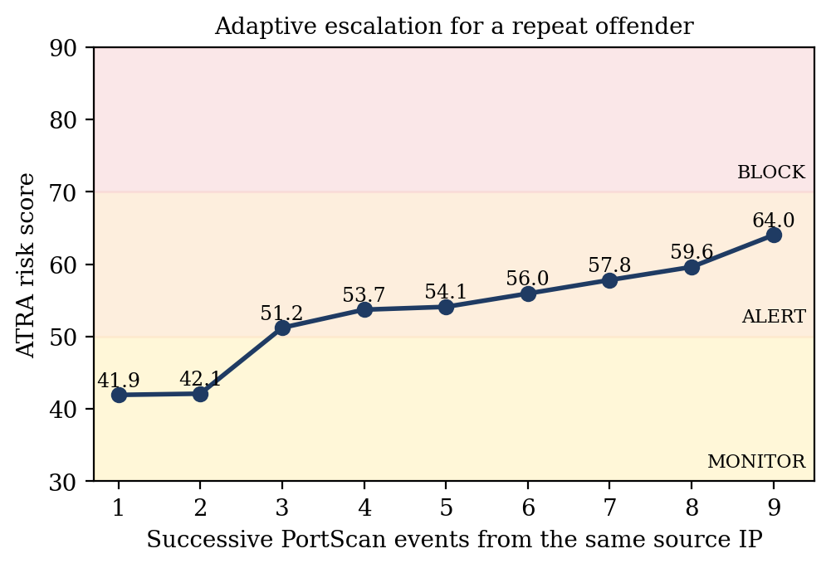
Figure No. 6.5: ADAPTIVE ESCALATION OF A REPEAT OFFENDER
The score of Equation 6.5 can be verified by hand. Table 6.2 compares a first time DDoS source with the repeat offender of the prototype log. The two events have almost the same attack type, severity and confidence, and the difference of about 20 points comes only from the history and the frequency components, which moves the response from ALERT to BLOCK.
Table 6.2: WORKED EXAMPLE OF ATRA SCORING (PROTOTYPE LOG)
Component (weight) | First time source | Repeat offender
Attack type S_type (25%) | 9 | 9
Severity S_sev (25%) | 9 | 9
Confidence S_conf (25%) | 9.30 | 9.67
History S_hist (15%) | 0.00 | 5.92
Frequency S_freq (10%) | 0.00 | 10.00
Risk score R | 68.25 | 88.06
Action selected | ALERT (50 - 69) | BLOCK (70 - 100)

The result shows that the proposed system detects attacks with a low false alarm rate and adds what the existing GTAE-IDS does not have: a risk score, memory of earlier behaviour, a graded automatic response, an attack log and a live dashboard.

CHAPTER 7
CONCLUSION AND FUTURE ENHANCEMENT

7.1 CONCLUSION
This project developed GTAE-ATRA-NIDS, a network and web intrusion detection system that detects anomalies with a Graph Transformer Autoencoder and responds with an Adaptive Threat Response Algorithm. The autoencoder is trained on benign traffic only, so it needs no labelled attacks and can see attacks that were not known in advance. The ensemble of Isolation Forest, One Class SVM and HBOS keeps the false positive rate at 7.56 %, and the Random Forest classifier names the attack.
ATRA converts every detection into a time decayed risk score and a proportional action, so a first time anomaly is monitored while a persistent attacker is escalated to an alert and then to a timed block. All decisions are logged with the components of the score and displayed on a live React dashboard that is fed by an Express application. The system therefore moves intrusion detection from a passive alert to an automatic, explainable and adjustable defence.
The evaluation also shows the limits of the present detection stage. The overall recall on the CIC-IDS2017 test data is 26.46 %, and attacks that resemble normal requests are hard to separate with an unsupervised model. The system is a prototype, and its results should be read as a measured baseline.

7.2 FUTURE ENHANCEMENT
- Improve the recall of low rate attacks by adding a small supervised head, semi-supervised learning, or request level features such as payload tokens.
- Train the web mode on real attacks collected against test applications such as DVWA and OWASP Juice Shop, using tools such as sqlmap and hydra on a local machine.
- Learn the weights of ATRA and the thresholds of the tiers from data or by feedback of the operators instead of fixing them by hand.
- Integrate with firewalls, a reverse proxy and iptables for enforcement, and handle HTTPS through reverse proxy logs.
- Reduce the effect of shared (NAT) IP addresses by identifying clients with session or device attributes in addition to the IP.
- Add notification channels such as e-mail and chat webhooks for the ALERT tier, and a distributed deployment for large networks.

REFERENCES
[1] J. Ghadermazi, S. Hore, A. Shah and N. D. Bastian, “GTAE-IDS: Graph Transformer-Based Autoencoder Framework for Real-Time Network Intrusion Detection,” IEEE Transactions on Information Forensics and Security, 2025.
[2] T. Bilot, N. El Madhoun, K. Al Agha and A. Zouaoui, “Graph Neural Networks for Intrusion Detection: A Survey,” IEEE Access, 2023.
[3] D. Pujol-Perich, J. Suarez-Varela, A. Cabellos-Aparicio and P. Barlet-Ros, “Unveiling the Potential of Graph Neural Networks for Robust Intrusion Detection,” 2023.
[4] X. Li, J. Zhang, Y. Yuan and C. Zhou, “Network Intrusion Detection with Edge-Directed Graph Multi-Head Attention Networks,” 2023.
[5] Y. Wang, Z. Han, J. Li and X. He, “BS-GAT: Behavior Similarity Based Graph Attention Network for Network Intrusion Detection,” 2023.
[6] M. Gharib, B. Mohammadi, S. H. Dastgerdi and M. Sabokrou, “AutoIDS: Auto-Encoder Based Method for Intrusion Detection System,” 2021.
[7] J. Zhou, G. Cui, S. Hu, Z. Zhang, C. Yang, Z. Liu, L. Wang, C. Li and M. Sun, “Graph Neural Networks: A Review of Methods and Applications,” 2018.
[8] V. K. Manavalasundaram, M. Namitha, M. A. Muhamudha Aqsa, V. Priyadharshini and R. Sudharsan, “Network Intrusion Detection Based on Graph Neural Network and Ensemble Learning,” 2023.
[9] M. Gorricho-Segura, X. Echeberria-Barrio and L. Segurola-Gil, “Edge-Based Analysis for Network Intrusion Detection Using a GNN Approach,” 2023.
[10] N. T. Hieu and N. H. Son, “Deep Learning-Based Cyber Attack Detection: A Comparative Study of Transformer and Convolutional Neural Network Architectures,” 2025.
[11] L. Guerra, T. Chapuis, G. Duc, P. Mozharovskyi and V.-T. Nguyen, “Self-Supervised Learning of Graph Representations for Network Intrusion Detection (GraphIDS),” 2025.
[12] I. Sharafaldin, A. H. Lashkari and A. A. Ghorbani, “Toward Generating a New Intrusion Detection Dataset and Intrusion Traffic Characterization,” Proc. 4th International Conference on Information Systems Security and Privacy (ICISSP), 2018.
[13] A. Vaswani et al., “Attention Is All You Need,” Advances in Neural Information Processing Systems (NeurIPS), 2017.
[14] V. P. Dwivedi and X. Bresson, “A Generalization of Transformer Networks to Graphs,” arXiv:2012.09699, 2020.
[15] F. T. Liu, K. M. Ting and Z.-H. Zhou, “Isolation Forest,” Proc. IEEE International Conference on Data Mining (ICDM), 2008.
[16] B. Scholkopf, J. C. Platt, J. Shawe-Taylor, A. J. Smola and R. C. Williamson, “Estimating the Support of a High-Dimensional Distribution,” Neural Computation, vol. 13, no. 7, 2001.
[17] M. Goldstein and A. Dengel, “Histogram-based Outlier Score (HBOS): A fast Unsupervised Anomaly Detection Algorithm,” KI-2012 Poster and Demo Track, 2012.
[18] L. Breiman, “Random Forests,” Machine Learning, vol. 45, no. 1, pp. 5-32, 2001.

