# Motionarium Controller ™

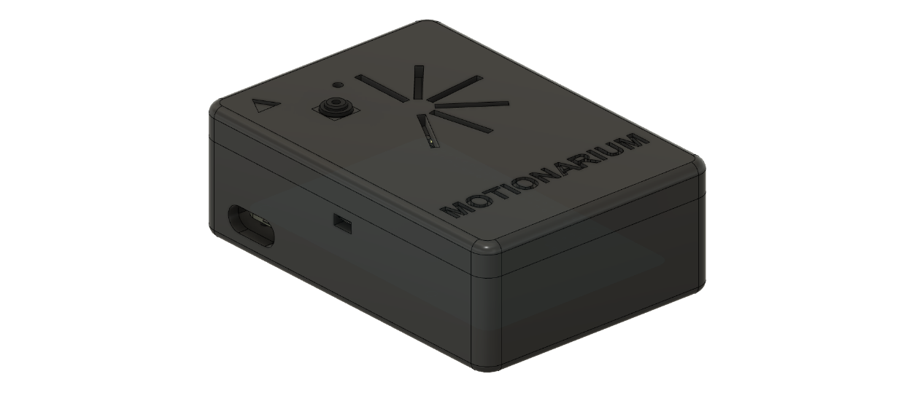

## 

|  |  |
| --- | --- |
|  |  |
| Size | 100mm x 70mm x 34 mm (35.5mm camera top included) |
| Weight | 25gr (packaging) + 43gr (processor) + 3g (camera) = 71gr |
| CPU | ARM Cortex-A53 1.2GHz |
| Power Supply | AC 5V 2.5A via Micro USB connector (power supply is not included) |
| Data Connection | USB 2.0 (packaged with USB 2/3 hybrid cable, but can be used with any certified USB standard cables with the Hi-Speed USB 2.0 logo featured on the packaging) |
| Mounting | Should be placed on the desk with camera facing the ceiling and the triangle on the top of the packaging showing "Up" according to you (your hand) |
| Interaction Zone | Minimum 30cm – Maximum 60cm distance from camera (depth)  19cm boundary from camera at 30cm distance |
| Camera | One camera with OVA5647 sensor |
| Camera Interface | Experimental Universal Video Class (UVC) release provides access to low-level controls such as LED brightness, gamma, exposure, gain, resolution, etc.; examples in C, Python, and Matlab, as well as OpenCV binding |
| LED | At top right corner of the camera there is one LED which is boot indicator. Whenever the LED is lightened up constantly, the device is up and ready to use. |
| Construction | PLA and Acrylic |
| Ambient Operating Temperature | 0 to 45 °C (RPi 3 Operating Temperature) |
| CPU Temperature at Full Load (Ambient Temperature of 33 °C) | Min: 54 °C – Max: 72 °C – Average: 67.8 |
| FPS (Frame Per Second) | (Camera Capture) 32 FPS  (Capture and Run ML Model) Min: 1.5 – Max: 4.8 – Average: 3.8 |
| Boot Time | (Approximately) 51secs |
| Latency | (Approximately) 2 – 5 secs |
| Minimum System Requirements | Windows 7, 8, 8.1, 10, 11 – MacOS X 10.7 – Linux distros with GNU Gnome Desktop. |

## Plots

Figure - Frame per Second of the device when it is capturing the image and run the Machine Learning model on it.

Figure - CPU Temperature (°C) at 100% Load.

## Source Code

Copyright 2022 © Motionarium Controller ™

The source code is available via [GitHub](https://github.com/Sharif-University-ESRLab/project-team-3) under MIT License:

Permission is hereby granted, free of charge, to any person obtaining a copy of this software and associated documentation files (the "Software"), to deal in the Software without restriction, including without limitation the rights to use, copy, modify, merge, publish, distribute, sublicense, and/or sell copies of the Software, and to permit persons to whom the Software is furnished to do so, subject to the following conditions:

The above copyright notice and this permission notice shall be included in all copies or substantial portions of the Software.

THE SOFTWARE IS PROVIDED "AS IS", WITHOUT WARRANTY OF ANY KIND, EXPRESS OR IMPLIED, INCLUDING BUT NOT LIMITED TO THE WARRANTIES OF MERCHANTABILITY, FITNESS FOR A PARTICULAR PURPOSE AND NONINFRINGEMENT. IN NO EVENT SHALL THE AUTHORS OR COPYRIGHT HOLDERS BE LIABLE FOR ANY CLAIM, DAMAGES OR OTHER LIABILITY, WHETHER IN AN ACTION OF CONTRACT, TORT OR OTHERWISE, ARISING FROM, OUT OF OR IN CONNECTION WITH THE SOFTWARE OR THE USE OR OTHER DEALINGS IN THE SOFTWARE.