## Development of

**Online Hotel Booking System for Hotel Sea View**

A Practicum Report Submitted By

Md. Tanvir Ahammad

ID # 20103172

A Practicum is the Partial Fulfillment of the Requirements

for the Award of Bachelor of Computer Science and Engineering (BCSE)



### Department of Computer Science and Engineering

College of Engineering and Technology

IUBAT – International University of Business Agriculture and Technology

Fall 2023

## Development of

**Online Hotel Booking System for Hotel Sea View**

A practicum report submitted in partial fulfillment of the requirements for the degree of Bachelor of Computer Science and Engineering (BCSE)

The practicum has been examined and approved,

Prof Dr. Utpal Kanti Das Chair and Professor

Dept. of Computer Science and Engineering

IUBAT – International University of Business Agriculture and Technology

Dr. Hasibul Rashid Chayon Associate Professor and Coordinator

Dept. of Computer Science and Engineering

IUBAT – International University of Business Agriculture and Technology

Nusrath Tabassum Senior Lecturer

Dept. of Computer Science and Engineering

IUBAT – International University of Business Agriculture and Technology

Department of Computer Science and Engineering College of Engineering and Technology IUBAT – International University of Business Agriculture and Technology

Fall 2022

=

### Letter of Transmittal

15th December 2022 To

The Chairman, Practicum and Placement Board College of Engineering and Technology – CEAT

IUBAT - International University of Business Agriculture and Technology 4 Embankment Drive Road, Sector – 10

Uttara Model Town, Dhaka-1230, Bangladesh

#### Subject: Letter of Transmittal.

Sir,

With due respect, I would like to approach you that it is a great opportunity as well as immense pleasure for me to submit this report titled **“Development of Online Hotel Booking System for Hotel Sea Place”** for the fulfillment of my Practicum course.

It was undoubtedly a splendid opportunity for me to work on this project to actualize my theoretical knowledge and has an enormous exposure with the corporate culture of a renowned company. Now I am looking forward for your kind appraisal regarding this practicum report.

I shall remain deeply grateful to you if you kindly go through this report and evaluate my performance. I hope that you would find the report comprehensive and competent augmented.

Thanking you,

Program: BCSE

### Letter of Authorization

15th December, 2022

IUBAT- International University of Business Agriculture and Technology 4, Embankment Drive Road, Sector 10

Uttara Model Town, Dhaka - 1230, Bangladesh.

#### Subject: Letter of Authorization.

Program: BCSE,

You will be happy to know that the project on “Development of Online Hotel Booking System for Hotel Sea Place”, I have received in your proposal under my continue internship. Based on your proposal you will have to submit the project as soon as possible. I hope you will successfully complete it on time. After successful completion of the project, you are requested to write a report based on the project.

For any kind of assistance feel free to contact with me.

Co– Supervisor Practicum Supervisor

Dr. Hasibur Rashid Chayon Coordinator and Associate Professor Dept. of Computer Science and Engineering IUBAT – International University of Business Agriculture and Technology

Mahmudul hasan Lecturer

Dept. of Computer Science and

Engineering IUBAT –

International University of Business Agriculture and Technology

### Student’s Declaration

I am Md. Tanvir Ahammad bearing ID#20103172, student of BCSE - Bachelor of Computer Science and Engineering program, under the College of Engineering and Technology (CEAT) of IUBAT- International University of Business Agriculture and Technology declaring that, this report on the topic of **“Development of Online Hotel Booking System for Hotel Sea View”** has been prepared for the fulfillment of the internship CSC 490, Practicum as well as the partial requirement of BCSE-Bachelor of Computer Science and Engineering degree.

The report and the project on ― **“Development of Online Hotel Booking System for Hotel Sea View”** are originally prepared by me. All module and procedure of this project is being made after proper inspection and internet information.

It has not been prepared for any other purposes, rewards or presentations.

Program: BCSE

### Acknowledgements

I, first and foremost, would like to express our gratitude to Almighty Allah for helping me to complete the report properly.

My sincere thanks to Prof. Dr. Abdur Rab, Honorable Vice Chancellor, IUBAT- International University of Business Agriculture and Technology to give me an opportunity to submit this practicum report.

My profound respect goes to Prof. Dr. Utpal Kanti Das, Chair and Professor, Department of Computer Science and Engineering, IUBAT- International University of Business Agriculture and Technology for approving me to work on this project.

My outmost and sincere gratitude goes to Dr. Hasibur Rashid Chayon, Coordinator of Department of Computer Science and Engineering, IUBAT- International University of Business Agriculture and Technology for allowing me to complete this project.

I would like to express our gratefulness to my supervisor Mahmudul Hasan, Lecturer, Department of Computer Science and Engineering, IUBAT- International University of Business Agriculture and Technology who has given me the opportunity to make such a project report for not only in this semester but also throughout my whole education life at IUBAT-International University of Business Agriculture and Technology by giving her valuable suggestions and advices at any time, at any situation. I would able to make this report effectively and properly only for her right direction.

I owe my deepest gratitude to my parents and our family members whose inexhaustible love was indispensable to endure in the tragic moments that confronted me once again with the vulnerability of life.

Lastly, this report would not have been possible without the essential and gracious support of many individuals and supported us in any respect to complete this project on time. I am also grateful to them.

### Supervisor’s Certification

This is to certify that Practicum report on **“Development of Online Hotel Booking System for Hotel Sea View”** has been carried out by bearing ID#20103172 of **IUBAT** – International University of Business Agriculture and Technology as a partial fulfillment of the requirement of practicum defense course. The report has been prepared under my guidance and is a record of the accomplished work carried out successfully. To the best of my knowledge and as per his declaration, no parts of this report has been submitted anywhere for any degree, diploma or certification.

Now he is permitted to submit the report. I wish his success in all his future endeavors.

Practicum Supervisor

Mahmudul Hasan, Lecturer

Department of Computer Science and Engineering College of Engineering and Technology (CEAT)

IUBAT- International University of Business Agriculture and Technology

### Departmental Certification

On behalf of the Department of Computer Science and Engineering of International University of Business Agriculture and Technology (IUBAT) we, the undersigned, certify that this practicum report **“Development of Online Hotel Booking System for Hotel Sea View”** for the award of Bachelor of Computer Science and Engineering (BCSE) degree was duly presented by Md. Tanvir Ahammad (ID No. 20103172) and accepted by the department.

Mahmudul Hasan Lecturer

Department of Computer Science and Engineering

IUBAT – International University of Business Agriculture and Technology

Dr. Hasibur Rashid Chayon Coordinator and Associate Professor

Department of Computer Science and Engineering

IUBAT – International University of Business Agriculture and Technology

Dr. Utpal Kanti Das Chair and Professor

Department of Computer Science and Engineering

IUBAT – International University of Business Agriculture and Technology

# Internship certificate

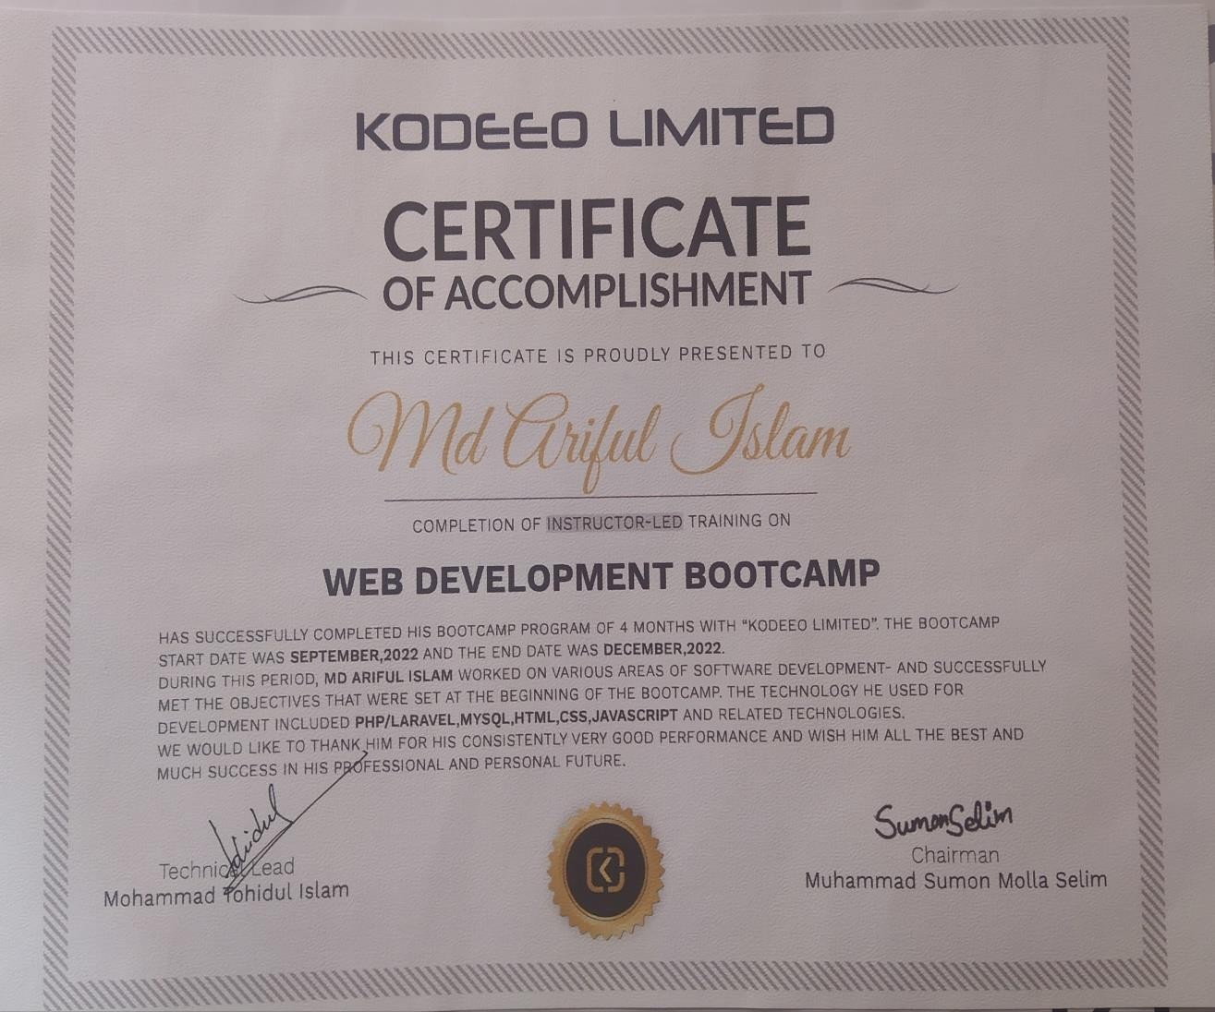

**Abstract**

Development of Online Hotel Booking System is website project developed for Kodeeo. By this online Hotel Booking System people can search for the room by giving their check in time and check out time. From there they can choose their desired room. They can see the details of the room. After that they have to register themselves to book their desired room through online. In this system admin will manage everything like can cancel booking or approve booking, add the rooms, amenities and so on. Customer can see all of their booking details whether they are approved or disapproved. They can make their payment after reaching the hotel and they don’t have to pay total amount at a time. The total amount will be calculated based on the day’s difference between two days. The due amount will be auto calculated. Admin can see the report of the list of booking and can search the list but giving the range of dates and also can make the pdf. So it is an easy online system to book the room.

### Abbreviations

AFP-Adjusted Function Point DBA-Database Administrator DET-Data Element Type

DT-Data Transition EI-External Input

EIF-External Interfaces File EO-External Output

EQ-External Query

ER-Entity Relationship FP-Function Point

FTR-File Type Referenced

GSC-General System Characteristics ILF-Internal Logical File

QA-Quality Assurance RET-Record Element Type

SDLC-Software Development Life Cycle SRS-Software Requirements Specification TDI-Total Degree of Influence

UFP-Unadjusted Function Point VAF-Value Adjustment Factor

### Table of Contents

|  |  |
| --- | --- |
| **Letter of Transmittal** …………………………………………………………………... | iii |
| **Letter of Authorization** ………………………………………………………………… | iv |
| **Student’s Declaration** ………………………………………………………………….. | v |
| **Acknowledgement** ……………………………………………………………………… | vi |
| **Supervisor’s Certification** …………………………………………………………... | vii |
| **Departmental Certification** ……………………………………………………………. | viii |
| **Internship Certification** ……………….……………………………………………….. | ix |
| **Abstract** …………………………………………………………………………………. | x |
| **Abbreviations** …………………………………………………………………………… | xi |
| **Table of Contents** ………………………………………………………………………. | xii |
| **List of Figures** …………………………………………………….…………………….. | xvi |
| **List of Table** …………………………………………………………………………….. | xviii |
| **Chapter 1: Project Introduction** ………………………………………………………. | 1 |
| 1.1 Introduction ……………………………………………………………………… | 2 |
| 1.2 Background of Study ……………………………………………………………. | 2 |
| 1.3 Objectives ……………………………………………………………………….. | 3 |
| 1.3.1 Broad Objectives …………………………………………………………. | 3 |
| 1.3.2 Specific Objectives ……………………………………………………….. | 3 |
| 1.4 Proposed System’s Benefits …………………………………………………….. | 4 |
| 1.5 Methodology …………………………………………………………………….. | 4 |
| 1.5.1 Data Sources ………….………...………………………………………… | 4 |
| 1.6 Limitation ………………………………………………………………………... | 5 |
| 1.7 Process Model …………………………………………………………………… | 5 |
| 1.7.1 Reason for Choosing Incremental Process Model ……………………….. | 7 |
| 1.8 Feasibility Study ………………………………………………………………… | 7 |
| 1.8.1 Technical Feasibility ……………………………………………………… | 7 |
| 1.8.2 Economical Feasibility ………………………………………………….… | 8 |
| 1.8.3 Operational Feasibility …………….……………………………………… | 8 |

|  |  |
| --- | --- |
| **Chapter 2: The Organization** …………………………………………………………. | 10 |
| 2.1 Organizational Overview ……………………………………………………….. | 11 |
| 2.2 Organization Services …………………………………………………………... | 11 |
| 2.3 Organization Location ………………….……………………………………..... | 12 |
| 2.4 Organization Vision …………………………………………………………….. | 13 |
| 2.5 Organization Mission …………………………………………………………… | 13 |
| 2.6 My position in this Organization ……………………………………………….. | 13 |
| 2.7 Organizational Structure ………………………………………………………... | 13 |
| **Chapter 3: Literature Review** ………………………………………………………… | 14 |
| **Chapter 4: Requirement Engineering** ……………………………………………….. | 16 |
| 4.1 Requirement Analysis …………………………………………………………... | 17 |
| 4.2 Requirement Engineering ………………………………………………………. | 17 |
| 4.2.1 User Requirement ………………………………………………………… | 18 |
| 4.2.2 System Requirement ……………………………………………………... | 18 |
| 4.2.3 Functional Requirement ………………………………………………….. | 20 |
| 4.2.4 Non-Functional Requirement ……………………………………………. | 20 |
| 4.2.5 Software Requirement …………….……………………………………… | 20 |
| 4.3 Use Case Diagram of the System ………………………………………………. | 20 |
| 4.3.1 Use Case Symbol ………………………………………………………… | 21 |
| 4.3.2 Use Case Diagram ……………………………………………………….. | 22 |
| **Chapter 5: System Planning** ………………………………………………………….. | 23 |
| 5.1 Functions of the Proposed System ……………………………………………… | 24 |
| 5.2 Function Point Estimation ….…………………………………………………... | 24 |
| 5.2.1 Identifying Complexity of transition function …………………………… | 26 |
| 5.2.2 Identifying Complexity of Data function ………………………………… | 29 |

|  |  |
| --- | --- |
| 5.2.3 Unadjusted Function Point Contribution ………………………………. | 30 |
| 5.2.4 Performance and Environment Impact ………………………… …….. | 32 |
| 5.3 Project Scheduling Chart ……………………………………………………….. | 33 |
| 5.4 Cost Estimation …………………………………………………………………. | 33 |
| 5.4.1 Personal Cost ……………………………………………………………… | 34 |
| 5.4.2 Hardware Cost ……………………………………………………………. | 35 |
| 5.4.3 Software Cost ……………………………………………………………... | 35 |

|  |  |
| --- | --- |
| 5.4.4 Estimation of Other Cost………………………………………………….. | 35 |
| 5.4.5 Accounts Table …………………………………………………………… | 36 |
| **Chapter 6: Risk Engineering** …………………………………………………….. | 38 |
| 6.1 Risk Management …………………………………………………………….. | 39 |
| 6.2 The RMMM Plan ……………………………………………………………... | 40 |
| **Chapter 7: Analysis Modeling** …………………………………………………… | 47 |
| 7.1 Software Analysis Pattern ……………………………………………………. | 48 |
| 7.2 Activity Diagram ……………………………………………………………… | 49 |
| **Chapter 8: Designing** ……………………………………………………………... | 51 |
| 8.1 Interface Design ………………………………………………………………. | 52 |
| 8.2 Data Flow Diagram …………………………………………………………… | 57 |
| 8.2.1 Context Level Diagram ………………………………………………… | 57 |
| 8.2.2 Level 1 Data Flow Diagram ……………….…………………………… | 58 |
| 8.2.3 Level 2 DFD of Process 1 ……………………………………………… | 59 |
| 8.2.4 Level 2 DFD of Process 2 ……………………………………………… | 59 |
| 8.2.5 Level 2 DFD of Process 3 ……………………………………………… | 60 |

|  |  |
| --- | --- |
| 8.2.6 Level 2 DFD of Process 4..…………………………………………….. | 61 |
| 8.2.7 Level 2 DFD of Process 5. …………………………………………….. | 61 |
| 8.2.8 Level 2 DFD of Process 5.1...………………………………………….. | 62 |
| 8.2.9 Level 2 DFD of Process 6..…………………………………………….. | 63 |
| 8.2.10 Level 2 DFD of Process 7..…………………………………………… | 64 |
| 8.2.11 Level 2 DFD of Process 7.1...………………………………………… | 64 |
| 8.2.12 Level 2 DFD of Process 8…..………………………………………… | 64 |
| 8.2.13 Level 2 DFD of Process 9..…………………………………………… | 64 |
| 8.2.14 Level 2 DFD of Process 10…………………………………………… | 64 |
| 8.3 Entity Relationship Diagram ………………………………………………… | 65 |
| **Chapter 9: Quality Assurance** ………………………………………………….. | 66 |
| 9.1 System Quality Management ………………………………………………... | 67 |

|  |  |
| --- | --- |
| 9.1.1 Software Quality Management Process …………………………. | 70 |
| 9.2 System Testing ……………….……………………………………………. | 70 |
| 9.2.1 System Testing Methodology ……………………………………… | 71 |
| 9.3 System Testing Design ….…………………………………………………. | 71 |
| **Chapter 10: Conclusion** …………………..……………………………………. | 72 |
| 10.1 Preface ……………………………………………………………………… | 73 |
| 10.2 Practicum and Its value …………………………………………………….. | 73 |
| 10.3 Conclusion ………………………………………………………………….. | 73 |
| 10.4 Limitations …………………………………………………………………. | 74 |
| 10.5 Future Plan …………………………………………………………………. | 75 |
| **Bibliography** ………………………………..…………………………………… | 77 |

**List of Figures**

|  |  |
| --- | --- |
| Figure-1.1: Incremental Process Model …………………………………………... | 5 |
| Figure-2.1: Organization Location ………………………………………………... | 12 |
| Figure-2.2: Organization Structure of Kodeeo …………………………………… | 13 |
| Figure-4.1: Use Case diagram of OHBS …………………………………………. | 23 |
| Figure-5.1: Project Schedule Chart ……………………………………………… | 35 |
| Figure-7.1: Activity Diagram for Admin…………………………………………. | 51 |
| Figure-7.2: Activity Diagram User …………………………...………................... | 52 |
| Figure-8.1: Interface of Home Page …………………………………………. | 54 |
| Figure-8.2: For checking the available room ……………………………………… | 54 |
| Figure-8.3: Result for searching available room ………………………………….. | 54 |
| Figure-8.4: Single room view …………………………………………………… | 54 |
| Figure-8.5: Single room information…………………………………….. | 55 |
| Figure-8.6: Booking button …………………………………….. | 55 |
| Figure-8.7: Login page for guest …………………………………………… | 55 |
| Figure-8.8: Signup form for guest ………………………………………. | 55 |
| Figure-8.9: Booking form for guest …………………………………………... | 56 |
| Figure-8.10: All room types view………………………………………….. | 56 |

|  |  |
| --- | --- |
| Figure-8.11: Login page for admin ……………………………………….. | 56 |
| Figure-8.12: Admin panel ……………………………………... | 56 |
| Figure-8.13: Room type list, adding room type …………………………... | 57 |
| Figure-8.14: Room list, adding room form …………………………………………… | 57 |
| Figure-8.15: Booking list …………………………....................................................... | 57 |
| Figure-8.16: Report generation and pdf making ………………………....... | 57 |
| Figure-8.17: Context Level Diagram …………………………………………………... | 58 |
| Figure-8.18: Level 1 DFD …………………………………………………………...…. | 59 |
| Figure-8.19: Level 2 DFD Process 1 …………………………………………………… | 60 |

|  |  |
| --- | --- |
| Figure-8.20: Level 2 DFD Process 2 …………………………………………………… | 60 |
| Figure-8.21: Level 2 DFD Process 3 …………………………………………………… | 61 |
| Figure-8.22: Level 2 DFD Process 4 …………………………………………………… | 61 |
| Figure-8.23: Level 2 DFD Process 5 ………………………………………………….... | 62 |
| Figure-8.24: Level 2 DFD Process 5.1………………………………………………… | 62 |
| Figure-8.25: Level 2 DFD Process 6 …………………………………………………… | 63 |
| Figure-8.26: Level 2 DFD Process 7 …………………………………………………… | 63 |
| Figure-8.27: Level 2 DFD Process7.1……………………….……………………….......  Figure-8.28: Level 2 DFD Process 8……………………………………………………..  Figure-8.29: Level 2 DFD Process 9……………………………………………………….  Figure-8.30: ER diagram for OHBS………………………………………………………. | 64  64  64  65 |

**List of Table**

|  |  |
| --- | --- |
| Table-5.1: Functions of Proposed System ……………………………………………… | 25 |
| Table-5.2: Functional point estimation for admin …………….……………………… | 26 |
| Table-5.3: Functional point estimation for guest……………………………………… | 28 |
| Table-5.4: Identifying Complexity (Transaction Function) for admin ………………… | 29 |
| Table-5.5: Identifying Complexity (Transaction Function) for guest………………… | 30 |
| Table-5.6: Identifying Complexity data Function ……………………… | 31 |
| Table-5.7: Unadjusted Function Point Contribution of Transition Function ………….. | 32 |
| Table-5.8: Unadjusted function Point Contribution of Data Function ……….………… | 32 |
| Table-5.9: Performance and environmental impact……………………………… | 33 |
| Table-5.10: Personal Cost Estimation ………………………………………………….. | 34 |
| Table-5.11: Hardware Cost Estimation ………………………………………………… | 34 |
| Table-5.12: Software Cost Estimation …………………………………………………. | 35 |
| Table-5.13: Other Cost Estimation …………………………………………………….. | 35 |
| Table-5.14: Account Table ……………………………………………………………... | 38 |
| Table-6.1 Project Risk (P01) …………………………………………………………. | 43 |
| Table-6.2: Project Risk (P02) …….…………………………………………………… | 44 |
| Table-6.3: Project Risk (P03) ……………….………………………………………… | 44 |
| Table-6.4: Project Risk (P04) ……………………………………………………… | 45 |
| Table-6.5: Technical Risk (T01) ……………………………………………………… | 45 |
| Table-6.6: Technical Risk (T02) ……………………………………………………… | 46 |
| Table-6.7: Technical Risk (T03) ………………………………………………………. | 47 |
| Table-6.8: Business Risk (BR01) ………………………………………………………. | 47 |
| Table-6.9: Business Risk (BR02) ………………………………………………………. | 48 |
| Table-6.10: Business Risk (BR03) ……………………………………………………... | 48 |
| Table-9.1: System Testing Scenario – 1 …………….………………………………….. | 49 |

|  |  |
| --- | --- |
| Table-9.2: System Testing Scenario – 2 ……………………………………………….. | 71 |
| Table-9.3: System Testing Scenario – 3 ……………………………………………….. | 71 |

|  |  |
| --- | --- |
| Table-9.4: System Testing Scenario – 4 ……………………………………………….. | 71 |
| Table-9.5: System Testing Scenario – 5 ……………………………………………….. | 72 |
| Table-9.6: System Testing Scenario – 6 ……………………………………………….. | 72 |
| Table-9.7: System Testing Scenario – 7 ……………………………………………….. | 72 |

# Chapter-1 Project Introduction

Internship is a practical experience of theoretically gained knowledge and can measure as a groundwork trial to be aware of any organization and to make oneself confident enough to enter into service life and start building a career. An, wonderful and effective way to connect academic experience with the professional working area. It allows gaining valuable experience in the workplace, provides the opportunity for skill development, and gives a competitive edge in the job search. This chapter attempts to describe the objectives, scope and all topics of the initialization period of this project.

### Introduction

Online is a Web-based application that allows individuals too conveniently and securely access the web as online through any Web-connected device, such as a computer, laptop, Smartphone or tablet. A hotel booking system is a software application that is implemented by hotels to allow guests to create secure online bookings. Through this system guests can book their room through online. They can make their payment. Guest can see all the rooms with their pictures then they can choose their desired rooms.

I have completed this project using “Incremental Process Model”. This report based on the project that I have completed in the course CSC 490. In this report I have described how I developed this system and how it will work.

### Background of Study

Before developing the project, I have studied on some other Online Hotel Booking Systems like how they work, how they maintain their websites, how they provide services to their guests. By using their system how customer can do registration on their system and book the rooms. After getting idea and knowledge I thought to work on this where I can work on those limitations they have faced. So, to develop my actual system I have studied on previously developed system, websites and forum of different organizations.

By studying on them I have found some differences between the systems and manual. So, by studying on them found some points those can be implemented on a new system to make the system more convenient to the users.

The aim is to automate its existing manual system by the help of computerized equipment’s and full-fledged computer software, fulfilling their requirements. So that their valuable data, information can be store for a longer period with easy accessing and manipulation of the same. Basically, the project describes how to manage for good performance and better services.

### Objectives

The objective of developing this project is to build an authentic, reliable, dependable platform where guests can choose their rooms and then book the rooms through online. They can make their payments through online. Customer will sign up to the system while they want to book any rooms. In my system admin can manage the whole system and can approve or cancel any booking.

#### Broad Objectives

The broad objective of this project is to develop software to manage all the information and track down records of users, booking, rooms, amenities, payments and other related issues.

#### Specific Objectives

The specific objectives of this project are:

* + - 1. To add rooms, room types, amenities.
      2. To manage all booking, payment records.
      3. To reduce duplication of information.
      4. To give power to admin to control the accessibility to the system.
      5. To improve information accuracy

### Proposed System’s Benefits

* To make booking easy and comfortable.
* To serve the guest without wasting their precious time.
* To make the system user-friendly.
* To make strong relationship with the guests
* Admin can manage the whole system.

### Methodology

For this project in data collection phase I collected primary and secondary data. Kodeeo Limited provided with all type of primary and secondary data needed to develop the system. The procedures and processes that I followed to develop this system are clearly described in the Analysis and Design chapter with illustrations.

#### Data Sources

For this project in data collection phase I collected two types of data

* Primary Data
* Secondary Data

**Primary Data:** Primary data are generated within the organization. Actually, the primary data are collected through the practical experience, observation, and face-to-face interview with both operators and user.

**Secondary Data:** Secondary data are generated by real life experience and studying different articles, newspapers, and research papers and of course information collected via Internet. Data, facts and statistics collected from different web sites and sources made us understand the project better.

#### Limitation

The project has some limitation those I have planned to develop in futures. These are

* In this software there is no forgetting password function.
* Online payment is not possible
* The system can’t send any email confirmation

#### Process Model

In this project, the Incremental Model is being used. In an incremental model, the whole requirement is divided into various builds. Multiple development cycles take place here, making the life cycle a “multi-waterfall” cycle. Cycles are divided up into smaller, more easily managed modules. An incremental model is a type of software development model like the V-model, Agile model, etc.

This model combines the elements of the waterfall model with iterative philosophy of prototyping. In this model, each module goes through the requirements, design, implementation and testing phases. Every subsequent release of the module adds function to the previous release. The process continues until the complete system achieved.

Here in figure 1.1, the incremental process model is shown:

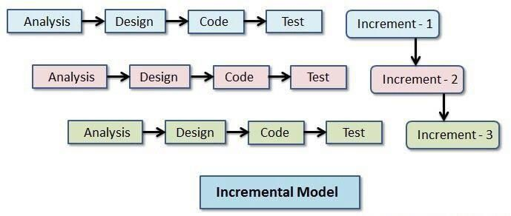

Figure **1. 1**: Incremental Process Model

#### Reason for Choosing Incremental Process Model

* Provides better support for process iteration.
* Reduces rework in the software construction process.
* As it reduces rework in coding, it is time efficient.
* Allows early delivery of parts of the system.
* Supports easier integration of sub-systems.
* Lower risk of project failure.
* Delivery priorities can be more easily set.

### Feasibility Study

A feasibility study is made to see if the project on completion will serve the purpose of the organization for the amount of work, effort and the time that spend on it. A feasibility study of a system proposal is according to its workability, which is the impact on the organization, the ability to meet their user needs and the effective use of resources. Thus, when a new application is proposed it normally goes through a feasibility study before it is approved for development.

The document the feasibility of the project that is being designed and lists various areas that were considered very carefully during the feasibility study of this project such as technical, economic and operational feasibility. The following are its features:

#### Technical Feasibility

The system must be evaluated from the technical point of view first. Feasibility must base on an outline design of the system requirement in terms of input, output, programs, and procedures. Having identified and outline system, the investigation must go to suggest the type of equipment, required method developing the system, of running the system once it has been designed. Technical issues are raised during the investigation are:

* Is it possible to develop the proposed system using the current technical resource?
* If not, can current technical resources be upgraded or added to in a manner that fulfills the request under consideration?
* Is there technology in existence that meets the specifications?

The project should be developed such that the necessary functions and performance are achieved within the constraints. The project is developed within the latest technology. Through the technology may become obsolete after some period of time, due to the fact that the newer version of the same software supports older versions, the system may still be used. So, there is minimal constant involved with this project. The system has developed using PHP the project is technically feasible development.

#### Economic Feasibility

Economic feasibility determines whether value of the investment exceeds the time and cost. The basic resources to consider our time, the cost of the full system study including the time of client and employees of the company with whom we are working, the estimate cost of hardware, the estimate cost of software, software development or software customization. The developing system must be justified by the cost and benefit. The following are some of the important financial questions asked during the preliminary investigation:

* The cost conducts a full system investigation.
* The cost of hardware and software.
* The benefits in the form of reduced costs or fewer costly errors.

Since the system is developed as part of project work, there is no manual cost to spend on the proposed system. Also, all the resources are already available, it gives an indication of the system is economically possible for development. Our developed system is economically feasible. When we compare the total cost and benefits from the system at that time, we see that our client will be beneficial from this system.

#### Operational Feasibility

Operational feasibility determines if the hotel booking are available to operate the system once it has been installed. Users that do not want a new system may prevent it from becoming operationally feasible. If users are virtually use the present system, see no problem with it and generally not involve in requesting a new system, resistance to implementing the new system will be strong. The new system has a low chance to become operational.

This includes the following questions:

* Will the proposed system cause harm?
* Is there sufficient support for the users?

The project would be beneficial because it satisfies the objectives when developed and installed. All behavioral aspects are considered carefully and conclude that the project is behaviorally feasible.

# Chapter-2 The Organization

Chapter 1 is representing the organizational overview, mission, vision and about company’s various services. In this chapter detailed organizational overview is discussed along with the organizational hierarchy and my position over there as intern.

#### Organizational Overview

Kodeeo a full-featured web solution, software development, mobile application, graphic & multimedia, domain hosting and digital marketing service providing company in Bangladesh Its core with the highly qualified Designers and Developers having experience of more than 5 years in various and complex designs and development. Kodeeo has satisfied the clients with the services like Web design and development, Mobile app design and development, Software development, SEO and social media Designing & Development. This companies customer centric and divert our efforts to act as a one-stop solution provider in the area of IT In every area of our, operations we work hard in understanding the Client’s requirement and providing the Kodeeo solution. We firmly believe in the philosophy of ‘Our vision is to make every youth skilled & employed’. We take pride in a team of highly qualified, skilled and motivated Professionals who are encouraged to lead, innovate and excel. Our team consists of top professionals who share a common vision and passion, providing our clients with critical insights and advice to succeed in today’s competitive environment. We believe in delivering Expertise, Excellence Services through our past Experience and providing the highest and best end use of services to our client. (Kodeeo, Ltd.)

#### Organization Services

Kodeeo is an Information Technology service provider organization which provides all kinds of professional and creative software, Enterprise software integration, Management info system, E- commerce, Game development, Web development & Mobile app solutions globally.

**Web Development:** At Kodeeo we focus on creating search engine friendly, aesthetically appealing and interactive website designs. It is a known fact that to build a strong web presence and to secure the countless marketing opportunities available on the internet, a good website is imperative, thus triggering a race for website design while designing and developing your website, our professionals keep in mind key factors like easy-navigation, overall consistency and content quality, stipulated timeframes and budget and backend support.

**Mobile Application:** We have a strong mobile application developer team of expert whose have the experience to build versatile mobile applications for various industries. All of our expert engineer working in android and IOS platform for more than five years. We work on native android which provide faster response of app and ensure the quality.

**Domain and Hosting Service Provider:** Kodeeo offers unbeatable, unlimited & lowest cost web hosting in Bangladesh, Complete with all the tools and apps you need. Make life easy with everything under the one roof. We are offering shared hosting packages like Linux shared hosting and windows shared hosting packages. Shared hosting is a good choice for new websites. If you are having a new website then you should use shared hosting. We are offering these packages at a reasonable price. You can choose any of them as your preference.

**Digital Marketing:** Kodeeo offer various kind of packages to make your company best in the internet world. Digital Marketing means promoting a product or brand which is very much essential to make a business successful. It increases visibility on web to your potential customers. As much as you are visible, you are getting closer to your business goal. It’s your most important strategy to expand your business. Kodeeo is a full-service digital agency that has client’s ranging from renowned companies to innovative startups.

* 1. **Organization Location**

House-14, Road-8, Sector-6, Uttara, Dhaka – 1230

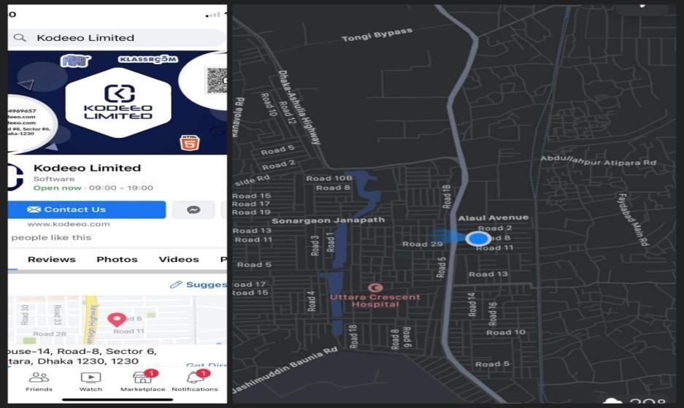

**Figure 2. 1: Organization Location**

#### Organization Vision

The mission of Kodeeo is to become a top leading IT company of Bangladesh and their vision is to empower the youth and become a successful IT company of digital Bangladesh. Kodeeo achieves competitive edge and has gained operational effectiveness and efficiency through the innovative use of technology.

### Organization Mission

Kodeeo was born as a one stop skills development platform provider. Their offerings coupled with the impeccable team behind it ensure satisfaction of client needs in relation to their characteristics

#### My position in this Organization

I am an intern developer to this organization. I am guided by a supervisor in this organization. He is very helpful and informative. I really learn a lot from him. I successfully completed my project in time. It was only possible by the guidance of my supervisor. It was also a big experience to maintain the office time for me. I also maintain the other rules of this organization. I am really happy to work with this office. It’s really made me prepare for the beginning of my career.

#### Organizational Structure

The structure of my organization is drawn below:

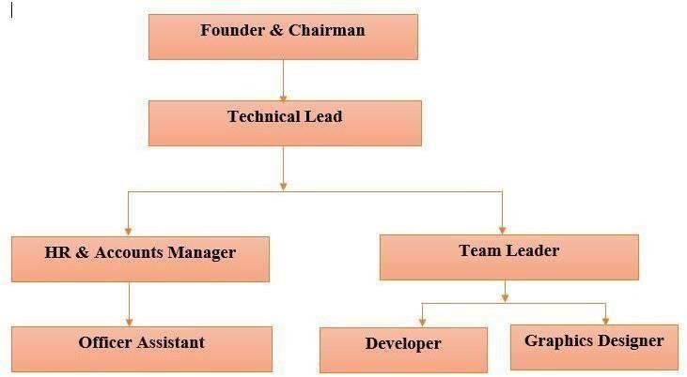

**Figure 2. 2: Organization Structure of kodeeo**

# Chapter-3 Literature Review

The “Online Hotel Booking System” has been developed to book rooms through online. This software is support to eliminate and in some cases reduce the hardships faced by the existing system.

Online hotel booking system is an online process which is known to all for booking the room through online.

I can go through different types of online hotel booking system software by making my project. Currently existing Online Hotel Booking System encompass:

A hotel reservation system, commonly known as a central reservation system (CRS) is a computerized system that stores and distributes information of a hotel, resort or other lodging facilities (www.mindspeakit.com). A CRS offers assistance to hoteliers to manage all of their online marketing and sales where they can upload their rates and service availabilities to be seen by sales channels (www.mindspeakit.com). The list of main modules that are present in a CRS are: Content, Information stored on a CRS and Reporting.

Content consists of Reservations, Profiles, Groups and Blocks, Rate and Inventory Control, Administration, Global Distribution Interface, Web-based Interface. Information commonly stored in a CRS consists of Room Types, Rate plans architecture, Room rates and conditions (guarantee, deposit, customized cancellation rules, minimum length of stay, maximum length of stay, closed to arrival, arrival not allowed, departure not allowed, …), Room inventories, Generic hotel information (address, phone number, fax number), Reservation information. The CRS Reporting module provides a number of standard reports. System reports may be generated automatically and may be run daily, weekly, monthly, yearly. It includes Expected Arrivals, Reservation, Property Forecast, Total Booking Activity, Stay Activity, Monthly Booking Activity, Daily Booking Activity and Property Detail.

# Chapter-4 Requirement Engineering

Chapter 4 combines all the requirements for developing the project. In this chapter detail of each of requirements is discussed along with use case diagram for better understanding of the project and matching the various requirements of the projects to be implemented.

### Requirement Analysis

Requirements analysis is a software engineering task that bridges the gap between system engineering and system design. Requirements analysis allows the software engineer to define the software allocation and build the module of the data, functional and behavioral domains that will treat by software. Requirement analysis provides the software designer with a representation of information, function and behavior of the system.

Requirements analysis is the first stage in the software development process. It encompasses those tasks that go into determining the needs or conditions to meet for a new or altered product taking account of the possibly conflicting requirements of the various stakeholders, Such as beneficiaries or users. Analysis the requirement is critical to the success of development project. Requirements must be actionable, measurable, testable, related to identified business need or opportunities, and defined to level of detail sufficient for system design.

### Requirement Engineering

Requirements engineering is, as its name suggests, the engineering discipline of establishing user requirements and specifying software systems. There are many definitions of Requirements Engineering; however, they all share the idea that requirements involve finding out what people want from a computer system and understanding what their needs mean in terms of design. Requirements engineering is closely related to software engineering, which focuses more on the process of designing the system that users want. Requirements of different types of my project are written below:

* + - User requirements
    - System requirements
    - Functional requirements
    - Non-functional requirements
    - Hardware Requirements
    - Software Requirements

### User Requirements

#### User requirements:

**Admin**

* + - 1. Admin can log in to the system
      2. Can manage the hotel information
      3. Can manage the room types
      4. Can manage the rooms
      5. Can manage the amenities
      6. Can approve or disapprove any booking
      7. Can manage the payment related details
      8. Can manage the report generation

#### Guest

1. Guest can check the available room
2. Can see all the room types
3. Can see all the rooms
4. Can book any available room
5. Can see the booking information

### System Requirements

#### Admin

* + - 1. Admin can manage the hotel information
         1. In here admin can add the hotel information
         2. Can update the hotel information
      2. Can manage the room types
         1. Admin can add the room types
         2. Can see all the added room types
         3. Can edit/view/ update the room types
      3. Can manage the rooms
         1. Can add the rooms
         2. Can choose the room types
         3. Can choose the amenities that are added with the rooms
      4. Can manage the amenities
         1. Can add the amenities
         2. Can see the amenities details
         3. Can edit/ delete the amenities
      5. Can approve or disapprove any booking
         1. Admin can see the booking details
         2. Can approve any booking and see the approved list
         3. Can disapprove any booking and see the disapproved list
      6. Can manage the payment related details
         1. Can take the payment and change the status to paid
         2. Can see the total amount and it will be auto calculated depending on the date difference or the number of days
         3. Can see the due amount and it will be auto calculated
      7. Can manage the report generation
         1. Can see the booking details here
         2. Can search the booking details by giving the date range
         3. Can print the details

**Guest**

1. Guest can check the available room
   1. Will give the check in date and check out date to see the available rooms
   2. Without login to the system can see the rooms
2. Can see all the room types
   1. Can see the room type details
   2. Can choose any room types
3. . Can see all the rooms
   1. Can see all the room details
   2. Can see the room image
   3. Can book the room
4. . Can book any available room
   1. For booking guest must have to signup
   2. Then they have to login to the system
   3. Then guest will fill up the booking form
   4. After submission they will get a success message
5. . Can see the booking information
   1. See the booking information in my booking list
   2. Can see the status whether the booking is approved or not

### Functional Requirements

* + - 1. Associate every online booking with an account
      2. Accept the date and time to check available rooms for that particular date
      3. Booking confirmation will be sent to the specified user by changing the status
      4. user can show the booking list
      5. Calculate and display accommodation charges
      6. Report generation

### Non-functional requirements

1. This system provides a well secure and trustable platform.
2. Easy tracking of records and updating can be done
3. Without providing valid information the form won’t submitted.
4. Without filling up mandatory fields no form will be submitted.

### Software Requirements

* Windows 10
* Xampp server.
* Visual Studio Code
* Web browser (Google chrome or Mozilla Firefox)

### Use Case Diagram of the System

A use case diagram at its simplest is a representation of a user’s interaction with the system that shows the relation between the user and the different use cases in which the user is involved.

A use case diagram can identify the different types of users of a system and the different use cases and will often be accompanied by other types of diagrams as well. The use case technique is used to capture a system’s behavioral requirements by detailing scenario driven threads through the functional requirements.

#### Use Case Symbol



**Actor:** An actor represents a set of roles that users of use case play when interacting with these use cases. Actors can be human or automated systems.

**Use case:** A use case represents a user goal that can be achieved by accessing the system or software application. A use case is the specification of a set of actions performed by a system, which yields an observable result that is typically of value for one or more actors of the system.

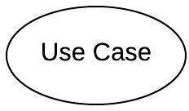

**Association:** Actor and use case can be associated to indicate that the actor participates in that use case. Therefore, an association corresponds to a sequence of actions between the actors and use case in achieving the use case.

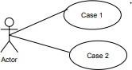

**Include:** An include relationship specifies how the behavior for the inclusion use case is inserted into the behavior defined for the base use case.



**Extend:** An extend relationship specifies how the behavior of the extension use case can be inserted into the behavior defined for the base use case.

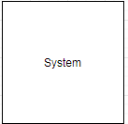

**System:** The use cases of the system are placed inside the system shape, while the actor who interact with the system are put outside the system. The use cases in the system make up the total requirements of the system.

#### Use Case Diagram

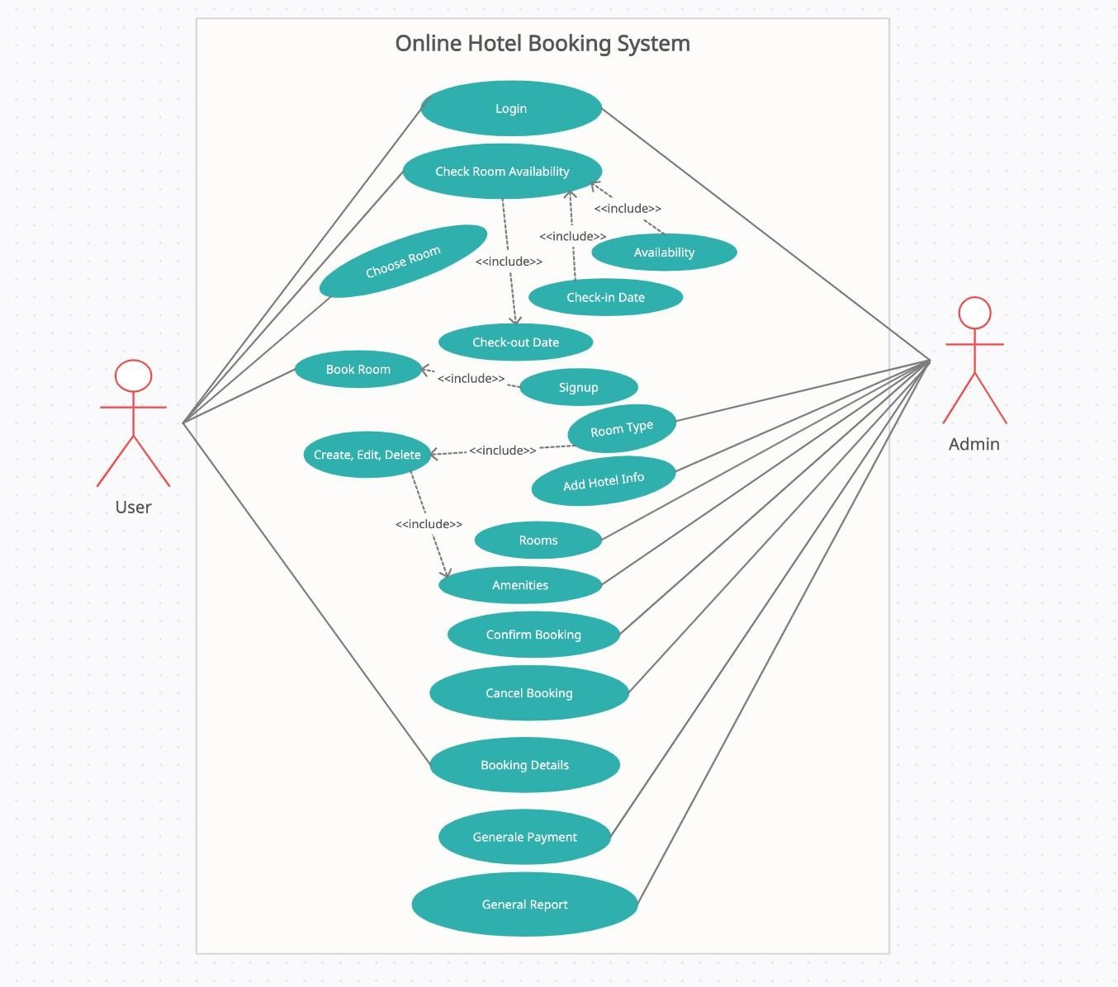

**Figure 4.1 use case for online hotel booking system**

# Chapter-5 System Planning

Project planning and scheduling chapter shows the functions of the project “Online Hotel Booking System”. The function point estimation, effort distribution and project schedule chart are also shown in this chapter.

#### Function of the Proposed System

**Table 5.1: Function of Proposed System**

|  |  |
| --- | --- |
| Login To The System | F1 |
| Add Hotel info | F2 |
| Add Room types | F3 |
| View Room types | F4 |
| Update Room types | F5 |
| Delete Room types | F6 |
| Add Rooms | F7 |
| Add Amenities | F8 |
| Manage amenities | F9 |
| Manage Rooms | F10 |
| Manage Booking | F11 |
| View Booking Record | F12 |
| Add Payment | F13 |
| Manage Payment | F14 |
| Generate Report | F15 |

#### Function Point Estimation

Thetaskofcountingfunctionpointsshouldbeincludedaspartoftheoverallprojectplan.This is counting function points should be scheduled and planned. The first function point count should be developed to provide sizing used for estimating.

**Transactional Functions** External Inputs [EI] External Outputs [EO] External Queries

#### Data Functions

* + - Internal Logical Files
    - External Interface Files

**Table 5.2: Functional point Estimation (Admin)**

|  |  |  |
| --- | --- | --- |
| **Functionality** | **Input** | **Output** |
| Login | Email, Password | Enter the Admin Dashboard |
| Add Hotel info | Id, address, email, contact no, website | Added into Database table |
| Update hotel info | Change the info and submit | Updated successfully |
| Add room types | Id, name, description, amount, image | Added into Database table |
| View room types | Click on view button | Display all rooms under this type as a table |
| Update room types | Click on Edit button | Updated successfully |
| Delete room types | Click on the Delete button | Record has been removed |
| Add Rooms | id, name, room number, type, no of accommodate, image, room type, amenities description, amount | Added into Database table |
| View Booking | Click on booking | Display all Booking list as a table |
| Approve Booking | Click on approve button of Booking | Status changed to booked |
| Disapprove Booking | Click on disapprove button of Booking | Status changed to disapprove |
| Add Amenities | Id, name, status | Added into Database table |
| Update amenities | Click on Edit button | Updated successfully |
| Delete amenities | Click on the Delete button | Record has been removed |

|  |  |  |
| --- | --- | --- |
| Add room amenities | Id, room id, amenities id | Added into Database table |
| Add payment | Id, method, booking id, user id, pay at, paid amount, comments,  status | Added into Database table |
| Give payment | Click on payment button | Payment added to the list |
| View payments | Click on Payment | Display payments as a table |
| Generate report | See booking details based on date range | Print the report |

**Table 5.3: Functional Point Estimation (Guest)**

|  |  |  |
| --- | --- | --- |
| **Functionality** | **Input** | **Output** |
| Registration | id, name, email, contact  no, address, password, gender | Added into Database Table |
| Login | Email, Password | Enter the user panel |
| Search rooms | Check in date, check out date | Display rooms info |
| Add booking | id, name, email, user id, room id, from date, to date, no of days, no of guest, total amount,  contact no, address, status | Added into the database |
| Booking Details view | Select rooms and book  that room | Display my booking detail |
| Payment | offline payment | Payment added to the payment details |

#### Identifying complexity:

**Identifying complexity of transition function**

#### Table 5.4: Identifying complexity of transition function (Admin)

|  |  |  |  |
| --- | --- | --- | --- |
| **Transition function** | **Field/ file involve** | **FTRs** | **DETs** |
| Login | **Fields-** Email, Password  **File-**login | 1 | 2 |

|  |  |  |  |
| --- | --- | --- | --- |
| Add Hotel info | **Fields-** Id, email, contact no, address, city  **File**- hotel | 1 | 5 |
| Update hotel info | **Fields** Id, email, contact no, address, city  **File**- hotel | 1 | 5 |
| Add room types | **Fields-** Id, name, description, amount, image  **File**-room type | 1 | 5 |
| View room types | **Fields-** Id, name, description, amount, image  **File**-room type | 1 | 5 |
| Update room types | **Fields-** Id, name, description, amount, image  **File**-room type | 1 | 5 |
| Delete room types | **Fields-** Id, name, description, amount, image  **File**-room type | 1 | 5 |
| Add Rooms | **Fields-** id, name, room number, type, no of accommodate, image, room type, amenities description, amount  **File-** room, room type, amenities | 3 | 10 |
| View Booking | **Fields-** id, name, email, user id, room id, from date, to date, no of days, no of guest, total amount, contact no, address, status  **File-**booking, user, room | 3 | 14 |
| Approve Booking | **Fields-** id, name, email, user id, room id, from date, to date, no of days, no of guest, total amount, contact no, address,  status | 3 | 14 |

|  |  |  |  |
| --- | --- | --- | --- |
|  | **File-**booking, user, room |  |  |
| Disapprove Booking | **Fields-** id, name, email, user id, room id, from date, to date, no of days, no of guest, total amount, contact no, address, status  **File-**booking, user, room | 3 | 14 |
| Add Amenities | **Fields-** Id, name, status  **File-**amenities | 1 | 3 |
| Update amenities | **Fields-** Id, name, status  **File-**amenities | 1 | 3 |
| Delete amenities | **Fields-** Id, name, status  **File-**amenities | 1 | 3 |
| Add Room Amenities | **Fields-** Id, room id, amenities id  **File-**room amenities, amenities, room | 3 | 3 |
| Add payment | **Fields-** Id, method, booking id, user id, pay at, paid amount, comments, status  **File**- payment, booking, user | 3 | 8 |
| View payments | **Fields-** Id, method, booking id, user id, pay at, paid amount, comments, status  **File**- payment, booking, user | 3 | 8 |

**Table 5.5: Identifying complexity of transaction function (Guest)**

|  |  |  |  |
| --- | --- | --- | --- |
| **Transition function** | **Field/ file involve** | **FTRs** | **DETs** |
| Registration | **Field**- id, name, email, contact no, password  **File**- user | 1 | 5 |
| Login | **Field**-Email, Password  **File-** login | 1 | 2 |
| Search rooms | **Field** Check in date, check out date  **File-**booking | 1 | 2 |
| Add booking | **Field** id, name, email, user id, room id, from date, to date, no of days, no of guest, total amount, contact no, address, status  **File-** booking, room, user | 3 | 14 |
| Booking Details view | **Field** id, name, email, user id, room id, from date, to date, no of days, no of guest, total amount, contact no, address, status  **File-** booking, room, user | 3 | 14 |

* + 1. **Identifying Complexity for Data Function**

#### Table 5.6. Identifying Complexity for Data Function

|  |  |  |  |
| --- | --- | --- | --- |
| **Data function** | **Field/ file involve** | **RETs** | **DETs** |
| Hotel | **Fields-** Id, email, contact no, address, city  **File**- hotel | 1 | 5 |
| Rooms (ILF) | **Fields-** id, name, room number, type, no of accommodate, image, room type, amenities description, amount  **File-** room, room type, amenities | 3 | 10 |
| Room types (ILF) | **Fields-** Id, name, description, amount, image  **File**- room type | 1 | 5 |
| Amenities (ILF) | **Fields-** Id, name, status  **File-**amenities | 1 | 3 |
| Room Amenities (ILF) | **Fields-** Id, room id, amenities id  **File-**room amenities, amenities, room | 3 | 3 |
| Booking (ILF) | **Fields-** id, name, email, user id, room id, from date, to date, no of days, no of guest, total amount, contact no, address, status  **File-**booking, user, room | 3 | 14 |
| Payment (ILF) | **Fields-** Id, method, booking id, user id, pay at, paid amount, comments, status  **File**- payment, booking, user | 3 | 8 |
| Users (ILF) | **Fields-** id, name, email, contact no, password  **File-** User | 1 | 5 |

* + 1. **Unadjusted function point contribution**

#### Table 5.7: Unadjusted function point contribution of transaction function

|  |  |  |  |  |
| --- | --- | --- | --- | --- |
| **Transition function** | **FTRs** | **DETs** | **Complexity** | **UFP** |
| Login(EQ) | 1 | 2 | Low | 3 |
| Add Hotel info(EI) | 1 | 5 | Low | 3 |
| Update hotel info(EI) | 1 | 5 | Low | 3 |
| Add room types(EI) | 1 | 5 | Low | 3 |
| View room types(EO) | 1 | 5 | Low | 4 |
| Update room types(EI) | 1 | 5 | low | 3 |
| Delete room types(EI) | 1 | 5 | low | 3 |
| Add Rooms(EI) | 3 | 10 | Average | 4 |
| View Booking(EO) | 3 | 14 | average | 5 |
| Approve Booking(EI) | 3 | 14 | average | 4 |

|  |  |  |  |  |
| --- | --- | --- | --- | --- |
| Disapprove Booking(EI) | 3 | 14 | average | 4 |
| Add Amenities(EI) | 1 | 3 | low | 3 |
| Update amenities(EI) | 1 | 3 | low | 3 |
| Delete amenities(EI) | 1 | 3 | low | 3 |
| Add Room Amenities(EI) | 3 | 3 | average | 4 |
| Add payment(EI) | 3 | 8 | high | 6 |
| Search room(EI) | 1 | 2 | low | 3 |
| Total |  |  |  | 61 |

**Table 5.8: Unadjusted function point contribution for data functions**

|  |  |  |  |  |
| --- | --- | --- | --- | --- |
| Data function | RETs | DETs | Complexity | UF P |
| Hotel (ILF) | 1 | 5 | low | 7 |
| Rooms (ILF) | 3 | 10 | low | 7 |
| Room types (ILF) | 1 | 5 | Low | 7 |
| Amenities (ILF) | 1 | 3 | Low | 7 |
| Room Amenities (ILF) | 3 | 3 | Low | 7 |
| Booking (ILF) | 3 | 14 | Low | 7 |
| Payment (ILF) | 3 | 8 | low | 7 |
| Users (ILF) | 1 | 5 | Low | 7 |
| Total |  |  |  | 56 |

* + 1. ***Performance and Environmental impact***

#### Table 5.9: Performance and environmental impact

|  |  |
| --- | --- |
| **GSC (General System Characteristics)** | **TDI** |
| 1. Data Communications | 4 |
| 2. Distributed Data Processing | 1 |
| 3. Performance | 4 |
| 4. Heavily Used Configuration | 2 |
| 5. Transaction Rate | 2 |
| 6. On-Line Data Entry | 1 |
| 7. End-user Efficiency | 2 |
| 8. Online Update | 1 |
| 9. Complex Processing | 2 |
| 10. Reusability | 2 |
| 11. Installation Ease | 4 |
| 12. Operational Ease | 3 |
| 13. Multiple Sites | 3 |
| 14. Facilitate Change | 1 |
| Total Degree of Influence (TDI) (Range 0 to 70 -> influence size±35%) | 32 |

Value Adjustment Factor (VAF) = (0.65 + (0.01*TDI))

= (0.65 + (0.01*32))

= 0.97

UFP = UFP (Data Function) + UFP (Transition Function)

= 56+61

=117

Adjusted Function Point (AFP) = UFP*VAF

= 117*0.97

= 113.49

Efforts for Project = AFP * Productivity

= 113.49×15.5

=1759 per hour

One person work 12 hour per day, = 1759 /12

= 146 days In a month, 25 days are working days, = 146/25

= 5.8 month

#### Project Schedule Chart

Total system development is a combination of set of tasks. These set of tasks should done sequentially and timely. Project schedule works as the guideline of the system developer. The following is the schedule chart of this project:

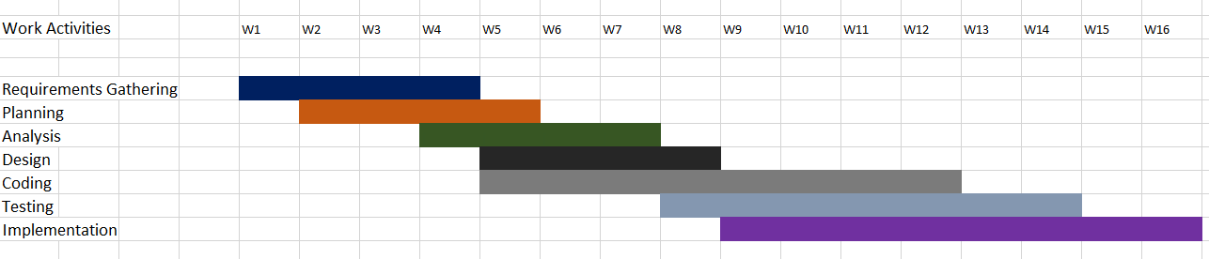

Figure 5.1: Project Schedule Chart

#### Cost Estimation

The approximation of the cost of a program is cost estimation. In this project, there are few factors to analyze and calculate the cost. Given below,

* Personnel cost
* Software cost
* Hardware cost
* Others

#### Personnel cost:

Number of days in a year = 365

Number of government holidays in a year =24 Number of weekly holidays in a year =52

Total number of working days to develop the project = 365-(52+24) = 289days

Total number of working days per months to develop the project = 289/12

=24.083 days

Organization working hours per day = 8 hours

Organization working hours per month=24.083*8 = 192.664hours Total working hour in 2.3 months = 24.083*8*3.36

= Approximately 647hours

#### Table 5.10: Personnel Cost

|  |  |  |
| --- | --- | --- |
| **Position** | **Salary/month** | **Salary/hour** |
| System Analyst | 35000 | 182.29 |
| Designer | 25000 | 130.2 |
| Coder | 20000 | 104.17 |
| Tester | 20000 | 104.17 |
| Total= 1,00000 | | |

* + 1. **Hardware Cost**

#### Table 5.11: Hardware Cost

|  |  |
| --- | --- |
| **Hardware** | **Cost** |
| Computer | 26,500 |
| Modem | 1,500 |
| Printer | 5,000 |
| **Total** | **33,000 BDT** |

* + 1. **Software Cost**

#### Table 5.12: Software Cost

|  |  |
| --- | --- |
| **Name** | **Amount** |
| Windows 10 | 8500 |
| MS Office 2016 | Free |
| XAMPP | Free |
| MySQL | Free |
| Notepad++ | Free |
| Total | **8500 BDT** |

* + 1. **Estimation of Other Cost Table 5.13: Estimation of Other Cost**

|  |  |
| --- | --- |
| **Name** | **Price (BDT)** |
| Transport | 8000 |
| Internet bill | 2800 |
| Other | 1500 |
| Total | **12300 BDT** |

#### Account Table

**Table 4.14: Accounts Table**

|  |  |
| --- | --- |
| Particulars | TK |
| Salary- |  |
| System Analyst | 35,000 |
| Designer | 25,000 |
| Coder Tester | 20,000  20,000 |
| Total | **1,00000 BDT** |

|  |  |
| --- | --- |
| Hardware Cost – |  |
| Computer | 26,500 |
| Modem | 1,500 |
| Printer | 5,000 |
|  | **33,000 BDT** |
| Software Cost – Windows 10  MS office 2016 Xampp MySQL  Notepad++ | **8,500**  **Free Free Free**  **Free** |
| Total | **8,500 BDT** |
| Other Costs- |  |
| Transport | **2,000** |
| House Rent | **10,000** |
| Other | **1,500** |
|  | **13,500 BDT** |
| Total Cost | **1,55000 BDT** |

# Chapter-6 Risk Engineering

A risk is a serious problem that might or might not happen. It is necessary to analyze the potential risks in a project, if the risks of a software project are not properly analyzed and estimated.

Many problems can plague the software project. Anyone developing ant type of system encounter with it and it has to be managed.

### Risk Management

Risk analysis and management are a series of steps that help a software team understand and manage uncertainty. Many problems can plague of software project. A risk is a potential problem; it might happen, it might not. But regardless of the outcome, it’s a really good idea to identify it, assess its probability of occurrence, and estimate its impact, and establish a contingency plan should the problem actually occur. Risk analysis and management are a series of steps that help a software them to understand and manage uncertainty.

To establish a risk management, model the following phases are followed:

**Identification:** Risk identification is the process of detecting potential risks or hazards through datacollection.Arangeofdatacollectionandmanipulationtoolsandtechniquesexists.Thetea m is using both automated and manual techniques to collect data and begin to characterize potential risks to Web resources. Web crawling is one effective way to collect information about the state of Web pages and sites.

**Classification:** Risk classification is the process of developing a structured model to categorize risk and fitting observable risk attributes and events into the model. The team combines quantitative and qualitative methods to characterize and classify the risks to Web pages, Web sites, and the hosting servers.

**Assessment:** Risk assessment is the process of defining relevant risk scenarios or sequences of events that could result in damage or loss and the probability of these events. Rosenthal describe the characteristics of a generic standard for risk assessment as "transparent, coherent, consistent, complete, comprehensive, impartial, uniform, balanced, defensible, sustainable, flexible, and accompanied by suitable and sufficient guidance.

**Analysis:** Risk analysis determines the potential impact of risk patterns or scenarios, the possible extent of loss, and the direct and indirect costs of recovery. This step identifies

Vulnerabilities consider the willingness of the organization to accept risk given potential consequences, and develops mitigation responses.

**Implementation:** Risk management implementation defines policies, procedures, and mechanisms to manage and respond to identifiable risks. The implemented program should balance the value of assets and the direct and indirect costs of preventing or recovering from damage or loss. There are different categories of risks that should be considered in any software project. The following categories of risks have been considered in this software project.

**Project risks:** These risks threaten the project plan. If these risks become real, it is likely that the project schedule will slip and that costs will increase. Project risks identify potential budgetary, schedule, personnel, resource, customer and requirement problems and their impact on the software project.

**Technical risks:** These risks threaten the quality and timeliness of the software to be produced. If a technical risk becomes a reality, implementation may become difficult or impossible. Technical risks identify potential design, implementation, interface, verification and maintenance problems. Moreover, specification ambiguity, technical uncertainty, technical obsolescence are also risk factors.

**Business risks:** These risks threaten the viability of the software to be built. The business risks can be market risks, building a system that no one really wants

Strategic risks, building a system that no longer fits into the overall business strategy for the company. Management risks, losing the support of senior management due to a change in focus or a change in people. Budget risks, losing budgetary or personnel commitment.

### The RMMM Plan

* + - **Risk Mitigation:** Proactive planning for risk avoidance.
    - **Risk Monitoring:** Assessing whether predicted risks occur or not, ensuring preventive steps are being properly applied, collect information for future risk analysis, attempt to determine which risks caused which problem.
    - **Risk Management:** Actions to be taken in the event that mitigation steps have failed and the risk has become a live problem.

**Type of Impact:** Catastrophic (1), Marginal (2), Tolerable (3), Critical (4).

**Type of Probability:** very low (75%).

**Project Risks:** Threaten the project plan. In my system, the bellow mentioned projects risks I needed manage.

#### Table-6.1 Project Risk (PR01)

|  |  |  |
| --- | --- | --- |
| Project Risk (PR01) | Date: 10-08-2021 | |
| Name | Changes the requirements | |
| Probability | Low (25%) |  |
|  |
| Impact | Marginal (2) | |
| Description | Customer may change their requirements. | |
| Mitigation and Monitoring | Requirements are redefined by the company due to time or business | |
| Management | Needs. Meeting will be held with the company regularly. This insures | |
| Status | That the product we are producing solves a problem. | |

**Table-6.2: Project Risk (PR02)**

|  |  |
| --- | --- |
| Project Risk(PR02) | Date: 06-08-2021 |
| Name | Poor Quality Documentation |
| Probability | Low (15%) |
| Impact | Catastrophic (1) |
| Description | Poor quality documentation of the members. |
| Mitigation & Monitoring | Meeting will be held routinely to offer documentation suggestions and topics. The progress on documentation will also have a monitor in each meeting. |
| Management | The addition of new topics or removal of unnecessary topics into the documentation will assigned to responsible person. |
| Status | Monitoring it. |

#### Table-6.3: Project Risk (PR03)

|  |  |
| --- | --- |
| Project Risk(PR03) | Date: 18-08-2021 |
| Name | **Lack of Development Experience.** |
| Probability | Moderate (30%) |
| Impact | Catastrophic |
| Description | Lack of developmental experience of the Members. |
| Mitigation & Monitoring | Each member of the team should watch and  See areas where another team member maybe weak. |
| Management | The members who have the most experience  in a particular area will be required to help For overcome problem arises for this risk. |
| Status | We are not facing such kind of problem yet. |

**Table-6.4: Project Risk (PR04)**

|  |  |
| --- | --- |
| Project Risk(PR04) | Date: 23-08-2021 |
| Name | Poor Comments in Code |
| Probability | Low (15%) |
| Impact | Marginal (2) |
| Description | Code of the developed system is not up to the mark. |
| Mitigation & Monitoring | A formal written standard must be  established to ensure quality of comments in all code. |
| Management | We should call a meeting with the development team to get rid of this problem and improve the quality of comments in  code. |
| Status | We are monitoring the issue. |

* **Technical Risks:** threaten product quality and the timeliness of the schedule. As this is my practicum project, therefore these types of risks need to be take care of properly.

Table-

#### 6.5: Technical Risk (TR01)

|  |  |
| --- | --- |
| Technical Risks(TR01) | Date: 27-08-2021 |
| Name | **Computer Crash** |
| Probability | Moderate (25-40%) |
| Impact | Tolerable (1) |
| Description | Computer may crash due to several reasons. |
| Mitigation & Monitoring | We should take proper follow up of computers. We also take regular data backup every day and we can use IPS to stop  Unexpected shutdown. |
| Management | If our computer has been crashed then we  Will restore backup. |
| Status | We are not facing such kind of problem yet. |

**Table-6.6: Technical Risk (TR02)**

|  |  |
| --- | --- |
| Technical Risks(TR02) | Date: 03-09-2021 |
| Name | **Technology Doesn’t Meet Specifications.** |
| Probability | Low (25%) |
| Impact | Catastrophic (1) |
| Description | Customer doesn’t have the technology to  Their desired specification. |
| Mitigation & Monitoring | Ensures that the product we are producing, and the specifications of the customer are  Equivalent. |
| Management | The customer should be immediately notified and whatever steps necessary to rectify this problem should be done. Preferably a meeting should be held between the development team and the customer to  Discuss at length this issue. |
| Status | We are not facing such kind of problem yet. |

#### Table-6.7: Technical Risk (TR03)

|  |  |
| --- | --- |
| Technical Risks(TR03) | Date: 08-09-2021 |
| Name | **Poor Training Skill in Team Members.** |
| Probability | Moderate (30%) |
| Impact | Catastrophic (1) |
| Description | Poor Training Skill in Team Members to  Train the Client. |
| Mitigation & Monitoring | The training team should have a clear knowledge about the entire functionality of the software. System analyst need to ensure  And monitor it while training session start. |
| Management | We should arrange a meeting with the train  team and come to a point to solve this Problem. |
| Status | We are not facing such kind of problem yet. |

* **Business Risk:** Threaten the viability of the software to be built (market risks, strategic risks, management risks, budget risks). As I am developing it as my practicum project by myself, classic business risks won’t be encountered here. The Probability of all type of Business Risks is therefore, determined as Low.

#### Table-6.7: Business Risk (BR01)

|  |  |
| --- | --- |
| Business Risk(BR01) | Date: 23-09-2021 |
| Name | Insufficient Budget |
| Probability | Low (10%) |
| Impact | Marginal (2) |
| Description | If the budget is low project may not Complete |
| Mitigation & Monitoring | The project need streaming server that is Costly to set-up. We find several alternative streaming services to reduce the budget risk. |
| Management | Refinement in project goal. A new plan for Regulate the budget. |
| Status | Not encountered. |

**Table-6.8: Business Risk (BR02)**

|  |  |
| --- | --- |
| Business Risk(BR02) | Date: 12-09-2021 |
| Name | **Not pay the installment of Software Cost.** |
| Probability | Very Low (5%) |
| Impact | Catastrophic (1) |
| Description | Customer doesn’t pay for the installment of  Software Cost. |
| Mitigation & Monitoring | We should make a good communication between customers and ensure that the entire Installment will be completed. |
| Management | The only course of action available would be  Find out the reason and come in a solution. |
| Status | Not encountered |

**Table-6.9: Business Risk (BR03)**

|  |  |
| --- | --- |
| Business Risk(BR03) | Date: 25-09-2021 |
| Name | **End User Accept System**. |
| Probability | Low (10%) |
| Impact | Critical (4) |
| Description | The system fails to gain user’s faith. |
| Mitigation & Monitoring | In order to prevent this from happening, the software will develop with the end user mind. The user-interface will design in a way to make use of the program convenient and  pleasurable. |
| Management | Training the users to familiarize them with  the new system. Releasing bug fixes for user Satisfaction |
| Status | The risk has not been arisen yet |

# Chapter-7 Analysis Modeling

Analysis modeling uses a combination of text and diagrammatic forms to depict requirements for data, function, and behavior in a way that is relatively easy to understand, and more important, straightforward to review for correctness, completeness and consistency. This section presents resources for conventional and object-oriented analysis (OOA) methods as well as resources for UML. Objectives of the analysis modeling are –

* + Domain Analysis
  + Describe what the client requires
  + Establish a basis for the creation of a software design
  + Define a set of requirements that can be validated once the software is built.

### Software Analysis Pattern

Software analysis patterns or analysis patterns in software engineering are conceptual models, which capture an abstraction of a situation that can often be encountered in modeling. An analysis pattern can be represented as a group of related, generic objects (meta- classes) with stereotypical attributes (data definitions), behaviors (method signatures), and expected interactions defined in a domain-neutral manner. By analysis modeling developer can finalize the specifications of the system. It is mandatory –

* + - To describe what the customer require
    - To establish a basis for the creation of a software design
    - To define a set of requirements that can be validated once the software is built.

### Activity Diagram

Activity diagram is an important behavioral diagram in UML diagram to describe dynamic aspects of the system. Activity diagram is essentially an advanced version of flow chart that modeling the flow from one activity to another activity. The diagrams describe the state of activities by showing the sequence of activities performed.

#### Activity diagram for admin

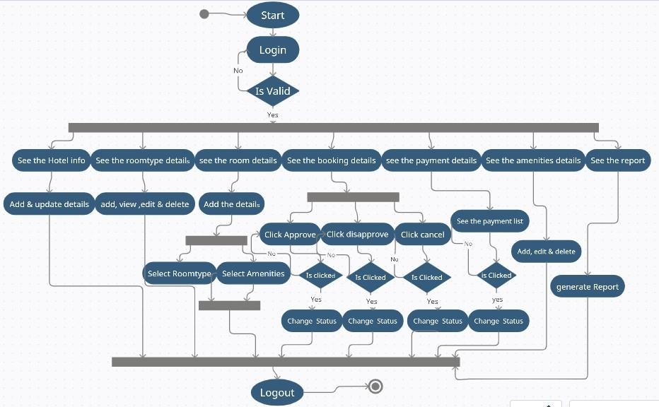

**Figure 7. 1- Activity diagram for admin**

#### Activity diagram for User

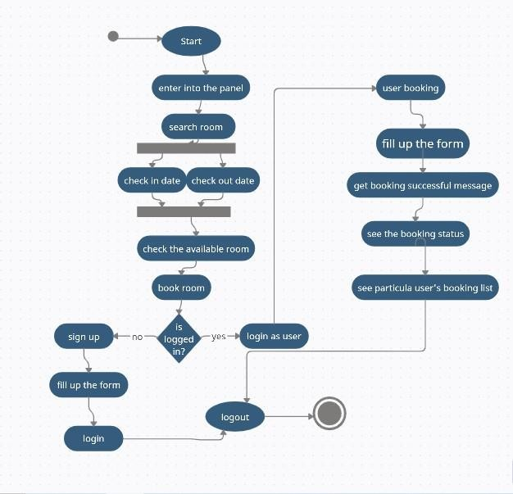

**Figure 7. 2- Activity diagram for user**

# Chapter-8 Designing

* 1. Interface design

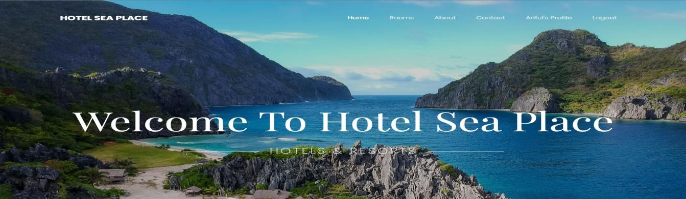

**Figure 8.1- Landing interface for online hotel booking system**

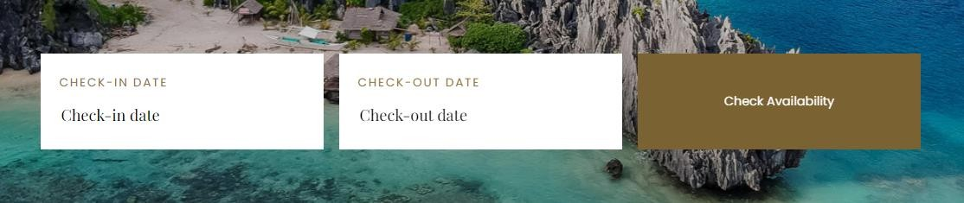

**Figure 8. 2- for checking the available room**

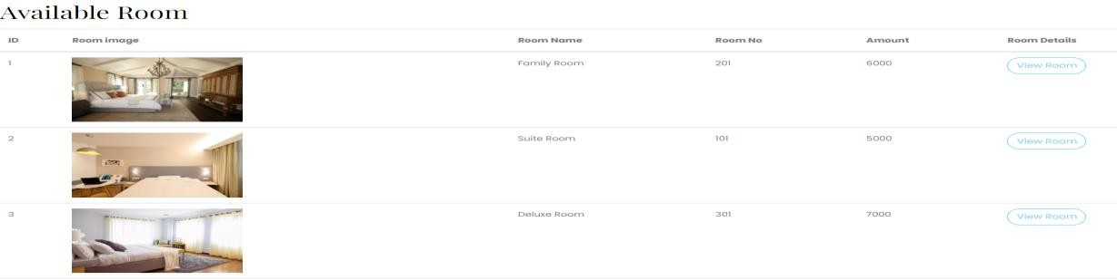

**Figure 8. 3- Result for searching available rooms**



**Figure 8. 4- Single room view**

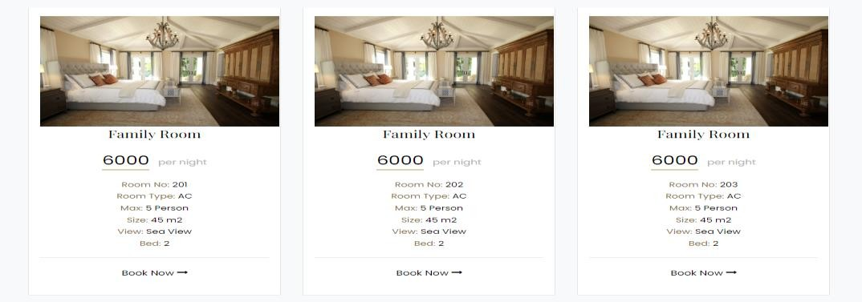

**Figure 8. 5- Single room information**



**Figure 8. 6- Booking button**

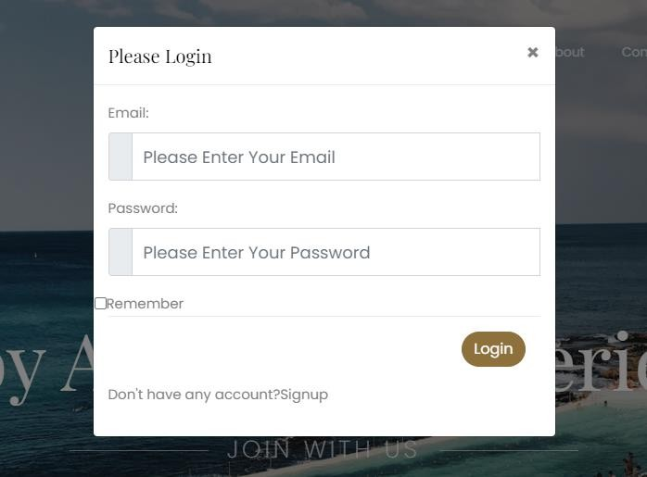

**Figure 8. 7 login page for guest**

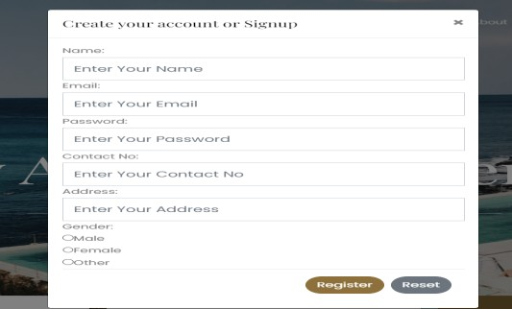

**Figure 8. 8 signup form for guest**

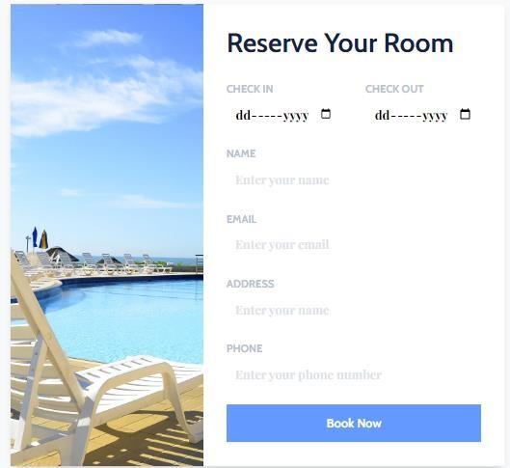

**Figure 8. 9 booking form for guest**

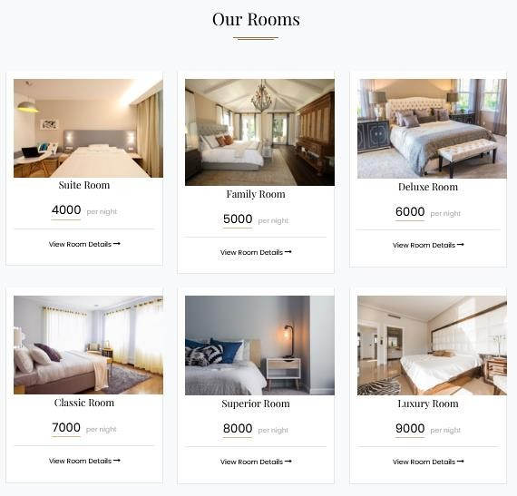

**Figure 8. 10 all room types view**

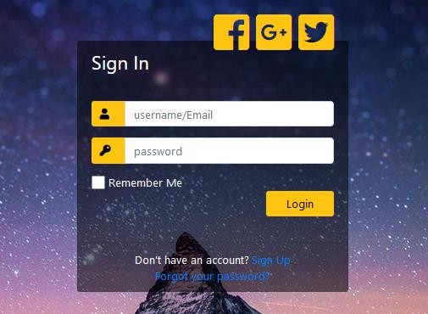

**Figure 8. 11 login form for admin**

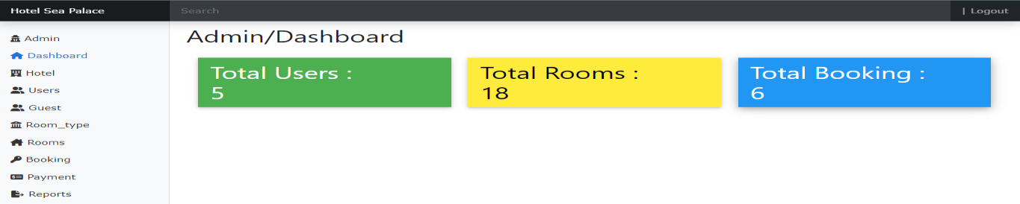

**Figure 8. 12 admin panel for admin Figure**

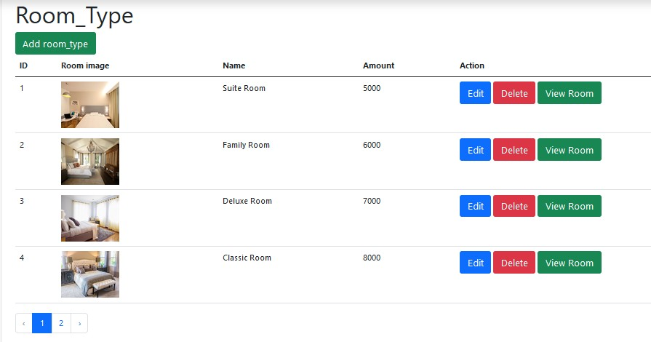

**8. 13 room type list, adding room type**

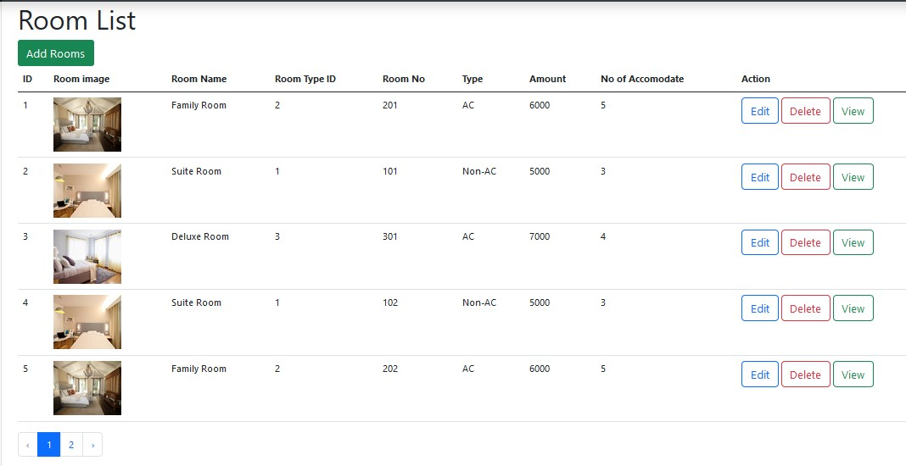

**Figure 8. 14 room list, adding room form**

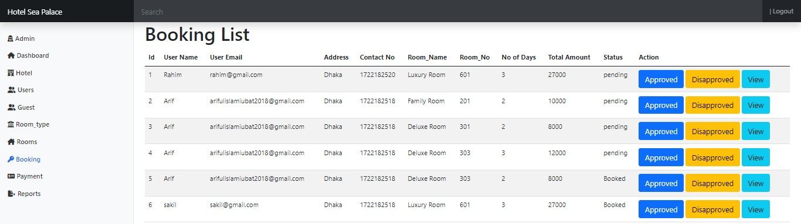

**Figure 8. 15 booking list**

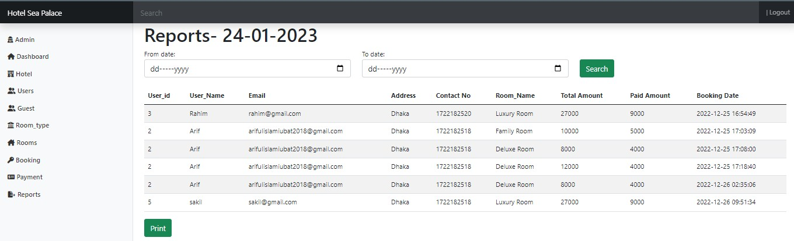

**Figure 8. 16 report generation and pdf making**

## Data Flow Diagram

#### Context Level Diagram

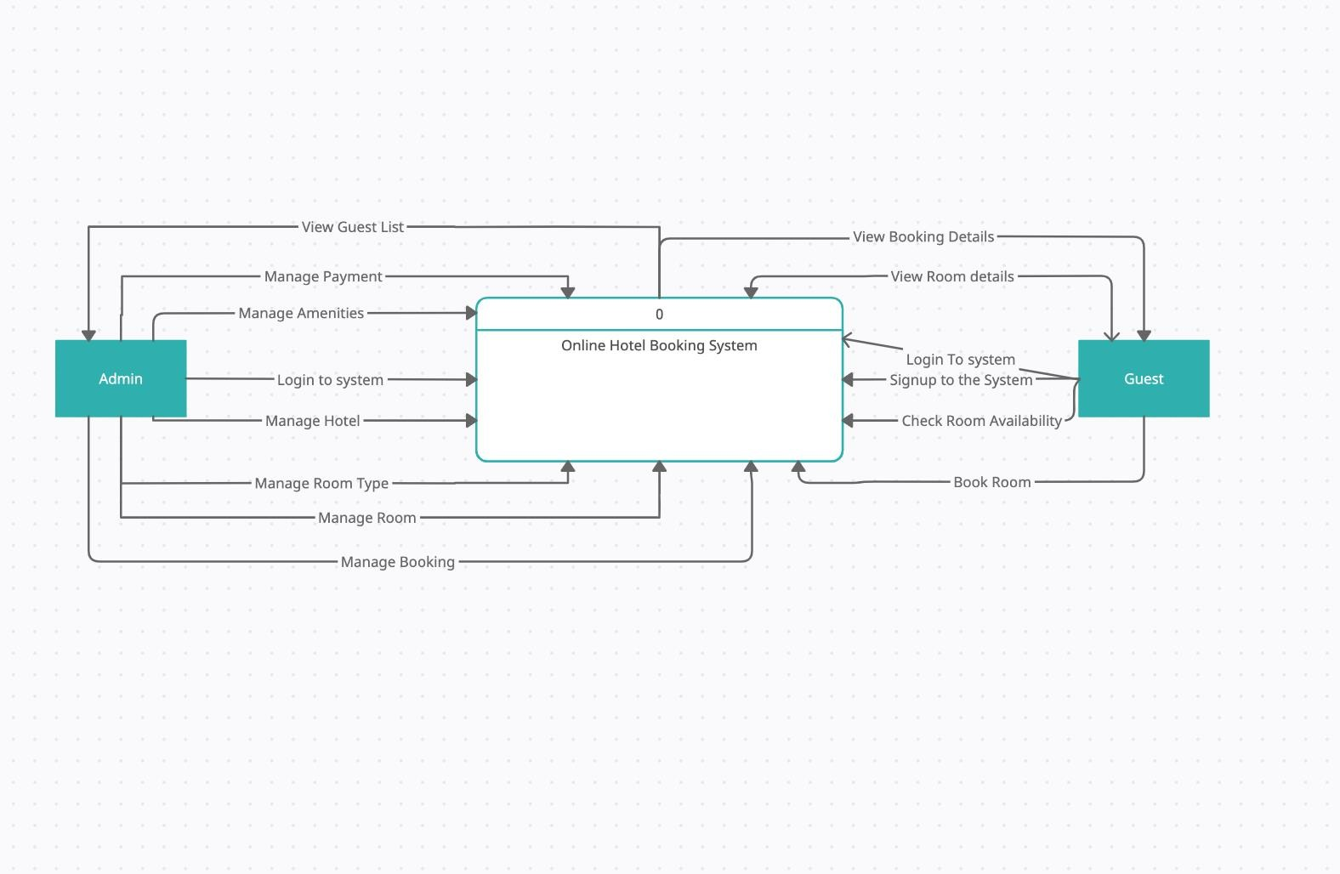

**Figure 8. 17- Context level**

## Level 1DFD

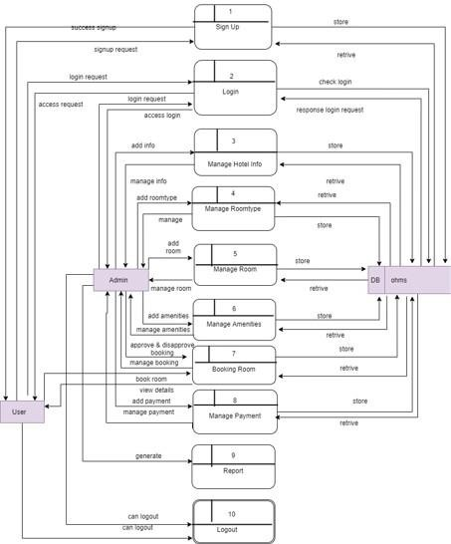

**Figure 8.18- level 1**

* + 1. **Level 2 DFD of Process1**

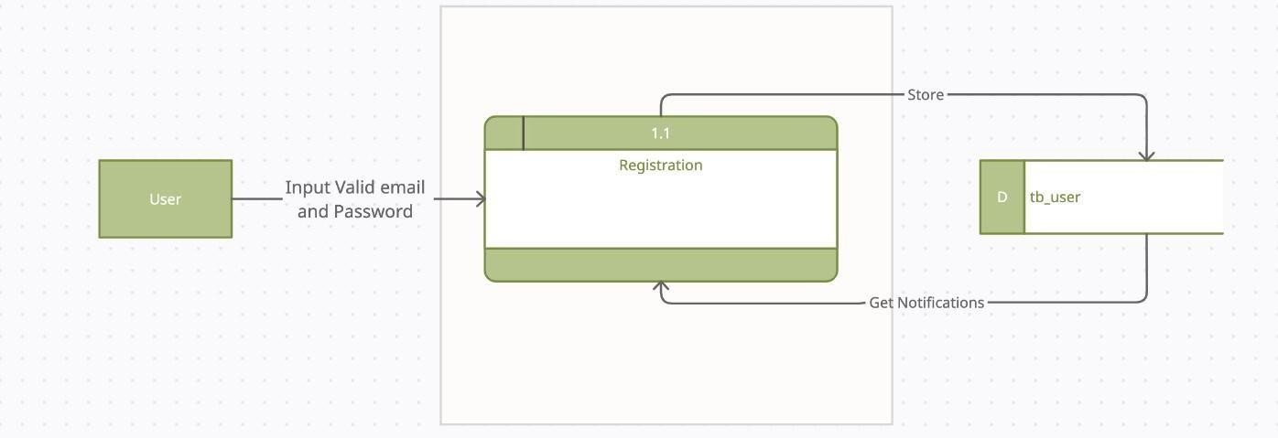

**Figure 8.19- level 2 process 1**

### Level 2 DFD of Process2

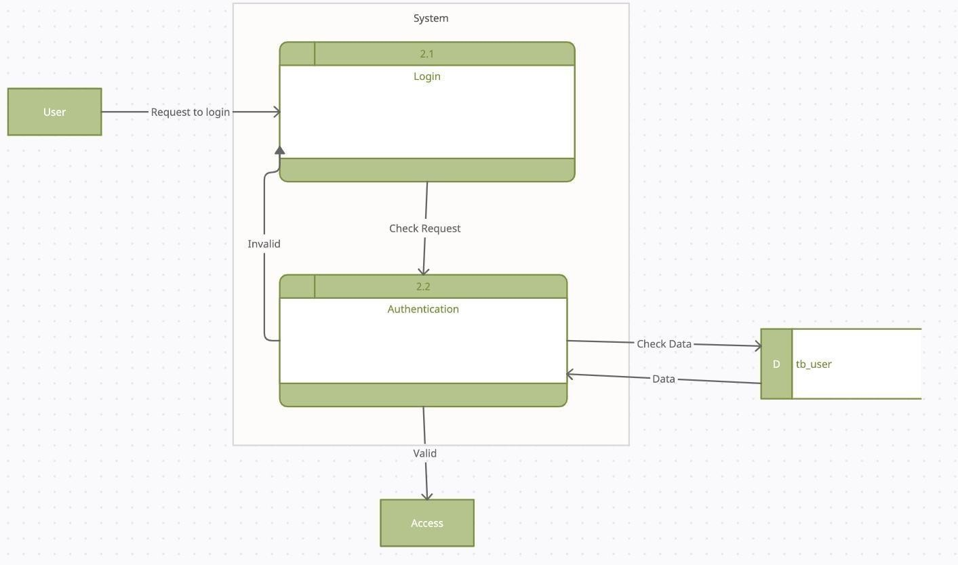

**Figure 8.20- level 2 process 2**

### Level 2 DFD of Process3

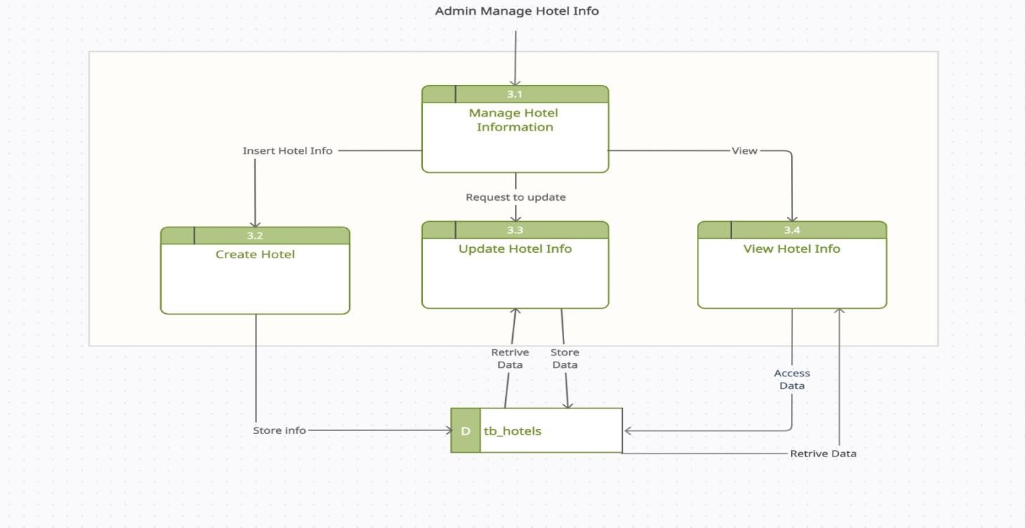

### 

**Figure 8.24- level 2 process 5**

### C:\Users\Tamanna\Downloads\Screenshot 2021-09-30 at 9.57.49 PM (1).pngLevel 2 DFD of Process 5.1

**Figure 8.25- level 2 process 5.1.1**

### Level 2 DFD of Process 6

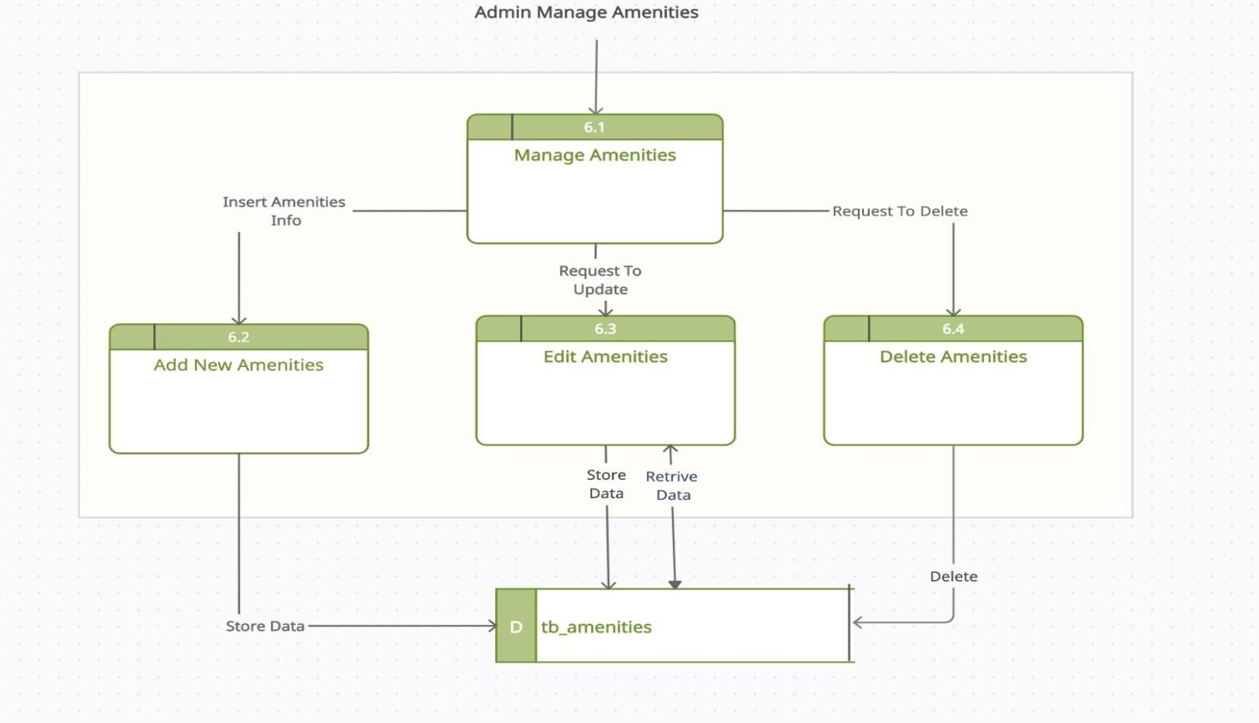

**Figure 8.26- level 2 process 6**

### Level 2 DFD of Process7

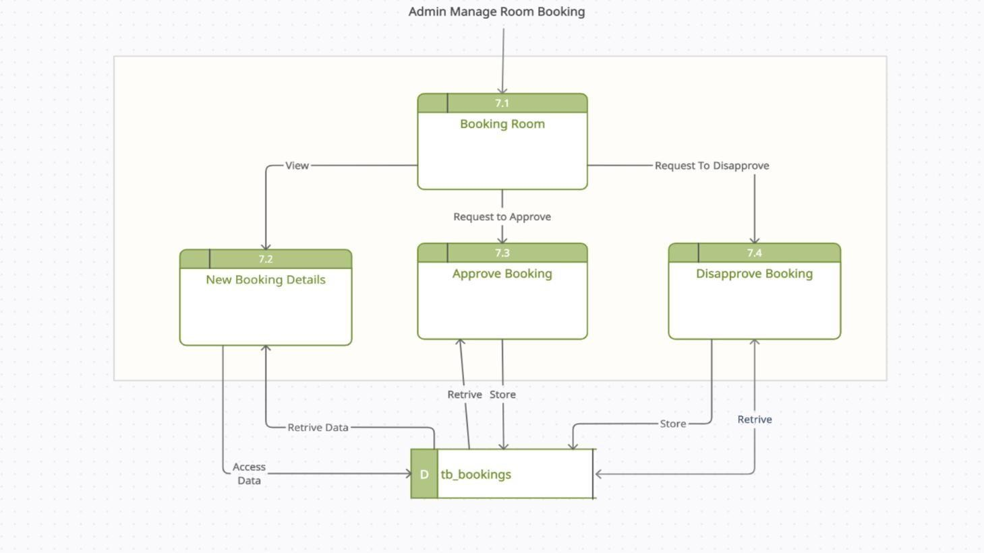

**Figure 8.27- level 2 process 7**

### Level 2 DFD of Process7.1

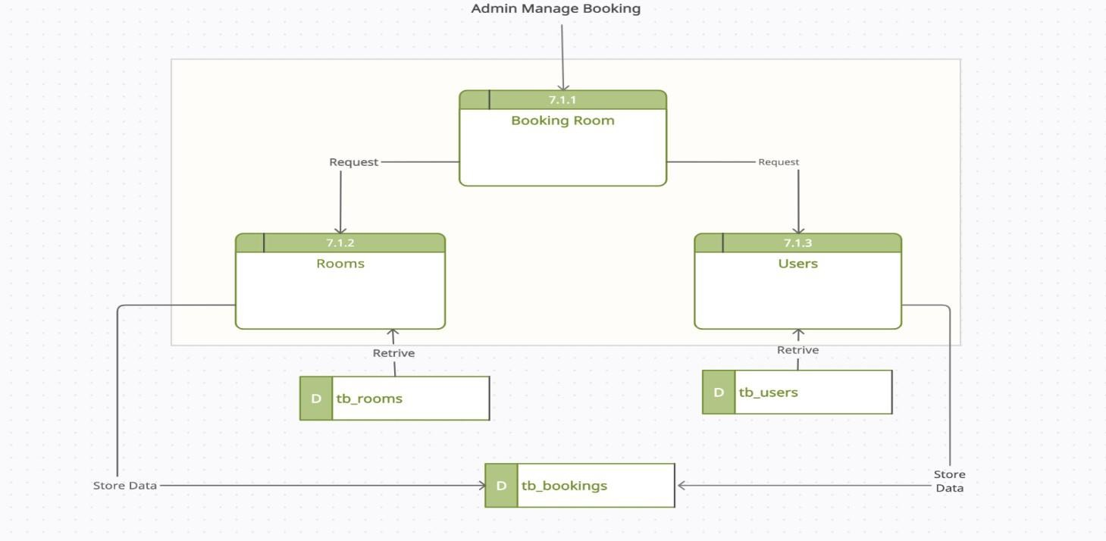

**Figure 8.28- level 2 process 7.1**

### Level 2 DFD of Process8

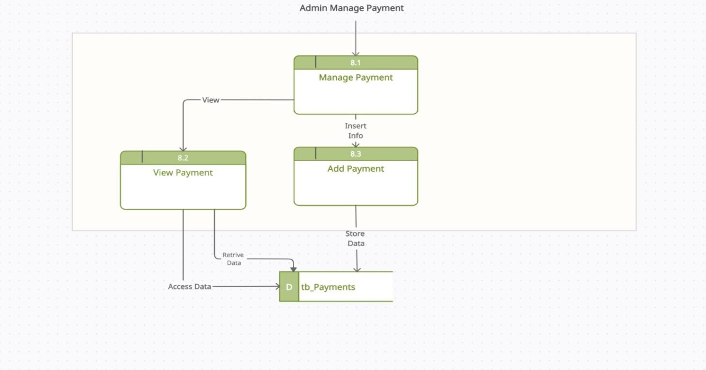

**Figure 8.29- level 2 process 8**

### Level 2 DFD of Process9

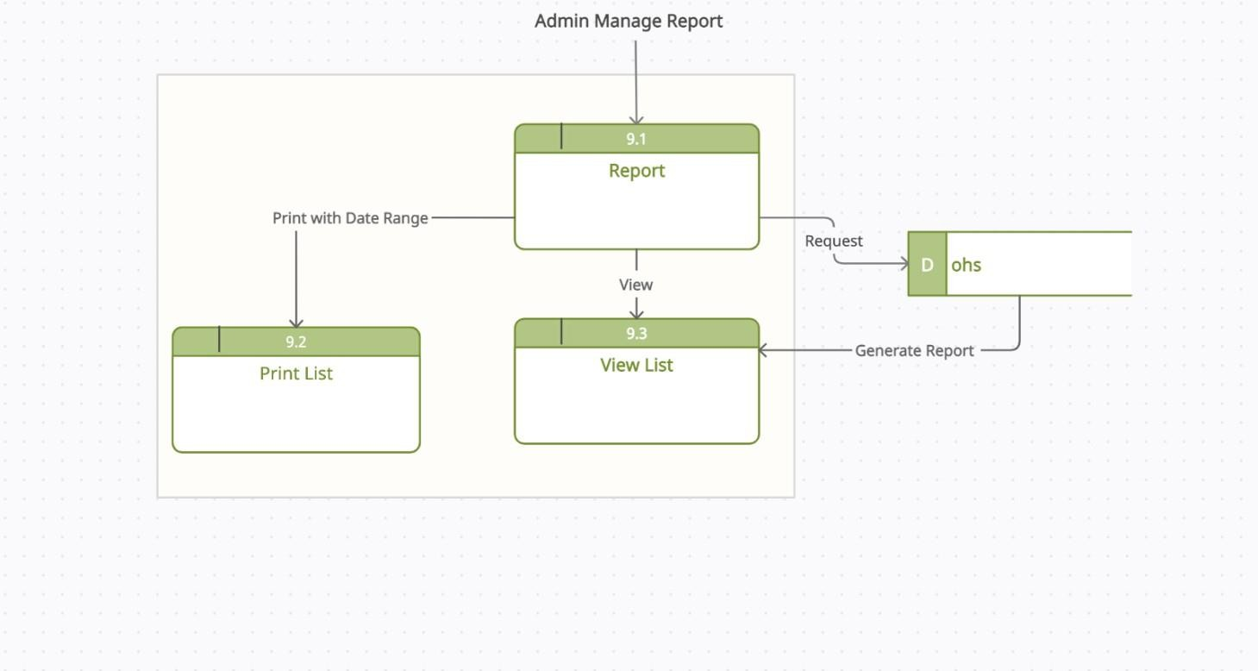

**Figure 8.30- level 2 process 9**

**Entity Relationship Diagram**

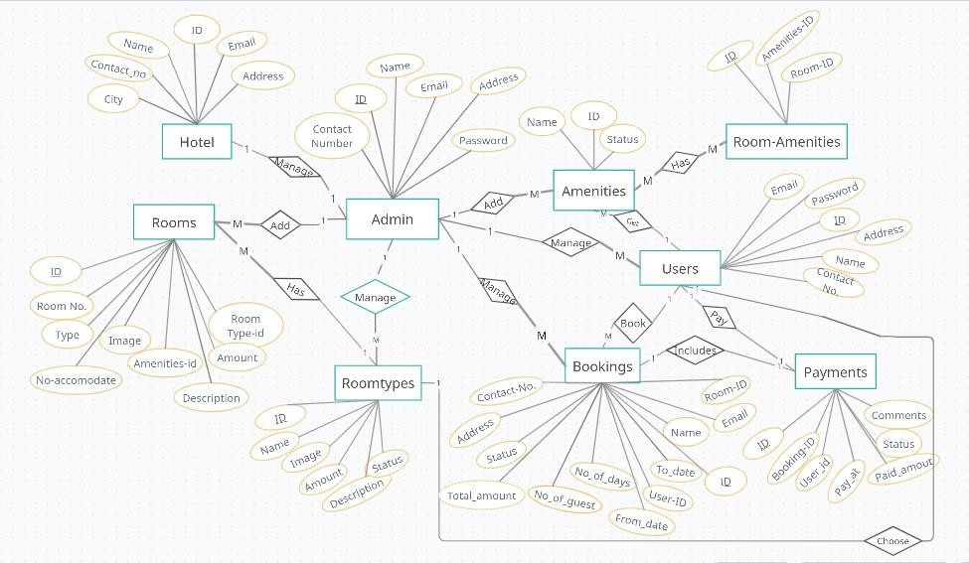

**Figure 8.31- ERD for online hotel booking system**

# Chapter-9 Quality Assurance

### System Quality Management:

A strategy for software testing integrates software test case design methods into a well- planned series of steps that result in the successful construction of a software. The strategy provides a road map that describes the steps to be conducted as a part of testing.

The quality of software is assessed by a number of criteria. External quality is what a user experiences when running the software in its operational mode. Internal quality refers to aspects that are code dependent and that are not visible the end-user. External quality is critical to the user, while internal quality is meaningful to the developer only. Some quality criteria are objective and can be measured accordingly. Some quality criteria are subjective and are therefore captured with more arbitrary measurement. There are mainly two types of quality:

External quality:

* + - Features
    - Speed
    - Space
    - Network usage
    - Stability
    - Robustness
    - Ease-of-use
    - Determinism
    - Back-compatibility
    - Security
    - Power consumption

Internal quality:

* + - Test coverage
    - Testability
    - Portability
    - Thread-safeness
    - Conciseness
    - Maintainability
    - Documentation
    - Legibility
    - Scalability

#### Software Quality Management Process

* + - * The aim of Software Quality Management (SQM) is to manage the quality of software and development and of its development process.
      * A quality product is one which meets its requirements and satisfies the user.
      * A quality culture is an organization environment where quality is viewed as everyone’s responsibility.

Some of the specific SQM processes defined in standard:

#### Quality Assurance Process:

Quality Assurance makes sure the project will be completed based on the previously agreed specifications, standards and functionality required without defects and possible problems. It monitors and tries to improve the development process from the beginning of the project to ensure this. It is oriented to “prevention”.

#### Verification and Validation Process:

In software project management, software testing and software engineering, verification and validation (V&V) is the process of checking that a software system meets specifications and that it full it’s indeed purpose. It is normally the responsibility of software testers as a part of the software development lifecycle.

In the verification, a client will either view the software or see it implemented in a test situation. At this point it is imperative that the client who is needed of the software is able to ascertain that this software is hitting all the parameters initially requested or desire. Only when this assurance is made should the next part of the verification and validation process be started. While this is not the last chance to ‘tweak’ the software into doing the tasks required it is part of the last steps before a project is completed and in being too quick to approve the software as this could cause problems later and could also result in more money required for the software later changes.

The next step of verification & validation of software is simple. Client Company will approve the software and validate it as being what is required. This stage usually means a systematic checking off various requirements. While this might sound tedious, it is necessary part of the procedure to insure that again, the result is exactly to the specifications of all concerned. The entire verification and validation process are part of a normal sequence of quality control for software.

### System Testing

System testing is a method of monitoring and assessing the behavior of the complete and fully integrated software product or system, on the basis of pre-decided specifications and functional requirements. It is a solution to the question “whether the complete system functions in accordance to its pre-defined requirements?”

It’s comes under system testing i.e. only external working features of the software are evaluated during this testing. It does not require any internal knowledge of coding, programming, design etc. and is completely based on users- perspective.

#### System Testing Methodology

A software product is termed ready only after going through various stages of software testing. From its internal structure and code to its basic features, functionality, performance and more, every major and minor component of the software is tested to guarantee its quality as well as its effectiveness.

Two Category of Software Testing:

* + - * Black Box Testing
      * White Box Testing

#### Black Box Testing:

Black-box testing which is also known as behavioral testing focuses on the functional requirements of the software. It enables the software engineer to derive sets of input conditions that will fully exercise all functional requirements for a program. The black-box testing method will be applied to test the modules of Human Resource Manage System.

#### White Box Testing:

White-box testing, also known as glass-box testing is a test case design method that uses the control structure of the procedural design to derived test cases. Using white-box testing methods, a software engineer can derive test cases that,

1. Guarantee that all independent paths within a module have been exercised at least once.
2. Execute all logical decisions on their true and false sides.
3. Execute all loops at their boundaries and within their operational bounds
4. Exercise internal data structures to ensure their validity.

The modules that contain some complex calculations or decision making code such as check the availability of the library item will be tested using white-box method.

* 1. **System Testing**

System Testing is the testing of a complete and fully integrated software product. Usually, software is only one element of a larger computer-based system. Ultimately, software is interfaced with other software/hardware systems. System Testing is actually a series of different tests whose sole purpose is to exercise the full computer-based system.

**Table 9.1: System Testing Scenario 1**

|  |  |
| --- | --- |
| **Testing scenario, No:1** | |
| Scenario | User Registration |
| Input’s | Name, email, phone, password ,address |
| Desired Output’s | When enter all basic info correctly, new  guest will be registered in the system. |
| Actual Output’s | For new guest registration my system work  Correctly |
| Verdict | Getting result from Desired Output’s and Actual  Output’s decided this system is successful for new customers’ registration. |

**Table 9.2: System Testing Scenario 2**

|  |  |
| --- | --- |
| **Testing scenario, No:2** | |
| Scenario | User Login testing scenario of my system |
| Input’s | E-mail, password of User for Login |
| Desired Output’s | When enter E-mail, password then get access  level defines. |
| Actual Output’s | For login my system works correctly |
| Verdict | Getting result from Desired Output’s and Actual Output’s decided this system is successful for  login. |

**Table 9.3: System Testing Scenario 3**

|  |  |
| --- | --- |
| **Testing scenario, No:3** | |
| Scenario | Admin can add, view, update and delete room types, amenities . |
| Input’s | Request to manage room types, amenities .. |
| Desired Output’s | Show the information to the admin |
| Actual Output’s | For showing all records my system works correctly. |
| Verdict | The process is worked correctly and successfully. |

**Table 9.4: System Testing Scenario 4**

|  |  |
| --- | --- |
| **Testing scenario, No:4** | |
| Scenario | Admin can approve, disapprove and cancel booking for  users |
| Input’s | Request to manage booking |
| Desired Output’s | Show information to the admin |
| Actual Output’s | For showing all booking list and details my system work  correctly. |
| Verdict | The process is worked correctly and successfully. |

**Table 9.5: System Testing Scenario5**

|  |  |
| --- | --- |
| **Testing scenario, No:5** | |
| Scenario | Admin can generate, view reports |
| Input’s | Request to view report |
| Desired Output’s | Show the list of booking report of specified time |
| Actual Output’s | For showing all correct records my system  work correctly. |
| Verdict | The process is worked correctly and successfully. |

**Table 9.6: System Testing Scenario6**

|  |  |
| --- | --- |
| **Testing scenario, No:6** | |
| Scenario | User can request and view booking |
| Input’s | Request to book rooms |
| Desired Output’s | Show the list of requested, confirmed and canceled  booking list |
| Actual Output’s | For showing all correct records my system  work correctly. |
| Verdict | The process is worked correctly and successfully. |

**Table 9.7: System Testing Scenario7**

|  |  |
| --- | --- |
| **Testing scenario, No:7** | |
| Scenario | User can send payments |
| Input’s | User will fill the payment fields |
| Desired Output’s | User will see the booking confirmation |
| Actual Output’s | For showing all correct records my system  work correctly. |
| Verdict | The process is worked correctly and successfully. |

# Chapter-10 Conclusion

### Preface

Today is the age of modern science and information and online communication, which is critical to development of more effective operational and management process. My earnest thanks, gratitude and salutations to these wonderful people from the deep down inside my heart.

### Practicum and Its value

In career development – as with most life issues – there is direct relationship between effort and reward. To me, practicum can be as a transition from engineering college study life to a real world workplace through hands on experience of engineering practices.

There are several major advantages for students completing a guided Practicum:

* + 1. Demonstration of practical application of studies
    2. Development of deeper skills in the selected research area
    3. Increases employability

Practicum does not offer hands-on experience only but also the trait of “coping up” in the society. Meeting with different types of people and encountering situations gives practical orientation to life. There are many more upright issues of practicum, which only the person experiencing it can sense and believe.

It is the gateway to the professional life, bridge between theoretical and practical knowledge. Now these days, engineering job recruiters no longer consider high grand’s rather they value the particle working experience, for which practicum proves to be vantage for the fresh entry level engineers in the job market.

Student of College of Engineering and Technology (CEAT) at IUBAT go for this practicum program carrying 6 credit hours weight, which goes for a semester long and usually after the completion of the course work. A report submitted after the completion of the practicum followed by a presentation and a comprehensive examination on the overall four years education.

### Conclusion

The main goal of this report to describe a system that make a Project to finish more efficiently. Guest can check the available room. In this project guest can choose and then book their room through online. Whenever they book any room that room will be unavailable for that particular date for others.

The biggest experience working at Kodeeo Limited is indeed being a part of designing and implementing software. I have learnt a lot of new things which was so much unknown to me. I have also learnt some technical issues which help to do better in future life. The following indicator will indicate some of my technical issue which I have learnt and implemented from this project. I have learned the designing strategy of a web-based project. I have analyzed strategy of a web-based project. While developing and the documentation of my project I have learnt a lot about software development as well how the report is to be done. I used Laravel as the back-end language to develop the system. I used HTML 5, CSS 3, bootstrap 4.5, JavaScript, jQuery as the front-end language to design the interface. For database and software interaction I have used MySQL. I tried my best level to implement a user- friendly interface so that it can be used without putting much effort. I have gone through quite a lot of analysis before starting to develop the project. It helped me to get a better view of the scenario. It can be developed in different ways with other features as well. It could make the system more efficient. I have further plan to develop those features in near future.

### Limitations

* Online payment is not possible
* The system can’t send any email confirmation

### Future Plan

This project is in initial stage. So, we will include more features for this system and based on user’s need we will maintain this system and give them support. Some more features are stated below:

* Geographical map
* Advance payment through online and refund option
* With one email can book many rooms
* Include invoice

# Bibliography

### Bibliography

*Hotel Sea Crown*. (2004). Retrieved from Hotel Sea Crown: <http://hotelseacrownbd.com/>Limited, M. (2021). *Joltarongo*. Retrieved from Joltarongo: https://joltarongo.com

*Long Beach Suites.* (2018). Retrieved from Long Beach Suites

Dhaka: https://longbeachsuitesbd.com/

*Youtube.com* **<**<https://www.youtube.com/watch?v=teDb_h6PT8w&t=1934s>>