Homomorphic Encryption Based Video Copy Detection in Multi View Videos Stored in a Cloud
Cloud services provides heavy computation or storage resources at cheaper cost so all e-commerce or social media applications are migrating to cloud servers. Sharing data in social media often increased storage cost due to duplicate video and comparing those videos in plain format can leak sensitive data from the video. To overcome from above issue we are employing Homomorphic algorithm which can perform computation on encrypted data without decryption so sensitive data will not be leak and duplicate video comparison can also be done by doing comparison on encrypted data.
In below screen showing python code which is comparing videos directly on encrypted data
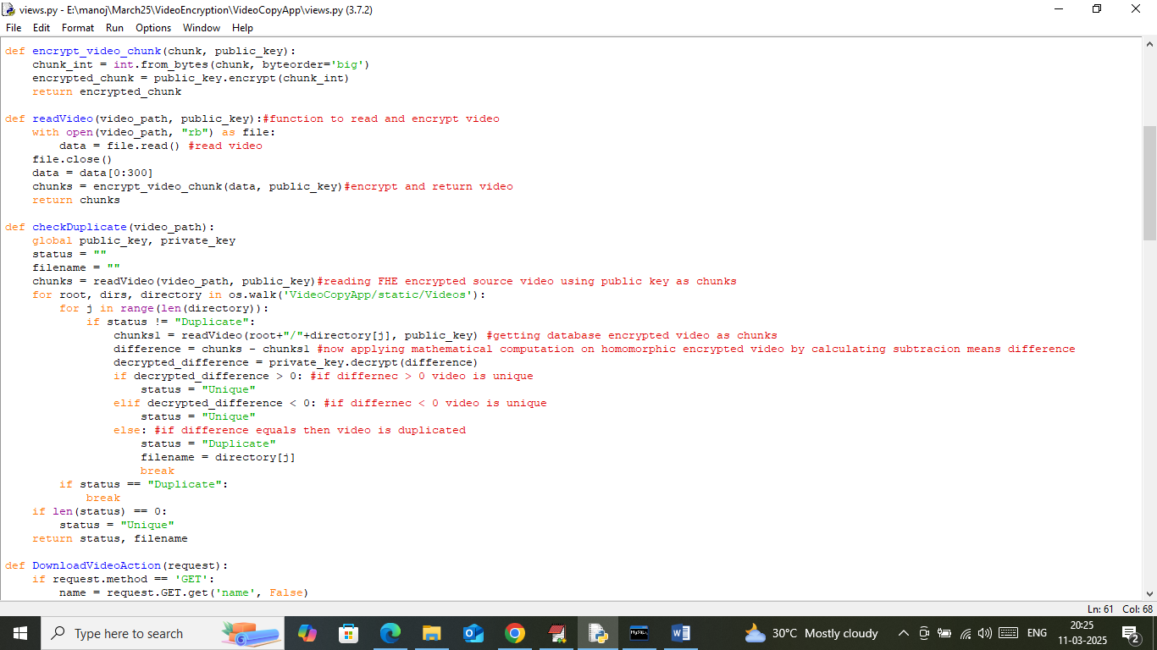
In above screen read red colour comments to know about Homomorphic encryption of videos and then comparing user uploaded videos with database videos by directly using encrypted data.
To implement this project we have designed following modules
- New User Sign up: user can sign up with the cloud server
- User Login: user can login to cloud server
- Upload & Detect Video Copy: using this module user can upload any video and then cloud server will encrypt video using Fully Homomorphic encryption and then encrypted video will be compared with existing cloud videos to detect duplication. If duplicate video found then cloud will not save that video and make a mark or link to exist video.
- Download video: using this module user can download available video from the cloud
SCREEN SHOTS
To run project double click on ‘runWebServer.bat’ file to start cloud server and then will get below page
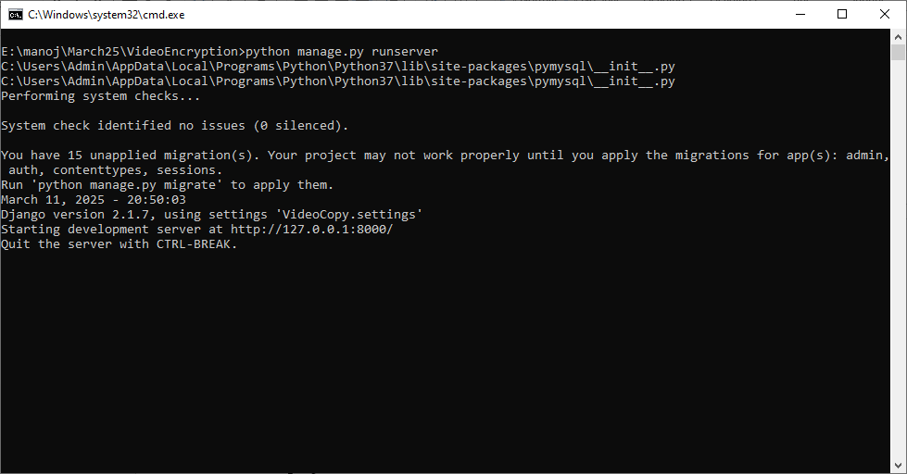
In above screen server started and now open browser and enter URL as http://127.0.0.1:8000/index.html and then press enter key to get below page
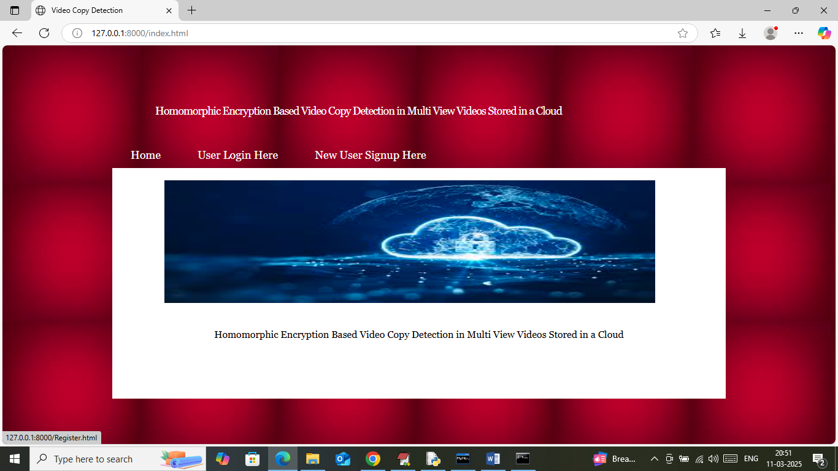
In above screen click on ‘New User Sign up’ link to get below page

In above screen user is entering sign up details and then press button to get below page
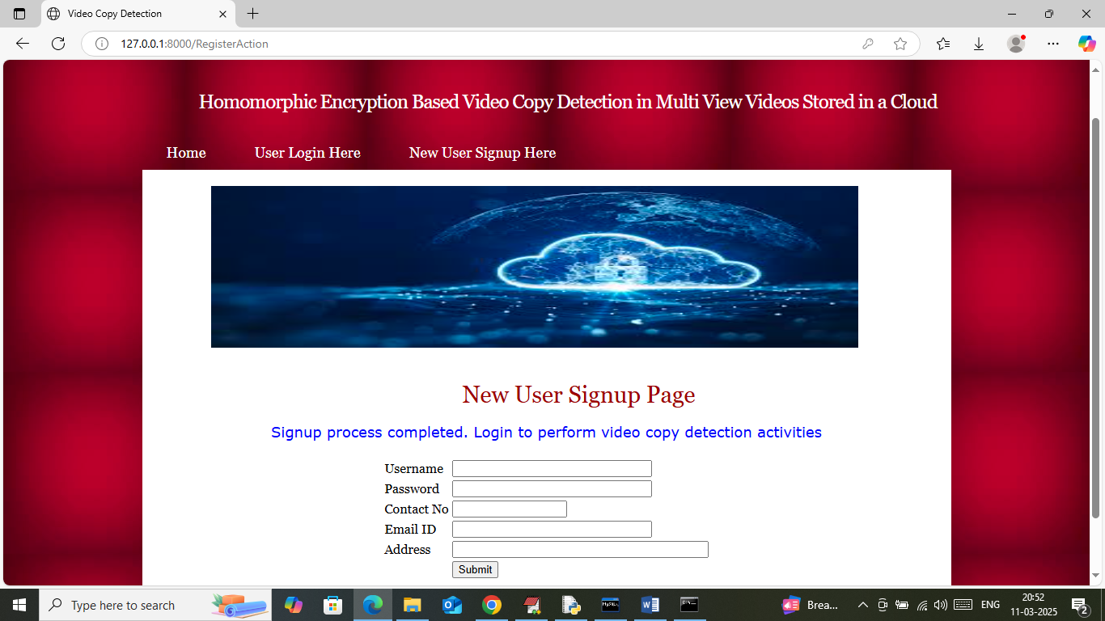
In above screen sign up completed and now click on ‘User Login’ link to get below page
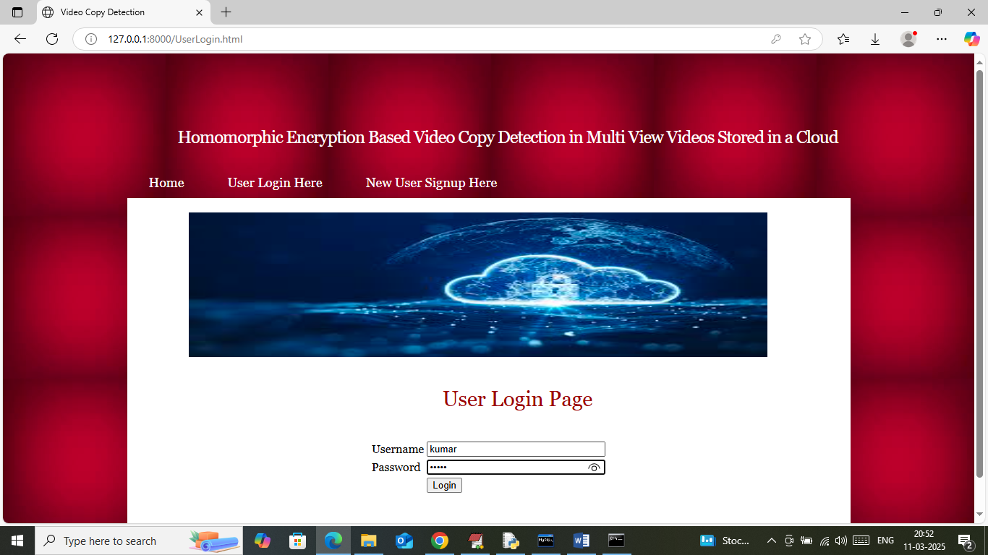
In above screen user is login and after login will get below page
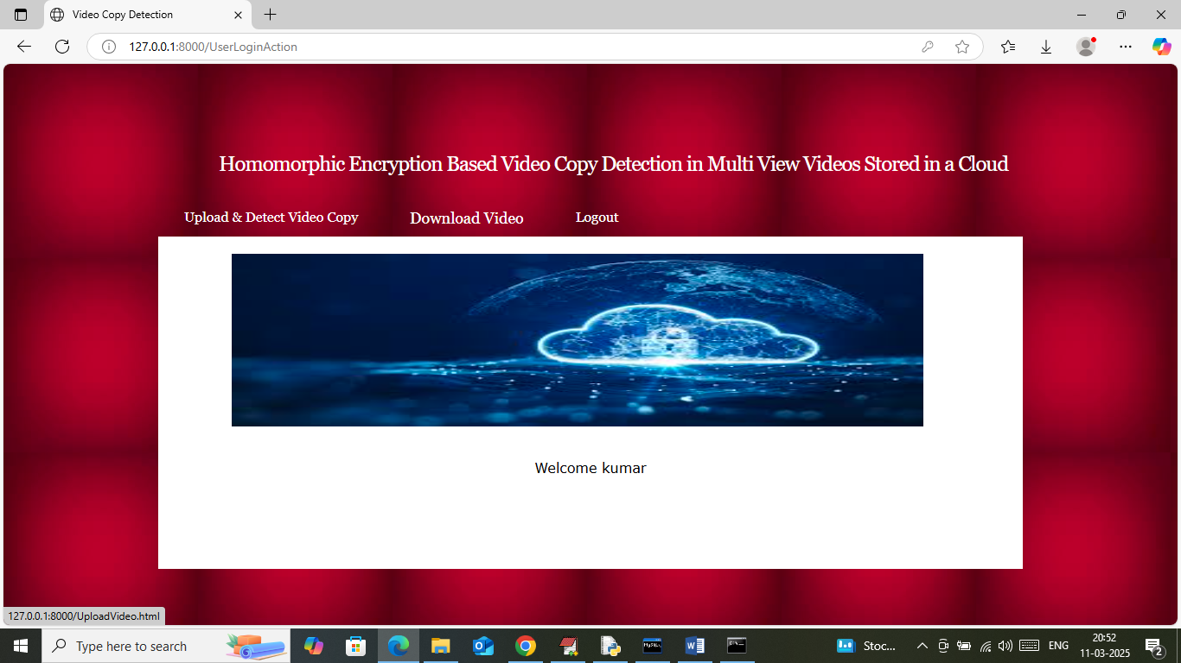
In above screen user can click on ‘Upload & Detect Video Copy’ link to get below page
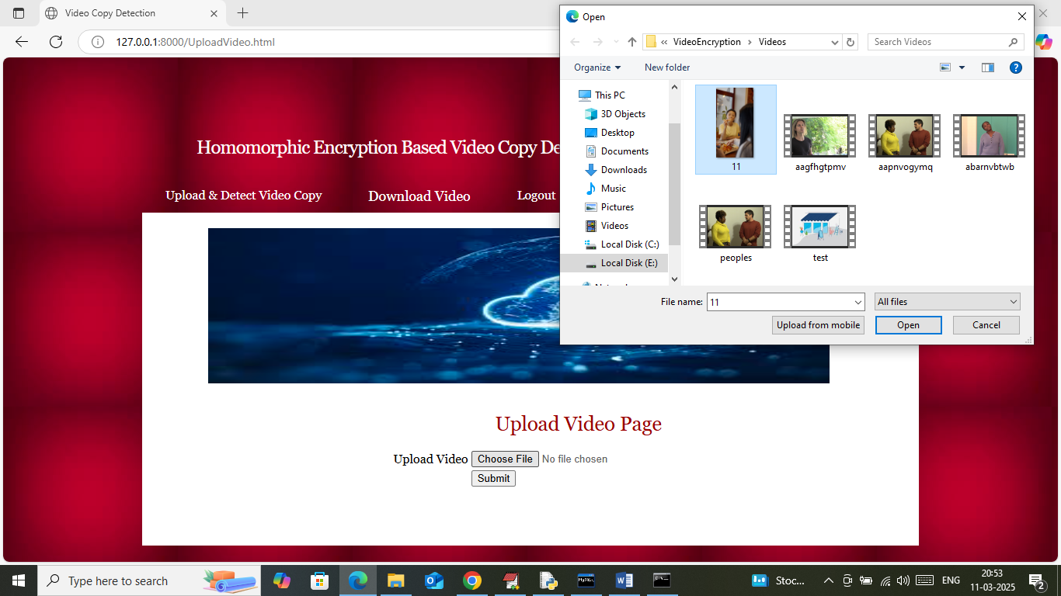
In above screen selecting and uploading video and then click on buttons to get below page
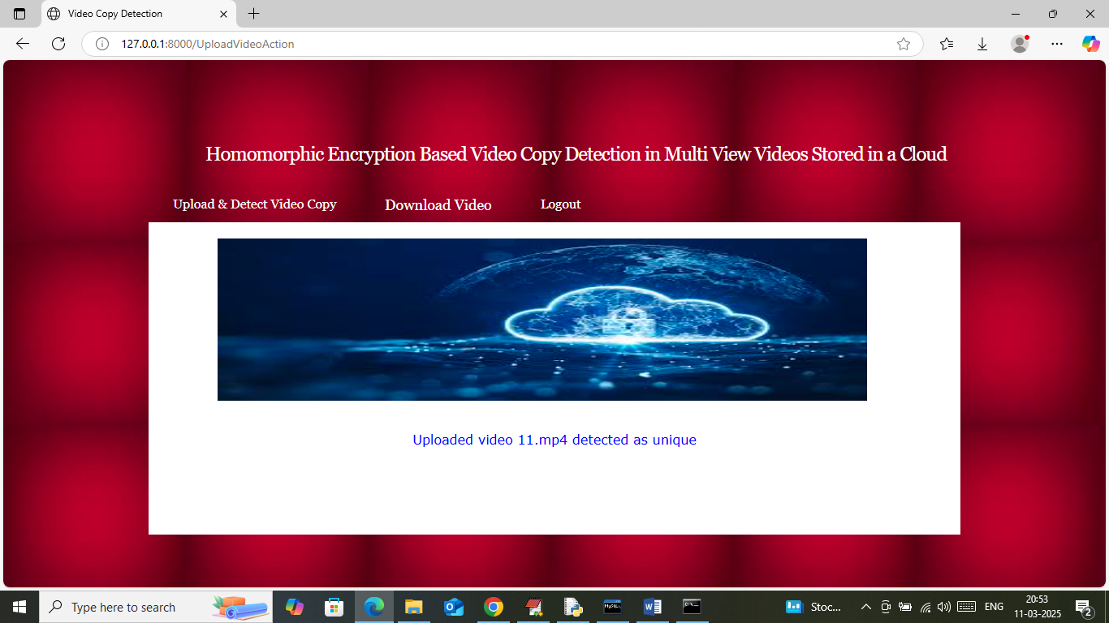
In above screen in blue text can see video detected as ‘Unique’ and similarly upload some other
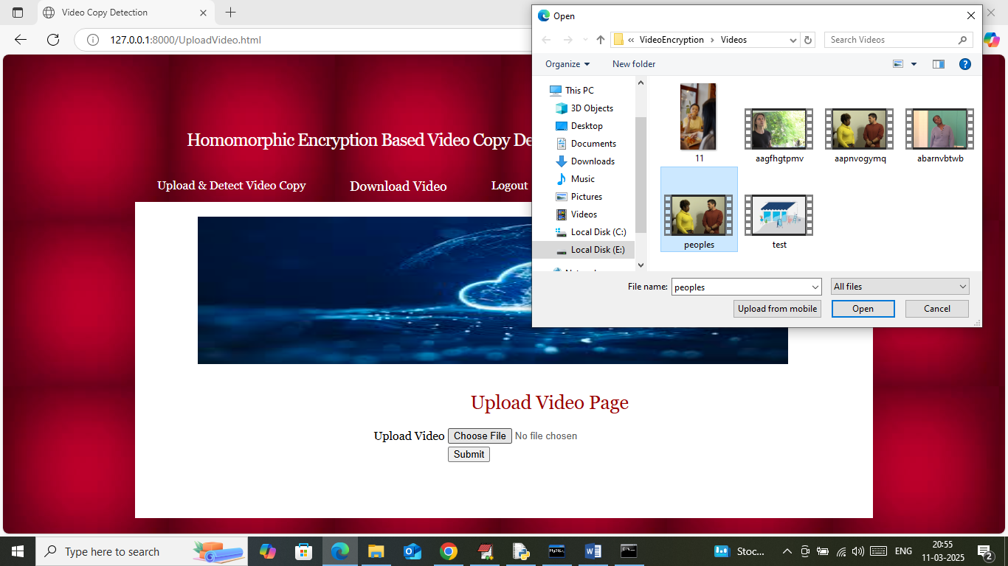
In above screen uploading another video and below is the output
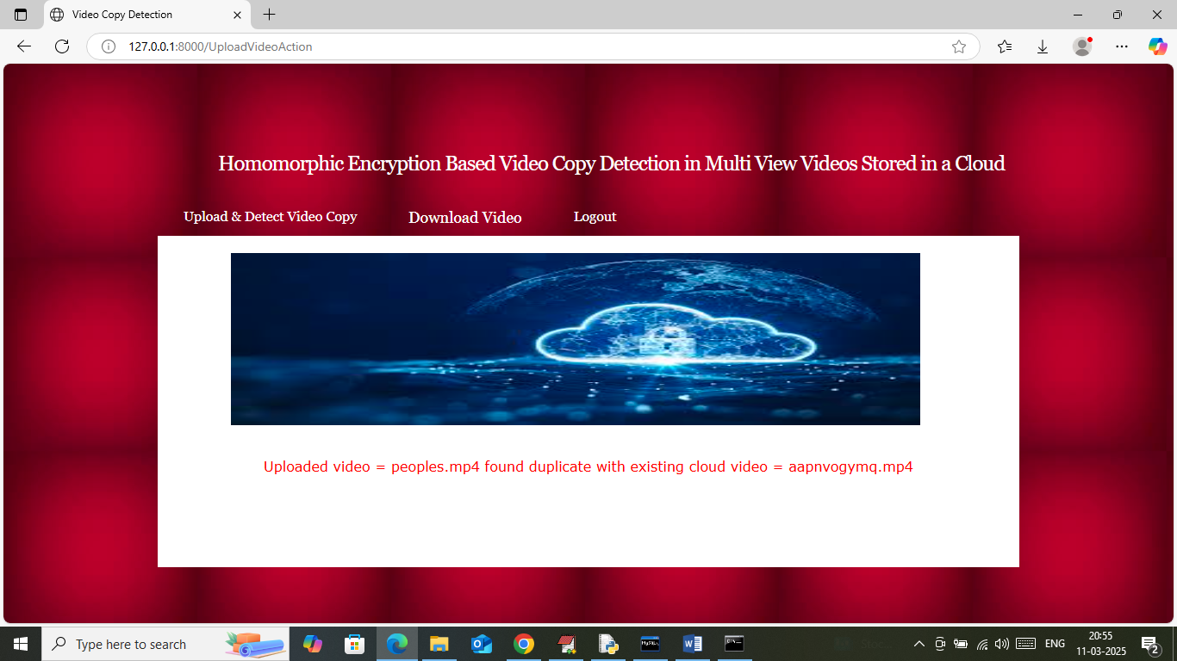
In above screen in red text can see uploaded video matched with cloud video and duplicate found so that video will not be saved and cloud space will be reduced and detection will be possible without decrypting and leaking sensitive data. Now click on ‘Download Video’ link to get below page
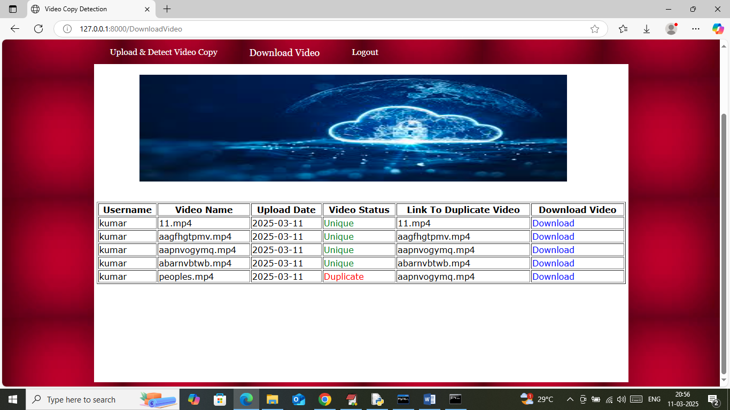
In above screen cloud will display list of video with status weather video is unique or duplicate and user can click on ‘Download’ link to download desired video.
So by using above application we can detect duplicated video copy using Homomorphic encryption

