HOMOMORPHIC ENCRYPTION BASED VIDEO COPY DETECTION IN MULTI VIEW VIDEOS STORED IN A CLOUD

Abstract:
With the exponential growth of video content shared and stored on cloud platforms, securing copyrighted videos and detecting unauthorized copies has become crucial. Multi-view videos, captured from multiple angles simultaneously, add complexity to this challenge due to large data volumes and varied perspectives. Traditional copy detection methods often fail to preserve privacy, especially when outsourced to untrusted cloud environments. To address this, we propose a homomorphic encryption-based video copy detection system that ensures privacy-preserving processing and efficient detection. Homomorphic encryption allows operations on encrypted data, enabling the cloud to perform similarity comparisons without accessing the original video content. This approach maintains the confidentiality of the videos while enabling robust and accurate detection of copied content across different views. The proposed system enhances both security and effectiveness in identifying video copies in a cloud-based environment.

Existing System:
The existing systems for video copy detection typically rely on feature extraction and matching mechanisms performed either locally or in the cloud. These systems analyze spatial and temporal features of videos to identify duplicates or near-duplicates. Multi-view video data adds complexity due to the increased amount of information and the diversity in camera angles. Existing solutions often involve plaintext processing, which requires that video data be decrypted in the cloud for comparison and indexing purposes.
Furthermore, most existing systems are designed for single-view video analysis and fail to adequately process or compare multi-view content. They do not support privacy-preserving operations and are vulnerable to data breaches or misuse when storing or processing sensitive or copyrighted videos in cloud servers.

Existing System Disadvantages:
• Lack of Privacy: Videos must be decrypted in the cloud for processing, exposing them to potential misuse or unauthorized access.
• Single-View Limitations: Inefficient handling of multi-view video data due to limited feature fusion and perspective comparison.
• High Computational Cost: Feature extraction and comparison for high-resolution videos are computationally expensive.

Proposed System:
The proposed system introduces homomorphic encryption to perform privacy-preserving video copy detection for multi-view videos stored in the cloud. In this approach, videos are preprocessed on the user side to extract robust, encrypted features using homomorphic encryption. These encrypted features are then uploaded to the cloud, where copy detection is performed directly on encrypted data, without revealing the actual content to the server.
The system utilizes multi-view feature alignment techniques to integrate information from various perspectives, enhancing the robustness of detection. By leveraging the mathematical properties of homomorphic encryption, operations such as similarity checking and feature comparison can be securely outsourced to the cloud, maintaining data confidentiality throughout the process.
Proposed System of Advantages:
• Privacy-Preserving: The cloud never accesses raw video content, ensuring end-to-end data confidentiality.
• Supports Multi-View Analysis: Capable of accurately detecting copies across various camera angles and views using integrated feature models.

System Architecture:

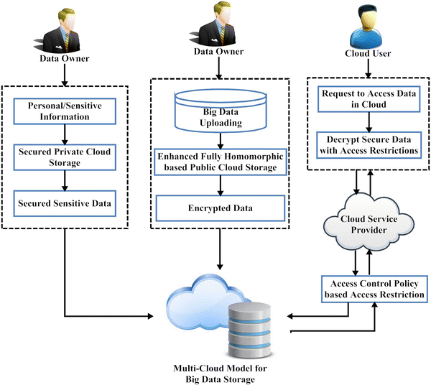

SYSTEM REQUIREMENTS:

HARDWARE REQUIREMENTS:

• System : Pentium IV 2.4 GHz.
• Hard Disk : 40 GB.
• Ram : 512 Mb.

SOFTWARE REQUIREMENTS:

• Operating system : - Windows.
• Coding Language : python.

