

**American International University- Bangladesh**

**CSC 2209: Object Oriented Programming 1 (JAVA)**

**CO1 Evaluation**

**Project Summary Report**

**Fall 2019-20**

**Group No: Section : F**

**Project Title: HOSPITAL MANAGEMENT SYSTEM**

|  |  |
| --- | --- |
| Student Name | Student Id |
| OMI, KAZI SHAHRIAR ISLAM | **17-35824-3** |
| ANOY, SHARAIN ISLAM | **17-34184-1** |
| MAHMUD, SHARIF | **17-33205-1** |

**Introduction:**

The project Hospital Management System is for computerizing the working in a hospital. The software takes care of all the requirements of an average hospital and is capable to provide easy and effective storage of information related to patients that come up to the hospital. The purpose of the project is to computerize the Front Office Management of Hospital to develop software which is user friendly, simple, fast, and cost – effective. It deals with the collection of patient’s information, diagnosis details, etc.

**User Category:**

There are three types of Users here. They are:

* Admin
* Doctor
* Receptionist

**Feature List:**

In this project the “**Admin**” has the following features:

* Login to the system by entering valid username and password
* Access Patient, Doctor and Receptionist information
* Create Doctor, Receptionist account for the system
* Add Patient, Doctor, Receptionist to the system
* Update Patient, Doctor, Receptionist information in the system
* View Patient, Doctor, Receptionist information in the system
* Delete Patient, Doctor, Receptionist information from the system

In this project the “**Receptionist**” has the following features:

* Login to the system by entering valid username and password
* Add Patient to the system
* Update patient information in the system
* Delete Patient from the system
* Set appointment for the patients

In this project the “**Doctor**” has the following features:

* Login to the system by entering valid username and password
* View Appointments

**GUI Description:** Dashboard view: Admin, Doctor, Receptionist can login from here.

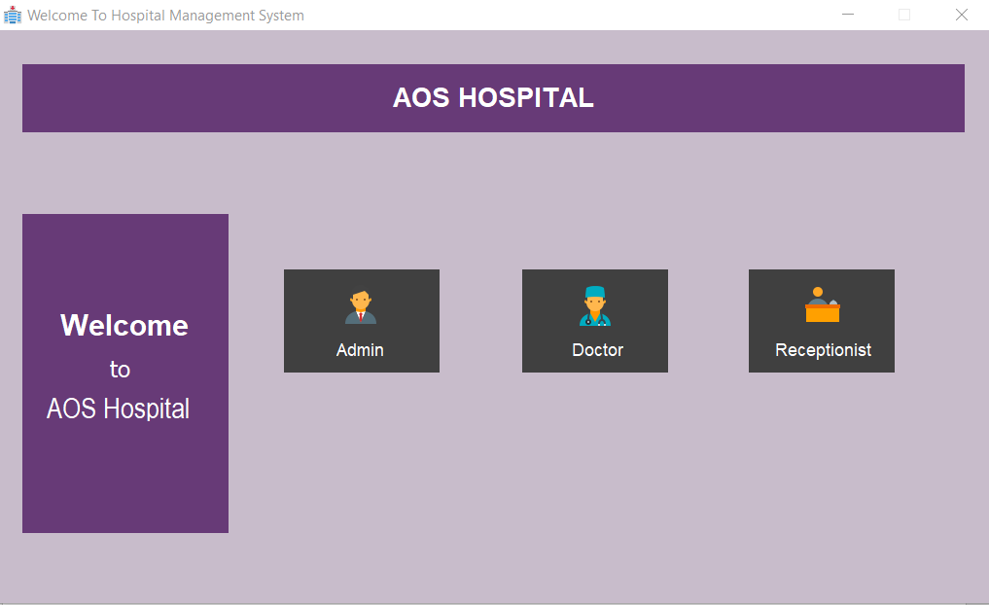

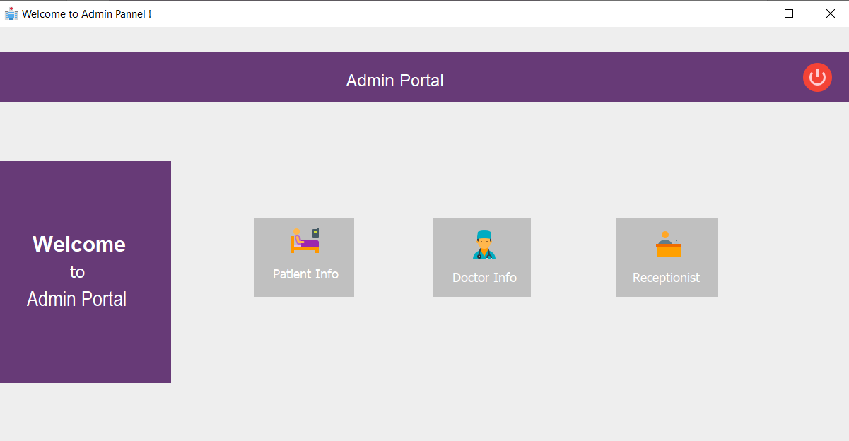

Admin can access patient, doctor and Receptionist information.

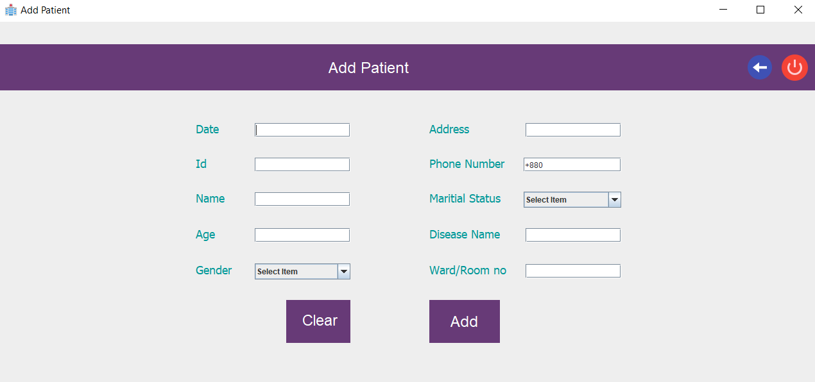

Admin can add patient and view patient information.

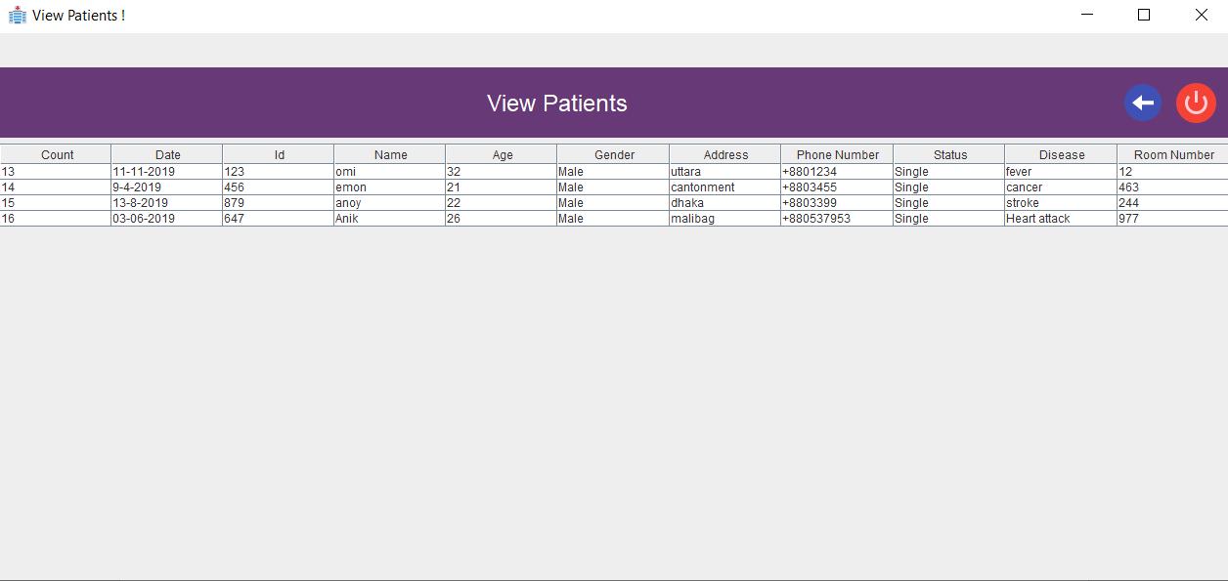

**Database Table Description:**

1. ADMIN TABLE 2. APPOINTMENT TABLE

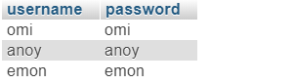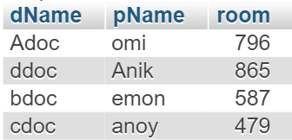

3. DOCTOR TABLE

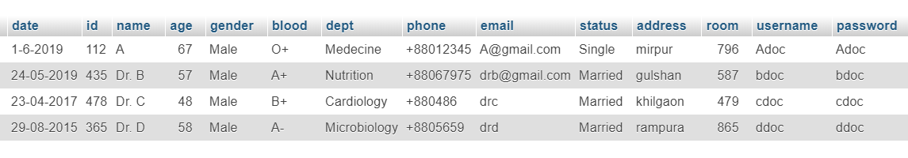

4. PATIENT TABLE

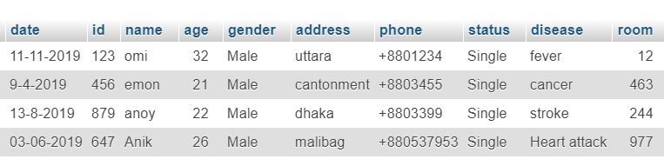

5. RECEPTIONIST TABLE

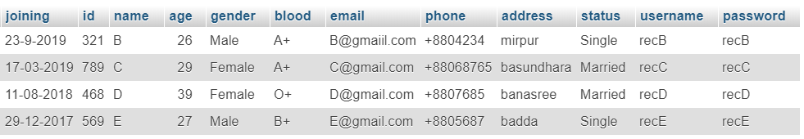

**Class Diagram:**

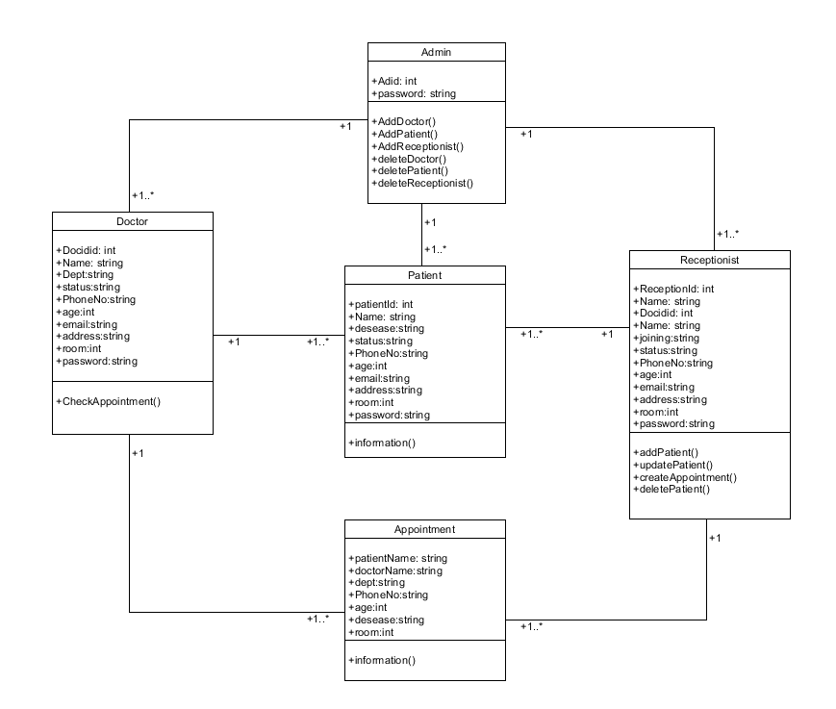

**Tools Used:**

To develop this project we have used the following:

* Netbeans 8.1
* Wampserver 3.1.4
* Mysql
* Umlet for class diagram

**OOP and Java Concepts Used:**

* java swing
* exception
* inheritance
* interface

**Impact of this Project:**

Hospitals currently use a manual system for the management and maintenance of critical information. The current system requires numerous paper forms, with data stores spread throughout the hospital management infrastructure. Often information is incomplete or does not follow management standards.

The proposed system is designed for any hospital to replace their existing manual paper-based system. The new system is to control the information of patients. Room availability, staff and operating room schedules and patient invoices. These services are to be provided in a efficient, cost effective manner.

**Limitations and Possible Future Improvements:**

Taking into account all the mentioned details, we can make the conclusion that the hospital management system is the inevitable part of the lifecycle of the modern medical institution. It automates numerous daily operations and enables smooth interactions of the users. Developing the hospital system software is a great opportunity to create the distinct, efficient and fast delivering healthcare model. Implementation of hospital management system project helps to store all the kinds of records, provide coordination and user communication, implement policies, improve day-to-day operations, arrange the supply chain, manage financial and human resources, and market hospital services.