**AMERICAN INTERNATIONAL UNIVERSITY–BANGLADESH (AIUB)**

FACULTY OF ELECTRICAL AND ELECTRONIC ENGINEERING

**EEE 4103:** Microprocessor and Embedded Systems Laboratory

Fall 2023-2024

**Section:** L, Group:

**LAB REPORT OEL:**

Implementation of automated door using Arduino UNO.

**Supervised By**

**PROTIK PARVEZ SHEIKH**

**Group members:**

|  |  |  |
| --- | --- | --- |
| **Name** | **ID** | **Department** |
| HOSSAIN, SAKIB | 21-45388-3 | CSE |
| JOY, BADHON NATH | 21-45390-3 | CSE |
| NAWAR, MARIA | 21-45394-3 | CSE |
| TASNIM, JANNAT ARA | 21-45667-3 | CSE |
| PRITY, SUBRINA ISLAM | 21-45813-3 | CSE |

**Date of Performance:** 09/12/23

**Title:** Implementation of automated door using Arduino UNO.

**Introduction:** The implementation of an automated door using Arduino UNO integrates a sonar sensor (HCSR04) to measure distance. When the distance is within a predefined range, the system activates an LED, simulating a door opening mechanism. This project showcases the application of Arduino in creating a simple yet effective automated entry system.

**Apparatus:**

* Arduino IDE (2.0.1 or any recent version)
* Arduino UNO (R3) board
* Sonar Sensor (HCSR04)
* Breadboard
* LEDs
* Jumper Wires.
* OLED display.

**Circuit Diagram:**

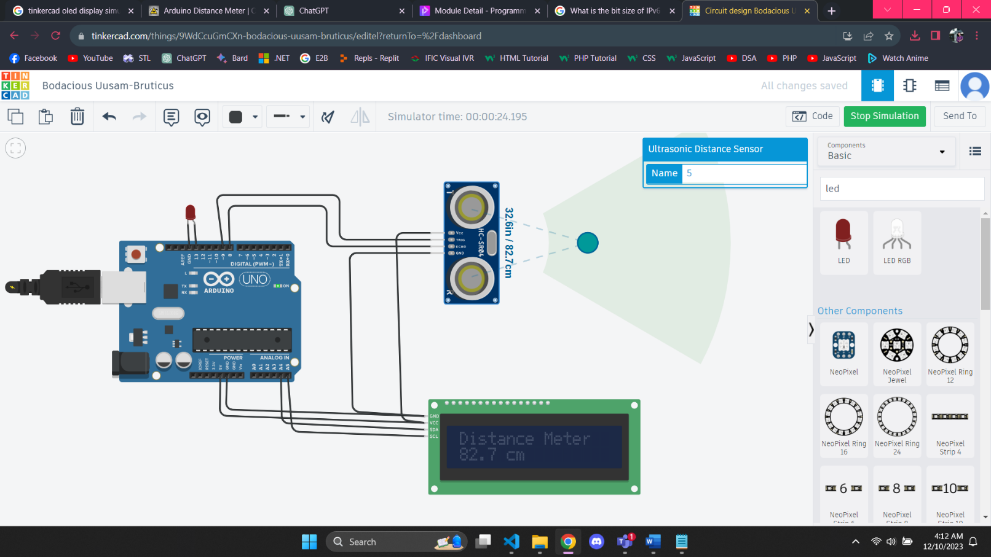

**Code:**

#include <SPI.h>

#include <Wire.h>

#include <Adafruit_GFX.h>

#include <Adafruit_SSD1306.h>

#define trigPin 9

#define echoPin 8

#define LED_PIN 13

#define OLED_RESET 4

Adafruit_SSD1306 display(OLED_RESET);

void setup() {

Serial.begin (9600);

pinMode(trigPin, OUTPUT);

pinMode(echoPin, INPUT);

display.begin(SSD1306_SWITCHCAPVCC, 0x3C); //initialize with the I2C addr 0x3C (128x64)

display.clearDisplay();

pinMode(LED_PIN, OUTPUT);

}

void loop() {

float duration;

float distance_cm;

float distance_in;

digitalWrite(trigPin, LOW);

delayMicroseconds(2);

digitalWrite(trigPin, HIGH);

delayMicroseconds(10);

digitalWrite(trigPin, LOW);

duration = pulseIn(echoPin, HIGH);

distance_cm = (duration/2) / 29.1;

distance_in = (duration/2) / 73.914;

display.setCursor(25,0); //oled display

display.setTextSize(1);

display.setTextColor(WHITE);

display.println("Distance Meter");

display.setCursor(10,20); //oled display

display.setTextSize(2);

display.setTextColor(WHITE);

display.println(distance_cm);

display.setCursor(90,20);

display.setTextSize(2);

display.println("cm");

display.setCursor(10,45); //oled display

display.setTextSize(2);

display.setTextColor(WHITE);

display.println(distance_in);

display.setCursor(90,45);

display.setTextSize(2);

display.println("in");

display.display();

delay(500);

display.clearDisplay();

Serial.println(distance_cm);

Serial.println(distance_in);

if (distance_cm <= 10)

{

digitalWrite(LED_PIN, HIGH);

}

else

{

digitalWrite(LED_PIN, LOW);

}

}

**Simulation:**



Fig: The LED turns off at a distance greater than 10 cm.

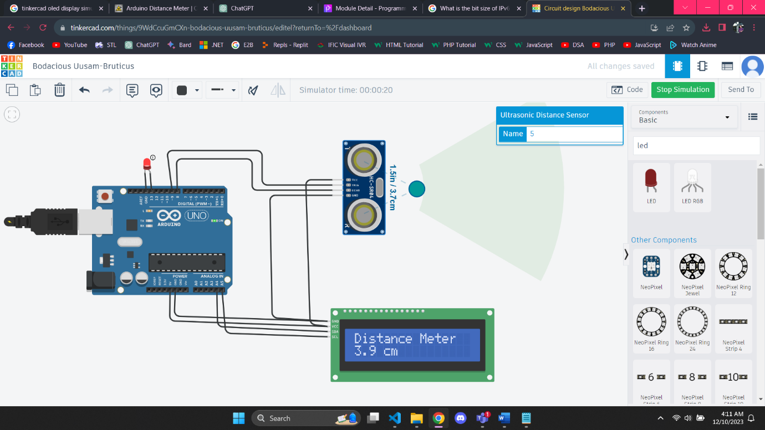

Fig: The LED turns on at a distance less than equal 10 cm.

**Hardware Result:**

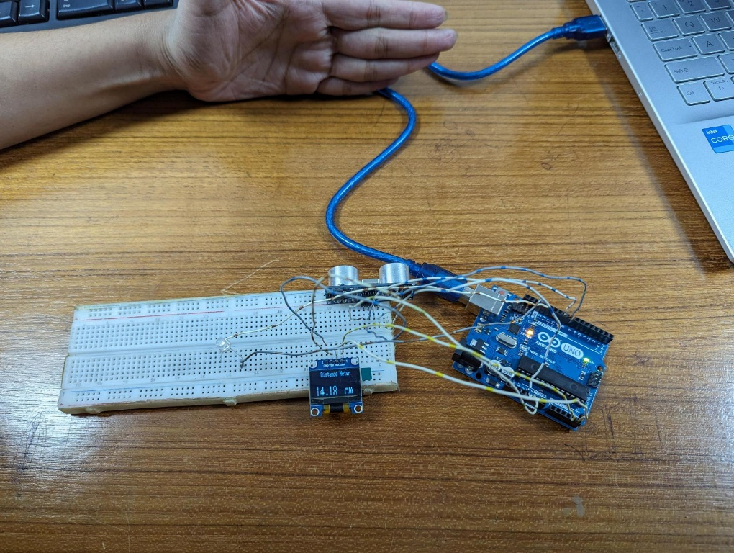

Fig: The LED turns off at a distance greater than 10 cm.

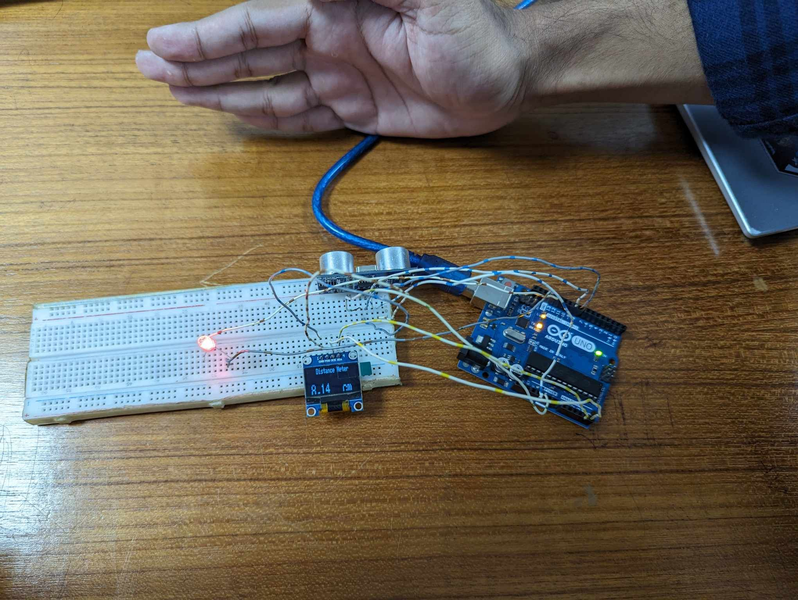

Fig: The LED turns on at a distance less than equal 10 cm.

**Discussion & Conclusion:**

The automated door implementation using Arduino UNO and a sonar sensor proves to be a practical and versatile project. The system accurately measures distances and triggers an LED when someone is within a specified range. This project demonstrates the potential for Arduino-based solutions in creating efficient and cost-effective automated systems for various applications, including security and convenience. Further enhancements could involve integrating additional sensors or expanding the automation capabilities for broader functionality.

**Reference(s):**

[1] Arduino IDE, <https://www.arduino.cc/en/Main/Software>accessed on May 3, 2019.

[2] Arduino and Proteus Library, [https://etechnophiles.com/add-simulate-ultrasonic-sensorproteus-2018-edition/](https://etechnophiles.com/add-simulate-ultrasonic-sensor-proteus-2018-edition/) accessed on May 3, 2019.

[3] Ultrasonic Distance Sensor in Arduino With TinkerCad <https://www.instructables.com/id/Ultrasonic-Distance-Sensor-Arduino-Tinkercad/>accessed on May 3, 2019.