Columns changed from categorical to numerical:
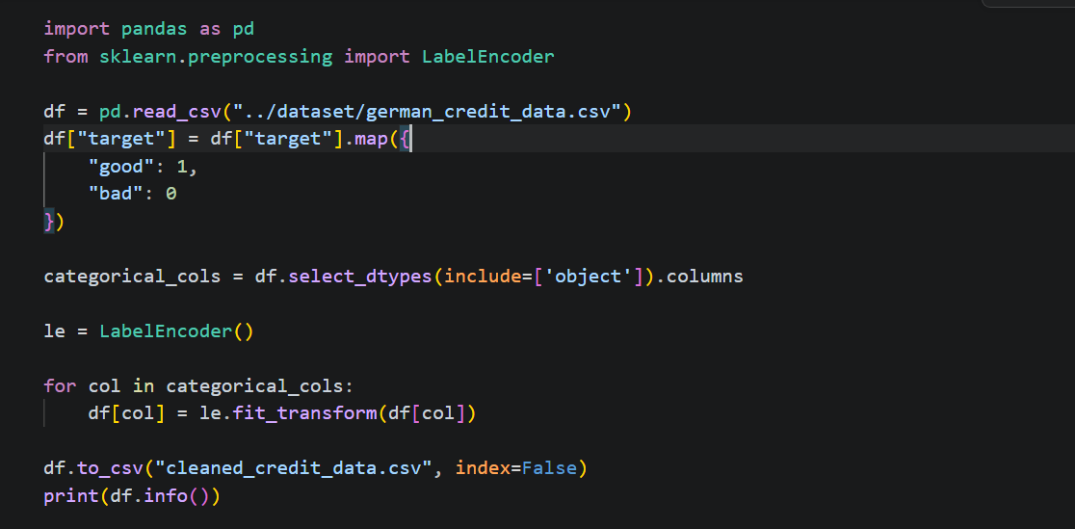

New data is saved in new file “cleaned_credit_data.csv”

