ATOA ASSIGNMENT

Clone the repo
To clone the repo use command “ git clone <REPO URL>
To clone the above mentioned repo use the below command:
git clone https://github.com/ATOAPaymentsLimited/SampleExpressApp.git

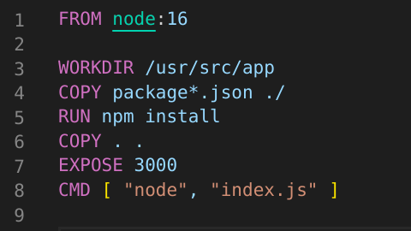
Dockerise the project create a docker file and docker-compose
Below is the code to create a Dockerfile for above project
This tells docker to,
  - Build an image starting with the Node image.
  - Set the working directory to /usr/src/app.
  - Copy package files to the current directory.
  - Run npm install to install the dependencies.
  - Copy the current directory . in the project to the workdir . in the image.
  - Describe that the container is listening on port 3000.
  - Set the default command for the container to “node index.js”.

Below is the code to create the docker-compose:

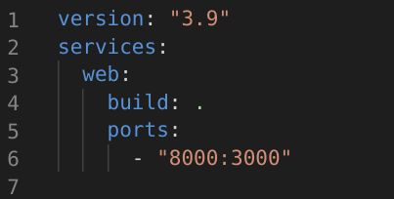
The web service uses an image that’s built from the Dockerfile in the current directory. It then binds the container and the host machine to the exposed port 8000. The express app container listens on port 3000.

Write a config file to deploy as a pod in Kubernetes with auto- scaling

Below is the manifest file to create a Kubernetes deployment for above project.
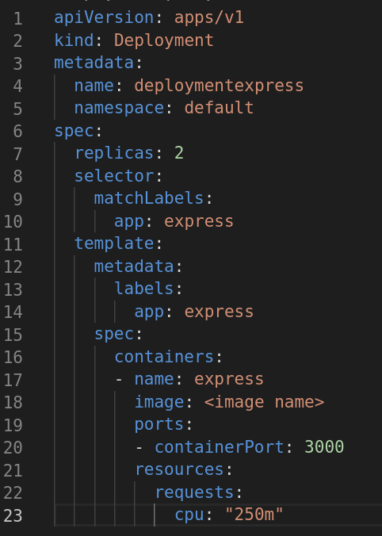

Below is the manifest file to create HPA(Horizontal Pod Autoscaler)

