SMS Spam Detection Using Machine Learning

1. Introduction

SMS spam messages are unwanted or unsolicited text messages that are often used for advertising, scams, or fraudulent activities. These messages can cause inconvenience and may expose users to security risks.

Machine Learning can help automatically identify spam messages by learning patterns from previously labeled messages. This project develops an SMS Spam Detection system that classifies text messages into two categories: Spam and Ham (Not Spam).

2. Objective

The main objectives of this project are:

- To develop a Machine Learning model for detecting spam SMS messages.
- To preprocess and analyze a labeled SMS dataset.
- To train and compare different classification algorithms.
- To evaluate model performance using accuracy, precision, recall, F1-score, and ROC-AUC.
- To create a simple application that predicts whether a message is spam or not.

3. Dataset Description

The project uses the SMS Spam Collection dataset, which contains text messages labeled as either spam or ham.

The dataset contains:

Description| Value
Total messages before preprocessing| 5,572
Ham messages| 4,825
Spam messages| 747
Messages after removing duplicates| 5,169

The dataset contains two main columns:

- Label: Indicates whether the message is spam or ham.
- Message: Contains the actual SMS text.

4. Data Preprocessing

The following preprocessing steps were performed:

1. Loaded the dataset using the Pandas library.
2. Selected the label and message columns.
3. Removed duplicate messages.
4. Converted message text to lowercase.
5. Converted the labels into numerical values:
- Ham = 0
- Spam = 1
6. Split the dataset into training and testing sets using an 80:20 ratio.
7. Used stratified splitting to maintain the proportion of spam and ham messages in both sets.

5. Feature Extraction

Machine Learning algorithms require numerical input. Therefore, the text messages were converted into numerical features using TF-IDF (Term Frequency-Inverse Document Frequency).

TF-IDF assigns numerical weights to words based on their importance in a message and across the dataset. These features were used to train the classification models.

6. Machine Learning Algorithms

Two classification algorithms were trained and evaluated.

6.1 Multinomial Naive Bayes

Multinomial Naive Bayes is a probabilistic classification algorithm commonly used for text classification. It estimates the probability that a message belongs to a particular class based on the words present in it.

The model was trained using an alpha value of 0.1.

6.2 Logistic Regression

Logistic Regression is a supervised classification algorithm that estimates the probability of a message belonging to a particular category.

It was trained with a maximum of 1,000 iterations.

7. Model Evaluation

The models were evaluated using the following performance metrics:

- Accuracy: Measures the percentage of correctly classified messages.
- Precision: Measures how many messages predicted as spam were actually spam.
- Recall: Measures how many actual spam messages were correctly identified.
- F1-score: Represents the balance between precision and recall.
- ROC-AUC: Measures how effectively the model distinguishes between spam and ham messages.

Cross-validation was also used to assess model performance across multiple data splits.

8. Results and Comparison

The models achieved the following results on the test dataset:

Evaluation Metric | Multinomial Naive Bayes | Logistic Regression
Accuracy | 98.26% | 96.71%
ROC-AUC | 0.9944 | 0.9892
Spam Precision | Approximately 97% | Approximately 99%
Spam Recall | Approximately 89% | Approximately 75%
Spam F1-score | Approximately 93% | Approximately 85%

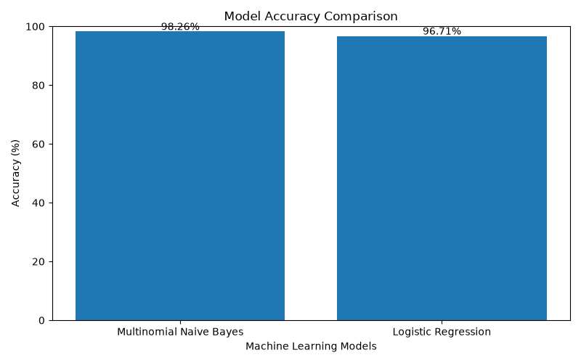

.

Multinomial Naive Bayes achieved higher accuracy, recall, F1-score, and ROC-AUC than Logistic Regression in this experiment.

Logistic Regression achieved higher precision for the spam class, but it missed more actual spam messages.
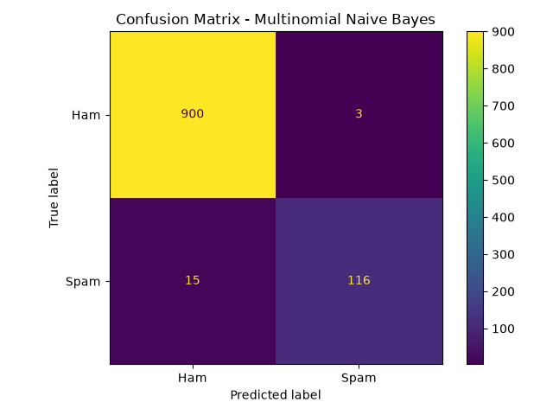

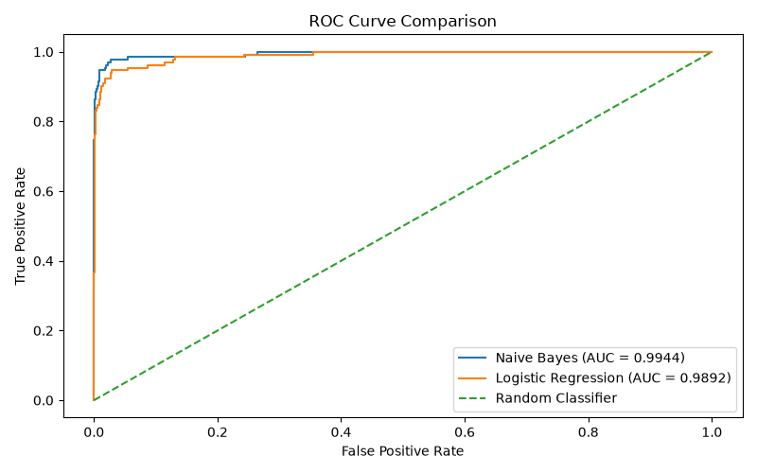

Note: The precision, recall, and F1-score values above are rounded. Use the exact values from the classification reports generated by your notebook if required.

9. Application Development

A simple Python application was developed to allow users to enter an SMS message and receive a prediction.

The application:

1. Accepts a message from the user.
2. Converts the message into TF-IDF features.
3. Passes the features to the trained model.
4. Displays the prediction as either:
- Spam Message
- Ham Message (Not Spam)

The trained model and TF-IDF vectorizer were saved using Joblib and loaded by the application.

10. Conclusion

This project successfully demonstrates how Machine Learning can be used to detect spam SMS messages.

The dataset was preprocessed, text messages were converted into TF-IDF features, and two classification algorithms were trained and evaluated. Multinomial Naive Bayes achieved the best overall performance, with an accuracy of approximately 98.26%.

The project also includes a simple Python application that allows users to test messages and receive predictions.

This project helped develop practical skills in data preprocessing, text feature extraction, Machine Learning model training, model evaluation, and application development.

11. Future Improvements

The project can be improved in the future by:

- Testing additional classification algorithms.
- Using a larger and more diverse dataset.
- Improving text preprocessing.
- Exploring alternative feature extraction methods.
- Developing a web-based interface for easier use.
- Evaluating the model on new real-world SMS messages.

