EXPERIMENT - 05
- Aim: To simulate a simple peer-to-peer network in Cisco Packet Tracer by connecting two PCs using appropriate devices, assigning IP addresses, and verifying successful communication between them.
Description: In this experiment, two PCs were connected in Cisco Packet Tracer using a copper straight- through cable (or via a switch if required). Each PC was assigned a unique IP address within the same network/subnet to enable communication. After assigning IP addresses, packet data was transferred between the PCs using the ping command to test connectivity.

This simulation demonstrates the concept of direct communication between hosts in the same network, IP address configuration, and basic packet flow verification.

Output:
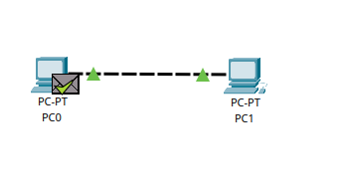
Connected Network Topology in Cisco Packet Tracer
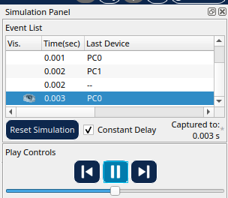
Packet Flow Simulation between PC1 and PC2
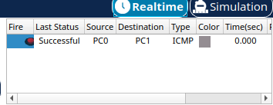
IP Address Configuration and Successful Connectivity Test
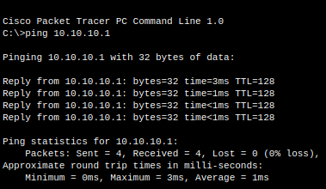

Result: The two PCs were successfully connected in Cisco Packet Tracer using proper cabling and IP configuration. After assigning valid IP addresses in the same subnet, packets were transmitted between the systems. The simulation and ping command results confirmed that the PCs could communicate with each other, thereby verifying the working of a simple peer-to-peer network.
- Aim: To design and simulate a simple LAN in Cisco Packet Tracer by connecting two PCs through a switch, assigning IP addresses, and verifying end-to-end communication.

Description :In this experiment, two PCs were connected to a central switch using copper straight- through cables. Each PC was assigned a unique IP address within the same network. The switch acted as the central connecting device, enabling communication between the PCs. Successful data transmission was verified using packet simulation mode and the ping command.This setup demonstrates
the basic working of a LAN using a switch, where multiple devices can be interconnected efficiently without direct cabling between them.

Output:
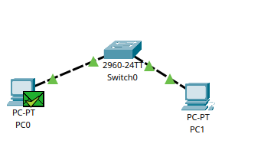
Network Topology with Two PCs Connected via a Switch
IP Address Configuration of PCs
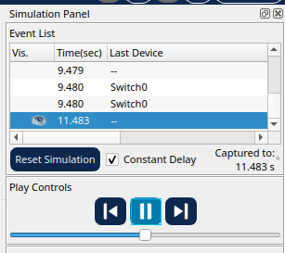
Packet Flow Simulation through the Switch
Result: The simple LAN was successfully designed and simulated in Cisco Packet Tracer. Two PCs were connected through a switch, assigned IP addresses within the same network, and verified for connectivity. The packet flow simulation and ping test confirmed successful end-to-end communication, demonstrating the basic functionality of a LAN using a switch.
- Aim: To simulate a local area network (LAN) by connecting multiple PCs to a switch, configuring IP addresses, and testing communication among them.
Description: In this experiment, more than two PCs were connected to a central switch using straight- through cables. Each PC was assigned a unique IP address in the same subnet. The switch provided central connectivity, allowing the PCs to exchange data packets. Successful communication was tested using simulation mode and the ping command.


Output:
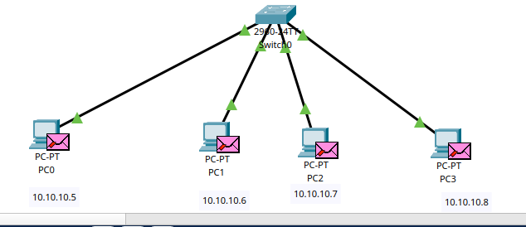
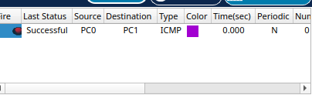
Result: All PCs were able to communicate with one another through the switch, confirming proper IP configuration and packet forwarding. The experiment validates how a switch enables multiple hosts to form a functional LAN.

- Aim :To establish direct peer-to-peer communication between two laptops by assigning IP addresses and testing connectivity.
Description: Two laptops were connected using a copper cross-over cable in Cisco Packet Tracer. Both laptops were assigned unique IP addresses within the same subnet. Direct packet transfer between them was tested using simulation and the ping command.

Output:
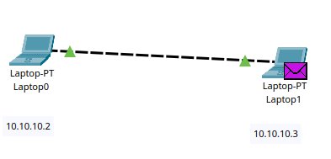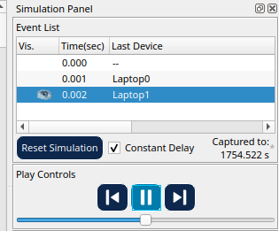

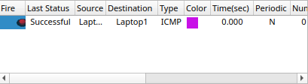
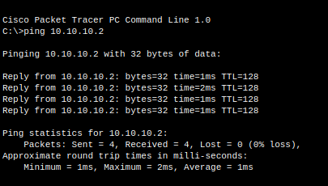


Conclusion: The laptops successfully communicated with each other after proper IP addressing. The experiment demonstrates direct peer-to-peer connectivity without using intermediate devices.

- Aim: To simulate a simple LAN by connecting two laptops through a switch, configuring IP addresses, and verifying communication.
Description: Two laptops were connected to a central switch using straight-through cables. Each laptop was given an IP address in the same subnet. The switch acted as the intermediary, forwarding packets between the laptops. Connectivity was tested via simulation mode and ping.

Output:
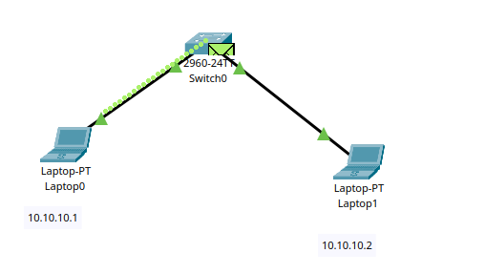
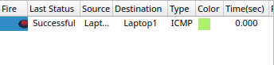

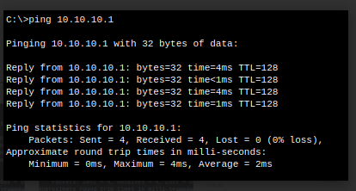
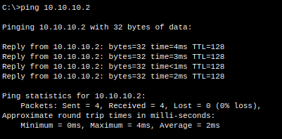


Conclusion: The laptops successfully exchanged data through the switch. The experiment shows how a switch enables smooth communication even between wireless devices (laptops) when connected via LAN ports.

- Aim: To create a small LAN by connecting a laptop and a PC through a switch, assigning IP addresses, and testing communication.
Description: A laptop and a PC were connected to a switch using straight-through cables in Cisco Packet Tracer. Each device was assigned an IP address within the same network range. The switch facilitated communication between the two end devices. Successful communication was verified with simulation and ping.

Output:
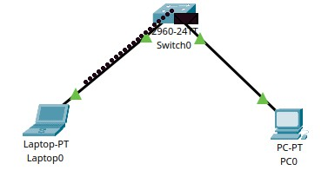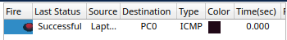
Conclusion: Both the laptop and PC communicated successfully via the switch, confirming correct IP addressing and switch operation. This setup demonstrates how heterogeneous devices (PC and laptop) can be interconnected in a LAN environment.

