EXPERIMENT – 6

- Aim: To connect two PCs directly to a router, assign IP addresses, configure default gateways, and verify communication between PCs and the router.

Description:

In this experiment, two PCs are connected individually to the router via Ethernet cables. The router acts as a central device managing network traffic. Each PC is assigned a unique IP address within the same subnet as the router. The subnet mask is configured to allow communication within the local network. Both PCs are configured to use the router's IP address as their default gateway to enable communication beyond the local network.
Example configuration:
  - Router IP:192.168.1.1,192.168.2.1
  - PC1 IP: 192.168.1.2
  - PC2 IP: 192.168.2.2
  - Subnet Mask: 255.255.255.0
  - Default Gateway (PCs): 192.168.1.1,192.168.2.1 Ping tests verify connectivity between PCs and the router. Output:
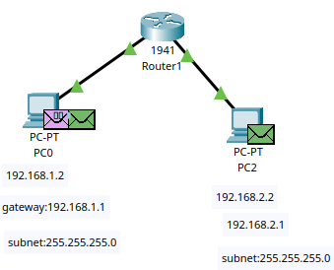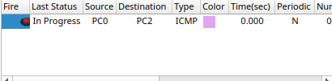
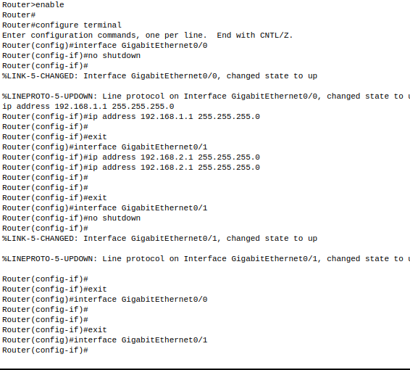


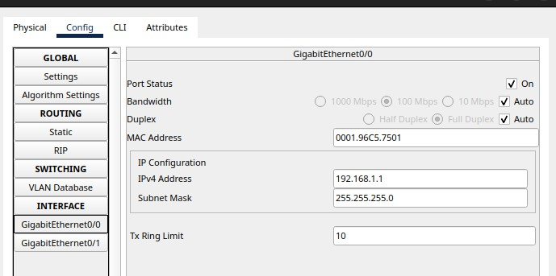
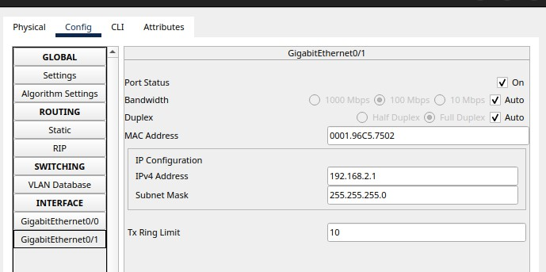
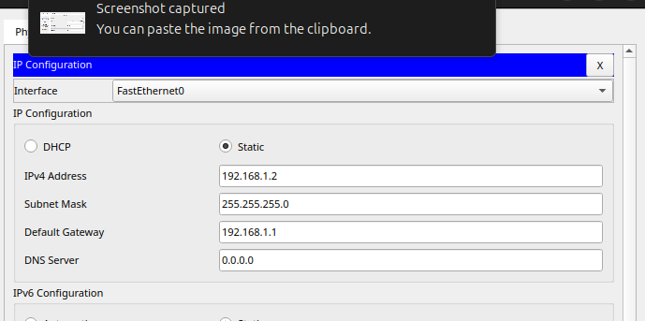
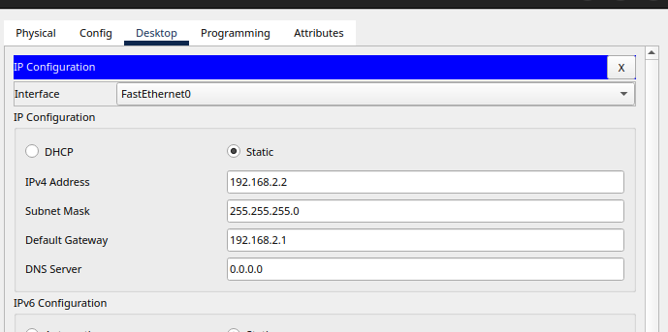

Conclusion: The experiment demonstrates that using a switch to connect multiple PCs to a router is effective for creating a local area network. Proper IP configuration ensures devices communicate internally and access external networks through the router. The switch efficiently manages network traffic within the LAN.
- Aim: To connect two PCs to a router through a switch, configure the PCs with appropriate IP addresses, subnet masks, and default gateways, and enable communication between the PCs and external networks via the router.

Description: In this experiment, two PCs are connected to a network switch, which is then connected to a router. The router acts as the gateway for the PCs, allowing them to communicate with devices outside their local subnet.
- Hardware Setup:
  - PC1 and PC2 are connected to ports on the switch.
  - The switch is connected to the router via an Ethernet cable.
- IP Configuration:
  - Assign static IP addresses to the PCs within the same subnet.
  - Set the subnet mask to define the network size.
  - Configure the default gateway on each PC as the IP address of the router’s interface connected to the switch.
- Example:
  - Router IP: 192.168.1.1
  - PC1 IP: 192.168.1.2
  - PC2 IP: 192.168.1.3
  - Subnet Mask for all: 255.255.255.0
  - Default Gateway for both PCs: 192.168.1.1
- Testing Connectivity:
  - Use the ping command on each PC to test communication with the router and the other PC.
  - Verify that PCs can access devices outside the local network through the router.

Output:
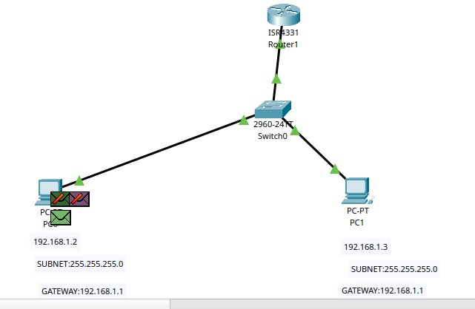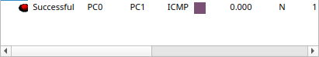

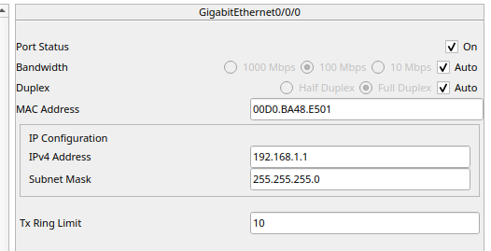
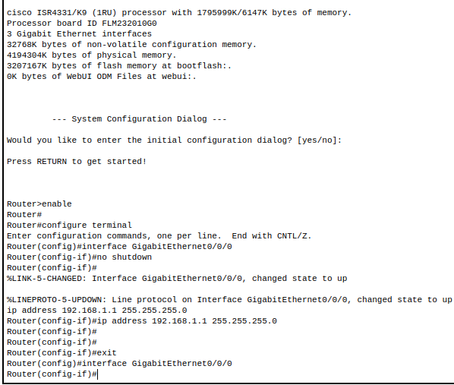
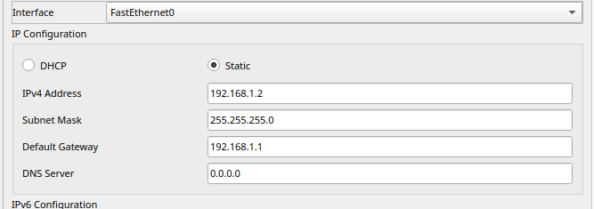
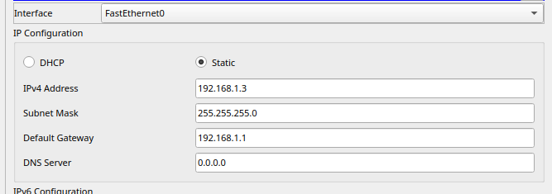


Conclusion: The experiment successfully demonstrates how to connect multiple PCs to a router via a switch, enabling local network communication and external network access through the router. Assigning correct IP addresses and configuring the default gateway ensures seamless data transmission within the LAN and to outside networks. This setup is fundamental for understanding basic network infrastructure and IP routing.

- Aim: To connect 4 PCs to a network using 2 switches and 1 router, configure IP addresses and default gateways, and verify communication between PCs within the local network and access to external networks through the router.
Description: In this experiment, four PCs are connected to two network switches, which are then connected to a single router. The router provides the gateway for the PCs to communicate with devices outside the local network or the internet.


Output:
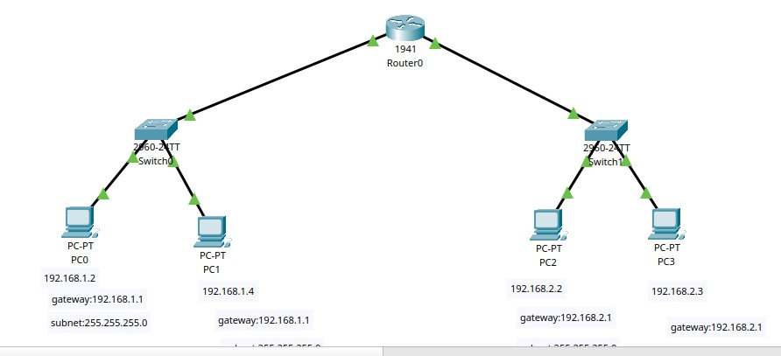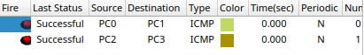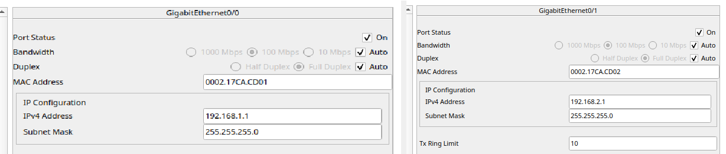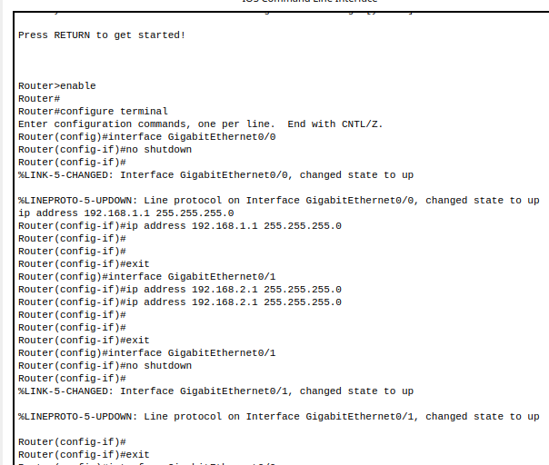
Conclusion: The experiment demonstrates how multiple PCs can be interconnected through switches to form a local area network. The router acts as a gateway, enabling communication beyond the local network. Using multiple switches expands the number of devices that can be connected efficiently. Proper IP configuration and gateway settings ensure seamless communication within the LAN and with external networks.

