Roll No: 160123733174 Exp. No: 07 Date:
EXPERIMENT-7
- Aim: To design and implement a Star Topology in Cisco Packet Tracer by connecting multiple PCs through a central switch and assigning IP addresses for communication within the same network.
Description:
  - Network designed using Star Topology in Cisco Packet Tracer.
  - Six PCs (PC0–PC5) connected to a central switch with straight-through cables.
  - Each PC assigned unique IP addresses: 10.10.10.1 – 10.10.10.6, subnet mask 255.0.0.0.
  - Switch acts as the central hub for communication.

  - Ensures smooth data transfer, easy fault detection, and scalability.
Diagram:
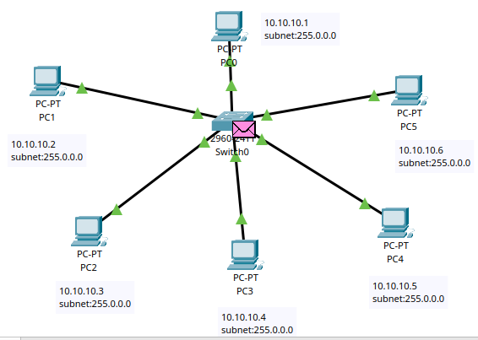
Table:
 | Device | IP address | Subnet
 | PC0 | 10.10.10.1 | 255.0.0.0
 | PC1 | 10.10.10.2 | 255.0.0.0
 | PC2 | 10.10.10.3 | 255.0.0.0
 | PC3 | 10.10.10.4 | 255.0.0.0
 | PC4 | 10.10.10.5 | 255.0.0.0
 | PC5 | 10.10.10.6 | 255.0.0.0
Procedure:
- Drag and drop a 2960 Switch to the workspace.
- Add the required number of PCs (e.g., 6 PCs).
- Connect each PC to the switch using Copper Straight-Through Cables.
- Assign IP addresses and subnet mask to each PC (e.g., 10.10.10.1/8, 10.10.10.2/8, etc.).
- Verify the connections by using the ping command between PCs.
Result:
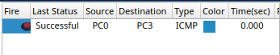

Page No. 42 Signature of the Faculty………………………...

Roll No: 160123733174 Exp. No: 07 Date:

CLI console message:
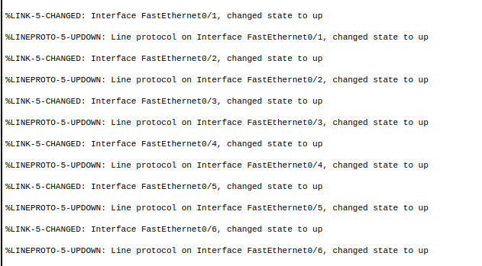

Conclusion: The Star Topology was successfully implemented in Cisco Packet Tracer. All PCs communicated effectively using the central switch, demonstrating reliable connectivity and easy network management.

2)Aim: To design and implement a Mesh Topology in Cisco Packet Tracer by interconnecting switches and connecting PCs to demonstrate reliable communication with redundancy.

Description:
- Network created using Mesh Topology in Cisco Packet Tracer.
- Four switches (Switch0, Switch1, Switch2, Switch3) interconnected with multiple links for redundancy.
- Four PCs (PC0–PC3) connected to switches with IP addresses:
o PC0 → 192.168.0.1 / 24
o PC1 → 192.168.0.2 / 24
o PC2 → 192.168.0.3 / 24
o PC3 → 192.168.0.4 / 24
- Subnet mask used: 255.255.255.0.
- Mesh connectivity ensures that if one link or switch fails, data can still be routed through alternative paths.
- Provides high fault tolerance, reliability, and continuous communication.

Diagram:
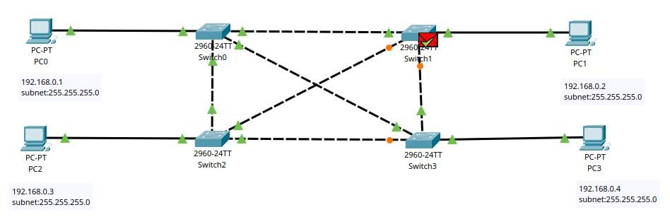

Page No. 43 Signature of the Faculty………………………...

Roll No: 160123733174 Exp. No: 07 Date:
Table:
 | Device | IP address | Subnet
 | PC0 | 192.168.0.1 | 255.255.255.0
 | PC1 | 192.168.0.2 | 255.255.255.0
 | PC2 | 192.168.0.3 | 255.255.255.0
 | PC3 | 192.168.0.4 | 255.255.255.0
Procedure:
- Drag and drop multiple Switches (e.g., 4 switches).

- Add PCs (one or more per switch, e.g., 4 PCs).
- Connect each PC to a switch using Copper Straight-Through Cables.
- Interconnect the switches with multiple links (to create mesh connectivity).
- Assign IP addresses and subnet mask to each PC (e.g., 192.168.0.1/24, 192.168.0.2/24, etc.).
- Test communication by pinging PCs to ensure redundancy and connectivity.
Result:
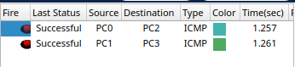
CLI console message:
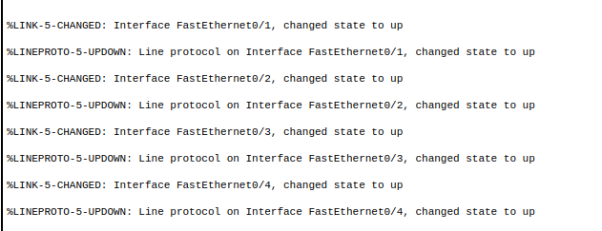
Conclusion: The Mesh Topology was successfully implemented, and PCs communicated effectively through redundant switch connections. The design ensures fault tolerance, as alternate paths maintain connectivity even if one link fails.
Page No. 44 Signature of the Faculty………………………...

